Mathematical Methods 1 – MA142

2024 NHT Assessment Guide

Marking Guide
Q# | Marks | Solutions | Mark allocation and notes
1a | 2 | $\frac{dy}{dx}=\left(2x\right)xe^{x^{2}+1}+e^{x^{2}+1}$  $\frac{dy}{dx}=(2x^{2}+1)e^{x^{2}+1}$ or $2(x^{2}+\frac{1}{2})e^{x^{2}+1}$ | 1M – evidence of product rule or see 2 terms added together both with e^  1A – factorise as shown, if named must be either f’(x) or dy/dx
1b | 2 | $\frac{3x^{2}⋅\log_{e}{x}-x^{3}⋅\frac{1}{x}}{{\left(\log_{e}{x}\right)}^{2}}$  $=\frac{\left(3\log_{e}{x}-1\right)x^{2}}{{\left(\log_{e}{x}\right)}^{2}}$ or $\frac{-x^{2}}{{\left(\log_{e}{x}\right)}^{2}}-\frac{3x^{2}}{\log_{e}{x}}$  At $x=e$  $f'(x)=\frac{\left(3⋅\log_{e}{e}-1\right)⋅e^{2}}{{\left(\log_{e}{e}\right)}^{2}}$  $=\frac{{2e}^{2}}{1}=2e^{2}$ | 1M – use of quotient rule or product rule (unsimplified OK), 2 terms one with $\log_{e}{x}$ on numerator, with correct denominator (accept ambiguous), plus/minus  1A -watch working, f’(x) must be correct, accept dy/dx
2a | 3 | Method 1 Elimination  $ax+\left(2-a\right)y=3$ Eqn 1  $ax+a^{2}y=\frac{2a^{2}+a}{2}$ Eqn 2 (formed by $a×E2$)  E1 – E2  $\left(2-a-a^{2}\right)y= \frac{6-a-2a^{2}}{2}$  $2-a-a^{2}=0$  $∴a=1$ or $a=-2$  For $a=-2$  $-2x+4y=3$  $x-2y=-\frac{3}{2}$  $∴a=-2$  Method 2 Substitution  $ax+\left(2-a\right)y=3$ Eqn 1  $x=-ay+\frac{2a+1}{2}$ Eqn 2  Sub E2 into E1  $$a\left(-ay+\frac{2a+1}{2}\right)+\left(2-a\right)y=3$$  $$-a^{2}y+a^{2}+\frac{a}{2}+2y-ay=3$$  $$y\left(-a^{2}-a+2\right)=3-a^{2}-\frac{a}{2}$$  $2-a-a^{2}=0$  $∴a=1$ or $a=-2$  $∴a=-2$  Method 3 Equate gradients/y-intercepts/y equations  $y=\frac{-a}{2-a}x+\frac{3}{2-a}$ Eqn 1  $y=-\frac{1}{a}x+\frac{2a+1}{2a}$ Eqn 2  $\frac{-a}{2-a}=-\frac{1}{a}$ $\frac{3}{2-a}$=$\frac{2a+1}{2a}$  $a^{2}=2-a$ $6a=3a-2a^{2}+2$  $0=a^{2}+a-2$ $0={2a}^{2}+3a-2$  $\left(a+2\right)\left(a-1\right)=0$ $\left(a+2\right)\left(2a-1\right)=0$  $∴a=1$ or $a=-2$ $a=1/2$ or $a=-2$  For $a=-2$  $y=\frac{1}{2}x+\frac{3}{4}$ Eqn 1  $y=\frac{1}{2}x+\frac{3}{4}$ Eqn 2  $∴a=-2$ for infinite solutions  Or set $y_{1}=y_{2}$ and get  $\frac{-a}{2-a}x+\frac{3}{2-a}$=$-\frac{1}{a}x+\frac{2a+1}{2a}$  Equate coefficients or isolate x to get equations as above  Method 4 - Matrix  $\left[\begin{matrix}a & 2-a \\ 1 & a\end{matrix}\right]\left[\begin{matrix}x \\ y\end{matrix}\right]=\left[\begin{matrix}3 \\ \frac{2a+1}{2}\end{matrix}\right]$  Same gradient when $Det A=0$  $$Det A=a^{2}-\left(2-a\right)$$  $\left(a+2\right)\left(a-1\right)=0$  $∴a=-2$  Method 5-Ratios  $$\frac{a}{1}=\frac{2-a}{a}=\frac{3}{\frac{2a+1}{2}}$$  $$a^{2}=\left(2-a\right)$$  $0=a^{2}+a-2$  $\left(a+2\right)\left(a-1\right)=0$  $∴a=-2$ | Multiple methods:  1M  - form $equation a×E2$ and attempt elimination of $ax$  - substitute E2 into E1 and attempt to isolate y  - equate gradients/equate y-intercepts/y= (any one), equate coefficients, or isolate x  - set up matrix and attempt to find DetA  - set up an equation involving a ratio of coefficients (at least 2 ratios)  1M – form a quadratic, set equal to zero and attempt to solve  1A only $a=-2$
2b | 1 | $$R\backslash \{-2,1\}$$ | 1A, a $∈$, not $x∈$,  accept $a≠-2,1$
2c | 1 | $a=0$ or $a=3$ | 1A – accept either value
3a | 1 | $\left(-∞,2\right)$ or $x<2$ | 1A
3b | 3 | 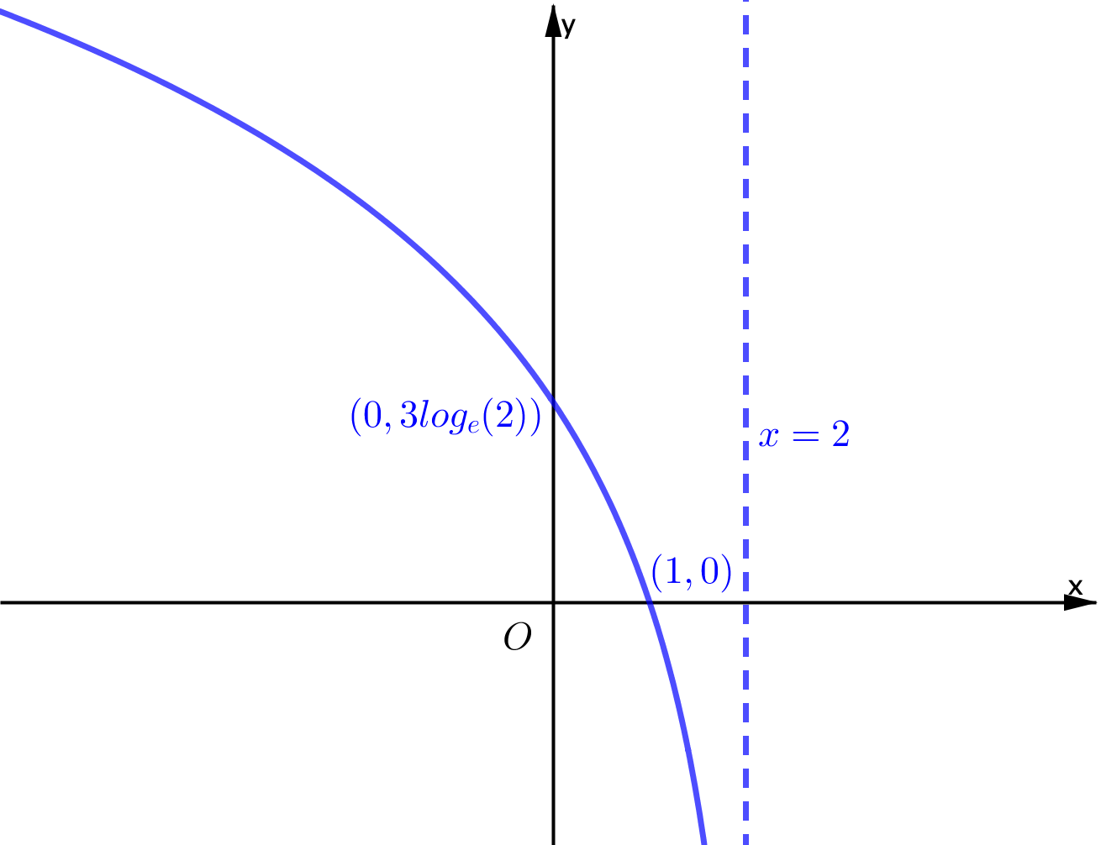 | 1A –shape, log graph reflected in y-axis  1A– asymptote labelled  , dash or dotted  1A -Coordinates labelled, ln(8) ok, must be base e  Independent marks
3c | 1 | $2-e≤x≤1$ or $\left[2-e, 1 \right]$ | 1A – either form, watch order
4a | 2 | $\left(g∘h\right)\left(x\right)=\log_{e}\left(2\left(e^{3x}+2\right)-3\right)$  $=\log_{e}\left(2e^{3x}+1\right)$  $h(x)$ is defined for $x∈R$  $2e^{3x}+1>0$ for $x∈R$  $∴\left(g∘h\right)\left(x\right)$ is defined for $x∈R$  Or  For $g∘h$ to be defined, Ran $h⊆$ Dom $g$  Since $(2,∞)⊆(\frac{3}{2},∞)$ $g∘h$ is defined  And Dom $\left(g∘h\right)=Dom h=R$  $∴\left(g∘h\right)\left(x\right)$ is defined for $x∈R$ | 1A – write a correct composite of $h$ and $g$  1M – indicate $2e^{3x}+1>0$ for ${dom}_{h} x∈R$  (only both marks if correct  $\left(g∘h\right)\left(x\right)$  OR-  1A $(2,∞)⊆(\frac{3}{2},∞)$  1M – valid conclusion and link  Dom $\left(g∘h\right)=Dom h=R$
4b | 1 | $\left(0,∞\right),$ $R^{+}$ | 1A, accept $y∈$
5a | 2 | $E\left(\hat{P}\right)=0.9$  $$sd\left(\hat{P}\right)=\sqrt{\frac{0.9∙0.1}{100}}$$  $$=0.03=\frac{3}{100}$$ | 1A ,$μ=$, mean=, $E\left(\hat{P}\right)=$,  1A $σ=$,  If E(X) or sd (X) then 1/2
5b | 2 | $$\operatorname{Pr}\left(\hat{P}>0.93\right)=Pr{(Z>\frac{0.93-0.9}{0.03}})=\operatorname{Pr}\left(Z>1\right)$$  $$=1-Pr⁡(Z<1)$$  $=1-0.84$  $$=0.16$$  $∴\operatorname{Pr}\left(\hat{P}>0.93\right)=0.16$ | 1M – attempt to standardise using their mean and standard deviation or indicate beyond one standard deviation, can use graph,  1A must see $\hat{P}>0.93$ or $X>93$  **if uses another statistical variable then ½, but must define to get 2/2
6a | 2 | Area $=\frac{\frac{2π}{3}-\frac{π}{6}}{2×3}\left(1+2∙\frac{3}{2}+2∙\frac{5}{2}+3\right)=\frac{\frac{3π}{6}}{6}(1+3+5+3)=\frac{π}{12}\left(1+3+5+3\right)$  Area=$\frac{1}{2}×\frac{π}{6}\left(1+\frac{3}{2}\right)+\frac{1}{2}×\frac{π}{6}\left(\frac{3}{2}+\frac{5}{2}\right)+\frac{1}{2}×\frac{π}{6}(\frac{5}{2}+3)$  Area= $π$ | 1M – correct set up of rule with correct y values, or attempt find area three trapezia (with correct y values)  1A
6b | 2 | $\int_{\frac{π}{6}}^{\frac{2π}{3}}{\left(\sin\left(2x-\frac{5π}{6}\right)+2\right)}dx=\frac{1}{k}$  LHS gives  $={\left[-\frac{1}{2}\cos\left(2x-\frac{5π}{6}\right)+2x\right]}_{\frac{π}{6}}^{\frac{2π}{3}}$  $=\left(0+\frac{4π}{3}-\left(0+\frac{π}{3}\right)\right)$  $=π$  $$∴k=\frac{1}{π}$$ | 1M –antiderivative of g(x) (dx) and attempt to substitute correct endpoints. $±\frac{1}{2}cos\left(2x-\frac{5π}{6}\right)+2x$  Or identifying symmetry about the point of inflection at $x=\frac{5π}{12}$ equates to the area Q6a).  1A working and answer must be in correct space, answer must come from using calculus  Answer must come from correct working (antiderivative)
7a | 1 | $\frac{2}{81}$ | 1A
7b | 2 | $\operatorname{Pr}\left(X<4 | X≥2\right)=\frac{Pr⁡(2≤X≤3)}{Pr⁡(X≥2)}$  $$=\frac{\frac{2}{9}+\frac{2}{27}}{1-Pr⁡(X=1)}$$  $$=\frac{\frac{8}{27}}{1-\frac{2}{3}}$$  $$=\frac{8}{27}×\frac{3}{1}$$  $$=\frac{24}{27}=\frac{8}{9}$$ | 1M – conditional expressed as numerator being sum of two fractions, the denominator as  1 minus a fraction. Must see powers of 3.  1A (unsimplified OK)
8a | 1 | $\frac{2}{3}{(3x+1)}^{\frac{1}{2}}=\frac{2}{3}\sqrt{3x+1}$ | 1A - $+c$ not necessary
8b | 3 | $\frac{1}{m}\int_{0}^{m}{\frac{1}{\sqrt{3x+1}}}dx=\frac{1}{3}$  $\frac{1}{m}{\left[\frac{2}{3}\sqrt{3x+1}\right]}_{0}^{m}=\frac{1}{3}$ or ${\left[\sqrt{3x+1}\right]}_{0}^{m}=\frac{m}{2}$  $\frac{2}{3}\left(\sqrt{3m+1}-1\right)=\frac{m}{3}$ or $\left(\sqrt{3m+1}-1\right)=\frac{m}{2}$  $\sqrt{3m+1}=\frac{m}{2}+1$  $3m+1=\frac{m^{2}}{4}+m+1$  $0=m^{2}-8m$  $∴m=0$ or $m=8$  $∴m=8$ | 1H – See equivalent of line 3, use their response to 8a. and substitute correct terminals and equate to $\frac{m}{3}$ or $\frac{m}{2}$ .  1M – manipulate by correctly squaring and expanding both sides to get a quadratic equal to 0.  1A
9a | 1 | $$f'(x)=-\left(x-1\right)e^{-x}+e^{-x}=\left(2-x\right)e^{-x}=-\left(x-2\right)e^{-x}$$ | 1A, not y, dy/dx ok
9b | 2 | - Reflection in the $x$-axis  - Dilation from the $x$-axis by a factor of $\frac{1}{e}$  - Translation in the positive $x$-direction of 1 unit. | 1A – reflection and translation.  1A – Correct dilation factor
9c | 1 | $\frac{d}{dx}\left(-x e^{-x}\right)=-e^{-x}+\left(-1\right)\left(-x e^{-x}\right)$  $=-e^{-x}+x e^{-x}$  $=\left(x-1\right)e^{-x}$ | 1M – evidence of product rule,  Correctly leading to given answer, must clearly show bracketed negative coefficients or individual terms and all working leading to f(x) or $\left(x-1\right)e^{-x}$
9d | 4 | $$f\left(3\right)=\left(3-1\right)e^{-3}$$  $=2e^{-3}$  $f^{'}\left(3\right)=\left(2-3\right)e^{-3}$  $=-e^{-3}$  $g\left(x\right)-2e^{-3}=-e^{-3}(x-3)$  $g\left(x\right)=-e^{-3}x+5e^{-3}$  $\int_{1}^{3}{\left(-e^{-3}x+5e^{-3}-f\left(x\right)\right)}dx$  $={\left[-e^{-3}\frac{x^{2}}{2}+5e^{-3}x-\left(-xe^{-x}\right)\right]}_{1}^{3}$  $=\left(-\frac{9}{2}e^{-3}+15e^{-3}+3e^{-3}-\left(-\frac{1}{2}e^{-3}+5e^{-3}+e^{-1}\right)\right)$  $=e^{-3}\left(-4+15+3-5-e^{2}\right)$  $=e^{-3}\left(9-e^{2}\right)=9e^{-3}-e^{-1}$ or  $=\frac{1}{e^{3}}\left(9-e^{2}\right)=\frac{9}{e^{3}}-\frac{1}{e}$ | 1A/H – set up correct equation for $g(x)$ or correct equation for their $g(x)$ based on correct $f(3)$and their $f’\left(3\right),$ equation must be a linear  1M – attempt to integrate their linear $g\left(x\right)$ with correct endpoints or use area of a trapezium with their $g\left(x\right)and x=1, x=3$  $$\int_{1}^{3}{g(x)dx}=6e^{-3}$$  1M – use recognition to integrate $f\left(x\right)$ and correct substitution of correct end points. $3e^{-3} and e^{-1}$ present  $$\int_{1}^{3}{f(x)dx}=-3e^{-3}+e^{-1}$$  1A – any valid form of solution

