2024 VCE Physics (NHT) external assessment report

Specific information
This report provides sample answers, or an indication of what answers may have included. Unless otherwise stated, these are not intended to be exemplary or complete responses.

Section A
Question | Correct answer | Comments
1 | A | Like charges repel, unlike charges attract. Gravitational forces always attract.
2 | C | $$F∝\frac{1}{d^{2}}$$  $$⇒\frac{F}{5}∝\frac{1}{{(5d)}^{2}}$$  d must increase to $\sqrt{5}d$.
3 | D | $$E=\frac{V}{d}$$  $$E=\frac{6}{2×{10}^{-3}}$$  $$E=3×{10}^{3} N C^{-1}$$
4 | A | $$v=\sqrt{\frac{GM}{r}}$$  If v is different then r must be different.
5 | B | For the loop to rotate in the direction shown, the right-hand slap rule shows that the field must orient from Q (north) to P (south).
6 | C | The transition from steady current to no current will cause a change in flux in the coils, causing a reading on the meter. Once the current has fallen to zero, there will be no more change in flux and the meter will read zero.
7 | B | $$P=VI$$  $$40=240×I$$  $$I=0.16 A$$  $$\frac{N_{p}}{N_{s}}=\frac{I_{s}}{I_{p}}$$  $$\frac{6}{1}=\frac{I_{s}}{0.167}$$  $$I_{s}=6×0.167=1.0 A$$
8 | B | $$EMF=-\frac{∆Φ}{Δt}$$
9 | D | The gravitational force is vertically down, and the air resistance force is horizontally to the left. The resultant vector is down and to the left.
10 | C | Kinetic energy is a scalar, so it is constant. Momentum is a vector, so it varies as direction varies.
11 | D | The speed of light is not constant in all transparent media.
12 | C | $$v=\sqrt{rg}$$  $$v=\sqrt{0.2×9.8}$$  $$v=1.4 m s^{-1}$$
13 | A | $$W=Fd$$  $$W=50×6.5$$  $$W=325 J$$
14 | B | $ΣF=0$. This is implied by the constant speed.  $$F_{f}=mg\sin{θ}$$  $$F_{f}=60×9.8×0.5$$  $$F_{f}=300 N$$
15 | A | Approaching at a constant velocity $⟹$ constant higher pitch.  Receding at a constant velocity $⟹$ constant higher pitch.
16 | D
17 | B | $$n=\frac{c}{c_{medium}}$$  $$1.63=\frac{3.00×{10}^{8}}{c_{medium}}$$  $$c_{medium}=1.84×{10}^{8} m s^{-1}$$
18 | A | At $8.0×{10}^{14} Hz$, photoelectrons emitted from metal 2 will have a lower kinetic energy than those emitted from metal 1. Therefore, they will have a lower velocity.
19 | C | $$E=\frac{hc}{λ}$$  $$E=\frac{6.63×{10}^{-34}×3.00×{10}^{8}}{650×{10}^{9}}$$  $$E=3.06×{10}^{-19} J$$  $$n=\frac{P_{total}}{P_{photon}}$$  $$n=\frac{30×{10}^{-3}}{3.06×{10}^{-19}}$$  $$n=9.80×{10}^{16} photons$$
20 | D | The electron double-slit experiment is evidence for the wave nature of matter.

Section B

Question 1a.
P must be positive and Q must be negative.
The force due to the magnetic field is downwards, so the force due to the electrical field needs to be upwards to balance.

Question 1b.i.
$F_{mag}=F_{elec}$ so $Bqv=Eq$.
$$B=\frac{E}{v}$$
$$B=\frac{2.4×{10}^{4}}{1.2×{10}^{5}}$$
$$B=0.2 T$$

Question 1b.ii.
No changes are required.
The force due to the magnetic field is now upwards and the force due to the electrical field is now downwards and the magnitudes remain the same.

Question 2a.
$$g=\frac{GM}{r^{2}}$$
$$g=\frac{(6.67×{10}^{-11})×(5.98×{10}^{24})}{{(4.22×{10}^{7})}^{2}}$$
$$g=0.224 N {kg}^{-1}$$

Question 2b.
$$T=\sqrt{\frac{4π^{2}r}{g}}$$
$$T=\sqrt{\frac{4π^{2}×4.22×{10}^{7}}{0.224}}$$
$$T=86240 s$$
$$T=24 hr$$

Question 2c.
Juan’s calculation is not correct.
Juan believes that the value for g is the same at the satellite’s altitude as it is on Earth’s surface. This is not the case as g decreases with altitude.

Question 3a.
$$F=BIl$$
$$F=(5×{10}^{-5})×(4.0×{10}^{3})×4$$
$$F=0.8 N$$

Question 3b.
From the formula, $F=BIl$, $F∝l$.
As l increases, F will increase.

Question 3c.
$$E=VIt$$
$$E=(500×{10}^{3})×(8.0×{10}^{4})×(120×{10}^{-6})$$
$$E=4.8×{10}^{6} J$$

Question 4a.
$$T=\frac{1}{f}=\frac{1}{10}$$
$$T=0.1 s$$

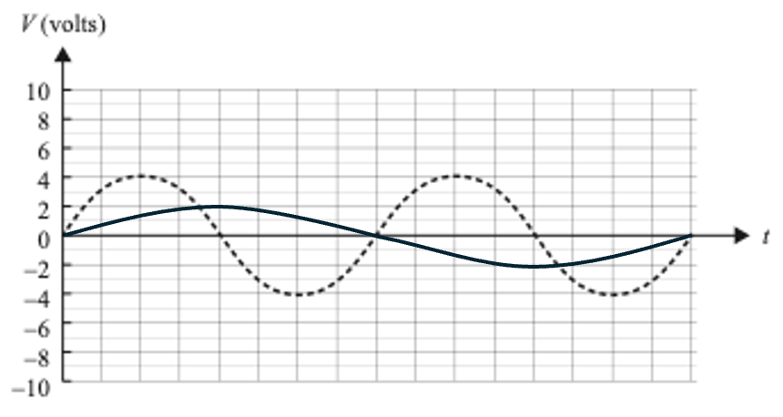
Question 4b.

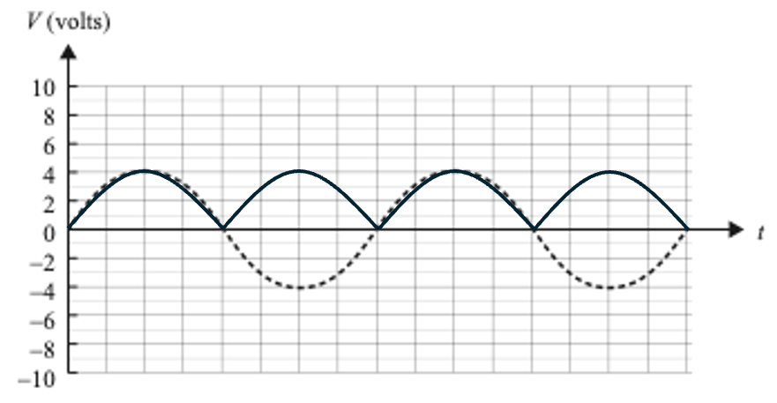
Question 4c.

Question 5a.
Particle P has the greater mass.
$r=\frac{mv}{Bq}$, therefore, as m increases, r increases.

Question 5b.
$$r=\frac{mv}{Bq}$$
$$0.64=\frac{m×(2.50×{10}^{4})}{0.010×(3.2×{10}^{-19})}$$
$$m=8.18×{10}^{-26} kg$$

Question 6a.
As the magnet approaches the loop, the loop experiences a change in flux.
According to Faraday’s law, a changing flux will induce a current in the loop.

Question 6b.
As the magnet moves to the right, the loop experiences an increasing flux to the right.
Lenz’s law states that a changing flux will induce a current that produces a changing flux that opposes the change that induced it. This means the current will produce an increasing flux to the left.
Using the right-hand grip rule, an anticlockwise current will produce an increasing flux to the left.

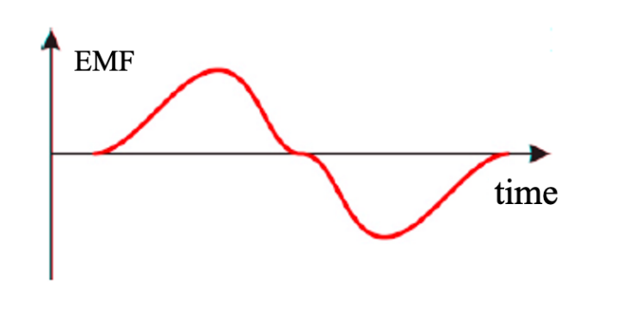
Question 6c.

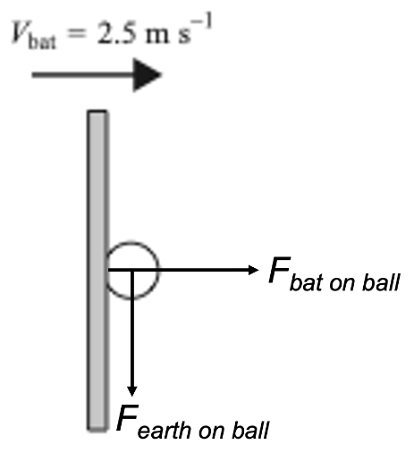
Question 7a

Question 7b.
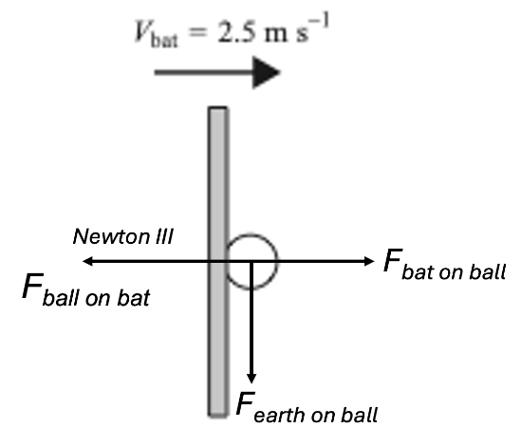

Question 7c.
$$m_{bat}u_{bat}+m_{ball}u_{ball}=m_{bat}v_{bat}+m_{ball}v_{ball}$$
$$\left(0.2×2.5\right)+\left(3.0×{10}^{-3}×0\right)=\left(0.2×2.4\right)+\left(3.0×{10}^{-3}×v\right)$$
$$0.5+0=0.48+\left(3.0×{10}^{-3}×v\right)$$
$$v=6.67 m s^{-1}$$
Or
$${∆p}_{bat}={∆p}_{ball}$$
$$0.2×\left(2.5-2.4\right)=3.0×{10}^{-3}×v$$
$$v=6.67 m s^{-1}$$

Question 7d.
The gravitational force on the ball is very small compared to the force of the bat on the ball. The ball will experience a significant change in momentum in the horizontal direction while experiencing very little change in momentum in the vertical direction.

Question 8a.
$$30\cos{15=29.0 m s^{-1}}$$

Question 8b.
$$30\sin{15=7.76 m s^{-1}}$$

Question 8c.
$$u=7.76, a=-9.8, v=0, s=?$$
$$v^{2}=u^{2}+2as$$
$$0=60.3-19.6s$$
$$s=3.1 m$$
Add initial 2.1 m
$$Therefore, max{height=5.2 m}$$

Question 8d.
The air resistance will slow the ball down / reduce its kinetic energy.
This means that the maximum height will be reduced.

Question 9a.
$$γ=\frac{1}{\sqrt{1-\frac{v^{2}}{c^{2}}}}$$
$$γ=\frac{1}{\sqrt{1-{0.9}^{2}}}$$
$$γ=2.294$$

Question 9b.
No, Adina will not see both ends of the train.
The train is moving in her frame of reference so length contraction means she will measure the train as being shorter:
$$L=\frac{L_{0}}{γ}$$
$$L=\frac{700}{2.294}$$
$$L=305 m$$
The contracted length of the train fits entirely within the tunnel.

Question 10a.
$$T\cos{30=mg}$$
$$0.8660T=4.9$$
$$T=\frac{4.9}{0.8660}$$
$$T=5.7 N$$

Question 10b.
$$F_{c}=T\sin{30}$$
$$F_{c}=5.7\sin{30=2.85 N}$$
$$a_{c}=\frac{F_{c}}{m}=\frac{2.85}{0.5}$$
$$a_{c}=5.7 m s^{-2}$$

Question 10c.
$$r=1.6\sin{30}=0.8 m$$
$$a_{c}=\frac{v^{2}}{r}$$
$$5.7=\frac{v^{2}}{0.8}$$
$$v=2.1 m s^{-1}$$

Question 11a.

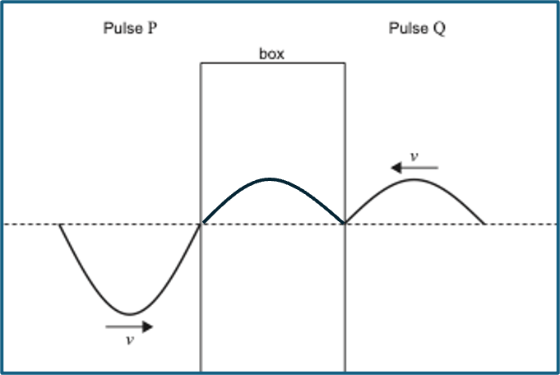
Question 11b.
The principle can be either superposition or constructive interference. The resulting waveform is the sum of the displacements of each individual wave.

Question 12a.
$$\sin{θ_{c}=\left(\frac{n_{2}}{n_{1}}\right)}$$
$$θ_{c}=\sin^{-1}\left(\frac{1.47}{1.50}\right)$$
$$θ_{c}=78.5˚$$

Question 12b.
$$n_{1}\sin{θ_{1}=}n_{2}\sin{θ_{2}}$$
$$1.00×\sin{24=1.5×\sin{θ_{2}}}$$
$$θ_{2}=\sin^{-1}\left(\frac{0.4067}{1.5}\right)$$
$$θ_{2}=15.73˚$$
Incident angle = $90-15.73=74.27˚.$
This is less than the critical angle so total internal reflection will not occur.

Question 13.
$$w=\frac{nλ}{d}$$
The width is the same for both patterns.
$$∴2×λ_{1}=2.5×λ_{2}$$
$$2×650=2.5×λ_{2}$$
$$λ_{2}=520 nm$$

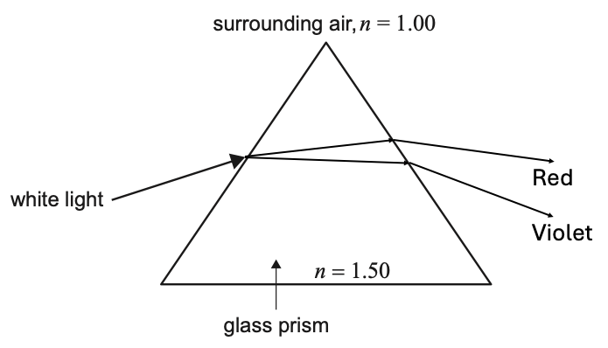
Question 14a.

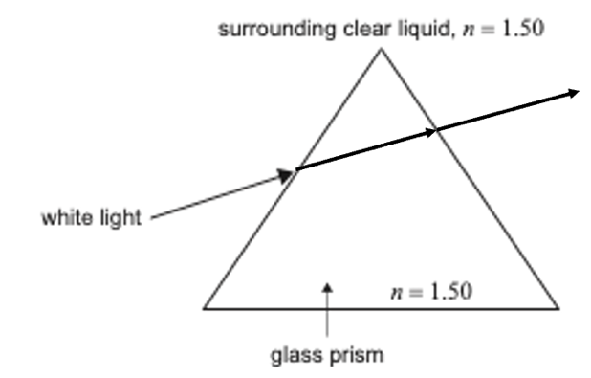
Question 14b.

Question 15.
Li is incorrect as diffraction occurs with wavelengths both shorter and longer than the gap width.
Chang is incorrect as the extent of the diffraction is determined by the wavelength.

Question 16a.
1.23 eV read from graph.

Question 16b.
$$W=hf-E_{k_{max}}$$
$$W=\left(4.14×{10}^{-15}×1.00×{10}^{15}\right)-1.23$$
$$W=2.91 eV$$

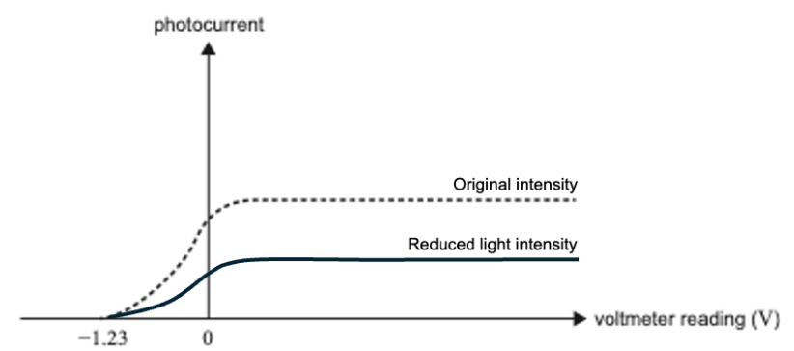
Question 16c.

Question 16d.
The new frequency is below the threshold frequency.
This means that the energy of the incident photons ($hf$), is insufficient to overcome the work function.

Question 17a.
$$E=\frac{hc}{λ}$$
$$137=\frac{4.14×{10}^{-15}×3.0×{10}^{8}}{λ}$$
$$λ=9.1×{10}^{-9} m$$

Question 17b.
$$λ=\frac{h}{\sqrt{2mE_{k}}}$$
$$λ=\frac{6.63×{10}^{-34}}{\sqrt{2×(9.1×{10}^{-31})×(137)×(1.6×{10}^{-19})}}$$
$$λ=1.1×{10}^{-10} m$$

Question 17c.
The diffraction pattern spacing depends on the wavelength. Since the patterns are different the wavelengths must be different.
Wavelength is determined by momentum, not energy, so even though they have the same energy, they have different momenta and, therefore, different pattern spacings.

Question 18a.
$$E=\frac{hc}{λ}$$
$$E=\frac{4.14×{10}^{-15}×3.00×{10}^{8}}{589×{10}^{-9}}$$
$$E=2.11 eV$$

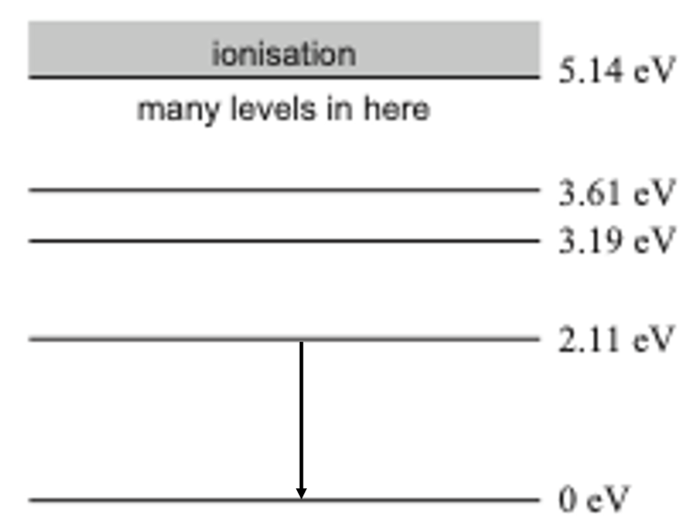
Question 18b.

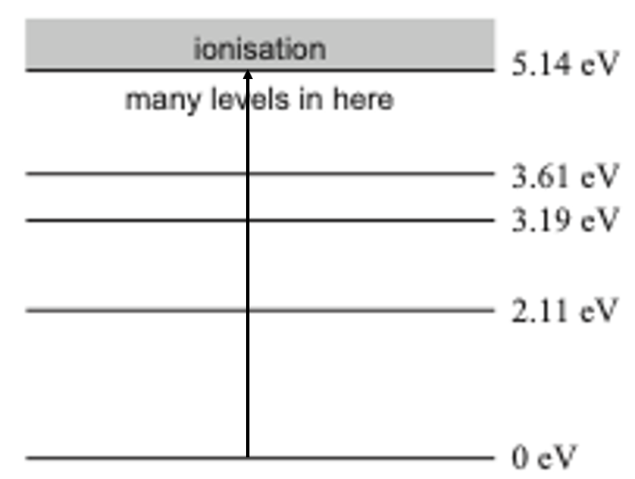
Question 18c.
The arrow could extend into the ionisation region.

Question 19a.
The concept being applied is conservation of energy.
$$\frac{1}{2}kx^{2}=mgh$$
$$h=\frac{kx^{2}}{2mg}$$

Question 19b.
The height would be reduced.
Spring potential energy (SPE) would be lost to accelerating the mass of the spring as well as the block.

Question 19c.
The independent variable is the compression (x).
The dependent variable is the height (h).

Question 19d.
Plotting x2 rather than x will result in a straight line. The k value can be found using the gradient of the line.

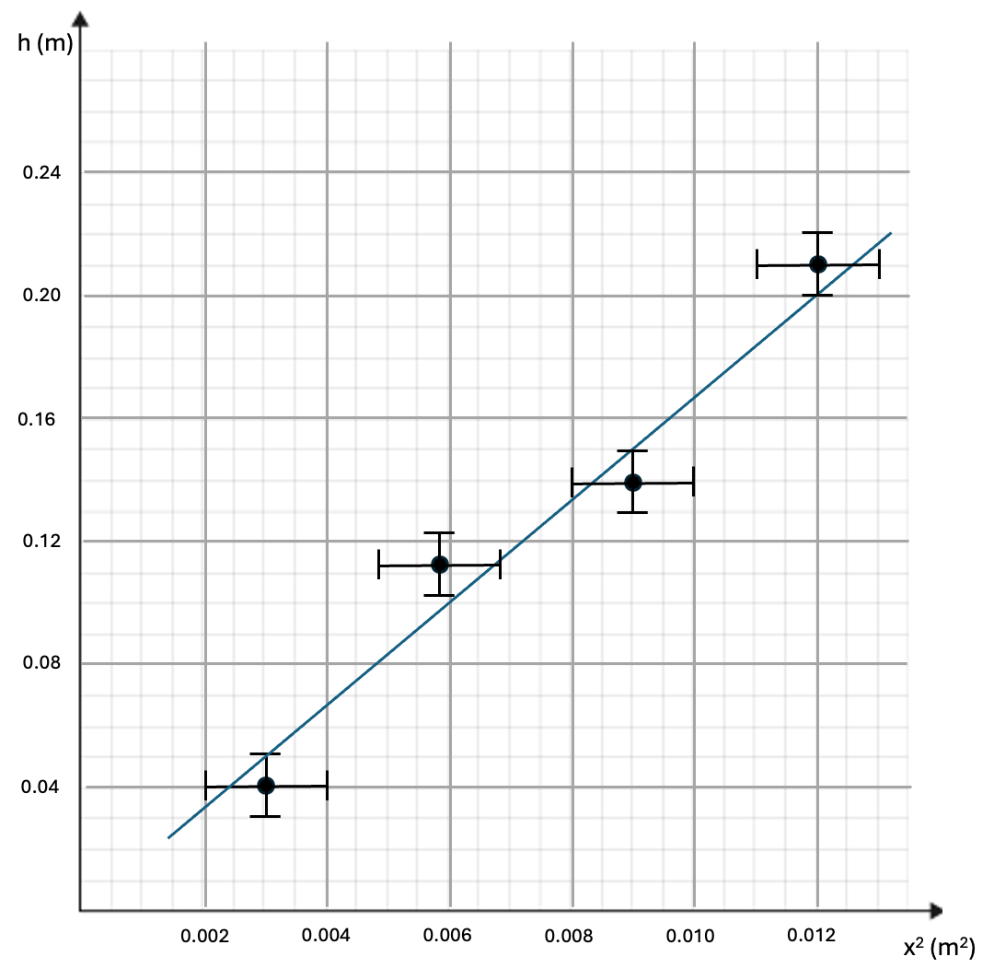
Question 19e.

Question 19f.
(0.003, 0.05) to (0.012, 0.20)
$$grad=\frac{rise}{run}$$
$$grad=\frac{0.20-0.05}{0.012-0.003}$$
$grad=16.7$ m⁻¹
Actual student calculation will depend on points chosen.

Question 19g.
$$h=\frac{kx^{2}}{2mg}=\frac{k}{2mg}×x^{2}$$
This has the form; $y=mx$.
Therefore,
$$grad=\frac{k}{2mg}$$
$$16.7=\frac{k}{2×0.15×9.8}$$
$k=49 N m^{-1}$

