2022 VCE Product Design and Technology external assessment report

General comments
The 2022 VCE Product Design and Technology exam was based on the VCE Product Design and Technology Study Design 2018–2023.
In Section B, approximately 55 per cent of students chose to design the single bike rack launch station and 45 per cent chose to do the cycling outer garment.
Areas of strength included:
- referring to the information given in the examination
- describing the profile of an end user
- ergonomic considerations
- risks in using a product
- comparison of attributes of the Sherpa folding cart and the Sherpa Power Barrow
- use of media for drawings
- most students attempting to answer all questions.
Areas for improvement included:
- understanding of command terms used in questions
- unnecessarily rewriting questions, which uses up space and time
- confusing research and development (R&D) with market research
- inadequate knowledge of
- low volume manufacturing
- parameters of user-centred design
- Extended Producer Responsibility
- the difference between a trial model and a high-quality prototype
- naming a specific material and a production process
- exploded drawings of details
- applying responses in Section B to the product chosen from the design scenario
- illegible handwriting.
When preparing for the examination students should focus on:
- the product design factors and their parameters
- terminology around design in industry
- drawing creatively using various media in response to past examination scenarios
- learning the names of specific materials, their characteristics and properties, several suitable production processes and drawing of details such as joins and/or fasteners.

Specific information
Note: Student responses reproduced in this report have not been corrected for grammar, spelling or factual information.
This report provides sample answers or an indication of what answers may have included. Unless otherwise stated, these are not intended to be exemplary or complete responses.
The statistics in this report may be subject to rounding resulting in a total more or less than 100 per cent.

Section A

Question 1
Mark | 0 | 1 | Average
% | 5 | 95 | 1.0
Most students correctly identified pineapple leaves. Other acceptable responses were organic cotton, bamboo or corn. Some students incorrectly named a part of the sneaker such as bamboo lining or cotton laces, which are not raw materials.

Question 2a.
Mark | 0 | 1 | 2 | 3 | Average
% | 5 | 14 | 34 | 47 | 2.3
Responses needed to include more details other than the waste pineapple leaves being used. They needed to refer to the sneaker’s end-of-life and how consumers could return them for disassembly, where components of the upper part could be composted, thus reducing landfill.
Many students wrongly assumed that the MoEa sneakers were fully compostable, when only the upper components were. Many also assumed that any plant-based leather, such as Piñatex® is compostable or biodegradable and won’t end up in landfill. This is not the case, especially when it is processed into a plastic polymer, regardless of whether it is made from renewable resources. Others assumed the sole, which was made from recycled material, could be recycled again but this was not stated in the article.
The following is an example of a high-scoring response.
They have allowed consumers to send their products back to MoEa at the end of its life so that it can be disassembled and composted appropriately, reducing waste in the environment and also taking producer responsibility for their products.

Question 2b.
Mark | 0 | 1 | 2 | 3 | Average
% | 11 | 25 | 39 | 25 | 1.8
Most students were able to state that transportation had a negative environmental impact due to either the distances or amount of travel undertaken at several stages in the sneaker’s lifecycle. High-scoring responses included both and also mentioned the carbon emissions or pollution created.
A small number of students stated there was no negative impact from transportation, which did not score any marks. Others included packaging, and while it has an environmental impact, the article did not mention how materials or sneakers were packaged and it was not asked about in the question.
The following are examples of high-scoring responses.
They have a negative environmental impact as the leaves are collected in the Philippines then have to be transported to Italy and then likely transported again potentially to France for manufacturing and then for distribution. This increases carbon footprint irregardless whether it is transported by sea, plane or rail (from Italy).
The MoEa sneakers undertake transport in many stages of the product life cycle. Including the transport of the leaves from the Philippines to Italy and the transport of the sneakers globally. All these forms of transport increase carbon emissions through the burning of fuel, and because the sneakers involve a lot of transport, there is more of an environmental impact.

Question 3
Mark | 0 | 1 | 2 | 3 | Average
% | 7 | 25 | 38 | 29 | 1.9
Most students scored in the middle range. High-scoring responses referred directly to the MoEa sneakers and how they avoided animal cruelty and would appeal to vegans or to the use of waste plant material as a renewable resource.
Many students incorrectly wrote that the plant-based leather materials could be composted, or that they wouldn’t end up in landfill. Other students assumed that because pineapple leaves are a waste product and presumably cheap, the sneakers would have less costs for materials, but that didn’t take into account the travel and the processing of the leaves with a PLA to create Piñatex®.
The following are examples of high-scoring responses.
Using pineapple leaves is beneficial as they are considered a naturally sourced material that if not used would be plant waste from farming. Thus, using pineapple leaves allow MoEa pineapple sneaker to divert plant waste from farming in the Philippines.
A benefit would be that the plant-based materials they use are vegan, meaning that consumers who don’t purchase products that use animal products in them can now purchase their product meaning MoEa pineapple sneakers will stand out compared to other shoe options, due to them not using animal products.

Question 4
Marks | 0 | 1 | 2 | 3 | 4 | 5 | 6 | Average
% | 11 | 12 | 21 | 19 | 18 | 11 | 7 | 2.9
To score full marks, the analysis needed to demonstrate a full understanding of both frameworks and how they applied to the MoEa sneaker. Very few students scored full marks, with most making a better analysis relating to Design for Disassembly (DfD) than of Extended Producer Responsibility (EPR). High-scoring responses included:
- aspects of the MoEa shoe that would align with DfD principles such as easy to separate different materials, pieces not glued, easily identifiable materials, etc.
- aspects of the MoEa shoe that would align with EPR such as the designer/manufacturer needing to consider the materials to be used, following DfD principles listed above, having instructions for consumers to return the shoes when disposing of them, materials being labelled for easy identification and manufacturers being responsible for the sneakers’ final disposal.
Some students wrote that the sneaker wasn’t designed with DfD as there were too many different materials and some were unable to be separated. This was a fair assumption but it needed to be analysed to score marks as shown in the first example response below.
Many students simply repeated that the sneakers were designed to be disassembled, which was not an analysis and did not add to their score. Common misconceptions on EPR were that it was a warranty system, that sneakers can be repaired or refunded if worn out or faulty, or stating an area of general responsibility unrelated to disposal of the product.
The following are examples of high-scoring responses.
Example 1
Design for Disassembly
Although the sneakers can be sent back to be disassembled, the disassembly doesn’t describe any of the product parts being reused in any way. The product is also difficult to repair as the parts are all connected and therefore although it will be disassembled, it does not follow the DfD framework.
Extended Producer Responsibility
MoEa takes EPR when allowing users to send back their products to be disposed of sustainably. As they are open to allowing consumers to send back their products, they are taking responsibility for the product (and in turn, waste) that they have created and removes this responsibility for the consumer to have to find a way to dispose of the product appropriately.
Example 2
Design for Disassembly
When the MoEa pineapple sneakers were designed, they were made to be able to separate parts made up of different materials, for easy recycling at the end of the product’s life cycle. Like how the upper component can be removed and composted. This is a good use of DfD.
Extended Producer Responsibility
MoEa have included EPR in how their sneakers are disposed of. MoEa will take back used sneakers to disassemble them and correctly dispose of the parts, taking full responsibility for the product at the end of its life cycle.

Question 5
Mark | 0 | 1 | 2 | 3 | Average
% | 43 | 25 | 16 | 16 | 1.1
Almost half of students confused research and development with market research, surveying users or with general research. ‘Research and development’ is a specific term related to invention or experimentation with materials, technologies, systems and/or processes that allow for more efficient manufacturing methods and/or product improvement. It helps companies to be globally competitive and can improve sales/profits. Responses needed to demonstrate this knowledge.
The following is an example of a high-scoring response.
Research and development has supported the sneaker’s development by leading to the invention of new materials and processes, such as pineapple leaves to process into fibres to create the material Pinatex. This r+d has led to the innovation of a new material which is new and innovative, offering the design a competitive edge against its competitors.

Question 6
Mark | 0 | 1 | 2 | 3 | 4 | Average
% | 14 | 19 | 27 | 23 | 16 | 2.1
Overall students were able to state reasons for and against a low volume scale. Some students explained what low volume manufacturing is, but this was not asked for. Some stated that low volume manufacturing is more costly in transportation, but this cannot be verified in the stimulus provided for the sneakers. Others stated that low volume allows for higher quality products than higher volumes, which is not necessarily the case, or that production is slower at low volume. Similarly, many responses included ‘lean manufacturing’ advantages, which also may or may not be the case regarding MoEa. A small percentage confused low volume with one-off, handmade or ‘tailor made’. Others were unclear on why a company would produce at a low volume and gave reasons related to consumer/user desires rather than a business/economic viewpoint.
The following is an example of a high-scoring response.
Low volume manufacturing may have been a good decision for MoEa as their priority is to be sustainable, environmentally friendly and through mass production - shoe sales might not have been achieved and in turn increase of wastage.
A problem with low volume scale manufacturing is it can be more expensive/costly than mass, therefore the costs must be considered before production.

Question 7a.
Mark | 0 | 1 | 2 | Average
% | 3 | 12 | 85 | 1.8
Students were easily able to describe a profile of an end user, mostly related to gardening, which was an obvious choice considering the product was named as a ‘garden’ cart. Some students related it to other contexts, such as transporting pets or family trips to the beach, which were also acceptable.

The following are examples of high-scoring responses that included some detail for an end-user’s profile.
One typical end user would be a paid gardener that always carries a lot of tools and has to travel.
One end user may be a farmer who needs to move objects over big plots of land that are rough and uneven.

Question 7b.
Mark | 0 | 1 | 2 | 3 | 4 | Average
% | 20 | 7 | 22 | 11 | 41 | 2.5
Good answers included descriptions of anthropometric data, safety for the user, comfort, ease of use and/or sizing to avoid strain or injury.
Many students included the amount of space or room in the Sherpa folding cart or the space required once folded up for its storage, but this is not relevant to ergonomics, unless the response referred to the weight being maneuvered or the folding of the cart by the end user. Other students listed two valid ergonomic considerations but failed to explain them. Many mentioned materials used, which do not necessarily relate to the ergonomics.
This was a typical question where many students took almost two lines rewriting the question, which was not required, not awarded marks and wasted space and time.
The following are examples of high-scoring responses.
The length, height and angle of the handle in relation to the body for optimum comfort when using product.
Height of the ground the cart is, to avoid excessive strain on end users’ muscles.
The handle of the product would need to use anthropomorphic data to understand the hand and grip needed, making it more comfortable for all fingers.
The length of the handle from the basket to allow a person stride without his feet hitting the cart. This would allow for easier usage and comfort.

Question 8a.
Mark | 0 | 1 | Average
% | 15 | 85 | 0.9
Most students chose a risk to a person related to folding the cart, such as crushing fingers or hands, overloading the cart and straining when pulling, rolling over feet or into a person when full, lifting into a car, using for unintended purpose, etc., which were acceptable answers.
Some referred to risks to workers during its manufacture, which was not asked for. Others referred to something destructive to the cart but if the follow up response in Question 8b. did not reference how the end user could reduce the risk, then no marks were awarded.

Question 8b.
Mark | 0 | 1 | 2 | Average
% | 22 | 21 | 57 | 1.4
Most students were able to explain how the end user could reduce/eliminate the risk they had identified in part a. Marks were awarded if a student stated a safety modification to the cart that could be done by the end user. However, a number of students mistakenly referred to how the manufacturer could reduce risk or modify the cart, but this was not asked for and did not score marks.
The following are examples of high-scoring responses.
(Question 8a.) Overweighting the max load limit and suddenly drops tools, etc.
(Question 8b.) To always keep track of how much load is being added into the cart because specification clearly states the max load of the cart.
(Question 8a.) Rolling the wheel over your feet.
(Question 8b.) The end user should wear appropriate footwear such as close shoes or even better steel capped boots.

Question 9
Mark | 0 | 1 | 2 | 3 | Average
% | 14 | 42 | 28 | 17 | 2.0
Most students could state how computer-aided design (CAD) can assist designers. However, many students only focused on CAD in the design and development stage and neglected to mention anything related to planning and production, which was required for full marks.
The following are examples of high-scoring responses.
In the design and development stage CAD could have been used to draw up a range of potential designs and mechanisms for the Sherpa Barrow to send off and receive feedback on. In the production stage, CAD could have been used in conjunction with CAM to directly drive the machines to produce the product in accordance to the exact designs.
CAD could be used to design the product so that it functions correctly and the pivot point is in the right place mathematically. It could then be used in unison with CAM to perfectly make each component.

Question 10
Mark | 0 | 1 | 2 | 3 | 4 | Average
% | 28 | 12 | 32 | 9 | 18 | 1.8
Few students scored full marks. High-scoring responses included two different legal responsibilities such as the legality of a product being safe for consumers, OH&S for safety at company premises, adherence to international or Australian Standards, the requirement to honour a warranty and/or the need to perform as advertised.
Many students included ‘sustainability’ as a legal responsibility, which was only awarded marks if the ISO 14000 environmental standard was referenced and its considerations described. Some students stated that OH&S was to ensure the barrow was made to be a safe product, but this was mixing up the legalities. OH&S is about the workplace being safe.
This question also illustrated the need for students to read the question carefully as many included copyrights, patents and trademarks, which are types of intellectual property and the question stated ‘other than’.
The following is an example of a high-scoring response.
OH&S / workplace safety. This ensures that workers and manufacturers are safe and not under threat during production by putting in place safety measures for their well-being.
Australian /ISO standards. This is a standardized and carefully considered set of guidelines in Australia which ensure safety, quality and efficiency in product development for producers, workers and end users.

Question 11
Mark | 0 | 1 | 2 | Average
% | 21 | 38 | 40 | 1.2
To score full marks, students needed to make clear reference to a user-centred design parameter. Many students wrote that information could be gathered to suit the end user but failed to relate their response to user-centred design.
The following are examples high-scoring responses with parameters of user-centred design shown in bold.
A target market interview could have been conducted at a local gardening store to gather information on what aspects of wheelbarrows the end users like and also what they would like to see in a new product. This data and feedback (open-ended information) could be used to improve the product and add innovative features to the Sherpa Power Barrow to improve quality of life.
These interviews can be used to gather what they like and what they find comfortable and appealing in their current wheelbarrow or what they would like in a new one if they don’t own one. This information can then be used and incorporated into the Sherpa Power Barrow.
Target market interviews could include open ended questions regarding the interests of end-users. This could help define their social and physical needs.

Question 12a.
Mark | 0 | 1 | Average
% | 2 | 98 | 1.0
Almost every student was able to identify one of the products from the examination to score one mark: either the Sherpa Folding Garden Cart or the Sherpa Power Barrow.

Question 12b.
Mark | 0 | 1 | 2 | 3 | Average
% | 5 | 11 | 29 | 55 | 2.4
This question was generally answered well, with students able to explain two attributes from the stimulus and compare them for the stated user, Bethanie. Full marks were awarded if students chose two attributes from the photos and texts (related to the cart and the barrow) and compared the products in terms of suitability for Bethanie.
Many students misread that the cart was made of ‘soft linen’ on the sides when the text stated ‘durable removable liner’.
The following are examples of high-scoring responses.
(Question 12a.) Sherpa Power Barrow
(Question 12b.) Bethanie would value the easy tipping function of the Sherpa Barrow as it would allow for easy transportation of soil into her vegetable garden. She would also highly value the high quality cordless electric motor aspect of the product as it would allow her to traverse her large backyard with reduced effort. This differs from the Sherpa folding cart, which whilst the ‘versatile/ easy fold down’ and rubber tread grip are two valuable features for Bethanie, the Sherpa power Barrow is thus the optimal choice for her gardening endeavours.
(Question 12a.) Sherpa Folding Cart
(Question 12b.) The folding cart can be used at different sizes, which is useful for Bethanie as she can have it fully extended when she needs to do gardening with large tools, but also make smaller so that when she is maintaining her vegetable garden, she does not have to drag the large barrow around. The adjustable handles helps her children help her as it can be made smaller. It is also safer for her children as the Power Barrow can tip over at the pivot point and harm children.
(Question 12a.) Sherpa Folding Cart
(Question 12b.) Bethanie should pick the folding cart firstly because she is young and fit, so she doesn't require the wheelbarrow to be electric. Secondly, her and her children have a veggie garden, so the kids would be able to pull the cart and with her pick the veggies and place them in the cart. Lastly, her home has uneven ground, so the Sherpa power Barrow might be too heavy to glide over the grounds, whereas the cart is light and can be pulled over potholes and bumps.

Section B

Question 1
Marks | 0 | 1 | 2 | 3 | 4 | 5 | 6 | 7 | 8 | Average
% | 14 | 1 | 5 | 6 | 12 | 9 | 17 | 13 | 21 | 5.0
Roughly one-fifth of students scored full marks. Acceptable answers included testing or research related to materials, exploration of ideas, feedback during production from end users and/or checking methods on the finished product. Many students wrote a statement about the finished product or as a constraint/consideration, but the response needed to be about what could be done to assist with decisions or what could be done to check if the criterion was met successfully. Other students responded with another evaluation question, which did not score any marks.
For the last evaluation question, students needed to interpret ‘innovation’ in terms of being new or an improvement. Some responses mentioned comparing existing products but did not explain clearly what would be compared to check innovation. Many added methods to decide whether the product was creative, which was not included in this evaluation question.
The following are examples of high-scoring responses for each of the evaluation questions.
Evaluation question | A process that could be used to evaluate the success of the product
Does the product allow for use in multiple weather conditions? | - Use of a UV test or chemical test, placing duct tape on half of the selected material to observe the effect of sunlight or water on materials.  - Test the product in multiple weather conditions. Use a test subject (person) to evaluate product in warm weather as well as under rain, etc.  - Testing materials against weather conditions of different types, then doing the same with prototypes of the product.  - Having a cyclist wear it in multiple weather conditions and rate their experience while wearing it.
Is the product durable? | - Use of a DROP TEST with a steel tube dropped from a fixed height to evaluate the durability of the selected material.  - Pulling at the seams and fabric of the top to test if they will break or tear under stress.
Are the colours used on the product easy to see? | - Place product far away and rate/evaluate visibility of the colours on the product.  - Complete a test and collect quantitative data from people to rank from 1-10 how easy the product is to see.  - Collecting data on the common bike, track or trail colours and choosing colours that stand out.
Is the product innovative? | - Use of end user interviews or questionnaires to gather insight and data into the level of success in innovation and creativity of the product.  - Conduct a survey and ask whether the participants have seen many products similar to it. Compare product to the market and look for similar products. Less similar products = increased innovation. Check final product for innovative technologies, materials and for processes.  - Create a survey for end-user to determine if the product is innovative.

Question 2
Mark | 0 | 1 | 2 | 3 | Average
% | 50 | 6 | 14 | 30 | 1.3
To score three marks, students needed to state a parameter of user-centred design listed on page 11 of the study design. Some students stated size, ‘ease of use’ or other desirable aspects of a product but those responses could not be awarded any marks.
The following are examples of high-scoring responses.
Ergonomics
Reason 1: So that the top can fit average measurements of both genders, increasing comfort (not to be too tight, loose on chest, etc.)
Reason 2: Easy to use feature to conduct a quick change, the feature (zip, clasps etc.) to make it easy to use for increasing well-being.
Anthropometric Data
Reason 1: Measurements of the circumference of the waist need to be considered so the top fits correctly.
Reason 2: Measurements of the arm span need to be considered so that the garment does not prohibit the end user for performing ie swimming.
Comfort
Reason 1: Product has to be worn in various conditions such as on a bike seat for a long time.
Reason 2: Product is used in repetitive movements and is not allowed to cause damage such as a rash or blisters.
Universal design
Reason 1: It is a unisex garment so much be able to fit all sizes.
Reason 2: Due to the need for it to be taken on and off efficiently, it must be comfortable for all users.

Question 3
Mark | 0 | 1 | 2 | 3 | 4 | Average
% | 18 | 6 | 12 | 21 | 44 | 2.7
Approximately 55 per cent of students chose to design in the ‘wood, metal and plastics’ category and 45 per cent chose textiles.
Students needed to name a specific material. Responses stating general categories such as wood, metal or plastic or overall material categories did not score any marks. They also needed to refer to that material’s characteristics that made it suitable for a part of the product. Some students neglected to do this and only explained the part or product.
The following are examples of high-scoring responses.
Stainless steel (marine grade).
Base plate of bike rack /launcher.
Stainless steel (marine grade) is a high quality, durable, hardwearing and chemically resistant material that will be very suitable for the event. The steel will be able to withstand scratches and dents from movement of bikes, components and individuals as well as withstand the sun, wind and rain which are potential weather conditions for the event.
Victorian Ash Timber
Combining the timber structure together
This timber will allow for the strong and stable combination of the bike rack. The timber is suitable for a vast majority of weather conditions so it will not deteriorate if it gets too much rain or sunlight. It is also an aesthetic timber that can draw the attention of many.
Polyester.
Main shirt.
Polyester is lightweight, durable which makes it suitable for all types of weather.
Nylon
The body and sleeves
Nylon is a synthetic and partially water resistant material. Nylon is not extremely absorbent and its manmade properties ensure it resists water. It is also lightweight, thus suitable for a range or weather conditions and a athletic event.

Question 4a.
Mark | 0 | 1 | Average
% | 30 | 70 | 0.7
Almost one-third of students did not write a production process. Some wrote a step of the product design process, while others wrote a technology involved in industrial production, neither of which was correct. To score any marks for Question 4, students needed to write a viable construction/production process in the space provided. For Question 4a., one suitable piece of machinery or equipment had to be named.

Question 4b.
Mark | 0 | 1 | 2 | 3 | Average
% | 32 | 4 | 10 | 54 | 1.9
Most students who identified a viable process in Question 4a. could outline three relevant steps. These did not need to be highly detailed but needed to be consecutive and accurate.
The following are examples of high-scoring responses.
Welding.
TIG welder
1 Ensure that the work is clamped down effectively and appropriate PPE is worn (leather shoes, dust coat, welding visor, leather gloves.
2 Use an engineering square to ensure that stainless steel components are effectively placed at 90 degrees or 45 degrees for a mitre join.
3 Create a ‘tac weld’ to fix the pieces temporarily in place, and if satisfied, fill in the rest of the space with the TIG welder.
45 deg mitre cuts with biscuits to join timber
Drop saw
1 The drop saw will be needed to be placed on a 45 degree angle to ensure a 45 degree cut.
2 The biscuit cuts on the timber to allow for it to combine.
3 The glueing and clamping together of the structure.
Joining
Domino joiner.
1 Measure the centre of where you want the join in all pieces of wood.
2 Using the domino joiner, cut the joins in the wood.
3 Using a small biscuit like piece of wood and glue, join your two pieces of wood.
Button hole
Sewing machine
1 Mark where you want the button hole to be with a line (fabric marker).
2 Follow the 6 steps on the buttonhole wheel on the sewing machine.
3 Use an unpicker to cut a hole for the button.

Question 5
Marks | 0 | 1 | 2 | 3 | 4 | 5 | 6 | 7 | 8 | 9 | 10 | 11 | 12 | Average
% | 2 | 1 | 2 | 3 | 5 | 11 | 14 | 16 | 14 | 11 | 10 | 6 | 4 | 7.2
Many drawings were too small, and many students filled the space with other views and detail drawings, neither of which were required. A design option (presentation drawing) needed to be pictorial to show realistically how the product could look. To score highly it needed to be large enough to include detail and be of realistic proportions. A technical or 2D drawing was not expected. High-scoring responses were neatly annotated and taken directly from the design scenario, which was essential.

Question 6
Mark | 0 | 1 | 2 | 3 | 4 | Average
% | 26 | 9 | 20 | 17 | 27 | 2.1
To score highly, responses needed to focus on an enlarged detail of a small part of the product, such as a join, fastener or mechanism. High-scoring responses used annotations to help communicate. Others drew more than one part or an exploded view (e.g. of the collar, pocket and the zip) in the space provided. This was not asked for and was often too small to show detail or clarity. Others included a larger area of the product in the drawing than was necessary, which also could not show detail. Many students repeated a drawing of their whole design, which did not score any marks and in some cases had more detail than what was required for Question 5.
The following are examples of high-scoring responses for Questions 5 and 6.
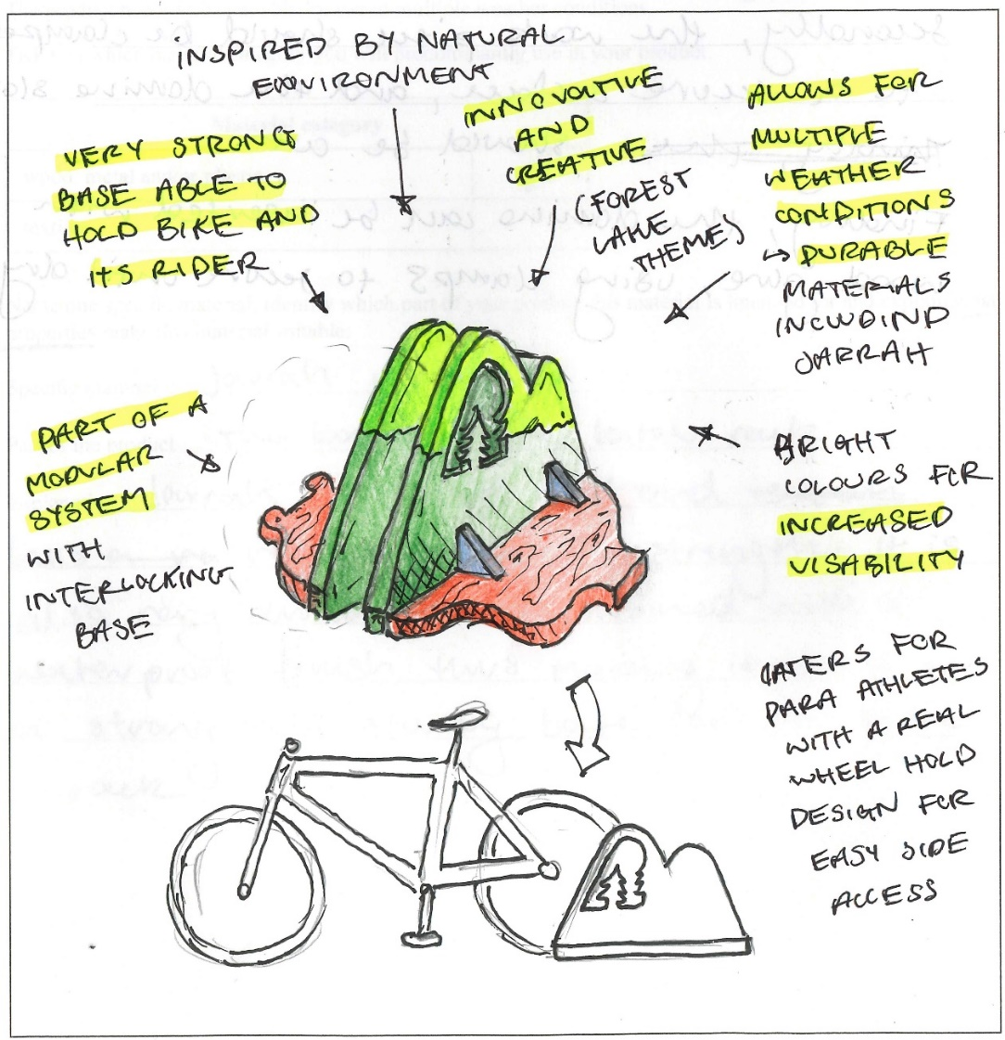
Question 5: Design option (presentation drawing)

Question 6: Exploded view
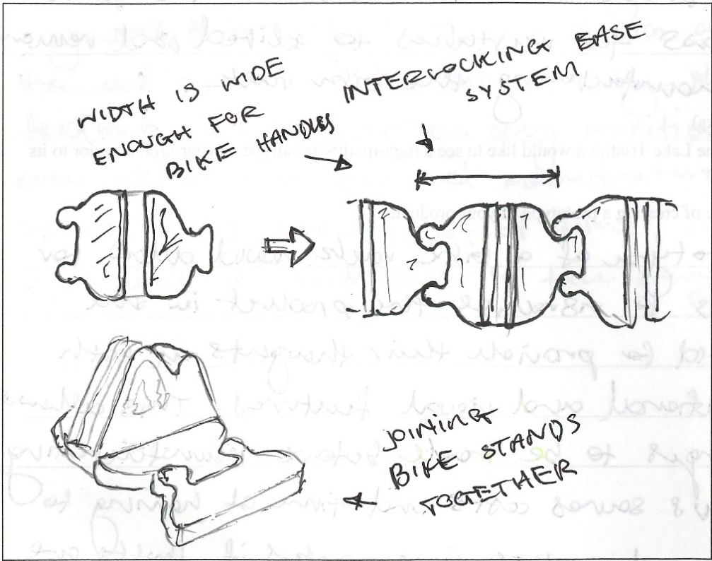
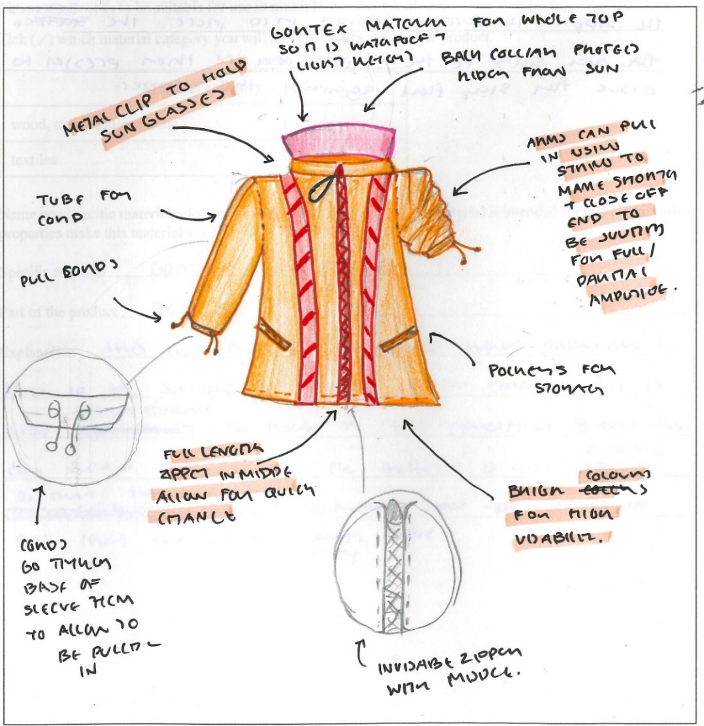
Question 5: Design option (presentation drawing)

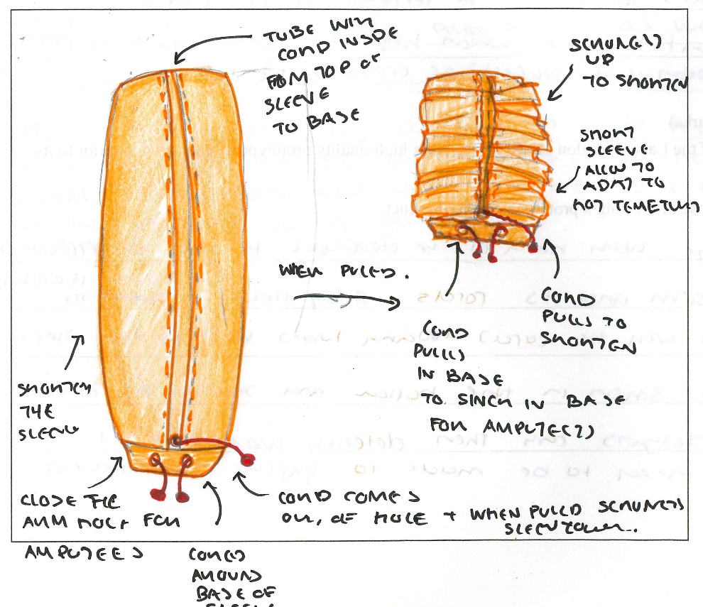
Question 6: Exploded view

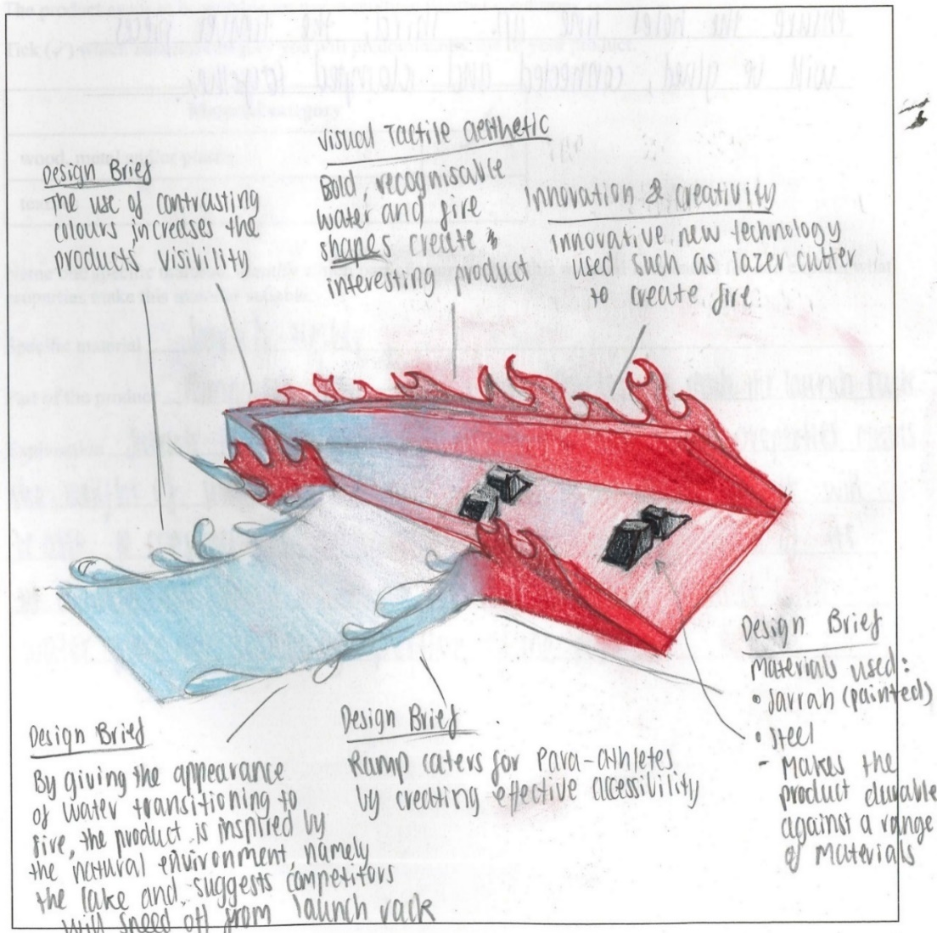
Question 5: Design option (presentation drawing)

Question 6: Exploded view
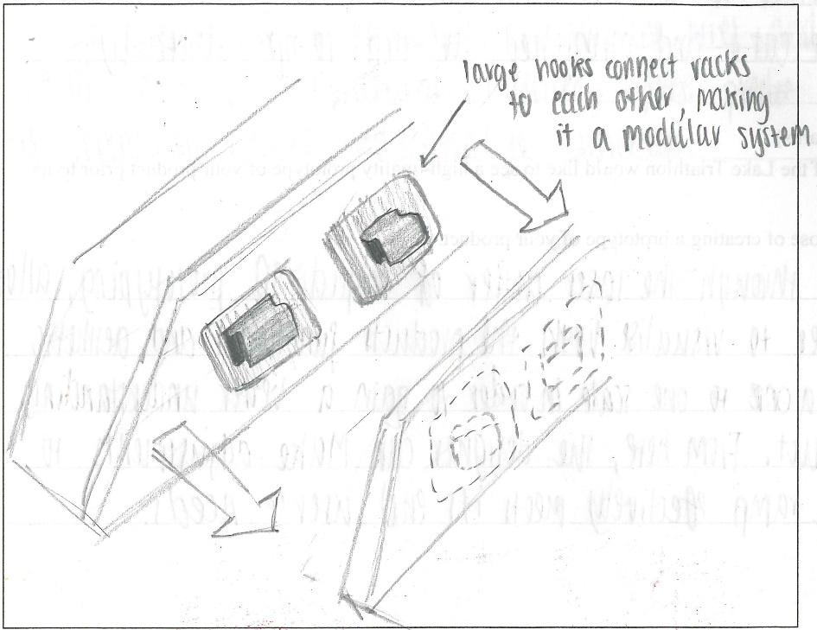
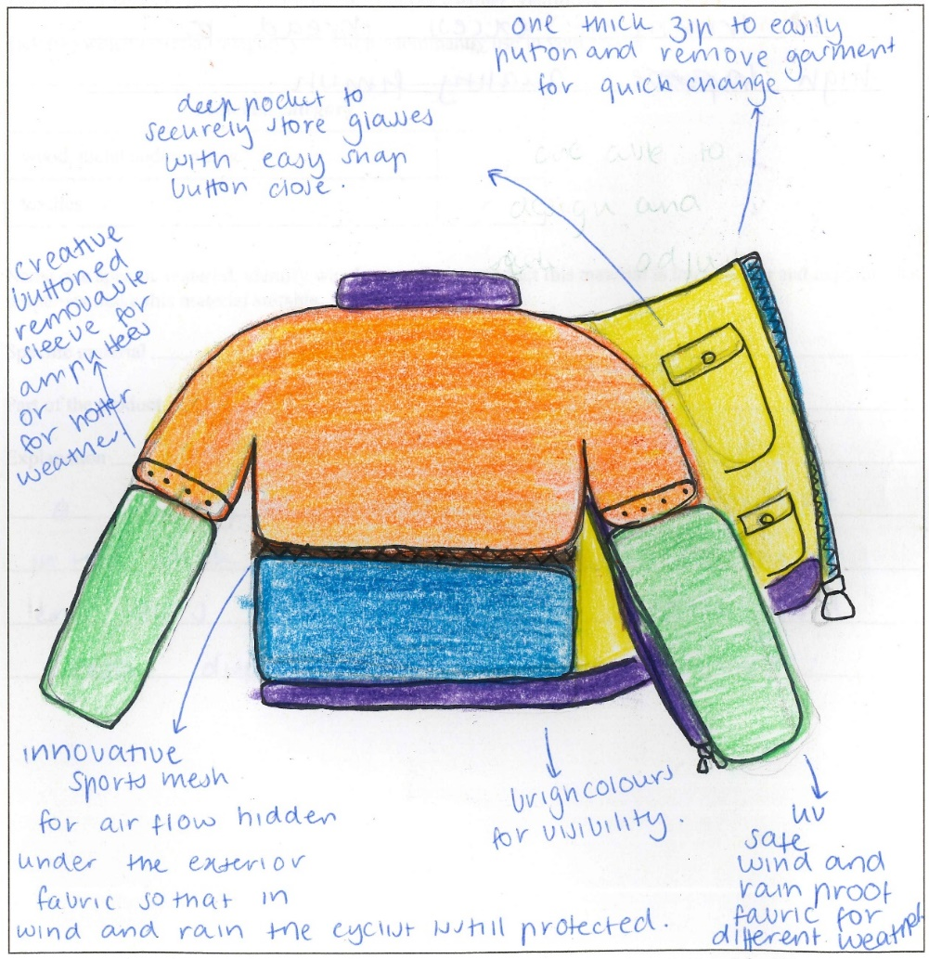
Question 5: Design option (presentation drawing)

Question 6: Exploded view
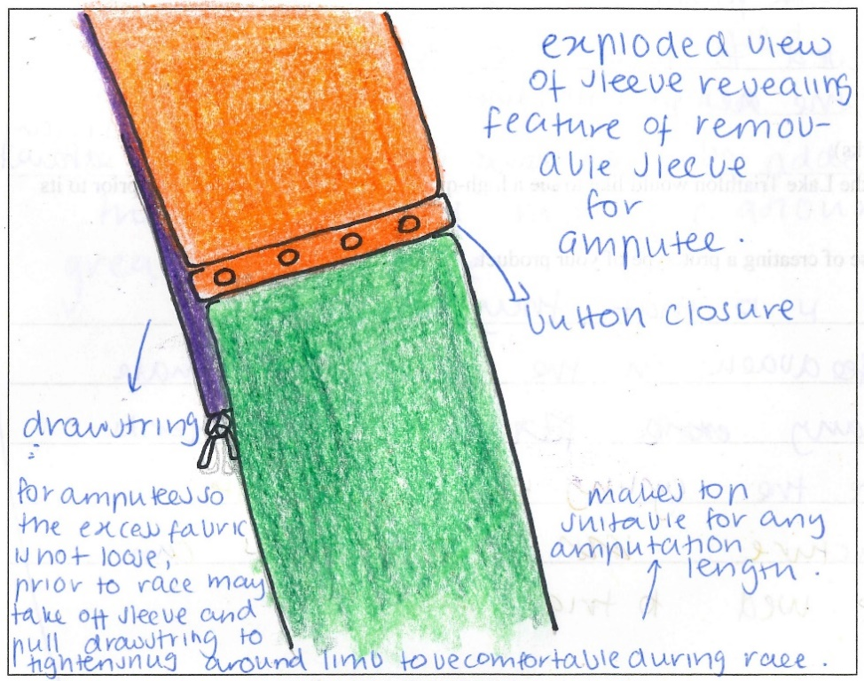
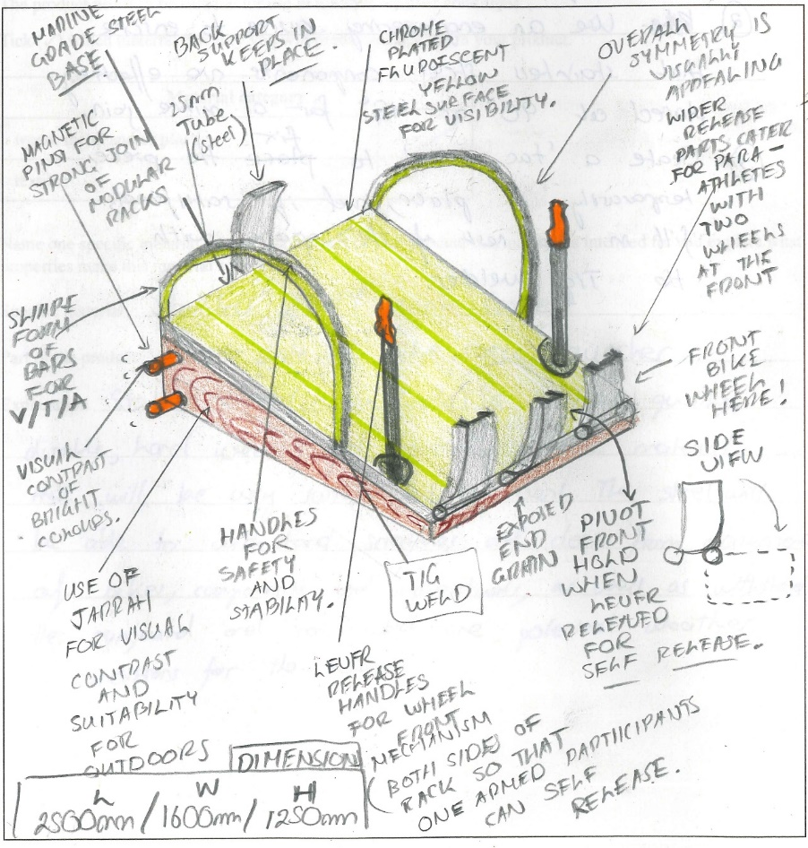
Question 5: Design option (presentation drawing)

Question 6: Exploded view
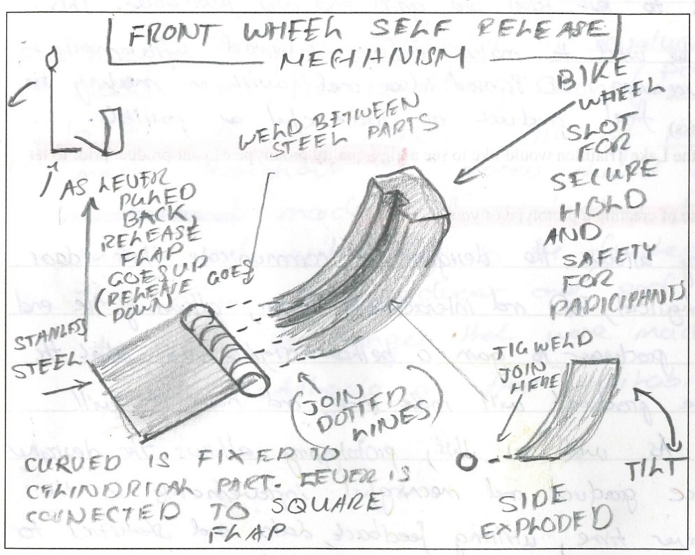
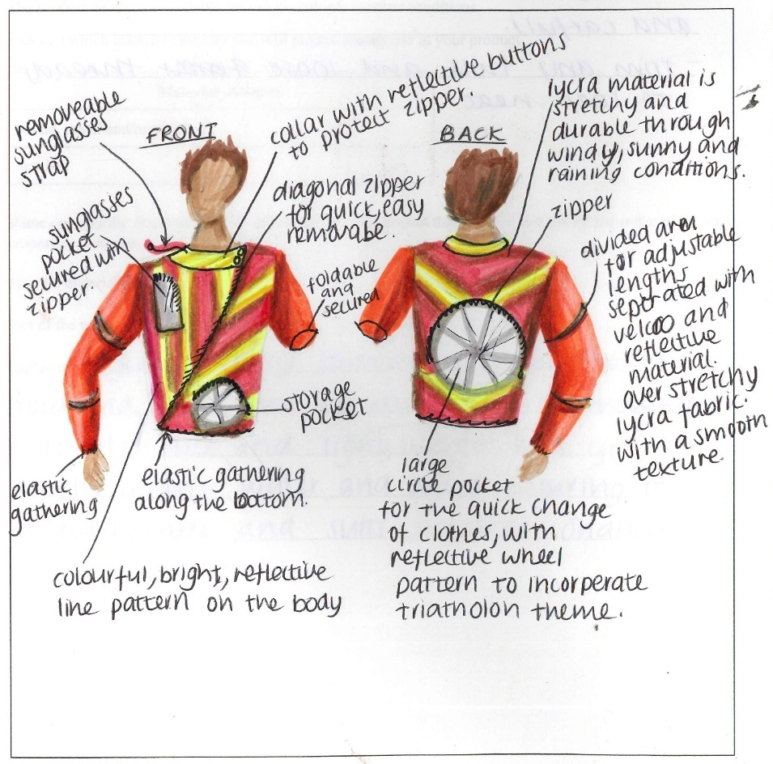
Question 5: Design option (presentation drawing)

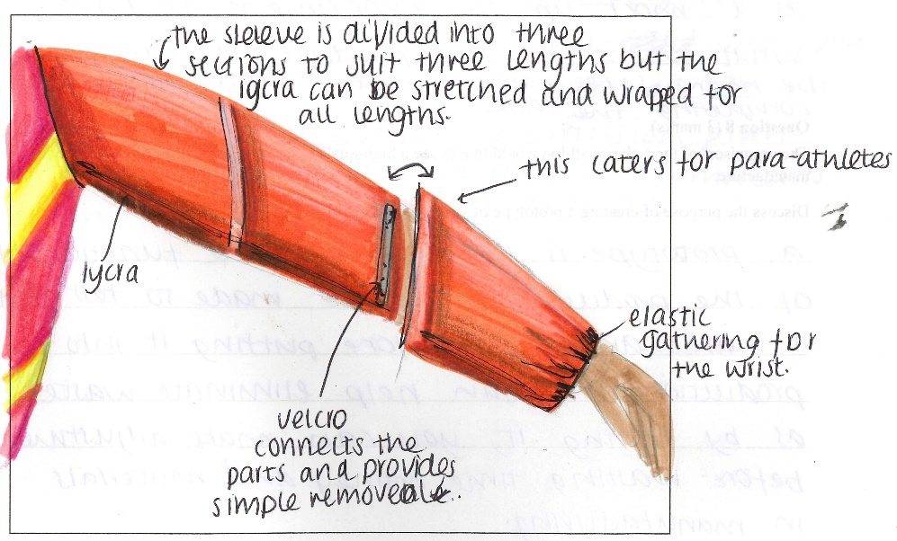
Question 6: Exploded view

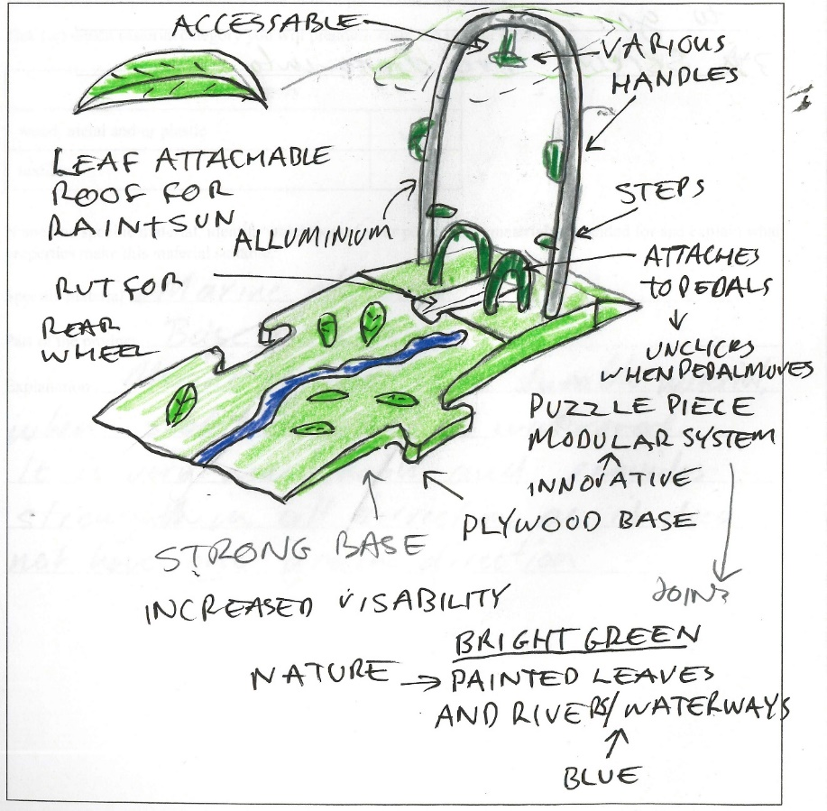
Question 5: Design option(presentation drawing)

Question 6: Exploded view
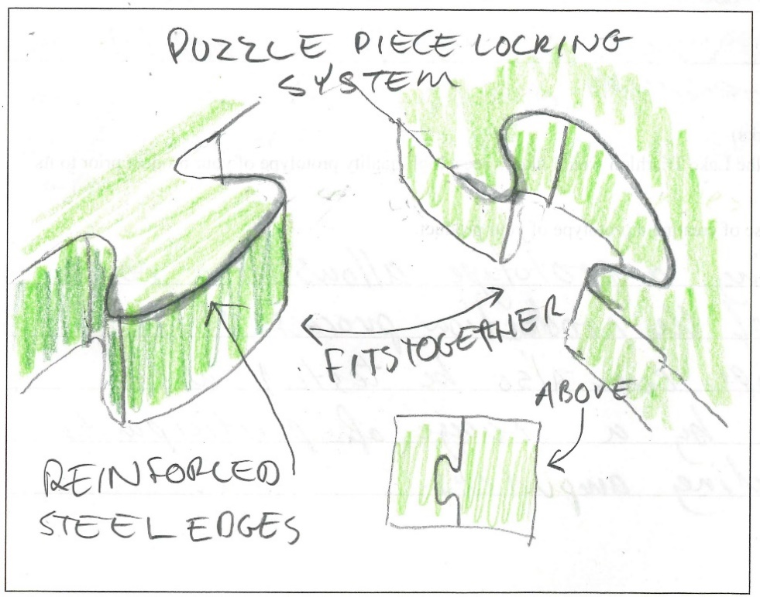
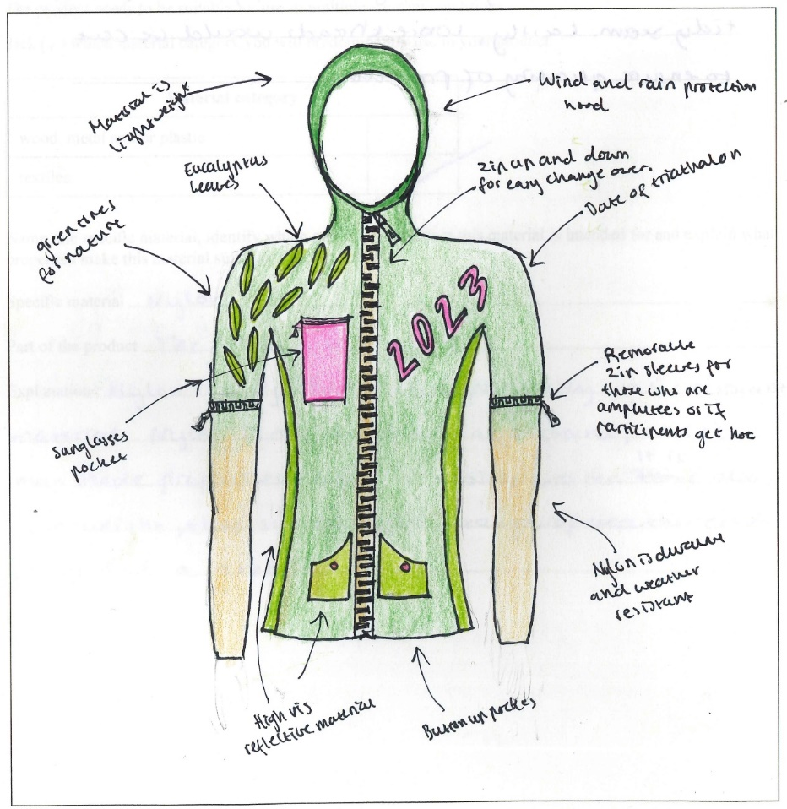
Question 5: Design option (presentation drawing)

Question 6: Exploded view
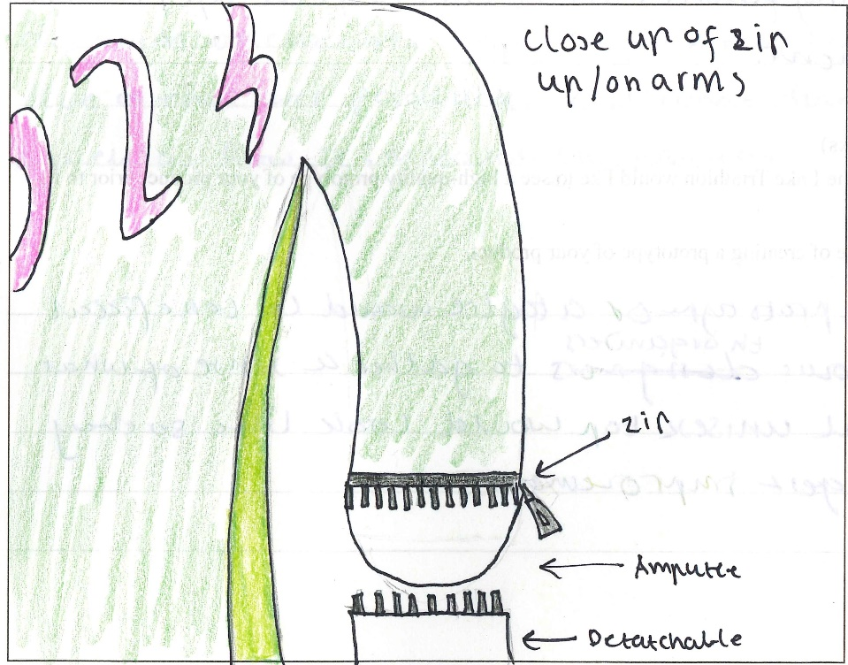
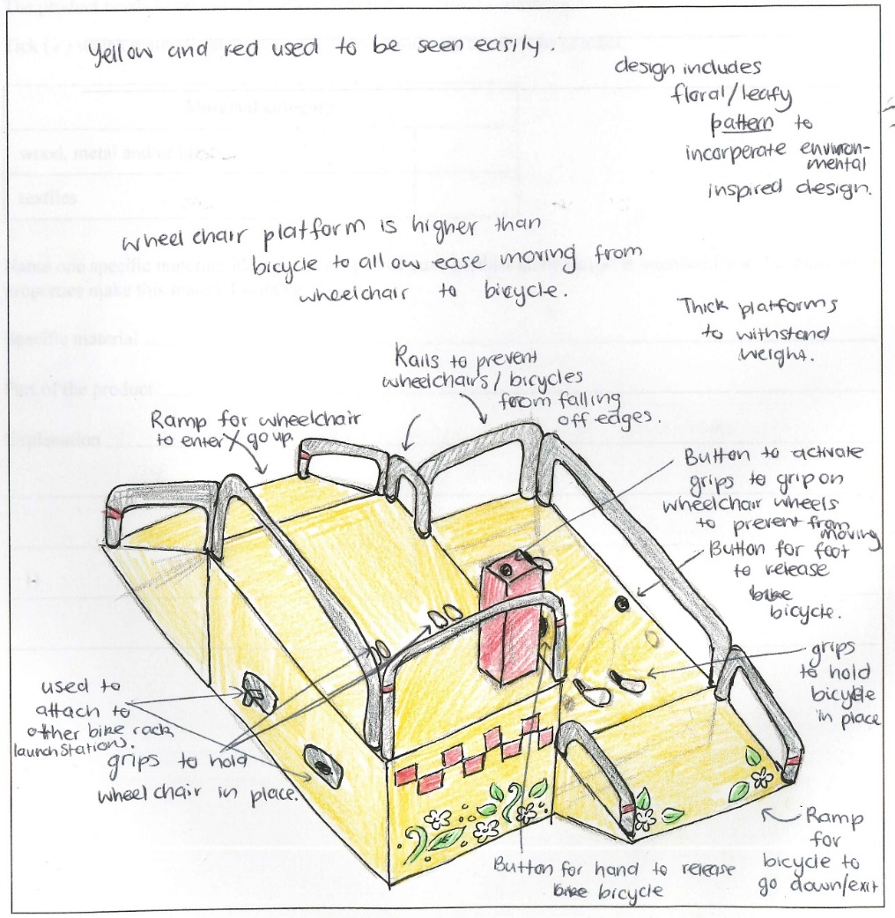
Question 5: Design option (presentation drawing)

Question 6: Exploded view
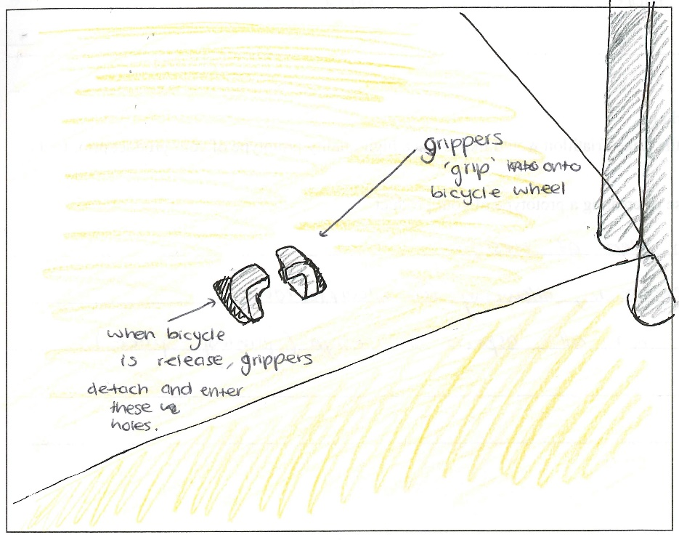
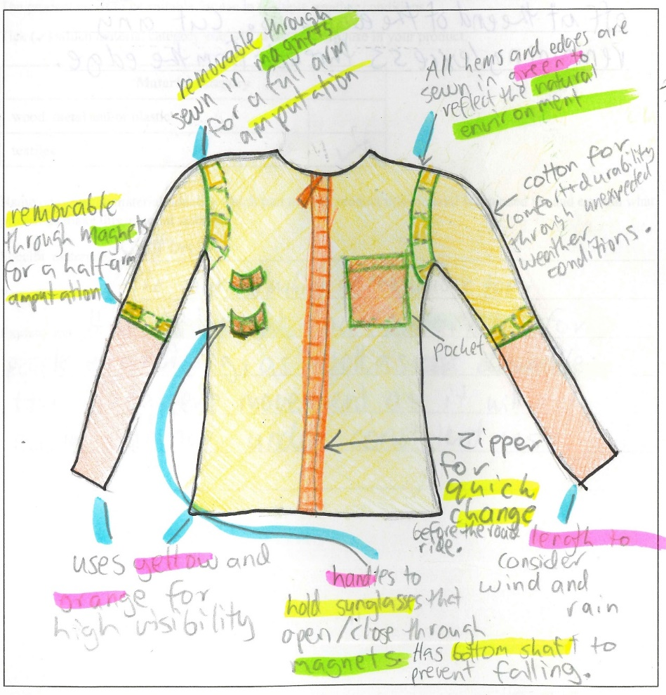
Question 5: Design option (presentation drawing)

Question 6: Exploded view
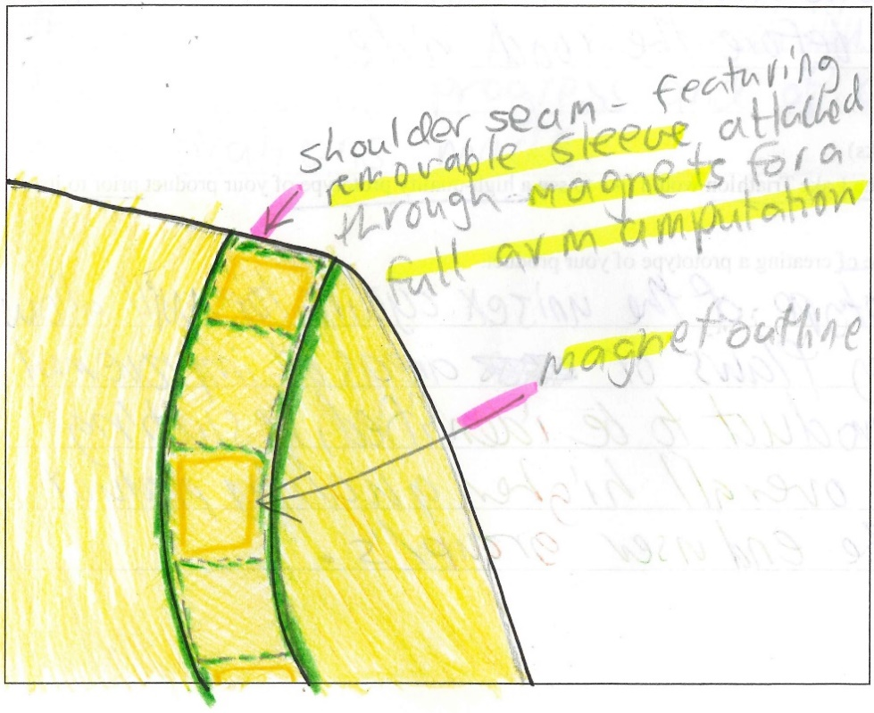

Question 7
Mark | 0 | 1 | 2 | 3 | Average
% | 50 | 11 | 20 | 19 | 1.1
Almost half the students scored zero for this question. Students needed to read the question carefully and avoid including CAD as stated.
To score full marks, students needed to make reference to their design drawing from Question 5 and relate their response to the design and development stage. Many students named a technology suitable for the manufacturing stage, which did not score marks.
The following are examples of high-scoring responses.
Rapid Prototyping such as 3D printing can be used for research and development of the rack to test and review the lock system and better refine for use.
3D printing could prototype the zipper embellishment and allow the designer to physically visualise the size and functionality of the embellishment before ordering /manufacturing many.
3D printing could be a technology adopted. This can be used to create small mock up ideas of the potential end product. This smaller version can help decide during the design and development stage what features to incorporate in the final product.
Laser cutting can be used to make a scale model that can determine where components that move will fit best. It can cut out fine and accurate details to see whether moving parts will move correctly and smoothly.

Question 8
Mark | 0 | 1 | 2 | 3 | Average
% | 8 | 16 | 38 | 38 | 2.1
Most students understood the purpose of creating a prototype prior to manufacture, such as showing the prototype to end users (i.e. organisers and/or participants of the Lake Triathlon) for feedback on its function(s), use, sizing, aesthetics or checking with the manufacturers. Many students wrongly likened it to a trial model, not a high-quality prototype as stated in the question.
The following is an example of a high-scoring response.
The prototype would allow them to evaluate whether the product is suitable for the event before committing to making many, as well as allowing for modifications to be made to ensure a well suited and high quality product.

Question 9
Mark | 0 | 1 | 2 | 3 | 4 | Average
% | 23 | 5 | 25 | 13 | 33 | 2.3
One-third of students were able to give an apt discussion of suitable techniques to record production activities and any modifications such as: a logbook, journal with notes and/or photos, records of phone conversations, annotation of preferred option drawing or technical drawing to show modifications and/or an evaluation report that explained any modifications.
Many students listed two techniques but did not provide a discussion.
Many students included mention of a scheduled production plan, which is planning that is completed before production starts. This could not be awarded marks unless it outlined a method provided during planning to record/report, such as providing a modifications table to enter information into or a ‘planned’ timeline to enter/compare actual completion dates.
The following are examples of high-scoring responses.
Logbook: a logbook could be utilised to record each step in the production process in detail. This allows producers to record any modifications that were made that differ from the original design.
End-user consultation: producers could also hold regular meetings with end-users to report progress of the production process as well as report any modifications that were made.
A production journal can be made which outlines what processes have taken place at every step of the production process. This allows the clients to see exactly how the product is looking at multiple stages and stop production to implement modifications as needed.
Emails and regular meetings between the organisers, designers and manufacturers when product is in production to discuss future manufacturing are used to communicate the progress and process, also allowing for modifications.

