2023 VCE Product Design and Technology external assessment report

General comments
The 2023 VCE Product Design and Technology examination was based on the VCE Product Design and Technology Study Design 2018–2023.
Areas of strength included:
- referring to the information given in the examination
- using colour in the design brief response drawing
- attempting to answer all questions
- annotating the design option drawings
- identifying constraints and considerations
- checking methods of evaluation criteria
- understanding the risks associated with production and risk management
- understanding the benefits of CAD
- understanding storage requirements.
Areas for improvement included:
- understanding the command terms used in the questions
- understanding the difference between a property and a characteristic and their application to a variety of different material types
- avoiding unnecessary rewriting of questions, which uses up space and time
- writing legibility
- understanding the parameters of user-centred design
- naming the three types of planned obsolescence: technical, functional and style
- understanding the importance of research and development
- understanding lean manufacturing
- naming both creative and critical design thinking techniques.
In preparing for the examination students could have focused on:
- the product design factors and their parameters
- terminology around design in industry
- drawing creatively using various media in response to specific scenarios
- learning the names of specific materials, their characteristics and properties, several suitable production processes and drawing of details such as joins and/or fasteners
- understanding the question command terms to be able to fully address the questions.

Specific information
This report provides sample answers or an indication of what answers may have been included. Unless otherwise stated, these are not intended to be exemplary or complete responses.
The statistics in this report may be subject to rounding, resulting in a total of more or less than 100 per cent.

Section A

Question 1
Marks | 0 | 1 | 2 | 3 | 4 | Average
% | 5 | 4 | 10 | 19 | 63 | 3.3
Student were asked to identify four constraints and considerations that may have been evident in the design brief for the Microsoft Adaptive Mouse
There was no need to classify each as either a constraint or a consideration; however, some students did so. The question stated ‘may have been evident in the design brief’, and, as such, a broad interpretation of acceptable responses was adopted.
Some students wrote evaluation criteria questions rather than identifying constraints and considerations.
Sample student response:
Must be accessible and useable by individuals of all abilities.
Must be reliable and consistently functional.
Consider ease of storage/repair/recharging
Consider widely appealing minimalist visual design.

Question 2
Marks | 0 | 1 | 2 | 3 | 4 | Average
% | 0.7 | 0.7 | 10 | 13 | 76 | 3.6
Students were required to describe the profile of two end users for this product and describe how the Microsoft Adaptive Mouse would meet the needs of each.
It was crucial here to both identify and describe the profile of two potential end users. It was important to explain how the adaptive mouse was then better able to meet their need.
Sample student response:
Elderly persons who may have arthritis and the use of an alternative mouse may prove to be both more accurate and comfortable to use.

Question 3a.
Marks | 0 | 1 | 2 | 3 | 4 | Average
% | 9 | 10 | 28 | 20 | 32 | 2.6
Many students answered this question well and were able to identify an advantage and a disadvantage.
Advantages:
- easily tailored to meet needs
- simple to produce
- allows the end user to personalise mouse cover
- improved comfort and ergonomic fit
- can be printed in a range of colours or materials
- cheap to produce
- files can be modified quickly
- 1:1 scale prototype to trial and fit
- can gain end-user feedback before mass production.
Disadvantages:
- production speed can be slow
- strength may not be the same
- wastage in misprints
- more expensive than injection moulding per part
- quality of finish
- uses low-quality materials that can be unstable
- cost of purchasing 3D printer
- costly to design in terms of time and labour.
The following is an example of a possible response:
ADVANTAGE - It is quick and easy to make and any design changes can be easily and quickly implemented
DISADVANTAGE - Multiple mouse covers may be produced before the right one is made for the individual which can increase waste.

Question 3b.
Marks | 0 | 1 | 2 | 3 | 4 | Average
% | 13 | 13 | 37 | 21 | 16 | 2.2
Students did not always link the customisable mouse covers directly to a sustainability issue. Many students were able to identify why the covers may extend the life of the mouse but were unable to explain why this improved the product’s sustainability. Strong responses were able to do this clearly and succinctly.
The following is an example of a possible response:
As the mouse covers are customised the end-user would both retain and use the mouse cover for longer, as they would be more highly valued, thus resulting in a reduction of landfill which is a significant environmental sustainability issue in modern western society.

Question 4
Marks | 0 | 1 | 2 | 3 | Average
% | 35 | 16 | 23 | 26 | 1.4
Students needed to specify the type of obsolescence correctly, as either technical, functional or style obsolescence. ‘Stylistic’ and ‘technological’ were not acceptable answers.
The benefit that followed could relate to either the end user or the producer, and some students were able to explain this well.
Some students discussed the broader theme of planned obsolescence and were unable to identify a type of obsolescence, preventing them from scoring full marks.

Question 5
Marks | 0 | 1 | 2 | 3 | 4 | 5 | 6 | Average
% | 3 | 5 | 18 | 23 | 27 | 12 | 12 | 3.5
Responses needed to include three innovations or modifications that were evident in a comparative analysis between the traditional existing mouse product and the Microsoft Adaptive Mouse.
Some possible innovations/modifications include:
- customisable cover
- adaptable parts for different end users
- improved aesthetics
- improved ergonomics/comfort (the mouse has a tail and a thumb rest)
- more inclusive and improved quality of life.
Students needed to be able to evaluate how any of the modifications from above were improvements in comparison to the traditional mouse to receive full marks.
Sample student response:
The product's shape has been modified to increase the ergonomics of the product through decreasing the size of the mouse to decrease the likelihood of discomfort, fatigue and injury for the user.
They have been innovative through creating new accessories such as the joystick, dual button and directional button. This provides a unique and alternative way of interacting with the product though still providing the same primary function.
They have been innovative in the use of design for disassembly through using sustainable joining methods such as the clips to attach the mouse cover to the mouse which extends the products life.

Question 6a.
Marks | 0 | 1 | 2 | Average
% | 43 | 29 | 28 | 0.9
Students were asked to explain why tests are important during research and development (R&D). Some students referred to market research; however, research and development does not include market research. A succinct description of research and development is a systematic activity, undertaken by business, involving experimentation and testing, the aim of which is to develop new products, materials, systems and processes, or to improve those that already exist. It goes hand-in-hand with innovation and improvement.
There were many reasons that testing is important:
- development of improved materials
- development of new or improved manufacturing process
- increased market share, and as such sales and profit, as a result of improved product
- products may last longer
- improvement to business reputations
- reduction of the need for recalls and repairs etc.

The following is an example of a possible response:
Tests are important for the Good Citizen sunglasses as this can help the creation of new materials by researching the strength and sustainability of different plastics to create the sunglasses.

Question 6b.
Marks | 0 | 1 | 2 | Average  rage
% | 79 | 6 | 15 | 0.4
Many students failed to understand the difference between a characteristic and a property.
A characteristic is a visible feature of a product. This relates to such things as finish (gloss, satin, matte, etc.), colour, texture or weight.
Acceptable characteristics included colour, texture, finish and weight (acceptable as either a characteristic or property).
Many students wrote about the general benefit of using recycled plastic without identifying a characteristic.

Question 6c.
Marks | 0 | 1 | 2 | Average
% | 51 | 11 | 38 | 0.9
As in Question 6b., many students failed to understand the difference between a characteristic and a property.
A property refers to how a material behaves, both physically and mechanically. Often some sort of test is required to discover it. Examples include durability, weather resistance, UV resistance, hardness, density, malleability and rigidity.
Acceptable properties included durability, weather resistance, UV resistance, hardness, weight, waterproofing, density, scratch resistance, malleability, rigidity and flexibility.
Many students wrote about the general benefit of using recycled plastic without identifying a property.

Question 7
Marks | 0 | 1 | 2 | 3 | 4 | Average
% | 10 | 12 | 36 | 24 | 18 | 2.3
For this question, it was important to link Design for Disassembly (DfD) with sustainability. If products are designed and produced so that they can be more easily recycled, sustainability is enhanced. Less waste is produced and therefore fewer associated negative environmental impacts are experienced. (Landfill and its side effects, for example, have the following repercussions: provision of land, methane gas emissions, contamination of soil and the water table, greenhouse emissions etc.)
Parts of or the whole product can be recycled.
Key links with Good Citizens glasses, because they can easily be taken apart, include the following:
- Broken parts can be replaced and as such the entire pair of sunglasses does not need to be discarded.
- Because parts can be replaced, the life cycle of the sunglasses is extended.
- Good Citizens will take back broken parts for recycling (EPR).
- Good Citizen glasses are made with non-permanent fixings.
Many students were able to discuss the benefit of only needing to replace parts when the glasses break. Full-scoring responses mentioned this and were able to explain the design features of clickable removable parts (not glues), and that this makes recycling the whole product at the end of its life, or product parts when broken, possible.

Question 8
Marks | 0 | 1 | 2 | 3 | 4 | 5 | 6 | Average
% | 16 | 15 | 25 | 15 | 8 | 6 | 15 | 2.7
When any question requires the discussion of parameters, the product design factors on page 18 of the study design must be used. Those most commonly used were comfort, ergonomics, anthropometric data, improved wellbeing and quality of life.
Many students were able to discuss size but not reference a parameter.

Question 9
Marks | 0 | 1 | 2 | 3 | 4 | Average
% | 41 | 22 | 20 | 9 | 8 | 1.2
Some students confused ‘just in time’ manufacturing with lean manufacturing. While ‘just in time’ could be a single aspect of lean manufacturing, they are not one and the same.
Many students wrote that lean manufacturing was appropriate for the scale of manufacturing; this was not relevant.
Many students wrote the benefit was that it is sustainable. While this is a possible side effect of lean manufacturing, it isn’t the primary goal.

Section B

Question 1
Marks | 0 | 1 | 2 | Average  rage
% | 26 | 19 | 54 | 1.3
A significant number of students wrote ‘check the prop …’ but did not make any attempt to outline the method by which that check would take place, as for example using ‘Have several actors of various sizes try on the headpiece and get feedback as to whether they felt it was suitable’, rather than simply ‘Check if the headpiece fits properly’.
Some students answered the question and did not provide a method of checking, for example ‘yes it does suit the theme’.

Question 2a.
Marks | 0 | 1 | 2 | Average  rage
% | 35 | 10 | 55 | 1.2
Creative thinking involves the creation or generation of ideas, processes and objects. It involves the creation of something new or original and involves the skills of ideation, flexibility, problem solving and imagery. Common techniques include mood boards, mind maps, brainstorming and SCAMPER.
Some students were not able to describe the stated technique and were unable to receive full marks for the question.
Sample student response:
Brainstorming - discuss and write down ideas with a group of people/designers. By bouncing ideas off one another, new ideas and extensions of ideas that may not have been considered individually can be generated.

Question 2b.
Marks | 0 | 1 | 2 | Average  rage
% | 53 | 11 | 36 | 0.9
Critical thinking involves the evaluation and objective analysis of an issue in order to form a judgment. Common techniques include PMI charts, evaluation questions, prototype and model analysis and comparative testing.
Some students were not able to describe the stated technique and were unable to receive full marks for the question.

Question 3
Marks | 0 | 1 | 2 | 3 | 4 | 5 | 6 | 7 | 8 | 9 | 10 | 11 | 12 | 13 | 14 | Average
% | 2 | 0.6 | 1 | 2 | 5 | 9 | 12 | 14 | 14 | 14 | 10 | 7 | 6 | 3 | 1 | 7.8
Most students found it difficult to develop an innovative product that also met the requirements of the brief. Drawings were not always clear. Some students only used pencils or pens.
Full-scoring responses were able to address the primary and secondary function of the brief, such as a screen that was also able to become a prop. This often required a second smaller drawing or annotation to explain the second function.
Full-scoring responses were rendered to show form, used colour and had clear annotations that directly related to the brief.
Some full-scoring responses also included detail about the construction of the product and demonstrated seams and joints, etc.
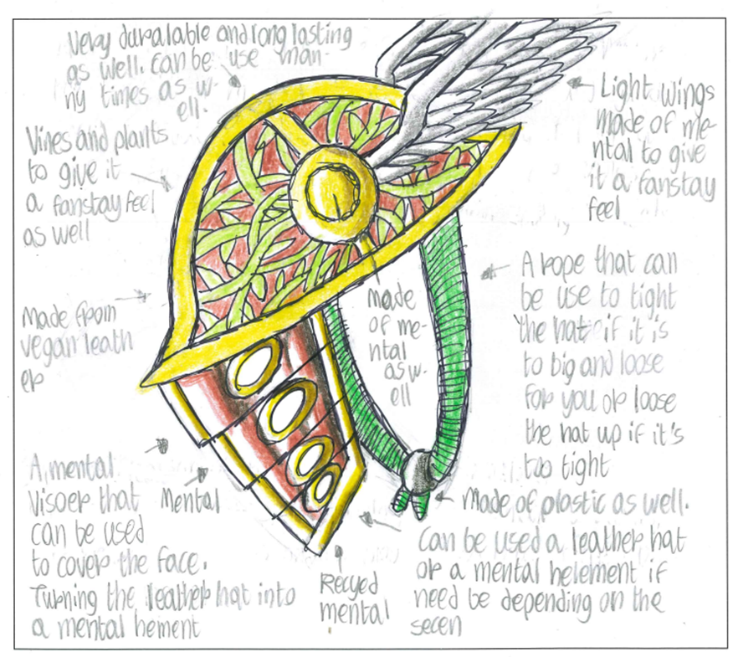
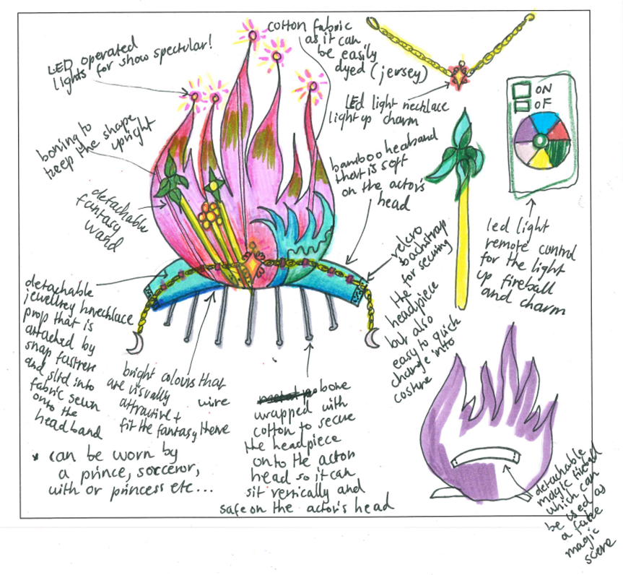
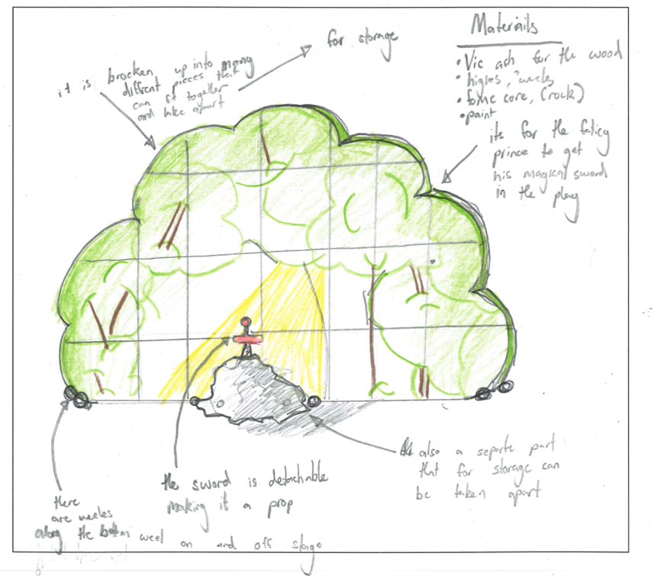
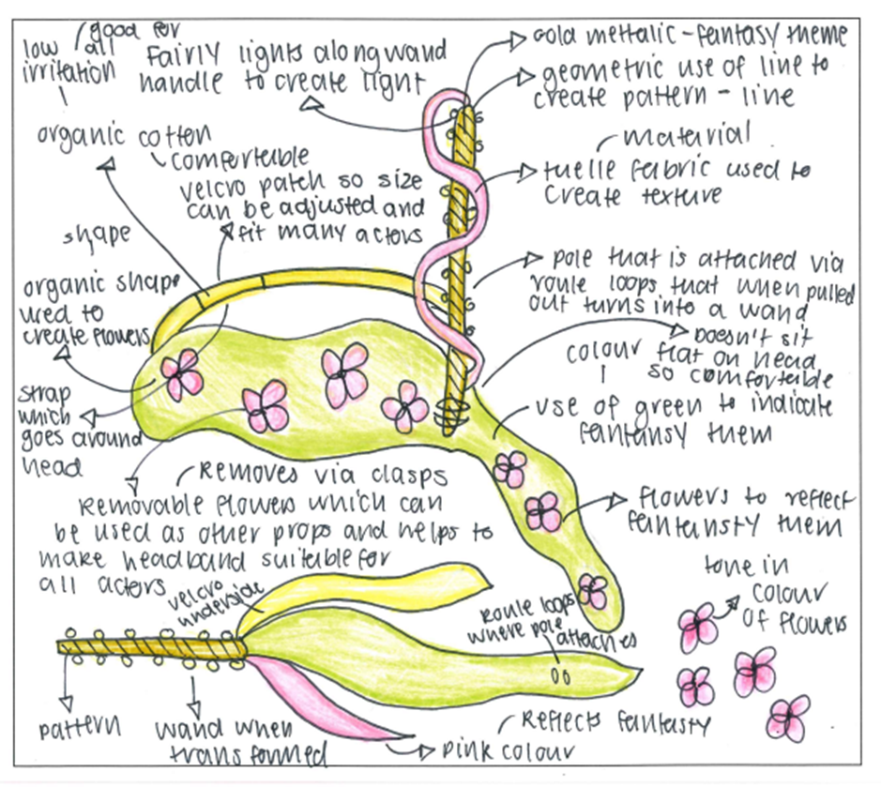
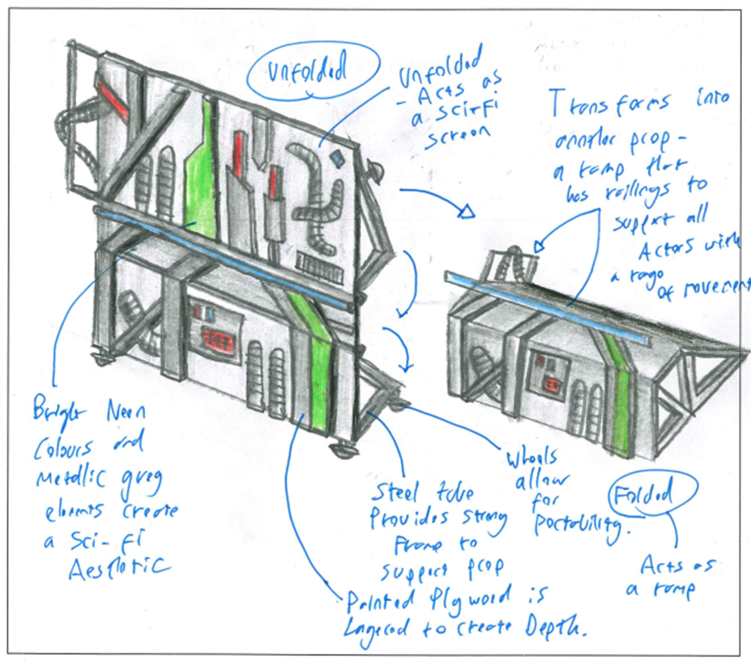
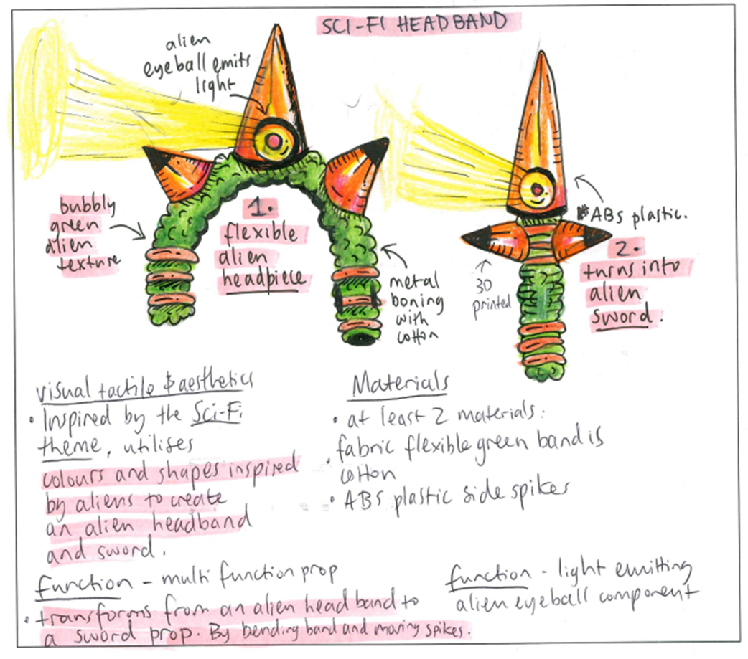

Question 4
Marks | 0 | 1 | 2 | 3 | 4 | 5 | Average
% | 9 | 10 | 23 | 24 | 19 | 13 | 2.8
Many students found an exploded view to be difficult. Some students repeated their design option without demonstrating further detail or a process, and this did not receive any marks.
Some students also failed to annotate in regard to materials and processes, instead making general annotations that related to the brief more broadly, not the materials or processes.
Full-scoring responses were able to explain in detail a part or section of the design and annotate to explain how it would be constructed and the specific materials that would be used.

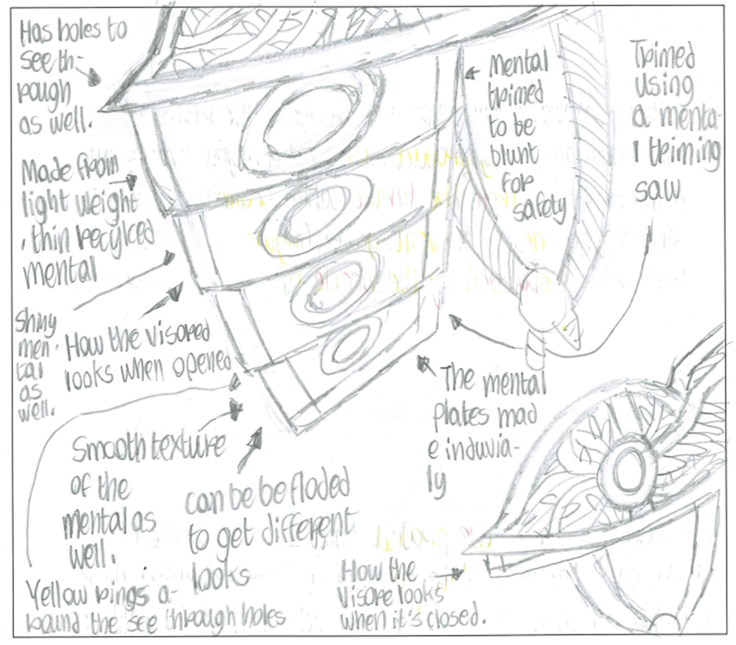
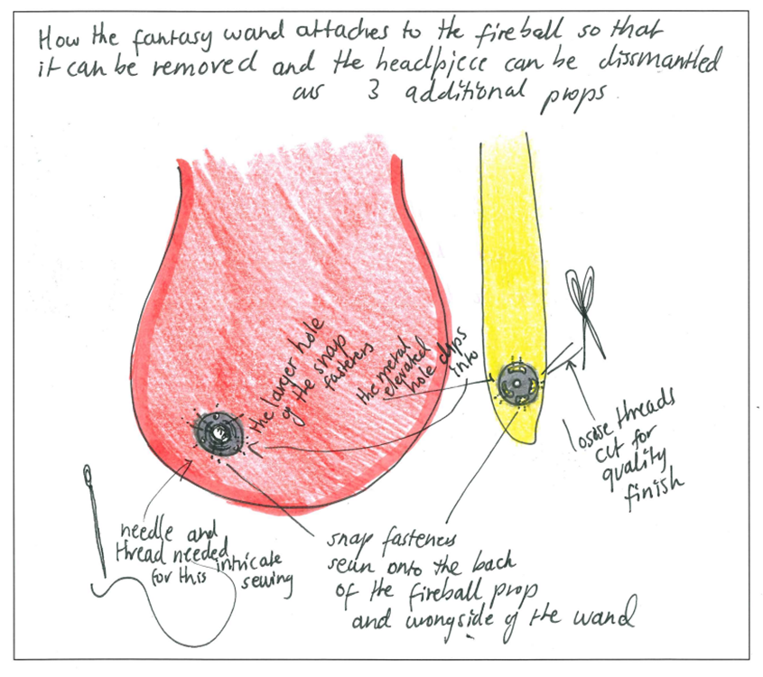
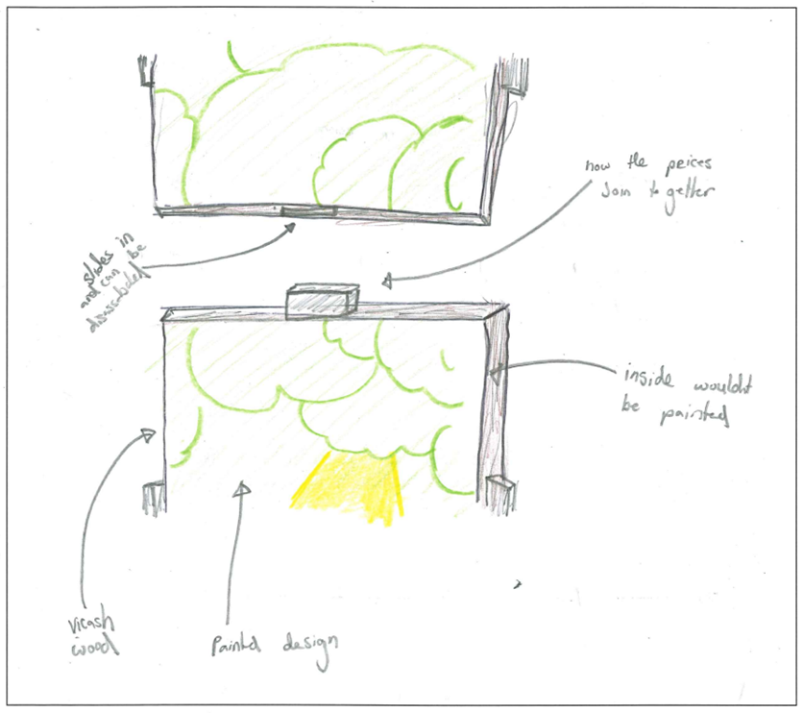
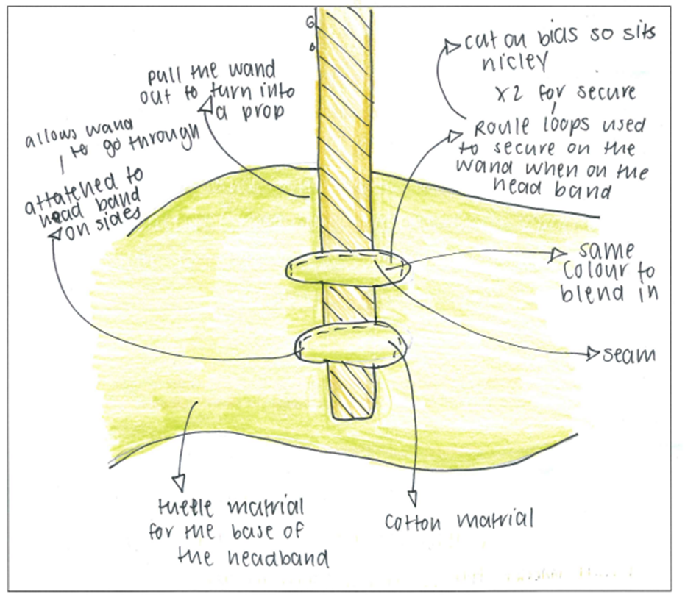
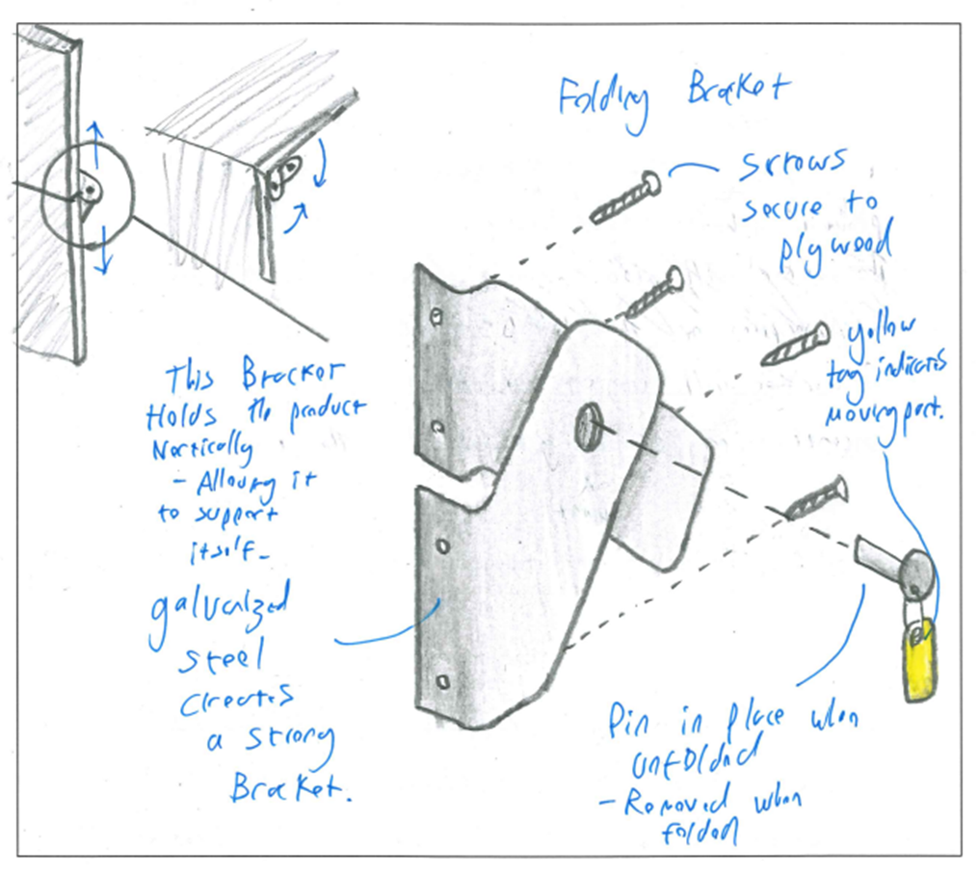
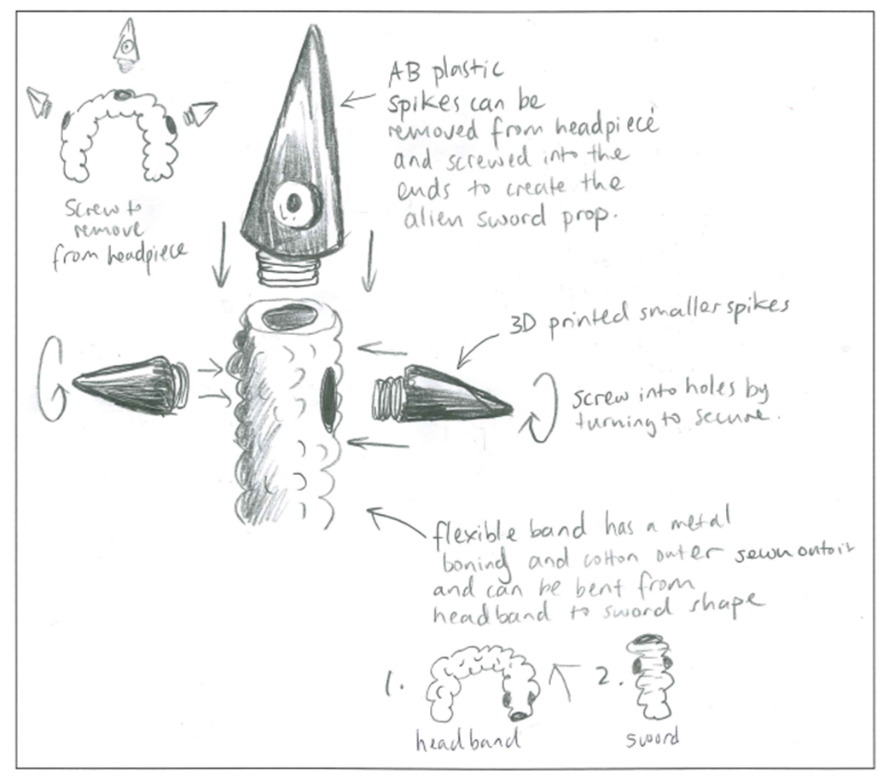

Question 5a.
Marks | 0 | 1 | 2 | 3 | 4 | Average
% | 21 | 7 | 19 | 13 | 39 | 2.5
Students needed to understand the difference between a risk and a hazard.
A hazard is the thing that could cause harm or injury, such as water on the floor, sharp needles, dust inhalation, loud noise, or sharp blades.
A risk is the chance of injury and how serious it could be.
Some students wrote about the risks associated with the use of the product they had designed, not the manufacture/production of their product. Students are reminded to read the questions carefully.

Question 5b.
Marks | 0 | 1 | 2 | 3 | 4 | Average
% | 21 | 13 | 29 | 17 | 20 | 2.0
This response needed to relate specifically to one risk stated in Question 5a.
Assessors were looking for a detailed response that explained at least two of the following points:
- use of personal protection equipment (PPE)
- training of staff/induction
- evaluation of hazards
- supervision
- maintenance/cleaning
- completing a risk assessment
- adopting a risk-management strategy
- safe operating procedures
- plant risk assessment.

Question 6
Marks | 0 | 1 | 2 | 3 | Average
% | 34 | 19 | 26 | 20 | 1.4
Some students could identify a modification but were unable to make the connection as to why that made it more appropriate for low-volume production. Making this connection was essential.
Some students referred to changes in their design to make it more marketable rather than efficient for production on a manufacturing scale.
Sample student response:
I would change the material used from solid Victorian Ash to veneered particle board to reduce the unit cost and negate the need to use widening joins to make each panel which will also save time.

Question 7
Marks | 0 | 1 | 2 | 3 | Average
% | 12 | 24 | 37 | 26 | 1.8
Most students answered this question well, but some only identified one or two benefits of computer-aided design (CAD). Full-scoring responses were able to identify three benefits.
For example:
- drawings can be rendered to get photorealistic 3D image
- more easily shared
- increased accuracy
- easily modified
- can be used for prototyping to gain feedback
- files can be converted for 3D printing models.

Question 8
Marks | 0 | 1 | 2 | 3 | Average
% | 8 | 22 | 42 | 29 | 1.9
Students were required to identify three specific storage requirements that were appropriate to the materials.
Possible responses include:
- Store away from direct sunlight to avoid fading.
- Store in a dry, secure location.
- Cover with a sheet to keep it dust free.
- Store in a box to avoid crushing.
Some students confused this response with a care label and referred to steps to maintain the product rather than to store it.

Question 9
Marks | 0 | 1 | 2 | 3 | Average
% | 17 | 17 | 38 | 28 | 1.8
Some students appeared to have run out of time and did not attempt this question, emphasising the importance of keeping track of the elapsed time while responding to questions.
Higher-scoring responses were able to clearly identify a problem and explain how this could be avoided, as well as identifying where, in the product design process, this solution should have occurred.
Sample student response:
The LED lights have a low battery life because no room is available for larger batteries. The designer could have addressed this problem by including a space to place the battery pack allowing double or triple A batteries. Through the use of trials and prototyping the designer could have discovered this issue earlier and addressed it before the final product was made.

