2020 VCE VET Engineering Studies written examination report

General comments
While there were some good results overall, a large number of students were unable to demonstrate an understanding of basic engineering principles in their responses. In particular, naming and stating correct uses of common hand tools, fundamentals of cutting speeds/RPM and uses of standard milling cutters were generally not answered well.
Some students provided partial responses that did not fully address the requirements of the question. Carefully reading the question before responding may help avoid this. This was particularly evident in design questions, such as Questions 16g. and 18a., where critical design criteria were missing in student responses.
Another area in which students need to improve is the development of work plans. A significant number of responses had entire operations missed and operations clearly out of sequence: for example, drilling holes and then marking out.
Areas that were answered well overall were drawing in third angle projection and basic computations.

Specific information
This report provides sample answers or an indication of what answers may have included. Unless otherwise stated, these are not intended to be exemplary or complete responses.
The statistics in this report may be subject to rounding resulting in a total more or less than 100 per cent.

Question 1
Marks | 0 | 1 | 2 | Average
% | 23 | 34 | 43 | 1.2
Possible responses included:
- ensure work piece is secure
- no flammable material around
- check condition of grinder (guard in place, cord not frayed etc.)
- check wheel is in good condition.

Question 2
Marks | 0 | 1 | 2 | Average
% | 25 | 27 | 48 | 1.2
Ferrous: Steel/Cast Iron/Stainless Steel
Non-ferrous: Brass/Bronze/Aluminium/Copper/Gold etc.

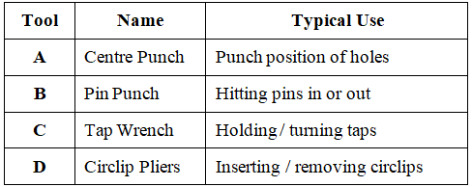
Question 3
Marks | 0 | 1 | 2 | 3 | 4 | Average
% | 19 | 57 | 16 | 6 | 2 | 1.2
Apart from the centre punch, very few students correctly answered other hand tools. Students need to have knowledge of a wide range of commonly used engineering hand tools.

Question 4
Marks | 0 | 1 | Average
% | 31 | 69 | 0.7
Possible responses included:
- can produce complex designs
- ideal for prototypes
- cost effective for smaller batches
- quality/accuracy.
This question was answered well by the majority of students.

Question 5
Marks | 0 | 1 | 2 | Average
% | 38 | 36 | 26 | 0.9
Case 1: Drill bit 'B', because it is smaller in diameter.
Case 2: Drill bit 'C', because aluminium requires a higher cutting speed than steel.
Most students did not demonstrate an understanding of the fundamental relationship between cutting speed and diameters and cutting speed requirements for hard/soft materials.

Question 6a.
Marks | 0 | 1 | Average
% | 94 | 6 | 0.1
Dial indicator

Question 6b.
Marks | 0 | 1 | Average
% | 77 | 23 | 0.2
Possible responses included:
- setting up work on a lathe
- setting up vice on a milling machine.

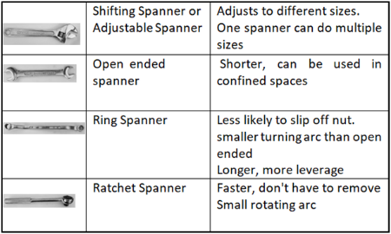
Question 7
Typical Answers Accepted
Marks | 0 | 1 | 2 | 3 | 4 | 5 | 6 | 7 | 8 | Average
% | 7 | 6 | 16 | 14 | 14 | 15 | 10 | 9 | 9 | 4.1
Apart from shifting spanner, few students knew the correct names and advantages of other spanners, indicating the need for familiarity and experience working with these tools.

Question 8
Marks | 0 | 1 | 2 | 3 | Average
% | 66 | 7 | 10 | 18 | 0.8
Tan Y = 30/120
Tan Y = 0.25
Y = 140
Angle X: 140 x 2 = 280
120
30
Y
Most students were unable to identify the correct triangle for this calculation. This would indicate that students require more practice in basic mathematical routines related to common engineering drawings.

Question 9
Marks | 0 | 1 | 2 | 3 | 4 | 5 | Average
% | 4 | 3 | 7 | 18 | 24 | 43 | 3.8
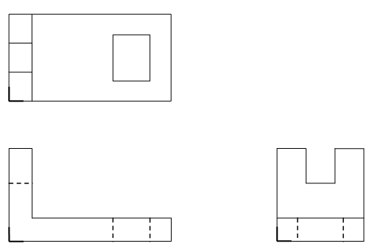
This was answered well by the majority of students. Common errors/omissions were views not placed in correct third-angle projection in relation to each other, and missing hidden lines.

Question 10a.
Marks | 0 | 1 | Average
% | 73 | 27 | 0.3
By setting it up against the centre in the tailstock (or similar).
Most students focused on how the tool is moved but did not mention how to ensure it is on centre height.

Question 10b.
Marks | 0 | 1 | Average
% | 89 | 11 | 0.1
Tool will rub or will not cut (or similar).
Most students just focused on the consequence of 'dimple' when facing, ignoring the consequence when turning diameters.

Question 10c.
Marks | 0 | 1 | Average
% | 4 | 96 | 1.0
185mm
This question was answered well by the majority of students.

Question 10di.
Marks | 0 | 1 | Average
% | 47 | 53 | 0.5
Major diameter of thread

Question 10dii.
Marks | 0 | 1 | Average
% | 54 | 46 | 0.5
Pitch of thread

Question 10diii.
Marks | 0 | 1 | Average
% | 31 | 69 | 0.7
0.61 x 2.5 = 1.525mm
This question was answered well by the majority of students.

Question 10ei.
Marks | 0 | 1 | Average
% | 70 | 30 | 0.3
Knurl

Question 10eii.
Marks | 0 | 1 | Average
% | 51 | 49 | 0.5
Used for grip

Question 10fi.
Marks | 0 | 1 | Average
% | 23 | 77 | 0.8
8mm

Question 10fii.
Marks | 0 | 1 | Average
% | 70 | 30 | 0.3
4mm
Although the majority of students were able to calculate the width correctly in Question 10fi., in this part of the question a large number of students were unable to calculate the depth.

Question 10g.
Marks | 0 | 1 | Average
% | 53 | 47 | 0.5
Use top slide at 45 degrees / Turn tool to 45 degrees and plunge cut

Question 11
Marks | 0 | 1 | 2 | 3 | 4 | 5 | 6 | Average
% | 10 | 18 | 15 | 19 | 31 | 6 | 1 | 2.6

Name | Load
Tapered roller bearing | B
Ball bearing | C
Thrust bearing | A
Apart from ball bearing, few students correctly named the other bearings.

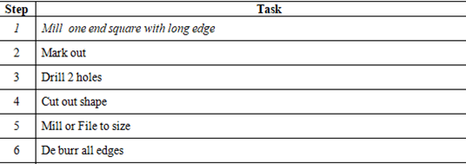
Question 12a.
Marks | 0 | 1 | Average
% | 74 | 26 | 0.3
Self-tapping screw (self-tapper)
Very few students correctly named the screw.

Question 12b.
Marks | 0 | 1 | Average
% | 64 | 36 | 0.4
Do not need nuts (not practical to use nuts inside RHS)
A large number of students incorrectly responded that this screw does not require a pre-drilled hole as the advantage for this scenario. A pre-drilled hole is required for all the screws; accessing the nut inside the tube was the main issue.

Question 13
Marks | 0 | 1 | 2 | 3 | 4 | 5 | Average
% | 7 | 17 | 27 | 25 | 19 | 6 | 2.5
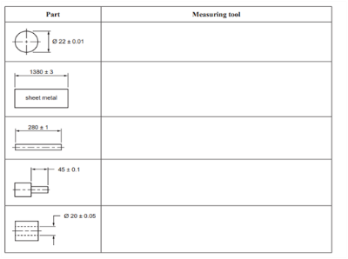
Some students did not take into account the tolerance/accuracy required when selecting the measuring tool. For example, a rule cannot measure to a tolerance of plus or minus 0.1 mm.
Micrometre
Tape Measure
Rule
Vernier Caliper
or Depth Micrometre
Vernier Caliper

Question 14
Marks | 0 | 1 | 2 | 3 | 4 | Average
% | 28 | 21 | 20 | 17 | 13 | 1.7
Very few students correctly answered this question. Common errors included completely missed steps and illogical sequencing.

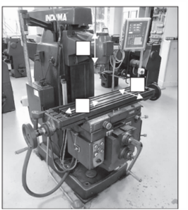
Question 15a.
X
Z
Y
Marks | 0 | 1 | 2 | 3 | Average
% | 13 | 62 | 0 | 25 | 1.4
The majority of students confused the 'Z' and 'Y' axes.

Question 15b.
Marks | 0 | 1 | 2 | Average
% | 92 | 6 | 2 | 0.1
A: Slot Drill
B: End Mill
The vast majority of students did not correctly name either one of the milling cutters.

Question 15c.
Marks | 0 | 1 | 2 | Average
% | 69 | 22 | 10 | 0.4
Milling cutter 'A', because it can be fed vertically to cut the slot.
It was evident that most students did not understand the difference between the two cutters, with most incorrectly selecting cutter 'B'.

Question 15d.
Marks | 0 | 1 | Average
% | 18 | 82 | 0.8
(320 x 38) / 16 = 760 RPM
This question was answered correctly by the majority of students.

Question 15ei.
Marks | 0 | 1 | Average
% | 23 | 77 | 0.8
Max Ø: 12.02
Max Ø: 12.00
This question was answered correctly by the majority of students.

Question 15eii.
Marks | 0 | 1 | Average
% | 85 | 15 | 0.2
Reamer
The majority of students could not name a reamer.

Question 15f.
Marks | 0 | 1 | 2 | Average
% | 50 | 31 | 19 | 0.7
Hold in vice. Set up piece with marked line above and parallel to vice jaw.
(Also accepted was lay flat in vice with piece overhanging and vice rotated to 30 degrees.)
The majority of students were able to correctly suggest the use of a vice but did not adequately describe the set up.

Question 16a.
Marks | 0 | 1 | 2 | Average
% | 66 | 24 | 10 | 0.4
Possible responses included:
- powder coating
- galvanising
- anodising.
A very low percentage of students correctly named two types. Some students answered 'painting', even though the question stated 'apart from painting'.

Question 16b.
Marks | 0 | 1 | Average
% | 21 | 79 | 0.8
Possible responses included:
- aluminium
- stainless steel
- galvanised sheet metal.
This was answered well by the majority of students.

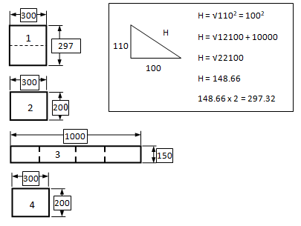
Question 16c.
Marks | 0 | 1 | 2 | 3 | 4 | Average
% | 12 | 12 | 56 | 2 | 18 | 2.0
The majority of students did not calculate the length of part 1. Other common errors related to misreading the drawing or mistakes in simple addition calculations.

Question 16d.
Marks | 0 | 1 | 2 | Average
% | 51 | 24 | 25 | 0.7
Part 1: 0.300 x 0.297 = 0.089
Parts 2 and 4: 0.300 x 0.200 = 0.06 (x2 = 0.12)
Part 3: 1 x 0.150 = 0.15
Total = 0.089 + 0.12 + 0.15 = 0.359m²

Question 16e.
Marks | 0 | 1 | 2 | Average
% | 76 | 2 | 22 | 0.5
Total sheet area = 1.2 x 3.6 = 4.32
0.359 / 4.32 = 0.083 = 8.3%
8.3% of 24.9 = 2.067kg

Question 16f.
Marks | 0 | 1 | 2 | Average
% | 72 | 7 | 21 | 0.5
Layout should show pieces together at one end of the sheet to maintain maximum sheet length, typically:
A number of students did not group the pieces closely together.
1
2
3
4

Question 16g.
Marks | 0 | 1 | 2 | Average
% | 24 | 27 | 49 | 1.3
Possible responses included:
- making roof wider and including lip to seal back
- rubber stripping around perimeter.
Some students did not fully answer the question to sketch and describe. While the majority of students sketched an acceptable design change, some did not include a proper description.

Question 16h.
Marks | 0 | 1 | 2 | Average
% | 36 | 39 | 25 | 0.9
Possible responses included:
- earth lead connected to work
- power is on
- check for paint/dirt on work piece preventing metal to metal contact
- condition/broken welder hand piece etc.
Some students did not respond in relation to an arc welder, suggesting that gas should be checked, which would indicate a lack of understanding of arc welding.

Question 16i.
Marks | 0 | 1 | 2 | Average
% | 28 | 55 | 17 | 0.9
Possible responses included:
- screws and nuts through letter box and disc
- pop rivets
- drill/tap disc and use metal thread screws.

Question 17a.
Marks | 0 | 1 | Average
% | 50 | 50 | 0.5
6000 / 183 = 32 pieces
50 per cent of students did not take into account the thickness of the blade, leading to an over calculation of the number of pieces that could be cut.

Question 17b.
Marks | 0 | 1 | Average
% | 69 | 31 | 0.3
183 x 32 = 5856
6000 - 5856 = 144mm

Question 17c.
Marks | 0 | 1 | 2 | Average
% | 47 | 5 | 47 | 1.0
144 / 6000 = 0.024 = 2.4%

Question 18a.
Marks | 0 | 1 | 2 | 3 | 4 | 5 | Average
% | 28 | 16 | 19 | 16 | 15 | 6 | 1.9
A wide range of designs were accepted and assessed on the following criteria:
- suitability/strength of material used
- overall strength of design (will it support full tank of water)
- attachment method to main tank (will not leak)
- ease of water tank removal
- practicality/simplicity of design.
Few students gained full marks for this question. Common issues included a lack of description/detail for the design and unsuitable materials used.

Question 18b.
Marks | 0 | 1 | 2 | Average
% | 72 | 10 | 18 | 0.5
Volume = πr² x length
= π (.15)² x 0.6
= 0.0707 x 0.6 = 0.0424m³
A large number of students used the incorrect formula for tank volume.

Question 18c.
Marks | 0 | 1 | Average
% | 75 | 25 | 0.3
42.4 + 2.4 = 44.8 kg

