2022 VCE VET Engineering Studies external assessment report

General comments
Students generally scored highly in the important area of safety in this year’s examination.
The majority of students attempted questions related to design and came up with relatively sound design ideas. Few students, however, adequately described their design idea and/or put in enough detail of the materials required.
Sketching and drawing interpretation were topics that students struggled with. In particular, questions involving correctly sketching using third-angle projection and drawing interpretation were answered poorly.
On the practical side of using engineering tools, the majority of students knew what tools were used for but could not correctly name them. Common tools such as ‘Phillips head screwdriver’ and ‘three-jaw chuck’ were often incorrectly named or not named at all.
Another area requiring improvement is operational planning. Basic mistakes such as drilling holes and then marking out the hole positions were made.
Another issue is students not reading the questions carefully and making assumptions with their responses. Examples of this were seen with Question 8, where students are asked to name the tool used for the fastener; instead, some students named the actual fastener shown. Also, in Question 15, where it is stated that the holes have already been marked out, and that tools to produce the holes are required, many listed marking-out tools in their response.
Students would also benefit in future examinations by having an understating of basic mathematical formulas relating to engineering, such as the area and circumference of circles, solving right-angle triangles using the Pythagorean theorem and basic trigonometry.

Specific information
The statistics in this report may be subject to rounding, resulting in a total of more or less than 100 per cent.

Question 1
Marks | 0 | 1 | 2 | 3 | Average
% | 1 | 6 | 38 | 55 | 2.5

PPE | Hazard
Safety glasses | Flying debris / cuttings
Hearing protection | Loud noise
Safety boots | Heavy items falling
Overalls/Apron | Hot chips / cuttings
Hair net | Long hair
Answered well by the majority of students. Some students included gloves as PPE, which can be a hazard around rotating equipment.
Common errors included repeating answers (e.g. overalls and apron or glasses and face-shield).

Question 2
Marks | 0 | 1 | 2 | 3 | Average
% | 3 | 9 | 27 | 62 | 2.5
Acceptable answers included:
- work sticking out too far / not supported
- chuck key in chuck
- tools on top of headstock
- guard not down.
Answered well by the majority of students. Some students clearly knew the answer, but did not know the correct terminology (e.g. ‘tightening thing’ instead of ‘chuck key’).

Question 3a.
Marks | 0 | 1 | Average
% | 32 | 68 | 0.7
Try square (also accepted were ‘engineers square’ or just ‘square’)
Answered well by the majority of students.

Question 3b.
Marks | 0 | 1 | 2 | Average
% | 13 | 58 | 29 | 1.2
1. Checking for squareness.
2. Marking out lines at 90° to an edge.
Answered moderately well by most students. A common error was ‘marking straight lines’, where a rule would be more appropriate.

Question 4a.
Marks | 0 | 1 | Average
% | 2 | 98 | 1.0
Gloves are required to be worn.

Question 4b.
Marks | 0 | 1 | Average
% | 5 | 95 | 1.0
Acceptable answers included:
- welding
- handling sharp material
- handling hot material.
Answered well by the majority of students.

Question 5
Marks | 0 | 1 | 2 | Average
% | 23 | 22 | 55 | 1.3

Ferrous | Non-Ferrous
Stainless Steel / Steel / Cast Iron / Mild Steel / Tool Steel / Wrought Iron | Aluminium / Brass / Bronze / Zinc / Copper / Lead / Nickel / Titanium / Gold / Silver / Tin
Answered well by most students.

Question 6
Marks | 0 | 1 | Average
% | 4 | 96 | 1.0
Acceptable answers included:
- risk of electrical shock
- high voltage.
Answered very well by the majority of students.

Question 7a.
Marks | 0 | 1 | Average
% | 53 | 47 | 0.5
Protractor
Correct terminology was not used by the majority of students. ‘Set square’ or ‘combination square’ were common incorrect responses.

Question 7b.
Marks | 0 | 1 | Average
% | 17 | 83 | 0.9
112°
Answered well by the majority of students. Some students did not look at both diagrams showing the angle is greater than 90°, and answered 68°.

Question 8
Marks | 0 | 1 | 2 | 3 | 4 | 5 | Average
% | 23 | 6 | 10 | 16 | 25 | 20 | 2.8

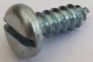  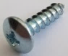  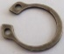  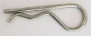 | Flat screwdriver /  Cross tip screwdriver
 | Phillips head screwdriver
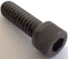 | Allen key / Hex key
 | Circlip pliers
 | Combination pliers / pliers / multi grips
Some students didn’t read the question correctly and put down the name of the fastener rather than the required tool.

Question 9a.
Marks | 0 | 1 | Average
% | 17 | 83 | 0.8
Acceptable answers included:
- Vernier Caliper
- digital Vernier/vernier
Answered well by the majority of students.

Question 9b.
Marks | 0 | 1 | 2 | Average
% | 39 | 48 | 13 | 0.8
Acceptable answers included:
- Not ‘zeroed’ before use
- Dirt on vernier jaws
- Not holding vernier flat / square on work piece
Some students could not come up with two causes of inaccurate readings. A few students answered ‘using wrong part of vernier’, which is an incorrect use of the tool rather than a reading inaccuracy.

Question 9ci.
Marks | 0 | 1 | Average
% | 31 | 69 | 0.7
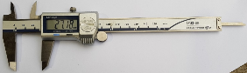
Some students circled the internal jaws rather than the depth rod.

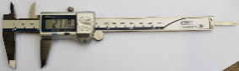
Question 9cii.
Marks | 0 | 1 | Average
% | 7 | 93 | 1.0
Answered well by the majority of students.

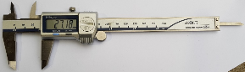
Question 9ciii.
Marks | 0 | 1 | Average
% | 5 | 95 | 1.0
Answered well by the majority of students.

Question 10a.
Marks | 0 | 1 | Average
% | 46 | 54 | 0.6
12.2
Incorrect answers indicate that the student did not use the table and guessed an answer; i.e., 12 was common which does not allow for any clearance.

Question 10b.
Marks | 0 | 1 | Average
% | 41 | 60 | 0.6
10.2
Generally answered well by the majority of students. Some students read the incorrect column on the chart.

Question 11
500
4^{O}
0.5
H
Sin 4° =
H
=
Sin 4^{O}
0.5
H
=
0.0698
0.5
H
7.16 m
H
=
Marks | 0 | 1 | 2 | Average
% | 68 | 11 | 21 | 0.6
Students had some difficulty answering this question, often using incorrect formula.
Some students disregarded the 4^{O} and tried using Pythagoras’ theorem.

Question 12
Marks | 0 | 1 | 2 | 3 | 4 | 5 | Average
% | 13 | 12 | 17 | 21 | 21 | 17 | 2.8
Most students sketched the three individual views reasonably well, but very few seemed to understand the relationship between the views for third-angle projection.
Other common errors included missing or incorrectly drawn hidden lines and centre lines.
Note: Due to the three views requested in figure 9 and the positioning of the ‘starting corners’ in the space for the sketch, some students may have been led to sketch the views as shown below. Students who sketched these views were not penalised.

Question 13a.
Marks | 0 | 1 | Average
% | 70 | 30 | 0.3
Three-jaw chuck
Very few students used the correct terminology.

Question 13b.
Marks | 0 | 1 | Average
% | 67 | 33 | 0.4
M18 thread
Few students answered this correctly, indicating a lack of understanding of basic operational planning.

Question 13ci.
Marks | 0 | 1 | Average
% | 70 | 31 | 0.3
Live centre / dead centre / ‘centre’ also accepted
The majority of students seemed to know what was required, but few named it correctly.

Question 13cii.
Marks | 0 | 1 | Average
% | 70 | 30 | 0.3
Tailstock
Few students knew the correct name.

Question 13di.
Marks | 0 | 1 | Average
% | 79 | 21 | 0.2
0.43mm
A large number of students correctly calculated the 0.86 required to come off, but not all halved it.

Question 13dii.
Marks | 0 | 1 | Average
% | 92 | 8 | 0.1
Cross slide
Very few students used the correct terminology. The majority of those who attempted the question gave answers trying to describe what the part of the lathe looked like.

Question 13e.
Marks | 0 | 1 | 2 | Average
% | 53 | 30 | 18 | 0.7
1. Using a die
2. Screw cutting on the lathe
The majority of students correctly answered one method (usually using a die); very few seemed to know about screw cutting on the lathe. A common answer also included ‘using a tap’, indicating a focus on cutting any thread and not relating the question to the external thread shown on the drawing.

Question 13f.
Marks | 0 | 1 | 2 | Average
% | 62 | 32 | 6 | 0.5
1. Turn tool to 45° and plunge cut
2. Turn top slide to 45° and use it to take cuts
Most students (although not always clearly) answered using the tool, but very few seemed to know the top slide could be used. A common incorrect answer was ‘use a file’.

Question 14
Marks | 0 | 1 | 2 | Average
% | 33 | 10 | 57 | 1.3
120
370
Generally answered well. Some students started by adding/subtracting what looked like random lengths, rather than starting by identifying/constructing a right-angle triangle.

Question 15
Marks | 0 | 1 | 2 | 3 | 4 | Average
% | 58 | 19 | 10 | 9 | 5 | 0.9
Acceptable answers included:
- drill for reaming
- Ø16 reamer
- tapping drill (8.5mm)
- M10 x 1.5 tap
- tap wrench
- pilot drill
- centre drill
Very poorly answered by the majority of students. Common errors were naming marking-out tools (the question states that the part is already marked out) and listing incorrect drill sizes, such as Ø10 or Ø16 drills.
Note: it was not expected that students knew the exact size drill for reaming, just that it was slightly smaller than the reamer diameter, hence ‘drill for reaming’ was accepted.

Question 16
Marks | 0 | 1 | 2 | 3 | 4 | 5 | 6 | Average
% | 54 | 18 | 11 | 8 | 6 | 2 | 1 | 1.1

Tool | Name | Common Use
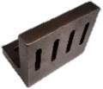  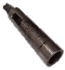 | Angle plate | Hold parts for marking out  Hold parts for drilling  Hold parts for milling
 | Drift | Remove morse tapers
 | Morse taper sleeve / sleeve | Enlarge taper to fit drill / tailstock
Answered poorly by the majority of students. Very few students knew the proper names of these common engineering tools, some even mistaking the drift for a centre punch.

Question 17a.
Marks | 0 | 1 | Average
% | 70 | 30 | 0.3
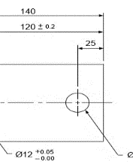
The majority of students did not appear to understand what a datum is, with incorrect arrows drawn around the drawing, and some students not attempting the question.

Question 17b.
Marks | 0 | 1 | Average
% | 70 | 30 | 0.3
Third-angle projection
The majority of students could not correctly identify this basic drawing symbol.

Question 17c.
Marks | 0 | 1 | 2 | 3 | 4 | Average
% | 23 | 15 | 28 | 10 | 24 | 2.0

Dimension | Maximum | Minimum
80 mm | 80.5 | 79.5
120 mm | 120.2 | 119.8
Ø 12 Hole | 12.05 | 12.00
Ø 16 Hole | 16.1 | 15.9
Students had some difficulty answering tolerances that were indicated on the drawing itself, often referring only to information in the title block.

Question 18a.
Marks | 0 | 1 | 2 | Average
% | 41 | 3 | 56 | 1.2
Π x Dia
3.142 × 122 = 383.3 mm
Answered well by most students. Most common error was using an incorrect formula for circumference.

Question 18b.
Marks | 0 | 1 | 2 | 3 | Average
% | 62 | 3 | 2 | 32 | 1.1
Area = πr²
Area = 3.142 × 60²
Area = 11,311
Vol = 11,311 × 300 = 3,393,300
Vol = 3.39 litres
Students had some difficulty answering this question, often using πx Dia instead of πr². Some students also confused radius of lid over canister, using 61² instead of 60².

Question 19
Marks | 0 | 1 | 2 | 3 | Average
% | 57 | 10 | 14 | 18 | 0.9
The majority of students did not start by identifying the right-angle triangle. This then led to incorrect lengths used in calculation. Some students used the correct triangle to find the angle, but didn’t double it to get the included angle
12
80
Tan X =
Tan X = 0.15
X = 8.53°
Angle ‘A’ = 8.53 x 2 = 17.06°
12
x
80

Question 20a.
Marks | 0 | 1 | Average
% | 29 | 71 | 0.7
Ball bearing
Answered well by the majority of students.

Question 20b.
Marks | 0 | 1 | 2 | Average
% | 5 | 17 | 78 | 1.8

Bearing part | Letter
Cage | C
Outer race | A
Balls | B
Inner race | D
Answered well by the majority of students.

Question 20c.
Marks | 0 | 1 | 2 | Average
% | 41 | 53 | 6 | 0.7
Office chair – Thrust bearing
Skateboard – Ball bearing
Students answered fairly well for the skateboard, but had difficulty with the correct bearing for the office chair.

Question 21
Marks | 0 | 1 | 2 | 3 | Average
% | 14 | 42 | 37 | 7 | 1.4

Operation | Step
Mark out holes | 5
Mill slot | 3
Cut 163mm long piece from bar | 1
Mill tapered long sides | 4
Drill holes | 7
Square off ends to 160mm | 2
Centre punch hole positions | 6
The majority of students had problems coming up with the best sequence of operations, with most not considering work holding. Common errors were drilling holes before milling tapered sides (making it more difficult to position holes) and milling tapered sides before slot (making it more difficult to hold in vise).

Question 22
Marks | 0 | 1 | 2 | Average
% | 60 | 10 | 30 | 0.7
Circ = π × Diam / 2
3.142 × 880 = 2765 / 2 = 1382
1800 – 440 = 1360
Length = 1382 +1360 + 1360 = 4102 mm
Students had some difficulties answering this question, often not identifying half the circle, or once identifying it, not taking the radius away from the 1800 to get the length of the straight pieces.

Question 23a.
Marks | 0 | 1 | 2 | Average
% | 49 | 6 | 46 | 1.0
Area: 3 × 1.8 = 5.4m²
Weight: 5.4 × 125.6 = 678.24 kg
Answered well by approximately half of students.
Common errors were not converting millimetres to metres, and using the tabletop size (1750 × 1000) instead of the steel plate specified in the question.

Question 23bi.
Marks | 0 | 1 | 2 | Average
% | 35 | 43 | 23 | 0.9
Acceptable answers included:
- chains
- plate lifting clamps
- magnetic lifter
- slings
- D-shackles
Students had some difficulty naming two accessories. Common errors were naming the crane hook and pallets for placing the plate on, rather than accessories to lift the plate.

Question 23bii.
Marks | 0 | 1 | 2 | Average
% | 34 | 42 | 24 | 0.9
Acceptable answers included:
- Check lifting capacity (SWL)
- Check condition of accessory (damaged/worn)
- Check that they are correctly secured/fitted
Common errors made by students included checking of the general area (e.g. nothing is in the way) and duplicating answers (e.g. make sure sling can lift the weight and make sure plate clamp is rated for the weight).

Question 23c.
Marks | 0 | 1 | 2 | Average
% | 55 | 7 | 38 | 0.9

Material | Length | No. of pieces
75 SHS | 1550 | 2
75 SHS | 650 | 3
75 SHS | 825 | 6
The most common error made was just taking the overall sizes from the drawing and not subtracting the 75mm for the RHS (i.e. 900 for the legs instead of 825).

Question 23di.
Marks | 0 | 1 | Average
% | 32 | 68 | 0.7
Small/short welds to hold the parts together.
Answered well by the majority of students. A common error was stating the reason for tack welding, rather than describing what tack welding is.

Question 23dii.
Marks | 0 | 1 | Average
% | 33 | 67 | 0.7
Acceptable answers included:
- Ensure frame is correct size / square before final welding
- Easier to make changes if anything is wrong
- Keep items in correct position for final welding
This question was answered well by the majority of students.

Question 23e.
Marks | 0 | 1 | 2 | 3 | 4 | Average
% | 46 | 26 | 15 | 9 | 5 | 1.0
Below is a possible design. All designs were assessed on:
- Practicality of design (suitable materials used / nothing sticking up obstructing use of tabletop)
- Enough detail to allow for manufacture
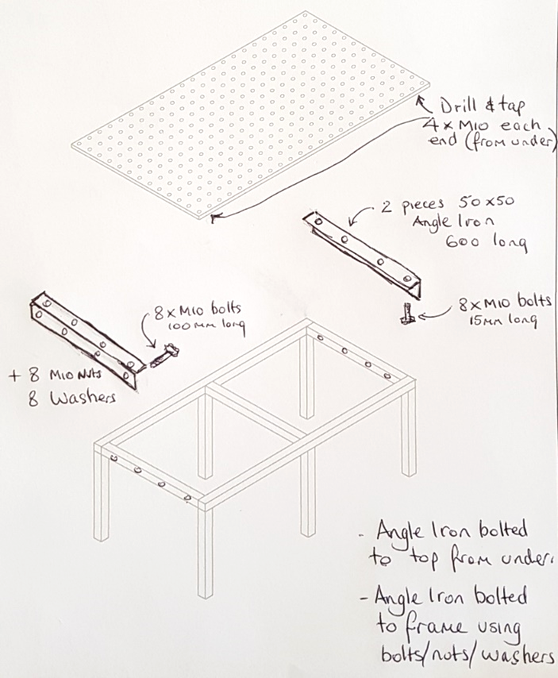
The majority of students sketched a design, but few could satisfy all requirements.
Common errors included:
- Having a good design concept, but not giving enough detailed information
- Using bolts from the top with the bolt head sitting above the tabletop
- Using standard bolts (without nuts) that screw into the thin RHS.
Students are advised to read the question carefully to understand the requirements and required detail of the design.

Question 23f.
Marks | 0 | 1 | 2 | 3 | 4 | Average
% | 33 | 22 | 16 | 17 | 12 | 1.6
Below is a possible design. All designs were assessed on:
- Practicality of design (suitable materials used / stabilising all six legs)
- Enough detail to allow for manufacture
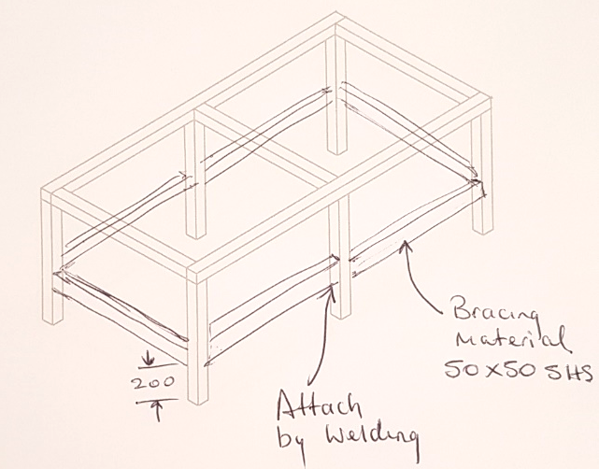
The majority of students sketched a design, but few could satisfy all requirements.
Common errors included:
- Not showing basic dimensions
- Adding bracing to the tabletop, rather than the legs
- Not bracing all legs
Students are advised to read the question carefully to understand the requirements and required detail of the design.

