2020 VCE Visual Communication Design examination report

General comments
In 2020 the Victorian Curriculum and Assessment Authority produced an examination based on the VCE Visual Communication Design Adjusted Study Design for 2020 only, and the examination assessed a range of key knowledge and key skills across Units 3 and 4.
Most students appeared to have sufficient time and completed the paper. Students generally handled the examination well and demonstrated creativity in the design tasks. Most students demonstrated a good understanding of the elements and principles of design and used these correctly in their responses. The Cross-study Specifications on page 9 of the 2018–2022 study design need to be referred to for the application of correct terminology.
A common error made by students was not reading each question carefully, leading them to miss important instructions contained within some questions. This was particularly evident in Questions 5b., 6bi. and 6bii. Students should remember to read questions carefully and fully comprehend what is being asked before answering.
Students with high-scoring responses:
- used correct and relevant terminology from the study design
- referred to the visual communication provided when answering the question
- attempted all questions and appeared to have allocated adequate time to complete them
- read the questions carefully and were able to interpret what each question was asking
- addressed all the criteria when responding to questions.
When required to explain/describe the relationship between two things, it is important that students link the two in their response. In this examination, students were required to relate things such as two elements and how, together, they effectively communicated the services provided by the company, the relationship between design decisions, and the target audience the visual communication was intended for. Students are advised to practise identifying the components of a question and drafting responses in revision periods. This is very important in complex questions where students are required to address a number of components.

Specific information
Student responses reproduced in this report have not been corrected for grammar, spelling or factual information.
This report provides sample answers or an indication of what answers may have included. Unless otherwise stated, these are not intended to be exemplary or complete responses.
The statistics in this report may be subject to rounding resulting in a total more or less than 100 per cent.

Question 1a.
Marks | 0 | 1 | Average
% | 2 | 98 | 1
Nearly all students gave the correct answer, which was to guide.

Question 1b.
Marks | 0 | 1 | Average
% | 20 | 80 | 0.8
Most students correctly identified trademark as the form of intellectual property that would best protect the given design.

Question 1c.
Marks | 0 | 1 | Average
% | 17 | 83 | 0.8
The correct answer was the third option.
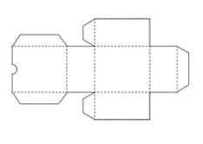
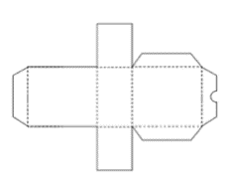
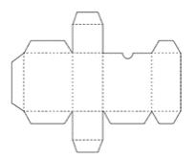

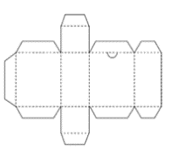
1 2 3 4
Most students correctly chose the third option as the correct packaging net. The majority of students who selected the incorrect option chose the second packaging net.

Question 1d.
Marks | 0 | 1 | Average
% | 59 | 41 | 0.4
The correct answer was the third option:
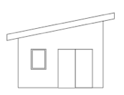
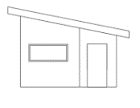
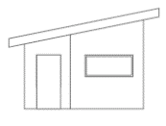
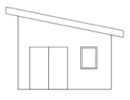

1 2 3 4
Many students incorrectly chose the option that showed the south elevation instead of the required north. The important convention students need to remember is that the north view is determined from the north of the floorplan when facing the building.

Question 2
Marks | 0 | 1 | 2 | 3 | Average
% | 31 | 30 | 20 | 19 | 1.3
Most students were able to correctly identify development of concepts as the required stage of the design process; however, their discussion often lacked evidence as to why the imagery provided was an example of this stage. Most students neglected to describe the skills used during the development of concepts stage of the design process.
The following are examples of high-scoring responses.
- The stage of the design process is development of concepts. As seen in Figure 5 the design of the scissor has multiple handles of different designs and which will best suit the design. The blade of the handle has been drawn to figure out the way it will mechanically operate, as well as the materials needed for the design, such as screws and bolts which make the scissors accessible to move freely. The design concept is developing the scissors into a final product by experimenting with different methods, materials and media. The scissors have a variety of concepts to help finalise what will be considered. Annotations are used to explain what is being conveyed and giving an explanation.
- Three drawings for the design of a pair of scissors would have been completed during the development of concepts stage of the design process. This is because the designer is exploring one idea thoroughly, as seen in the detailed diagrams of the scissors’ function with the bolt in the bottom drawings. The use of colour also suggests that this was completed during development of concepts because it is normally the stage where a designer begins to explore the aesthetics of a design.

Question 3
Marks | 0 | 1 | 2 | 3 | 4 | Average
% | 5 | 17 | 36 | 29 | 13 | 2.3
Many students appeared to have misread the question and neglected to discuss how line and type were used together. Many more did not discuss how line and type were used together to effectively communicate the services provided.
Most students successfully discussed the way line and type were used separately, with a general reference to services. The majority of students wrote about line and its role in creating the logo or to suggest a dog. Stronger responses made the additional connection between the winding line and a road or the swift service provided by the company, while others mentioned how this suggested the testing process.
Students needed to analyse the characteristics of line and type presented in the image to show how these communicate the nature of the services.
The following are examples of high-scoring responses.
- The use of line in the logo makes the inner section of the ‘s’ take on the appearance of a test tube, this highlights the sampling nature of the clinic. Through the implementation of the elongated lines that connect both the ‘A’ and the ‘S’ it appears quite fluid as well as contemporary with the sans-serif text. This may work to depict the quick and fluid testings of the clinic as well as it modern and advances operations in sampling.

- The designer has manipulated the type to achieve a lowing, flattened logo that resembles the image of a dog, thus effectively conveying that ASAP laboratories specializes in animals. The italic ‘s’, created by the use of flowing line highlights their name ASAP (as soon as possible) suggests, the forward lean of the ‘s’ implying speed. This along with the use of simple line to create the shapes of dog ears and a tail implies that ASAP aims to provide easy, effective service to animals.

Question 4
Marks | 0 | 1 | 2 | 3 | 4 | 5 | 6 | Average
% | 4 | 5 | 10 | 22 | 31 | 21 | 7 | 3.6
Most students were able create a design using connecting sans serif lower-case letters. Some students, however, did not follow all the instructions included in the dot points. Often, they did not ensure the type was touching all sides, and many students did not respond to the constraint that 50 per cent of the space needed to be utilised. While many students attempted to achieve a sense of flow with type, some used other elements, such as shape and line, to create a representation of flow in their designs. Weaker responses had the word flow as vertical and stable, while others placed the words to one side of the space.
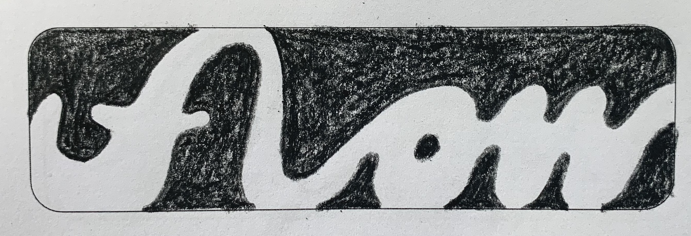
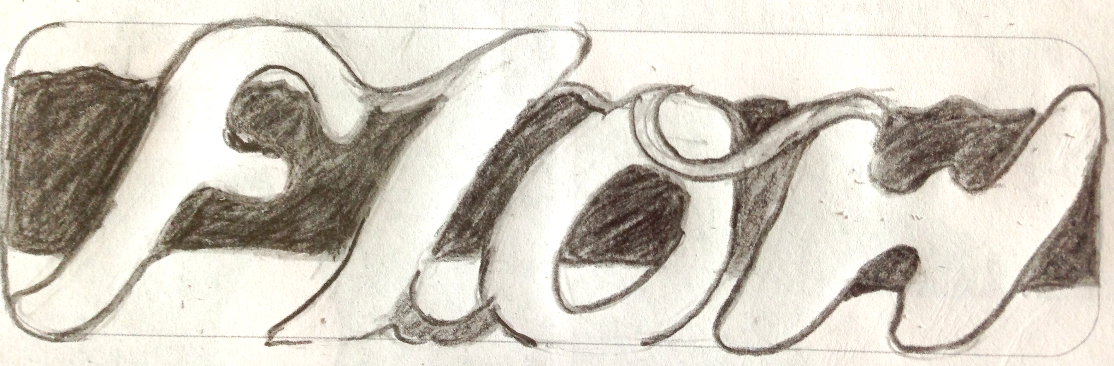
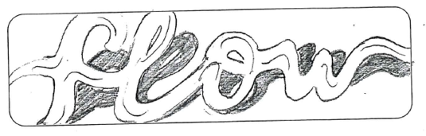
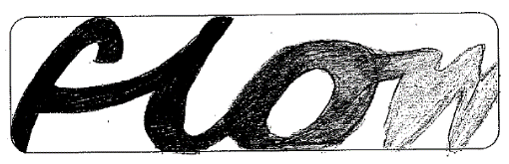
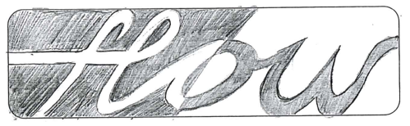
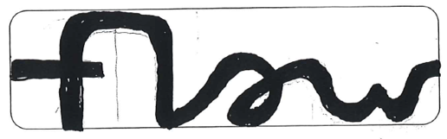
The following are examples of high-scoring responses.

Question 5a.
Marks | 0 | 1 | 2 | Average
% | 23 | 35 | 42 | 1.2
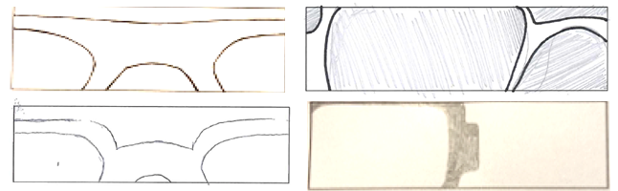
Most students were able to maintain proportions and scale up the glasses. Students who scored highly cropped the glasses’ frame within the box to increase the scale of the frame. They allowed the edge of the work area to cut off the frame rather than filling the space provided without altering the scale of the frame.
The following are examples of high-scoring responses.

Question 5b.
Marks | 0 | 1 | 2 | 3 | 4 | 5 | 6 | 7 | Average
% | 11 | 4 | 6 | 8 | 16 | 28 | 21 | 6 | 4.1
Most students were able to create a basic design using at least two fames from Question 5a. The majority of students were successful at maintaining proportion, reducing scale and representing hierarchy. Most students used two colours, but many students incorrectly also used black, either as an outline or a ground.
Students who did not score well may have not read all the details of the question and drew only one pair of glasses or did not consider hierarchy in their design. A few did not maintain the same proportions, making the frames too thick, or changed the shape of the lens piece.
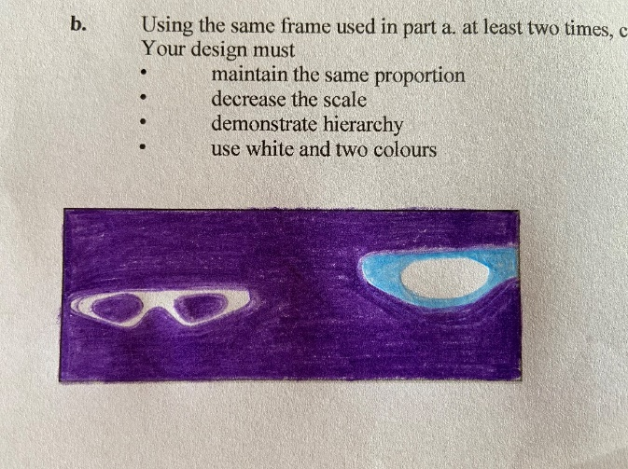
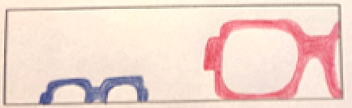
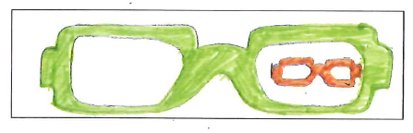
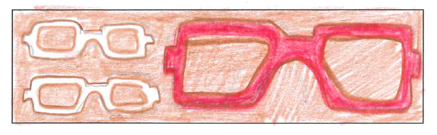
The following are examples of high-scoring responses.

Question 6a.
Marks | 0 | 1 | Average
% | 15 | 85 | 0.8
Most students correctly identified the field of design as environmental design.

Question 6bi.
Marks | 0 | 1 | 2 | 3 | Average
% | 4 | 15 | 40 | 41 | 2.2
Generally, this question was handled well, with most students clearly identifying an audience and using appropriate evidence from Figure 8. Students who scored highly often discussed parents, young children (aged 2–10) or people who are into fitness/active lifestyles. Students who scored less well did not link the design decision to their chosen audience or chose too broad an audience, while some did not read the question carefully and provided evidence for their answer from Figure 9.
The best responses specifically discussed the details such as the scale and distance apart of the footholds on the climbing construction in relation to its age appropriateness; some focused on the layout of the park – versatile, continuous pathways that still have a meandering feeling, natural gardens, seating with/without backs and the strategic placement of the seats, safety surfaces etc.
The following are examples of high-scoring responses.
Active adults could be a possible target audience as the designer has made room for wide foot paths that bikes can also go on. As well as featuring an outdoor gym to enjoy out in public and without paying. It is a welcoming environment for movement as it does not feature a lot of benches either.
A possible target audience could have been families of middle class socio economic status and with younger children perhaps age 3 – 12. A design decision to appeal to this audience could have been the choice of vivid and vibrant colours across the environment, This colour pallet, consisting of bright yellows, reds and greens creates a more friendly atmosphere within the landscape and is thus more inviting for young children to play in.

Question 6bii.
Marks | 0 | 1 | 2 | 3 | Average
% | 10 | 15 | 37 | 38 | 2
Generally, this question was handled fairly well, with most students clearly identifying an audience and using appropriate evidence from Figure 9. A small number of students incorrectly repeated the same audience and/or design decisions, while some students provided evidence from Figure 8 for both responses or referred to both images in their answer, which was inconsistent with the instructions. A few students identified the target audience as parents with children but went on to discuss how the designer made decisions related to the children and not the primary target audience identified, being the parents. Some students provided long and detailed descriptions of the target audience, which they then struggled to find evidence for, while others used obscure evidence such as very small details in the background of the images rather than focusing on the main equipment depicted. Most students correctly described what they saw in the image and referenced the play equipment; however, to achieve a high score, students needed to discuss design decisions in detail, identifying a deliberate change or inclusion to a design and how this would then cater specifically to the identified target audience.
The following are examples of high-scoring responses.
- Figure 9 shows a children’s adventure playground. Climbing walls and structures along with steps to walk/jump along provide an environment where children 4-12 can explore and test out their boundaries. Children work on strength and skill development in a playful way with a cushioned floor for safety.
- Children may be a possible target audience due to the playground nature of the climbing objects and hexagons. Every pillar or tall object features a plastic rock climbing part encouraging energy and exercise in kids wanting to run around and play outside.

Question 7a.
Marks | 0 | 1 | 2 | 3 | 4 | Average
% | 31 | 19 | 29 | 17 | 5 | 1.5
This question was not answered well. Many students were able to identify a relevant specialist, such as a textile designer, embroiderer or typographer and some were able to identify what skills the specialist would have contributed. Few students, however, went on to explain how the specialist would have collaborated with Daniel New, and even less provided evidence from Figure 10 to strengthen their response. In collaborations, it is necessary to identify and describe a two-way interchange of ideas and skills that would collectively lead to the development of a concept.
Most students discussed what skills the specialist offered without explaining how those skills would be used in a joint effort with the designer, specifically during the development stage of the design process. It is important to note that Daniel New, the designer who was given the brief to create the cover, would be a graphic designer and therefore identifying him as a specialist would not be correct. Similarly, a number of students identified the author as either the specialist or the designer.
The following is an example of a high-scoring response.
The designer would have collaborated with a textile designer. They may have experimented with different types of threads such as silk, cotton, wool to sew the leaves, fruit and bird. The textiles designer would have offered suggestions to the designer on materials that would be durable, create texture, produce the right colours the designer wanted but still be flat enough for a book cover. The designer would have guided the specialist in terms of the colours they wanted them to use and designed the imagery the specialist embroidered.

Question 7b.
Marks | 0 | 1 | 2 | Average
% | 22 | 37 | 41 | 1.2
Generally, this question was handled fairly well, with most students describing a relevant principle and explaining how it was used effectively. Some students incorrectly discussed design elements, in particular colour and texture. It is important for students to have an understanding of the basic characteristics and function of each principle of design.
The following are examples of high-scoring responses.
- Cropping has been used in the design. The front of the book shows only part of a tree. The tree then wraps around the spine, and probably goes around the back of the book. This is effective as it creates a cohesive design, that maintains engagement of the audience, as they flip it around to see if it wraps all the way around and possibly on the inside of the book.
- Contrast - The tree trunk appears to be screen printed on to the fabric cover in the same way that the serif type of the title Maggie’s Harvest. The contrast of the embroidered leaves, fruit and bird create an asymmetrical balance to the cover with the tree wrapping around the entire front and back of the book.

Question 8a.
Marks | 0 | 1 | 2 | 3 | 4 | 5 | 6 | 7 | 8 | Average
% | 27 | 15 | 12 | 10 | 8 | 7 | 8 | 8 | 6 | 2.9
The majority of students who attempted this question were successful in drawing the planometric floorplan from point A, with most using 45-degree angles, and a few opting for 30/60-degree angles. Students who responded correctly were able to extrude the details from the plan and apply correct dimensions as supplied in the question. While some students correctly drew the circle round and not as an ellipse, a number of students did not place the circle and triangle in the correct position in relation to the floor plane.
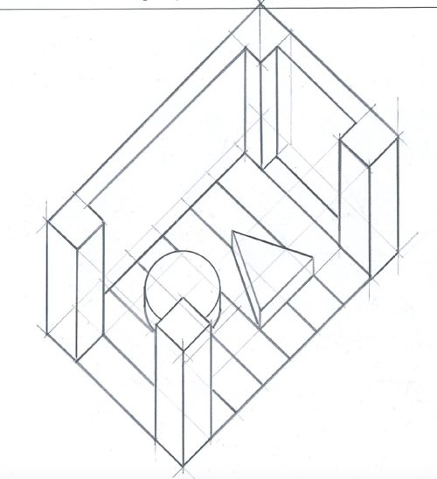
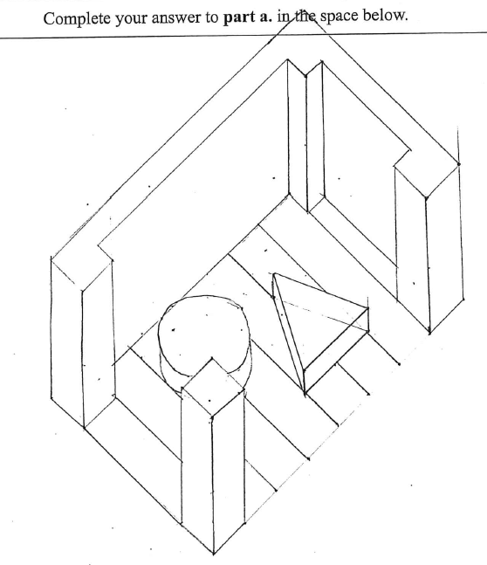
The following are examples of high-scoring responses.

Question 8b.
Marks | 0 | 1 | 2 | 3 | 4 | 5 | 6 | 7 | Average
% | 27 | 17 | 17 | 16 | 12 | 7 | 3 | 1 | 2.1
While most students were able to use the correct vanishing point and draw the object from Question 8a., many were unable to maintain the correct proportions and thickness of the box. The common error was the inability to maintain the square proportions of the cart, instead elongating the box as a rectangle. The length of the box should have been considerably shorter than the width to ensure that it appeared as a square in perspective. While many students did understand the basic function of a vanishing point and receding lines in one-point perspective, many did not use the technique of ‘crating’ to support their drawing. Most students found visualising wheels in the correct position and proportion difficult. Some students forgot the rule in one-point perspective that vertical lines stay vertical and only parallel lines moving away from the viewer converge at the vanishing point.
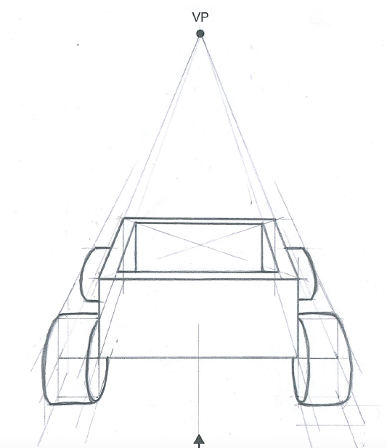
The following is an example of a high-scoring response.

Question 9
Marks | 0 | 1 | 2 | 3 | 4 | 5 | 6 | 7 | 8 | 9 | Average
% | 2 | 2 | 3 | 7 | 12 | 18 | 21 | 20 | 12 | 3 | 5.6
Generally, this question was answered well, with the majority of students indicating the light source correctly. Overall, the surface textures were handled well, although a number of students neglected to add the coarse texture needed to represent roughcast concrete. More attention to contrast in lights and darks to create form was needed by many students, and a few students didn’t use colour, even though this was required in the question. Students frequently acknowledged the light source on the metal pole but did not attempt to enhance the form of the wooden block which, along with the metal above the wood block, was required to be shaded on top as the source of light was below.
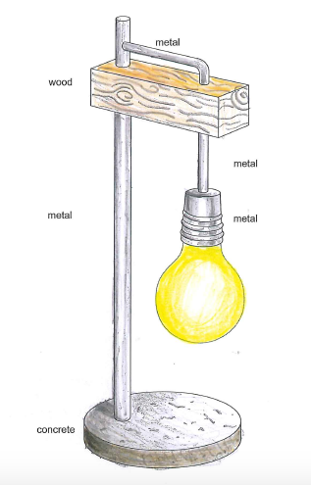
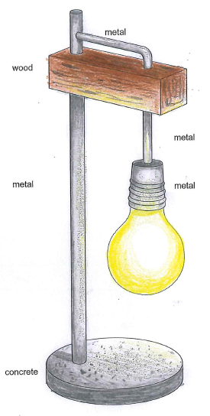
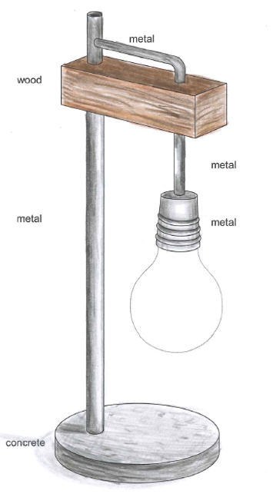
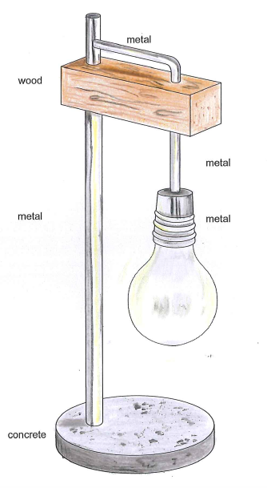
The following are examples of high-scoring responses.

Question 10
It was necessary for students to identify the contexts shown in the images. Furthermore, as the contexts shown were all part of a similar context (shopping centre walls), students were required to identify specific contexts and differentiate between the precise needs when adapting the designs for these contexts. More successful responses did not simply describe the appearance of the signs but described how they had been designed and then adapted or changed to suit individual contexts that were clearly identified.

Question 10a.
Marks | 0 | 1 | 2 | Average
% | 67 | 20 | 13 | 0.5
This question required students to consider what decisions may have been made based on the context of the signs and was poorly answered. Most students understood how the design might be adapted, but they struggled to describe a decision that was applied to both examples provided. They had difficulty explaining how the designer adapted the design from one image to the other. Many students incorrectly discussed decisions that did not change across the two contexts, such as using particular colours, linework or symbols. It is possible that some students did not read the question carefully as many discussed a decision that addressed one context, but very few considered how the signage was adapted to suit both contexts.
The following are examples of high-scoring responses.
- While the range of symbols evident in Figure 14 identify the location of the toilets, it is clear in Figure 15, that the designer decided to isolate the female shape from the others when used in a different context. This emphasises the gender the toilet is intended for.
- The designer decided to alter the scale of the symbol to place a much larger almost life-size symbol on the wall inside the entrance on the dark textured wall. This change of scale allows the symbol to be easily seen in the new context. While the original smaller symbols clearly visible on the white wall in Figure 14 they would have been lost on this wall.

Question 10b.
Marks | 0 | 1 | 2 | Average
% | 32 | 30 | 38 | 1.1
This question was answered fairly well by the students who attempted it. Most students were able to successfully discuss how the signage had been adapted in one context only, but many did not clarify their answer. Some successful adaptions included scale, repetition and LED backlighting.
The following is an example of a high-scoring response.
Figure 15 shows the repeated lighting of the female symbol outside the entrance. Purple lighting contrasts against white wall making it easy to see. Larger scale symbol on the inside of the entrance emphasises the gender the toilet is intended for and allows the symbol to be seen against the dark texture wall.

Question 11a.
Marks | 0 | 1 | 2 | 3 | 4 | Average
% | 4 | 11 | 20 | 36 | 29 | 2.8
Most students generated an effective range of visualisation drawings (three or more) representing SCOOP. High-scoring responses included drawings that provided various options for both type and image. Although it was not required by the question, some students used the opportunity to generate ideas that combined type and image in preparation for Question 11b. Some students only developed type or image, resulting in a less successful solution. Other students did not provide a range of ideas in both type and imagery, or their ideas were all very similar. Many students did not differentiate type and image, using the same type but with different images or vice versa.
A few students used design thinking techniques to annotate their visualisation drawings, which was not required for this question and would have taken up unnecessary time.
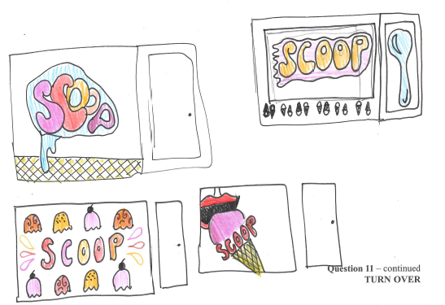
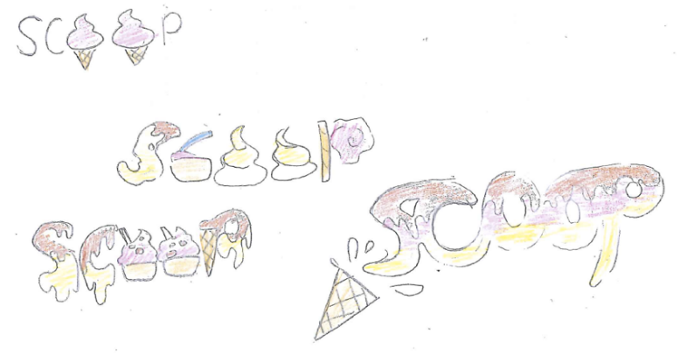
The following are examples of high-scoring responses.

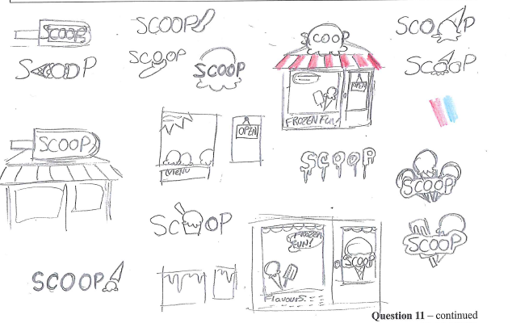
Question 11b.
Marks | 0 | 1 | 2 | 3 | 4 | 5 | 6 | Average
% | 6 | 3 | 17 | 22 | 25 | 19 | 9 | 3.5
Most students used the ideas generated in Question 11a. to create two designs that were distinctly different. Many considered the whole shopfront, although some only used one window. This indicated a lack of understanding of the question, which required students to create a design for the entire shopfront and not just for the main window. Students should have been guided by the area provided for their answer, which was the entire shopfront and not just a rectangle. If the intention had been for students to create a design for the window only, it would have been stated in the question. Some students used both type and image but did not combine them as required in the question. A high-level response would show a creative or thoughtful interaction between the type and image rather than merely using both in the design.
A high-scoring response included annotation that evaluated how the design addressed both functional and aesthetic factors. Most students were able to discuss the functional aspects considered in their design, such as legibility, safety and/or light. Few students, however, successfully discussed the aesthetic consideration of creating a funky design. Many students labelled their concepts rather than referencing the concept’s function and/or aesthetics in their annotations. A number of students wrote detailed annotations demonstrating critical thinking, many using PMI, which was not required in the question.
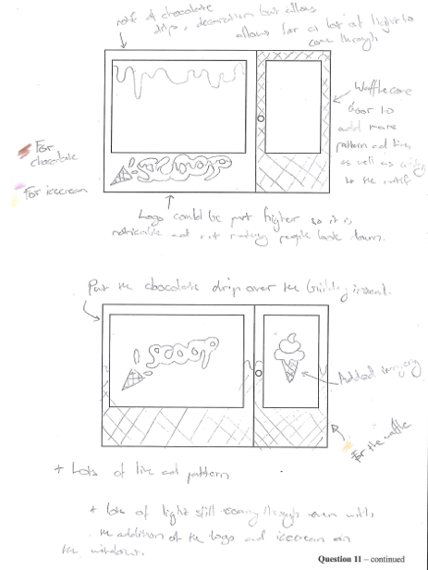
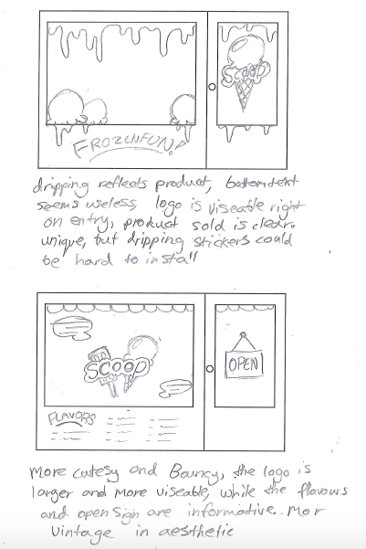
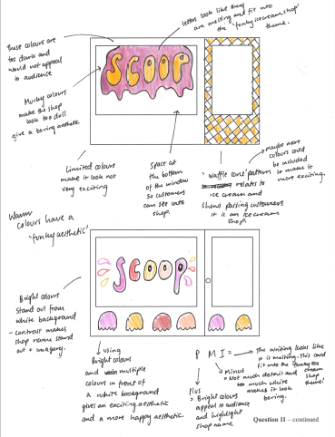
The following are examples of high-scoring responses.

Question 11c.
Marks | 0 | 1 | 2 | 3 | 4 | 5 | 6 | 7 | 8 | 9 | Average
% | 9 | 1 | 1 | 3 | 8 | 19 | 27 | 21 | 9 | 2 | 5.4
A high-level response presented creative and well-considered designs that addressed all areas of the shopfront and responded to each dot point in the question to produce a successful final presentation. Students with higher quality responses considered and addressed areas of weakness identified in the critical annotations in Question 11b. when finalising their design. A large number of students only considered the glass areas of the template and therefore presented less successful designs in response to the brief. Other students worked outside the specified shopfront represented by the template; these additions could not be considered as only work in the designated area could be assessed. Without the critical annotations in Question 11b., many students could not score highly as the question required them to address these in the final design.
Most students addressed the constraints outlined in the question, leaving clear areas in the windows for light and using pattern, although some erroneously considered the repetition of an object sufficient to address the need for pattern. Most students only used the design elements specified in the question; however, some incorrectly added form through tonal rendering.
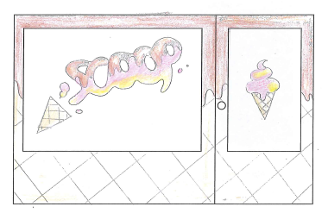
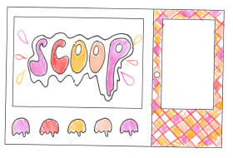
The following are examples of higher-scoring responses.

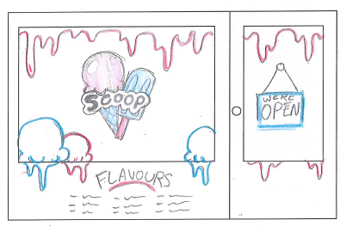
Question 11d.
Marks | 0 | 1 | 2 | 3 | 4 | Average
% | 25 | 11 | 20 | 27 | 17 | 2
A high-level response presented a simplified image from Question 11c. that included the bridges needed for the design to be successfully laser cut. These high-scoring designs addressed both dot points in the question and demonstrated a clear understanding of asymmetrical balance.
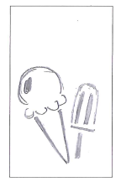
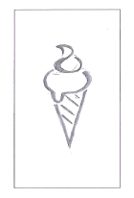
The following are examples of high-scoring responses.

