2021 VCE Visual Communication Design external assessment report

General comments
In 2021 the Victorian Curriculum and Assessment Authority produced an examination based on the VCE Visual Communication Design Study Design 2018–2022, and the examination assessed a range of key knowledge and key skills across Units 3 and 4. Questions required students to respond using both written and practical-based skills.
Students responded to all questions on the paper and addressed the criteria for each question in their responses. They were able to refer and respond to the stimulus supplied for some questions and integrate it into their discussion. However, students are reminded to manage their time effectively to complete all questions on the paper. Students are reminded to read the questions carefully and refer to the coloured examples in the resource booklet to assist them in preparing their responses. They should pay attention to key terminology within the questions, such as the design elements and principles, which are explained in the cross-study specifications on page 9 of the study design so they can respond accurately.
During the examinations, students are required to visualise and sketch ideas quickly using selected design elements and principles. Practice in visualisation and concept development will prepare students for the practical questions in the examination. Students are encouraged to focus on the practical application of aspects of Visual Communication Design in their school-assessed task, such as the use of design elements and principles, particularly during the generation of ideas and development of concepts stages.
Students preparing for future Visual Communication Design examinations are encouraged to practise past papers to become familiar with the general format and style of questions. Most importantly they should complete questions under timed conditions to help them recognise areas of challenge, such as technical drawing, rendering and design-based questions, and allocate their time accordingly. Building confidence within the examination itself and being disciplined with their time will go a long way in ensuring students receive the best result possible. Teachers are encouraged to help students structure their written responses in a clear and concise manner, as there were some instances where responses were confusing or contradictory. Finally, it is advisable that students familiarise themselves with the resource imagery and stimulus material provided (perhaps during reading time) before commencing any response.

Specific information
Note: Student responses reproduced in this report have not been corrected for grammar, spelling or factual information.
This report provides sample answers or an indication of what answers may have included. Unless otherwise stated, these are not intended to be exemplary or complete responses.
The statistics in this report may be subject to rounding resulting in a total more or less than 100 per cent.

Question 1a.
Marks | 0 | 1 | Average
% | 21 | 79 | 0.8
Overall, this question was answered well, with a majority of students correctly selecting serif.

Question 1b.
Marks | 0 | 1 | Average
% | 43 | 57 | 0.6
Although a majority of students correctly selected patent, there was clearly some confusion with trademark.

Question 1c.
Marks | 0 | 1 | Average
% | 42 | 58 | 0.6
The answer was creative thinking. Figure 3 demonstrated the use of a SCAMPER, as indicated by the key words in the annotations, which should have allowed students to make the connection with creative thinking.

Question 1d.
Marks | 0 | 1 | Average
% | 28 | 72 | 0.7
The majority of students correctly chose digital-based methods. Although the poster in Figure 4 was type-based, typography is not a method listed in the study design.

Question 2a.
Marks | 0 | 1 | Average
% | 27 | 73 | 0.8
The majority of students responded with ‘to inform’ or ‘to promote’. Longer responses were also acceptable, such as ‘to inform the audience of the Reconciliation Action Plan’. Students who incorrectly answered this question often used terminology not relevant to the study design, such as ‘to communicate’, or stated inappropriate purposes such as ‘to advertise’ or ‘to teach’.

Question 2b.
Marks | 0 | 1 | 2 | 3 | Average
% | 24 | 28 | 32 | 16 | 1.4
Acceptable design elements that were used in responses about the effectiveness of the design element with figure-ground were colour, type and point. Line and shape were also acceptable, but far less common. Students should note that not every design element will be applicable and therefore should select the dominant element that allows for better discussion. For instance, discussing ‘tone’ was not as relevant as discussing ‘colour’ as the dominant element. Colour is used effectively with figure-ground through the use of different blue tones and the contrasting background.
It is crucial for students to know the key terminology from the study design and be able to distinguish between design elements and design principles. A number of students incorrectly discussed design principles (pattern and hierarchy) instead of the design elements in their responses.
Students need to discuss how their selected design element was used effectively with figure-ground. They needed to discuss either how the two worked together or how the use of the design element distinguished the figure from the ground. Responses that scored highly were able to discuss how figure and ground was created using the design element and how it was used effectively.
The following are examples of high-scoring responses.
Design element of colour has been used effectively with figure-ground, as the ‘negative’ space has been made white so that the coloured arts such as the text and the artwork/illustrations can be seen clearer. The figure’ is the text and artwork that is coloured a dark blue with a light blue, and the ‘ground’ is the white background/dark blue background which helps to contrast.
The design element of point has been used effectively with figure-ground due to its flowing and curvy direction and lighter blue colour. The smaller circles to resemble point pop from the dark flat background, making it easy to identify as an Aboriginal artwork. Point acts effectively as the figure.
The design element type has been used effectively with the design principle figure-ground as the bold, sans-serif type acts as a good heading as the figure, with the ground being a navy background, as well as acting as a good sub heading on the second page also using a bold sans serif font with a smaller bold & not bold sans serif type.

Question 2c.
Marks | 0 | 1 | 2 | 3 | Average
% | 10 | 32 | 41 | 17 | 1.7
Many students were able to describe how the artwork was enlarged and cropped in the layout on the front cover of the booklet, and then twice within the layout of the double-page spread.
Responses that scored highly referred to the position of the cropping (e.g. bottom left corner, half of the pattern was cropped out, the pattern took up the majority of the front cover) and then explained how it was used effectively (e.g. to create space for the type, create hierarchy/balance, to allow the audience to see the detail in the artwork). Students should keep the focus of their discussion on the key words in the question, in this case the use of the design principle of ‘cropping’, and not on the effectiveness of its use.
The following are examples of high-scoring responses.
In figure five, the graphic has been repeated and cropped into the opposite corners in order to create a sense of balance whilst also framing the text; without cropping, the images would have more visual weight; thus, the designer has cropped them in order to ensure the text is at a high priority in the hierarchy.
Cropping has been used effectively as in the bottom left-hand corner the artwork has been cropped through the middle to look like its over lapping off the edge, similarly at the top right-hand corner of the second landscape, the layout show the artwork being cropped to fit in the corner. Cropping can be seen on the portrait page as the artwork takes up most of the space of the layout but is cropped along the side and bottom to fit into the corner.

Question 3a.
Marks | 0 | 1 | 2 | 3 | Average
% | 30 | 33 | 25 | 12 | 1.2
Students demonstrated an understanding of design constraints and were able to answer all aspects of the question. Students were required to discuss one design constraint using Figures 6 and 7 as evidence to explain and justify the constraint they identified. Most students described the building and discussed one design constraint. Common design constraints discussed by students included creating a ‘modern’ ‘or ’contemporary’ design for a building, either using geometric forms or by increasing the scale.
The following are examples of high-scoring responses.
One design constraint may be that the client desired the museum to be taller and contain more levels. This is evident as in figure 6, the building seems to be only 1-2 levels whilst in figure 7 the building seems to contain many more levels. This would allow the museum to display more art or serve more functions e.g. community meetings.
The designer might have been given the constraint of a modern and inviting design as the old buildings entrance in figure 6 appears enclosed and the design appears busy in comparison to the new design in figure 7 that uses vertical line and horizontal lines in the form to create a clean modern aesthetic.

Question 3b.
Marks | 0 | 1 | 2 | Average
% | 29 | 30 | 41 | 1.1
Many students identified a material in Figure 8 such as metal, glass or copper, and explained why the designer used it with reference to its aesthetic factors. Many students referenced the modern/contemporary aesthetic or its minimalistic appearance.
Students were required to discuss the aesthetic factors of the material rather than its functional qualities. For example, using glass because it is transparent and light, or metal because of the contrast in colour created by the rusted surface.
The following are examples of high-scoring responses.
Material – rust coloured metal
The rust coloured metal panels provides a striking, vibrant orange colour which contrasts with the green foliage and steel grey panels which make up the rest of the building, making it stand out against its surroundings.
The designer has chosen to use glass in the new building, seen in the large windows below and above the steel cladding in figure 8. This enhances the modern and contemporary look of the establishment, creating a more clean and minimalistic appearance to the building.
The designer has incorporated metal sheets as the main material of the building. The silver reflective sheet allows surrounding factors, such as trees, rusted metal and greenery to stand out, while still creating a natural aesthetic to the building. The designer has also incorporated mini holes in the metal sheets to add further depth to it.

Question 4
Marks | 0 | 1 | 2 | 3 | 4 | 5 | 6 | 7 | 8 | 9 | Average
% | 4 | 3 | 6 | 10 | 14 | 18 | 19 | 15 | 7 | 3 | 5.0
Students were required to demonstrate their understanding of design elements and principles such as type, shape, line and cropping in a practical task. They were required to create a two-dimensional design and three-dimensional design for both sides of a key ring using the architectural features of the Shepparton Art Museum. Some students approached this question quite literally, drawing a detailed interpretation of the building, while others opted to focus on a particular feature or simplify the building. The stronger designs for both sides of the key ring utilised the triangular space effectively and thoughtfully. However, ‘line’ was not always clearly used on Side B, as it was often disrupted by the use of shape or shading.
For design questions, it is crucial for students to read the outlined criteria carefully. In this instance, it should be noted that Side A had to be two-dimensional and Side B was required to be three-dimensional. Additionally, students had difficulty maintaining the integrity of the logotype for ‘sam.’, featured in Figure 9. Students were expected to replicate the type-based logo only on Side A using sans serif, lower-case, bold type, complete with the full stop, as opposed to manipulating the typography by using upper case or writing the word ‘sam’ in their usual handwriting.
The following are examples of high-scoring responses.
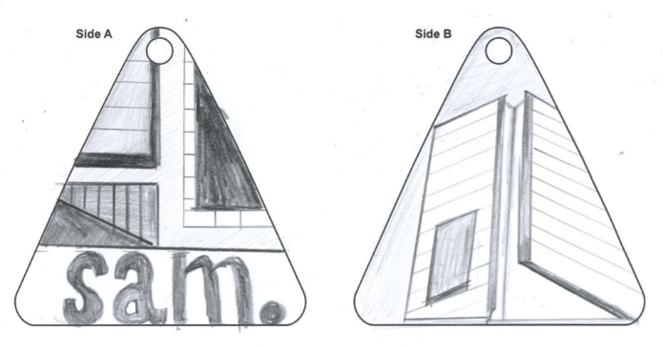
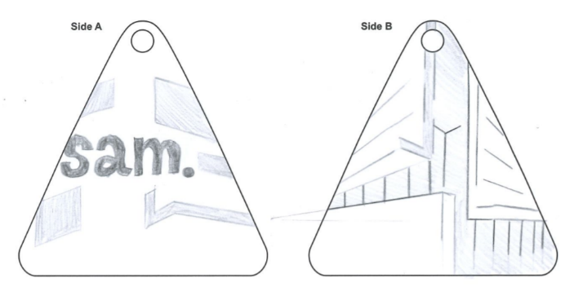

Question 5a.
Marks | 0 | 1 | 2 | 3 | Average
% | 41 | 33 | 12 | 13 | 1.0
Students were required to describe two methods used by Laura Blythman during the development of concepts stage. It was important for students to go beyond simply identifying the methods and provide an appropriate description of how the method may have been used. Using words such as ‘explore’ and ‘experiment’ were relevant to the development of concepts stage and often enhanced student responses.
Students discussed methods including painting, collage, drawing and photography. Students should be familiar with the specific list of methods outlined in the study design on page 9 in the cross-study specifications. Many students were unable to successfully identify methods, and common incorrect terminology that was used by students included ‘watercolour’, which is a medium, and ‘cutting and pasting’ or ‘colouring’, which are merely descriptions of what the designer may have done. It is important that students studied Figure 10 in reference to the question as ‘printing’ and ‘digital-based methods’ were discussed, referring to the printed image on the examination paper.
The following are examples of high-scoring responses.
Blythman would have explored manual collage during development of concepts to find an ideal layout of imagery and texture and profit from its playful aesthetic properties. Collage would have allowed her to include a large amount of imagery and plan leaf and flower position before creating a final one. She also would have experimented with painting, such as with watercolour as seen on some of the paper in figure 10. This allowed her to play with colour, tonal and textural contrast and harmony (like the large green-yellow-blue petal which follows an analogous colour scheme).
One method explored is collage. This can be seen through the different colours and styles of paper connected to form shapes. Another method used or explored may have been drawing. This would involve creating the flower and/or shape that the designer may have wanted to use in their refined design later on.

Question 5b.
Marks | 0 | 1 | 2 | Average
% | 36 | 33 | 32 | 1.0
This question required students to describe two decisions that the shoe designer made to complement the design of the chosen fabric. Common responses included a discussion of the design decision by the shoe designer to use a clean white rubber sole, as it contrasted with the pattern of the fabric and did not detract from it, or a discussion regarding the choice to use coloured edging around the border of the fabric using a dominant colour from the pattern to compliment the fabric. Other relevant decisions referenced the use of design elements and design principles in the design of the shoe including the rounded toe, strap and cut-out section.
Some students misinterpreted the question and discussed design decisions that were functional and not related to the design of the fabric. These included the decisions the shoe designer made for the shoes that were appropriate for children, for example, that the designer included a Velcro strap because children can’t tie their laces.
The following is an example of a high-scoring response.
The use of a rubber sole creates a white, solid space that contrasts to the intricate, vibrant surface design, creating visual appeal and further emphasising the illustrations. Black or pink Velcro bands/rims have taken colours from the surface imagery to combine durability of the fabric with visual consistency with the fabrics colour schemes.

Question 6a.
Marks | 0 | 1 | Average
% | 15 | 85 | 0.9
Most students correctly identified the design field of the modular seating in Figure 12 as industrial design. It is important that students study the stimulus imagery carefully as they needed to recognise that the modular seating was the focus, as explained in the question. Some students incorrectly identified environmental design, most likely due to the context of an airport in the image. Other incorrect responses were product design and communication design.

Question 6b.
Marks | 0 | 1 | 2 | 3 | Average
% | 29 | 46 | 18 | 7 | 1.1
Students were required to describe two needs that might have been identified in the brief that would have influenced the form of the modular seating. Many students were able to identify at least one relevant need and link it to the form of the seating. Responses that scored highly identified the needs clearly before explaining their possible influence on the form. Some students were not familiar with the definitions in the study design and confused a need with a constraint.
Students described needs including that the seating be modular, that it could seat many people, that it was comfortable and that it provided a level of privacy. Students were also able to identify and discuss the needs by analysing the seating. Some students identified ‘bright colours’ as a need, which was not relevant as it has no influence over the form of the seating.
The following is an example of a high-scoring response.
1. Needs the capacity to seat multiple people. Kontouris has opted to include a range of different forms, some including back rests to accommodate for flexible seating capacity. 2. Needs to have flexible configuration to fit many differently sized spaces. Kontouris has segmented the form of the seats so they tesselate with each other and can be combined without gaps in multiple different contexts.

Question 6c.
Marks | 0 | 1 | 2 | 3 | Average
% | 48 | 27 | 16 | 9 | 0.9
Students were required to discuss two ways in which the designer might have evaluated the seating during one stage of the design process. Students discussed surveys of the target audience, feedback from the client, a PMI or SWOT analysis, and the testing of prototypes as evaluative strategies that the designer may have used. A definition of design thinking techniques is provided in the study design on page 12. The question required students to discuss critical and reflective thinking techniques that are used in evaluation. Some students discussed creative thinking techniques, such as brainstorming and SCAMPER. These thinking techniques are generally used in the research, generation of ideas and development of concepts stages of the design process, rather than for evaluation.
Students are reminded to read the question carefully and respond with reference to the imagery provided both on the examination paper and in the resource book. In this question, many students identified the evaluation methods the designer may have used and did not relate their discussion to the images of the seating provided.
Students were required in their responses to identify the stage of the design process that evaluation was used by the designer. They must correctly identify the stages of the design process and the actions that are carried out by the designer at each stage. The stages of the design process are outlined on pages 10 and 11 of the study design in the cross-study specifications. Many students identified development of concepts and refinement as stages of the design process in which a designer would evaluate their designs. However, a number of students did not identify any stage of the design process, which prevented in-depth responses. Responses that did not score well were generic, used incorrect terminology and identified the ‘evaluation stage’ or the ‘critical thinking stage’ as a stage in the design process.
Responses that scored highly clearly referenced the seating in discussing an evaluation technique.
The following is an example of a high-scoring response.
During development of concepts, the designer could have used a reflective thinking strategy like SWOT to evaluate the seats usefulness, threats and opportunities in society and the relevant context. An audience poll could have been done to gain an insight into what materials or colours are favoured by others, before moving to refinement.

Question 7a.
Marks | 0 | 1 | 2 | 3 | 4 | 5 | 6 | 7 | 8 | Average
% | 19 | 17 | 19 | 19 | 15 | 8 | 2 | 0.5 | 0.5 | 2.3
In this question students were required to draw a third-angle orthogonal drawing from an isometric drawing of a button with two holes. Overall, students were able to draw the three views of a third-angle orthogonal drawing that were correctly placed and aligned, depicting a circle for the top view and thin rectangles for the front and side views. However, students were required to accurately apply the technical conventions of an orthogonal drawing, such as the equidistant alignment of the views, hidden lines, centre lines and the overall scale of the button. Many students incorrectly drew the overall circle in the top view as 50 mm in diameter instead of 40 mm. The two small circular cut-outs in the top view were often incorrectly measured as 10 mm in diameter instead of 8 mm. It is important for students to measure isometric drawings on the 30° lines, not simply left to right across the major axis. They could have also measured the ellipses of the button and the cut-outs in Figure 13 by using an ellipse template.
Students were able to draw the third-angle orthogonal symbol and label the views in the drawing accurately using the correct method outlined in the Technical Drawing Specifications included in the Examination Specifications for Visual Communication Design. However, in some responses, labels were often written in lower case or on the top or side of the drawing, not centred underneath as specified in the Technical Drawing Specifications. In some responses, the third-angle orthogonal symbol was drawn back to front or drawn with missing lines. Students must understand the conventions of technical drawing and the methods of converting two-dimensional representation to three-dimensional representation and the reverse, as specified in the Key Knowledge and Skills for Unit 3 Area of Study 1 in the study design. They should be able to apply these conventions to examination questions as well as school coursework and the school-assessed task. Dimensioning of the drawing was not required in the response to Question 7a.
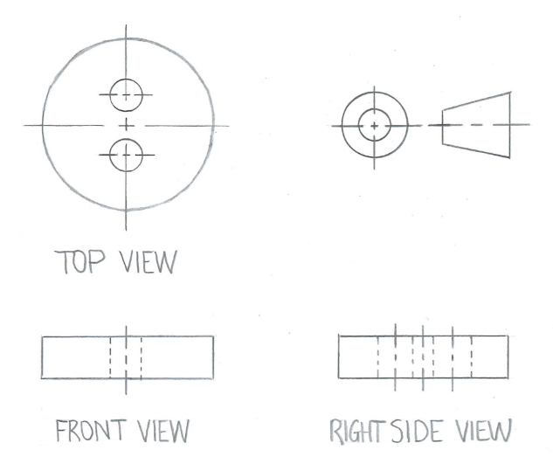
The following is an example of a high-scoring response (this may not appear to scale).

Question 7b.
Marks | 0 | 1 | 2 | 3 | 4 | 5 | 6 | 7 | Average
% | 22 | 12 | 12 | 14 | 16 | 15 | 7 | 1 | 2.7
Students were required to draw a packaging net of the isometric representation of a container for hot food. As in Question 7a., students were required to apply the technical conventions outlined in the Technical Drawing Specifications, including maintaining a scale of 1:1, using correct line conventions to represent cut lines, fold lines and tabs. Most students had a sound understanding of how the container would unfold to become a packaging net, with many including a small base, two trapeziums and two rectangles. Students are also encouraged to study the information on page 10 of the Technical Drawing Specifications to understand the conventions for packaging nets.
Although most students were able to draw the 20 mm x 20 mm square base, they often incorrectly measured the height of the trapezium shape at 35 mm instead of 40 mm. Instead of measuring the vertical distance from the baseline to the top, they measured the length of the front angled line in the isometric drawing. This often impacted on the measurement of the two rectangular shapes by making them too short. Some students incorrectly drew parallelograms with angled sides instead of rectangles. As in Question 7a., students must understand the conventions of technical drawing and the methods of converting two-dimensional representation to three-dimensional representation and the reverse, as specified in the Key Knowledge and Skills for Unit 3 Area of Study 1 in the study design. They should be able to apply these conventions to examination questions as well as school assessed coursework and the school-assessed task.
Some students drew the fold and cut lines well, ensuring that each piece connected to another piece or a tab and had dashed lines to indicate where it would be folded. Some students neglected fold lines altogether, completing their entire net in solid lines. Some students had tabs in the correct position, but they were too thin compared to the 10-mm-width demonstrated in the isometric drawing. Students are encouraged to study the information on page 16 of the Technical Drawing Specifications to understand line styles and conventions.
The following are examples of high-scoring responses (these may not appear to scale; they have been rotated to fit the page):
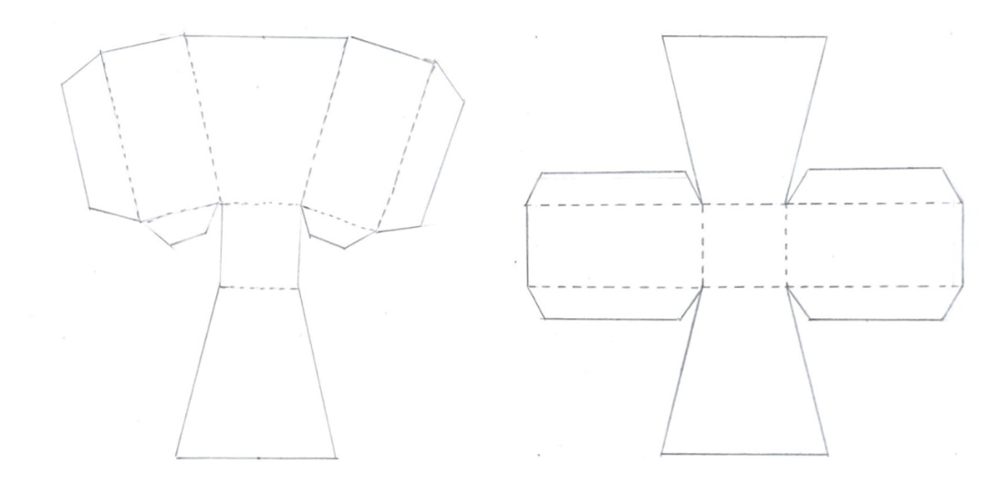

Question 8
Marks | 0 | 1 | 2 | 3 | 4 | 5 | 6 | 7 | 8 | 9 | Average
% | 4 | 3 | 7 | 15 | 20 | 20 | 16 | 10 | 4 | 1 | 4.5
Students were required to render a drawing of painting equipment in a canvas holder using tone and colour to represent surface textures of the equipment and holder, as well as demonstrating shadows created by the light source. Responses that scored highly rendered the surface textures of the various materials, completed rendering the drawing in full, and applied tone and texture to the drawing in relation to the light source, including cast shadows.
Students demonstrated skill in rendering canvas, wood, metal and the paintbrush bristles. However, many students neglected to render the back flap of the canvas holder and incorrectly rendered the metal sections with wood texture.
Most students who included cast shadows correctly placed them slightly to the left of the palette knife and brush, and subtly underneath the strings of the holder. Shadows that were rendered on the back flap of the holder and shadows that indicated that the holder was standing on solid ground were also acceptable.
Students were required to use tone in response to the light source. Students must attempt to demonstrate the placement of highlights and shadows in their rendering using tone. Responses that scored highly used darker tones in the crevasses of the rounded pockets of the holder to create forms in the brush and palette knife.
Responses that did not score well coloured in the shapes of the holder and painting equipment without considering where highlights and shadows are placed to create three-dimensional form.
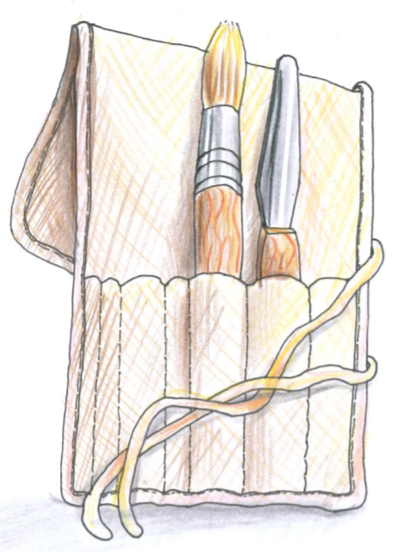
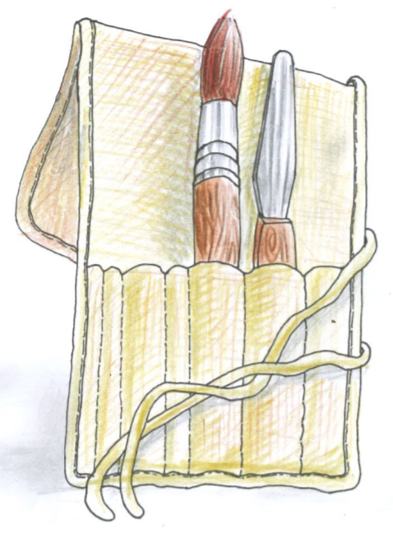
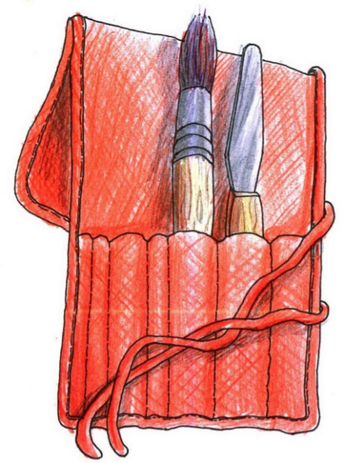
The following are examples of high-scoring responses.

Question 9a.
Marks | 0 | 1 | 2 | Average
% | 38 | 26 | 36 | 1.0
Students were required to identify one factor that might have influenced the design of the postage packs and carrier and describe how it might have influenced the design of them. Most students were able to identify an environmental, social, cultural, legal, financial or ethical factor that would influence the design but could not describe how these factors influenced the design of the packs. Responses that scored highly included descriptions of the impact of the relevant factor on the material of the packaging, how it could be re-used as a bag, the ink that may have been used for the type, and that the colour black was chosen by the designer as it assists with biodegradation. Students should understand the factors that influence design decisions as outlined in Unit 3 Area of Study 2 in the study design.
The following are examples of high-scoring responses.
The high amounts of single-use plastics polluting landfill and the earth is of major environmental concern as they degrade very slowly and harm wildlife. Thus, the reusability and biodegradability of these packaging bags reduce the amount in landfill and speed up degradation, addressing this factor. The use of typical recycling shapes on the logo help communicate this to users.
An environmental factor is that these packs should be reusable and biodegradable. This has influenced the design’s material, as a bioplastic with the same durable, flexible and watertight capabilities has been specifically selected to fulfil this need.

Question 9b.
Marks | 0 | 1 | 2 | Average
% | 43 | 43 | 14 | 0.7
Question 9b. required students to explain why the logo used by the company that produced the postage packs is a registered design. In Unit 3 Area of Study 2 and Area of Study 3, students are required to understand the practices used by designers to acknowledge ethical and legal obligations in their work. They need to apply their knowledge across a range of contexts and questions. For this question, students needed to recognise that this logo was a symbol that could be used by any company in their designs, as long as they met the standards and criteria set by ‘Home Compostable’, which is the logo for Home Composting set by the Australian Standards Association.
Responses that scored highly explained that the reason for registering the logo was to ensure that other companies would need to ask permission to use the logo on their products, and meet the standards to maintain the logo’s integrity. Responses that did not score well included pre-prepared responses referring to trademark use, which were not applied to the use of the logo in the question.
The following is an example of a high-scoring responses.
It is a registered design as it is connected to a company that uses the logo as its own design and this logo is used on other companies’ packaging, which the other company would need to receive permission to use this logo and therefore must comply with the standard.

Question 10a.
Marks | 0 | 1 | 2 | Average
% | 36 | 40 | 24 | 0.9
Students were required to describe the design decisions the designer made to relate the surface design of the container to the product and where it was made. Responses that scored highly described how design decisions related to the images in Figure 18 and to the dairy region where it was made. They described more than one decision, including the use of the cow print that forms the background, the green gradient at the base of the packaging and the icons of the farm animals.
Some students only focused on the surface design of the container and did not link the decisions made by the designer to the dairy region where the ice cream was made. Instead, they linked the designer’s use of cow print to the fact that milk, the main ingredient in ice cream, comes from cows. Some students who wrote that the designer had included the words ‘Waratah Bay’ in the surface graphics, because that was where the product came from, did not understand the role of the designer in the design of the surface graphics. The company name ‘Waratah Bay Ice Cream Co’ would have been provided by the copywriter and would have been included as a constraint in the brief.
The following is an example of a high-scoring response.
The designer’s decision to use a cow patch pattern as well as the greenery on the bottom of the package connects the product to the fields where the cows who produced the milk for this product live. By having the green gradient up, it replicates the rural landscape during a misty morning where the cows may be grazing.

Question 10b.
Marks | 0 | 1 | 2 | Average
% | 24 | 42 | 34 | 1.1
In this question many students were able to discuss two techniques the designer used to gain attention. In their discussion they were required to describe how the techniques gained the attention of the viewer. Responses included a description of humour in the mathematics equation, which used bold cartoon icons of the chicken plus the cow equalling ice cream. Other techniques described referred to the use of design elements and principles, such as the use of the cow print to create figure-ground, and the large, all caps, contrasting type used to highlight the name of the company.
Students must be clear in their understanding of the role of and decisions made by the designer, specialists and clients in the design and production of visual communications. As in Question 10a., some students made incorrect links to aspects of the design the designer was not responsible for. In this instance, the name of the ice cream flavour, ‘Lumpy & Bumpy’, would have been created by the marketing team and was not a decision made by the designer. In the example in Figure 18, the designer is responsible for the characteristics and functions of typography conventions and the decisions surrounding its use in the design, not necessarily what it says.
The following are examples of high-scoring responses.
1. Bold contrast with the inclusion of black and white both in the cowprint and the type, in order to use both familiarity, comedy and visual weight to attract attention. 2. Use of visual language through symbols in the equation ‘chicken + cow = ice cream’ to use humour and nonverbal language to attract attention.
The fun cow patch pattern all over the package stands out and engages with the audience as it conveys what animal was used to create this product. They then find the imagery to create an equation for producing ice cream which adds humour to the design, further maintaining audience attentions.

Question 11a.
Marks | 0 | 1 | 2 | 3 | Average
% | 8 | 17 | 42 | 33 | 2.0
Question 11a. was the first part of four that required students to respond to a brief for the fabric design for a children’s bed set based on Australian wildlife. It is important that teachers and students read the report for Question 11 to understand the scaffolding of the task and the relationship to the stages in the design process.
All four parts had overall criteria for the design, including the use of a motif (shape) based on one of the wildlife images on page 13 of the resource book, the emphasis of shape, the use of a coloured background and the effective application of the design principle of contrast using colour in the design.
Students were required to generate a range of visualisation drawings using the imagery of wildlife provided in the resource book. Students generally understood that a ‘range’ required three or more drawings – either three different drawings of the one animal, or three or more different animals. There were some thoughtful and well-executed visualisation drawings of wildlife that effectively referred to the imagery in the resource book.
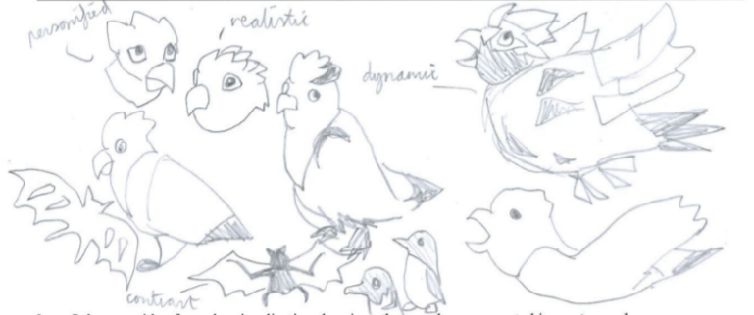
The following are examples of high-scoring responses.
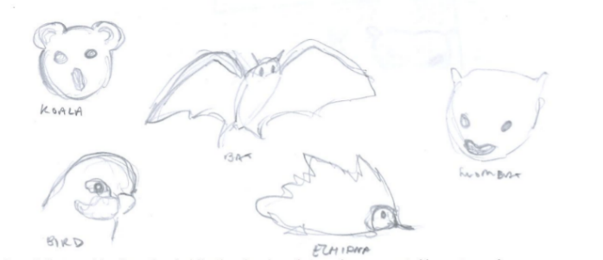

Question 11b.
Marks | 0 | 1 | 2 | 3 | Average
% | 16 | 46 | 30 | 8 | 1.3
In Question 11b., students were to select one idea from their visualisation drawings generated in Question 11a. and develop a motif for the fabric design. The motif had to be based on one of the wildlife images on page 13 of the resource book. The key word ‘develop’ in the question required students to explore and push their ideas further from the visualisation drawings produced for Question 11a. This is the stage where students would be expected to begin testing different colour combinations, emphasising shape and trialling different ideas. However, many students completing a single drawing or sketch that only slightly modified an idea from the previous stage.
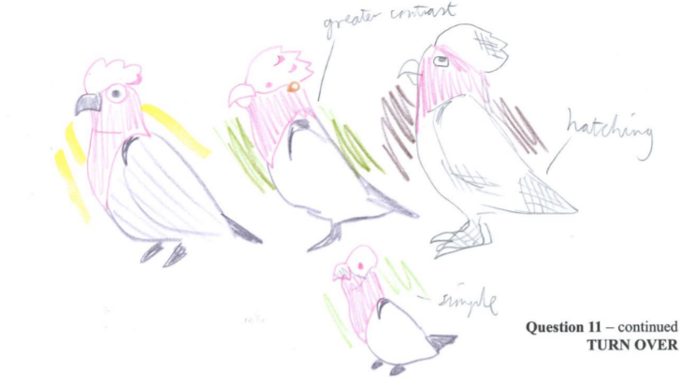
The following are examples of high-scoring responses.

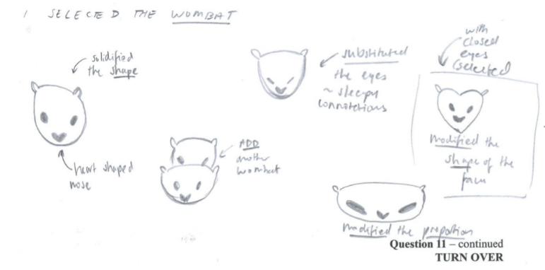

Question 11c.
Marks | 0 | 1 | 2 | 3 | 4 | 5 | 6 | 7 | 8 | Average
% | 12 | 2 | 4 | 10 | 13 | 22 | 18 | 14 | 6 | 4.5
In Question 11c., students were to use the motif from Question 11b. multiple times to create the fabric for the doona cover. Responses that scored highly followed the criteria carefully: they emphasised shape, used a colour background, contrasted the colour in their motif with the background and repeated the motif several times within the rectangular boundary. The quality of the design was also assessed, including the use of skill in drawing and how well the student met the requirements of the brief. Responses that scored highly considered the overall aesthetic qualities of the design and repeated their motif in an interesting way using design elements such as shape, colour and line, and design principles such as pattern (repetition and alternation), figure-ground, contrast and proportion.
Responses that did not score well used white/black/grey for their motif, which did not create contrast using colour; did not emphasise shape within the motif; or simply drew the motif only once.
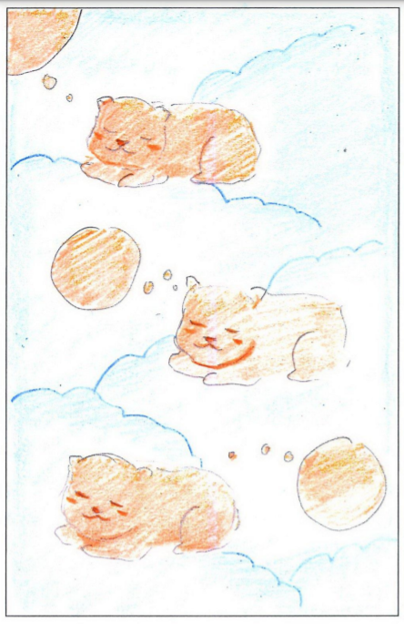
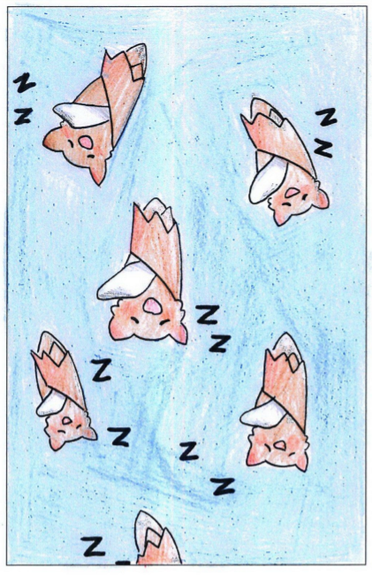
The following are examples of high-scoring responses.

Question 11d.
Marks | 0 | 1 | 2 | 3 | 4 | 5 | 6 | 7 | Average
% | 21 | 6 | 9 | 17 | 16 | 14 | 11 | 7 | 3.2
In Question 11d., students were required to create a fabric design for a pillowcase to complement their design of the doona cover. The fabric design in Question 11c. was used as a basis for the pillowcase design and it was to be completed as a presentation drawing. As in Question 11c., responses that scored highly followed the criteria for the question carefully. They had features such as colour and style that enabled the pillowcase to complement the design for the doona cover, they used the motif from the doona cover design but applied a different scale, and adapted the colours of the doona cover design. The responses that adapted the colours well either inverted them, or used complementary or analogous colours that presented the doona cover and pillowcase as a set. Their annotations identified and explained two or more design changes.
Responses that did not score well did not apply all of the criteria required in the question and only responded to part of the brief. They did not explain the two changes to their designs in their annotations. Instead, they only described the changes they made, such as the increase or decrease in scale of the motif, or how they adapted the colours of the motif in the pillowcase design.
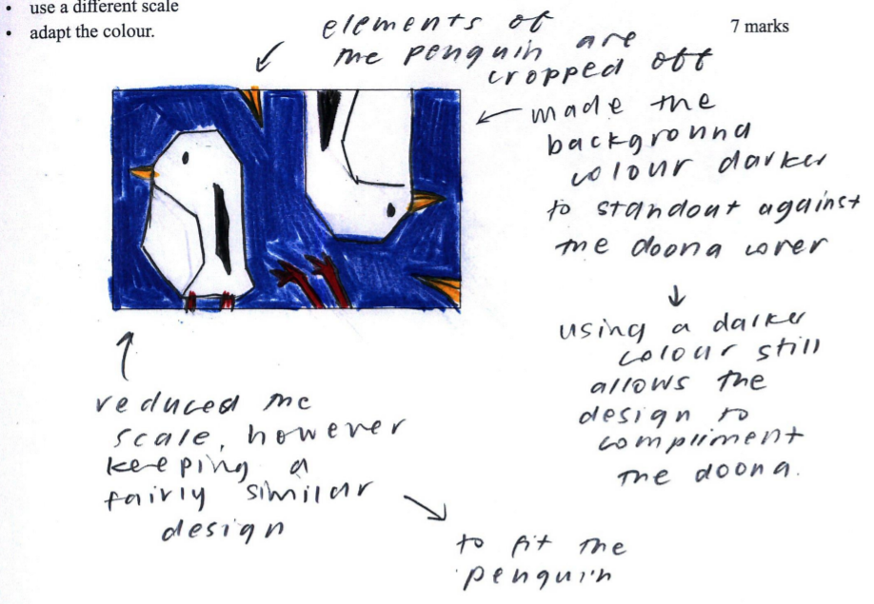
The following are examples of high-scoring responses.

