2022 VCE Visual Communication Design external assessment report

General comments
In 2022 the Victorian Curriculum and Assessment Authority produced an examination based on the VCE Visual Communication Design Study Design 2018–2022, and the examination assessed a range of key knowledge and key skills across Units 3 and 4. Questions required students to respond using both written and practical skills.
Students attempted all of the questions on the examination, responding critically on analytical components and creatively on the practical-based questions. There were some excellent responses to each of the questions on the paper, which are featured throughout this report. These responses are examples of the various ways in which students can approach the questions and achieve high marks. It was pleasing to see students attempt questions even when they may not have been entirely sure on the correct response, as many students were still able to gain some marks by justifying their response through their writing or through demonstrating competency in their practical skills.
However, there were some simple errors made that suggested either a misreading or misinterpretation of the question. Paying careful attention to the subject-specific terminology used in the question, as well as having a sound understanding of what each term means, is crucial for students to achieve higher marks. There appeared to be misinterpretations of words such as: context, factors, specialists, elements, principles, purpose and distinguishing characteristics. These terms are featured across the study design and are an important component of the examinable material. Additionally, it is worth noting that when a question asks for a specific number of answers (i.e. ‘one material’ or ‘two constraints’) students must reflect this in their response, as adding more than what is required often leads to confusing answers.
While many students appeared to work efficiently to complete the paper, there were some students who found the length challenging and potentially mismanaged their time. Students studying for future Visual Communication Design examinations are advised to practise a range of questions by trialling which style of questions are generally achievable in less time, and which might take longer, to ensure they balance the allocation of time across the entire exam.
Finally, teachers are encouraged to assist students in the process of deconstructing past exam questions, to ensure students are aware of the complexities and nuances within them. It was unfortunate that students often constructed thoughtful responses, both in writing and practically, but only referenced one aspect of the question. Addressing the question in full is a skill in itself and should form part of the students’ revision.

Specific information
This report provides sample answers or an indication of what answers may have included. Unless otherwise stated, these are not intended to be exemplary or complete responses.
The statistics in this report may be subject to rounding, resulting in a total of more or less than 100 per cent.

Question 1a.
Marks | 0 | 1 | Average
% | 44 | 56 | 0.6
Many students were able to correctly select depict for the purpose of the world map in Figure 1. Some students incorrectly selected guide, potentially misconceiving that any type of map must be used to guide an audience. Inform was also a common incorrect response given.

Question 1b.
Marks | 0 | 1 | Average
% | 65 | 36 | 0.4
Refinement was the correct answer, as the folio page in Figure 2 demonstrates only minor changes to the logotype, which is synonymous with this stage of the design process. Many students incorrectly selected development of concepts; however, this stage would usually embrace more significant changes and alterations to the concept.

Question 1c.
Marks | 0 | 1 | Average
% | 34 | 66 | 0.7
Most students were able to identify option 2 as the correct ‘G’ created using a vector-based medium. Some students incorrectly selected option 4 as it appears digital; however, given there is evidence of pixels, it was likely created using raster-based medium.

Question 1d.
Marks | 0 | 1 | Average
% | 21 | 79 | 0.8
There were a range of responses to this question; many correctly selected option 2. A common error was option 3, as some students were confused as to where the front view was.

Question 2a.
Marks | 0 | 1 | 2 | 3 | Average
% | 17 | 28 | 36 | 19 | 1.6
Students were expected to describe the purpose of the CNE sign and explain how the context of the sign addresses this purpose. Higher-scoring responses often began by describing what the intended purpose of the sign was (i.e. to ‘identify’ Carnegie Station or to ‘inform’ passers-by of Carnegie Station’s location), before explaining how the context assists with addressing that purpose.
Students mostly opted for the correct purposes being ‘to identify’ or ‘to inform’; however there were a few students who discussed ‘advertise’ or ‘promote’, which were incorrect in this instance. Some students appeared to misinterpret the term ‘context’, instead listing features of the sign such as ‘the large capital letters’ or that the sign ‘lights up at night’ when, in fact, the context is referring to the surrounding environment in which the sign is placed (i.e. outside the Carnegie railway station, under the overpass.) It is important that students understand that context is referring to where they might find a design, as opposed to what it is or its features.
The following is an example of a high-scoring response.
The purpose of the CNE sign is to identify the newly developed Carnegie railway station the large sign with “CNE” in capital letters. Possibly representing an abbreviation of “Carnegie” is placed right in front of the Carnegie station on a wide brick footpath, where a lot of pedestrians, possibly train commuters walk past, to clearly identify to the audience that this is Carnegie station.

Question 2b.
Marks | 0 | 1 | 2 | 3 | 4 | Average
% | 8 | 13 | 31 | 29 | 19 | 2.4
In part b., students were required to identify one material and explain how two constraints in the brief may have impacted on this choice of material. Most students were able to successfully identify a material used for the sign in Figure 5. Common responses were ‘metal’, ‘hard plastic’ and ‘steel’. A few students incorrectly identified ‘lights’ or ‘white paint’ as a material.
In terms of the constraints, many students discussed constraints such as the sign needing to be durable, weatherproof and protective of the electrical features on the inside of the sign. Many students were able to do this well, by clearly articulating the possible constraint, and then linking this to the choice of material selected. However, some students found this challenging and merely discussed the qualities or characteristics of the material (e.g. ‘metal is strong and durable’ or ‘plastic is shiny and sleek’), and not a possible constraint (e.g. ‘the client required a strong and durable material to withstand inclement weather’) before explaining how this constraint resulted in the choice of material.
The following is an example of a high-scoring response:
Material: Metal
Explanation: Constraint 1: the railway stations sign needs to be [stand] a range of weather conditions. This influenced the designer to use strong, thick metal for the construction of the stand as it is heavy and can stand the rain and dust and sunshine in the outdoor area.
Constraint 2: the sign needs to install inner lighting. Metal has a malleable feature which allows the designer to punch small holes on the surface to form mesh, therefore allowing the red light located inside the sign to shine through at night.

Question 3a.
Marks | 0 | 1 | 2 | 3 | Average
% | 19 | 31 | 35 | 15 | 1.5
Students were asked to discuss one design decision that was made, with reference to both the form and function of the Rollie. Most students made a genuine attempt to respond to this question, with many able to discuss a design decision made, and making reference to the form and function of the Rollie. Many decisions related to the materials used, the cylindrical opening, the curved edges and the two round compost bins on either side. Some students were then able to successfully link that decision to the function and form of the Rollie.
Unfortunately, a number of students wrote responses that discussed function and form independently to the decision identified. It is important for students to recognise the key components of a question and ensure that they are covering all aspects of it, addressing it in full as opposed to focusing on one aspect of the question only. Students who discussed the ‘cylindrical form’ as opposed to the ‘circular shape’ often had more comprehensive responses, as they were able to distinguish form from shape effectively. Furthermore, students who were able to discuss how the Rollie actually functions, as opposed to simply mentioning that it aerates compost, also often received higher marks for a more comprehensive response.
The following is an example of a high-scoring response.
A function of the design is for the inner section to spin allowing for exercise. A design decision would have been to create the rounded form. The inner section of the design is circular, which allows for a child to easily spin and roll it. The squared off flat form creating the base allows for the entire design to be [stationary] while the inner circle spins.

Question 3b.
Marks | 0 | 1 | 2 | 3 | 4 | Average
% | 49 | 18 | 13 | 9 | 11 | 1.2
Students were required to identify two factors and discuss how the designer might have responded to each of them in different ways. It is important that students ensure they only use factors that are mentioned in the study design such as environmental, social, ethical, legal, cultural and financial factors. Some students incorrectly used similar terms such as ‘safety’ or ‘cost’, instead of categorising them into the correct factor as listed in the study design.
In terms of the discussion based on the selected factors, higher-scoring responses used clear references from Figure 6 to discuss the possible ways in which the designer had responded to the identified factors. Many students had discussions that implied the factor, but it is important to note that students were required to discuss how the designer may have responded to these, as opposed to just stating that the design needed to be ‘sustainable’ or be ‘safe for children’, for example. Many students identified ‘social factors’ but did not follow up with a discussion on how the wheel engaged groups of children in exercise and play.
The following is an example of a high-scoring response:
Factor 1: Environmental: The use of the material wood leaves a low environmental impact as it is bio-degradable, justifying why it was chosen.
Factor 2: Ethical: To avoid unethical impacts of the wheel in terms of harming children, the designer would have made prototypes that were tested to ensure safety and stability.

Question 4
Marks | 0 | 1 | 2 | 3 | 4 | 5 | 6 | 7 | 8 | Average
% | 2 | 4 | 8 | 16 | 23 | 22 | 17 | 6 | 2 | 4.3
For this design-based question, students were required to create two designs based on the imagery of the knife and spoon shapes in Figure 7, emphasising the design principles of ‘balance – symmetry’ and ‘pattern – alternation’. The designs were required to use only white and two colours, and the shapes were able to be cropped, reversed, repeated and scaled. Most students attempted this question and were able to gain some marks for their designs, as they met some or all aspects of the criteria in the question.
Many students used only white and two colours across the two designs, however, it was not uncommon for students to use black or grey outlines or multiple colours in their designs, which was deemed incorrect. Pattern – alternation was interpreted well with some creative designs demonstrated, whereby the knives and spoons were alternating colours, changed orientation or were reflected and/or rotated. There were a number of responses that used pattern repetition where a pattern was simply repeated rather than alternated. There was some confusion over representing balance – symmetry, as it was not uncommon for students to misinterpret how a ‘line of symmetry’ (either vertically or horizontally) works – it must be the same design on both sides.
While many students manipulated the knife and spoon shapes using cropping, reversing, repeating and changing the scale (as per the question), they needed to be aware that changing the scale meant that the proportions of the knife and spoons needed to be maintained and recognisable. There were many instances where students had not maintained these proportions (within a reasonable level) and their spoons and knives became unrecognisable. Students were awarded marks for the quality of their designs. It is important that students use both the template and the allocated time, as effectively as possible.
Below are two examples of high-scoring responses.

Example 1
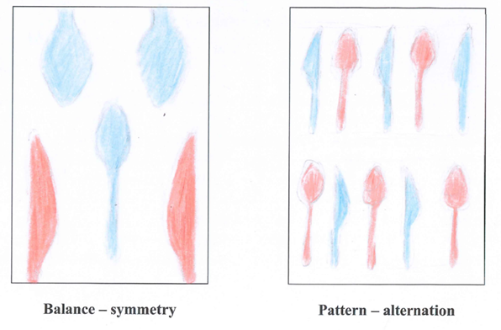
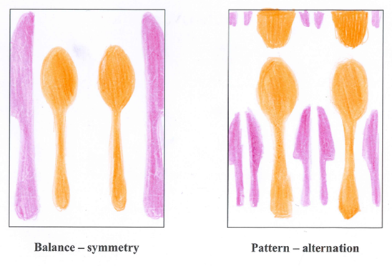
Example 2

Question 5
Marks | 0 | 1 | 2 | 3 | 4 | 5 | 6 | 7 | 8 | 9 | 10 | Average
% | 26 | 17 | 14 | 11 | 8 | 7 | 6 | 4 | 3 | 2 | 1 | 2.7
This question required students to convert the orthogonal drawing in Figure 8 into an isometric drawing from point A. Many students made a reasonable attempt to construct the overall structure of the breeding box, often using a ‘crating’ technique (the process of using guidelines to create a proportioned box to house the object) to ensure the correct overall proportions. Many students attempted to draw the ellipse on the side of the box; however it was often on the incorrect angle or was not positioned correctly. Additionally, it appeared that most students had trouble correctly demonstrating the depth of the ellipse, with many students either not showing it at all or it being too thin. The other difficulty students appeared to have was getting the angle of the roof accurate, as many were too steep. Again, this is where the crating technique would have assisted students with the pitch of the roof.
While most students who attempted this question appeared to understand the isometric conventions, there was a small number of students who incorrectly drew the breeding box using other three-dimensional drawing methods, such as planometric, one- and two-point perspective and oblique. The other interesting observation worth noting was that some students misinterpreted the arrow direction and drew the isometric from underneath the breeding box, looking up at it.
Below are two examples of high-scoring responses.
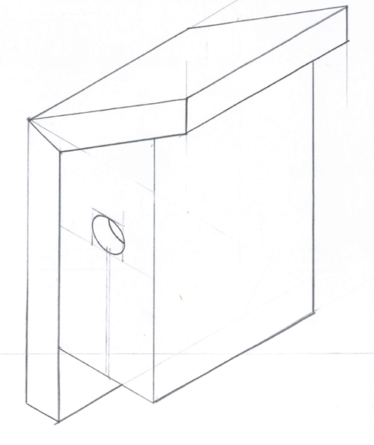
Example 1

Example 2
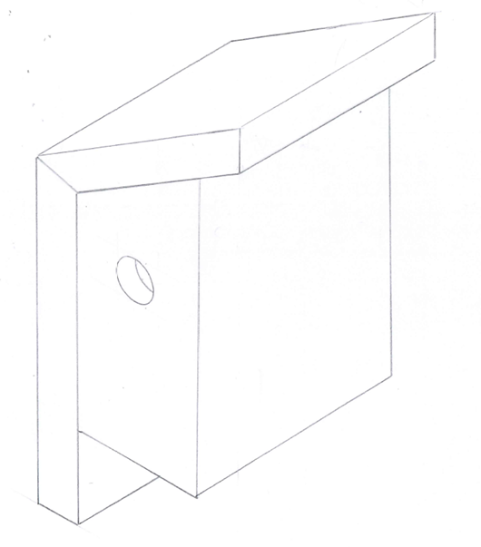

Question 6
Marks | 0 | 1 | 2 | 3 | 4 | Average
% | 4 | 5 | 31 | 46 | 14 | 2.6
Students were required to identify two design elements from Figure 9 and explain how they communicate the characteristics of the Great Alpine Road environment. Overall, this question was generally handled well, with students commonly choosing design elements such as colour, line, type and shape to discuss. There was some effective discussion around how the selected elements reflected the characteristics of the Great Alpine Road environment, such as the colours representing the mountains and sky, the shapes resembling peaks of the mountains and line conveying the windy roads. Higher-scoring responses also made use of descriptive language, such as ‘thick, curvy, white lines’ or ‘bold, upper case, sans serif type’ as opposed to just ‘line’ or ‘type’ on its own. Generally, colour and line were explained well, but often shape was poorly discussed as students incorrectly referred to the ‘A’ as shape instead of type. Some students began their responses by discussing type as their selected element, for instance, but then moved into more of a discussion around line. Therefore, it is important that students are discussing elements in a more consistent manner, as opposed to blending responses, which may render them confusing.
The following is an example of a high-scoring response:
Type has been used to create the blocky letter A. The triangular sans serif type face mimics that of a mountain of alpine area, communicating the characteristics of the environment. Colour has been used with a deep forest green in the bottom half and a dark sky blue in the top. This mimics the land and the sky and the green colour could represent trees found in the alpine environment.

Question 7
Marks | 0 | 1 | 2 | 3 | 4 | Average
% | 13 | 25 | 37 | 19 | 6 | 1.8
Students were required to identify two design principles and explain how the designer used them together to attract visitors to Australia. Most students were able to identify two design principles used in Figure 10, with common selections including contrast, pattern (repetition), balance (asymmetrical), hierarchy and figure-ground. Students were able to describe how the designer used them in the poster; however, figure-ground continues to create problems for some students where the identification of each component and their impact on the design often lacks a clear distinction between the two. Additionally, many students described the balance to be symmetrical, which was incorrect in this instance.
Higher-scoring responses explained the use of the design principles together. However a common occurrence was that students explained them separately. Students must explain how their selected design principles have been used together (e.g. ‘the contrast of white organic lines on the blue of the sea help to create a clear repetitive pattern…’). Additionally, they need to be able to directly link how the use of a principle may attract tourists to Australia specifically, as opposed to just using common phrases such as ‘…to create an eye-catching design’ or ‘…to appeal to the audience’, as these are vague statements that did not fully address the question. Students also need to go beyond phrases such as ‘contrast and hierarchy are used together to attract tourists to Australia’, as this is just repeating the question and not actually explaining how this works.
The following are two examples of high-scoring responses:
Example 1
The designer has used contrast to split the colours of the background diagonally. Helping contrast, figure-ground has emphasised it more when the swimmers jump from the yellow to the blue water. The figures with the tan skin, similar to orange, is able to contrast extremely well with the blue water. The bright use of contrast easily catches the attention of the audience, and the strong figure-ground of the swimmers [red] type helps maintain the audience’s engagement which ultimately attracts them to visit the lovely beaches of Australia.
Example 2
The designer has created contrast to elevate the pattern. The vibrant tangerine [changes] contrast against its complementary ocean blue, creating a visually energetic and bold look. The repetition of the three figures creates a pattern, as the orange bodies ‘submerge’ into the blue water. The pattern of the white lines on the deep blue adds even more contrast, [showcasing] Australian beaches and the beautiful waves on the shore.

Question 8
Marks | 0 | 1 | 2 | 3 | 4 | 5 | 6 | 7 | Average
% | 4 | 4 | 11 | 20 | 26 | 22 | 10 | 3 | 3.8
Students were asked to design a logo for a local skate park in the template provided, using only the three shapes in Figure 11. Responses needed to utilise figure-ground, emphasise shape, use each shape only once, touch all sides of the template and use approximately 50% black and 50% white.
Most students made a solid attempt at this question, emphasising the element of shape quite well by filling in their shapes with solid fill (black or white), or at least enclosing their lines to create a shape. Also, most students planned their designs according to the 50% black and 50% white rule. It should be noted that it was acceptable for students to use a grey lead pencil, fineliner or black biro to represent the ‘black’ within their design.
However, some students did not consider all of the dot points in the question, as many designs did not address the criteria around the use of figure-ground, the use of each shape only once or include shapes that touched all sides of the design.
In terms of the use of figure-ground, it is important that students understand that they need to deliberately treat the ground in some way. It could be by filling the ground black and having white figures (shapes), or even overlapping shapes and being creative with positive and negative space.
Some students had repeated shapes or included shapes or type that were not referenced in the question. However, it was pleasing to see many students increased the scale and cropped the shapes to create more dynamic logo designs. Similar to Question 4, students needed to be cautious when scaling the shapes to keep them in proportion and recognisable, as a wheel should be circular and not oval-shaped, for example. Students were again awarded marks for the quality of their design in terms of the effective use of the template provided and appropriateness for a logo for a skate park.
Below are four examples of high-scoring responses.
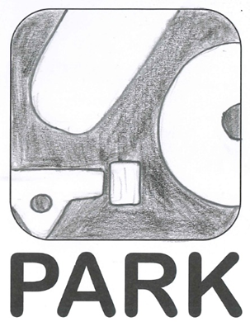
Example 1

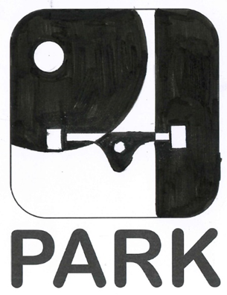
Example 2
Example 3
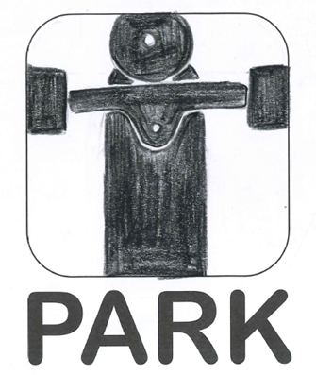
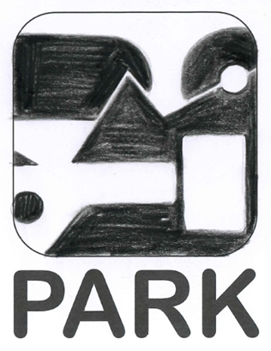
Exqample 4

Question 9
Marks | 0 | 1 | 2 | 3 | 4 | 5 | 6 | 7 | 8 | 9 | Average
% | 2 | 2 | 8 | 18 | 21 | 21 | 14 | 9 | 4 | 1 | 4.5
This question required students to render a metal pencil sharpener using greyscale. Most students attempted this question and were able to apply basic tonal shading, with the top right of the sharpener being lighter and the back (or left-hand side) being darker. High-scoring responses were able to convey a reflective metal texture in response to the light source indicated by the arrow. They were also able to accurately identify where the cast shadows should be placed, and rendered using effective shading techniques employing a range of 2B–6B graphite pencils.
However, many students did not accurately depict a metallic surface (no texture, just tone) and were unable to correctly place cast shadows on the sharpener itself (back left of screw) or onto the ground (also back and left). Students who did account for shadows, either on the sharpener or on the ground, often had them going in a slightly different direction.
Unfortunately, there was little consideration for the ridges on the left-hand side, often shaded straight over, and some students found shading the elliptical hole at the front right difficult to interpret. Considering students should be quite familiar with this object and material, it was a poorly answered question, which will require further practice.
Following are three examples of high-scoring responses:
Example 1
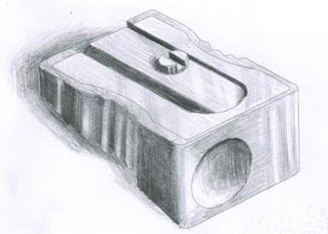
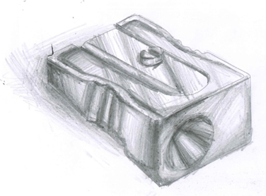
Example 2

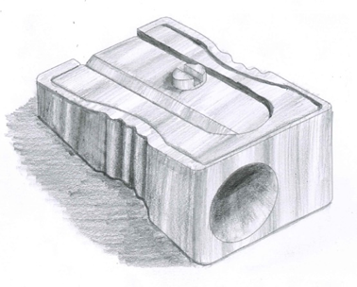
Example 3

Question 10a.
Marks | 0 | 1 | 2 | Average
% | 63 | 27 | 10 | 0.5
This question required students to describe two distinguishing characteristics of the environmental field of design, as well as to make reference to the images of the Royal Botanic Gardens Cranbourne featured in Figure 13. Students who responded strongly to this question were able to talk in general terms about characteristics that are pertinent to environmental design, such as: designs that are built for humans to inhabit, usually ‘one-off’ larger scale projects, site specific, respond to their surrounding environment, etc. They were then able to link these characteristics back to the reference imagery in Figure 13.
However, many students unfortunately appeared to misinterpret this question and instead described two characteristics of the gardens, referring to various features such as the circular-shaped bridge or the materials used. Even the students who mentioned correct characteristics of environmental design in general did not always link them back to the gardens in the figure.
Students are encouraged to familiarize themselves with the key knowledge and skills in the study design to ensure they are familiar with the distinguishing characteristics of each of the three design fields: Communication, Industrial and Environmental. The characteristics of the three design fields are listed on p. 12 of the VCE Visual Communication Design Study Design.
The following is an example of a high-scoring response:
- Interacts within the given environment: seen by the way in which the installation interacts with the water
- Is made specifically for a particular landscape: the installation would not be perfectly applicable to any other environment, was built for Royal Botanical Gardens Cranbourne in particular.

Question 10b.
Marks | 0 | 1 | 2 | 3 | Average
% | 31 | 35 | 24 | 10 | 1.2
This question required the students to explain how the landscape designer of the gardens might have collaborated with two other specialists to make this space accessible to the general public. High-scoring responses to this question included reference to specialists such as civil engineer, carpenter, botanist, metal worker or council member, as opposed to using general terms such as ‘tradesperson’ or ‘materials expert’. Other incorrect specialists were those that overlapped too closely with the landscape designer themselves, such as an ‘architect’ or an ‘environmental designer’, as the landscape designer is in fact an environmental designer and would likely be responsible for planning the spaces.
Students who scored highly correctly identified relevant specialists, then discussed how they might have collaborated with the landscape designer to make the gardens accessible to the general public. While some students did this well, many merely described their role in general, but made no attempt to discuss the collaborative process, nor the way in which this made the gardens accessible.
The following is an example of a high-scoring response:
They might have worked with a biologist to evaluate whether creating a space across the lake would disturb any current wildlife or fauna that would be viewed. Also to discuss friendly underwater structures that [don’t] harm the habbitat. Additionally collaborating with a welder of metal materials, this would allow the landscape designer to understand the flexibilities of metals and which one can be used the for circle [illec]. Otherwise the circles might have been too small or too large, or the grating might have been to large to allow public members to use in a safe manner.
*if the habbit has aggrigated, possible bio hazards could arise and therefore safety would be compromised.

Question 11a.
Marks | 0 | 1 | 2 | 3 | Average
% | 4 | 8 | 37 | 51 | 2.4
This question required students to generate a range of annotated visualisation drawings for the design of a courtyard garden for a modern art gallery. Students generally responded well to this question by generating three or more sketches of what the courtyard space could look like, visualised various arrangements and layouts, and accompanied their drawings with annotations.
However, some students only completed one or two drawings when ‘a range’ is considered to be three or more. Additionally, some students focused solely on the furniture that would go into the courtyard, such as the seats and garden beds, but not the courtyard as a whole. It was important that students demonstrated the ability to plan the courtyard space and how the features would interact with each other in relation to the space, considering accessibility and circulation.

Below are two examples of high-scoring responses.
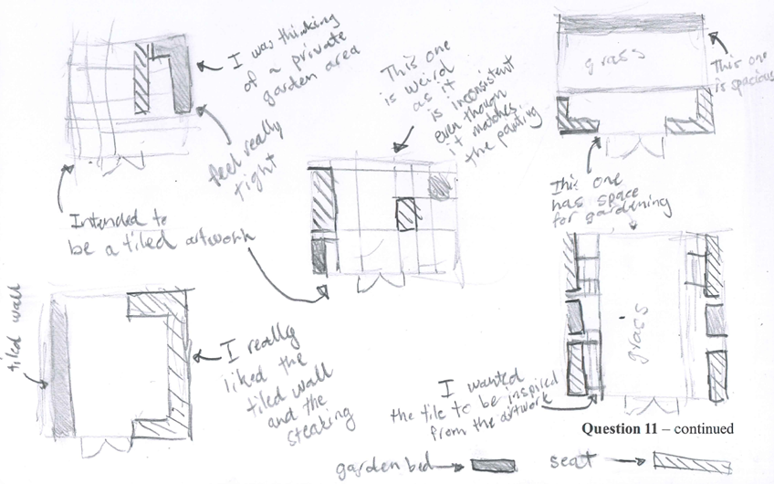
Example 1

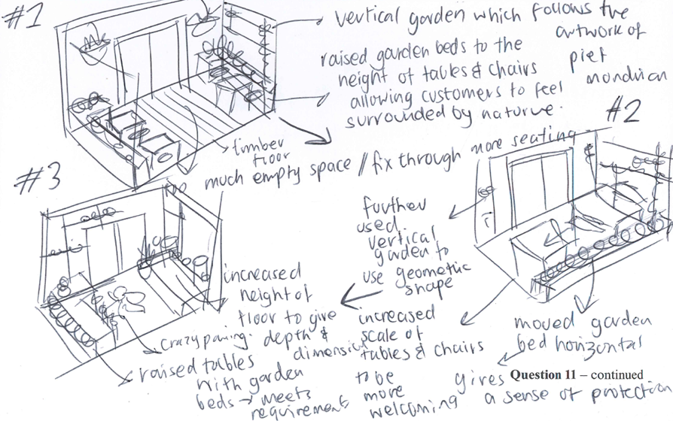
Example 2

Question 11b.
Marks | 0 | 1 | 2 | 3 | Average
% | 14 | 13 | 36 | 38 | 2.0
Students were then required to select one concept from the visualisation drawings in part a. and use this concept to develop a courtyard design. Students were able to draw this in any method they saw fit, with higher-scoring responses often working in both two and three dimensions, to convey their concept clearly. For instance, it was common to see sketches of a floor plan indicating the access from the gallery doors, the placement of seating and plants, which then corresponded to a perspective or planometric sketch, which assisted with the heights of the raised garden beds and other features that were better demonstrated three-dimensionally. Some students decided to annotate their concept, which was not required, but often helped to clarify their ideas.
Some students did not appear to carry an idea through from part a., instead coming up with a new concept for part b. Again, similar to part a., some students simply focused on the features of the courtyard but had no drawing that brought these features together to actually plan the space. Students scored more highly when demonstrating clear inspiration from the work of Piet Mondrian, by utilising primary colours, thick black lines and geometric shape/form.
It was also important for students to be aware of the mark allocation here (3 marks), where they are only asked to develop one idea. Therefore, one drawing would suffice, but if the student did more than one drawing, they needed to be linked to the same idea. Where students completed multiple drawings of different ideas, the first idea was marked.
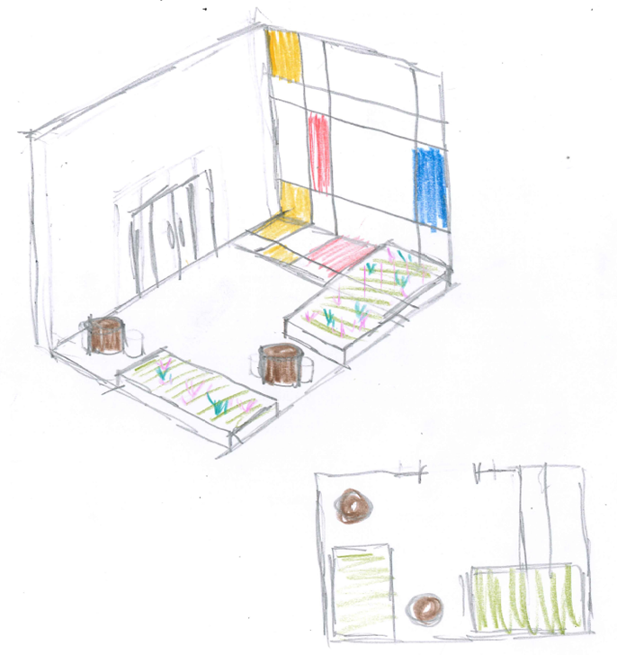
Here is an example of a high-scoring response:

Question 11c.
Marks | 0 | 1 | 2 | 3 | 4 | 5 | 6 | Average
% | 14 | 5 | 17 | 35 | 21 | 7 | 1 | 2.7
In part c. students were required to complete a scaled floor plan of the courtyard design developed in part b. using the template provided.
High-scoring responses to this question made use of relevant technical conventions, responded to all aspects of the brief in Question 11 in terms of what was to be included (seating, garden beds and plants) and had a clear influence from the paintings by Piet Mondrian. They also considered the access from the gallery doors and the circulation of the space, and ensured they had clear and effective communication through their drawings.
It was apparent that many students were unable to use the standard drawing conventions associated with architectural floor plans, or were not prepared to at least add labels or a key/legend that clearly identified the various aspects of the plan. Rather, many students simply drew rectangles and lines, which ended up being confusing to identify what was a seat, what was a garden bed and what was another feature entirely (such as a table or water feature). It was evident that these students had limited knowledge of environmental design and the technical drawings associated with this field, as it was generally poorly answered. It is recommended that students follow the advice in the VCE Visual Communication Design Technical Drawing Specifications listed in the examination specifications regarding technical drawing specifications for environmental design.
Here is an example of a high-scoring response.
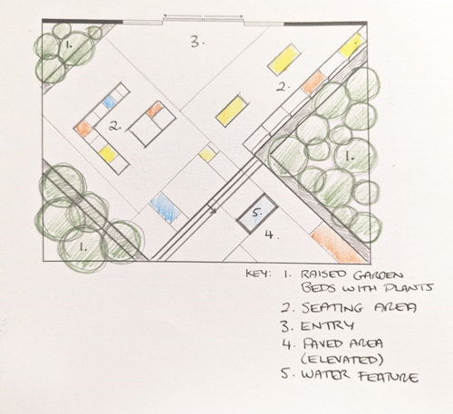

Question 11d.
Marks | 0 | 1 | 2 | 3 | 4 | 5 | 6 | 7 | 8 | 9 | 10 | Average
% | 18 | 3 | 6 | 11 | 14 | 17 | 16 | 10 | 5 | 1 | 0.2 | 4.0
This question asked students to use the template provided to complete a rendered planometric drawing of their scaled floor plan of the gallery courtyard from part c. Students were required to use colour and tone to render their drawing of the space, maintain the appropriate scale and carry through the inspiration from Piet Mondrian.
High-scoring responses to this question used the planometric drawing conventions well, maintaining vertical and 45-degree lines. They clearly included the raised garden beds, plants and seating within the design, and thoughtfully planned for access to the gallery and circulation around the space. These responses were also influenced by the work of Piet Mondrian to impact the seating, walls, the floor surfaces, etc.
Students were required to read the initial brief at the beginning of Question 11 carefully to determine that the wall was 4000 mm in reality, represented by 40 mm on the page, meaning that the scale was 1:100. Many students had difficulty maintaining an appropriate scale and just appeared to approximate the scale of their chairs and garden beds, which led to some oversized furniture at times. Furthermore, students often omitted particular features listed in the brief, such as by not including seating or using pot plants instead of raised garden beds.
Finally, students were required to render their designs using tone and colour. Students who did this well generally referenced the primary colours to represent Piet Mondrian’s work and used a consistent light source to apply tone to the various surfaces within the design. Some students only managed a basic application of colour and often tone was neglected.
Below are two examples of high-scoring responses.
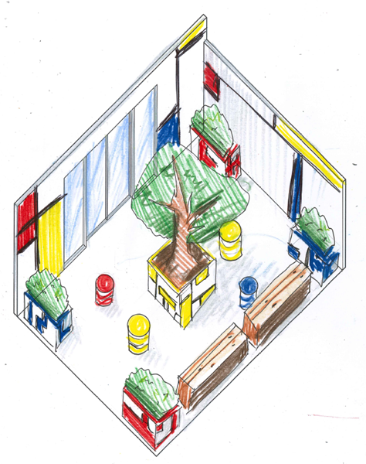
Example 1
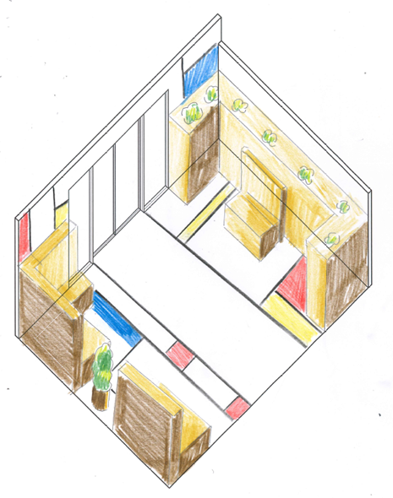
Example 2

Question 11e.
Marks | 0 | 1 | 2 | 3 | Average
% | 51 | 21 | 22 | 6 | 0.9
Finally, in part e., students were required to write a pitch to the judges of the competition to explain how their courtyard design met the requirements of the brief.
High-scoring responses here went beyond solely describing their design and repeating the information contained in the brief. They clearly explained how their design met the aesthetic and functional objectives set out in that brief. Many students did not attempt this question, which may indicate that they had not left enough time or did not follow the prompt to ‘Turn Over’ as indicated on the preceding page.
The following is an example of a high-scoring response:
This redesigned court yard space for Modern art gallery is a perfect well thought out space that provides easy access from the gallery. This space has taken inspiration for [Piet Mondrien’s] artworks as it accurately showcases similar colour and geometric shapes. This space allows for people who are visiting the gallery to admire the vibrant colour of his work by sitting down at any colourful bench option as well as gaze at many plants. This provides a safe and warm environments that allows any one and everyone to feel inspired about art making.

