2023 VCE Visual Communication Design external assessment report

General comments
In 2023, the Victorian Curriculum and Assessment Authority produced an examination aligned with the VCE Visual Communication Design Study Design 2018–2023. The examination assessed a range of key knowledge and skills spanning Units 3 and 4. Questions required students to respond using both written and practical skills.
Many students attempted all of the questions on this examination. It was pleasing to see students approaching questions with sound use of descriptive language and making connections between the questions and the visual stimuli, as well as providing many creative and imaginative responses to the design-based questions. Sample responses to each question are highlighted in this report, demonstrating the diverse approaches that led to high scores.
The stronger responses were from students who attentively considered subject-specific terminology and grasped the meaning of terms such as ‘aesthetic functions’, ‘techniques’, ‘audience characteristics’ and ‘factors’. Some students appeared to misread or misinterpret aspects of questions, making errors that resulted in noticeable omissions from their responses. Additionally, the students who scored highest across the board were often those who ensured they attempted all questions on the exam and appeared to be diligent with their time management, as opposed to those students who focused on fewer questions in more depth but left other questions unanswered.
It is important to note that while this is the last examination in the current study design, there will still be many aspects of this report that will guide both students and teachers with the examination for the new study design in 2024 and beyond.

Specific information
This report provides sample answers or an indication of what answers may have included. Unless otherwise stated, these are not intended to be exemplary or complete responses.
The statistics in this report may be subject to rounding, resulting in a total more or less than 100 per cent.

Question 1a.
Marks | 0 | 1 | Average
% | 16 | 84 | 0.8
Correct answer: industrial design
This question was well answered; however, ‘product design’ was chosen incorrectly by some students who opted for the more specific type of design within the field of industrial design.

Question 1b.
Marks | 0 | 1 | Average
% | 35 | 65 | 0.7
Correct answer: collage
This question was reasonably well answered, but some students opted for ‘printing’. However, the designer initially used collage to create this detailed depiction of a bird. This highlighted the importance of studying the larger, coloured version of the figure in the resource book.

Question 1c.
Marks | 0 | 1 | Average
% | 18 | 82 | 0.8
Correct answer: pencil
Students appeared to find this question quite straightforward, correctly identifying ‘pencil’ as the medium used.

Question 1d.
Marks | 0 | 1 | Average
% | 43 | 57 | 0.6
Correct answer: balance – asymmetrical
While there were aspects of the design in Figure 4 that appeared symmetrical, when closely studying the overall composition and layout of the poster, it can be seen to be asymmetrically balanced. The ‘2021’ in the bottom left corner, as well as differing imagery on both sides of the central character, should have led students to the correct answer of asymmetrical balance. A small number of students opted for colour, which was used, but is a design element not a principle.

Question 2a.
Marks | 0 | 1 | 2 | 3 | 4 | Average
% | 3 | 11 | 41 | 30 | 14 | 2.4
Students were expected to identify two design elements and describe how they contributed to the aesthetic function of the web banner for the ‘Ballarat Begonia Festival’. Many student responses commonly identified a combination of design elements such as colour, type and shape, and used descriptive language to communicate how the designer had used them within the web banner. High-scoring responses were able to do this in addition to thoroughly describing how the selected elements contributed to the aesthetic function. The use of adjectives to describe the elements was particularly noteworthy, and is reflective of the practice students have had with visual analysis in Unit 3 Outcome 1, as well as throughout their School Assessed Task.
The main aspect of this question that was not well addressed was the ability to link the design elements to how they connected to the aesthetic function. It is crucial that students read the question in full, and not just focus on identifying and describing elements in general. Some students mentioned aesthetics in their responses; however, they were not always able to explain what kind of aesthetic was created. Many students often referred to ‘aesthetic function’ or used generic terms such as ‘aesthetically pleasing’ to describe the design.
While design elements such as tone and texture were evident in Figure 5, their inclusions were more subtle than type, colour and shape, and therefore students who selected tone and texture generally found it more challenging to describe how their use contributed to the aesthetic function. Students are generally encouraged to select the most obvious answers, as they usually provide more avenues for discussion. This advice can be applied to many other questions within the examination.
The following are examples of high-scoring responses:
Two design elements utilised were the use of shape and type. Sans serif, bold type has been incorporated to balance the design’s imagery/logo by being placed next to the design. The type uses different scales in lettering in order to establish balance, whilst creating a visually appealing, playful aesthetic. Shape has been incorporated beside the text incorporating the layering of different, unusual wavy and straight shapes to further communicate the idea of a playful and fun aesthetic.
Organic shapes are combined to create abstract leaves and flowers for the ‘b’ icon for the logo. The shapes are overlapped and slightly transparent to create a layered effect which reflects the delicate yet contemporary aesthetic. An all caps, sans serif type has been used to emphasise the words ‘Ballarat’ and ‘Blooms’ by using a larger point size. The smaller L sits in the negative space of another L in the word ‘Ballarat’ which also reinforces a somewhat playful aesthetic.

Question 2b.
Marks | 0 | 1 | 2 | 3 | Average
% | 14 | 25 | 41 | 19 | 1.6
Students were asked to discuss one technique the designer used within the web banner to gain the attention of the audience, as well as one technique to maintain their attention. Students appeared to handle this question quite well, commonly discussing techniques such as the manipulation of type, the colours used to create contrast and hierarchy, and reference to the intricate nature of the logo/imagery of the flower. High-scoring responses required students to discuss two different techniques, as well as adding a level of detail to their response.
Some students used the same technique to explain how the designer gained and maintained attention, which was problematic as it did not fully answer the question and often led to repetitive responses. While it was technically possible for students to discuss two techniques to do with a particular aspect of the design, such as the type for example, this was often not handled well as students could not successfully separate the discussion into how it attracted and maintained attention. Some students simply discussed just one technique to gain or maintain attention, but not both.
A small number of students appeared to use terminology such as ‘wit’ or ‘metaphor’ as techniques to gain/maintain attention – fitting their technique under a specific term, rather than providing a general discussion of a technique that was preferred.
The following are examples of high-scoring responses:
The designer has used colour to gain the target audience’s attention. The complementary colours in the flower and leaf gain that attention. The manipulation of the flower as a lower-case ‘b’ and the treatment of the type in the words where Bs, Ls and Os have been altered which maintains that attention.
The soft apricot colour of the separate shapes of type and image with the contrasting green leaf shape gain our attention. The abstract nature of the flower and leaf maintains our attention because it is not immediately obvious it is a flower. The type has been adjusted to fit a rectangular shape. To do this the Ls in Ballarat and the Os in bloom have been manipulated to add interest and maintain our attention.

Question 3 (Stage 1).
Marks | 0 | 1 | 2 | 3 | Average
% | 37 | 29 | 18 | 16 | 1.1

Question 3 (Stage 2)
Marks | 0 | 1 | 2 | 3 | Average
% | 32 | 30 | 23 | 15 | 1.2
In Question 3, students were required to consider the range of drawings of a portable speaker depicted in Figure 6, and then identify and discuss the two stages of the design process shown.
Many students correctly identified the Development of Concepts and Resolution of Presentations as the two stages of the design process shown. Strong discussions about these respective stages included an outline of the typical characteristics expected during the stage, as well as clear reference to the drawings in Figure 6. Students referred to the right-hand side of Figure 6 to discuss how the designer was developing the idea further in terms of the form, handle and materials. Meanwhile, the left-hand side of the figure, often explained as the final design, served as the client's presentation. It is worth noting that students could have written about ‘Resolution of Presentations’ in the ‘Stage 1’ section, and the ‘Development of Concepts’ in the ‘Stage 2’ section, as there was no penalty for switching these around.
Students are expected to use correct terminology from the study design, therefore ‘Concepts’ or ‘Resolution’ did not suffice as stages of the design process. Furthermore, it was quite common for students to incorrectly state ‘Generation of Ideas’ and/or ‘Refinement’ as stages of the design process. It became evident that students were having difficulties distinguishing between the ‘Development of Concepts’ and ‘Generation of Ideas’ stages, often referring to the drawings on the far right of the figure as ‘visualisation drawings’ that were evidence of the design generating ideas. Additionally, some students referred to the singular concept of the speaker on its own as ‘Refinement’, not accounting for the fact that the refinement stage would have multiple speakers with subtle tweaks made, as opposed to just one speaker.
The following are examples of high-scoring responses:
Development of Concepts – During the development of concepts stage, the designer seeks to explore possible adjustments of the design. This may include form, colour, materials of features. In figure 6, the designer has explored possible handle placements and charging port locations to discover the best option for the speaker.
Resolution of Presentation – During the resolution of presentation, the designer has concluded their final design and presents the final idea. This may be in the form of a poster, 3D digital or physical model. In Figure 6 the presentation is on the left of the page and depicts a high-quality resolution of the portable speaker, using an isometric drawing method, complete with realistic rendering to provide the client with an accurate depiction of the speaker.

Question 4a.
Marks | 0 | 1 | 2 | 3 | 4 | 5 | 6 | 7 | 8 | 9 | Average
% | 12 | 5 | 7 | 10 | 13 | 16 | 14 | 12 | 8 | 3 | 4.4
Question 4a. presented students with an isometric drawing of a wooden block, requiring them to complete a third-angle orthogonal drawing. Students generally made a good attempt at the orthogonal drawing, with many able to include three views, maintain a scale of 1:1, and include relevant solid lines, including the circle on the front view.
Although students were able to align their views, it was quite common for them not to be equidistant. Even those who used the 45° drafting method still managed to have inconsistent distances between views. Chain lines and hidden lines were attempted, but not always executed well. Common issues included chain lines that looked like dashed lines or did not extend past the drawing. Often the dashed line on the top view was missing, or the chain lines on the side/top views or circle were not present. Labelling views was attempted in some cases, but the conventions were not always followed, with some type being lower case, left-aligned, and/or on top of the drawing.
The following is an example of a high-scoring response:
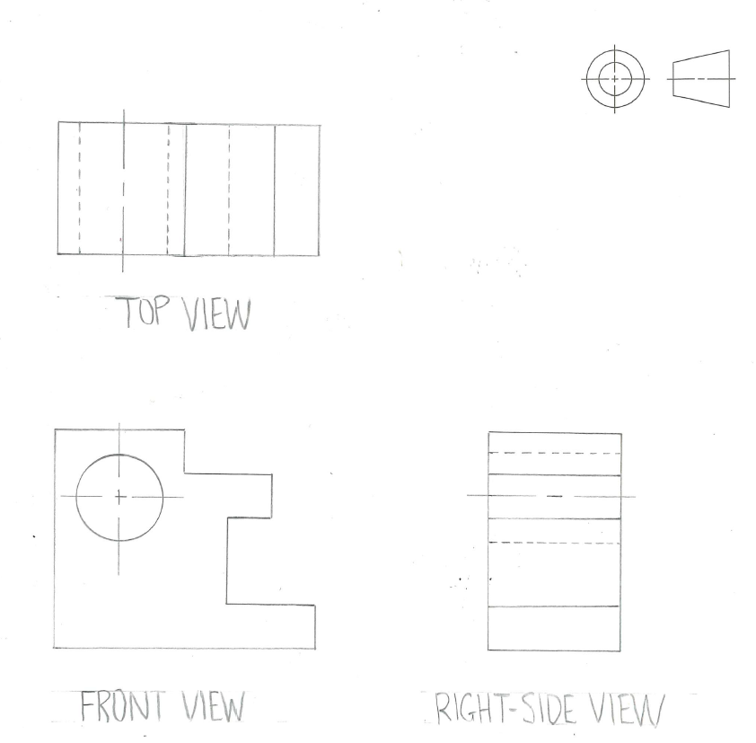

Question 4b.
Marks | 0 | 1 | 2 | 3 | 4 | 5 | 6 | 7 | Average
% | 35 | 22 | 19 | 12 | 8 | 2 | 1 | 0 | 1.5
This technical drawing question required students to complete an isometric drawing of the packaging net featured in Figure 8. Students were quite capable of drawing the isometric from the correct viewpoint (A) and were able to create a box form of the correct dimensions. Strong drawings included the correct size ellipse on the front side of the container, orientated on the correct angle. The ‘envelope’ top folds were featured occasionally; however, the inside corner and tabs visible through the elliptical cut-out were rarely shown.
The top of the container caused some problems, with many students leaving the triangular flaps up, creating a ‘pitched roof’ to the container. However, the clear dashed line that runs across the triangle suggests that it must fold down to create an ‘envelope’ shaped top. Additionally, the top rectangular sections were too short to facilitate a pitched roof.
Some students drew the box on its side or reflected, while others did not use the isometric drawing conventions. There were some planometric and perspective views, despite there being an example of an isometric drawing in part a. that students could have used as reference to correctly draw in the 30° angles. Interestingly, some students added an additional curve to their ellipses to show the thickness of the paper/card; however, they were not required to do this, nor were they penalised for doing so. For technical drawings, it is acceptable for guidelines to remain, as long as there is clear distinction between guidelines and solid outlines of the drawing (as seen in the response below).
The following is an example of a high-scoring response:
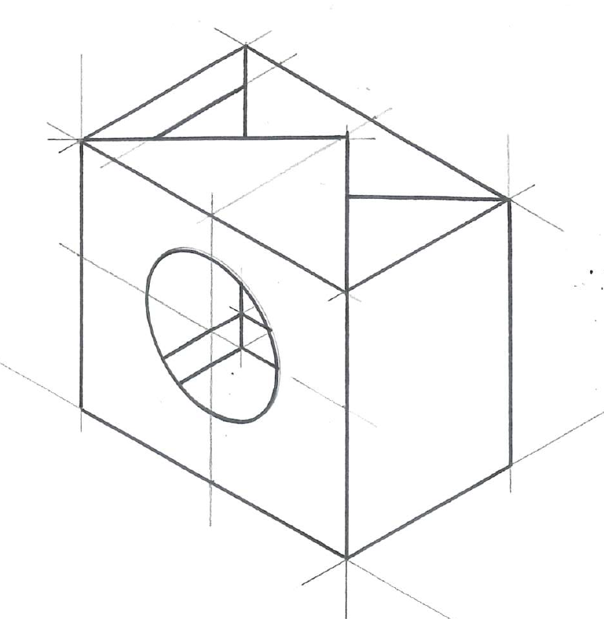

Question 5a.
Marks | 0 | 1 | 2 | 3 | 4 | 5 | 6 | 7 | 8 | Average
% | 2 | 4 | 10 | 18 | 19 | 21 | 16 | 8 | 2 | 4.3
In the first of the design-based questions, students were asked to create a sign for Shipwreck Coast Shire, simplifying the imagery used in Figure 10. They were required to use shape and figure-ground as the primary design elements and principles in their design, as well as black and white only.
The best student responses took inspiration from the Golden Plains Shire example in Figure 9, meaning they were able to use clear, simplified shapes, with a sound understanding of how to create figure-ground. There was often some overlap of shapes, with contrasting sections of black and white that were deliberate in their approach to figure-ground. They also used solid black (either fineliner or pencil) and avoided using tone or shades of grey. They were able to simplify the shapes, yet still have them clearly resemble the ship, cliffs and waves featured in Figure 10.
Some lower-scoring responses over-simplified the ship to look like a children’s toy sailboat, or the cliffs often became unrecognisable. Additionally, some responses over-utilised line as a design element, emphasising this more than shape. They also did not consider figure-ground and simply placed a black silhouette on the white paper, not attempting any overlap, or deliberate treatment of the ground. Further to this, many students did not reference the example in Figure 9 and created illustrations loosely based on the imagery provided, which was surprising given the Golden Plains Shire example was specifically included for students to have an indication of how the element and principle could be applied.
The following are examples of high-scoring responses:
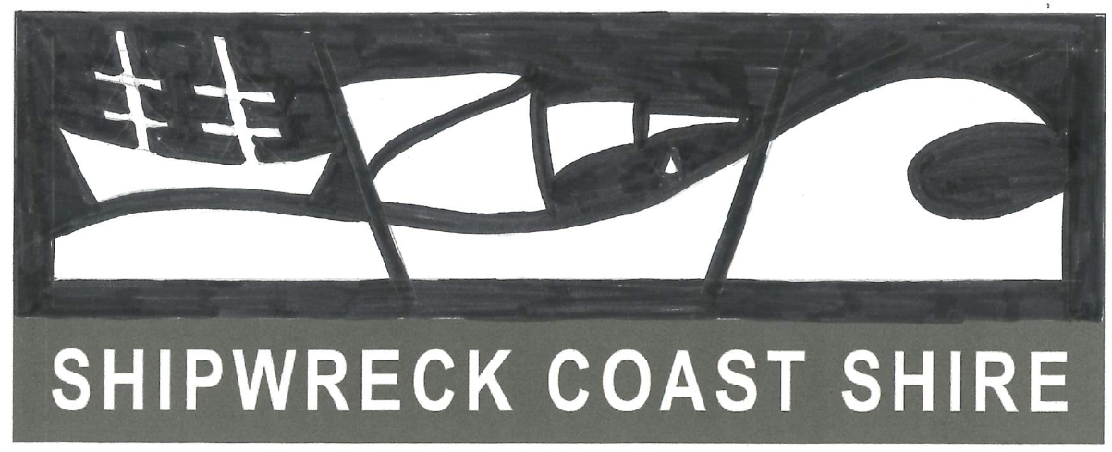
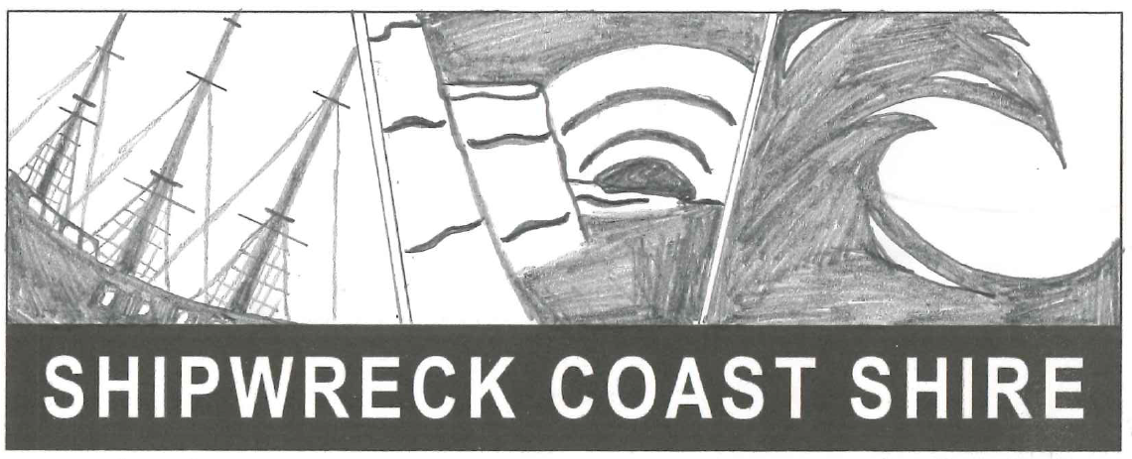

Question 5b.
Marks | 0 | 1 | 2 | Average
% | 35 | 48 | 17 | 0.8
Part b. required students to explain the decisions they had made to adapt the imagery to their signage in part a. Strong responses to this question were ones where students had explained specifically how they approached the task in detail, such as ‘I scaled the ship up to demonstrate its importance’ or ‘I created one continuous flowing line through the sign to act as a water level that helped tie the design of the three images together.’ Unfortunately, some students simply restated what the brief asked them to do, hence they did not score well on this question.
Students are also reminded to be conscious of plurals within questions. The word ‘decisions’ implies that, to achieve full marks, students must explain at least two decisions they made.
The following is an example of a high-scoring response:
Given all three images relate to the water, I decided to use a wavy line that continued across all three segments of my sign to tie the design together. I opted for a water figure on a simple black ground to create simplicity within the design, along with thin black lines used to divide spaces, making it easy for the viewer to understand.

Question 6a.
Marks | 0 | 1 | 2 | 3 | Average
% | 10 | 36 | 39 | 15 | 1.6
In this question, students were asked to describe how the original design in Figure 11 has been adapted for the digital media context in Figure 12. Many students accurately discussed how the original image in Figure 11 had been split-up or cropped to feature three small sub-sections in Figure 12. They mentioned how the neighbouring housing and people within the scene had been omitted to create a more compact illustration that fits within the portrait orientation of mobile screen/device. The strongest responses also often made mention of how type was added to fill the space at the bottom and create meaningful connections to the cause, as well as create links/buttons to find out more information, which is relevant to a digital context.
Lower-scoring responses often lacked detail, and/or didn’t comment on how the adaptations were suitable for the digital context. Other students didn’t mention how the orientation changed from landscape to portrait, or how type was added.
The following is an example of a high-scoring response:
The digital media example has been adapted to effectively support three vertical format images relevant to the screen of a phone. Images from the original design have been cropped to focus on specific services offered and each vertical format has had text added to further explain the service offered by ACDC and to promote the brand.

Question 6b.
Marks | 0 | 1 | 2 | 3 | 4 | Average
% | 22 | 24 | 31 | 12 | 11 | 1. 7
Part b. required students to describe two different characteristics of the target audience, using evidence from Figure 12. Strong responses often made mention of those who might suffer with poor mental health, those with a physical disability, the elderly, social media users, people living in Australia etc. as they were all able to be linked back to the visual in Figure 12.
Many responses opted for quite general characteristics of the target audience, which should be avoided. For instance, identifying ‘all ages’ or ‘all genders’ as a characteristic was not specific enough to the question. Students are encouraged to consider the visual stimulus and respond explicitly to that, as opposed to going into the examination with generic responses pre-prepared. ‘All ages’ is not appropriate, as young children would not be interested in this design. Therefore, those students who specified an age range or described ‘elderly people’, for example, were able to link this to the visual and justify it.
Some students described these characteristics well, but did not use evidence from Figure 12 to validate their responses. Occasionally, students used evidence from Figure 11 that was not featured in Figure 12. It is crucial that students focus on the correct figures in these types of questions.
The following is an example of a high-scoring response:
Older communities – As shown in the third image on the right-hand side of Figure 12, an older woman is being taken care of, demonstrating that those who are older are a targeted audience.
Those struggling with mental health conditions – This is demonstrated through the text on the middle image in Figure 12, saying ‘we deliver free information on mental health…’ which clearly articulates their service and who it is for.

Question 6c.
Marks | 0 | 1 | 2 | Average
% | 67 | 14 | 19 | 0.5
In this question, students needed to identify one factor and describe how it might have influenced the design of the visual communication in Figure 11. Strong responses correctly identified either social or ethical factors, and then proceeded to describe how it impacted specifically on the design. General responses described how inclusivity was a social factor that influenced the designer to consider the demographics of the audience and was able to represent this through a range of characters who appear to be different ages, races, genders, abilities, etc.
Overall, this question was not answered well, with many students not identifying a relevant factor from the study design. It was evident that many students did not acknowledge ‘factors’ as a key term, and just interpreted this as a general word, meaning that some responses centred around the colour choice of orange, or creating a cartoon instead of using photography. Some students had reasonable discussions around being inclusive and representing a range of different people within a community; however, they were still unable to identify the key terminology required. Conversely, some students identified the factor correctly, but then only described why the factor was important rather than addressing its impact on the design in Figure 11. Students are encouraged to revise the factors of design and take note of the changes in the new study design for 2024.
The following is an example of a high-scoring response:
The social factor of inclusivity and diversity has influenced the design in Figure 11 as is includes all different ages, body shapes and races. This allows the audience to identify with the design more easily, as its inclusive of all.

Question 7
Marks | 0 | 1 | 2 | 3 | 4 | 5 | 6 | 7 | 8 | 9 | 10 | Average
% | 3 | 5 | 9 | 12 | 13 | 16 | 16 | 11 | 9 | 4 | 1 | 4.9
This question provided students with a line drawing of a bathroom vanity unit that they were required to render. Within their render, students needed to demonstrate a range of materials/surfaces such as chrome tapware, a tiled splashback, wooden cabinets, a ceramic basin and a mirror. Students were expected to show tone in relation to the light source, include cast shadows, and use texture and colour to render the surfaces as per the labelled diagram in Figure 13.
Overall, this question was attempted by many students and had a high completion rate. Strong responses had an accurate use of tone, with shadows placed behind the basin, under the taps, and under the lip of the bench top. They ensured that materials were in the correct positions and had represented all materials with appropriate colour and texture. For example, they used a wood grain for the cabinets; high levels of contrast for the chrome; a smooth, even tone for the tiles and basin; and even some subtle streak lines on the mirror. Strong responses demonstrated a level of care taken, regardless of the timed conditions, conveying a high level of quality.
Overall, the wood grain was typically the strongest material demonstrated by students. However, tone was not always handled well, with many students applying very little tonal variation across the figure. Students are encouraged to initially work out where the light from the arrow would hit and apply tone and shadows to the darker areas before applying texture and colour. Some students need to be aware that simply shading the bench brown was not necessarily demonstrating a wood grain texture, nor was using a greylead pencil to shade the chrome tapware. A wood grain should have lines that flow through the bench top and cabinets, whereas chrome should have a high level of contrast between black and white and tones of grey. Some students, in an attempt to create white tiles, predominantly left the tiled area blank, as opposed to including some shading. Similarly with the mirror: instead of including some angled reflection streaks, students left this surface blank or included shading that was far too dark.
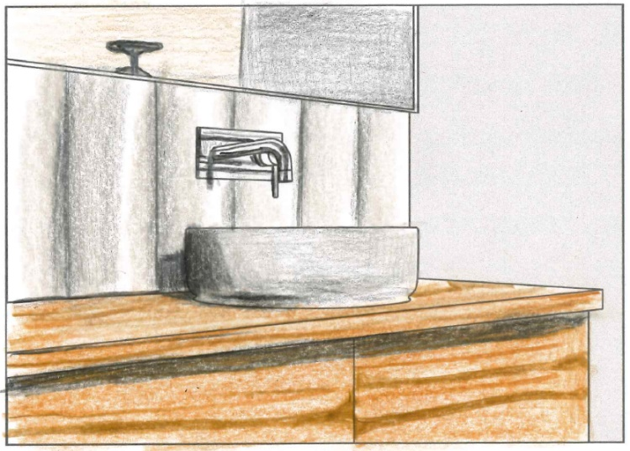
The following are examples of high-scoring responses:
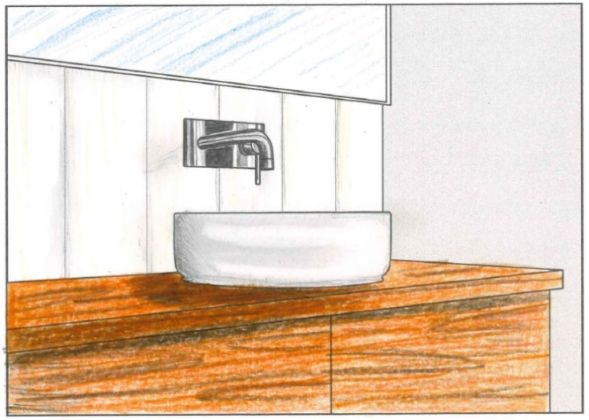

Question 8a.
Marks | 0 | 1 | 2 | Average
% | 3 | 12 | 85 | 1.8
In Question 8a., students were required to identify one design element and one design principle that were evident in the book cover in Figure 15. Students answered this question very well, with only a small percentage making errors such as identifying two elements or two principles, or using incorrect terminology such as ‘typography’ instead of ‘type’.
Common design elements identified were: Shape, colour, type and tone.
Common design principles identified were: Figure-ground, contrast, hierarchy and cropping.

Question 8b.
Marks | 0 | 1 | 2 | 3 | Average
% | 13 | 35 | 39 | 13 | 1.5
This question asked students to discuss how the design element and principle identified in part a. have been used together to effectively reflect the title of the book in Figure 15, The Curiosity of the Black Cat. Most students attempted this question, with the stronger responses discussing the selected element and principle together and clearly discussing how they work to reflect the title. Often these connections were about the shape of the girl’s silhouette and how it contrasts with the bright colours, gaining attention and reflecting the idea of ‘searching’, which may reflect curiosity. Other students discussed how the dominant black ground created a darker, more mysterious cover, reflecting the ‘black cat’ aspect of the title.
Some students, however, were unable to discuss how the element and principle selected were used to reflect the title conceptually, merely referencing the title in terms of the text itself and not what it meant. For example, some students had discussed how the contrast of the white type on the black ground created a clear and legible title, which is not the same as how contrast works to reflect the meaning of the title. Another issue was that students occasionally discussed the element and principle separately, as opposed to focusing on how they work together. Students are encouraged to practise analysing visual stimuli, discussing how elements and principles work hand in hand, not just on their own.
Some students referred to black and white as colours, or discussed elements and principles that were not highly relevant in this example, such as form, pattern, or symmetrical balance. There was also some confusion around figure-ground and which aspects of the book were in fact the figure and the ground. This often happened when students referred to the black ground as a ‘background’ when in fact the figure of the cat’s head leads to imagery that spans into the distance, becoming a background. Hence, many students did not score well on this question.
The following is an example of a high-scoring response:
Shape and contrast have been used together within the book cover in Figure 15 to reflect the title. The shape of a girl appearing to search for someone is emphasised through a black silhouette which contrasts with the colourful background in the overall shape of a cat. This helps to convey a sense of curiosity, whilst visually depicting a cat, assisting to reflect the title.

Question 9a.
Marks | 0 | 1 | 2 | 3 | 4 | Average
% | 6 | 10 | 26 | 35 | 24 | 2.6
This question required students to respond to the brief by generating at least three visualisation drawings for the tram surface design. Students needed to create a connection to four of the Melbourne buildings in the resource book, by simplifying them using colour and shape, but not type.
Overall, students responded well to this question, as they were able to consider the key requirements such as generating at least three ideas, a connection to the four buildings in the resource book, as well as the use of shape and colour. Strong responses were those that clearly followed these criteria, often using coloured geometric shapes such as triangles to represent the façade of Federation Square, or semi-circles to represent the dome of Flinders Street Station. They were also able to connect multiple buildings together to form a design, as opposed to students who drew separate stand-alone designs. While annotations were not required in this part of the question, some students used them as an intuitive way of generating ideas. These annotations did not contribute to the assessment of the student response.
As in Question 5a., the use of shape was problematic for some students, who either emphasised line or created three-dimensional sketches of the buildings’ forms. Some students also used only greylead to sketch, meaning a mark for use of colour (a key component of the brief in this case) was unable to be awarded. Occasionally, it was difficult to identify the connection to four different buildings in the resource book. Often one or two buildings were clear, but students did not always utilise significant features of the buildings, such as pillars, domes, windows, roofs etc., to ensure their designs were deemed ‘recognisable’.
The following are examples of high-scoring responses:
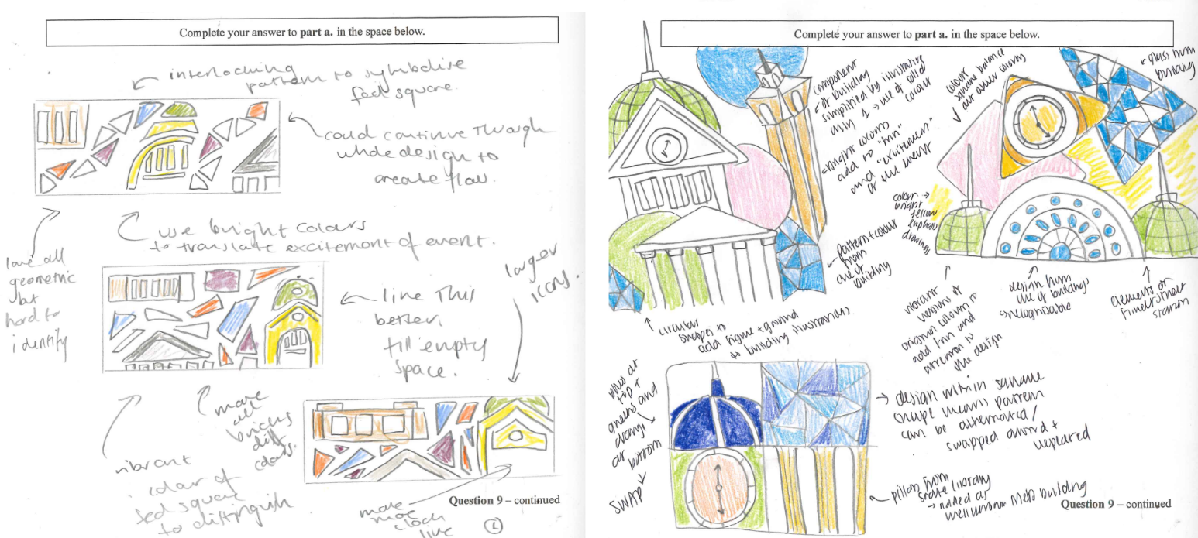

Question 9b.
Marks | 0 | 1 | 2 | 3 | 4 | 5 | Average
% | 8 | 6 | 24 | 31 | 26 | 5 | 2.8
In this part of the question, students were required to use their designs from part a. and apply them to the tram surface template in Figure 16. Higher-scoring responses utilised the tram template in full, had a clear connection to the ideas in part a., and were able to simplify the buildings in a fun and exciting way.
While this question was well attempted, in many of the designs the buildings drawn were not always recognisable, or they were far too detailed, which didn’t translate clearly on the template. Additionally, the template of the tram was not always used in full; instead, the bottom half was used for the design and the top section remained blank/white.
Some students provided responses where their design extended beyond the tram template, with Australian flags and domes placed on top of the tram, for example. While students were not penalised for these additions, it is important that they read the brief carefully and only work on what is required to utilise their time effectively.
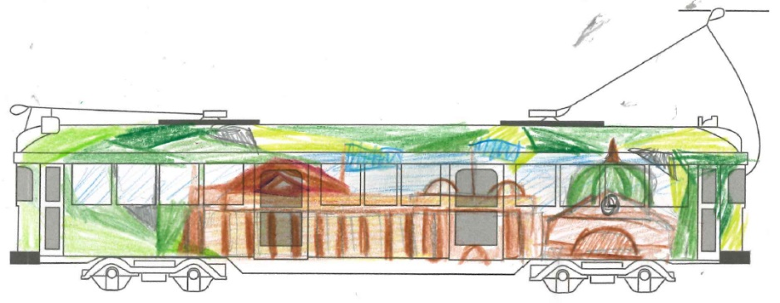
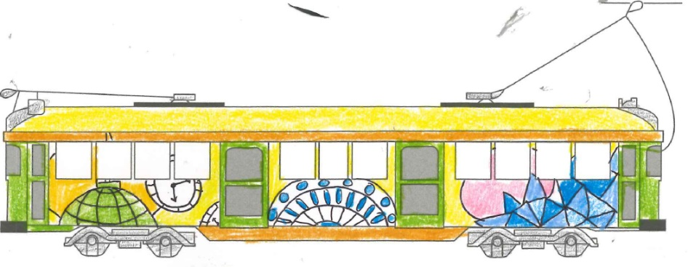
The following are examples of high-scoring responses:

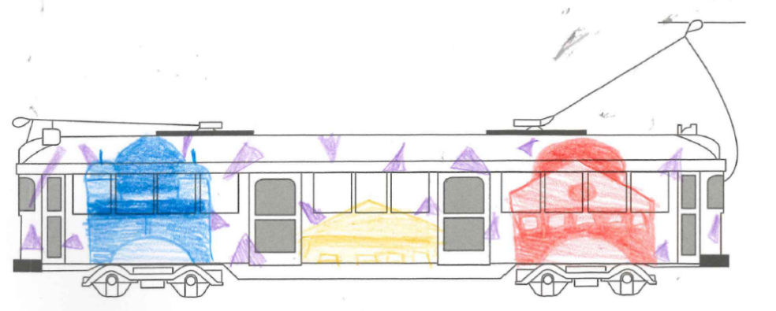

Question 9c.
Marks | 0 | 1 | 2 | 3 | 4 | 5 | Average
% | 19 | 8 | 14 | 21 | 23 | 15 | 2.6
Students were then required to adapt their tram design from part b. and create a poster for the tram stop to celebrate the 30th year anniversary. They were expected to generate at least three ideas for the poster in part c., manipulate type for ‘30’ and ‘City Circle Tram’, convey a particular hierarchy of information – 30, image and ‘City Circle Tram’ – and evaluate their designs using design thinking.
This was well attempted by students, with strong responses fulfilling each of the criteria mentioned above. They also often drew small rectangles to represent the proportions of the poster, exploring different typefaces in each of the three spaces, experimenting with hierarchy, and adapting their imagery to fit the new context. Design thinking, when done well, was often in the form of reflective and evaluative annotations.
While many students responded with at least three ideas, there were some who either used basic handwriting for the type, or kept their type similar across the different ideas and did not explore ways of manipulating it. Hierarchy was attempted well when giving thought to the use of scale, colour and layout; however, some students found this challenging when solely using greylead. Others did not achieve hierarchy when they left out ‘30’ and/or ‘City Circle Tram’. Students should always look at the question carefully and highlight/underline key pieces of information to ensure they include these when generating ideas in the first part of the question.
The following are examples of high-scoring responses:
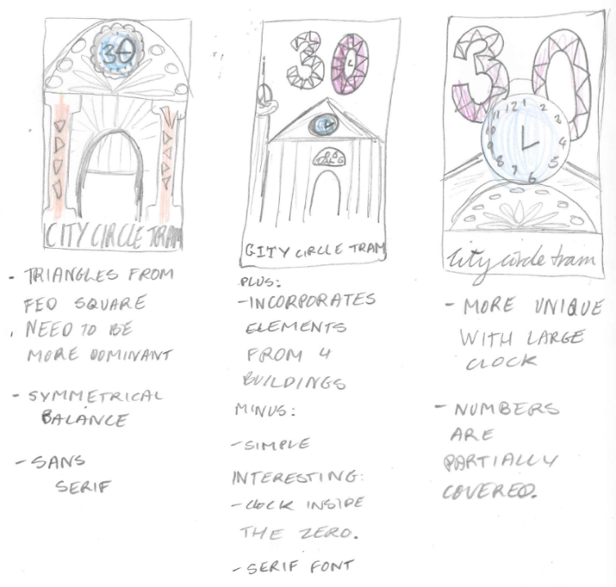
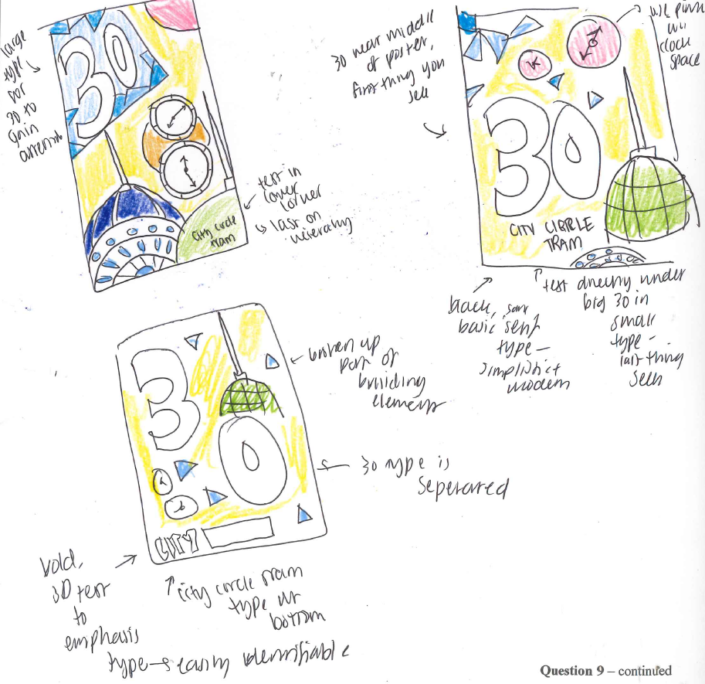

Question 9d.
Marks | 0 | 1 | 2 | 3 | 4 | 5 | 6 | 7 | 8 | 9 | Average
% | 20 | 2 | 5 | 8 | 14 | 18 | 17 | 10 | 4 | 1 | 4
In part d., students needed to finalise their ideas from part c. by using the tram stop poster template in Figure 17. They were required to select their preferred layout design from part c. in terms of type, imagery and hierarchy, while also fulfilling the overall brief, which asked for the design to reflect ‘the excitement and fun nature’ of the event.
As with part c., strong responses to this question were those that were able to include type that was engaging and interesting, yet managed to create hierarchy as required. The imagery still had a clear link to the building(s), the overall design conveyed a level of fun and excitement and was suitable for a tram stop context.
Most students were able to include the key information such as the type and imagery; however, the skills required to create hierarchy were not always executed well. Often students appeared to simply place the type and imagery down on the page, rather than considering the aesthetics of the poster or being strategic in terms of the scale, colour and placement required. The style of type, the colours used, and the effectiveness of shape for the imagery, all contributed to the level of fun and excitement the poster could convey, and this aspect was not always carefully considered by students.
The following are examples of high-scoring responses:

