Technical conventions

VCE Visual Communication Design
2024–2028

Revised April 2024

Authorised and published by the Victorian Curriculum and Assessment Authority
Level 7, 2 Lonsdale Street
Melbourne VIC 3000
© Victorian Curriculum and Assessment Authority 2024

No part of this publication may be reproduced except as specified under the Copyright Act 1968 or by permission from the VCAA. Excepting third-party elements, schools may use this resource in accordance with the VCAA educational allowance. For more information go to https://www.vcaa.vic.edu.au/Footer/Pages/Copyright.aspx.
The VCAA provides the only official, up-to-date versions of VCAA publications. Details of updates can be found on the VCAA website at www.vcaa.vic.edu.au.
This publication may contain copyright material belonging to a third party. Every effort has been made to contact all copyright owners. If you believe that material in this publication is an infringement of your copyright, please email the Copyright Officer vcaa.copyright@edumail.vic.gov.au
Copyright in materials appearing at any sites linked to this document rests with the copyright owner/s of those materials, subject to the Copyright Act. The VCAA recommends you refer to copyright statements at linked sites before using such materials.
The VCAA logo is a registered trademark of the Victorian Curriculum and Assessment Authority.

Contact us if you need this information in an accessible format - for example, large print or audio.
Telephone (03) 9032 1635 or email vcaa.media.publications@edumail.vic.gov.au
Contents
Introduction 4
Australian Standards (AS) 4
Technical conventions for three dimensional drawing 4
Paraline drawing 4
Isometric drawing 4
Planometric drawing 6
Perspective Drawing 9
One point perspective 10
Two point perspective 11
Technical conventions for two dimensional drawings 13
Packaging net 13
Third-angle orthogonal drawing 14
Layout 16
Scale 16
Views 16
Labelling 18
Line styles and conventions 18
Dimensioning orthogonal drawings 21
Plans and elevations 26
Dimensioning plans and elevations 38
Labelling 38
Naming plan and elevation drawings 40
Technical Flats 41

Introduction
This resource material provides advice and support on technical conventions listed in the Study specifications and Key Knowledge and Skills across the VCE Visual Communication Design study 2024-2028. This resource document draws upon conventions from the Australian Standards (AS).

Australian Standards (AS)
Technical conventions are based on a set of standards that have been globally agreed upon by the International Standards Organisation (ISO). These standards are then tailored to the needs of each country, depending on their measuring system (metric or imperial), environmental conditions, manufacturing processes and developments in technology. The Australian Standard AS 1100 provides the technical conventions for all Australian engineers, architects, designers, surveyors and patternmakers to follow.
The standards for Australian technical conventions can be found at: www.saiglobal.com/pdftemp/previews/osh/as/as1000/1100/1100101.pdf

Technical conventions for three dimensional drawing
Three-dimensional representation drawings included in this guide are paraline (isometric and planometric) and perspective (one and two point) drawings.

Paraline drawing
Paraline drawings have receding lines remaining parallel to each other. Paraline drawings are a most convenient way to create dimensionally accurate drawings because true measurements may be made to a consistent scale in each plane. Paraline drawings include ‘isometric’ and ‘planometric’ drawings.

Isometric drawing
Isometric drawings are constructed with both sides receding from a corner edge at 30 degrees to the horizontal. Isometric drawings provide a comprehensive overall view of an object. Refer to Figure 1.
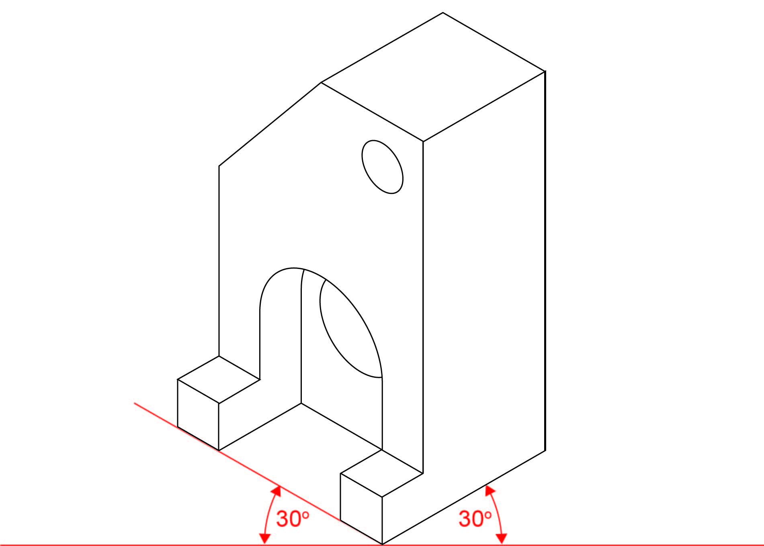
Figure 1
Isometric drawing

Planometric drawing
Planometric drawings are very similar to isometric drawings. However, the base (or plan) of the object retains its true shape–the angle between two perpendicular sides receding from the front corner is 90 degrees. A Planometric drawing may be done where both receding planes are 45 degrees or one side
is set at 30 degrees and the other is at 60 degrees. Planometric drawings are used to depict three dimensional interiors or exteriors. Refer to figure 2.
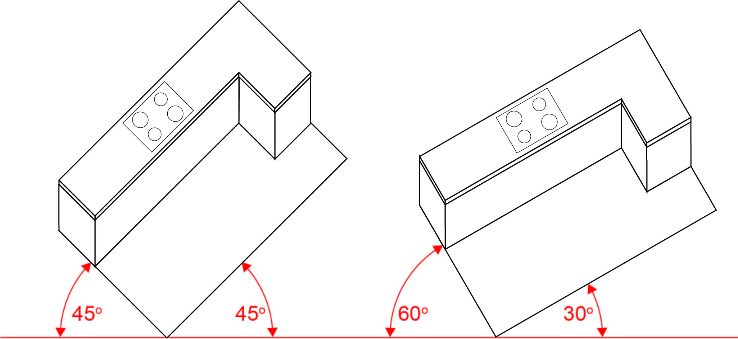
Figure 2
Planometric drawings showing 45 degrees and 60/30 degrees.

Constructing and applying ellipses in paraline drawing
A good method of drawing an ellipse is to use the box method known as ‘crating’:
- Note the relationship between a circle and a square. The red and green dots are the points that you use to draft your ellipse.
- Draw a square in isometric and locate the centre using diagonal lines
- Mark out the positions where the circle cuts the diagonal lines in the isometric projection
- Join all points with one flowing curved line to make the ellipse.
Refer to Figures 3a, 3b, 4 and 5.

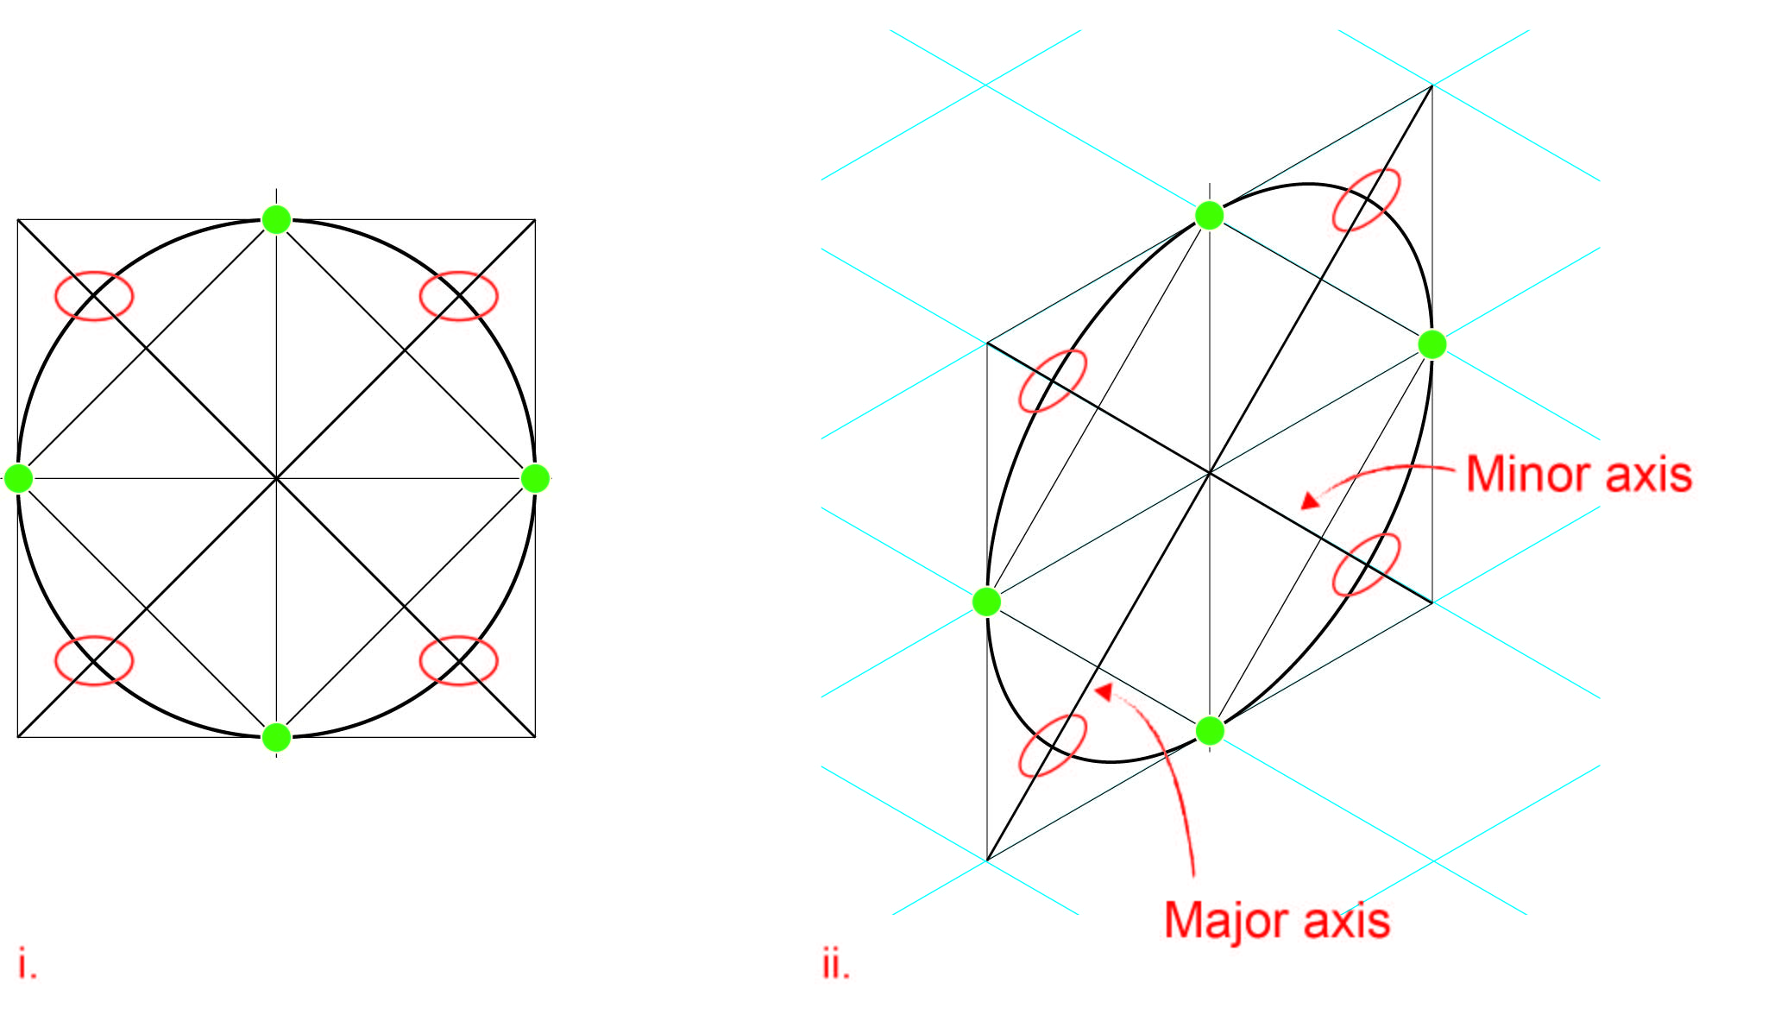
Figure 3a
The relationship between a square and a circle to create an ellipse.
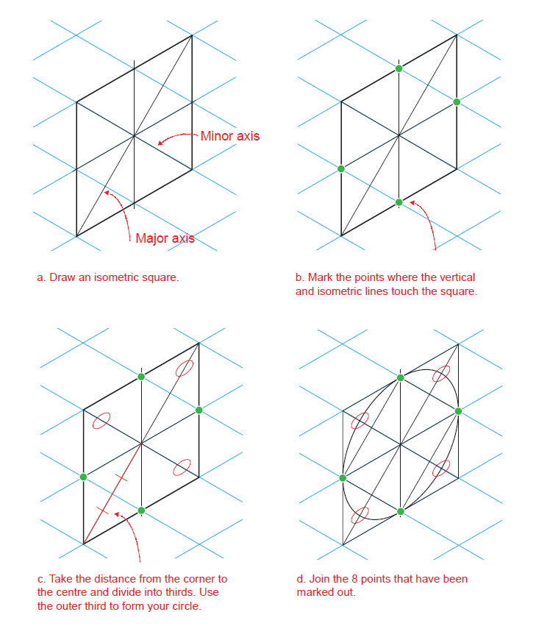
Figure 3b
An explanation of how to use a square to draft an ellipse.
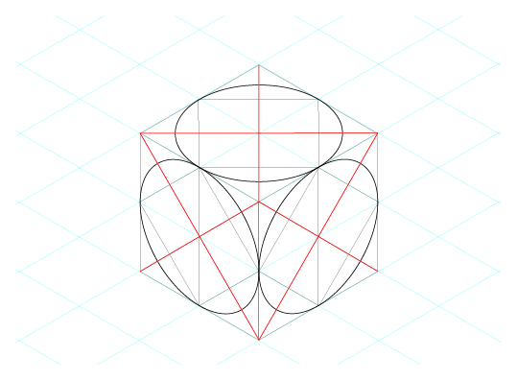

Figure 4
This figure shows how an ellipse can be applied to each face of an isometric cube. In each case the ellipse is the same, but the major axis is rotated.
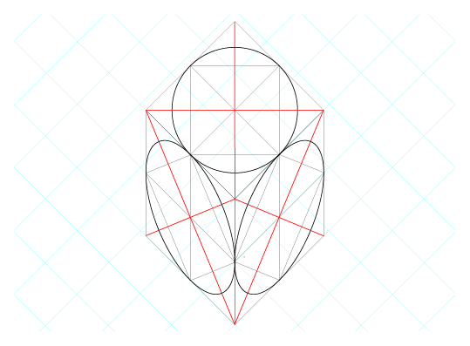
Figure 5
Ellipses can be applied to each face of a planometric cube in the same way. However, note that the ellipse angle is different to those shown in isometric drawing, and that because a planometric drawing is based on an undistorted ‘top’ view, circles remain true to their shape on the top of a planometric form.

Perspective Drawing
‘Perspective’ is a system used to depict objects and structures in a naturalistic manner consistent with human vision. Although perspective drawings may appear similar to paraline drawings in the creation of form, perspective receding lines converge towards the horizon (eye level) rather than remaining parallel to each other. The position of the object in relation to the horizon line determines the view we see of the object. Perspective drawings can include ‘one point’, ‘two point’ perspective and ‘three point’ perspective. However, in VCE Visual Communication Design the expectation that students will understand one and two point perspective drawing. Refer to Figure 6.
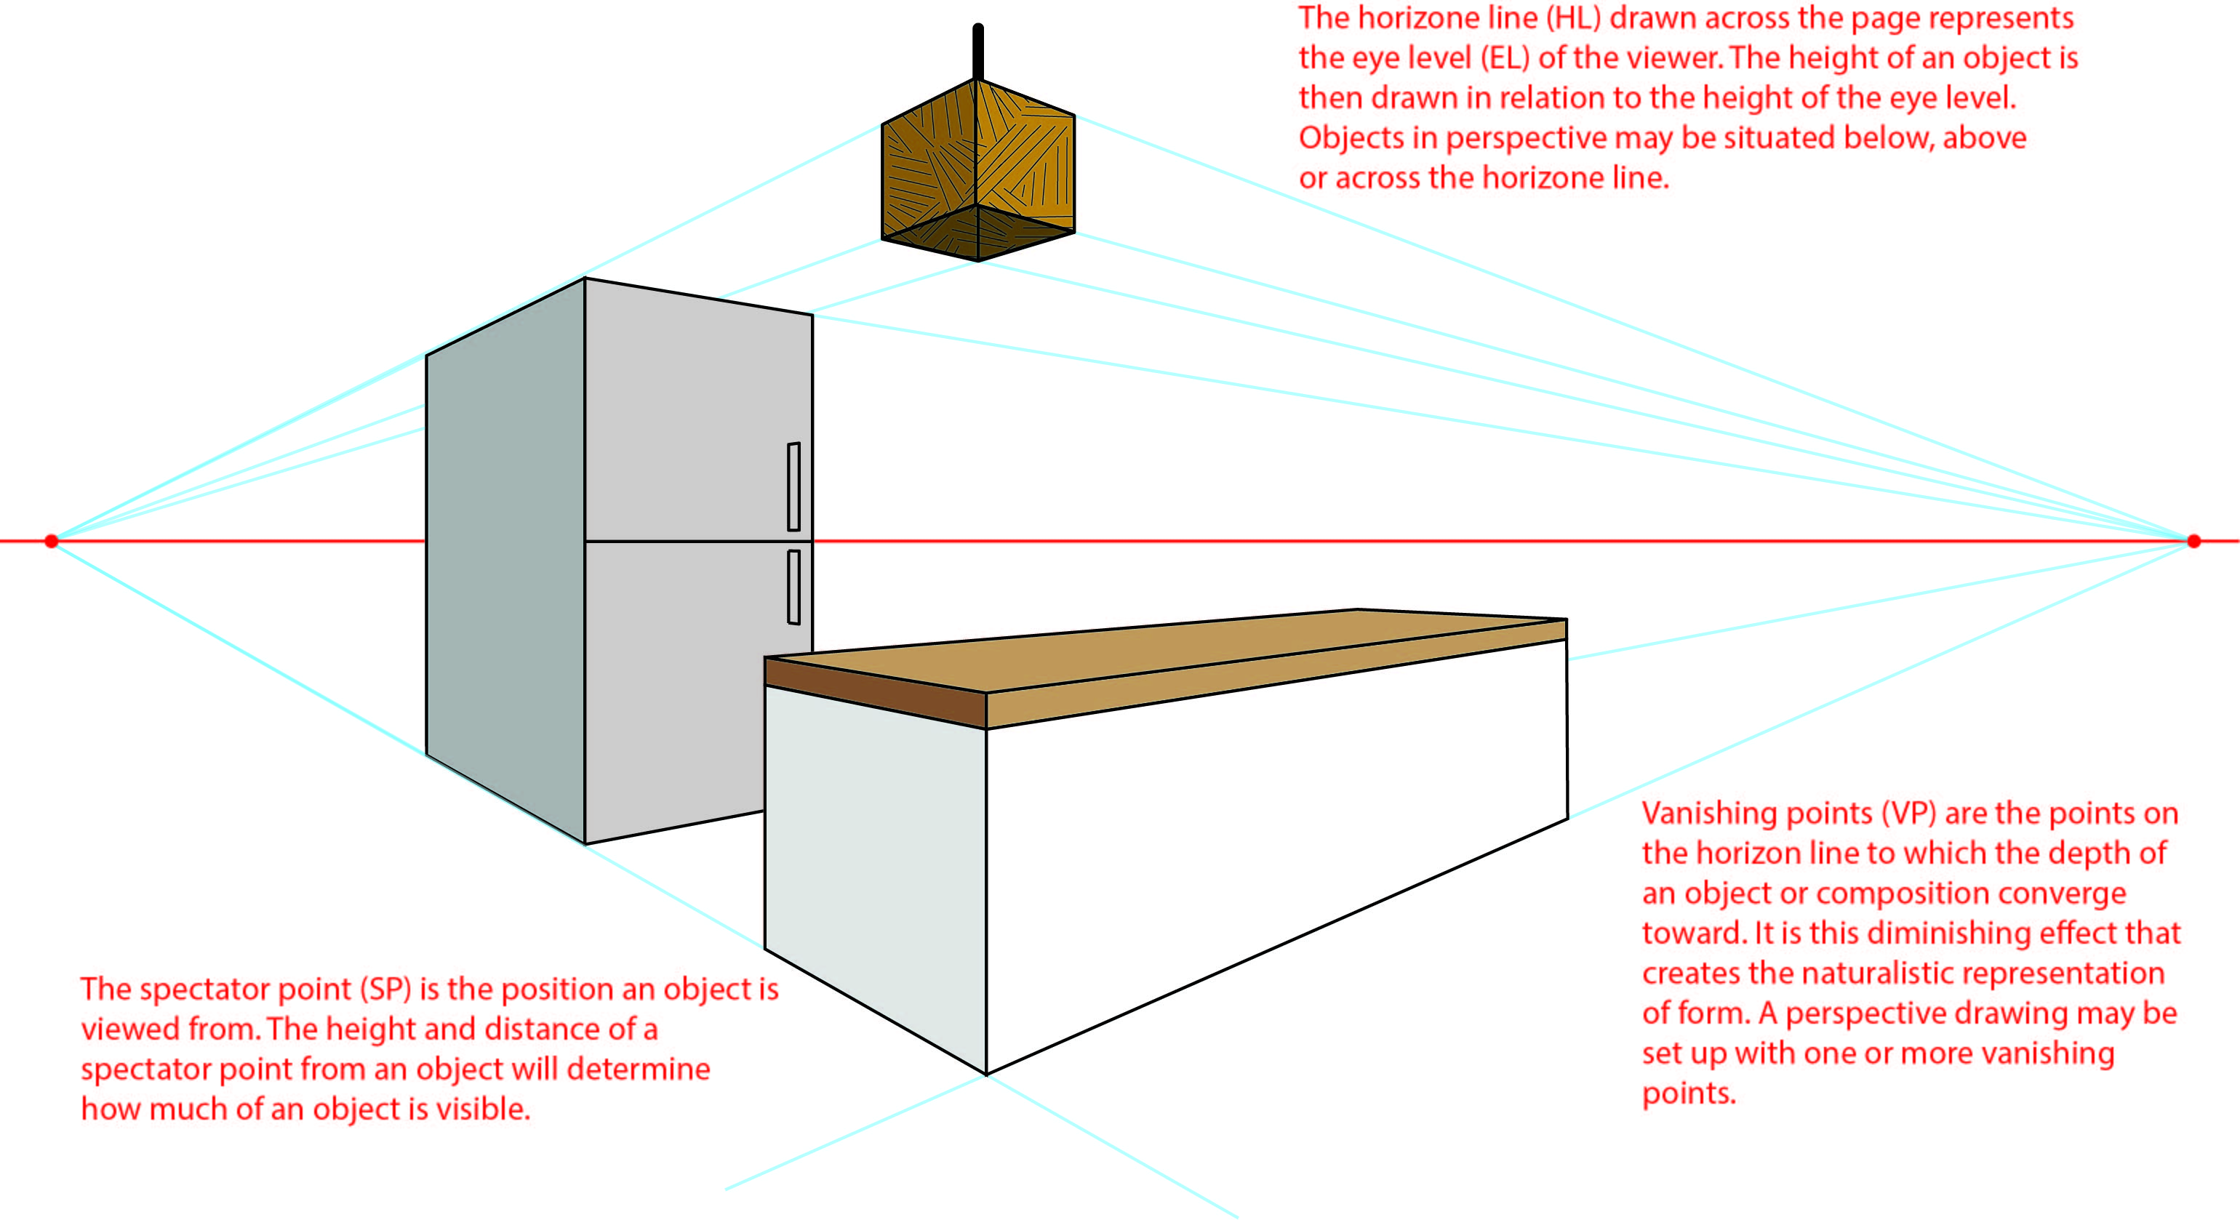

Figure 6
Illustration of terms used and position of objects relative to horizon line in a perspective drawing

One point perspective
Objects or structures are drawn ‘front on’ on the picture plane. Sides of the object recede with lines converging to one vanishing point on the horizon line. The vanishing point may be situated outside the object for an exterior view, or inside it for an interior view. Actual measurements may be applied to the horizontal and vertical lines (parallel to the picture plane). When drawing the receding lines, the proportions of the object are maintained depending on the position of the horizon line and vanishing point. Refer to Figure 7.
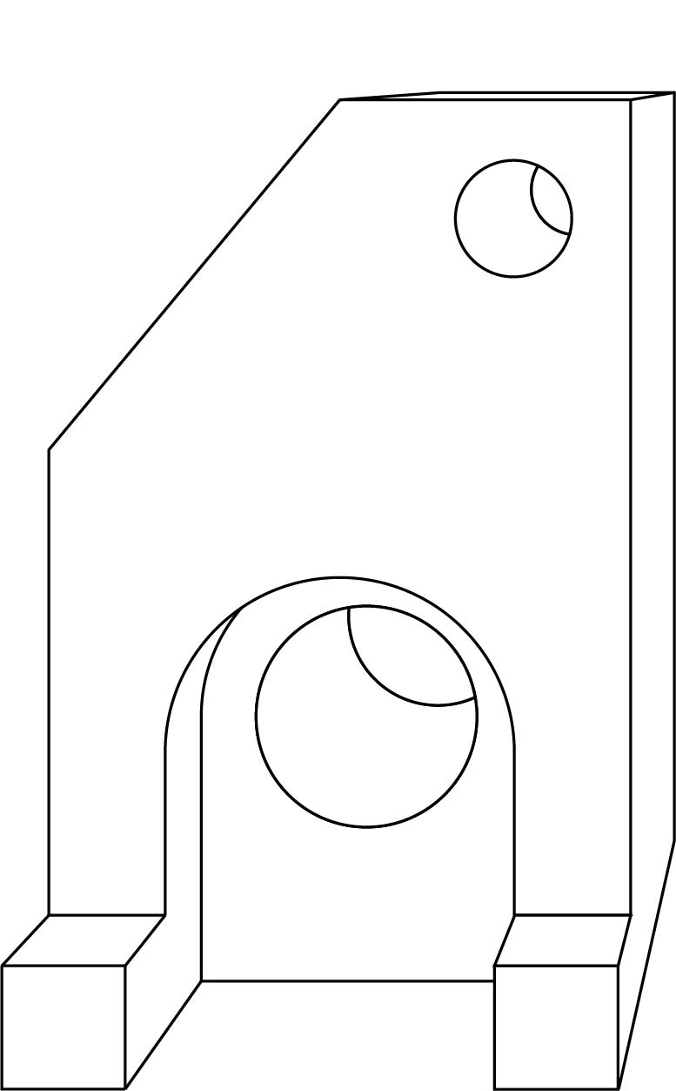
Figure 7
One-point perspective drawing.

Two point perspective
Objects or structures are drawn from a corner view with the depth of the object (sides) drawn with receding lines converging at either of the two vanishing points on the horizon line. Refer to Figure 8.
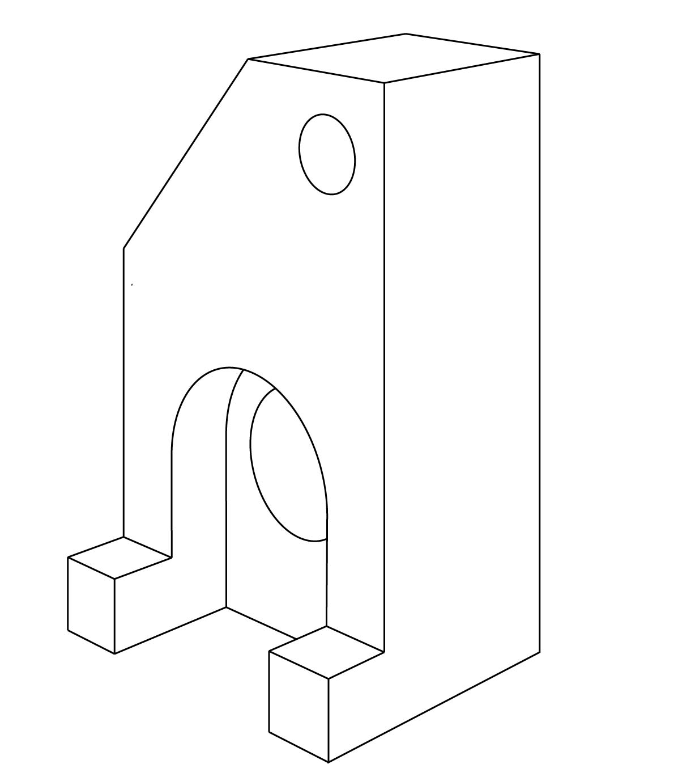
Figure 8
Two-point perspective drawing

Constructing and applying ellipses in paraline drawing
Ellipses are constructed in the same way for one- and two-point perspective as both drawing methods use receding planes. However, circles remain as circles on planes parallel to the picture plane (front) in a one-point perspective.
Unlike in paraline drawing ellipses must be constructed within correctly proportioned squares in one or two-point perspective. The vertical centre line of the square and ellipse shift towards the vanishing point in keeping with the diminishing size of objects as they recede from the viewer. Refer to Figure 9.
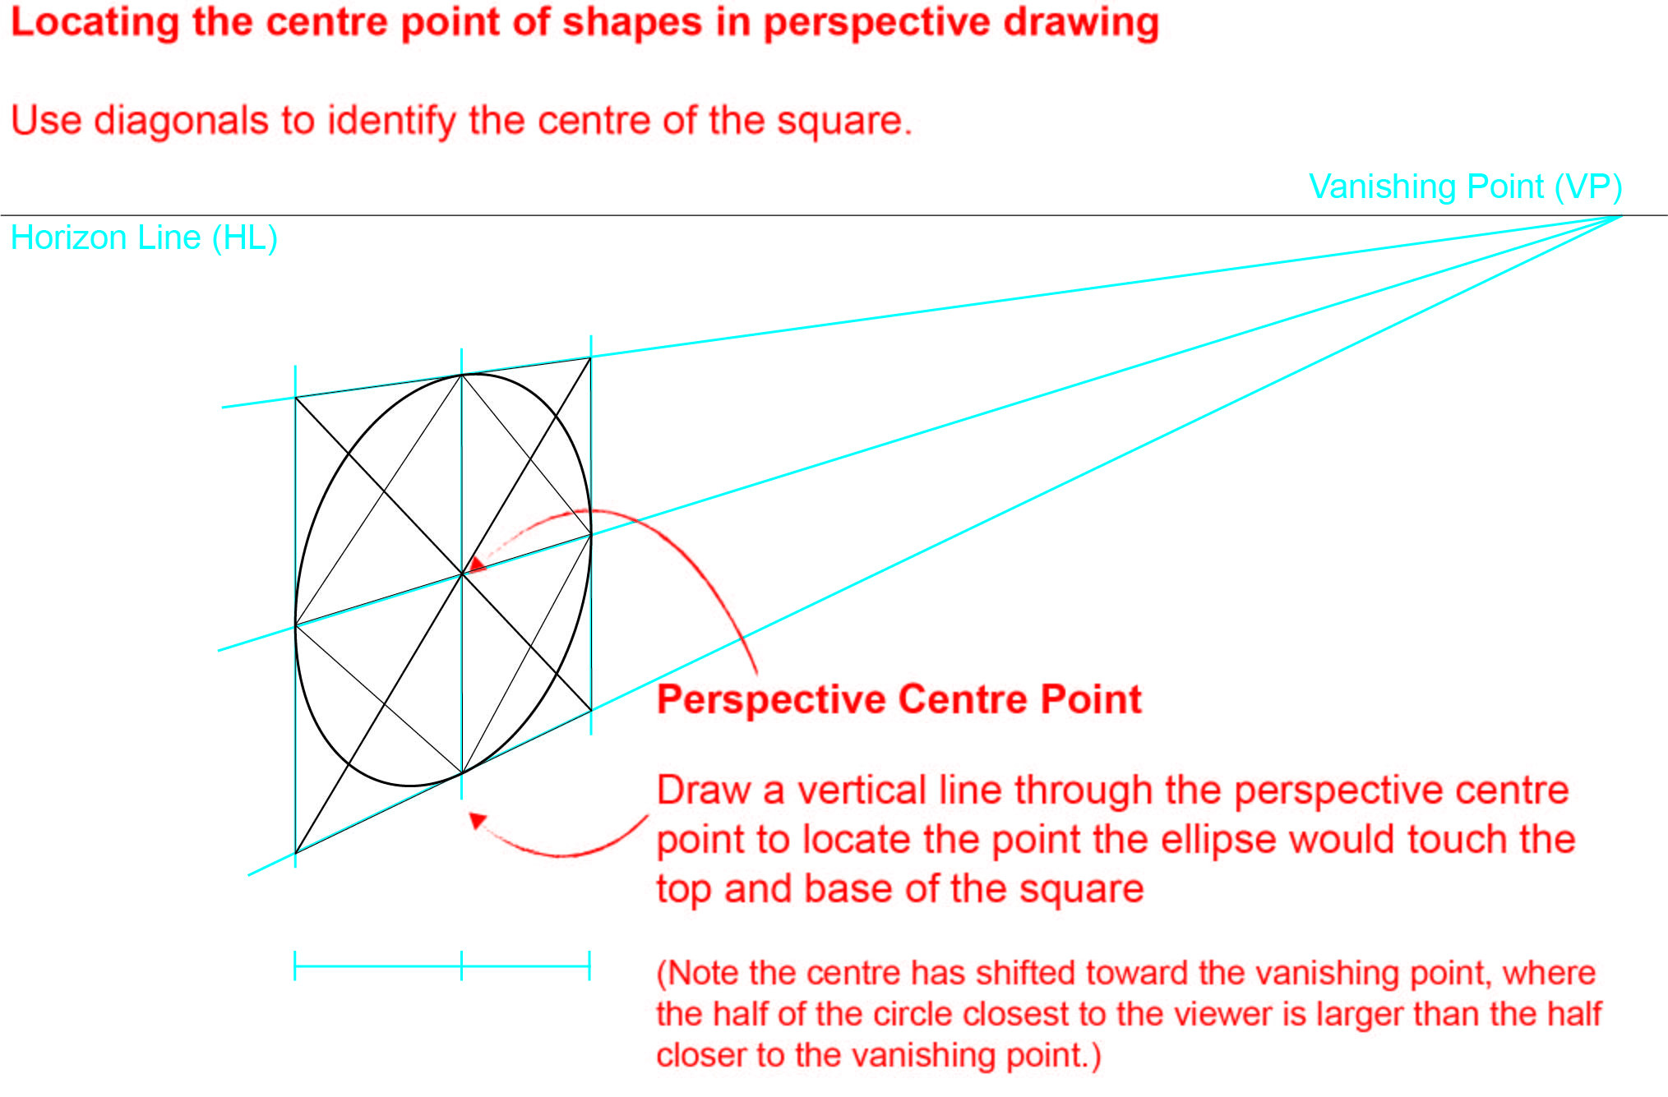

Figure 9
Constructing ellipses in perspective.

Technical conventions for two dimensional drawings

Packaging net
A packaging net is a drawing of a flat two-dimensional shape that when folded becomes a three-dimensional form. It can also be referred to as a development net or a dieline. Often a packaging net will include tabs for stability and fastening. The drawings are to scale and involve the use of line conventions that indicate fold lines (broken lines) and cutting edge (solid outline). Refer to Figure 10.

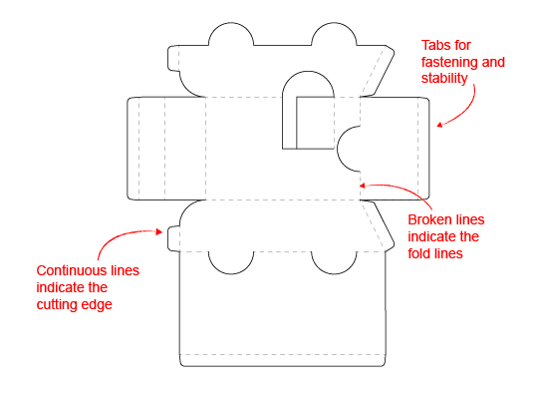

Figure 10
Packaging net that when cut out and folded will form a simplified version of a car.

Third-angle orthogonal drawing
Third-angle orthogonal drawings bear a direct relationship to three-dimensional paraline and perspective drawings.
Figure 11a is an isometric drawing of a solid object. Figure 11b is the same object drawn two-dimensionally as an orthogonal drawing.
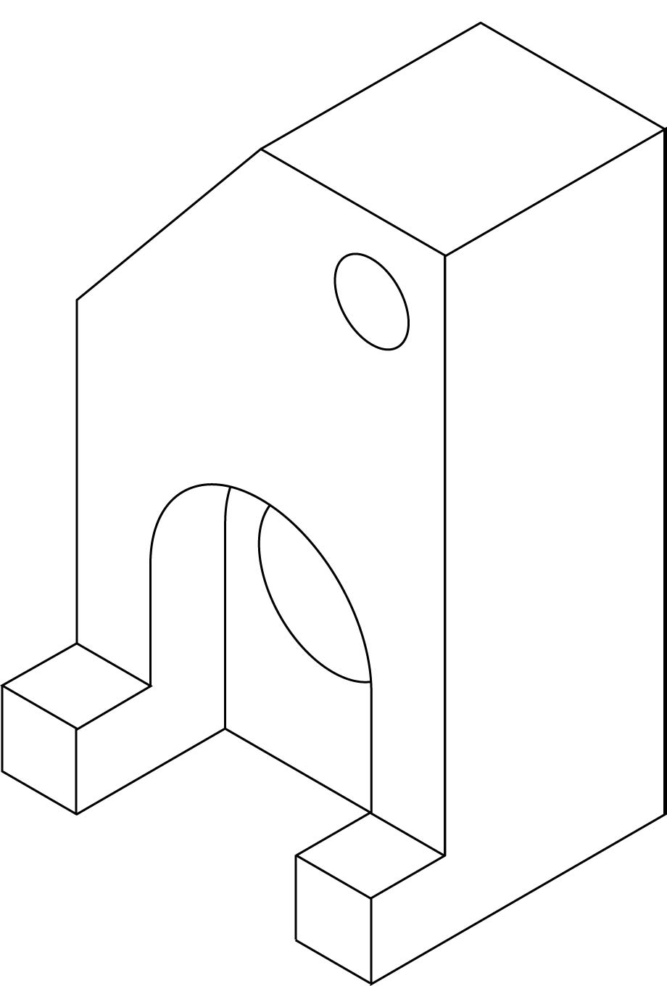
Figure 11a
Each view of an object (front, top, sides and the base) is drawn separately using only two dimensions but is kept aligned and to the same scale. Combining multiple views allows all three dimensions to be considered. ‘Third-angle’ projection refers to the layout of views and is identified by a special symbol placed on each sheet. Refer to figure 11b.

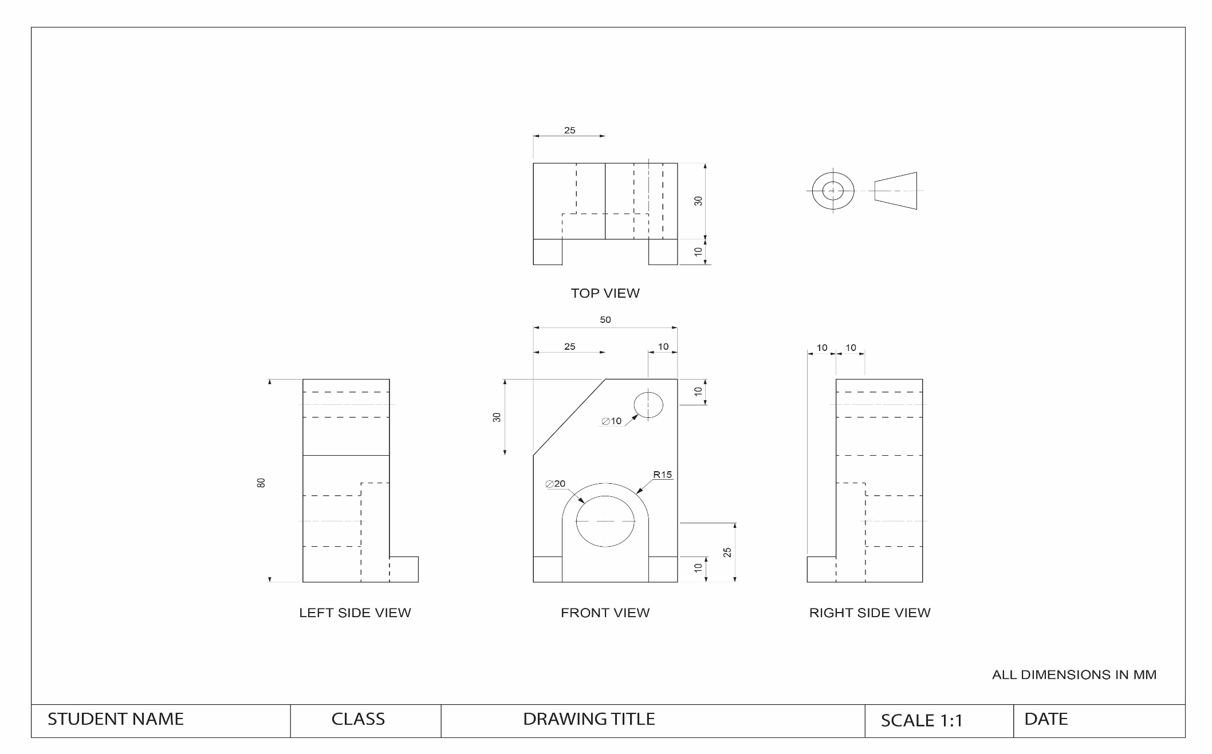

Figure 11b
Third-angle orthogonal drawing showing three labelled views, title box and the Third Angle Orthogonal symbol. (FIGURE NOT TO SCALE)

Figure 11b
Third-angle orthogonal drawing showing three labelled views, title box and the Third Angle Orthogonal symbol. (FIGURE NOT TO SCALE)

Layout
Plan the drawing and the placement of views before commencing the drawing. The drawing should be drafted before commencing to determine the scale and views before transcribing them onto the final A3 sheet. Figure 11b shows appropriate positioning using an A3 sheet of paper.

Scale
The actual size of the object and the scale of its representation will determine the size of the drawing. A scale is expressed as a ratio where the first number refers to the drawn view and the second to the actual object. For example, the scale 1:50 means the size of the drawing is fifty times smaller than the object.
The following scales are recommended for Othogonal drawings: :
- Where objects are too big to fit on a sheet choose from 1:2, 1:5, 1:10, 1:20, 1:50 and 1:100.
- Where objects are too small to be drawn in detail choose from 2:1, 5:1 or 10:1.

Views
Orthogonal drawings can include a selection of an object’s six views to communicate the features of the object. In practice only the views required to describe the object clearly are drawn. Third Angle Orthogonal projections are recommended.
The views are known as:
- TOP VIEW
- FRONT VIEW
- LEFT SIDE VIEW or RIGHT SIDE VIEW
- BASE VIEW
- BACK VIEW
The conventions of this drawing method dictate that the FRONT VIEW is chosen as the view that communicates the most information about the object. Refer to Figure 11b.

Placement of views
The TOP VIEW is always directly above the FRONT VIEW and the SIDE VIEWS are always ‘next to’ and ‘aligned to’ the FRONT VIEW. The measurement of the distance between views can vary depending on information required such as dimensioning and available space on the page, as long as this measurement is equidistant between the views.
To position the views equidistantly use the 45-degree method to place and project the views. The following steps describe the process.
- The FRONT VIEW must be drawn first, then vertical lines should be projected up to give the width/ length of the TOP VIEW.
- Measure and complete the TOP VIEW.
- Project the horizontal lines from the FRONT VIEW to give the height of the SIDE VIEW.
- Where the maximum width and height projection lines on the FRONT VIEW meet, a 45 degree line is drawn.
- Project horizontal lines from the TOP VIEW to meet the 45 degree line, then where they cross that line, draw them vertically down, until they return to the base line of the drawing. This method will create the width of the SIDE VIEW.
- All line types should now be present on the TOP VIEW.
- Referring to the FRONT and SIDE VIEW the various lines will need to be defined and drawn using the correct line type.
Once completed all views will be equidistant apart.
Refer to Figure 12.
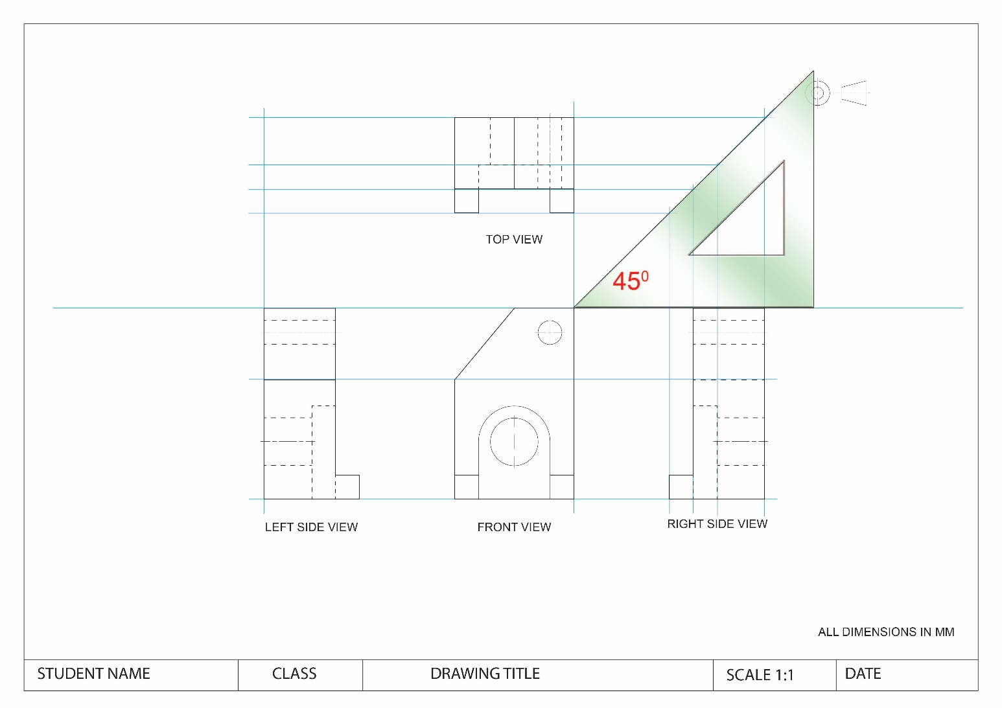
Figure 12
The third-angle orthogonal drawing showing the 45-degree method of construction. Use this method to project the widths of the SIDE VIEW from the TOP VIEW. This keeps the views aligned and equidistant.
FIGURE NOT TO SCALE

Labelling
- Each view should be labelled as follows: using an uppercase, sans serif typeface
- using label height of 5 mm
- the labels are located in a centred position 10mm below each view, should a view also require dimensioning below, the label is then positioned centred and 10mm from the last dimension line.
Refer to Figure 13.
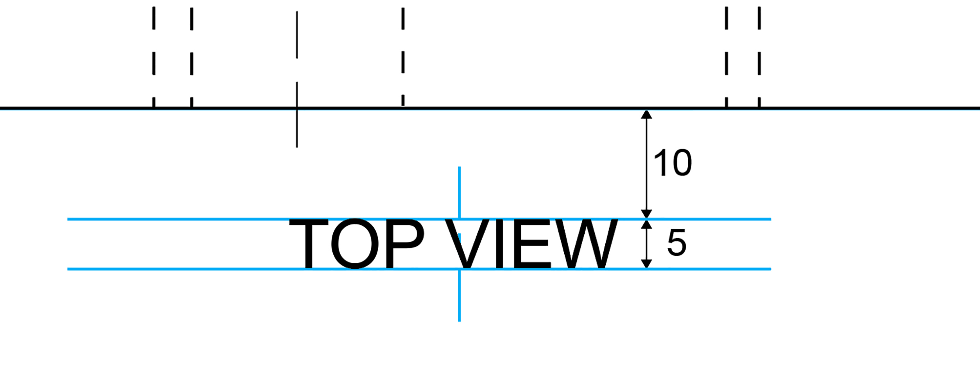
Figure 13

Line styles and conventions

Line styles and weights
The use of different line styles and widths is important in orthogonal l drawings as they are used to describe details and features of objects. Line styles make drawings easier to read. For example, solid lines used to show the outline of an object will stand out from broken lines showing hidden details. It is recommended to use a minimum of two line weights to meet line style conventions:
- A heavier line to draw the views that represent the object being drawn and dashed lines to represent hidden lines
- A thinner ‘half weight’ line to provide additional information such as centre, projection and dimension lines.
When using different line types the following rules apply.
- The length and spacing of dashes should be consistent on any particular drawing(s). It is recommended that only one thickness of dash line be used in any one drawing. Dashed lines should start and end with dashes in contact with the visible or hidden lines from which they originate. If a dashed line meets a curved line tangentially, it should be with a solid portion of the line.
- Chain lines should start and finish with a long dash.
- When centre lines define centre points they should cross one another at dash portions of the line. Centre lines should extend only a short distance beyond the features unless required for dimensioning or other purposes. Centre lines should not stop at another line of the drawing.
- Table 1 and 2 depict the appropriate line styles and conventions for third-angle orthogonal drawings.

Line styles and conventions
Thick continuous | 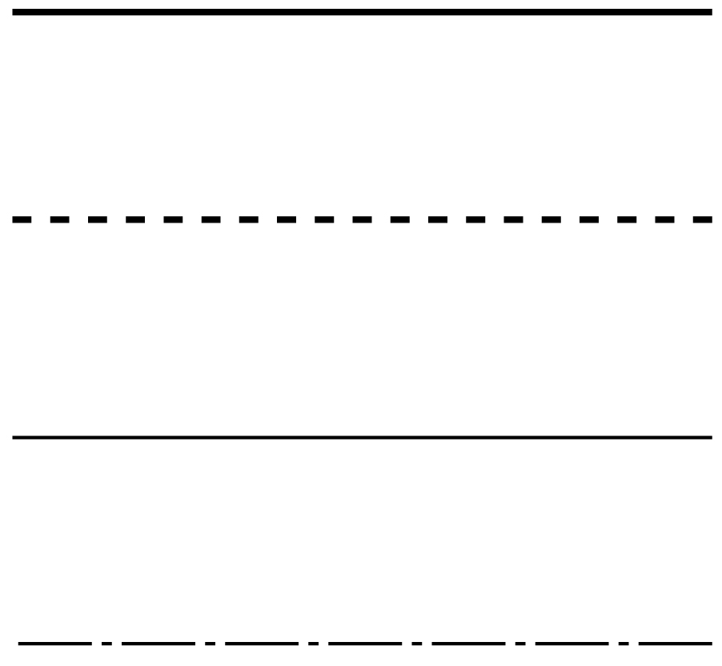 | Visible lines are used on each view; includes arcs/circles/curves/title block and border
Thick dashed |  | Hidden lines are used on each view. Dashes start and end with contact to a visible or hidden line.
Thin continuous |  | Thin continuous lines are used for dimension lines, projection lines, leaders, used in title block.
Thin chain |  | Centre lines are for axes of solid forms
Table 1

Recommended line widths | Suggested mm
Visible lines are used on each view; includes arcs/circles/curves/title block and border | 0.30-0.35
Hidden lines are used on each view. Dashes start and end with contact to a visible or hidden lines | 0.30-0.35
Thin continuous lines are used for dimensioning lines, projection lines, leaders and type used in the title block | 0.18-0.20
Centre lines, are used for axes of solid forms, pitch lines (ie: a roof line)  Note: centre lines show symmetry | 0.18-0.20
Table 2
Frequently in orthogonal drawing visible lines, hidden lines and/or centre lines coincide. There are three rules to follow:
- Visible (or object) lines are always shown in preference to hidden lines or centre lines.
- Hidden lines take precedence over centre lines.
- If a visible line obscures a centre chain line that extends beyond the outline of the object, the whole centre line is removed.
Refer to Figure 14

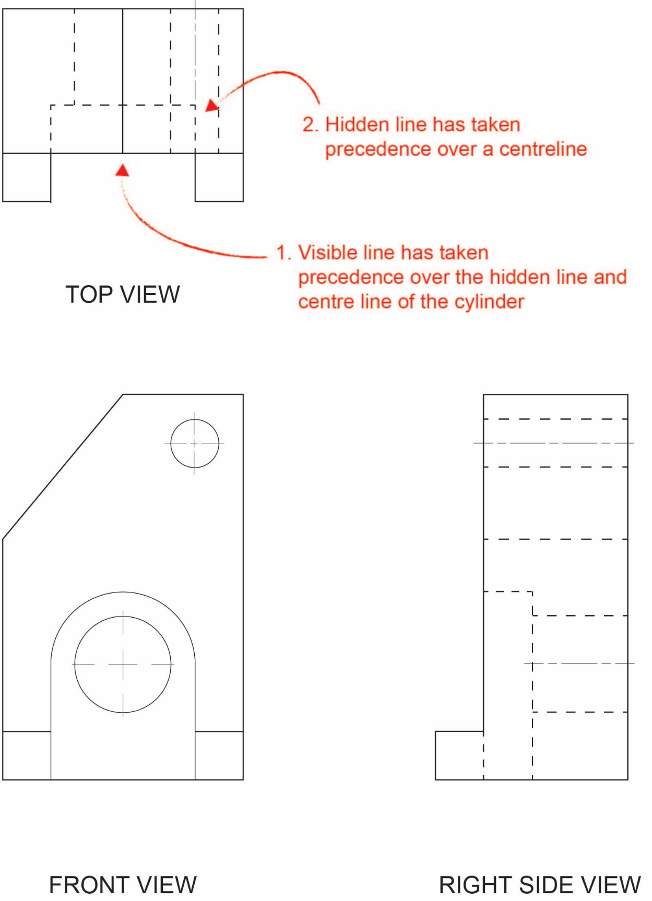

Figure 14
Lines taking precedence (blocking out) other lines.
Order of precedence is: Visible line, Hidden line and then Centre line

Dimensioning orthogonal drawings

Dimension styles
The following dimensioning guidelines and styles can apply:
- The position where dimension lines should be placed is based on easy access. Placement between the views, with consideration of where other dimensions would need to be placed, is a good starting point.
- Wherever possible place dimensions outside the outline of the object.
- It is a convention that all measurements are shown in millimetres unless otherwise indicated. Do not write ‘mm’ after every measurement; the preferable convention is to write ‘ALL DIMENSIONS IN MM’ in an appropriate place on the drawing such as directly below the symbol, or above the title block or if space permits, within the title block.
- Dimension figures are written on top of the dimension lines. When placing dimension figures on vertical dimension lines, rotate the page or drawing once to the right. Then continue to place dimension figures.
- Never repeat a dimension. Always check that dimensions are not repeated on another view. Place dimensions on the view that shows a detail most clearly. If there are repeated components, such as holes of the same size, only one is required to be dimensioned.
- Ensure that there are dimensions for the height, width and depth.
- Ensure that all crucial dimensions are included to allow the object to be interpreted.
- Try to avoid dimensioning hidden lines.
- Space dimension lines so that the dimensions are not over-crowded.

Dimension placement
- Projection lines are thin lines which are placed 1 mm from the drawing and extend beyond the last dimension line by 2 mm. They define the area being dimensioned and never touch the actual object.
- Dimension lines are thin continuous lines with arrowheads placed at each end touching the projection line. Each dimension line starts 10mm from the object and is then 10mm apart from the next. Smaller dimensions are placed closer to the object. Longest dimension lines are furthest away from a view (for example, total height).
- Arrowheads are drawn 3 mm long by 1 mm wide. They can be open or solid and always touch (but do not cross) projection lines.
Refer to Figure 16.

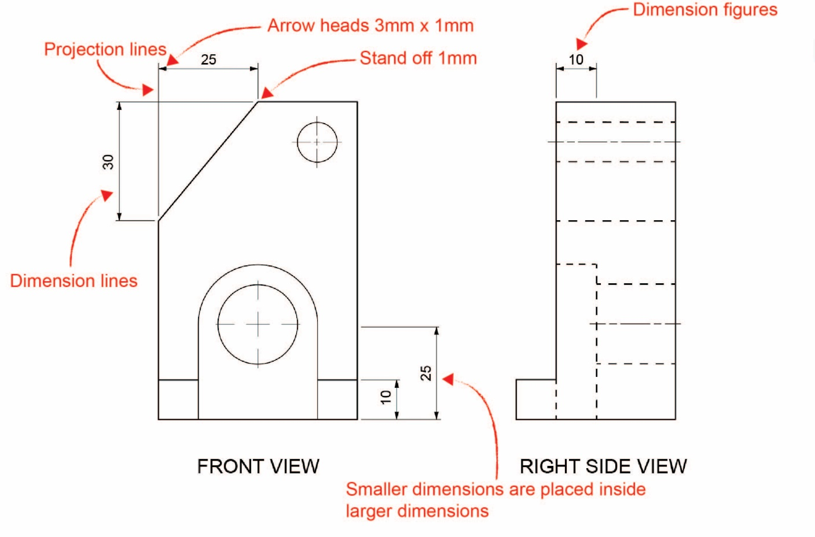
Figure 16
Examples of dimension lines, projection lines and arrowheads.

Dimensioning circles and arcs
Curves such as rounded corners are shown as an arc. The full circle may be shown as a construction line and its centre is shown as it occurs within the arc. The arc is dimensioned by its radius and the centre is marked with the ‘chain line’ cross (Figure 17 and 18).
Holes are shown as circles using the correct line for outlines. They are dimensioned by their diameter with the ‘Ø’ symbol and are marked with the ‘chain line’ cross.
When dimensioning a circle a leader is often used. Leaders stop with an arrowhead touching a line. They are always ‘sloped’ and are used to carry dimension numbers for diameters (∅) and radii (R). They may carry a notation, for example, ∅30 (Figure 18).
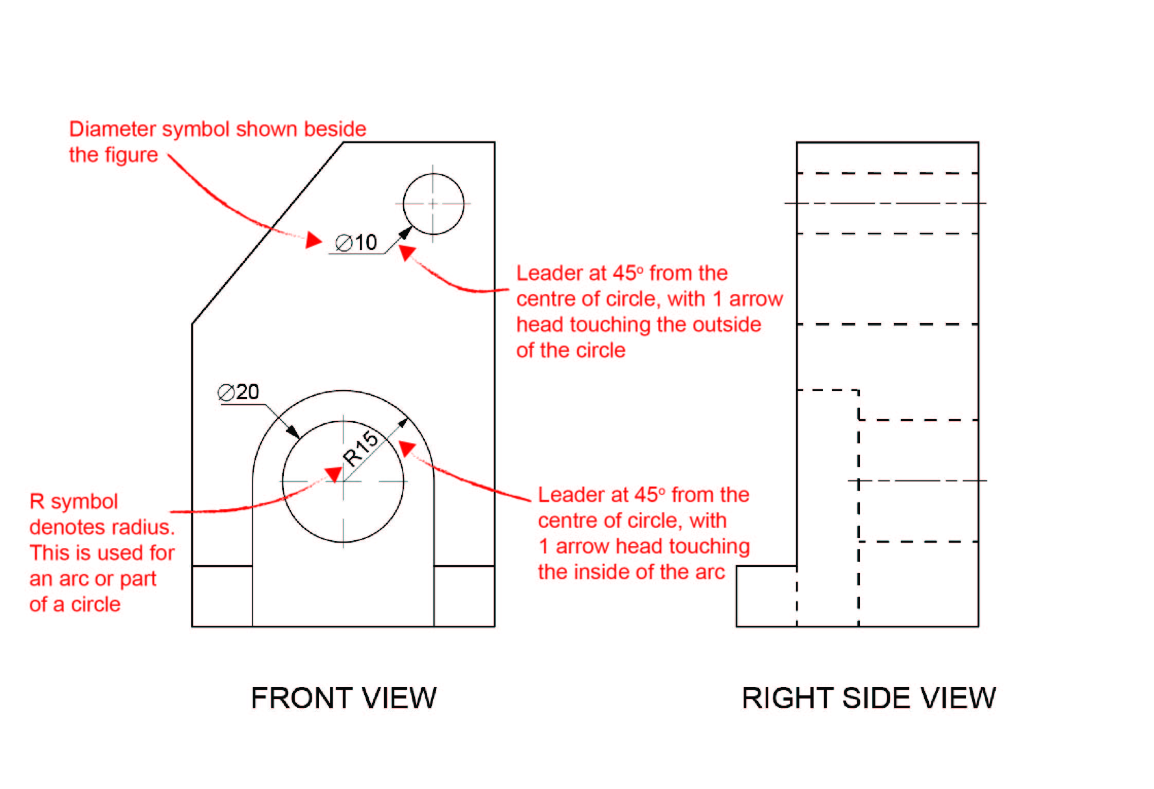
Figure 17
Example of dimensioning holes and arcs.

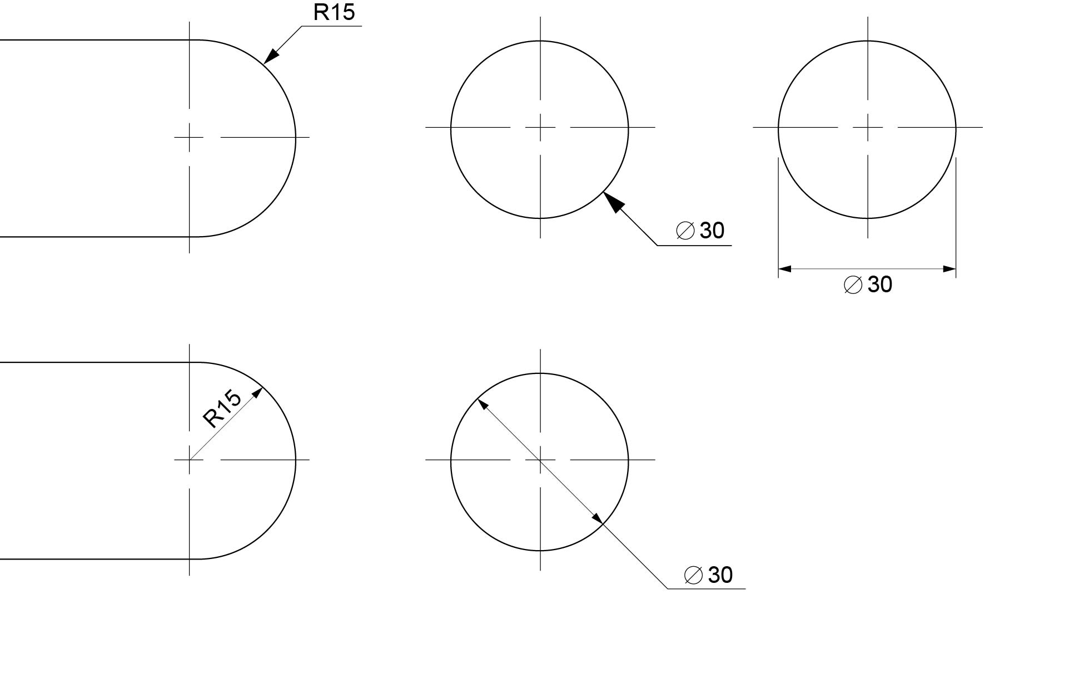
Figure 18
Alternative methods for dimensioning arcs and circles.

Third angle orthogonal projection symbol
All drawings must show the correct projection symbol to identify the projection system used. The projection symbol is part of labelling requirements and is placed on the drawing along with the labelling of views. When drawing this symbol maintain the same proportions and line conventions as seen in Figure 19 and place the symbol in the top right hand corner as seen in Figure 21. The symbol can be drawn easily if you consider only 2 measurements in its construction for example ‘8’ and ‘16’. This suggests then that the object which the symbol represents is 16mm wide, with the diameter of the narrow end 8mm and the diameter of the wide end 16. Then if the two views are positioned with a gap of 8mm, the symbol is accurate and a manageable size. Note: there is no need to include these dimensions in the drawing.
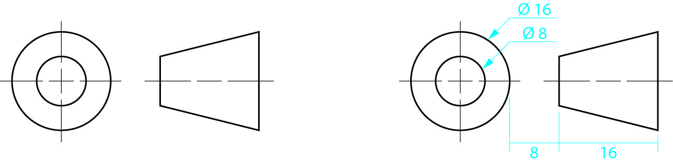

Figure 19
Third angle orthogonal symbol and suggested construction method.

Naming Orthogonal drawings
The purpose of a title block is to identify the ownership of a drawing and provide information such as the title of the drawing, scale and date created.
A title block should include the following:
- title of the drawing
- author of the drawing
- date drawn
- scale including a reference to the units used in the drawings
Refer to Figure 20 and 21.
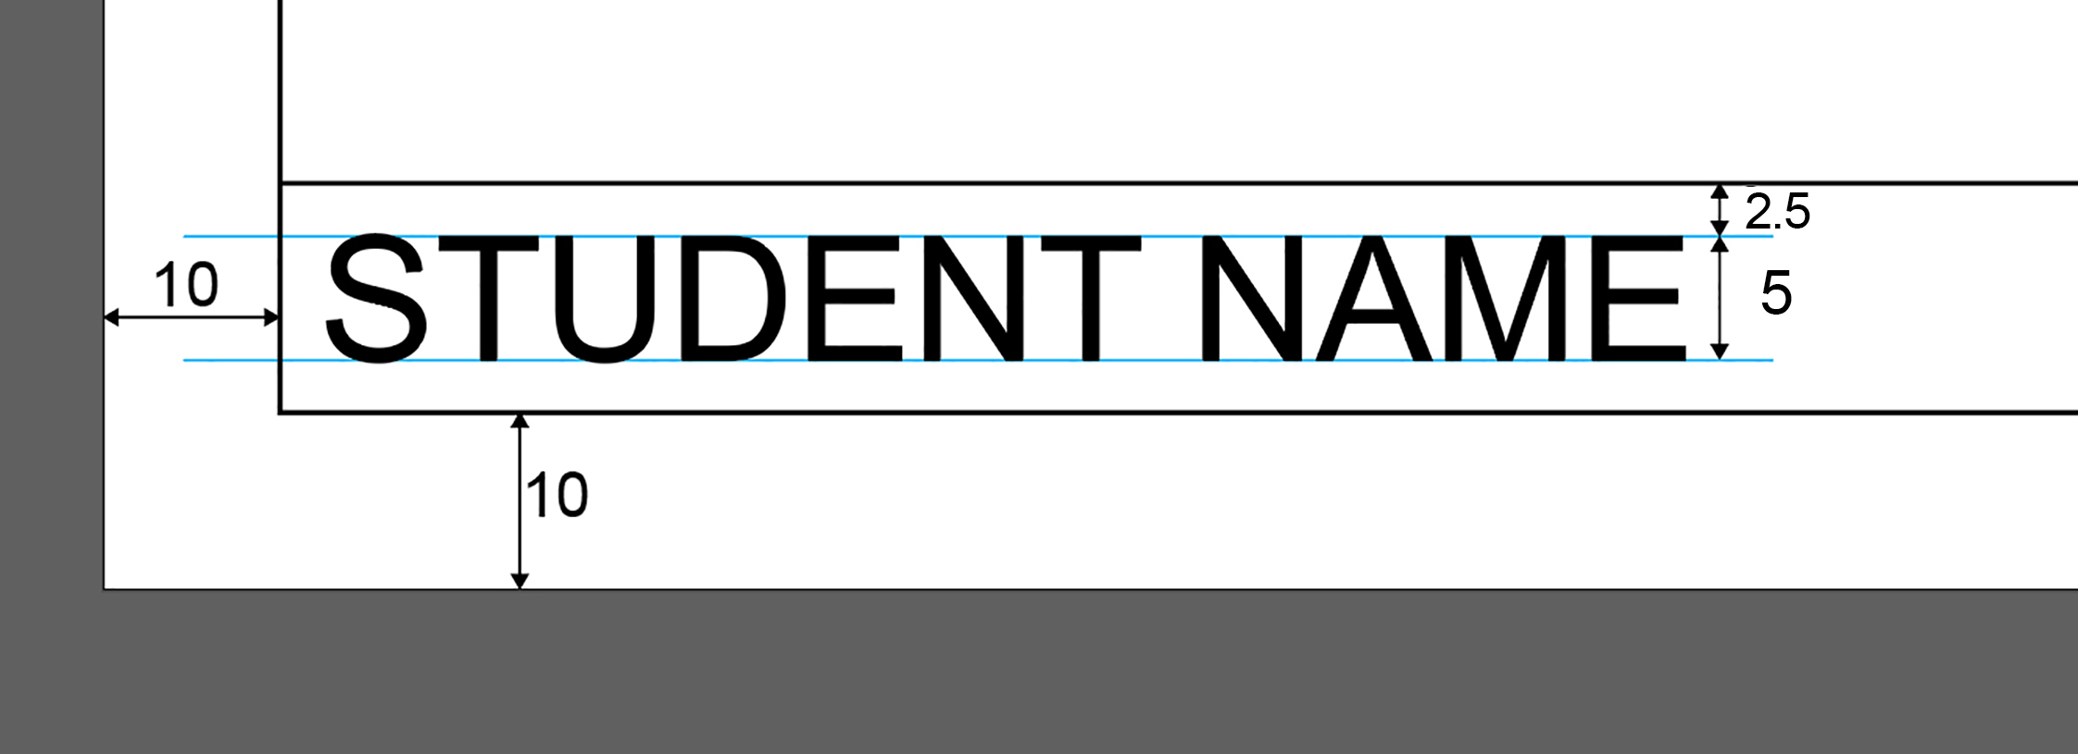
Figure 20
Size and placement of written information in the title block

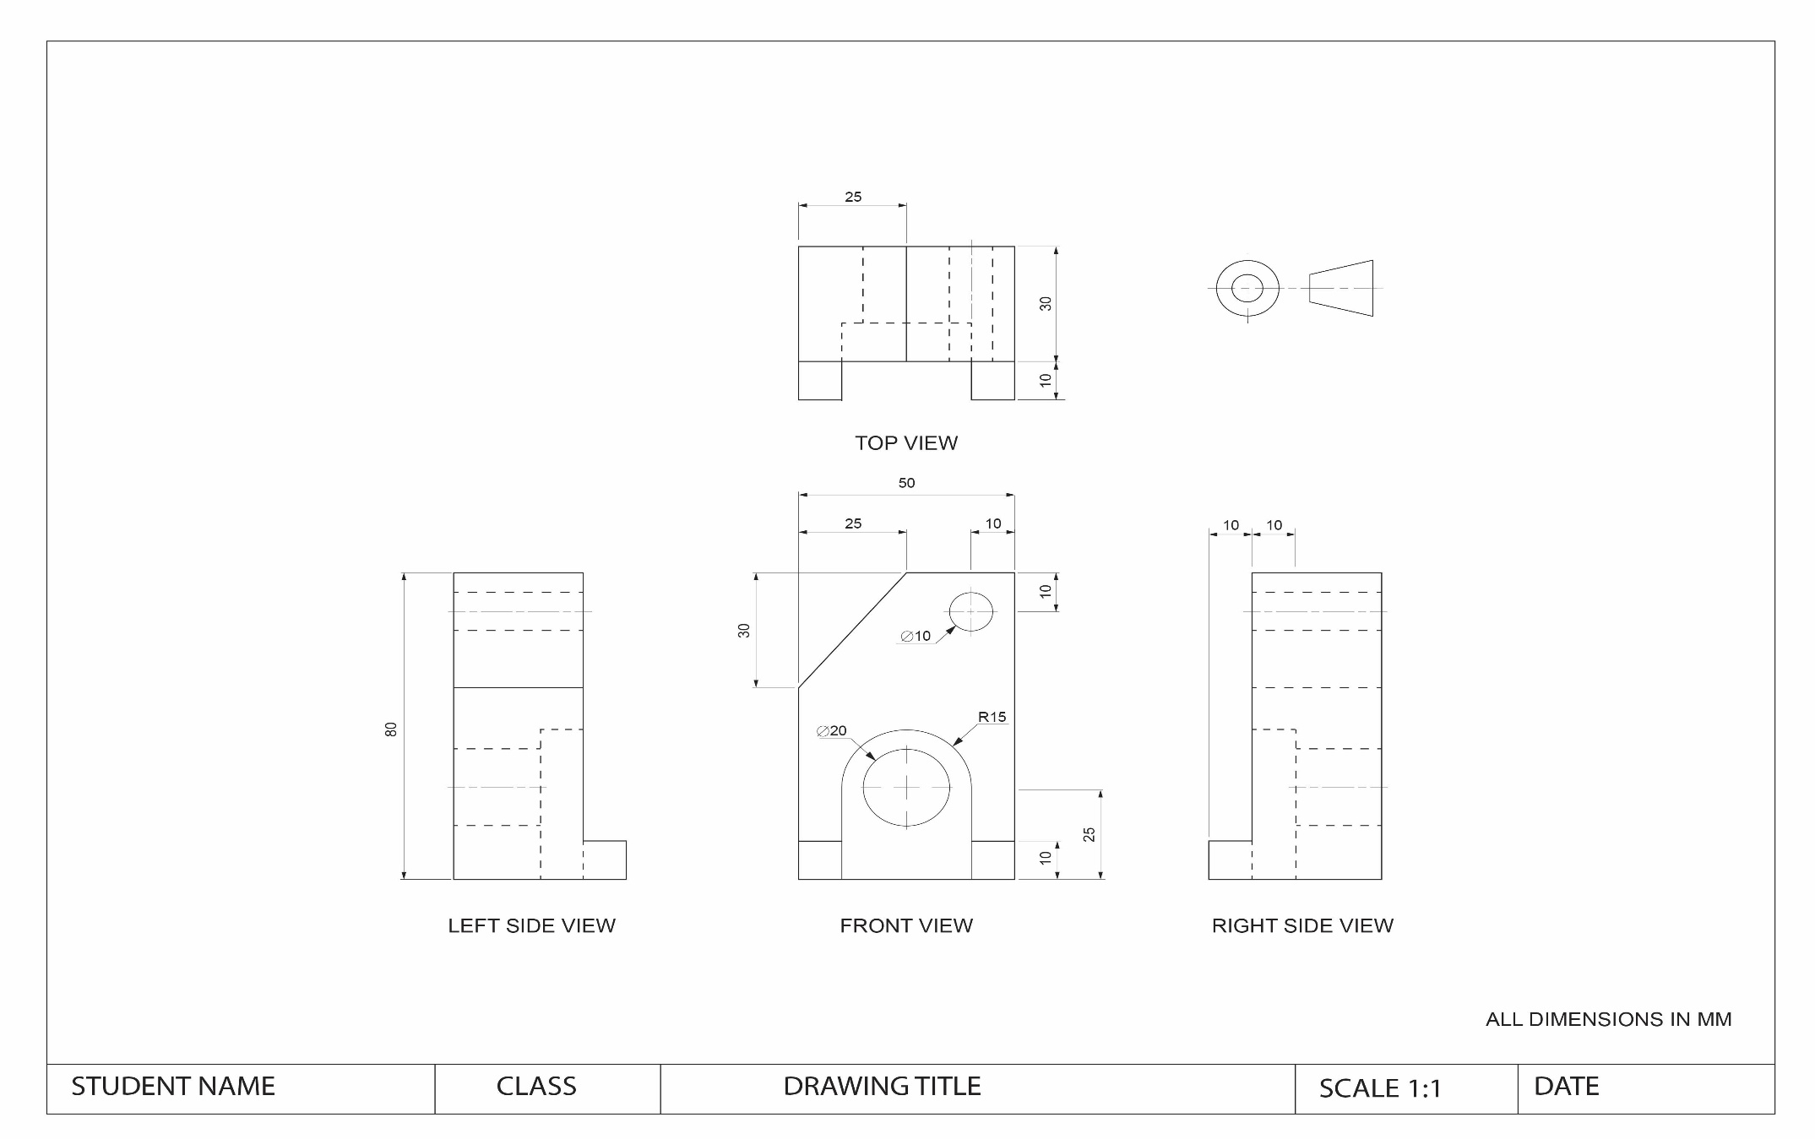

Figure 21
Third angle orthogonal drawing showing views, dimensions, naming of view and the third angle orthogonal symbol. (FIGURE NOT TO SCALE).

Plans and elevations
Where Orthogonal drawings refer to ‘views’, architectural drawings refer to plans and elevations.
Plans and elevations may include:
- site plans (showing relationship of the building to site, orientation of site with title boundary, larger foliage or landscape features)
- landscape plans (design concepts for external landscaping for gardens, parks etc.)
- floor plans and elevations
Floor plans and elevations can provide information about the following: overhanging roof lines
- openings including windows and doors
- stairways
- key dimensions for overall sizes, rooms, doors and windows where appropriate.
- Presentation drawings for floor plans and elevations should include: labelling; for example, rooms and key descriptive notes
- north point symbol (on plans)
- a title block including scale, date drawn, author’s name, drawing number and site address if applicable.
Refer to Figure 22
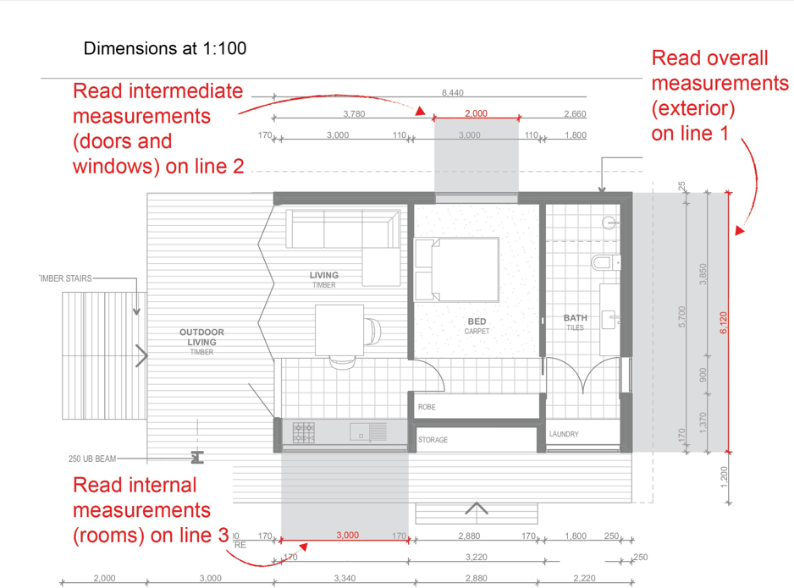

Figure 22
Ground floor plan at 1:100 showing an overview of line conventions used for architectural drawings.
FIGURE NOT TO SCALE

Scale
Plans and elevations depict the built environment including buildings and landscape environments. Some drawings may depict a group of buildings together, yet others show a section of a room. For this reason a wide range of scales can be applied to the drawings including 1:500, 1:100, 1:15, 1:20 and 1:5. The level of detail required in a drawing will impact the scale used.
Refer to Figures 23 and 24.
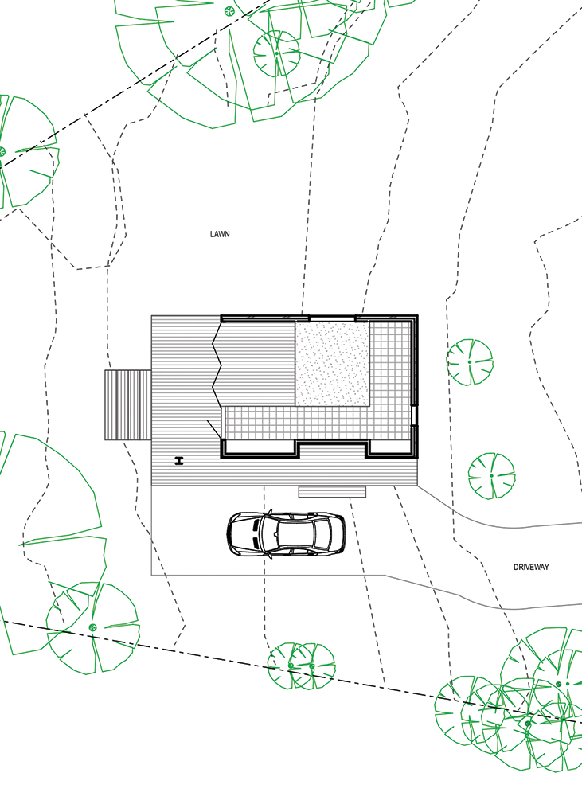 | 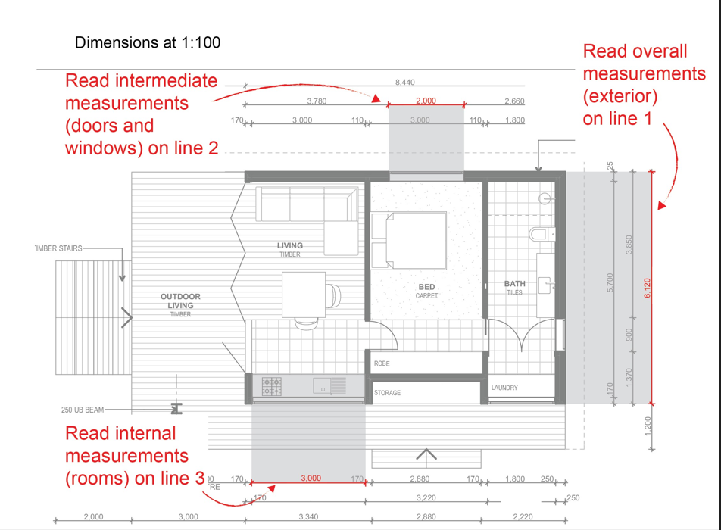
Figure 23
Representations of scale of the same building in plans (from left) at 1:200, 1:100 and 1:50
FIGURE NOT TO SCALE

‘North point’ symbol
A building must be represented according to its ‘aspect’, including sunlight and shade. . Therefore, a ‘north point’ symbol needs to be clearly shown on plans. The symbol must clearly indicate the direction of north; this is often done in a graphic representation of a compass but can also be indicated simply with an arrow accompanied by the letter ‘N’ or the word ‘NORTH’. A plan should be orientated on the page so that north is at the top of the drawing.

Views
Views of plans are named in order of representation such as SITE PLAN, GROUND FLOOR PLAN, FIRST FLOOR PLAN and subsequent floor plans. Elevations are named by the direction they face, shown in relation to the ‘North point’ on the plan. Thus, the four elevations of a rectangular building are written as NORTH ELEVATION, EAST ELEVATION, SOUTH ELEVATION and WEST ELEVATION.

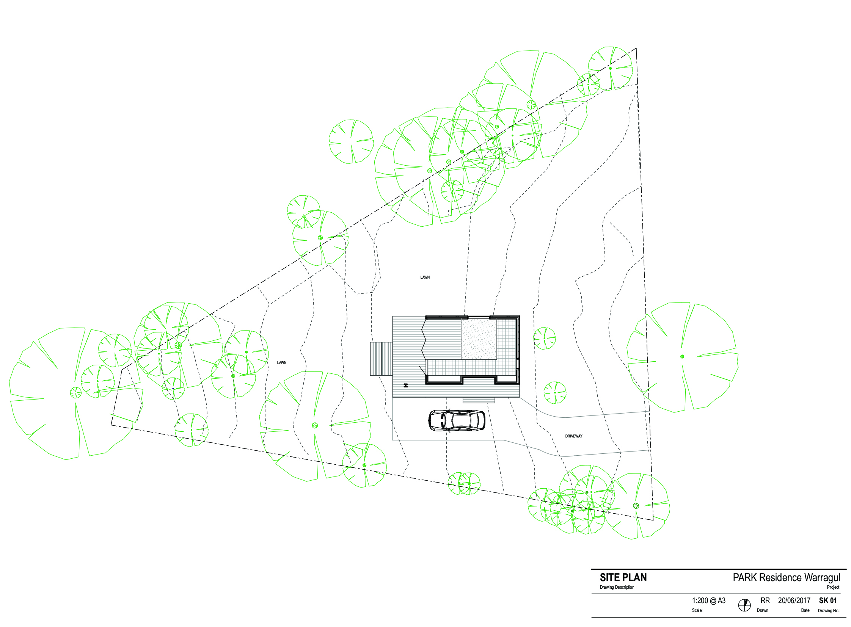

Figure 24
Landscape plan detailing site, contour levels, trees and vegetation types at the appropriate scale of 1:200. FIGURE NOT TO SCALE

Setting out plans and elevations
Plans and elevations are set out differently from a third-angle orthogonal drawing. It is common for architectural drawings to show one (or more) plan(s) per sheet and one (or more) elevation(s) per sheet (Figure 25). Groups of drawings should be drawn to the same scale and they should correspond with each other in terms of visual alignment. If plans are indicating different levels of a building a dotted line (hidden detail) should be shown on the previous level to indicate relative position. With elevations they should be arranged where practicable on a common ground line and the elevations positioned relative to a common (shared) corner, for example; ‘North Elevation’ then ‘West Elevation’;’South Elevation’ then ‘East Elevation’. Grouping of such drawings presented on the same page should generally be drawn to the same scale.
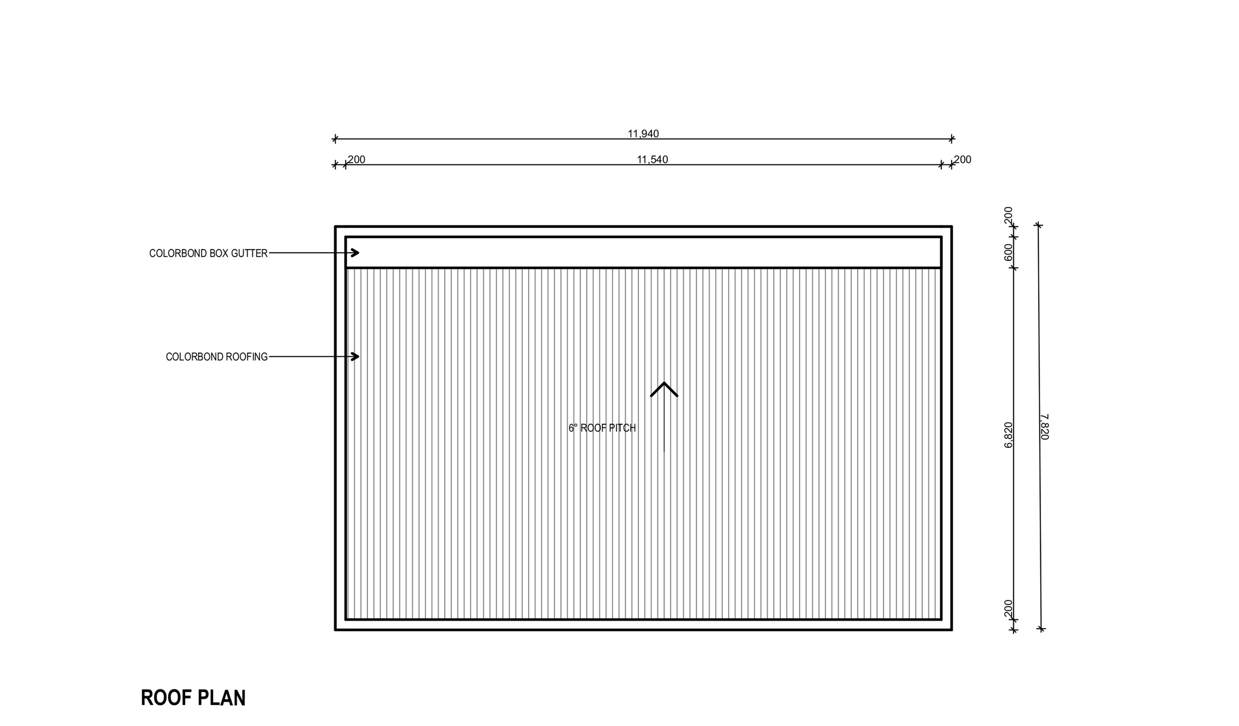 | 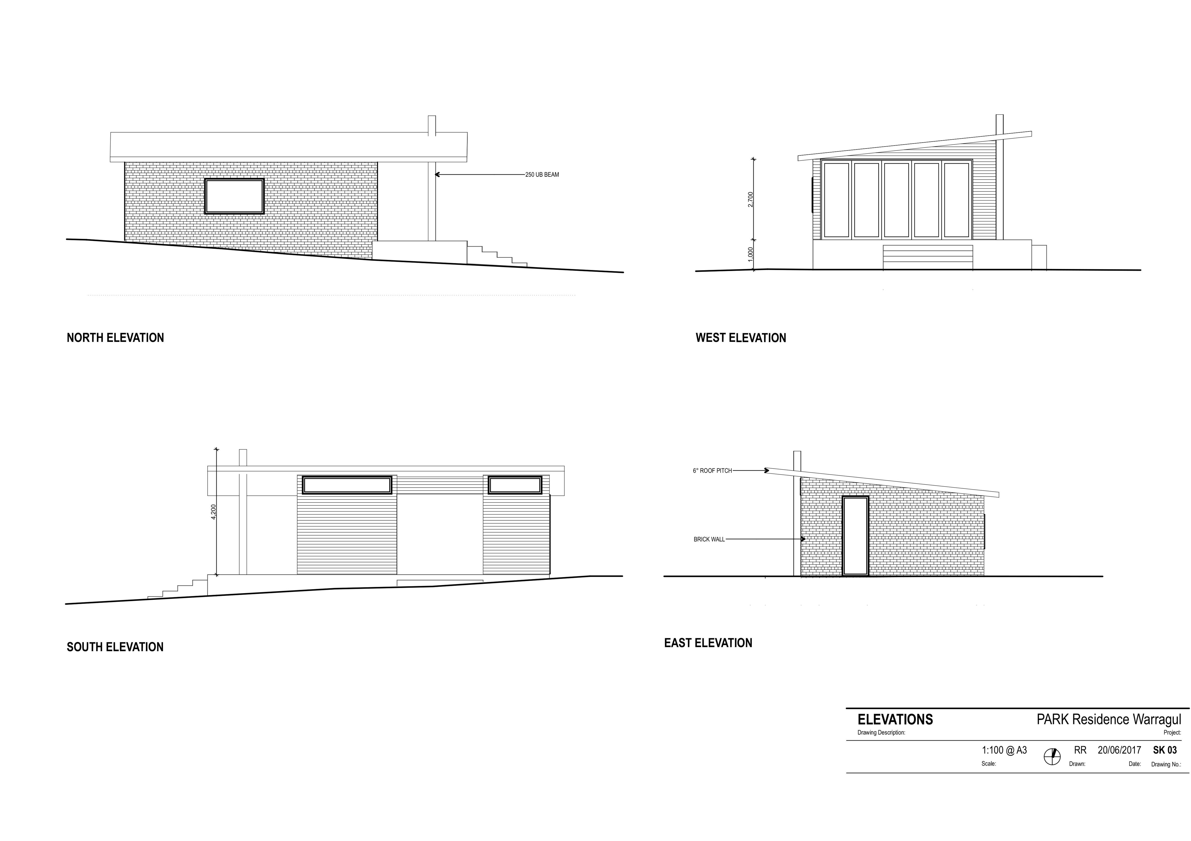
Figure 25
Two floor plans are set out at left. Four elevations are set out at right.
FIGURE NOT TO SCALE

Table 3 provides a recommendation of the layout of architectural drawings that require more than one sheet. See also Figure 26
Drawing type | Drawings per sheet | Typical scale
Cover sheet | List of drawings and views
Site plan | One per sheet, centred. | 1:200
Floor Plans in order. | One or two plans to a sheet | 1:100
Elevations in order | Two elevations to a sheet, centred. | 1:100
Table 3

Table 4 outlines the recommended conventions for lines in plans and elevations.
Line conventions
Thick continuous | 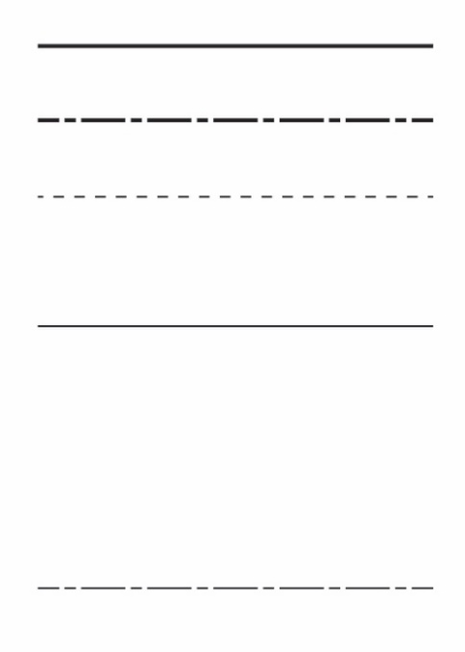 | Outlines of exterior walls  Ground lines.
Thick chain |  | Title boundary
Thin dashed |  | Roof over in plan or representation of eaves
Thin continuous |  | General building details  Roof ridge lines  Fall indicator in showers, bath, etc.  Direction of swing indicator for doors and panels  Doors, windows  Dimension lines, projection lines
Table 4

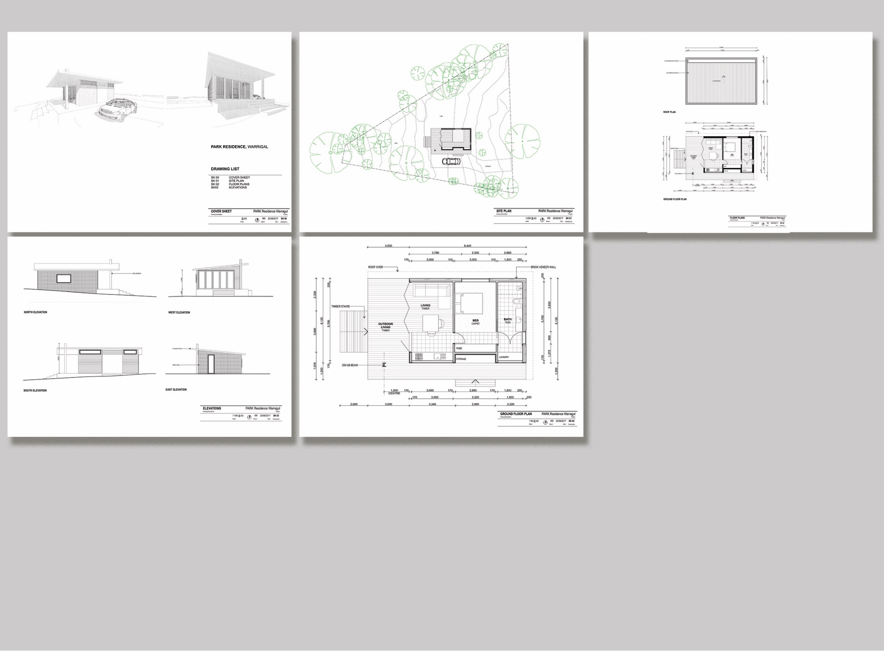

Figure 26
A collection of drawings for a project.
From top left clockwise: cover sheet, site plan, plans, elevations and plan at a larger scale.

Symbols in plans and elevations
In addition to lines, other symbols are used to denote features of buildings.

Scale
All architectural symbols need to be drawn at the same scale as the drawing on which they are shown. Tables 5 and 6 show a range of architectural features with typical dimensions and suggested scales.

Representing walls
There are two main kinds of walls in buildings: exterior and interior.
Interior walls are represented differently depending on the scale of the drawing. At a scale of 1:100 they are shown as a solid, continuous line 1mm thick; at a scale of 1:50 or 1:20 they are shown as two parallel thin lines 2 mm or 5 mm apart respectively.
Exterior walls are shown as two parallel lines representing the thickness of the wall. At a scale of 1:100 the two lines create a 3mm thick line. They are usually filled in black or grey (the grey to reduce visual impact) or hatched to represent a particular material. Refer to Tables 5 and 6.
When working with different scales, representing the thickness of walls can become confusing. An easy way to demonstrate the representation of walls is that the exterior wall is solid and 3 times thicker than the interior wall.
Typical widths/ thicknesses of architectural features
Item | Width in mm | At 1:100 in mm | At 1:50 in mm | At 1:20 in mm
Exterior wall | 270 | 3 | 6 | 15
Interior wall | 110 | 1 | 2 | 5
Door | 820 | 8 | 16 | 40
Kitchen bench | 600 | 6 | 12 | 30
Island bench | 1000 | 10 | 20 | 50
Bathroom bench | 500 | 5 | 10 | 25
Toilet space allowance | Min w 900 x 1500 | 9 x 15 | 18 x 30 | 45 x 90
Wardrobe | 600 | 6 | 12 | 30
Table 5

Typical heights of architectural features shown in elevation
Item | Height in mm | At 1:100 in mm | At 1:50 in mm | At 1:20 in mm
Domestic floor to ceiling | Typical 2700 | 27 | 34 | 170
Door | 2040 | 20 | 40 | 120
Kitchen bench | 900 | 9 | 18 | 45
Island bench | 900 | 9 | 18 | 45
Bathroom bench | 900 | 9 | 18 | 45
Dining table | 750 | 7.5 | 15 | 37.5
Study desk | 750 | 7.5 | 15 | 37.5
Coffee table | 400 | 4 | 8 | 20
Table 6

Representing doors
In the plan view, doors are shown as a thick line running perpendicular to the closed position and in the full open position of the door. A thin line arc is used to describe the swing. Sliding doors are shown as thick lines, spaced apart, as if positioned in a double or triple track, and arrows are placed parallel to the direction of slide to denote direction of movement. Refer to Table 5 for the representation of door widths.
In the elevation views, doors are shown as plain rectangles without handles. Doors to wardrobes, cupboards or other joinery are shown with thin diagonal lines extending from the upper and lower corners on the hinged side to the centre on the opposite side to denote direction of swing. Refer to Figure 27.
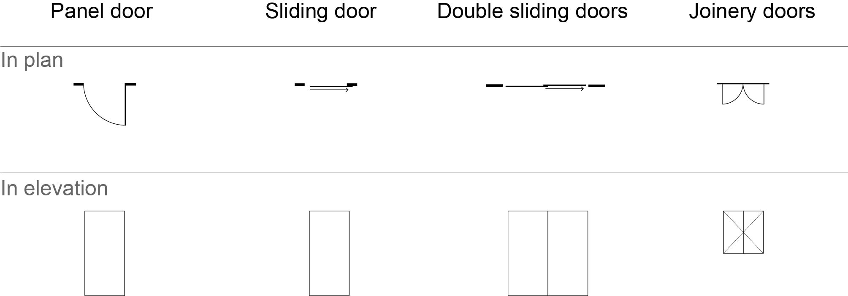

Figure 27
Doors at 1:100 scale.

Representing windows
Windows are represented using combinations of thin lined rectangles.
In the plan view, windows are shown as a long, white rectangular gap, the same thickness as the wall in which it is placed. The glass is then shown by one or two thin continuous lines centred and parallel to the wall.
Windows in the elevation views are drawn to scale and are shown as thin lined rectangles. Frames are shown simply, and the direction of opening is shown with a diagonal ‘V’. Refer to Figure 28.
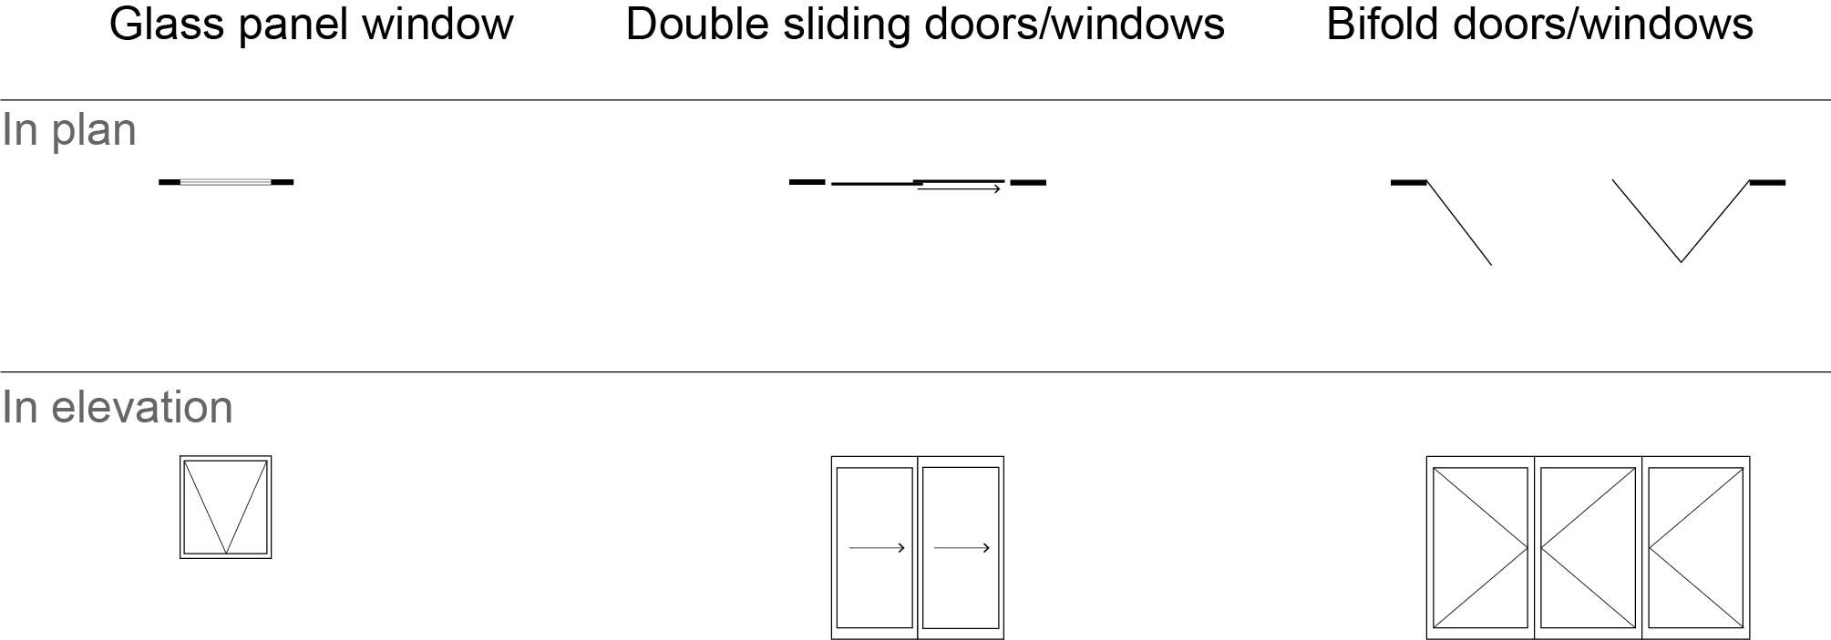

Figure 28
Doors shown at 1:100 scale.

Representing interior features
A consistent set of symbols is used to represent interior features. The emphasis is on clarity, so details are minimal and do not detract from the purpose of the drawing. Symbols are constructed from thin continuous lines. Refer to Figure 29.
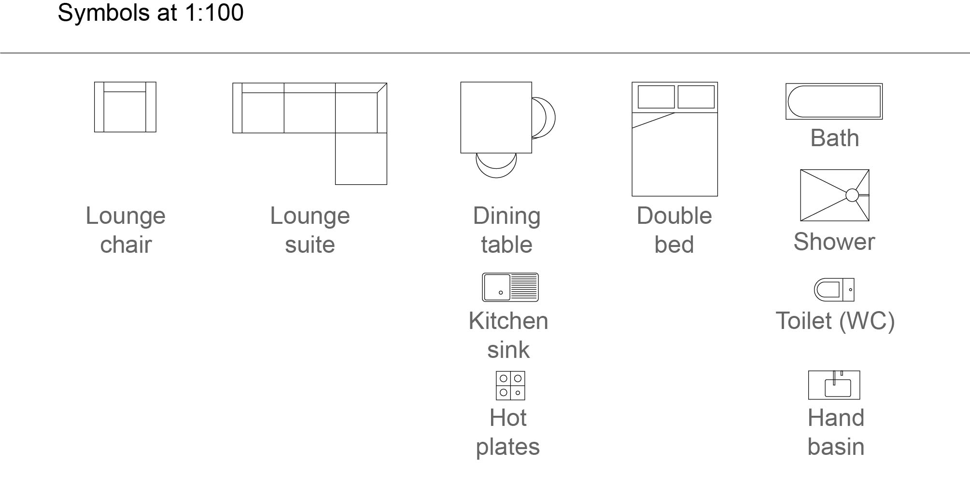

Figure 29
Symbols used to represent interior features.

Stairs and ramps
In a plan view, stairs are shown as an outline. A thin continuous line is drawn through the centre of the staircase to indicate the direction of rise. In an elevation elevation views, a staircase is drawn as it appears from the front, rear or side, including relevant handrails. A ramp is shown in the plan view as a simple rectangle. Refer to Figure 30.
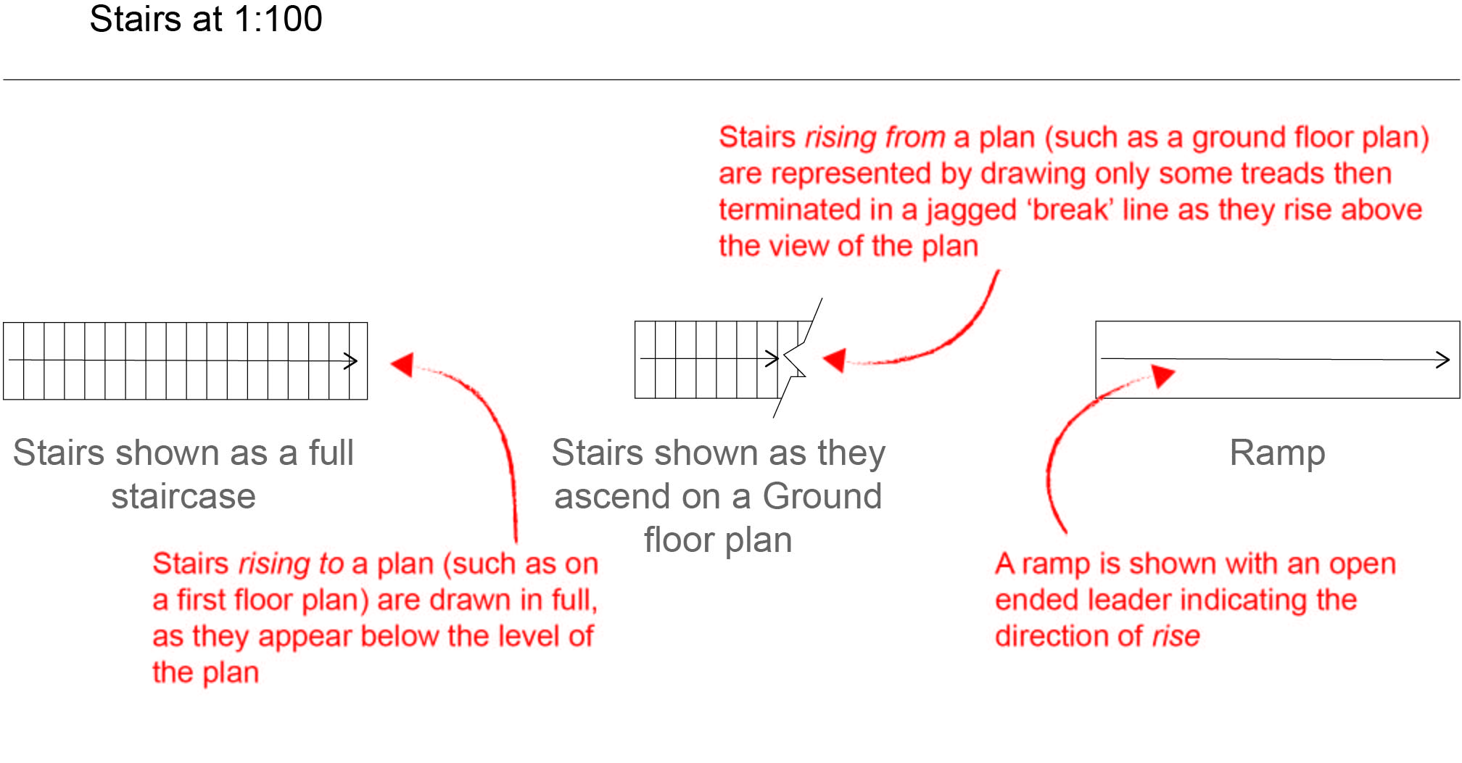

Figure 30
Stairs and ramps details

Dimensioning plans and elevations
In plans and elevations dimensions should be included for clarity and purpose. For example, a floor plan may include room dimensions but may not include sizes of kitchen cupboards.

Dimension placement
Dimensions referencing features are placed in the following order:
- The first line (close to the building) shows external features such as windows or other openings and external walls,
- The second line shows internal features such as internal rooms and wall thicknesses.
- The third line shows the overall external building dimensions, corner to corner.
Projection lines are used along the dimension line to depict features of the design. Projection lines are short, 3mm long and centred across the dimension line. Longer projection lines may be used at either end of an overall dimension line for clarity.
Plans and elevations do not use arrows to terminate dimensions. Dimensions in plans and elevations are terminated with short, 3 mm long 45 degree cross marks centred on the dimension line.
Dimension numbers are indicated in small sans serif figures. Numbers are placed above dimension lines and centred. Dimensions that denote sizes too small to fit the numbers may be placed directly adjacent the space. Dimension numbers should print at 2 mm high.
All dimensions are recorded in millimetres. Refer to Figure 31.

Labelling
When a sheet contains only one view, the name of the view is shown in the title block of the drawing. Where the sheet contains more than one view, each view is titled at the lower left corner of the view. View names should be shown at approximately 3 mm high, in uppercase and in a sans serif face.

Labelling features
Plans and elevations sometimes require annotations for additional information that may not be apparent in the drawing. An example of an annotation could be “ROOF OVER” to denote a roof line above in a plan. These annotations should be in small blocks of left aligned, sans serif uppercase that print at 2mm high.

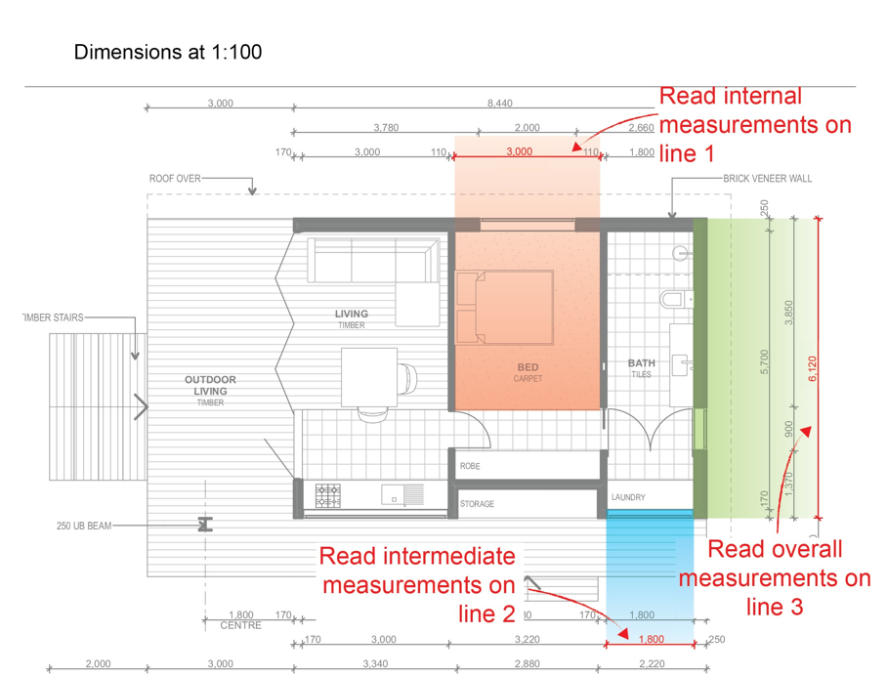

Figure 31
Dimension placement - three lines of dimensions outside each wall.

Naming plan and elevation drawings
Presentation drawings of plans and elevations must have a title block that includes the following:
- drawing title
- project title
- scale
- sheet size
- north point indicator
- author’s name
- date drawn
- sheet number.
Refer to Figure 32
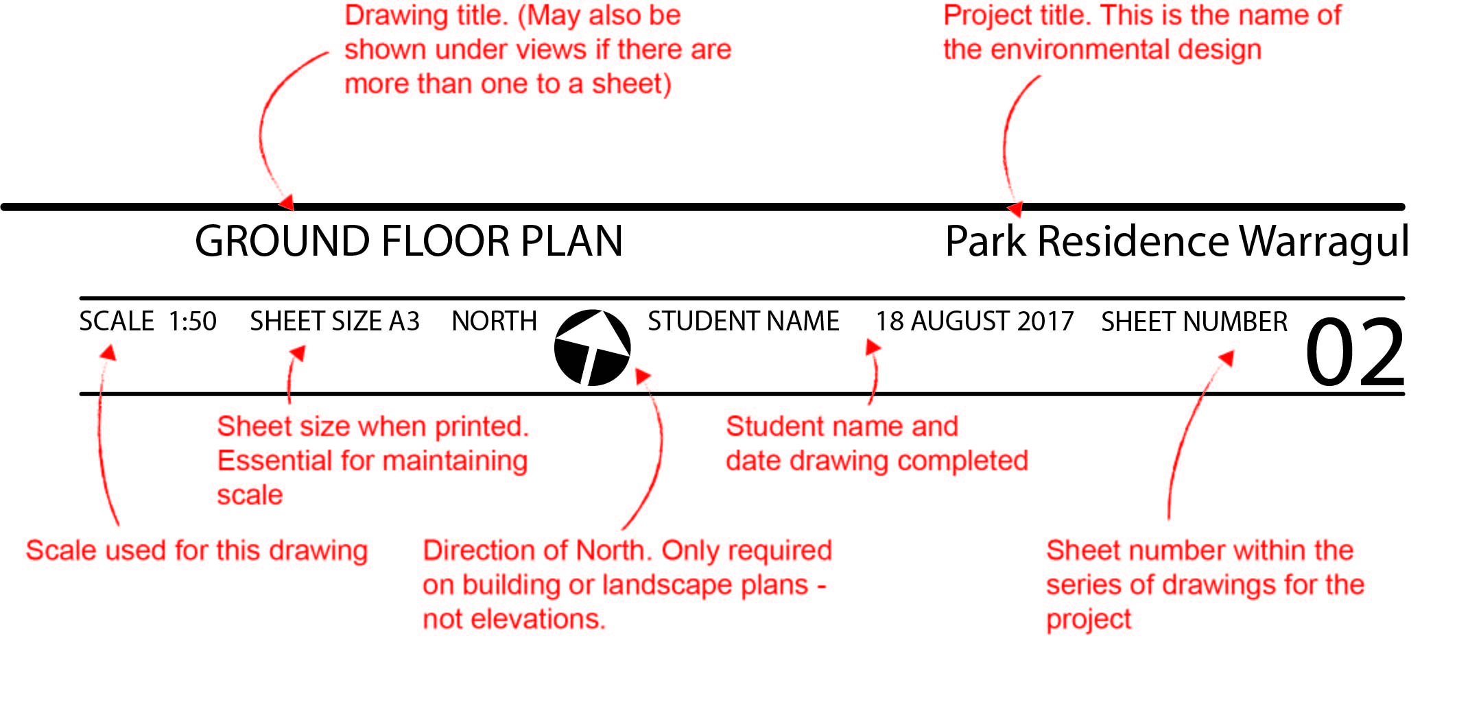

Figure 32
An example of a title block suitable for environmental drawings.
This particular title block would be positioned right aligned and placed in the bottom right corner of a sheet.

Technical Flats
Technical flats are visual representations of clothing designs created through two-dimensional drawings, equivalent to a blueprint. These drawings show the garment when laid flat and use basic solid lines to showcase the details and features of a garment in a straightforward, precise illustration that captures the essential elements of a design, including seams, stitches and patterns. seams, stitches, and fabric patterns. Technical flats provide a clear and accurate depiction, serving as a valuable tool for communication between designers, pattern makers, and manufacturers in the fashion industry. Refer to Figure 33, 34 and 35
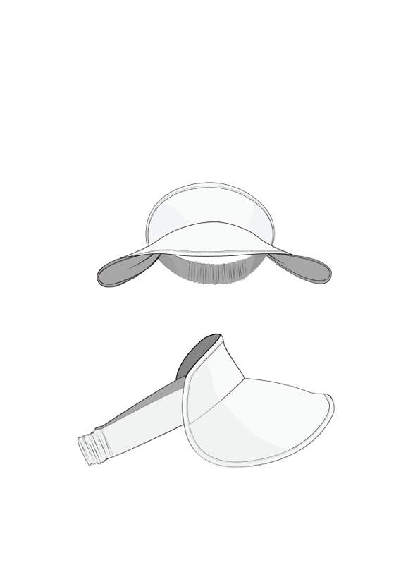
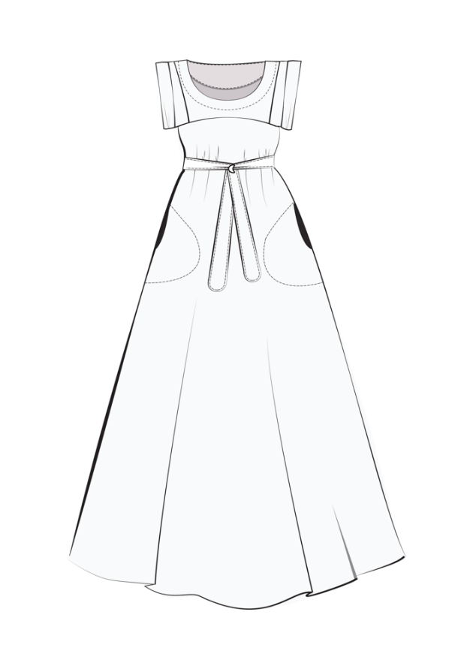
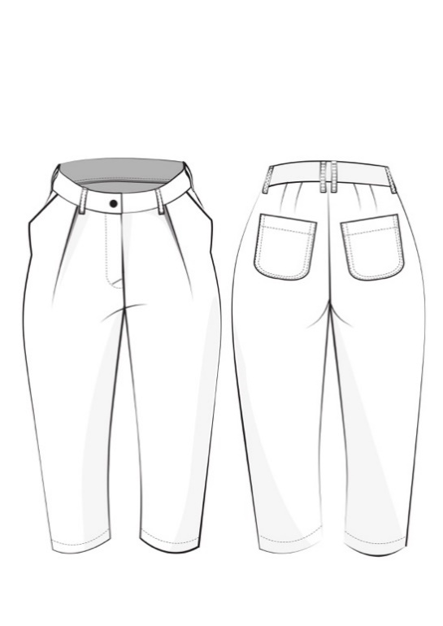
Figure 32 Celestial Dress by Pattern Fantastique
Figure 32 Celestial Dress by Pattern Fantastique
Figure 32 Celestial Dress by Pattern Fantastique

