Using formative assessment rubrics in English


Punctuation

Levels 1–6

Authorised and published by the Victorian Curriculum and Assessment Authority
Level 7, 2 Lonsdale Street
Melbourne VIC 3000
© Victorian Curriculum and Assessment Authority 2019.

No part of this publication may be reproduced except as specified under the Copyright Act 1968 or by permission from the VCAA. Excepting third-party elements, schools may use this resource in accordance with the VCAA educational allowance. For more information go to: https://www.vcaa.vic.edu.au/Footer/Pages/Copyright.aspx.
The VCAA provides the only official, up-to-date versions of VCAA publications. Details of updates can be found on the VCAA website: www.vcaa.vic.edu.au.
This publication may contain copyright material belonging to a third party. Every effort has been made to contact all copyright owners. If you believe that material in this publication is an infringement of your copyright, please email the Copyright Officer: vcaa.copyright@edumail.vic.gov.au
Copyright in materials appearing at any sites linked to this document rests with the copyright owner/s of those materials, subject to the Copyright Act. The VCAA recommends you refer to copyright statements at linked sites before using such materials.
At the time of publication the hyperlinked URLs (website addresses) in this document were checked for accuracy and appropriateness of content; however, due to the transient nature of material placed on the web, their continuing accuracy cannot be verified.

The VCAA logo is a registered trademark of the Victorian Curriculum and Assessment Authority.

Contents
What is formative assessment? 4
Using formative assessment rubrics in schools 4
The formative assessment rubric 5
Links to the Victorian Curriculum F–10 5
The formative assessment task 8
Description of the task (administration guidelines) 8
Evidence collected from this task 9
Interpreting evidence of student learning 10
Setting the scene 10
Sample 1 11
Sample 2: Evidence of student learning 13
Sample 2 14
Sample 2: Evidence of student learning 15
Any feedback given 15
Sample 3 16
Sample 3: Evidence of student learning 19
Any feedback given 19
Using evidence to plan for future teaching and learning 20
Teacher reflections 20

What is formative assessment?
Formative assessment is any assessment that is used to improve teaching and learning. Best-practice formative assessment uses a rigorous approach in which each step of the assessment process is carefully thought through.
Assessment is a three-step process by which evidence is collected, interpreted and used. By definition, the final step of formative assessment requires a use that improves teaching and learning.
For the best results, teachers can work together to interrogate the curriculum and use their professional expertise and knowledge of their students to outline a learning continuum including a rubric of measurable, user-friendly descriptions of skills and knowledge. Teachers can draw on this learning continuum and rubric to decide how to collect evidence of each student’s current learning in order to provide formative feedback and understand what they are ready to learn next.
The VCAA’s Guide to Formative Assessment Rubrics outlines how to develop a formative assessment rubric to collect, interpret and use evidence of student learning to plan teaching and learning. For more information about formative assessment and to access a copy of the guide, please go to the Formative Assessment section of the VCAA website.

Using formative assessment rubrics in schools
This document is based on the material developed by one group of teachers in the 2019 Formative Assessment Rubrics project. The VCAA acknowledges the valuable contribution to this resource of the following teachers: Emma Mallia (Brunswick North West Primary School) and Anne McDonald (Tyabb Primary School), Allison Anderson (Kunyung Primary School) and Angela Houghton (Murrumbeena Primary School). The Victorian Curriculum and Assessment Authority partnered with the Assessment Research Centre, University of Melbourne, to provide professional learning for teachers interested in strengthening their understanding and use of formative assessment rubrics.
This resource includes a sample formative assessment rubric, a description of a task/activity undertaken to gather evidence of learning, and annotated student work samples.
Schools have flexibility in how they choose to use this resource, including as:
- a model that they adapt to suit their own teaching and learning plans
- a resource to support them as they develop their own formative assessment rubrics and tasks.
This resource is not an exemplar.
Additional support and advice on high-quality curriculum planning is available from the Curriculum Planning Resource.

The formative assessment rubric
The rubric in this document was developed to help inform teaching and learning in English. This rubric supports the explicit teaching of punctuation.
This formative assessment rubric is designed to provide teachers with information about what students are currently demonstrating in relation to punctuation. It is designed to enable students to show that they can:
- use a range of punctuation during writing
- use punctuation to make their writing more interesting, precise and fluent.

Links to the Victorian Curriculum F–10

Curriculum area: English
Mode: Writing
Strand: Language
Sub-strand: Text structure and organisation
Levels/Bands: Level 1 to 6
Achievement standard/s extract: Level 6
They use accurate … punctuation for clarity ...
Content Description/s: Level 1
Recognise that different types of punctuation, including full stops, question marks and exclamation marks, signal sentences that make statements, ask questions, express emotion or give commands (VCELA190)
Level 2
Recognise that capital letters signal proper nouns and commas are used to separate items in lists (VCELA225)
Level 3
Know that word contractions are a feature of informal language and that apostrophes of contraction are used to signal missing letters (VCELA260)
Level 4
Recognise how quotation marks are used in texts to signal dialogue, titles and quoted (direct) speech (VCELA291)
Level 5
Understand how the grammatical category of possessives is signalled through apostrophes and how to use apostrophes with common and proper nouns (VCELA322)
Level 6
Understand the uses of commas to separate clauses (VCELA349)

Learning continuum  English  Levels 1 – 6  Mode: Writing  Strand: Language  Sub-strand: Text structure and organisation. |  |  | Phase 1 | Phase 2 | Phase 3 | Phase 4 | Phase 5 | Phase 6
 |  |  | Student uses boundary punctuation to write simple sentences. | Student uses punctuation accurately to write a variety of sentences (question, exclamation, comment and statement). | Student uses punctuation to assist the reader. | Student experiments with punctuation to give voice/engage the reader. | Student uses punctuation for cohesion in a complex sentence. | Student uses punctuation to create complex texts for different purposes and audiences.
Organising element | Action | Insufficient evidence | Quality criteria
Punctuation | 1.Capitalisation | 1.0 Insufficient evidence |  |  | 1.1 Uses capital letters to signal proper nouns (names, places, days of the week, and months of the year). | 1.2 Uses capital letters for titles. | 1.3 Uses capital letter for acronyms. For example, NSW.
Punctuation | 2. Boundary punctuation | 2.0 Insufficient evidence | 2.1 Uses a capital letter at the beginning of a sentence and a full stop at the end of a simple sentence. | 2.2 Uses an exclamation mark or question mark at the end of a simple sentence to match the meaning. |  |  | 2.3 Writes correct boundary punctuation for dialogue.  For example, “Come here,” called Tom. | 2.4 Writes correct boundary punctuation for split dialogue.  For example, “Come here,” called Mum, “you need to finish your homework.”
Punctuation | 3. Commas | 3.0 Insufficient evidence |  |  | 3.1 Uses commas to separate a list. | 3.2 Experiments with commas in complex sentences. | 3.3 Experiments with commas in dialogue. | 3.3 Separates clauses in complex sentences with a comma.
Punctuation | 4. Quotation marks | 4.0 Insufficient evidence |  |  |  | 4.1 Uses quotation marks to signal dialogue, titles and/or direct speech.  For example, “come here” called Mum  (additional punctuation not assessed). |  | 4.2 Uses quotation marks for split dialogue.  For example, “come here” called Mum, “you need to finish your homework.”  (additional punctuation not assessed).
Punctuation | 5. Apostrophes | 5.0 Insufficient evidence |  |  | 5.1 Uses apostrophes for contractions. |  | 5.2 Uses apostrophes for singular possession including words ending in s. | 5.3 Uses apostrophes for plural possessives.

The formative assessment task
The following formative assessment task was developed to elicit evidence of each student’s current learning and what they are ready to learn next.

Description of the task (administration guidelines)
Instructions
Teachers:
- collect recent independent writing samples (no older than three weeks), or have students complete a narrative writing piece
- familiarise themselves with the rubric and teacher guidelines
- use the rubric to evaluate students’ ability to use punctuation when writing.
Considerations
- This rubric is designed to be used at different stages throughout the year to inform student progress and their ability to punctuate different genres.
- Writing tasks should be reflective of current classroom learning to engage students.
- Students may complete the task in the format that best suits their needs, for example handwritten or typed.
Notes on terminology
- Boundary punctuation includes capital letters, questions marks, full-stops, exclamation marks.
- Split dialogue is when dialogue is interrupted by other text. The second speech fragment begins with a lower case because it is a continuation of the first speech fragment. For example: "Are you telling me," he gasped, "that you are lost?" (The second speech fragment begins with lower case because the sentence is split.)
- Experiments refers to when students may be attempting to use a form of punctuation but are not using it correctly.
Glossary
Simple sentence
- Contains one clause and expresses a complete thought. It has a subject and a verb and may also have an object or complement.
Complex sentence
- Contains an independent (or main) clause and one or more dependent (or subordinate) clauses. The dependent clause is joined to the independent clause through subordinating conjunctions like ‘when’, ‘while’, and ‘before’. A complex sentence will not make sense without an independent clause. In the following example, the dependent clause is italicised and the conjunction is in bold: ‘When the sun came out, we all went outside.’
See the Victorian Curriculum F–10 English Glossary for additional information.

Evidence collected from this task
- Student writing samples

Interpreting evidence of student learning
Evidence collected from each student was mapped against the rubric:
The quality criteria that were achieved was shaded in blue.
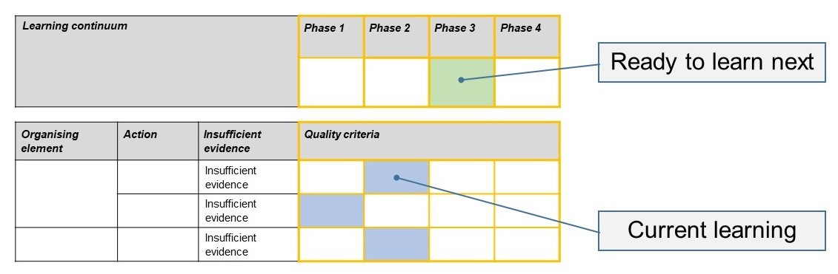
The phase that the student is ready to learn next was shaded in green.

Please note, the following annotated student work samples are representative examples only.

Setting the scene
The following samples were collected and annotated by teachers at three different schools. At each school, writing is taught using a different approach. There was variation in the presentation of the task with some teachers explicitly informing their students that punctuation would be assessed and that they had to include examples of what they knew about punctuation within their writing. In each case, students were provided with a writing prompt, and time to plan, draft and edit. It was expected that students already had a sense of how to construct a narrative text.

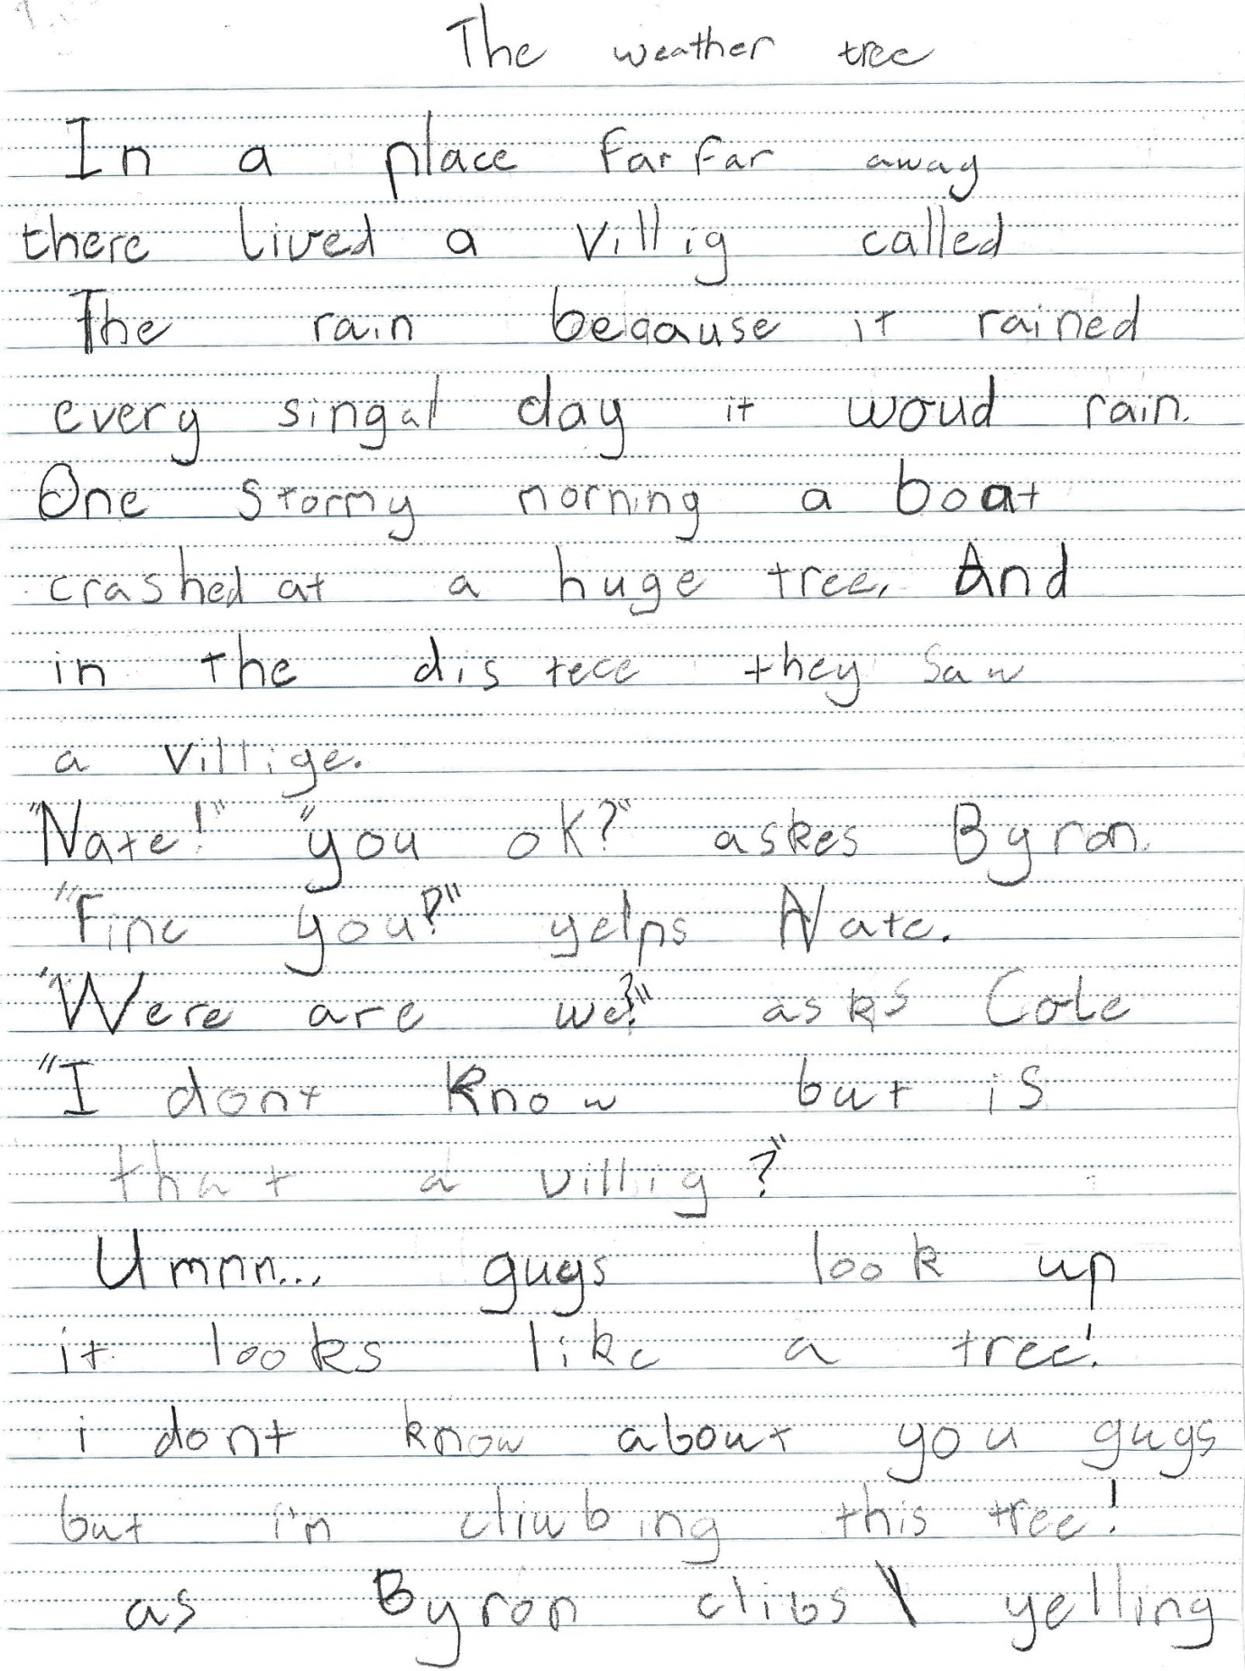
Sample 1

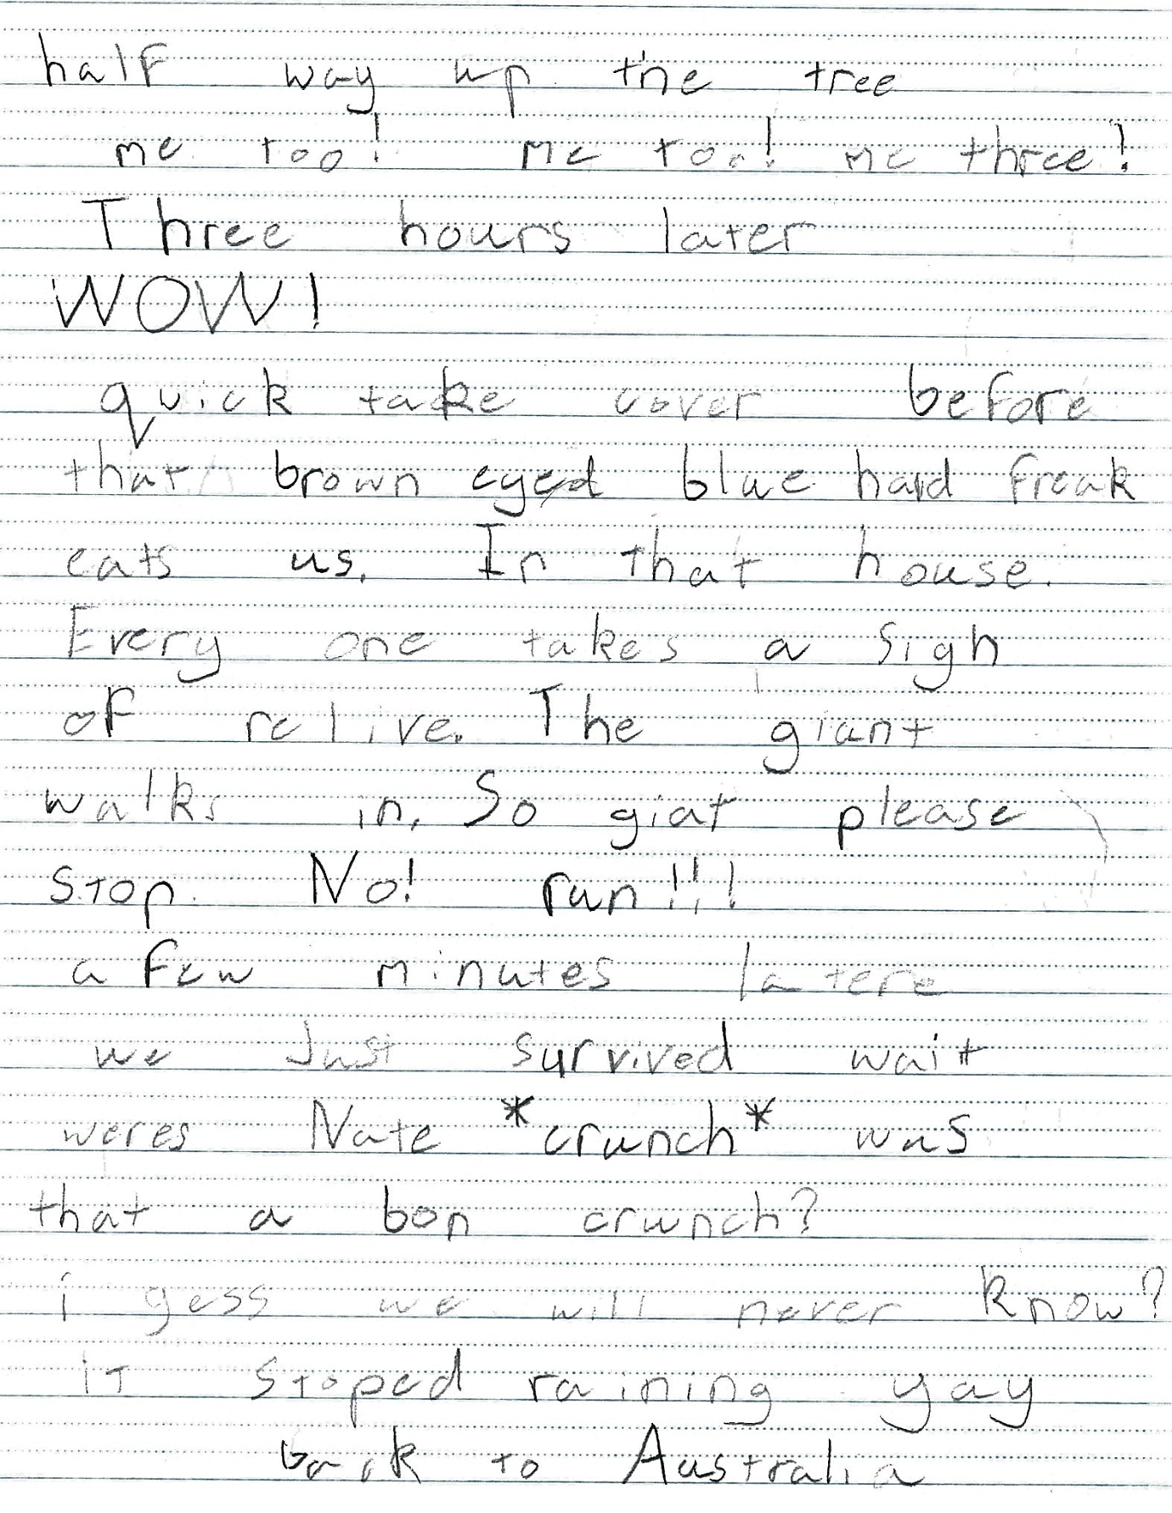

Sample 1: Evidence of student learning

Annotations
- 1.1 Bryon, Nate, Australia.
- 2.2 Evidence that both question mark and exclamation mark are used several times each. “Nate!” “you ok?” asks Byron.
- 4.1 Showed enough evidence of quotation marks used correctly. E.g. “Where are we?” asks Cole. However, this was used inconsistently. Not all dialogue is punctuated with quotation marks.

Insufficient evidence:
- Action 3 and 5.

What is the student ready to learn next?
This student is ready to undertake further learning at Phase 3. She has accomplished the criteria for Phases 1 and 2 and has accomplished one out of three of the criteria in Phase 3.
The student has provided evidence that she can use a range of punctuation to assist the reader; however, additional evidence is required to establish what this student knows about using commas and apostrophes (Actions 3 and 5).
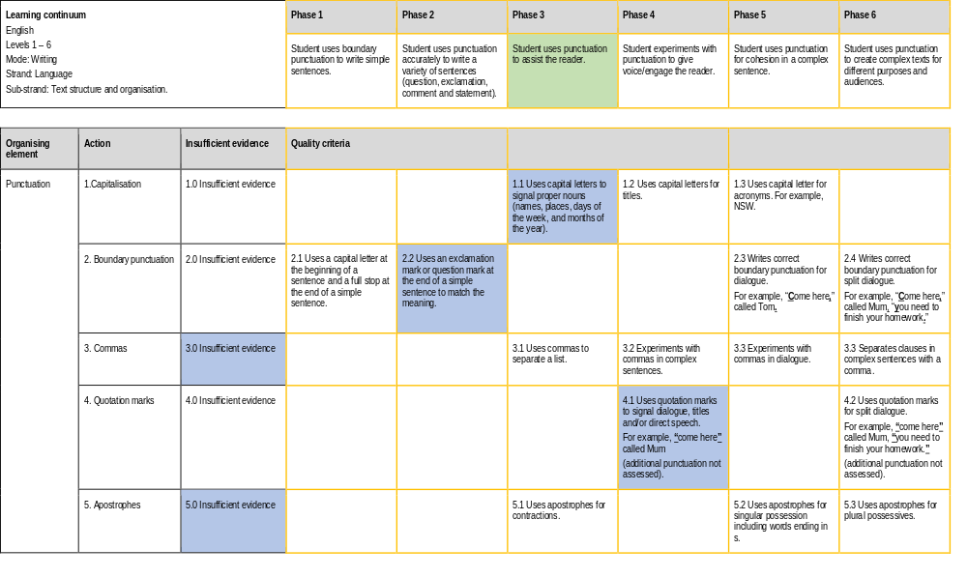

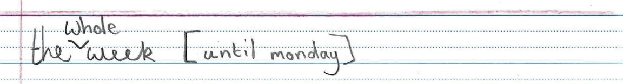
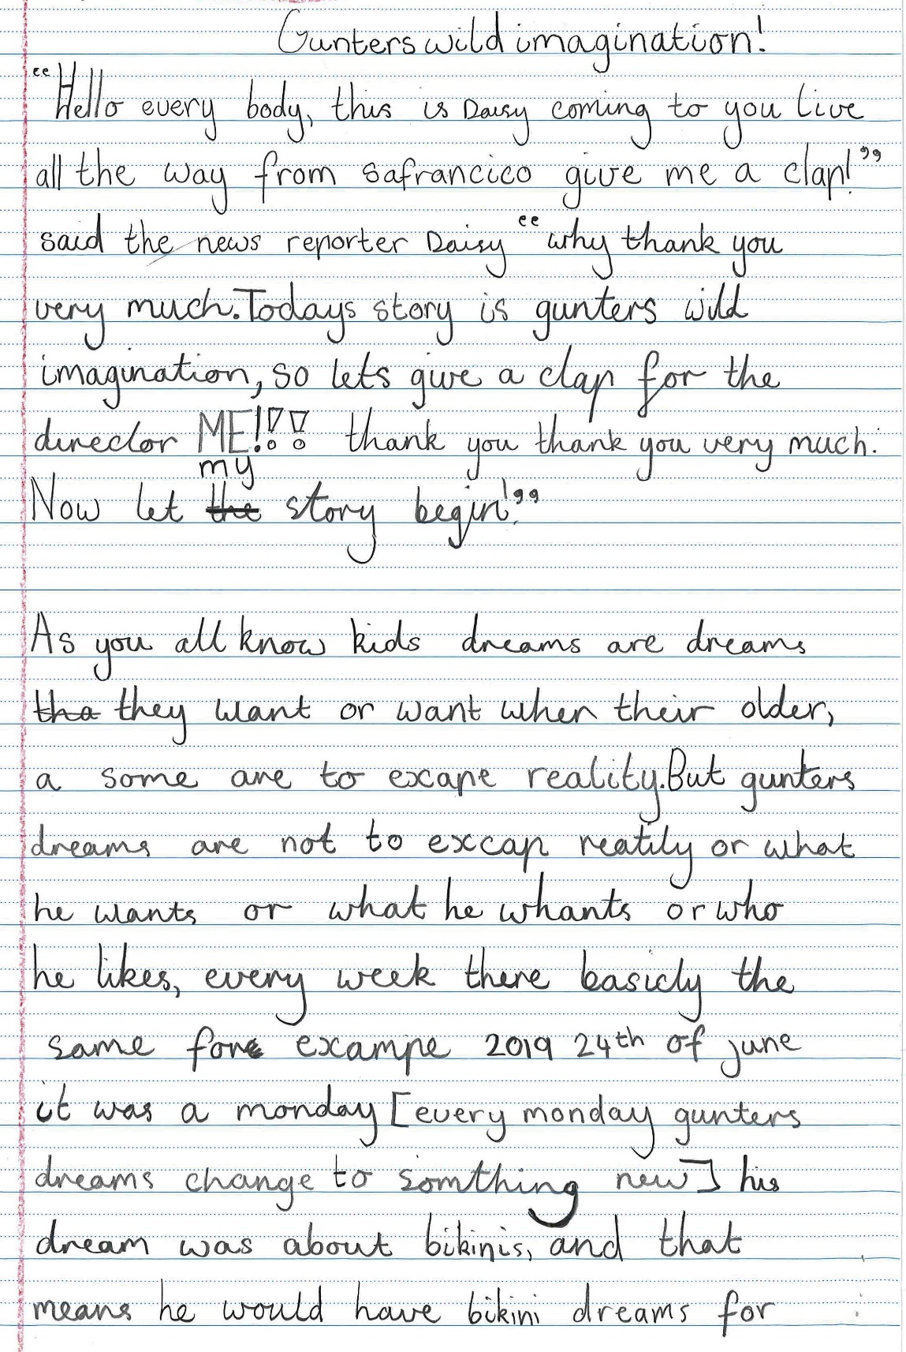
Sample 2

Sample 2: Evidence of student learning

Annotations
- 2.2 Student used exclamation marks throughout the text.
- 3.2 Student experimented with commas in some sentences; however, these sentences are not necessarily complex sentences.
- 4.1 Quotation marks are used to signal direct speech.

Insufficient evidence:
- Action 1. The student has not used capitals for proper nouns such as the days of the week (Monday), month (June) and used capitals inconsistently for some names (Gunters).
- Action 5. There is no evidence of the use of apostrophes. Examples of where they should be used include: today’s, Gunter’s, let’s.

What is the student ready to learn next?
This student was placed at Phase 3 because the writing sample meets criteria in Phases 1 and 2. Although there is some evidence of being able to meet criteria from Phase 4 in the writing sample, the work sample shows significant gaps in Phase 3.
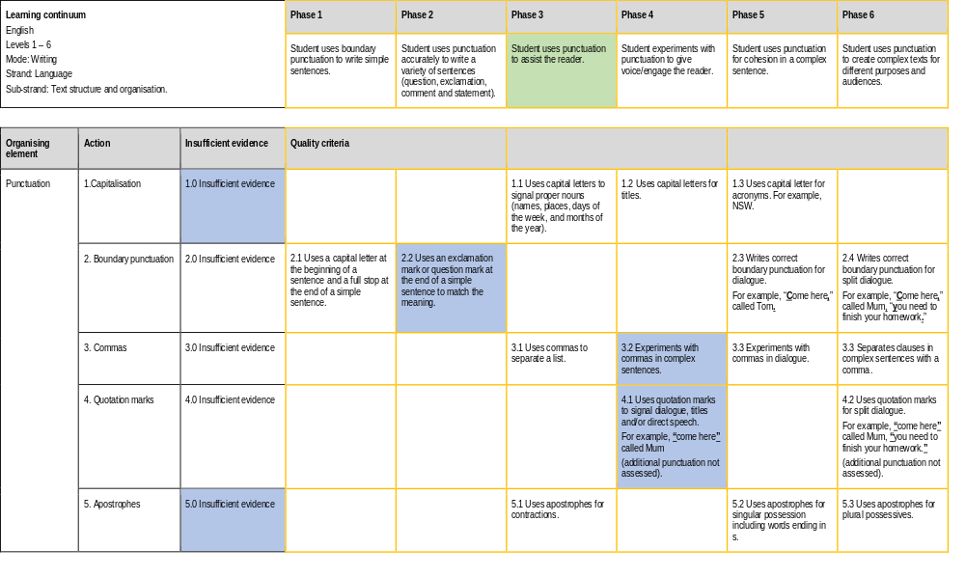

Any feedback given
This student has been set a goal to practice using boundary punctuation with quotation marks. Additional teaching activities will be provided to practice using capitals for proper nouns and the different uses of apostrophes.

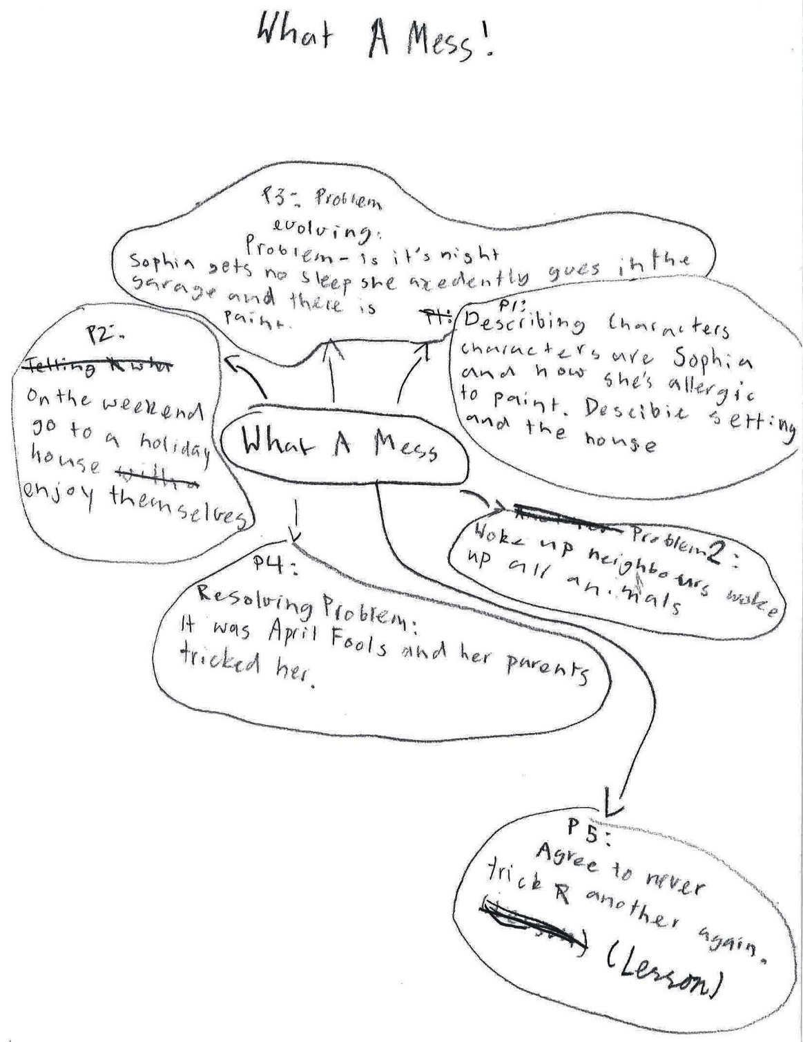
Sample 3
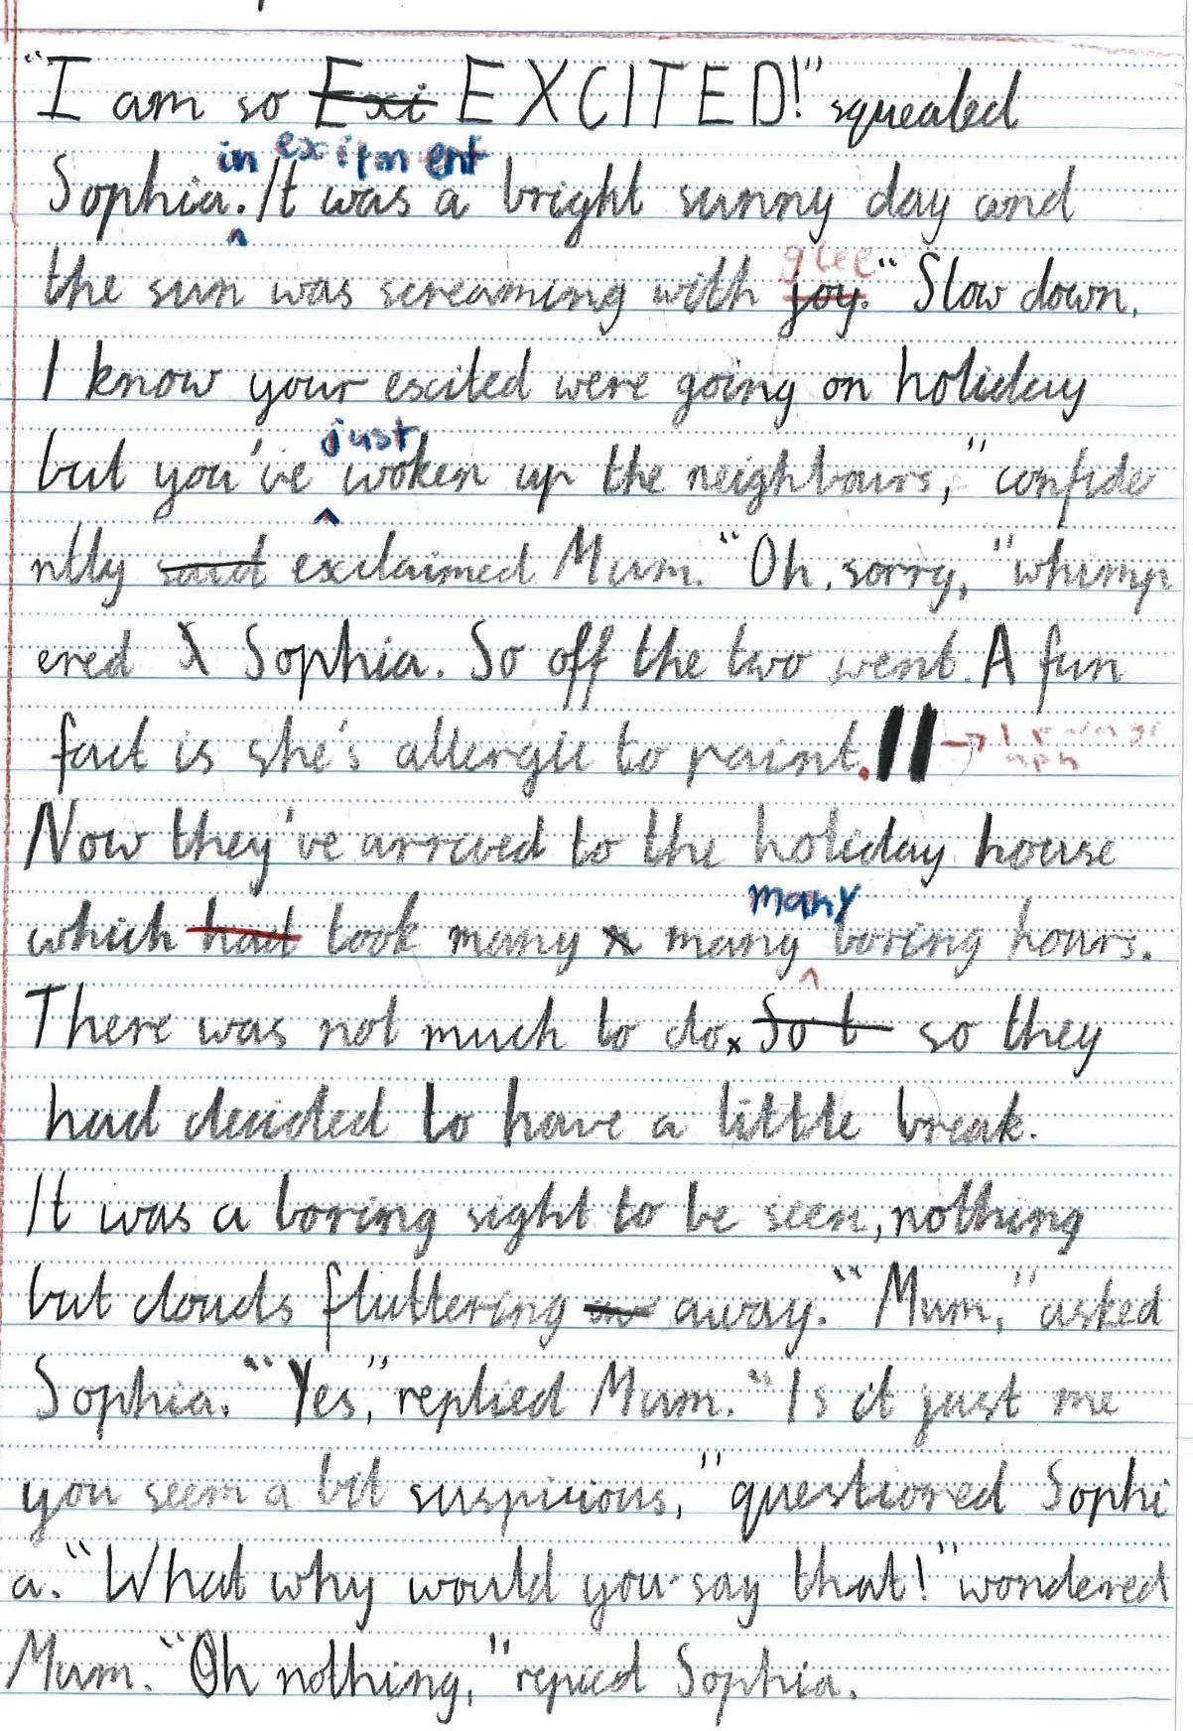
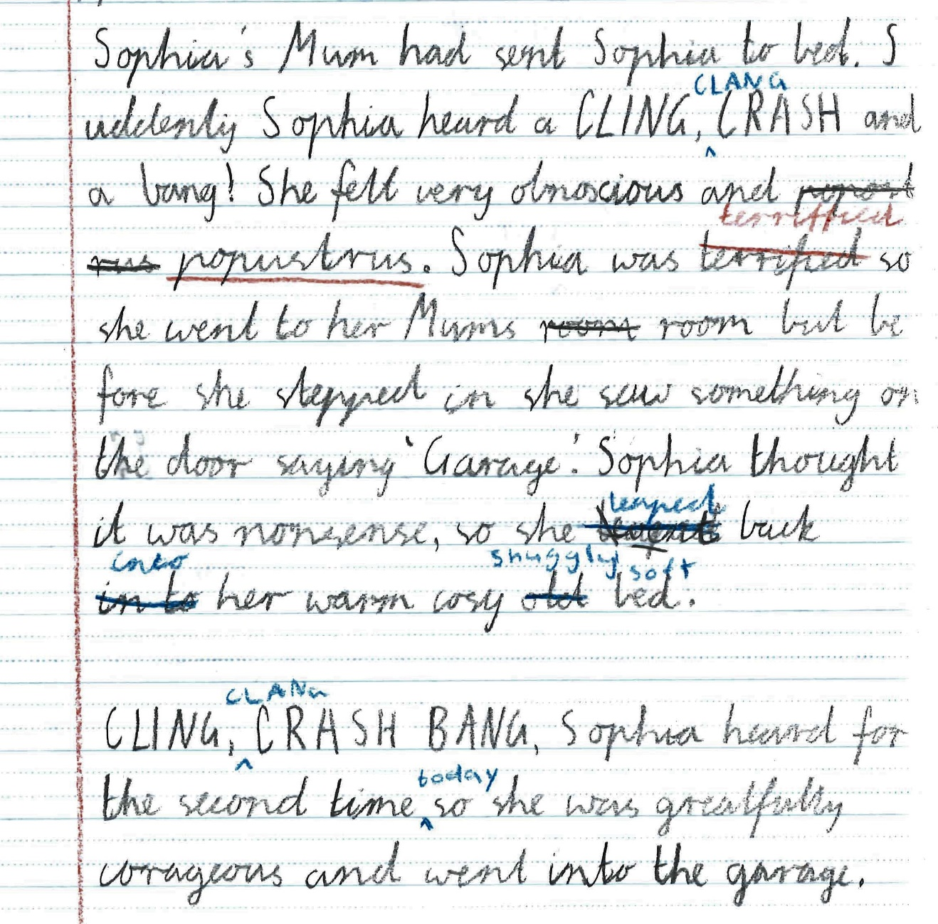

Sample 3: Evidence of student learning

Annotations
- 1.1 Correctly used a capital letter for proper nouns ‘Mum’ and ‘Sophia’. One incorrect example, ‘Sophia’s Mum’, but all other examples correct.
- 2.3 Multiple examples of correct use of boundary punctuation for dialogue.
- 3.3 Multiple examples of experimenting with commas in dialogue.
- 4.1 Multiple examples of quotation marks to indicate direct speech.
- 5.2 Example of apostrophes for singular possession: Sophia’s

What is the student ready to learn next?
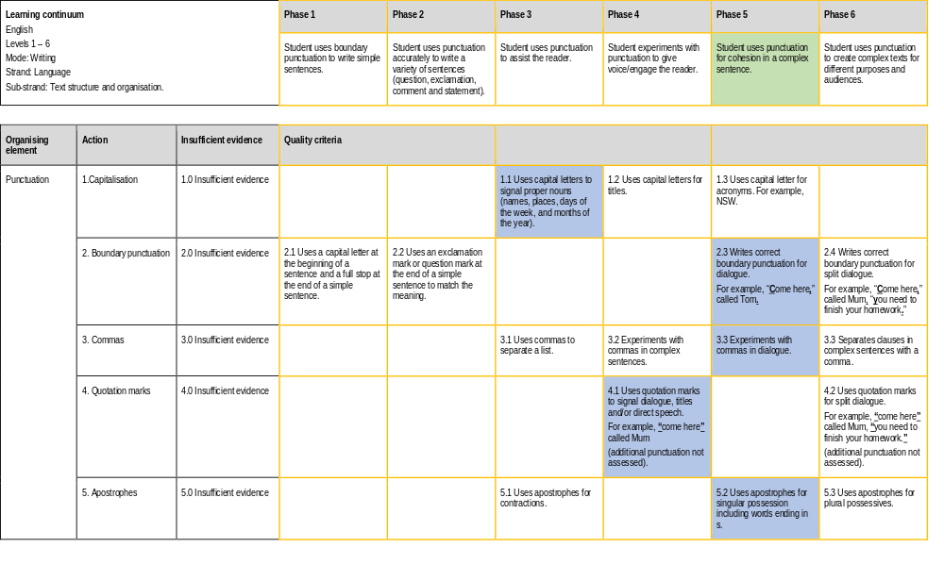
This student was placed at Phase 5. As this is a narrative piece of writing it doesn’t show evidence of using commas for a list or capitals for a title or headings. These may be more evident in an informational piece. However, it has provided evidence of learning for all criteria in Phases 1, 2, 3 and 4. Therefore, this student’s next step is Phase 5.

Any feedback given
The student was commended for their use of a variety of punctuation. A subsequent mini-lesson was conducted with this student on using capital letters for titles.

Using evidence to plan for future teaching and learning
The data showed that there was a broad range of understandings regarding the use of punctuation. This information was used to inform whole class and small group instruction on the use of punctuation and enabled for differentiation through grouping students with like needs for explicit instruction.
For one teacher, this task provided timely information as the next lesson explored information texts that included sub-headings. The data informed planning whole-class focus areas in subsequent lessons, including further exploration of how to use quotation marks for dialogue and punctuating dialogue. While the majority of the class will work on these skills, the teacher will undertake further work with a group of students who need additional support and practice on punctuation of split dialogue.
For another teacher, the data highlighted that explicit teaching related to punctuation is required in a sentence containing direct speech. For example, when and where to use commas, question marks, exclamation marks and full stops with quotation marks within a sentence that includes direct speech and narration.
For all teachers, the data indicated that some students require additional time to practise and consolidate their understanding of basic sentence boundary punctuation, such as full stops and capital letters with fluency. The evidence suggested that there may be some common misconceptions still present.
It also highlighted that although all of the actions in the rubric had been taught in the past it was essential to continually revise them along with understanding the structure of a sentence.

Teacher reflections
- I plan to use this formative assessment rubric multiple times. I will be conducting this task again across a range of genres over time, and allowing my students multiple opportunities to demonstrate competencies and show growth over time.
- I will consider modifying and refining the rubric to have an additional action for other types of punctuation not currently covered, for example, ellipses, brackets, colons, use of capitals for emphasis.
- The task could also be modified to focus on text editing using punctuation. The passage to be edited would allow students to demonstrate their understanding of all the criteria on the rubric. I believe this would give me an understanding of the students who can use each punctuation type in an editing capacity and provide insight into those students who know how to use a particular type of punctuation; however, they may not necessarily use it automatically in their own writing. This approach will provide a second set of data and another opportunity as some students may have known how to use a particular form of punctuation but have not demonstrated it in the piece of text assessed.

