Computational and
algorithmic thinking
in Mathematics

Unpacking the content descriptions

Level 1



Authorised and published by the Victorian Curriculum and Assessment Authority
Level 7, 2 Lonsdale Street
Melbourne VIC 3000
© Victorian Curriculum and Assessment Authority 2019

No part of this publication may be reproduced except as specified under the Copyright Act 1968 or by permission from the VCAA. Excepting third-party elements, schools may use this resource in accordance with the VCAA educational allowance. For more information go to: https://www.vcaa.vic.edu.au/Footer/Pages/Copyright.aspx.
The VCAA provides the only official, up-to-date versions of VCAA publications. Details of updates can be found on the VCAA website: www.vcaa.vic.edu.au.
This publication may contain copyright material belonging to a third party. Every effort has been made to contact all copyright owners. If you believe that material in this publication is an infringement of your copyright, please email the Copyright Officer: vcaa.copyright@edumail.vic.gov.au
Copyright in materials appearing at any sites linked to this document rests with the copyright owner/s of those materials, subject to the Copyright Act. The VCAA recommends you refer to copyright statements at linked sites before using such materials.

The VCAA logo is a registered trademark of the Victorian Curriculum and Assessment Authority.

Contents
Explicitly teaching computational and algorithmic thinking 4
Overview of the resource 5
How the chicken really crossed the road 6
Additional teaching resources 10
Appendix 1 11
Appendix 2 12
Appendix 3 14
Appendix 4 16

Explicitly teaching computational and
algorithmic thinking
The Computational and algorithmic thinking – Unpacking the content descriptions resources unpack the Victorian Curriculum F–10 Mathematics content descriptions that address computational thinking and algorithms at each level in the Patterns and algebra sub-strand of the Number and Algebra strand.
Each resource provides teachers with links between one Mathematics content description and extract from the achievement standard related to computational and algorithmic thinking and a teaching and learning activity that is designed to develop computational thinking and problem-solving skills and produce corresponding algorithms in a mathematical context. Teachers can also find excerpts from the Victorian Curriculum Mathematics and Digital Technologies glossaries in Appendix 3.
The resources have been developed with respect to teaching in the Mathematics learning area of the Victorian Curriculum and they also include suggestions how these activities could be extended to the Critical and Creating Thinking and Digital Technologies curriculums.
Teachers will find detailed ideas about how to integrate Mathematics with one or both of Digital Technologies and Critical and Creating Thinking in Appendix 1 and Appendix 2 respectively.

Overview of the resource

Curriculum area and level: Mathematics, Level 1
Strand and sub-strand: Number and Algebra, Patterns and algebra
Content description: Recognise the importance of repetition of a process in solving problems (VCMNA094)
Achievement standard (extract): Students … continue simple patterns involving numbers and objects with and without the use of digital technology.

Title: How the chicken really crossed the road
Timing: 1 or 2 lessons (approx. 50–100 minutes)
Description: Students work together to help Henny the chicken and her chicken friends cross a road with the help (or not!) of a group of foxes.
Students work towards recognising the importance of repeated processes in solving similar problems. They use visual representations to explore the solution process and to demonstrate their thinking.
Learning objectives: Students can:
create a visual representation to show a solution process
identify repeated patterns
describe an algorithm
test and improve a solution.
Printable materials: These printable materials are included as Appendix 4:
chicken, fox and skateboard images
road and crossing picture
other symbols and images.

How the chicken really crossed the road

Teacher instructions
- Get students to work in pairs or small groups.
- Give the following printed resources to each pair or group:
- 1 × set of chicken, fox and skateboard images
- 1 × road and crossing picture
- 2 × sets of other symbols and images.
- Introduce the problem and the rules (below), and then ask students to work through the three situations (see Activity 1, Activity 2 and Activity 3).
- Challenge and extend students to experiment with varying animal numbers and begin to predict solutions (see Challenge and extend). Use the words ‘algorithm’, ‘sequence’ and ‘steps’ to reinforce the process of coming up with a set of instructions to solve a task and also introduce the terms ‘algorithmic thinking’ and ‘computational thinking’ (see Appendix 3).
- Finally, reflect on the activity as a class or in small groups (see Reflection).

Problem
It is a very hot day and four chickens (Henny, Frank, Rosie and Little Chook) need to cross the very hot road. Four sneaky foxes (Fox 1, Fox 2, Fox 3 and Fox 4) want to cross the road, too. The animals must use the skateboard to cross the road.

Rules for crossing the road
- Animals must cross at the crossing.
- Animals must ride on the skateboard to cross the road because the road is hot.
- No more than two animals can ride on the skateboard at any time.
- For the skateboard to move across the road, it must have at least one animal on it.
- At any time:
- if there are the same number of chickens and foxes left on one side of the road, then all the chickens are safe
- if there are more chickens than foxes left on one side of the road, then all the chickens are safe
- if there are more foxes than chickens left on one side of the road, those chickens will get eaten! You will have to start all over again!

Tip: Teachers are encouraged to use and clearly define ‘algorithm’ and ‘sequence of steps’ to reinforce the process of coming up with a set of instructions to solve a task (see the Victorian Curriculum Mathematics Glossary or Appendix 3).

Activity 1 – Two chickens and one fox
Get students to place the skateboard, Henny, Frank and one fox on one side of the picture of the road.
How can Henny, Frank and the fox all cross the road to safely reach the other side?
Ask students:
- How can the animals cross the road?
- Is this the only way?

► Cross-curricular links
See Appendix 2 for ways to link this activity to the explicit teaching of Critical and Creative Thinking.

Activity 2 – Two chickens and two foxes
Get students to place the skateboard, Henny, Frank and two foxes on one side of the road.
How can they all cross the road to safely reach the other side?
Students can create a visual representation of their actions on their table, or on the floor, using the other symbols and images to keep track of their solution process. For example, they might use the symbols and images to create a visual representation of the animals’ movement like below.
Tip: If needed, model a visual representation for students, such as the one below.
Note: Each arrow indicates one move of the skateboard across the road and the direction of that move. The first move is on the left of the visual representation, and the final move is on the right.

Discussion prompts
Is there only one way for all the animals to cross? Why? Why not?
Once students have found one solution, challenge them to find another solution or aim for a more efficient (shorter) solution. Students should write down their solutions or photograph the visual representations of their solutions (using a device such as an iPad) to keep track of them.
Discussion prompts
- Have you found all the solutions? How do you know?
- Is this the shortest (most efficient) solution? Why/why not? How do you know?
- Which sequences of steps lead to the chickens being eaten? When does this happen? How can you prevent this?

► Cross-curricular links
See Appendix 1 and Appendix 2 for ways to link this activity to the explicit teaching of Digital Technologies and/or Critical and Creative Thinking.

Activity 3 – Three chickens and three foxes
Place the skateboard, Henny, Frank, Little Chook and three foxes on one side of the road.
How can they all cross the road to safely reach the other side?
Students should proceed as they did for Activity 2.
Discussion prompts
- Is there a repeating pattern that you notice between your solution for two chickens (Activity 2) and three chickens (Activity 3)?
- Have you found all the solutions? How do you know?
- Is this the shortest (most efficient) solution? Why/why not? How do you know?
- Which sequences of steps lead to the chickens being eaten? When does this happen? How can you prevent this?

Challenge and extend
Students experiment with varying numbers of starting animals. They have four chickens and four foxes to experiment with.
For example, they could investigate:
- What about two foxes and one chicken? Is this possible? Why/why not?
- Are solutions possible for all animal combinations? Why/why not?
Students track their solutions for each activity and note any patterns they see in their solutions. They then propose an overall solution by identifying patterns they found in the other activities, and then test this proposed solution.

► Cross-curricular links
See Appendix 1 and Appendix 2 for ways to link this activity to the explicit teaching of Digital Technologies and/or Critical and Creative Thinking.

Reflection
With the class, or in small groups, the teacher could ask students to discuss each activity and different strategies that students used to come up with a solution.
Groups reflect on the strategies they used as they worked through each of the three activities. Tell students that algorithmic thinking is the type of thinking required to design, test and evaluate problem-solving processes in a systematic way, using algorithms. Then ask students:
- How did you demonstrate algorithmic thinking in this task?
- What surprised you about this activity?
- What did you find interesting?
- What are some questions you have after having done this activity? (What next?)

Tip: Reflection is an important aspect of any computational-thinking focused activity because it encourages students to consider the different aspects of the task, such as defining the problem and breaking the task down, selecting tools and processes, problem-solving, teamwork and verifying their solution. This helps students reflect on the process of their own learning (meta-learning) and how the skills they have used might transfer to other contexts.

Additional teaching resources
- Math Playground: Grade 1 Math provides a number of online games that encourage students to practise the processes of addition and subtraction.
- Search FUSE (Department of Education and Training) for ‘number patterns’. This will provide a list of resources for exploring repeated patterns using numbers, shapes and sound.
- Graph Paper Programming is an unplugged activity that provides an introduction to programming.
- The VCAA has also published Unpacking Digital Technologies Content Descriptions for Foundation to Level 2.

Appendix 1

Suggestions for explicitly teaching Digital Technologies (stimulus only)

Curriculum area: Digital Technologies
Strand: Creating Digital Solutions
Band: Foundation to Level 2
Content description: Follow, describe and represent a sequence of steps and decisions (algorithms) needed to solve simple problems (VCDTCD017)
Achievement standard (extract): Students design solutions to simple problems using a sequence of steps and decisions.
Suggestions that extend Activities 2 and/or 3:
- Discuss using cards with arrows or symbols to create a simple algorithm.
- Record the steps as symbols to solve a problem, for example, using arrows.

See also Unpacking Digital Technologies Content Descriptions for Foundation to Level 2.

Appendix 2

Suggestions for explicitly teaching Critical and Creative Thinking (stimulus only)

Curriculum area: Critical and Creative Thinking
Strand: Reasoning
Band: Foundation to Level 2
Content description: Compare and contrast information and ideas in own and others’ reasoning (VCCCTR005)
Achievement standard (extract): They use reasons and examples for different purposes.
Suggestions that link to Activities 2 and/or 3:
- When discussing the range of solutions, get students to compare their ideas to work out if they have a similar solution to others or a uniquely different one. Assist them to see that this will help us to truly see if we have found all the solutions.
- Share points of view and discuss information and ideas used to help reach each location. For example, ‘How did your solution work? Does it use fewer steps than mine? What strategies did you use to find this solution?’
- Talk about two algorithms with the same outcome (solving the crossing problem) and identify the strategy or strategies used in each, as well as similarities and differences. For example, ‘I got there using this strategy. Our algorithms are different because … They are similar in the way that they …’ Discuss why one strategy might be preferred.

Curriculum area: Critical and Creative Thinking
Strand: Meta-Cognition
Band: Foundation to Level 2
Content description: Investigate ways to problem-solve, using egocentric and experiential language (VCCCTM009)
Achievement standard (extract): Students demonstrate and articulate some problem-solving approaches.
Suggestions that link to Activity 1:
- Show students what a visual representation is and assist students to understand why it is often a useful way to solve problems and show key aspects of thinking.
- Discuss visual representation as a problem-solving approach; for example, ‘Did it make the process easier? What was it most useful for?’
- Discuss how students used visual representation as an approach to problem-solving; for example, ‘I wanted to show the direction the chickens would travel, so I used arrows.’

Curriculum area: Critical and Creative Thinking
Strand: Questions and possibilities
Band: Foundation to Level 2
Content description: Make simple modifications to known ideas and routine solutions to generate some different ideas and possibilities (VCCCTQ003)
Achievement standard (extract): Students generate ideas that are new to them …
Suggestions that link to Activities 2 and/or 3:
- Try different algorithms to solve each crossing problem (modification of their original algorithm), for example, to try and find the smallest number of steps.
- Explore different ideas for solving the problems through experimenting with different modifications such as the number of chickens and foxes or the size of the skateboard (on their own and with others through collaboration).

Appendix 3

Excerpts from the Victorian Curriculum Mathematics and Digital Technologies glossaries
There are some commonalities in the terms used when explicitly teaching computational and algorithmic thinking in Mathematics and Digital Technologies; however, there are also some subtle but important differences in the definitions of terms. Some of these common terms and their definitions are listed below, under the two different curriculum areas.
If you are going to explicitly teach Mathematics, please refer to the Victorian Curriculum Mathematics Glossary. If you are also going to explicitly teach Digital Technologies, refer to the Victorian Curriculum Digital Technologies Glossary.

Mathematics

Algorithm
An algorithm is a process that can be carried out mechanically, using a well-defined set of instructions, to perform a particular task or solve a type of problem. Examples of mathematical algorithms include processes for tasks such as ordering a set of numbers from smallest to largest, multiplying many-digit decimal numbers, factorising linear expressions, determining which of two fractions is larger, bisecting an angle, or calculating the mean of a set of numbers.

Algorithmic thinking
Algorithmic thinking is the type of thinking required to design, test and evaluate problem-solving processes in a systematic way, using algorithms.

Coding
A process by which algorithms are represented for implementation. For computers, this is done using a coding language such as block coding, C++, JavaScript, Python, Wolfram Language.

Computational thinking
In this context, computational thinking is considered to be linked to algorithmic thinking. This type of thinking is usually considered specific to computers which involves solving problems, designing systems and implementation.

Sequence (number)
A sequence is an ordered set of elements such as numbers, instructions or objects. From an algorithmic point of view, a sequence is an ordered set of instructions or actions.

Unplugged
A commonly used term for computational thinking activities carried out without digital technology. “Unplugged” representations of algorithms may include structured mathematical processes, English representations (steps) or flowcharts.

Digital Technologies

Algorithm
A description of the steps and decisions required to solve a problem. For example, to find the largest number in a list of positive numbers:
- Note the first number as the largest
- Look through the remaining numbers, in turn, and if a number is larger than the number found in 1, note it as the largest.
- Repeat this process until complete. The last noted number is the largest in the list.
Flowcharts are often useful in visualising an algorithm.

Computational thinking
A problem-solving method that involves various techniques and strategies in order to solve problems that can be implemented by digital systems, such as organising data logically, breaking down problems into components, and the design and use of algorithms, patterns and models.

Appendix 4

Chicken and fox images
You may wish to print these on cardboard or laminate them.
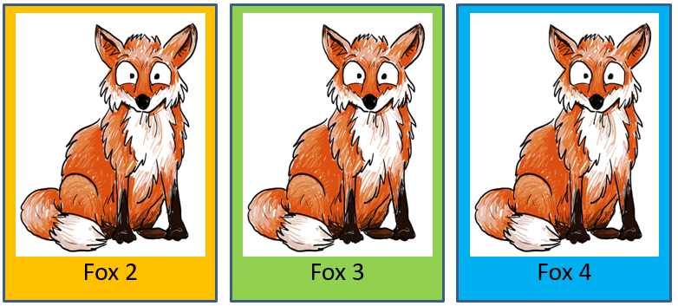
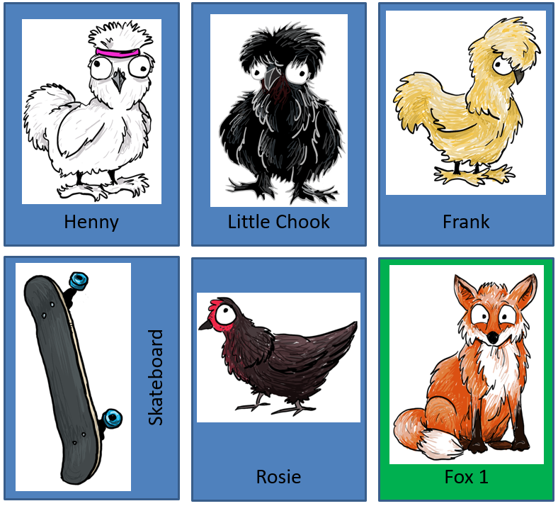

Road and crossing
This could be printed at A3 size.
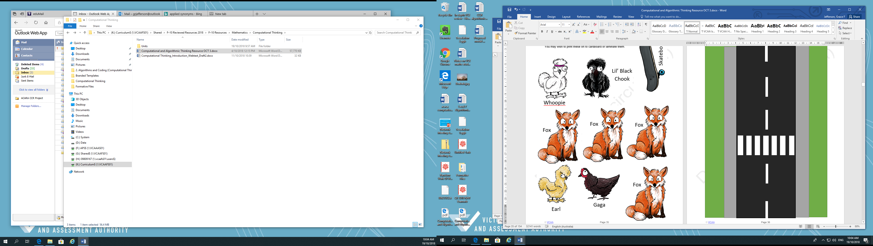

Other symbols and images
Students can use these symbols and images to create flowcharts of their solution process.

