Computational and   
algorithmic thinking   
in Mathematics

Unpacking the content descriptions

Level 2

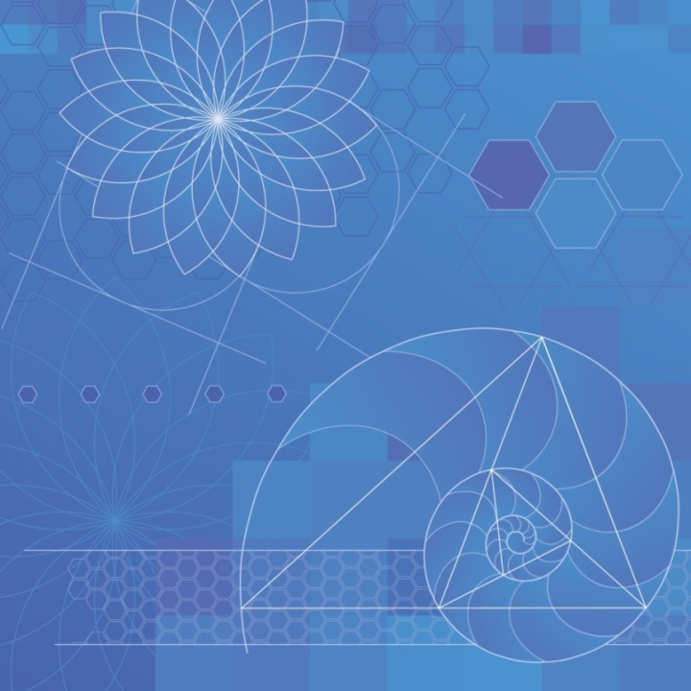

Authorised and published by the Victorian Curriculum and Assessment Authority  
Level 7, 2 Lonsdale Street  
Melbourne VIC 3000

© Victorian Curriculum and Assessment Authority 2019

No part of this publication may be reproduced except as specified under the *Copyright Act 1968* or by permission from the VCAA. Excepting third-party elements, schools may use this resource in accordance with the [VCAA educational allowance](https://www.vcaa.vic.edu.au/Footer/Pages/Copyright.aspx#schools). For more information go to: <https://www.vcaa.vic.edu.au/Footer/Pages/Copyright.aspx>.

The VCAA provides the only official, up-to-date versions of VCAA publications. Details of updates can be found on the VCAA website: [www.vcaa.vic.edu.au](http://www.vcaa.vic.edu.au).

This publication may contain copyright material belonging to a third party. Every effort has been made to contact all copyright owners. If you believe that material in this publication is an infringement of your copyright, please email the Copyright Officer: [vcaa.copyright@edumail.vic.gov.au](mailto:vcaa.copyright@edumail.vic.gov.au)

Copyright in materials appearing at any sites linked to this document rests with the copyright owner/s of those materials, subject to the Copyright Act. The VCAA recommends you refer to copyright statements at linked sites before using such materials.

The VCAA logo is a registered trademark of the Victorian Curriculum and Assessment Authority.

Contents

Explicitly teaching computational and algorithmic thinking 4

Overview of the resource 5

The Monster Mash 6

Additional teaching resources 9

Appendix 1 10

Appendix 2 11

Appendix 3 12

Appendix 4 14

Explicitly teaching computational and   
algorithmic thinking

The *Computational and algorithmic thinking – Unpacking the content descriptions* resources unpack the Victorian Curriculum F–10 Mathematics content descriptions that address computational thinking and algorithms at each level in the Patterns and algebra sub-strand of the Number and Algebra strand.

Each resource provides teachers with links between one Mathematics content description and extract from the achievement standard related to computational and algorithmic thinking and a teaching and learning activity that is designed to develop computational thinking and problem-solving skills and produce corresponding algorithms in a mathematical context. Teachers can also find excerpts from the Victorian Curriculum Mathematics and Digital Technologies glossaries in Appendix 3.

The resources have been developed with respect to teaching in the Mathematics learning area of the Victorian Curriculum and they also include suggestions how these activities could be extended to the Critical and Creating Thinking and Digital Technologies curriculums.

Teachers will find detailed ideas about how to integrate Mathematics with one or both of Digital Technologies and Critical and Creating Thinking in Appendix 1 and Appendix 2 respectively.

Overview of the resource

**Curriculum area and level:** Mathematics, Level 2

**Strand and sub-strand:** Number and Algebra, Patterns and algebra

**Content description:** Apply repetition in arithmetic operations, including multiplication as repeated addition and division as repeated subtraction ([VCMNA114](http://vcaa2015.esa.edu.au/Curriculum/ContentDescription/VCMNA114))

**Achievement standard (extract):** Students … perform simple addition and subtraction calculations, using a range of strategies … [They] represent multiplication and division by grouping into sets and divide collections and shapes into halves, quarters and eighths. They recognise increasing and decreasing number sequences involving 2s, 3s, 5s and 10s …

**Resource title:** The Monster Mash

**Timing:** 2 lessons (approx. 100 minutes)

**Description:** Students use printed monster images to experiment with the idea of multiplication as repeated addition. They then use these monsters to explore the concept of sharing a set of objects equally between a small number of groups.

**Learning objectives:** Students can:

show the process of repeated addition

explain how repeated addition is the same as multiplication

share a set of objects equally between a small number of groups.

**Printable materials:** These materials are included as Appendix 3 . You may wish to print them onto card or laminate them for small groups. Print one set per group.

Monsters

Grouping circles

The Monster Mash

Activity 1 – Part 1

*From little monsters, big things grow*

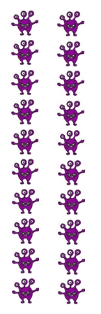**Tip:** Teachers are encouraged to use and clearly define the terms ‘algorithm’ and ‘repetition’ in this activity, to reinforce the process of following a set or sequence of instructions to solve a problem (see the [Victorian Curriculum Mathematics Glossary](http://victoriancurriculum.vcaa.vic.edu.au/LearningArea/LoadFile?learningArea=mathematics&subject=mathematics&name=Mathematics%20Glossary.docx&storage=Glossary)).

Teachers could give students the opportunity to come up with their own agreed class definition before, during or after the activity, and then compare it with the definition in the glossary.

* Students work in small groups of two or three students. Give each group a set of printed monsters (Appendix 4).
* Students will work first on repeated addition.
* Groups start with no monsters laid out.
* Get students to place two purple monsters in front of them. (Keep track of how many times students do this.)
* Ask students to add two more monsters underneath. Explain that they are doing repeated addition. Also explain that this is an algorithm (repeated process).
* Now ask students, how many monsters are there all together?
* Repeat this until students run out of monsters (see right for an example). Ask students:
* What do you notice about the total numbers of monsters each time?
* How many monsters are there all together? (20 monsters)
* How many times did you add two monsters?   
  (count how many rows = 10)

**Tip:** You may want to explain that students are skip counting by groups of two, or you may use the two times tables as a reference.

* Next, have students calculate multiplying 2 × 10 by counting out 10 groups of 2 monsters. Ask:
* How many monsters are there all together?
* How is this similar to when you did repeated addition?
* Can you show me how these two methods (repeated addition 10 times and multiplication) are the same?

**Discussion prompts**

* We know that 2 + 2 + 2 + 2 + 2 + 2 + 2 + 2 + 2 + 2 = 20 (10 groups of repeated addition) and we also know that 2 × 10 = 20. What is happening here? What is the link?
* Get students to discuss in their small group how repeated addition and multiplication gave the same answer. Why do they think this happened? Do they think this will always happen? Why/why not?
* As a class, get students to summarise their findings.

Activity 1 – Part 2

Students can repeat Part 1 using the other monsters supplied and using different numbers (see below). Remind students to always start with no monsters laid out.

* Blue monsters
* groups of 3
* 8 groups of 3 = 24
* explain that students are skip counting by 3s
* Green monsters
* groups of 4
* 6 groups of 4 = 24
* explain that students are skip counting by 4s
* Orange monsters
* groups of 5
* 4 groups of 5 = 20
* explain that students are skip counting by 5s

After each different monster, discuss the links between repeated addition and multiplication.

► **Cross-curricular links**

See Appendix 1 and Appendix 2 for ways to link this activity to the explicit teaching of Digital Technologies and/or Critical and Creative Thinking.

Activity 2

*Divide and conquer*

* In small groups, students now experiment with grouping and division.
* Start with the purple monsters. Remind students that they have 20 monsters, or 2 × 10   
  (10 groups of 2).
* Students sort these monsters evenly into two groups using the grouping circles for 2 monster groups (Appendix 3). Ask students:
* How many monsters are in each group? (10 monsters)
* How many groups of 2 can be made from 20? (10)
* Discuss division – that is, the way a large number can be split into smaller, equal groups. Link division to multiplication. For example, say ‘We had 2 × 10 = 20. Now we know 20 can be shared out into 10 groups (circles) of 2.’
* Leave the monsters in their groups.

**Discussion prompts**

* Now, we know 20 ÷ 2 = 10 and 2 × 10 = 20 are two ways of expressing the same relation.
* When you ask ‘What is 20 ÷ 2?’, you are really asking ‘How many groups of 2 are in 20?’
* We know 10 groups of 2 made up this number. So, the answer to 20 ÷ 2 = 10.

**Tip:** Students might like to glue or Blu Tack the monsters down as they work.

► **Cross-curricular links**

See Appendix 1 and Appendix 2 for ways to link this activity to the explicit teaching of Digital Technologies and/or Critical and Creative Thinking.

Challenge and extend

Extension activity 1

* Students can repeat Activity 2 with the other monsters, using the different grouping circles in Appendix 3.
* 24 blue monsters split between 3 groups. *Prompt:* What is 24 ÷ 3?
* 24 green monsters split between 4 groups. *Prompt*: What is 24 ÷ 4?
* 20 orange monsters split between 5 groups. *Prompt:* What is 20 ÷ 5?
* Can students predict the number of monsters that will end up in each circle by thinking about their repeated addition for each type of monster?

Extension activity 2

* Do all the sets of different-coloured monsters fit evenly into each of the different grouping circles? For example, do the 20 purple monsters fit evenly into 3 groups? 4 groups? 5 groups?
* Have students experiment with the other coloured monsters and discuss their results in their small groups. Ask students:
* Which monster groups can be divided evenly? Which don’t divide evenly? Why do you think this is?
* Can you use repeated addition to figure out why this might be the case?

Reflection

In small groups or as a class, ask students:

* What is the relationship between repeated addition and multiplication? Can you show this using an example?
* What is the link between multiplication (groups added) and division (splitting into groups)?
* What surprised you about this activity?
* What did you find interesting?
* What are some questions you have following this activity?

**Tip:** Reflection is an important aspect of any computational-thinking focused activity because it encourages students to consider the different aspects of the task, such as defining the problem and breaking the task down, selecting tools and processes, problem-solving, teamwork and verifying their solution. This helps students reflect on the process of their own learning (meta-learning) and how the skills they have used might transfer to other contexts.

Additional teaching resources

* [Solve multiplication problems by using repeated addition](https://nzmaths.co.nz/ao/solve-multiplication-problems-using-repeated-addition), NZMaths – resources for a lesson involving repeated addition
* [Skip counting: how many birds?](https://www.resolve.edu.au/skip-counting-how-many-birds), reSolve – an activity exploring patterns and repeated skip counting

Appendix 1

Suggestions for explicitly teaching Digital Technologies (stimulus only)

**Curriculum area:** Digital Technologies

**Strand:** Creating Digital Solutions

**Band:** Foundation to Level 2

**Content description:** Follow, describe and represent a sequence of steps and decisions (algorithms) needed to solve simple problems ([VCDTCD017](http://victoriancurriculum.vcaa.vic.edu.au/Curriculum/ContentDescription/VCDTCD017))

**Achievement standard (extract):** Students design solutions to simple problems using a sequence of steps and decisions.

**Suggestions that link to Activities 1 and 2:**

* Following basic step-by-step instructions.
* Following instructions and steps sequentially, including decision making.

See also [Unpacking Digital Technologies Content Descriptions](https://vcaa.vic.edu.au/Documents/viccurric/digitech/Unpacking_the_Content_Descriptions/Unpacking_Digital_Technologies_Content_Descriptions-F-2.docx) for Foundation to Level 2.

Appendix 2

Suggestions for explicitly teaching Critical and Creative Thinking (stimulus only)

**Curriculum area:** Critical and Creative Thinking

**Strand:** Reasoning

**Band:** Foundation to Level 2

**Content description:** Compare and contrast information and ideas in own and others reasoning ([VCCCTR005](http://victoriancurriculum.vcaa.vic.edu.au/Curriculum/ContentDescription/VCCCTR005))

**Achievement standard (extract):** They use reasons and examples for different purposes.

**Suggestion that links to Activity 1:**

* Comparing reasons for how the same answer is reached using different methods and whether this will always happen.

**Curriculum area:** Critical and Creative Thinking

**Strand:** Meta-Cognition

**Band:** Foundation to Level 2

**Content description:** Investigate ways to problem-solve, using egocentric and experiential language ([VCCCTM009](http://victoriancurriculum.vcaa.vic.edu.au/Curriculum/ContentDescription/VCCCTM009))

**Achievement standard (extract):** Students demonstrate and articulate some problem-solving approaches.

**Suggestions that link to Activities 1 and 2:**

* Discussing the process of dividing monsters evenly between each group using visual representation as a problem-solving approach; for example, ‘Did it make the process easier?’, ‘What was it most useful for?’
* Discussing their problem-solving approach and thinking out loud to a partner while constructing sentences such as ‘I want to know when a number will divide evenly into two groups. I know from before that …’

Appendix 3

Excerpts from the Victorian Curriculum Mathematics and Digital Technologies glossaries

There are some commonalities in the terms used when explicitly teaching computational and algorithmic thinking in Mathematics and Digital Technologies; however, there are also some subtle but important differences in the definitions of terms. Some of these common terms and their definitions are listed below, under the two different curriculum areas.

If you are going to explicitly teach Mathematics, please refer to the [Victorian Curriculum Mathematics Glossary](http://victoriancurriculum.vcaa.vic.edu.au/LearningArea/LoadFile?learningArea=mathematics&subject=mathematics&name=Mathematics%20Glossary.docx&storage=Glossary). If you are also going to explicitly teach Digital Technologies, refer to the [Victorian Curriculum Digital Technologies Glossary](https://victoriancurriculum.vcaa.vic.edu.au/LearningArea/LoadFile?learningArea=technologies&subject=digital-technologies&name=Digital%20Technologies%20Glossary.docx&storage=Glossary).

Mathematics

Algorithm

An **algorithm** is a process that can be carried out mechanically, using a well-defined set of instructions, to perform a particular task or solve a type of problem. Examples of mathematical algorithms include processes for tasks such as ordering a set of numbers from smallest to largest, multiplying many-digit decimal numbers, factorising linear expressions, determining which of two fractions is larger, bisecting an angle, or calculating the mean of a set of numbers.

Algorithmic thinking

**Algorithmic thinking** is the type of thinking required to design, test and evaluate problem-solving processes in a systematic way, using algorithms.

Coding

A process by which algorithms are represented for implementation. For computers, this is done using a coding language such as block coding, C++, JavaScript, Python, Wolfram Language.

Computational thinking

In this context, computational thinking is considered to be linked to algorithmic thinking. This type of thinking is usually considered specific to computers which involves solving problems, designing systems and implementation.

Sequence (number)

A **sequence** is an ordered set of elements such as numbers, instructions or objects. From an algorithmic point of view, a sequence is an ordered set of instructions or actions.

Unplugged

A commonly used term for computational thinking activities carried out without digital technology. “Unplugged” representations of algorithms may include structured mathematical processes, English representations (steps) or flowcharts.

Digital Technologies

Algorithm

A description of the steps and decisions required to solve a problem. For example, to find the largest number in a list of positive numbers:

1. Note the first number as the largest
2. Look through the remaining numbers, in turn, and if a number is larger than the number found in 1, note it as the largest.
3. Repeat this process until complete. The last noted number is the largest in the list.

Flowcharts are often useful in visualising an algorithm.

Computational thinking

A problem-solving method that involves various techniques and strategies in order to solve problems that can be implemented by digital systems, such as organising data logically, breaking down problems into components, and the design and use of algorithms, patterns and models.

Appendix 4

Monsters

Print one set per group and cut them out.

You may wish to stick the monsters onto card or laminate them.

|  |  |  |  |
| --- | --- | --- | --- |
|  |  |  |  |
|  |  |  |  |
|  |  |  |  |
|  |  |  |  |
|  |  |  |  |

|  |  |  |  |
| --- | --- | --- | --- |
|  |  |  |  |
|  |  |  |  |
|  |  |  |  |
|  |  |  |  |
|  |  |  |  |
|  |  |  |  |

|  |  |  |  |
| --- | --- | --- | --- |
|  |  |  |  |
|  |  |  |  |
|  |  |  |  |
|  |  |  |  |
|  |  |  |  |
|  |  |  |  |

|  |  |  |  |
| --- | --- | --- | --- |
|  |  |  |  |
|  |  |  |  |
|  |  |  |  |
|  |  |  |  |
|  |  |  |  |

Grouping circles

Print at A3 size so that all the monsters fit inside.

**2 monster groups**

**3 monster groups**

**4 monster groups**

**5 monster groups**