Computational and   
algorithmic thinking   
in Mathematics

Unpacking the content descriptions

Level 5



Authorised and published by the Victorian Curriculum and Assessment Authority  
Level 7, 2 Lonsdale Street  
Melbourne VIC 3000

© Victorian Curriculum and Assessment Authority 2019

No part of this publication may be reproduced except as specified under the *Copyright Act 1968* or by permission from the VCAA. Excepting third-party elements, schools may use this resource in accordance with the [VCAA educational allowance](http://victoriancurriculum.vcaa.vic.edu.au/Curriculum/ContentDescription/VCCCTQ003#schools). For more information go to: <https://www.vcaa.vic.edu.au/Footer/Pages/Copyright.aspx>.

The VCAA provides the only official, up-to-date versions of VCAA publications. Details of updates can be found on the VCAA website: [www.vcaa.vic.edu.au](https://www.mathplayground.com/grade_1_games.html).

This publication may contain copyright material belonging to a third party. Every effort has been made to contact all copyright owners. If you believe that material in this publication is an infringement of your copyright, please email the Copyright Officer: [vcaa.copyright@edumail.vic.gov.au](mailto:vcaa.copyright@edumail.vic.gov.au)

Copyright in materials appearing at any sites linked to this document rests with the copyright owner/s of those materials, subject to the Copyright Act. The VCAA recommends you refer to copyright statements at linked sites before using such materials.

The VCAA logo is a registered trademark of the Victorian Curriculum and Assessment Authority.

Acknowledgements:

Images of Australian coins reproduced by permission, © the Royal Australian Mint. Designers:  Stuart Devlin and ($2) Bertram Ainslie Roberts/Horst Hahne.

Contents

Explicitly teaching computational and algorithmic thinking 4

Overview of the resource 5

Take a (random) walk 6

Additional teaching resources 15

Appendix 1 16

Appendix 2 17

Appendix 3 19

Appendix 4 21

Explicitly teaching computational and   
algorithmic thinking

The *Computational and algorithmic thinking – Unpacking the content descriptions* resources unpack the Victorian Curriculum F–10 Mathematics content descriptions that address computational thinking and algorithms at each level in the Patterns and algebra sub-strand of the Number and Algebra strand.

Each resource provides teachers with links between one Mathematics content description and extract from the achievement standard related to computational and algorithmic thinking and a teaching and learning activity that is designed to develop computational thinking and problem-solving skills and produce corresponding algorithms in a mathematical context. Teachers can also find excerpts from the Victorian Curriculum Mathematics and Digital Technologies glossaries in Appendix 3.

The resources have been developed with respect to teaching in the Mathematics learning area of the Victorian Curriculum and they also include suggestions how these activities could be extended to the Critical and Creating Thinking and Digital Technologies curriculums.

Teachers will find detailed ideas about how to integrate Mathematics with one or both of Digital Technologies and Critical and Creating Thinking in Appendix 1 and Appendix 2 respectively.

Overview of the resource

**Curriculum area and level:** Mathematics, Level 5

**Strand and sub-strand:** Number and Algebra, Patterns and algebra

**Content description:** Follow a mathematical algorithm involving branching and repetition (iteration) ([VCMNA194](http://victoriancurriculum.vcaa.vic.edu.au/Curriculum/ContentDescription/VCMNA194))

**Achievement standard (extract):** Students solve simple problems involving the four operations using a range of strategies including digital technology. They estimate to check the reasonableness of answers.

**Title:** Take a (random) walk

**Timing:** 2–3 lessons (approx. 100–150 minutes)

**Description:** Students explore the concept of ‘random walk’ algorithms. Students first use a coin or die (or a similar random number generator) to simulate a random walk on a number line or in the classroom.

Next, students experiment with different probabilities and predicting the outcomes of their walks.

Finally, students work to complete a random walk in two dimensions using a grid.

**Learning objectives:** Students can:

link the probability outcomes when rolling a die or flipping a coin to outcomes in a simulation

describe the process of a random walk

use technology to simulate a random walk (optional)

explain the application of random walks in the world around them (extension).

**Resources:**  Per small group (two or three students):

‘Random walk the plank’ sheet (pirate counter and ship number line) (Appendix 4)

one page of triangular grid paper per student (Appendix 4)

coloured markers/pencils

set of dice or coins

set of die outcome tables

calculators, CAS and/or online resources

Wolfram software (optional).

Take a (random) walk

In groups of two or three, students experiment with a random walk along a number line. They collect all their group data together and use the data as the basis for a class discussion.

Provide each group with the materials listed in the Overview of the resource.

Scaffold and support

Software and online resources

Students may use technology to generate random numbers for these activities. This can be done using calculators, software and/or online resources.

Online resources include:

* [Virtual Dice at Curriculum Bits](https://www.curriculumbits.com/prodimages/details/maths/mat0005.html): Select 1, 2 or 3 dice to roll at once, and +/- dice. (Note: Flash required.)
* [Dice Roller at Random.org](https://www.random.org/dice/): This random number generator is based on natural phenomena.
* [Coin Flipper at Random.org](https://www.random.org/coins/?num=1&cur=60-aud.1dollar): Flip any number and type of coin from all over the world.

Wolfram software

Wolfram software is internationally recognised as a powerful STEM learning tool. It has applications in the areas of computation, problem modelling and programming. Victoria’s Department of Education and Training has a licence for the following Wolfram products:

* Wolfram Mathematica
* Wolfram Alpha Pro
* SystemModeler
* Mathematica Online
* Wolfram Programming Lab.

The licence covers these programs being used in Victorian schools. The programs can be used on school computers, teacher devices and student devices.

For access and further information, visit the Department of Education’s [Wolfram software](https://www.education.vic.gov.au/about/programs/learningdev/vicstem/Pages/wolframsoftware.aspx) webpages.

Activity 1 – Walk the plank (on the number line)

* Students work in group of two or three.
* Provide students with ‘Random walk the plank’ printed resource (see Appendix 4).
* Students start with a Pirate Pete counter at number 5 on their number-line plank. This is the middle of the plank. They will be carrying out a random walk by flipping a coin or rolling a die. Depending on the outcome of the walk, Pirate Pete will move backwards along the plank to the safety of the pirate ship or walk off the plank to be eaten by sharks.

**Tip:** If a coin or die is not available, students may use some of the free coin and die simulators online. Teachers can also explore digital device apps that can be used for the same purpose.

* The first random walk will use a random number generator with an equal probability of Pirate Pete moving from his starting point and travelling left or right. Students use the coin or die to determine each step Pirate Pete takes.
* Students use the following instructions (depending on whether they use a die or coin). Each option provides equally likely outcomes.

Option 1: Coin outcomes

|  |  |
| --- | --- |
| **Outcome** | **Movement** |
| Heads  Australian coin with 'head' facing up | Take 1 step to the right  Green arrow pointing right |
| Tails  Australian coin with 'tail' facing up | Take 1 step to the left  Orange arrow pointing left |

Option 2: Die outcomes

|  |  |
| --- | --- |
| **Outcome** | **Movement** |
| Roll a 2, 4 or 6 (even numbers)  Drawing of a die showing 2Drawing of a die showing 4Drawing of a die showing 6 | Take 1 step to the right  Green arrow pointing right |
| Roll a 1, 3 or 5 (odd numbers)  Drawing of a die showing 1Drawing of a die showing 3Drawing of a die showing 5 | Take 1 step to the left  Orange arrow pointing left |

Scaffold and support

Before the activity, ask students to think-pair-share with the large group – do they think an equal number of pirates in their classroom will get to safety or be eaten by sharks? Why?

* Set up a table on the whiteboard or the wall for students to record class data.

|  |  |
| --- | --- |
| **Ship tally** | **Sea tally** |
|  |  |
| Total: | Total: |

* Students record whether Pirate Pete gets to the safety of the ship or falls into the sea. It will take them several rolls/flips before Pirate Pete reaches either end of the plank.

Scaffold and support – vocabulary focus

* Refer to each time Pirate Pete either reaches the boat or falls in the sea as a ‘trial’.
* Students are running a ‘simulation’ of a random walk.

Example

Here is an example of a random walk (with H = heads and T = tails) where Pirate Pete ends up in the sea. Remember: heads = he moves one step (number) to the right; tails = he moves one step left.

The flips were H, H, T, H, H, H, T, H, H.

Random walk (shown with arrows starting at 5):

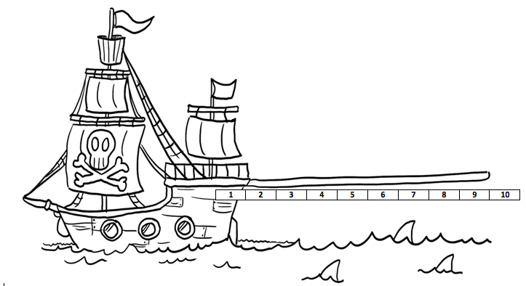



* Students may like to run multiple trials. Each time Pirate Pete reaches either the safety of the ship or falls in the sea, have students add a tally mark to the class data. Set a time limit for students to add to the class data. Remember to always start Pirate Pete back in the middle of the plank at number 5.
* Remind students to group the tally marks in groups of five. For example, if there are four tally marks under the ship column on the board and they want to add the next mark, they should add the next tally mark as a diagonal line. At the end of the allocated time, add up the tally marks and compare the number of times Pirate Pete reached safety and the times he fell into the sea. The table might look like this:

|  |  |
| --- | --- |
| **Ship tally** | **Sea tally** |
| ||| | | |
| Total: 18 | Total: 11 |

* You might like to have students graph this either in their books or together as a class. A bar chart representing this data could be:

**Discussion prompts**

* Does this look like the outcome you predicted?
* Why do you think it does/doesn’t?
* What do you think would happen if you continued this simulation for longer (more trials)? What would the graph look like then?
* Explore the idea that with additional trials the numbers would approach a more even distribution of outcomes. This is the concept of ‘expected outcomes’.

Alternative Activity 1 – Walk the plank (in the classroom)

This activity is great for kinesthetic learning. Each student will need a coin to flip or will need to use a digital device to simulate this.

* Students complete this activity in the classroom.
* Mark a line with masking tape down the middle of the classroom. Have one wall in front represent the safety of the pirate ship and the wall behind represent the sea full of sharks.
* Students start on the line and take one step forward or one step backwards as they flip a coin (heads = forward, tails = backwards).
* Students sit down when they reach either safety or sea.

This experiential activity demonstrates where students end up and, as the activity progresses, how their random flips place them all in different positions. You might like to have students standing up at each end of the room so they can see the distribution of outcomes (no need for a class tally or graph).

Ask the same discussion questions as for the number-line version of the activity.

► **Cross-curricular links**

See Appendix 1 and Appendix 2 for ways to link this activity to the explicit teaching of Digital Technologies and Critical and Creative Thinking.

Challenge and extend

Repeat the walk the plank activity but with uneven probabilities of moving each way. For example, students could use a die and the following table.

|  |  |
| --- | --- |
| **Outcome** | **Movement** |
| Roll a 6:  Drawing of a die showing 6 | Take one step to the right  Green arrow pointing right |
| Roll any other number:  Drawing of a die showing 1 Drawing of a die showing 2Drawing of a die showing 3 Drawing of a die showing 4Drawing of a die showing 5 | Take one step to the left  Orange arrow pointing left |

Students can create their own tables of die outcomes or use one of those provided (see Appendix 4). Students should then:

* predict which side they think their pirate will end up landing on most often
* predict how many steps they think it will take to reach one end compared to the method of equal probabilities from Activity 1. More steps? Fewer steps? Why?

For this activity, students in their small groups should run at least 10 trials and record the outcomes (ship or sea). Have students keep a tally of their results and graph them, as before.

Encourage students to predict what the graph will look like based on the outcomes for the die that they chose.

**Discussion prompts**

* Did your graph match your prediction?
* Were you surprised by the results?

Activity 2 – Random walk on a grid

In this activity, students help Pirate Pete find treasure he buried on Iteration Island. He has forgotten where he buried it, but he has left a map!

Students will follow a similar algorithm for generating the random walk as in Activity 1, but this time in two dimensions on triangular grid paper (see Appendix 4). This is Pirate Pete’s treasure map. There are a numbers of X marks on the grid where Pirate Pete hid treasure.

Students can work on this activity individually. To move, the student needs to roll a die and then refer to the compass in the top corner of the grid paper (see below).

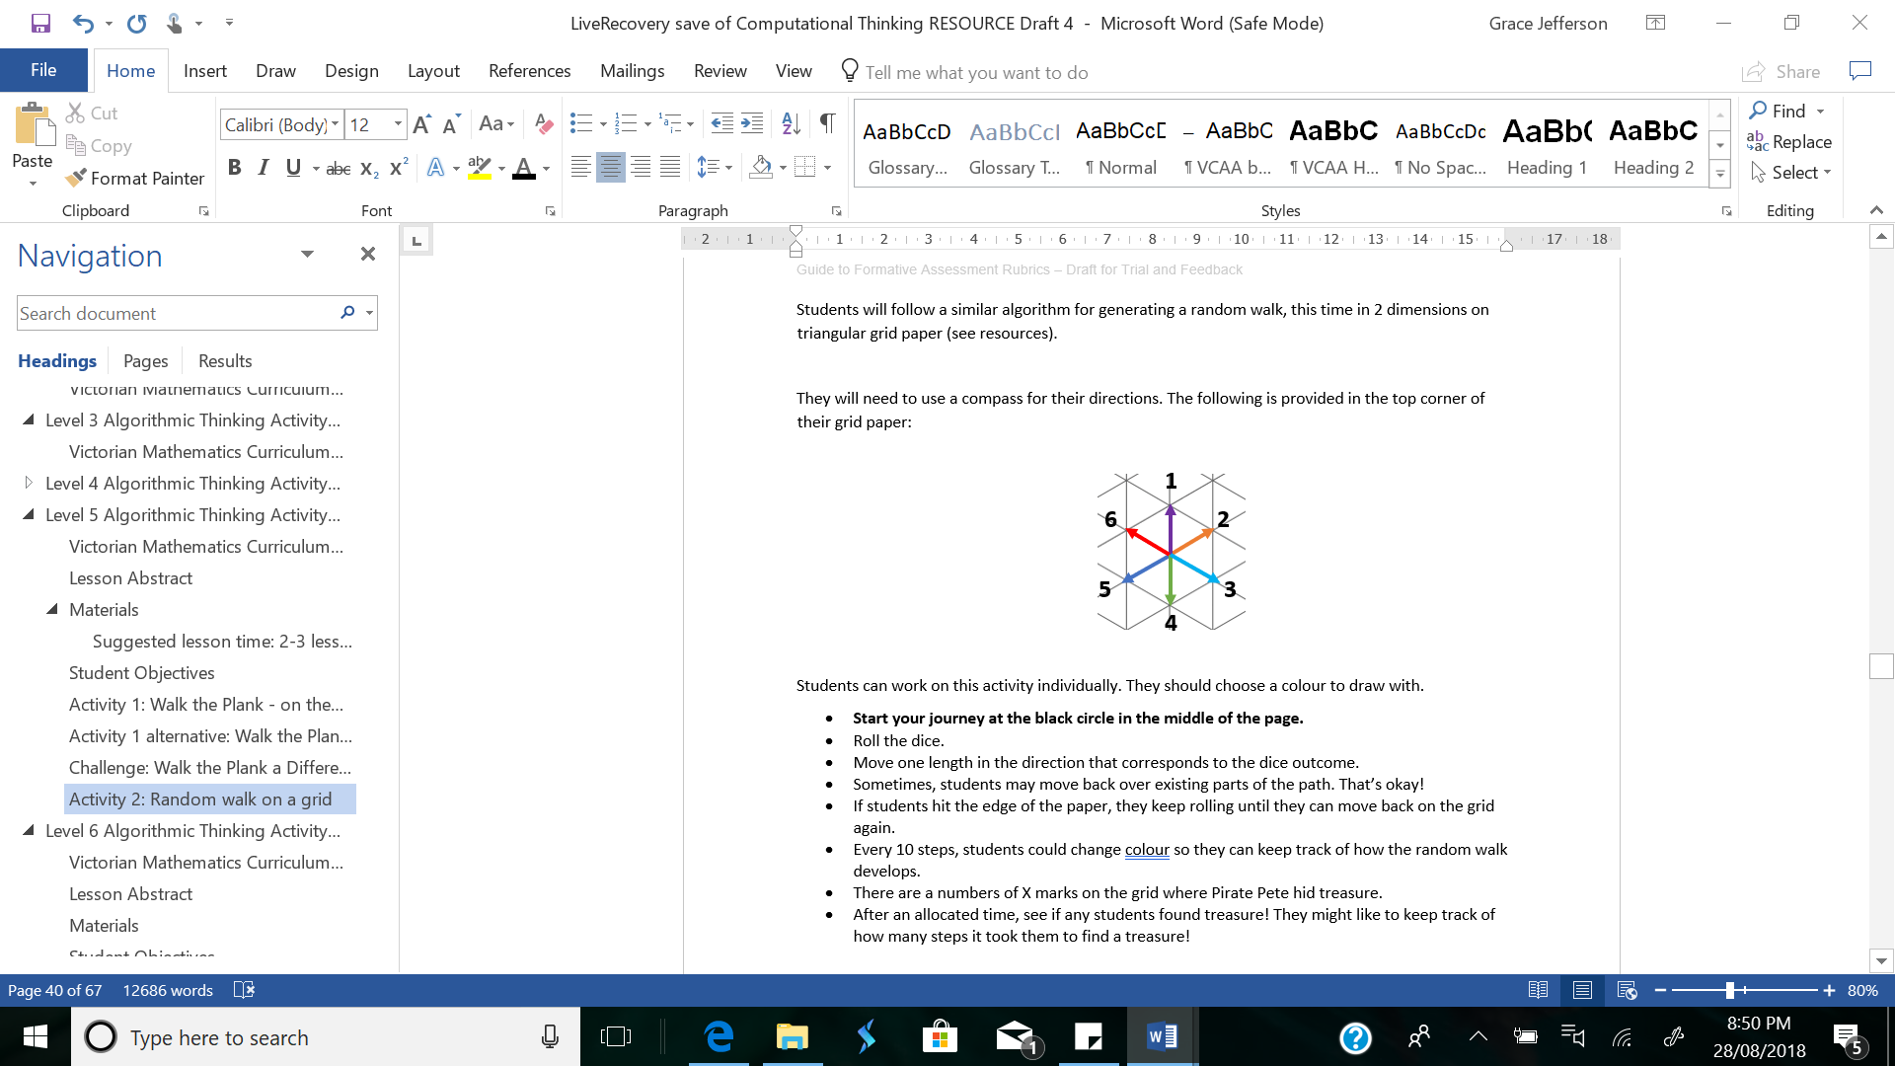

* Ask the students to follow these instructions:
* Choose one colour to draw with.
* Start your journey at the black circle in the middle of the page.
* Roll the die.
* Move one length in the direction that corresponds to the die outcome.
* Sometimes, you may move back over existing parts of the path. That’s okay.
* If you hit the edge of the paper, keep rolling until you can move back on the grid again.
* Every 10 steps, you could change colour so you can keep track of how the random walk develops.
* After an allocated time, see if any students found treasure. They might like to keep track of how many steps it took them to find the treasure.

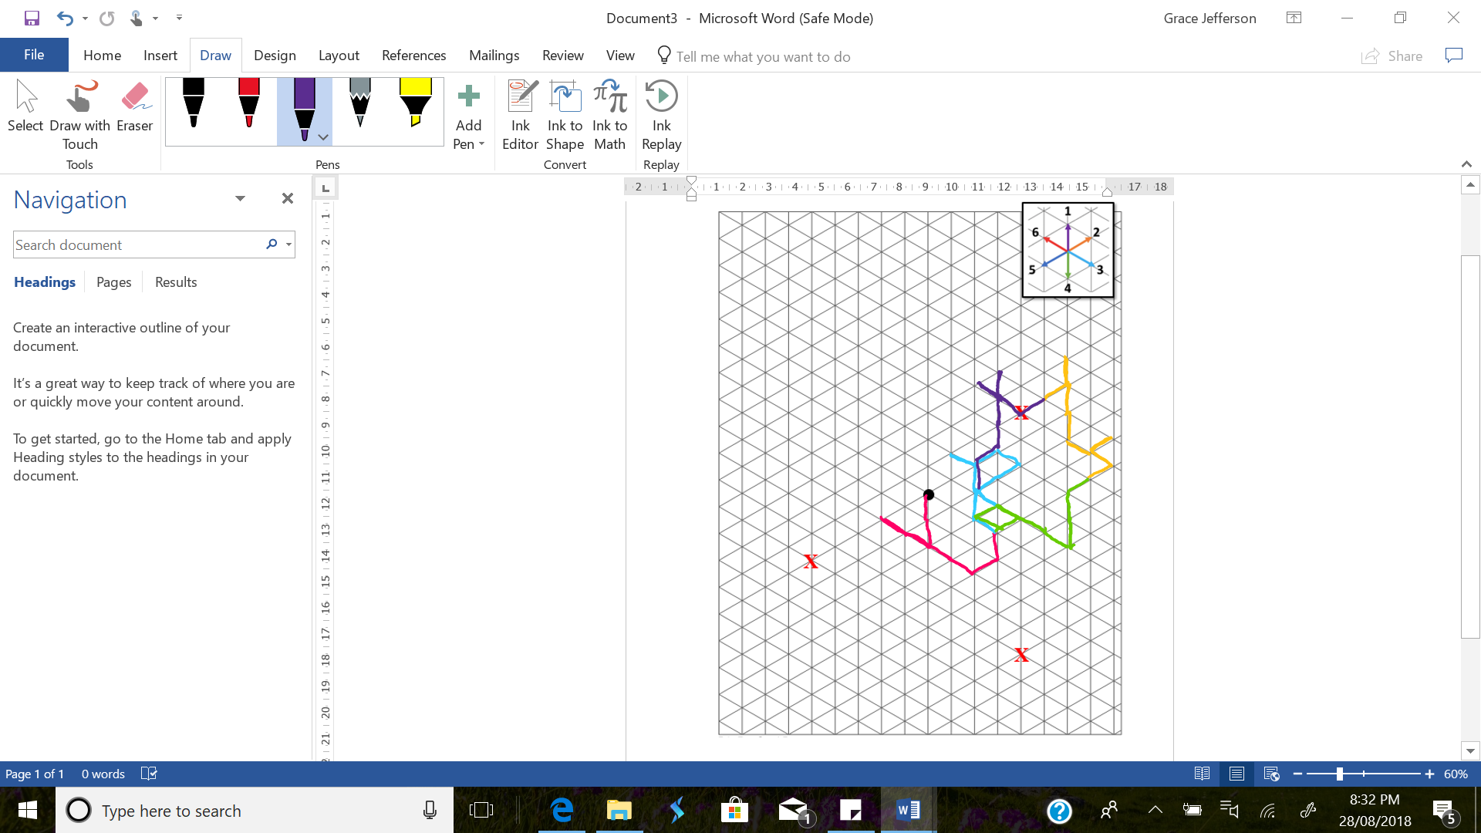Example

An example random walk on the triangular grid is shown here. It took 41 steps to find an X on the grid in this walk. Every 10 steps, the colour was changed.

**Discussion prompts (small groups or whole class)**

* What does this random walk look like? Is there any pattern to it? Why/why not?
* Do you move more often in any one direction? Why/why not?

► **Cross-curricular links**

See Appendix 1 and Appendix 2 for ways to link this activity to the explicit teaching of Digital Technologies and Critical and Creative Thinking.

Challenge and extend

Students requiring extension could explore the applications of random walks in our world.

Option 1

* Random walks are involved in the way animals hunt using a Lévy walk or Lévy flight. These walk patterns follow a random walk as they explore a small area, with large jumps as they move between territories. This is discussed in the clip [How Every Living Thing 'Hunts' The Same Way](https://www.youtube.com/watch?v=TdzD5X2vMxE) (YouTube). This is something we see with ants when they are searching for food.
* Students might like to study the movement of ants around an area, maybe with food crumbs, to see if they find the food – much like their treasure hunt activity on the triangular grid! This extension activity should be done outside or in a contained space, such as a portable ant farm.
* Teachers may want to look at [an article on Lévy walks](https://bio.biologists.org/content/7/1/bio030106) as background.

Option 2

* Random walks in three dimensions are seen in the movement of air and liquids through the process called Brownian motion. This is seen in the way dust particles move in air. Students might like to use a torch in a darkened room, look at the dust particles and think about how these dust particles move. How would they describe this movement, referring to their experience with random walks?

Activity 3 (optional) – random walks using technology

Students may experiment with a random walk they can generate using interactive technology. They should choose how many iterations (steps) to take and the program will run the random walk for them.

The walks below are a few of examples of 2D walks generated on a square grid with 500 steps (starting at the green dot and finishing at the red dot). Notice that they are different each time.

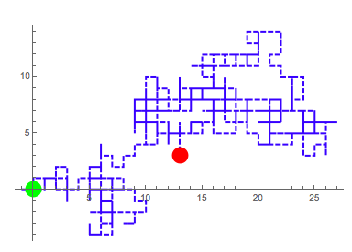

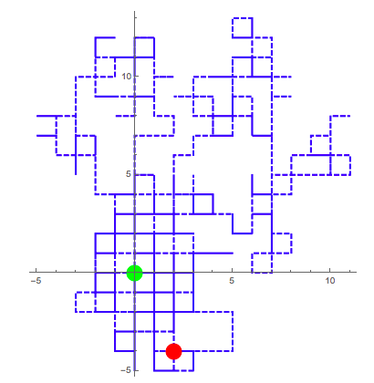

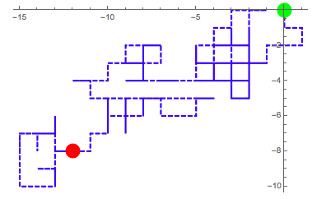

► **Cross-curricular links**

See Appendix 1 and Appendix 2 for ways to link this activity to the explicit teaching of Digital Technologies and Critical and Creative Thinking.

Reflection

With the class or in small groups, students should discuss how an algorithm was used in these activities. Between activities, reflect as a class on the students’ predictions based on the coin/die outcomes and whether the outcome of Pirate Pete’s walks turned out the way they expected.

Ask students:

* How does the algorithm work in each activity?
* What was the purpose of this task?

**Tip:** Reflection is an important aspect of any computational-thinking focused activity because it encourages students to consider the different aspects of the task, such as defining the problem and breaking the task down, selecting tools and processes, problem-solving, teamwork and verifying their solution. This helps students reflect on the process of their own learning (meta-learning) and how the skills they have used might transfer to other contexts.

Additional teaching resources

* The Code.org unplugged lesson [Real-Life Algorithms: Paper airplanes](https://code.org/curriculum/course2/2/Teacher#Activity1) provides a lesson plan and resources on revising algorithms and making a paper airplane using clear instructions.
* [Hour of code](https://code.org/learn) (also by Code.org) includes online activities that encourage students to use algorithmic thinking to create small games or navigate through mazes and puzzles, such as the [Angry Birds maze activity](https://studio.code.org/hoc/1).
* [FUSE](https://fuse.education.vic.gov.au/) isa free resource produced by the Department of Education and Training. FUSE provides Victorian Curriculum resources, interactive websites, videos and games, and the ability for teachers to create and share their own content to FUSE. A FUSE algorithm resource search can be found [here](https://fuse.education.vic.gov.au/Search/Results?AssociatedPackageId=&QueryText=algorithms&SearchScope=Primary). Particular activities that would be good to cover would be the [Unplugged Activity: My robotic friends](https://fuse.education.vic.gov.au/Resource/LandingPage?ObjectId=5167443f-702f-435c-8b4b-1628c977210b&SearchScope=Primary) and [Algorithms explained for Level 5 and 6 students](https://fuse.education.vic.gov.au/Resource/LandingPage?ObjectId=965d7baa-5d31-472c-92ca-08d296829543&SearchScope=Primary)

Appendix 1

Suggestions for explicitly teaching Digital Technologies (stimulus only)

**Curriculum area:** Digital Technologies

**Strand:** Creating Digital Solutions

**Band:** Levels 5 and 6

**Content description:** Design, modify and follow simple algorithms represented diagrammatically and in English, involving sequences of steps, branching and iteration [(VCDTCD032)](https://victoriancurriculum.vcaa.vic.edu.au/Curriculum/ContentDescription/VCDTCD032)

**Achievement standard (extract):** Students … developing algorithms … they incorporate decision-making, repetition …

**Suggestions that extend Activities 1–3:**

* following, modifying and describing the design of a game involving simple algorithms represented diagrammatically or in English, for example creating a flowchart with software that uses symbols to show decisions, processes, and inputs and outputs
* experimenting with different ways of representing an instruction to make a choice, for example branches in a tree diagram or using an ‘IF’ statement to indicate making a choice between two different circumstances, using a spreadsheet or a visual program
* experimenting with different ways of representing an instruction to make a repetition, for example loops in a flowchart diagram or using a ‘REPEAT’ statement

See also [Unpacking Digital Technologies Content Descriptions](https://www.vcaa.vic.edu.au/Documents/viccurric/digitech/Unpacking_the_Content_Descriptions/Unpacking_Digital_Technologies_Content_Descriptions-5-6.docxx) for Levels 5 and 6.

Appendix 2

Suggestions for explicitly teaching Critical and Creative Thinking (stimulus only)

**Curriculum area:** Critical and Creative Thinking

**Strand:** Questions and possibilities

**Band:** Levels 5 and 6

**Content description:** Experiment with alternative ideas and actions by setting preconceptions to one side ([VCCCTQ022](http://victoriancurriculum.vcaa.vic.edu.au/Curriculum/ContentDescription/VCCCTQ022))

**Achievement standard (extract):** They use appropriate techniques to copy, borrow and compare aspects of existing solutions in order to identify relationships and apply these to new situations.

**Suggestion that links to Activity 1:**

* Considering how their initial predictions might have been influenced by preconceptions of what randomness is like. Then, experimenting with the idea of randomness as having ‘clumps’ of data, as well as equally spaced data points, for example when predicting the position of people in a random walk across the classroom.

**Curriculum area:** Critical and Creative Thinking

**Strand:** Reasoning

**Band:** Levels 5 and 6

**Content description:** Consider the importance of giving reasons and evidence and how the strength of these can be evaluated [(VCCCTR025)](http://victoriancurriculum.vcaa.vic.edu.au/Curriculum/ContentDescription/VCCCTR025)

**Achievement standard (extract):** They explain how reasons and evidence can be evaluated.

**Suggestions that link to Activity 1:**

* Investigating why we might need to evaluate evidence in different ways, for example, checking how data was collected during Activity 1 (in small groups and when collated as class data) and whether there is any bias in this data.

**Curriculum area:** Critical and Creative Thinking

**Strand:** Reasoning

**Band:** Levels 5 and 6

**Content description:** Examine the difference between valid and sound arguments and between inductive and deductive reasoning, and their degrees of certainty [(VCCCTR027)](http://victoriancurriculum.vcaa.vic.edu.au/Curriculum/ContentDescription/VCCCTR027)

**Achievement standard (extract):** They explain and apply basic techniques to … test the strength of arguments.

**Suggestion that links to Activities 1 and 2:**

* Exploring the link between probability and inductive reasoning (where a conclusion is drawn from a series of particular instances), for example when conducting the experiments using the different probabilities of dice and/or coins (chance) in each Challenge and extend activity.

**Curriculum area:** Critical and Creative Thinking

**Strand:** Meta-Cognition

**Band:** Levels 5 and 6

**Content description:** Investigate thinking processes using visual models and language strategies [(VCCCTM029)](http://victoriancurriculum.vcaa.vic.edu.au/Curriculum/ContentDescription/VCCCTM029)

**Achievement standard (extract):** Students represent thinking processes using visual models and language.

**Suggestion that links to Activities 1–3:**

* Using visual representations of random walks in two and three dimensions to explore the idea of randomness and chance, and reflecting on the *strengths* of visual representation for this purpose

Appendix 3

Excerpts from the Victorian Curriculum Mathematics and Digital Technologies glossaries

There are some commonalities in the terms used when explicitly teaching computational and algorithmic thinking in Mathematics and Digital Technologies; however, there are also some subtle but important differences in the definitions of terms. Some of these common terms and their definitions are listed below, under the two different curriculum areas.

If you are going to explicitly teach Mathematics, please refer to the [Victorian Curriculum Mathematics Glossary](https://victoriancurriculum.vcaa.vic.edu.au/LearningArea/LoadFile?learningArea=mathematics&subject=mathematics&name=Mathematics%20Glossary.docx&storage=Glossary). If you are also going to explicitly teach Digital Technologies, refer to the [Victorian Curriculum Digital Technologies Glossary](https://victoriancurriculum.vcaa.vic.edu.au/LearningArea/LoadFile?learningArea=technologies&subject=digital-technologies&name=Digital%20Technologies%20Glossary.docx&storage=Glossary).

Mathematics

Algorithm

An **algorithm** is a process that can be carried out mechanically, using a well-defined set of instructions, to perform a particular task or solve a type of problem. Examples of mathematical algorithms include processes for tasks such as ordering a set of numbers from smallest to largest, multiplying many-digit decimal numbers, factorising linear expressions, determining which of two fractions is larger, bisecting an angle, or calculating the mean of a set of numbers.

Algorithmic thinking

**Algorithmic thinking** is the type of thinking required to design, test and evaluate problem-solving processes in a systematic way, using algorithms.

Coding

A process by which algorithms are represented for implementation. For computers, this is done using a coding language such as block coding, C++, JavaScript, Python, Wolfram Language.

Computational thinking

In this context, computational thinking is considered to be linked to algorithmic thinking. This type of thinking is usually considered specific to computers which involves solving problems, designing systems and implementation.

Sequence (number)

A **sequence** is an ordered set of elements such as numbers, instructions or objects. From an algorithmic point of view, a sequence is an ordered set of instructions or actions.

Unplugged

A commonly used term for computational thinking activities carried out without digital technology. “Unplugged” representations of algorithms may include structured mathematical processes, English representations (steps) or flowcharts.

Digital Technologies

Algorithm

A description of the steps and decisions required to solve a problem. For example, to find the largest number in a list of positive numbers:

1. Note the first number as the largest.
2. Look through the remaining numbers, in turn, and if a number is larger than the number found in 1, note it as the largest.
3. Repeat this process until complete. The last noted number is the largest in the list.

Flowcharts are often useful in visualising an algorithm.

Computational thinking

A problem-solving method that involves various techniques and strategies in order to solve problems that can be implemented by digital systems, such as organising data logically, breaking down problems into components, and the design and use of algorithms, patterns and models.

Appendix 4

✂

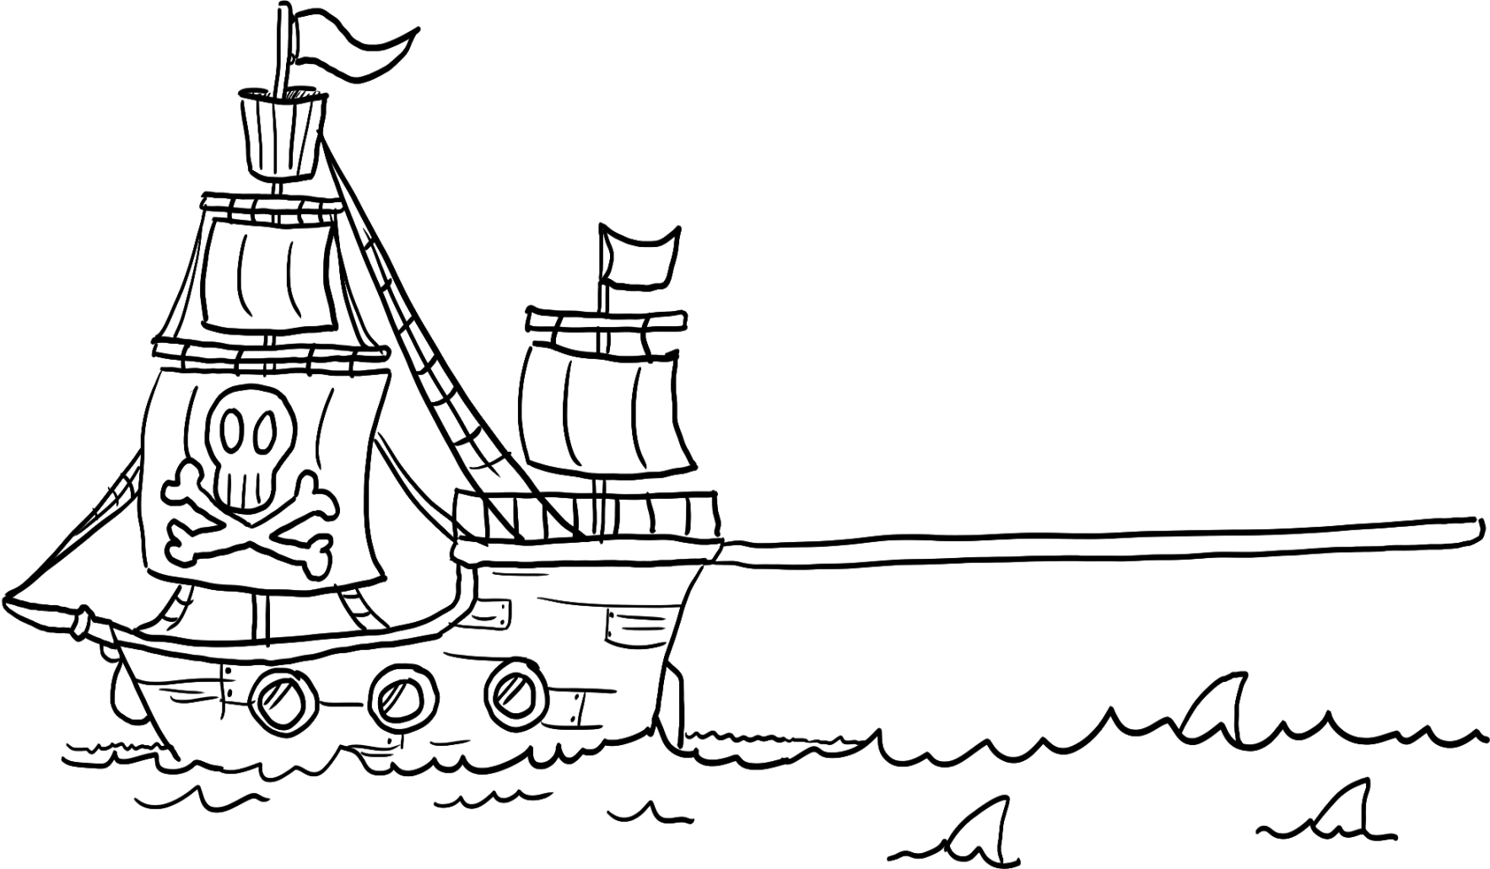

|  |  |  |  |  |  |  |  |  |  |  |
| --- | --- | --- | --- | --- | --- | --- | --- | --- | --- | --- |
| **0** | **1** | **2** | **3** | **4** | **5** | **6** | **7** | **8** | **9** | **10** |



**SHIP**

**SEA**

Random walk the plank

1. Start Pirate Pete on the number 5.
2. Flip a coin. Heads, Pete moves one space right. Tails, Pete moves one space left. Repeat until Pete   
   reaches either the number 1 or 10.
3. Pirate Pete is safe when he reaches the ship and lands on number 1.
4. Pirate Pete falls in the sea when he lands on number 10. Oh dear! Poor Pirate Pete!

Triangular grid for a random walk

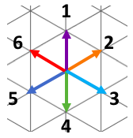Triangular grid paper for random walk, with compass in top right corner.

**X**

**X**

**X**

Coin and die outcome tables for Activity 1

Option 1: Coin outcomes

|  |  |
| --- | --- |
| **Outcome** | **Movement** |
| Heads  Australian coin with 'head' facing up | Take 1 step to the right  Green arrow pointing right |
| Tails  Australian coin with 'tail' facing up | Take 1 step to the left  Orange arrow pointing left |

Option 2: Die outcomes

|  |  |
| --- | --- |
| **Outcome** | **Movement** |
| Roll a 2, 4 or 6 (even numbers)  Drawing of a die showing 2Drawing of a die showing 4Drawing of a die showing 6 | Take 1 step to the right  Green arrow pointing right |
| Roll a 1, 3 or 5 (odd numbers)  Drawing of a die showing 1Drawing of a die showing 3Drawing of a die showing 5 | Take 1 step to the left  Orange arrow pointing left |

Die outcome tables

Die outcomes: Table 1

|  |  |
| --- | --- |
| **Outcome** | **Movement** |
| Roll a 2, 4 or 6 (even numbers)  Drawing of a die showing 2Drawing of a die showing 4Drawing of a die showing 6 | Take one step to the right  Green arrow pointing right |
| Roll a 1, 3 or 5 (odd numbers)  Drawing of a die showing 1Drawing of a die showing 3Drawing of a die showing 5 | Take one step to the left  Orange arrow pointing left |

Die outcomes: Table 2

|  |  |
| --- | --- |
| **Outcome** | **Movement** |
| Roll a 6  Drawing of a die showing 6 | Take one step to the right  Green arrow pointing right |
| Roll any other number  Drawing of a die showing 1 Drawing of a die showing 2Drawing of a die showing 3 Drawing of a die showing 4Drawing of a die showing 5 | Take one step to the left  Orange arrow pointing left |

Die Outcomes: Table 3

|  |  |
| --- | --- |
| **Outcome** | **Movement** |
| Roll a number greater than or equal to 5  Drawing of a die showing 5Drawing of a die showing 6 | Take one step to the right  Green arrow pointing right |
| Roll a number less than 5  Drawing of a die showing 1 Drawing of a die showing 2Drawing of a die showing 3 Drawing of a die showing 4 | Take one step to the left  Orange arrow pointing left |

Die Outcomes: Blank

|  |  |
| --- | --- |
| **Outcome** | **Movement** |
|  | Take one step to the right  Green arrow pointing right |
|  | Take one step to the left  Orange arrow pointing left |