Computational and
algorithmic thinking
in Mathematics

Unpacking the content descriptions

Foundation



Authorised and published by the Victorian Curriculum and Assessment Authority
Level 7, 2 Lonsdale Street
Melbourne VIC 3000
© Victorian Curriculum and Assessment Authority 2019

No part of this publication may be reproduced except as specified under the Copyright Act 1968 or by permission from the VCAA. Excepting third-party elements, schools may use this resource in accordance with the VCAA educational allowance. For more information go to: https://www.vcaa.vic.edu.au/Footer/Pages/Copyright.aspx.
The VCAA provides the only official, up-to-date versions of VCAA publications. Details of updates can be found on the VCAA website: www.vcaa.vic.edu.au.
This publication may contain copyright material belonging to a third party. Every effort has been made to contact all copyright owners. If you believe that material in this publication is an infringement of your copyright, please email the Copyright Officer: vcaa.copyright@edumail.vic.gov.au
Copyright in materials appearing at any sites linked to this document rests with the copyright owner/s of those materials, subject to the Copyright Act. The VCAA recommends you refer to copyright statements at linked sites before using such materials.

The VCAA logo is a registered trademark of the Victorian Curriculum and Assessment Authority.

Contents
Explicitly teaching computational and algorithmic thinking 4
Overview of the resource 5
X marks the spot 6
Additional teaching resources 9
Appendix 1 10
Appendix 2 11
Appendix 3 13
Appendix 4 15

Explicitly teaching computational and
algorithmic thinking
The Computational and algorithmic thinking – Unpacking the content descriptions resources unpack the Victorian Curriculum F–10 Mathematics content descriptions that address computational thinking and algorithms at each level in the Patterns and algebra sub-strand of the Number and Algebra strand.
Each resource provides teachers with links between one Mathematics content description and extract from the achievement standard related to computational and algorithmic thinking and a teaching and learning activity that is designed to develop computational thinking and problem-solving skills and produce corresponding algorithms in a mathematical context. Teachers can also find excerpts from the Victorian Curriculum Mathematics and Digital Technologies glossaries in Appendix 3.
The resources have been developed with respect to teaching in the Mathematics learning area of the Victorian Curriculum and they also include suggestions how these activities could be extended to the Critical and Creating Thinking and Digital Technologies curriculums.
Teachers will find detailed ideas about how to integrate Mathematics with one or both of Digital Technologies and Critical and Creating Thinking in Appendix 1 and Appendix 2 respectively.

Overview of the resource

Curriculum area and level: Mathematics, Foundation
Strand and sub-strand: Number and Algebra, Patterns and algebra
Content description: Follow a short sequence of instructions (VCMNA077)
Achievement standard (extract): Students … match individual objects with counting sequences [and] represent, continue and create simple patterns.

Title: X marks the spot
Timing: 2 lessons (approx. 100 minutes)
Description: Students follow a sequence of instructions to move one object (a pirate) from one location to another on a grid (treasure map).
Students then create their own treasure maps on a blank grid and identify possible sequences of steps to locate the treasure.
Learning objectives: Students can:
follow a sequence of instructions to find a location
create a possible sequence of instructions to find a location.
Printable materials: The following printable materials are included as Appendix 4. They could be printed at A3 size, and printed on cardboard or laminated.
Pirate’s treasure map (grid)
Blank treasure map (grid)
Pirate counter
Sequence cards (set of 5)
Location cards (set of 5)
Direction cards (arrow symbols)

X marks the spot

Teacher instructions
- Students will be using a set of movement sequence cards to follow a sequence of instructions to find a location.
- Get students to work individually.
- Give the following printed resources to each student:
- 1 × pirate’s treasure map (grid)
- 1 × blank treasure map (grid)
- 1 × pirate counter
- 1 × set of 5 sequence cards
- 1 × set of 5 location cards
- 1 × set of direction cards (arrow symbols).
- Ask students to cut out the sequence cards, location cards and direction cards.

Activity 1
Ask students to place their pirate counter on the ‘Start’ square of the pirate’s treasure map (grid). They should place all five location cards and all five sequence cards in front of them.
Students then select one sequence card at a time (starting with Sequence 1) and move their pirate around the grid, following the sequence of steps on each card.
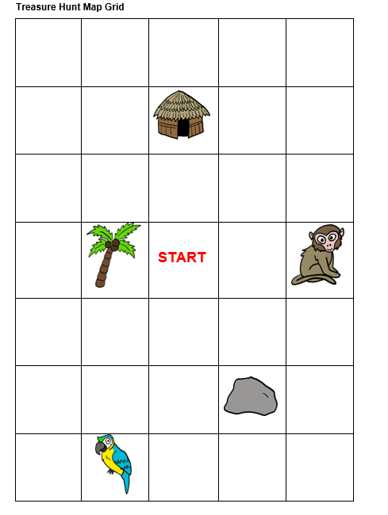
Each individual arrow symbol in the sequence cards represents the movement of one space in the direction shown. Each time a student follows a sequence of steps, they arrive at a different location (the rock, palm tree, monkey, hut or parrot). These locations are all the places the pirate has hidden some treasure. They should then select the corresponding location card and put aside the pair of cards (that is, one sequence card and its corresponding location card).
For example, Sequence 1 leads to the monkey.
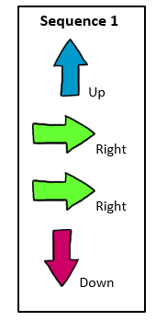

Tip: Teachers are encouraged to use and to clearly define ‘sequence of steps’ to reinforce the process of following a set of instructions to solve a task (see the Victorian Curriculum Mathematics Glossary or Appendix 3). Teachers may provide a definition or ask students to come up with an agreed class definition before the activity.
Students should place their pirate back at the ‘Start’ square and repeat for all the sequence cards.
At the end of the activity, students will have five sequence cards paired up with their corresponding location card.

Activity 2
Students will now create their own treasure map, using the blank treasure map (grid).
Each student should mark the location of their treasure by drawing an ‘X’ in one grid square on the blank map.
Students then come up with a possible sequence of steps that will get their pirate to the treasure from the ‘Start’ square. They could use the arrow symbols to put together their sequence of steps, or they could write their arrow directions on a whiteboard or on paper.
Students should check that their sequence of steps takes them to the treasure at ‘X’, and then give their sequence to another student to check.
For example, the following is a possible sequence of instructions for this marked map.

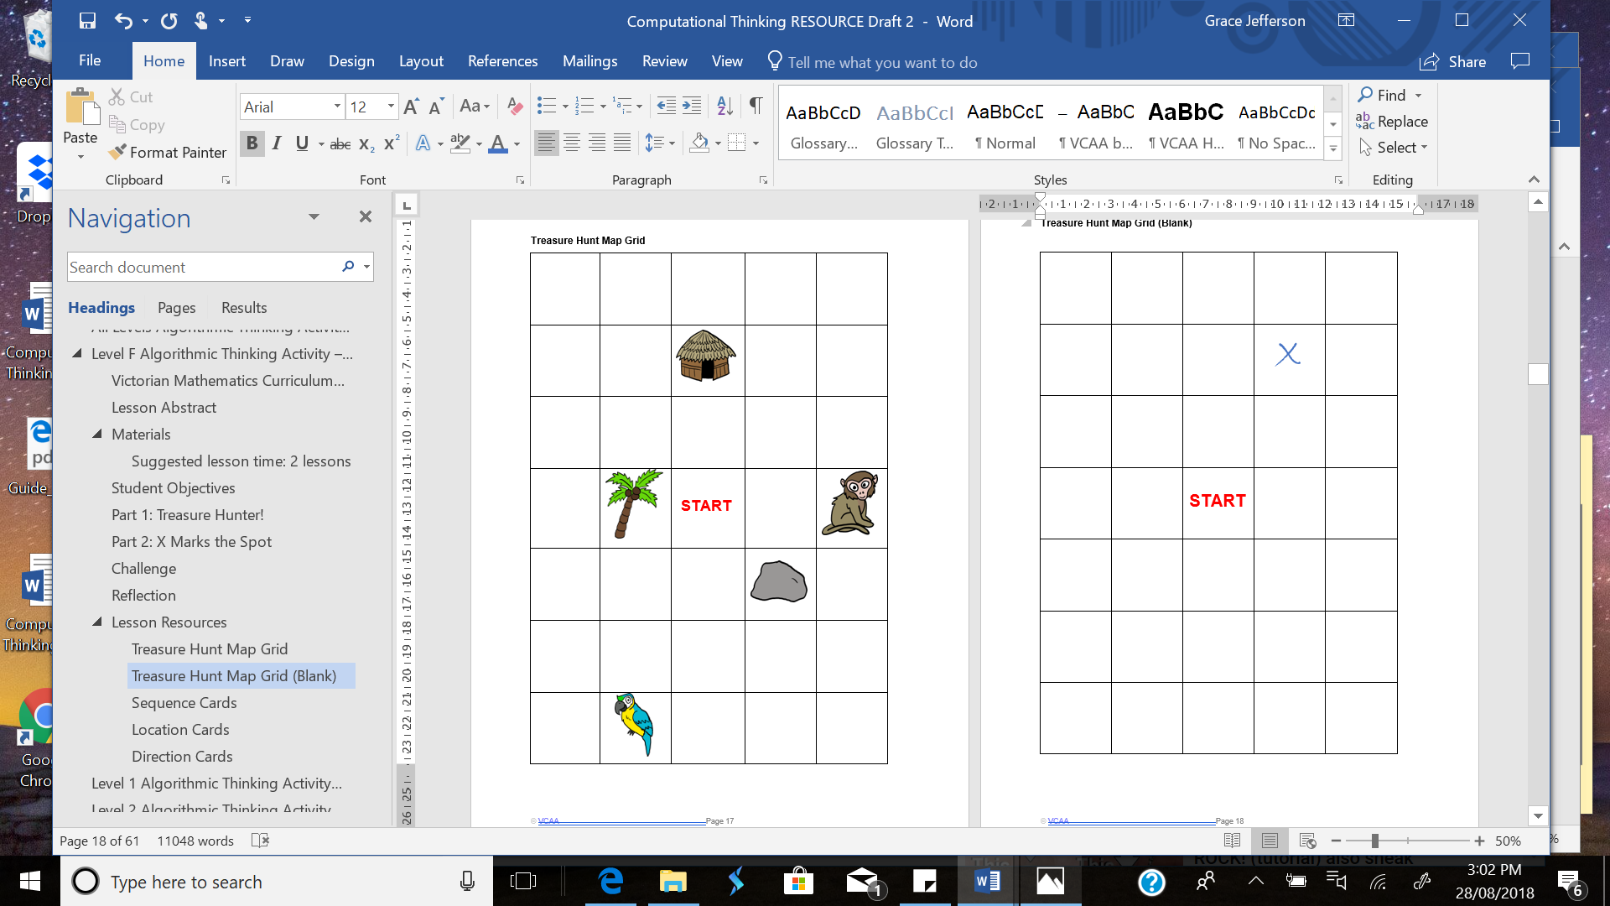

► Cross-curricular links
See Appendix 1 and Appendix 2 for ways to link this activity to the explicit teaching of Digital Technologies and/or Critical and Creative Thinking.

Challenge and extend
Ask students to create different sequences of steps to get from ‘Start’ to ‘X’ on the treasure maps they’ve created, for example:
- sequences of steps with different numbers of direction cards used
- a sequence of steps where they use only three types of direction cards
- a sequence of steps where they use all four types of direction cards
- the shortest possible sequence of steps to get to their ‘X’ (how do they know it is the shortest sequence of steps?)
Some students might want to create their own treasure map with additional pictures and symbols – rather than just an ‘X’ – to give to a partner to solve.

Reflection
Students share their findings from Activity 1 (their pairs of location/sequence cards) and compare their solutions from Activity 2.
Ask the class to discuss the different strategies they used to overcome any challenges and what other kind of problems these strategies might be used for.
Discussion prompts
- Can you think of any sequences using the direction cards that wouldn’t work? Why wouldn’t they work? How do you know? How can you show this?
- What happens when you use a left arrow followed by a right arrow. Where do you end up? What happens when you use an up arrow followed by a down arrow? Now where do you end up? What is similar about these two situations?

Tip: Reflection is an important aspect of any computational-thinking focused activity because it encourages students to consider the different aspects of the task, such as defining the problem and breaking the task down, selecting tools and processes, problem-solving, teamwork and verifying their solution. This helps students reflect on the process of their own learning (meta-learning) and how the skills they have used might transfer to other contexts.

Additional teaching resources
- CS Fundamentals Unplugged offers free activities to explore algorithms unplugged. Age appropriateness of activities is indicated. ‘Happy Maps’, ‘Happy Maps (Extended)’, ‘Move It, Move It’ and ‘My Robotic Friends Jr.’ offer activities to extend student understanding of sequences (including both following and creating sequences).
- Graph Paper Programming is an unplugged activity that provides an introduction to programming.
- Digital Technologies Hub offers the activity ‘Buzzing with Bee-Bots, Years F–2’.
- The Australian Computing Academy has an unplugged version of Bee-Bots called Wom-Bots. Wom-Bots can be cut out and moved to follow a sequence of visual instructions (arrows) stuck to their backs.
- The interactive Hour of Code Maze Activity lesson is a simple online introduction to algorithmic thinking and solving simple mazes.

Appendix 1

Suggestions for explicitly teaching Digital Technologies (stimulus only)

Curriculum area: Digital Technologies
Strand: Creating Digital Solutions
Band: Foundation to Level 2
Content description: Follow, describe and represent a sequence of steps and decisions (algorithms) needed to solve simple problems (VCDTCD017)
Achievement standard (extract): Students design solutions to simple problems using a sequence of steps and decisions.
Suggestions that link to Activity 2:
- Using cards with arrows or symbols to create a simple algorithm.
- Recording the steps as symbols to solve a problem, for example, using arrows.

See also Unpacking Digital Technologies Content Descriptions for Foundation to Level 2.

Appendix 2

Suggestions for explicitly teaching Critical and Creative Thinking (stimulus only)

Curriculum area: Critical and Creative Thinking
Strand: Questions and possibilities
Band: Foundation to Level 2
Content description: Make simple modifications to known ideas and routine solutions to generate some different ideas and possibilities (VCCCTQ003)
Achievement standard (extract): Students generate ideas that are new to them …
Suggestions that link to Activity 2:
- Investigating whether simple changes to instructions for sequences of steps make a significant difference to the pathway.
- Experimenting with sets of instructions to compare the most common pathways to an object against less common ones.
- Trying different sequences of steps to reach the same location (modification of their original sequence), for example, to try to find the shortest possible route.

Curriculum area: Critical and Creative Thinking
Strand: Reasoning
Band: Foundation to Level 2
Content description: Compare and contrast information and ideas in own and others reasoning (VCCCTR005)
Achievement standard (extract): They use reasons and examples for different purposes …
Suggestions that link to Activity 2:
- Sharing points of view and discussing information and ideas used to help reach each location; for example, ‘How did you get there? Can you show me how you got there?’
- Talking about two methods with the same outcome (final location) and identifying the strategy used in each, identifying similarities and differences; for example, ‘I got there using these arrows. Mine are different to yours but we ended up at the same place’ or ‘Why did you use this method?’

Curriculum area: Critical and Creative Thinking
Strand: Meta-Cognition
Band: Foundation to Level 2
Content description: Investigate ways to problem-solve, using egocentric and experiential language (VCCCTM009)
Achievement standard (extract): Students demonstrate and articulate some problem-solving approaches …
Suggestions that link to Activity 2:
- Discussing sequencing of steps as a problem-solving approach in response to a ‘How do I…?’ problem, and experimenting with different sequences of steps.
- Discussing their problem-solving approach and thinking out loud with a partner.

Appendix 3

Excerpts from the Victorian Curriculum Mathematics and Digital Technologies glossaries
There are some commonalities in the terms used when explicitly teaching computational and algorithmic thinking in Mathematics and Digital Technologies; however, there are also some subtle but important differences in the definitions of terms. Some of these common terms and their definitions are listed below, under the two different curriculum areas.
If you are going to explicitly teach Mathematics, please refer to the Victorian Curriculum Mathematics Glossary. If you are also going to explicitly teach Digital Technologies, refer to the Victorian Curriculum Digital Technologies Glossary.

Mathematics

Algorithm
An algorithm is a process that can be carried out mechanically, using a well-defined set of instructions, to perform a particular task or solve a type of problem. Examples of mathematical algorithms include processes for tasks such as ordering a set of numbers from smallest to largest, multiplying many-digit decimal numbers, factorising linear expressions, determining which of two fractions is larger, bisecting an angle, or calculating the mean of a set of numbers.

Algorithmic thinking
Algorithmic thinking is the type of thinking required to design, test and evaluate problem-solving processes in a systematic way, using algorithms.

Coding
A process by which algorithms are represented for implementation. For computers, this is done using a coding language such as block coding, C++, JavaScript, Python, Wolfram Language.

Computational thinking
In this context, computational thinking is considered to be linked to algorithmic thinking. This type of thinking is usually considered specific to computers which involves solving problems, designing systems and implementation.

Sequence (number)
A sequence is an ordered set of elements such as numbers, instructions or objects. From an algorithmic point of view, a sequence is an ordered set of instructions or actions.

Unplugged
A commonly used term for computational thinking activities carried out without digital technology. “Unplugged” representations of algorithms may include structured mathematical processes, English representations (steps) or flowcharts.

Digital Technologies

Algorithm
A description of the steps and decisions required to solve a problem. For example, to find the largest number in a list of positive numbers:
- Note the first number as the largest
- Look through the remaining numbers, in turn, and if a number is larger than the number found in 1, note it as the largest.
- Repeat this process until complete. The last noted number is the largest in the list.
Flowcharts are often useful in visualising an algorithm.

Computational thinking
A problem-solving method that involves various techniques and strategies in order to solve problems that can be implemented by digital systems, such as organising data logically, breaking down problems into components, and the design and use of algorithms, patterns and models.

Appendix 4

Pirate’s treasure map (grid)
Start

Blank treasure map (grid)
Start

Sequence cards
Sequence 4
Right
Down
Left
Left
Left
Right
Up

Sequence 3
Left
Down
Left
Down
Down
Right

Sequence 1
Up
Right
Right
Down

Sequence 2
Left
Up
Up
Right

Sequence 5
Left Down Right

Location cards

parrot

hut

rock

monkey

palm tree

Pirate counter


Arrow symbols

