2021 VCE Applied Computing: Software Development external assessment report

General comments
The 2021 VCE Applied Computing: Software Development examination comprised three sections: Section A, which contained 20 multiple-choice questions (worth a total of 20 marks); Section B, which contained five short-answer questions (worth a total of 20 marks); and Section C, which was a case study with 13 questions (worth a total of 60 marks).
Section A was answered quite well by most students. In Sections B and C some students found it difficult to demonstrate their theoretical knowledge or use subject-specific terminology correctly. The key weakness in many responses in these sections was a lack of detail and depth of understanding. Students are encouraged to consider the command term used in the question stem (e.g. ‘describe’, ‘explain’ or ‘outline’), the number of marks and the number of lines provided as a guide to the detail and depth of the required response. In Section C, some students found it difficult to apply their knowledge to the case study.
During the examination, students should:
- endeavour to use correct technical terminology
- discuss all options when asked to justify a choice or compare one option with another
- respond to key terms, such as ‘state’, ‘explain’ and ‘describe’
- re-read each question and their response to ensure that the question has been answered
- remove the case study insert from the question and answer book, and refer to it when completing Section C
- include sufficient specific detail, rather than general detail, in responses.

Specific information
Note: Student responses reproduced in this report have not been corrected for grammar, spelling or factual information.
This report provides sample answers or an indication of what answers may have included. Unless otherwise stated, these are not intended to be exemplary or complete responses.
The statistics in this report may be subject to rounding resulting in a total more or less than 100 per cent.

Section A – Multiple-choice questions
Question | Correct answer | % A | % B | % C | % D | Comments
1 | A | 97 | 3 | 0 | 0
2 | C | 4 | 5 | 61 | 30
3 | A | 81 | 8 | 2 | 9
4 | D | 11 | 20 | 21 | 48 | An information system goal is going to support an overall goal of an organisation (as opposed to individual functional and non-functional requirements).
5 | D | 9 | 2 | 10 | 79
6 | B | 15 | 77 | 8 | 0
7 | A | 35 | 22 | 2 | 41 | The effectiveness of a project plan can be determined by assessing the project plan against the project’s scope and timeline (as opposed to the effectiveness of a project, which can be determined by assessing the project against the evaluation criteria developed in the design stage).
8 | D | 23 | 0 | 13 | 64
9 | A | 19 | 6 | 12 | 63 | At a system level, a context diagram is used to model the flow of data into and out of a system (as opposed to a data flow diagram, which is used to show the flow of data through a process).
10 | D | 42 | 13 | 17 | 27 | Affordance considerations relate to the way in which a user interacts with a system based on its design. They do not include offsets of development costs.
11 | C | 0 | 7 | 86 | 7
12 | C | 0 | 14 | 86 | 0
13 | A | 78 | 7 | 5 | 10
14 | D | 15 | 26 | 17 | 42 | As per the study design, factors influencing the integrity of data, include accuracy, authenticity, correctness, reasonableness, relevance and timeliness.
15 | C | 6 | 1 | 83 | 10
16 | B | 7 | 74 | 7 | 12
17 | C | 10 | 30 | 36 | 24 | The first error in the trace table is:  min j  This is because this line of code should not run (as the conditional statement on line 5 will return FALSE).
18 | B | 1 | 48 | 30 | 21 | Although the outer loop of the selection sort algorithm will run seven times (once of reach position in the array), there will only be five swaps, as on the remaining two iterations the smallest value will already be in position.
19 | C | 17 | 15 | 59 | 9
20 | A | 64 | 12 | 10 | 12

Section B

Question 1
Mark | 0 | 1 | 2 | 3 | 4 | Average
% | 20 | 20 | 38 | 9 | 13 | 1.8
To achieve two marks for this question, students needed to state two distinct purposes of internal documentation. A range of purposes were accepted, including that internal documentation:
- provides meaning to syntax
- assists others to read the code
- assists with debugging and testing
- assists with maintenance.
To achieve full marks in this question, students needed to explain how a naming convention would be useful for each distinct purpose identified. Possible aspects of naming conventions that can help included:
- the use of meaningful names
- including the data type in the variable name
- aiding readability.
Although most students were able to identify two distinct purposes, some repeated the same (or similar) purpose twice. Many students failed to address the question and explain how a naming convention would help their identified purpose, and some didn’t identify a naming convention for each purpose.
The following is an example of a high-scoring response.
Purpose 1: Helps ensure other developers understand what the code does
Explanation: This will help the other developers better understand the functions of the overall software as a consistent naming convention makes the documentation easier to follow and learn.
Purpose 2: Helps reduce the amount of time required for maintenance/debugging
Explanation: As the naming convention creates consistency, this means that less time will be spent trying to learn the code and its functions and allows quick maintenance to occur, reducing development cost.

Question 2
Mark | 0 | 1 | 2 | 3 | Average
% | 3 | 9 | 44 | 44 | 2.3

Existing tickets will need to work with the new system | Technical
The new system will process payments in Australian dollars | Economic or Technical
Location tracking data must be de-identified | Legal
Most students were able to correctly classify two out of the three constraints. Some incorrectly identified usability instead of technical for Constraint 1 and social instead of legal for Constraint 3.

Question 3
Mark | 0 | 1 | 2 | 3 | Average
% | 19 | 35 | 35 | 10 | 1.4
Students were awarded marks for discussing the consequences of providing stored medical data to a university and for referring in context to the Privacy Act 1988 (Cth) and the Health Records Act 2001 (Vic). Although many students were able to write a general statement about the scenario breaching both Acts, few were able to explain the implications of the different Acts on the scenario. Many students also made incorrect statements in relation to consequences, for example ‘they could go to jail’ or ‘they could get in trouble with the police’.
The following is an example of a high-scoring response.
The Privacy Act 1988 is a federal law that can apply to organisations that collect health data. This law would also apply to the University if it were given access to the data. The Health Act 2001 is a Victorian Law that requires data to be collected only for the stated purpose unless separate consent is obtained. Given the company would only have access to the data for the purpose of providing the service of wearable devices, they would need to gain consent from each user of each wearable device in order to provide this data to the university. This is impractical, so they cannot provide the data to the university, even if it is de-identified. A possible legal consequence might be fines.

Question 4a.
Mark | 0 | 1 | 2 | Average
% | 93 | 3 | 5 | 0.1
Very few students identified that the mistake in the data flow diagram was the missing outgoing data flow and that the appropriate fix was to add a data flow out of 5.0 Prepare data packets. Many incorrectly stated that the mistake was the data flow diagram was missing a data store; however, a data store is not a mandatory aspect of every data flow diagram and each data flow diagram must have data flowing out.

Question 4b.
Mark | 0 | 1 | 2 | Average
% | 52 | 29 | 19 | 0.7
Some students correctly identified quick sort as the most appropriate sorting algorithm; however, few were able to justify why. Marks were awarded for justification, for example, the speed of the quick sort in comparison to selection sort, and the limited battery capacity of the Relentless rover requiring a faster sorting algorithm.
The following is an example of a high-scoring response.
Given that Relentless has limited battery power, quick sort would be preferable over selection sort, as it performs less comparisons, thereby saving power used by the processor.

Question 5a.
Mark | 0 | 1 | 2 | Average
% | 16 | 36 | 49 | 1.4
Many students were able to correctly state that usability testing is testing for the ease of use of a solution by real users and that functional testing checks that algorithms correctly return particular outputs for given inputs.
The following is an example of a high-scoring response.
Functional testing ensures that a solution is logically correct and behaves as expected (according to functional requirements. Whereas usability testing focuses on user experience and any issues that arise within the client’s use of the solution, i.e. can they use it easily?

Question 5b.
Mark | 0 | 1 | 2 | Average
% | 10 | 34 | 56 | 1.5
Most students were able to construct an argument that employees developing a product would have knowledge and bias about how that software works and that employees are not real users or representative of the senior citizens that the application is intended for.

Question 5c.
Mark | 0 | 1 | 2 | Average
% | 43 | 29 | 29 | 0.9
Appropriate data collection methods included:
- Qualitative:
- screen recordings of user case studies
- comments from users relating to ease of use
- Quantitative:
- ratio of typed searches relative to direct clicks
- task completion times
- survey (with a link to collecting numeric data)
- number of successfully completed tasks
The following is an example of a high-scoring response.
Qualitative data
Interviews with senior citizens about the appearance and accessibility of the landing screen.
Quantitative data
Surveys: Ask seniors to use a Likert scale and points system to quantify their ease of use, readability and recording the time taken to understand the page, The level of effort needed to navigate to the landing page.

Section C

Question 1
Mark | 0 | 1 | 2 | 3 | Average
% | 41 | 32 | 20 | 8 | 1.0
Marks were awarded for justification of the decision to use the waterfall model and a description of the waterfall model in the context of the case study. Although many students were able to make correct factual statements about the waterfall model, few related their responses back to the case study. Responses that scored highly mentioned the specific needs of the project and how continuous feedback was not required, hence a linear approach was fine and an iterative one such as agile (or spiral, which was not often mentioned) was warranted.
Many students incorrectly stated that when using the waterfall model, tasks must be completed one at a time, as opposed to stages.
The following is an example of a high-scoring response.
The waterfall development model requires each stage to be completed before the next task can start. Melissa has chosen this model to help her with her Gantt chart construction because the project has been clearly defined to her by Timothy. As the project has been clearly defined to her, the ease of being able to manage this project, as one person, goes well with the order of the waterfall model tasks.

Question 2a.
Mark | 0 | 1 | 2 | 3 | Average
% | 38 | 16 | 18 | 28 | 1.4
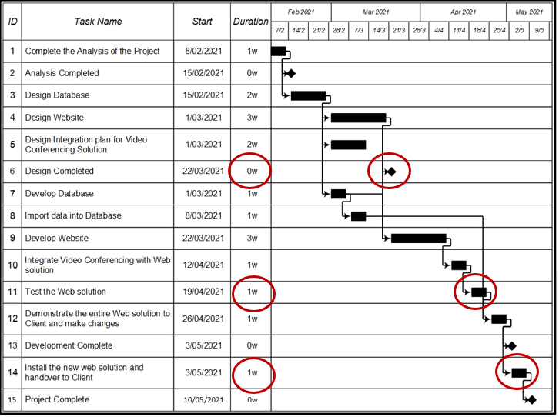
Marks were awarded for the completion of the duration and appropriate shape/dependency of a task. Many students forgot to complete the duration column and others forgot to correctly draw arrows showing dependencies between tasks.

Question 2b.
Mark | 0 | 1 | 2 | Average
% | 32 | 16 | 53 | 1.2
Many students were able to justify that the database team should not be worried because the only task dependent on Task 8 is Task 12, which is five weeks away.

Question 2c.
Mark | 0 | 1 | Average
% | 68 | 32 | 0.3
Some students were able to correctly calculate the critical path of 13 weeks.

Question 3a.
Mark | 0 | 1 | 2 | Average
% | 45 | 19 | 36 | 0.9
Many students correctly identified two items from within the scope of the project (as outlined in the project task table), including:
- development of a database for client details and booking data
- integration of the video conferencing app/system.
A number of students incorrectly stated that the development of the videoconferencing app/system was within the scope of the project.
Some students also incorrectly listed functional requirements such as ‘store athlete data’ or ‘make a booking’ as scope.

Question 3b.
Mark | 0 | 1 | Average
% | 72 | 28 | 0.3
Few students correctly identified that the development of the videoconferencing app/system was outside the scope of the project.

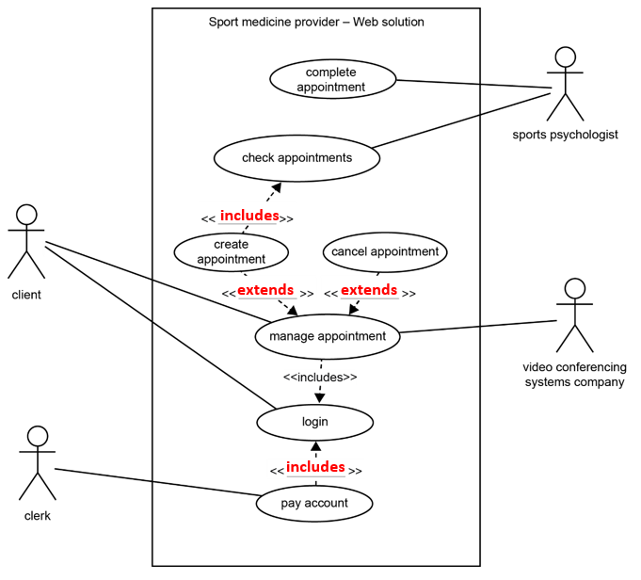
Question 4
Mark | 0 | 1 | 2 | 3 | 4 | Average
% | 17 | 17 | 16 | 30 | 19 | 2.2
Includes: The included use case is part of the initiating use case. For example, ‘login’ is part of ‘pay account’.
Extends: The extended use case is an optional component of the initiating use case. For example, ‘manage appointment’ is complete on its own but can optionally include ‘create appointment’ and ‘cancel appointment’.

Question 5
Marks | 0 | 1 | 2 | 3 | 4 | 5 | 6 | Average
% | 14 | 4 | 8 | 12 | 16 | 16 | 31 | 3.8
This question was generally answered well.
Existence checking: Marks were awarded for explaining that an existence check validates data by ensuring that a control or field is not empty. Many students related their explanation to the name and suburb control, others related their explanation to the state or date of birth field having a default value. Some students incorrectly stated that an existence check looks up a value in a database.
Range checking: Marks were awarded for explaining that a range check validates that data entered falls within an acceptable range. Some students referred to the date picker restricting dates entered to valid dates before today, others referred to the postcode text box validating postcodes within an acceptable range.
Type checking: Marks were awarded for explaining that a type check ensures that the correct type has been entered into a control. Some students referred to textboxes validating phone number, Medicare and postcode controls, while others referred to the date picker.
Some responses provided only an explanation of the type of check but did not include an example and therefore could not be awarded marks.

The following is an example of a high-scoring response:
Existence checking: Existence checking ensures the data provided is complete and that nothing is missing. For example, an existence check can be used to ensure the user provides their full name, which is useful and important in identifying who the data belongs to.
Range checking: Range checking ensures the data provided is reasonable and valid, by matching the data against a range of acceptable values. For example, a range check could be used to ensure the age of the user is above 18 (if that’s what the company wants), and below something unreasonable like 150 years old (using the D.O.B. of the oldest person alive serves as a reasonable upper bound).
Type checking: Type checking ensures the data provided matches the data type entered matches the acceptable data type. For example, the data type for postcode is string (because some postcodes begin with 0), however there can’t be any special characters or letters, the characters must be digits.

Question 6
Marks | 0 | 1 | 2 | 3 | 4 | 5 | 6 | Average
% | 55 | 14 | 12 | 13 | 4 | 1 | 2 | 1.1
This question was not answered well. Very few students were awarded full marks for writing the pseudocode to complete a binary search. Although many students were awarded marks for indentation, the correct use of variable names and the correct use of a control structure, very few were awarded marks for the use of the conditions leading to a change of the LowAppt/HighAppt values and leading to correct output. Many students failed to display evidence that the values being searched were in the CurrentApptIDs array, and incorrectly compared the NewApptID variable with the value of the MidAppt (as opposed to CurrentApptIDs[MidAppt]).
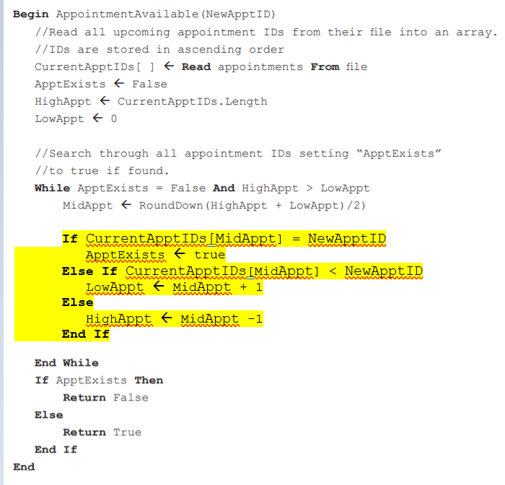
Variations of the following pseudocode were accepted as the correct solution to this question.

Question 7a.
Marks | 0 | 1 | 2 | 3 | 4 | 5 | Average
% | 27 | 29 | 20 | 5 | 8 | 11 | 1.8
This question was generally not answered well. Most students were unable to demonstrate an understanding of boundary testing, which requires each branch of an if statement and subsequent if statements to be systematically tested. Many students wrote abbreviations of output and not the correct output from the algorithm (‘Appointment created’ and ‘Invalid Appointment’). Students were awarded marks for writing the correct (and full) variable names for each test. Many students repeated the same test more than once. Some students wrote out tests with a value only for the variable Appointment.Time.
Test | Expected result | Actual result
Appointment.Date = 22/01/2022 | Appointment created | Appointment created
Appointment.Date = 18/01/2022  Any date less than 20/1/2022 | Invalid appointment | Invalid appointment
Appointment.Date = 20/01/2022  Appointment.Time = 14.00  *Any appointment time between 13.31 and 23.59 | Appointment created | Invalid appointment
Appointment.Date = 20/01/2022  Appointment.Time = 13.30 | Invalid appointment | Invalid appointment
Appointment.Date = 20/01/2022  Appointment.Time = 13.00  *Any valid appointment time between 0.00 and 13.29 | Invalid appointment | Appointment created

Question 7b.
Mark | 0 | 1 | Average
% | 55 | 45 | 0.5
The line of pseudocode that produced the error was:
IF Current_Time > Appointment.Time THEN

Question 7c.
Mark | 0 | 1 | Average
% | 46 | 54 | 0.6
Students were required to rewrite the full line of pseudocode identified in Question 7b., with a less than sign as opposed to a greater than sign.
IF Current_Time < Appointment.Time THEN

Question 7d.
Mark | 0 | 1 | Average
% | 79 | 21 | 0.2
Students were required to identify that one hour should be added to the Current_Time or one hour should be subtracted from the Appointment_Time.

Question 8
Mark | 0 | 1 | 2 | Average
% | 52 | 38 | 10 | 0.6
Many students did not attempt this question.
Students were awarded marks for a response demonstrating an understanding that software auditing is about more than functionality testing, and that it aims to discover issues relating to security that often result from interaction with other modules as part of a larger system. Students were also awarded marks for discussing the implications of a login module not being correctly audited, which is that it could open up company and athlete data to unauthorised access.
The following is an example of a high-scoring response.
Software auditing should be performed to ensure Kareem’s module is compliant with the security standards necessary for a login system. This is particularly important since it acts to restrict user access to sensitive medical information. Hence software auditing is important as it can detect potential vulnerabilities that can be fixed prior to release. Hence they cannot be exploited by malicious actors, protecting patient data once the system is live.

Question 9a.
Mark | 0 | 1 | Average
% | 90 | 10 | 0.1
As per the study design, students should be familiar with the formatting and structural characteristics of files, including delimited (CSV), plain text (TXT) and XML file formats.
XML item | Element type
id="7575" | Attribute or parameter or field
<VideoConferencingAppointments> | (Root) element or tag or parent

Question 9b.
Mark | 0 | 1 | 2 | 3 | Average
% | 59 | 25 | 13 | 3 | 0.6
Few students provided factually correct statements about either XML or CSV and few provided a suitable reference to the case study.
Statements about XML included:
- XML has the benefit of having self-describing data (tags) and hierarchy, which gives a lot more flexibility in the way that data is stored and communicated.
- In the example given, each ‘appointment’ element has a differing number of ‘attendee’ child elements, requiring the use of a more complex data hierarchy.
When asked to justify, it is important that a clear comparison be made between the two alternatives to explain the benefit of one alternative in comparison to the other. Justifications for using XML over CSV included:
- XML files enable the embedding of metadata using element names and attributes, whereas CSV files do not.
- XML files also enable data to easily have defined hierarchies and relationships, whereas CSV files would require additional documentation or data to describe how each value should be interpreted.
- As appointments are able to have more than one attendee, the data file needs to be able to support a multi-dimensional data structure, which is easily implemented in XML when compared to CSV.
These are examples of incorrect statements from students:
- XML is faster than CSV.
- XML is smaller in file size than CSV.
- XML is more secure than CSV.
- XML can be used on more platforms than CSV.
The following is an example of a high-scoring response.
XML is much better when transferring data between systems, as it formats the data in a way using user defined tags so that it is easily interpreted by different systems. CSV is unable to achieve this, as it is limited to separating data through commas, without any further info on what fields the data is in, if it is an attribute etc.

Question 10
Mark | 0 | 1 | 2 | 3 | Average
% | 71 | 9 | 14 | 7 | 0.6
As per the study design, students need to be familiar with the physical and software security controls used to protect software development practices and to protect software and data, including version control, user authentication, encryption and software updates
Some students were awarded marks for recommending version control as an appropriate strategy to protect the website development process by alerting the website development team to a more recent version of the database. Marks were also awarded for recommending:
- the date of the most recent change should be included in the filename
- the document version number should be included in the filename
- files should be stored in a source control repository so that the latest version is always available.
Some students incorrectly stated that backup or archiving should be used as an appropriate strategy.
The following is an example of a high-scoring response.
Version control could be used to ensure that all files are uniquely catalogued and identified. If Melissa adopts this, the development team will be able to identify which files are in-date or out-of-date as the exact version of the file will be known. This will help them as they will be less likely to access out-of-date files, hence saving time during the development stage.

Question 11a.
Mark | 0 | 1 | Average
% | 49 | 51 | 0.5
Students were awarded a mark for identifying SQL injection. Some students provided incorrect answers, such as denial of service attack or cross-site scripting attack.

Question 11b.
Mark | 0 | 1 | 2 | Average
% | 56 | 24 | 21 | 0.7
Students were awarded marks for describing that SQL injection works by entering scripted commands into the input field of a database query and enabling an attacker to read or modify data that they would not otherwise have access to.

Question 11c.
Mark | 0 | 1 | 2 | 3 | Average
% | 59 | 20 | 15 | 5 | 0.7
Students were awarded marks for explaining that data validation would check for the presence of special characters associated with SQL, which could be used to penetrate a database allowing for the access and modification of data.
Some students tried to answer the question by referring to existence, type and range checks without a reference to an SQL injection.
The following is an example of a high-scoring response.
An SQL injection includes using special checks and delimeters to escape the input textbox and directly access and perform actions on the SQL database.

Question 12
Mark | 0 | 1 | 2 | Average
% | 53 | 32 | 15 | 0.6
Students needed to explain how a field could be created to store appointment frequency or a function could be written to calculate appointment frequency, which would represent visits per month as an integer data type. Marks were also awarded for explaining how data could be sorted/processed/searched based on this new variable, so that the top five athletes could be targeted for discounts on their services.
The following is an example of a high-scoring response.
The ‘client records’ data structure could be modified to include a ‘total appointments’ field, which is added to every time the client completes an appointment. This could then be sorted for in descending order, and the top 5 records will be the 5 most frequent users.

Question 13a.
Mark | 0 | 1 | 2 | Average
% | 38 | 48 | 14 | 0.8
Students were awarded marks for any two of the following:
- Back up the database.
- Archive the database.
- Appropriately dispose of the data on the old system by erasing/overwriting or physically destroying the storage media.

Question 13b.
Mark | 0 | 1 | 2 | 3 | Average
% | 25 | 24 | 27 | 25 | 1.5
Students were awarded marks for listing and outlining any three of the following considerations:
- frequency of backup
- backup media
- location/security of backups
- backup type (full, differential or incremental)
- testing
- restoration/recovery
- retention period
- amount/quantity of data (size).
The following is an example of a high-scoring response.
1. The type of backup – whether it is an incremental, differential or full backup
2, How often the data will be backed up
3. What storage media will be used to store the data, such as the cloud.

Question 13c.
Mark | 0 | 1 | 2 | Average
% | 37 | 49 | 14 | 0.8
Students were awarded marks for storing archived data separately to the main database.
- Regular backups will require less physical space.
- Regular backups will take less time.
- Retrieval of backups will take less time.
- Frees space on the system.
- No confusion between old and new data.
When responding, many students confused the processes of backup and archiving. Many also incorrectly commented that storing the archival data separately to the backup data would make it more secure.
The following is an example of a high-scoring response.
1. Takes less time to perform a full back-up on the main database as there are less files.
2. Frees up space on the main database for data that will actually be used.

