VCE Health and Human Development (2018–2024)

World Health Organization (WHO) Priorities 2019–2025

Updated VCAA advice February 2024

Introduction
In 2022, the World Health Organization approved the extension of the Thirteenth General Programme of Work (GPW 13) from 2023 to 2025, to cover the priorities and work of the WHO for 2024 and 2025.
In 2024, students undertaking VCE Health and Human Development (2018–2024) will study and be assessed against the priorities and work of the WHO Thirteenth General Programme of Work (GPW 13) 2019–2025. Specifically, this relates to the following key knowledge and key skills in Unit 4, Area of Study 2: Health and human development in a global context:
- priorities and work of the WHO
- explain the priorities and the work of the WHO and discuss how the WHO priorities are reflected in different scenarios.

Thirteenth General Programme of Work 2019–2025
The Thirteenth General Programme of Work 2019–2025 (GPW 13) sets the strategic direction of the WHO for 2019–2025. It is based on the Sustainable Development Goals (SDGs), with a commitment to achieve SDG 3 (‘Ensure healthy lives and promote well-being for all at all ages’) and is relevant to low-, middle- and high-income countries. GPW 13 provides a vision of ‘A world in which all people attain the highest possible standard of health and well-being’ and summarises the WHO’s mission to promote health; keep the world safe; and serve the vulnerable.
While SDG 3 is central to the WHO’s work, the work of the WHO is implicated in, influences, or is influenced by all of the SDGs, either directly or indirectly. The relationship between GPW 13 and the SDGs is shown in Figure 1.

Figure 1. The relationship between the WHO’s work and the SDGs
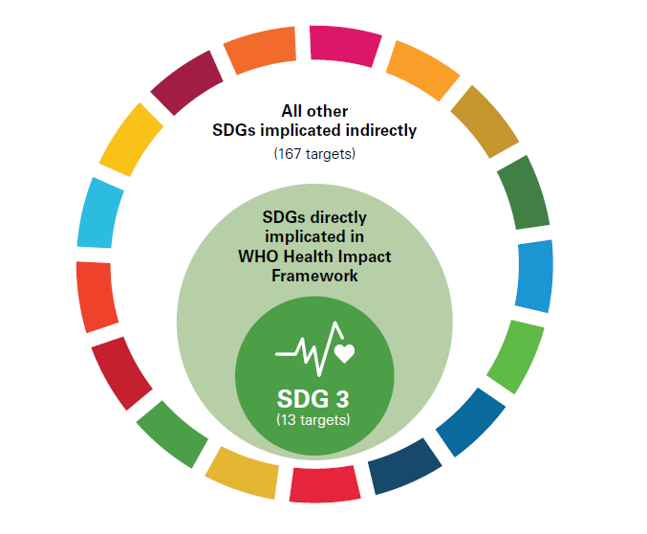
Source: World Health Organization (2019), Thirteenth General Programme of Work 2019–2023, p.9

What is the rationale for the WHO extending GPW 13 by 2 years to 2025?
The world is going at less than a quarter of the pace needed to reach health-related SDGs by 2030. Furthermore, the COVID-19 pandemic revealed that no country was fully prepared for a pandemic of its scope and scale. The objective of extending the GPW 13 by 2 years to 2025 is to strengthen country capacity and accelerate progress towards the achievement of the triple-billion targets and health-related SDGs. (Source: World Health Organization, 2022, Thirteenth General Programme of Work, 2019–2025: Report on the outcomes of the Member States consultation process)

How does the 2024–2025 extension of GPW 13 apply to VCE Health and Human Development?
The overarching goal to ensure healthy lives and promote wellbeing for all, at all ages, is the foundation for the work of the WHO in 2019–2025.
Figure 2 shows that the 3 WHO ‘core’ priorities (linked to the triple-billion targets) have been retained and will remain the focus of study in VCE Health and Human Development in 2024. The labels ‘Provide health’, ‘Protect health’ and ‘Promote health’ have been added to emphasise the focus of each priority.
There are 2 new priorities which support the work of the WHO, labelled ‘Power health’ and ‘Perform for health’ (see Figure 2). These priorities will not be examinable in 2024.
WHO core priorities (Provide health, Protect health and Promote health)
For the purposes of VCE Health and Human Development (2018–2024), the 3 core priorities listed below will remain the focus for key knowledge ‘priorities and work of the WHO’ and applying the key skills ‘explain the priorities and the work of the WHO and discuss how the WHO priorities are reflected in different scenarios’.
- Provide health - achieving universal health coverage
- Protect health - addressing health emergencies
- Promote health - promoting healthier populations

New priorities supporting the work of WHO (Power health and Perform for health)
For the purposes of VCE Health and Human Development (2018–2024), the 2 new priorities will not be examinable in 2024.
As shown in Figure 2, the priorities are all interconnected. For example, strengthening health systems also makes them more resilient and better able to detect and control outbreaks before they spread, and improved public health functions contribute to good-quality health care within universal health coverage (UHC) and the strong surveillance systems necessary for early disease detection and control.

Figure 2. GPW 13: A set of interconnected priorities and goals to ensure healthy lives and promote wellbeing for all at all ages
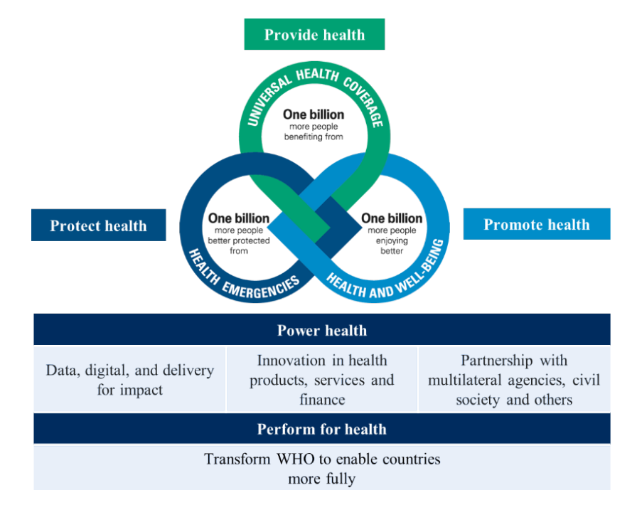
New priorities: not examinable in 2024
Existing ‘core’ priorities: examinable in 2024
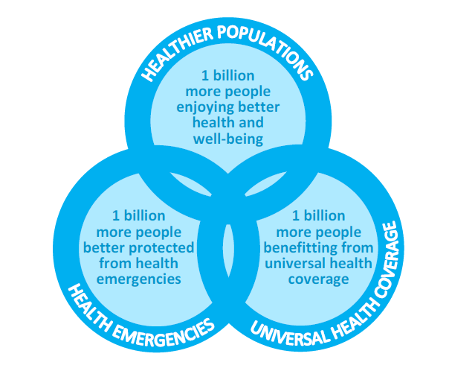
Source: World Health Organization, 2022, Thirteenth General Programme of Work, 2019–2025 – Report on the outcomes of the Member States consultation process

Additional detail for core priorities (retained from previous WHO support document)
The additional detail below, related to the 3 WHO core priorities, is still applicable for the extension of GPW 2013 for 2024–2025.

Universal health coverage (UHC):1 billion more people benefitting from UHC
The WHO aims to progress towards UHC by addressing:
- service access and quality
- health workforce
- access to medicines, vaccines and health products
- governance and finance
- health information systems
- advocacy
- country support.

Health emergencies: 1 billion more people better protected from health emergencies
The WHO aims to ensure that 1 billion people are better protected from health emergencies by:
- building and sustaining resilient national, regional and global capacities required to keep the world safe from epidemics and other health emergencies; and
- ensuring that populations affected by acute and protracted emergencies have rapid access to essential life-saving health services including health promotion and disease prevention.

Healthier populations: 1 billion more people enjoying better health and wellbeing
The WHO will contribute to people enjoying better health and wellbeing through 5 platforms:
- improving human capital across the life course
- accelerating action on preventing non-communicable diseases and promoting mental health
- accelerating elimination and eradication of high-impact communicable diseases
- tackling antimicrobial resistance
- addressing health effects of climate change in small island developing states and other vulnerable states.

Conclusion
For the purposes of VCE Health and Human Development (2018–2024), students are expected to be able to:
- explain the priorities and work of the WHO (focussing only on the ‘core priorities’)
- describe how the work of the WHO contributes to achieving SDG 3
- discuss how the WHO ‘core’ priorities are reflected in different scenarios.

References
The Thirteenth General Programme of Work 2019–2023 can be accessed at who.int/iris/bitstream/handle/10665/324775/WHO-PRP-18.1-eng.pdf
Extending the Thirteenth General Programme of Work, 2019–2023 to 2025: Frequently Asked Questions can be assessed at cdn.who.int/media/docs/default-source/documents/about-us/thirteenth-general-programme/gpw13-extension_faq_11aug22.pdf?sfvrsn=94f007d6_2
Thirteenth General Programme of Work, 2019–2025: Report on the outcomes of the Member States consultation process (including the progress towards the SDG-based triple-billion targets and rationale for extending GPW 13) can be assessed at who.int/gb/ebwha/pdf_files/EB152/B152_28-en.pdf

