VCE Mathematical Methods Unit 3

Sample application task: Product functions and pendulum clocks
The application task is to be of 4–6 hours’ duration over a period of 1–2 weeks.

Introduction
A context such as the following could be used to develop an application task that investigates how a product function of an exponential decay function and a circular function can be used to model the motion of the pendulum of a clock after the driving force has stopped.
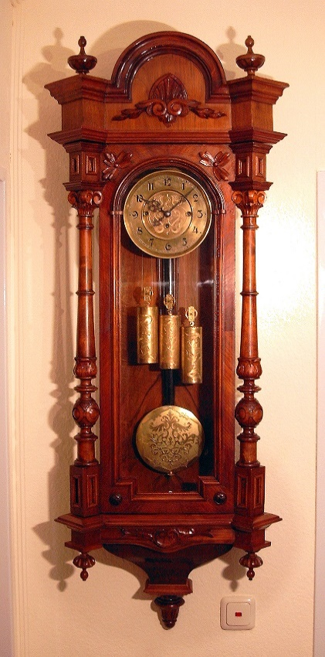

Component 1
Introduction of the context through specific cases or examples
- Draw the graphs of $f:R→R, f\left(t\right)=5e^{-kt}$ for several (at least five) values of 0 < k < 1 on the same set of axes.
- Draw the corresponding graphs of and on the same set of axes, and comment on
the similarities and differences between these graphs.
- Draw the graphs of $g:\left[0, 2π\right]→R, g\left(x\right)=\sin\left(ax\right)$ for several (at least five) values of a together on the same set of axes. State the period for each function, and comment briefly on the similarities and differences between these graphs.

Component 2
Consideration of general features of the context
- For k = 0.2; a = 1, sketch the graphs of ƒ₁(t) = 5e^{–kt} , ƒ₂(t) = –5e^{–kt} and s(t) = 5e^{–kt} sin(at), where
t ∈ [0, 4π].
- Find the derivative of s(t), in terms of t, k and a, and hence for k = 0.2; a = 1, find the coordinates of the first two maximum/minimum points for s(t) with x coordinates closest to the y-axis.
- Find the coordinates of any points of contact between the graphs of s(t) and ƒ₁(t) and between the graphs of s(t) and ƒ₂(t). Briefly comment on the relationship between these points of contact and the graph of sin(t). Hence, state the exact x coordinate for the point of intersection closest to the y-axis.
- State the coordinates of intersection between the graphs of s(t) and sin(t), over the given domain. Comment on these findings. Hence, give the exact coordinates of these intersection points.

Component 3
Variation or further specification of assumption or conditions involved in the context to focus on a particular feature or aspect related to the context
Brian has recently purchased a grandfather clock. The rate at which the hands of the clock move is controlled by a pendulum, which is kept in regular motion by slowly descending weighted chains.
When the weights reach their lower point and stop moving, the pendulum swing begins to change, causing the hands of the clock to slow down and gradually stop. From the time when the swing begins to change, the horizontal displacement, s cm, of the point, P, at the end of the pendulum, from the vertical, as shown in the following diagram, can be modelled by functions with the rule s(t) = 5e^{–kt}sin(at), where t > 0 is the time in seconds after the pendulum swing begins to change and k and a are real constants. For Brian’s clock,
k = 0.2 and a = 1.

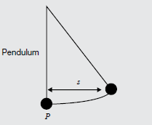

- Find the horizontal displacement of the pendulum for several seconds after the weights stop descending, and draw a series of diagrams corresponding to the position of the pendulum at these times.
- Draw a series of diagrams of the position of the pendulum the first several maxima. If the pendulum is deemed to have come to rest when the swing is less than 0.01 cm, find how long the pendulum takes to come to rest.
- Brian has a friend, Jana, who also bought a similar grandfather clock. Jana’s clock is modelled by the same rule for the horizontal displacement when the weights stop descending, where k = 0.4 and a = 1. Draw the graph of the two pendulums’ horizontal displacement for t ³ 22. Compare the behaviour of the two pendulums and discuss how the different values for k affect the motion of the point P after the swing of the pendulum begins to change.

Areas of study
The following content from the areas of study is addressed through this task.
Area of study | Content dot points
Functions, relations and graphs | 2, 3, 4, 5, 6
Algebra, number and structure | 4, 5
Calculus | 2, 3, 4, 5
Data analysis, probability and statistics | –

Outcomes
The following outcomes, key knowledge and key skills are addressed through this task.
Outcome | Key knowledge dot points | Key skills dot points
1 | 1, 2, 3,4, 6, 7, 9, 10, 11 | 1, 2, 6, 7, 8, 9, 10, 11, 12
2 | 1, 2, 5 | 1, 2, 4, 5, 6, 7
3 | 1, 2, 3, 4, 5, 6, 8 | 1, 2, 3, 4, 5, 6, 7, 9, 11, 12

