VCE Mathematical Methods Unit 3

Sample application task: Splining a pathway
The application task is to be of 4–6 hours’ duration over a period of 1–2 weeks.

Introduction
A context such as the following could be used to develop an application task that investigates how a variety of functions, and piecewise (hybrid) functions constructed from these, could be used to model sections of pathway, such as parts of a bicycle track adjacent to a river, creek or wetland: for example, the Yarra Bend public park in Melbourne.
The process of constructing such a function is called splining.

Component 1
Introduction of the context through specific cases or examples. Students should
Consider the problem of determining a quadratic function
$f:R→R, f\left(x\right)=ax^{2}+bx+c,$the graph of which passes through three specified points. Suppose two of these points, A and B, have coordinates (1, 4) and (2, 2) respectively. The third point, C, has an x-coordinate of 4 and is given as (4, k) where k is an arbitrary real constant.
Explore the effect of varying k on the graph of the function.
- Suppose that C is determined to be (4, 1.5). Investigate cubic functions of the form
$f:R→R, f\left(x\right)=ax^{3}+bx^{2}+cx+d$with graphs that pass through the points A, B and C.
Explore the effect of d on the behaviour of the graphs of these cubic functions. Identify a value of d that gives a cubic function closely matching the quadratic function that passes through the same three points.
- A fourth point, D, has coordinates (0, m). For different values of m find pairs of quadratic functions, the first pair containing points D, A and B and the second containing the points B and C. These two curves must be smoothly joined at B. Determine the effect of m on the behaviour of the graphs produced.

Component 2
Consideration of general features of the context. Students should
Consider the various sections of the river using different combinations of specified coordinates and dimensions. The following provides a sample.
A new bicycle track is to be constructed along the Yarra River in Kew between two pedestrian bridges labelled A and B on the map shown below.
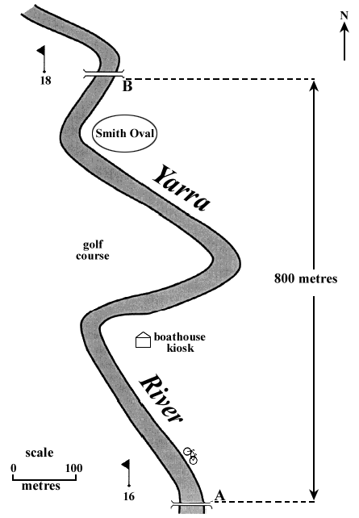

The track cannot be constructed on the western side of the river due to the presence of the golf course.
The track is to follow the curves of the river on the eastern side. That is, it will go from A to B by the boathouse kiosk, passing between the river and Smith Oval.
- Explore how a model can be developed between the pedestrian bridges A and B using a series of smoothly joined quadratic functions.
- Design a measure for how well the pathway matches the curve of the river and apply it to the model.

Component 3
Variation or further specification of assumption or conditions involved in the context to focus on a particular feature or aspect related to the context. Students should
Improve the fit of your bicycle track, according to the measure you have designed, by using a combination of different types of functions.
Alternatively, identify an outline, curve or path in some other context and suitably model this by a piecewise function, which may include function types other than polynomial functions.

Areas of study
The following content from the areas of study is addressed through this task.
Area of study | Content dot points
Functions, relations and graphs | 1, 2, 5, 6
Algebra, number and structure | 1, 4, 5, 6
Calculus | 3, 4
Data analysis, probability and statistics | –

Outcomes
The following outcomes, key knowledge and key skills are addressed through this task.
Outcome | Key knowledge dot points | Key skills dot points
1 | 1, 4, 6, 7, 9, 10, | 1, 6, 9, 10, 12
2 | 1, 2, 3, 5 | 1, 2, 3, 5, 7
3 | 1, 2, 3, 4, 5, 8 | 1, 2, 3, 4, 5, 6, 7, 9, 11, 12

