VCE Mathematical Methods Unit 4

Sample modelling or problem-solving task: Traversing terrains
The modelling or problem-solving task is to be of 2–3 hours’ duration over a period of 1 week.

Introduction
A context such as the following could be used to develop a modelling or problem-solving task that involves modelling travel over different terrains at different average speeds for each terrain, and using this information to optimise the time of travel. Bushwalkers travel over different types of terrain, from cleared to dense bush. The denseness of the bush and the ruggedness of the terrain influence the average speed of travel. By planning a route to take such factors into consideration, the total time taken to travel from one point to another can be optimised. In calculating estimates of the time for a particular route, a walker uses his or her average speed for each different type of terrain they are likely to encounter.
For a walk through a particular type of terrain, the distance travelled, d km, can be calculated as the product of the average speed, v km/h, and the time travelled at this speed, t hours. On a typical two-day walk a bushwalker might cover a distance of up to 30 km with walking speeds of up to 5 km/h over cleared terrain.

Part 1
- For a typical two-day walk, choose several representative values for average speed and draw a graph of the relationship between t and d for each of these values.
- Similarly, choose several representative values for the distance to be travelled and draw a graph of the relationship between t and v for each of these values.
- Discuss the key features of each of the two families of graphs and the differences between them.

Part 2
A bushwalk is planned from Ardale to Brushwood. As shown in the diagram below.

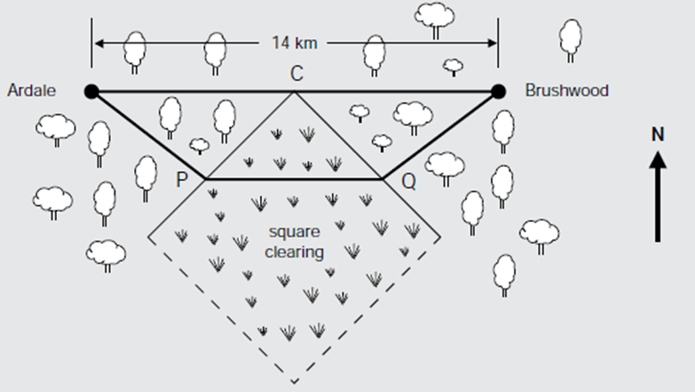

The direct route, a distance of 14 km, goes entirely through rugged bush country. However, there is a large square clearing situated as shown. This clearing has one diagonal along the perpendicular bisector of the direct route and one corner, C, at the midpoint of the direct route.
One of the bushwalkers believes that time will be saved if they travel from Ardale to Brushwood on a route similar to the one shown passing through P and Q, where the section PQ is parallel to the direct route. The side length of the square clearing is 7 km, and the part of this route that goes across the square clearing is parallel to the direct route.
- Choose a suitable variable, and hence determine a mathematical relationship that can be used to determine the total time for a route of this type. Draw the graph of this relationship and discuss its key features.
- Find and describe the route for which the travelling time will be least and compare it with the direct route.

Areas of study
The following content from the areas of study is addressed through this task
Area of study | Content dot point(s)
Functions, relations and graphs | 6
Algebra, number and structure | 5
Calculus | 1, 4, 5
Data analysis, probability and statistics | –

Outcomes
The following outcomes, key knowledge and key skills are addressed through this task.
Outcome | Key knowledge dot points | Key skills dot points
1 | 1, 4, 6, 7, 9, 10 | 1, 6, 9, 12
2 | 1, 2, 3, 5 | 1, 2, 3, 4, 5, 6, 7
3 | 1, 2, 3, 4, 5, 6, 8 | 1, 2, 3, 4, 5, 6, 7, 9, 10, 11, 12, 13

