VCE Physics 2017–2023
School-based assessment report
This report is based on the school-based assessment audit and VCAA statistical data.
All official communications regarding the Victorian Certificate of Education (VCE) Physics Study Design are provided in the VCAA Bulletin. It is recommended that teachers individually subscribe to the VCAA Bulletin to receive updated information regarding the study. The VCE and VCAL Administrative Handbook and Important Administrative Dates are published on the Administration page of the VCAA website.
GENERAL COMMENTS
Responses to the Unit 3 and Unit 4 School-based assessment audits for VCE Physics indicate that teachers have generally made a successful transition from the previous study design to the reaccredited VCE Physics Study Design 2017–2023. School-based assessment enhances validity of student assessment by providing opportunities for non-routine and open-ended physics contexts and applications to be explored in greater depth and breadth than is possible in an examination.
The audit process
The School-based assessment audit enables the VCAA to check the assessment tasks are compliant with the VCE principles of assessment and the requirements of the VCE Physics Study design.
Schools are advised to prepare their responses using the question summary before they begin to complete the questionnaire. Some questions may require consultation with colleagues, for example, locating the school provider number or details of the school redemption policy.
Schools should ensure that all requested materials are submitted for the audit. Materials potentially required for submission are listed in the VCE and VCAL Administrative Handbook. If materials are not submitted as requested a judgment cannot be reached by the audit panel as to whether the school concerned has satisfied VCAA requirements for school-based assessment.
The first stage of the audit requires schools to complete a study-specific audit questionnaire by providing information about assessment planning, timelines, resources, the types of assessment tasks set and the conditions under which students sit the tasks. The majority of audited schools designed and used tasks that met the requirements of the reaccredited study design and the VCE assessment principles, however a number of schools proceeded to the second stage of the audit process due to issues including insufficient information about how SAC tasks were developed and narrowness of assessment task types.

For each Outcome, the audit questionnaire asked what the students are required to do for the assessment task(s) as well as the conditions under which the task(s) are conducted. For a small number of responses, further evidence was requested about the task(s) since it was not clear whether the task(s) met the definition of the task type.
In audit responses where only one task was used to assess an outcome, it was usually the case that the task was designed to cover a majority of the dot points in the key knowledge and skills. However, there were a few instances of a single assessment task that only addressed a single key knowledge point. In such instances, the school was advised to consider incorporating an additional task to increase the coverage of the content.
Assessment planning
Almost all schools provided an assessment timetable at the beginning of the school year to students to assist them in planning for assessment. In many schools, SAC tasks are used for both formative and summative purposes.
Prior to each School-assessed Coursework task being undertaken, students should be given a clear and accurate statement of:
- the outcome being assessed
- the task type
- the requirements and conditions of the task
- the contribution of the task to the final outcome score.
Many schools provided students with the assessment rubrics that will be used to assess the task prior to the task being undertaken.
For some Outcomes, three or four different SAC tasks had been planned. If multiple assessment tasks are to be used, schools are advised to consider reducing the length of some tasks so that the total assessment time for an Outcome is not excessive.
Task development
Overall, tasks addressed a wide range of key knowledge and required students to demonstrate relevant key science skills. Many schools described how assessment tasks were developed to ensure that higher order/more complex questions were included and weighted appropriately. Reference was made to Bloom’s taxonomy, defined verbs in the VCE Physics Advice for teachers, VCAA performance descriptors, use of closed/open questions, inclusion of qualitative and quantitative questions and use of different task types.
Despite a broader range of assessment task types being offered across Units 3 and 4 of the reaccredited study design, most schools adopted a conventional approach to assessment with very little uptake of the newer task types. Schools are advised to refer to the online VCAA publication VCE Physics Advice for teachers that outlines an approach to one of the newer assessment tasks – an explanation of the operation of a device. This publication also includes advice about developing School-assessed Coursework tasks, the nature of scientific inquiry, sample teaching and learning activities and programs, elaborations of assessment tasks and examples of performance descriptors. Although most teachers reported using VCAA performance descriptors to assess student work, these are not mandated; in some cases it may be more appropriate to use school-developed marking schemes.
A range of methods were used to develop SAC tasks. In most cases, new tasks are developed each year by the individual teacher whilst some teachers modified tasks from previous years. Schools are reminded that it is not acceptable to use unmodified form as authentication issues may arise. Returning SAC tasks to students enables valuable feedback to be provided as well as enabling students to refer to the tasks for examination revision purposes.
A significant proportion of schools indicated they were using commercially developed tasks, tasks made freely available on various websites, particularly the VicPhysics website, and/or past VCAA examination questions. Although all teachers had checked these materials against the VCE Physics Study Design for alignment, significant modifications must be made in order to avoid authentication issues. These tasks and examination questions (including associated examination reports) are readily available in the public domain, and therefore are accessible to students. Tasks developed collaboratively with other teachers must also be modified so that the tasks are unique to each school. Tasks may be adapted by changing data values, requiring different formulae, changing the ‘unknown’ variable and/or modifying the stimulus material on which the questions are based.
A key finding of the audit was that many schools selected assessment tasks across the Outcomes that could be classified as ‘examination mimic’ tasks, thereby compromising the VCE assessment principle that ‘assessment will be balanced’. Teachers are advised to select a suite of assessment tasks across each Unit that provide a range of opportunities for a student to demonstrate in different contexts and modes the knowledge, skills, understanding and capacities set out in the study design, being mindful of not ‘over-assessing’ students. Additionally, a number of schools have not differentiated the ‘test’ task type from the ‘data analysis’ task type and/or the ‘response to structured questions’ task type. Commonly, the types of questions asked in ‘data analysis’ and ‘response to structured questions’ tasks effectively made them ‘test’ type tasks. Teachers are advised to refer to the VCE Physics Advice for teachers for elaborations of these task types.
Material requirements for SAC tasks were, in general, similar to external examination requirements, particularly for ‘examination mimic’ task types, and typically involved students being able to access pre-written notes (one folded A3 sheet or two A4 sheets bound together by tape), formula sheet, pens, pencils, highlighters, erasers, sharpeners, rulers and a scientific calculator. Students were also instructed as to what materials could not be used during SAC tasks: usually, blank sheet/s of paper, mobile phones and correction fluid/tape were not permitted.
External resources used as a basis for developing SAC tasks included observations of the relative positions of the Sun, Earth, the moon and planets including bearings for where rises and sets occur, the VicPhysics excursion to Luna Park, GoKarting excursions and use of the school/local gymnasium to investigate motion and collisions, indoor rock climbing excursions to investigate tension and energy, visits to construction sites where the construction manager explained the physics of the construction and how loads and forces are managed safely in the design and construction of a specific structure, local area visits to demonstrate generation and transmission of electricity, the ANSTO Australian Synchrotron excursion related to interactions between light and matter and guest speakers (often PhD students) involved in relevant physics research.

Authentication
The audit question requesting a description of how each task had been adapted to ensure that authentication issues did not arise was not always answered or the response was often incomplete. This resulted in several schools being required to submit further evidence in the form of the actual SAC tasks and marking schemes used for Unit 3 assessment.
All schools audited indicated that SAC tasks were completed under supervision, making authentication of student work less problematic. Authentication processes also included teachers requiring that student logbooks be kept at school for those assessment tasks (such as annotations of practical activities from a logbook or a report of a student investigation) where the SAC task itself involved preparatory laboratory work.
Schools with multiple classes and more than one teacher indicated marking consistency was achieved through the use of a prepared answer sheet, discussion and/or cross-marking. For schools with only one Physics class, marking validation was often achieved by working with another Physics teacher within the school – or a Physics teacher at a different school – to mark a sample of ‘top’, middle’ and ‘low’ student work. These practices are important in order to ensure an accurate student rank order is attained.
Schools need to be aware of the authentication requirements set out in the VCE and VCAL Administrative Handbook. Any work set over an extended period of time should include a process for authentication of student work. Most schools provided details about the procedure used to authenticate student work that included how logbooks were used by students and monitored by the teacher. It is recommended that particular attention is paid to authentication for Unit 4 Outcome 3 and that as much work as possible is observed, completed in class, initialed and dated by the teacher on a regular basis.
Practical work
Most schools followed the recommendations in the study design related to hours of practical work to be undertaken in each area of study for Units 3 and 4. Schools allocating only a few hours to undertaking and reporting on the student-designed investigation in Unit 4 Area of Study 3 were advised to review their timelines so that explicit teaching of relevant key knowledge and key skills as well as the provision of student feedback occurred in future. A number of schools provided a comprehensive set of practical activities that covered a wide range of key knowledge and key science skills. Log books are used extensively.
Specific electrical safety instructions were provided to students in all schools in relation to practical work in Unit 3 Area of Study 2 and, if relevant, students developing investigations related to electricity for their independently-designed investigation in Unit 4 Area of Study 3.
Student-designed practical investigation
The Unit 4 Outcome 3 student practical investigation, whilst being able to be scheduled at any point across Units 3 and/or 4, was undertaken by most schools after the completion of Unit 3 and before commencing Unit 4, as shown in the graph below:
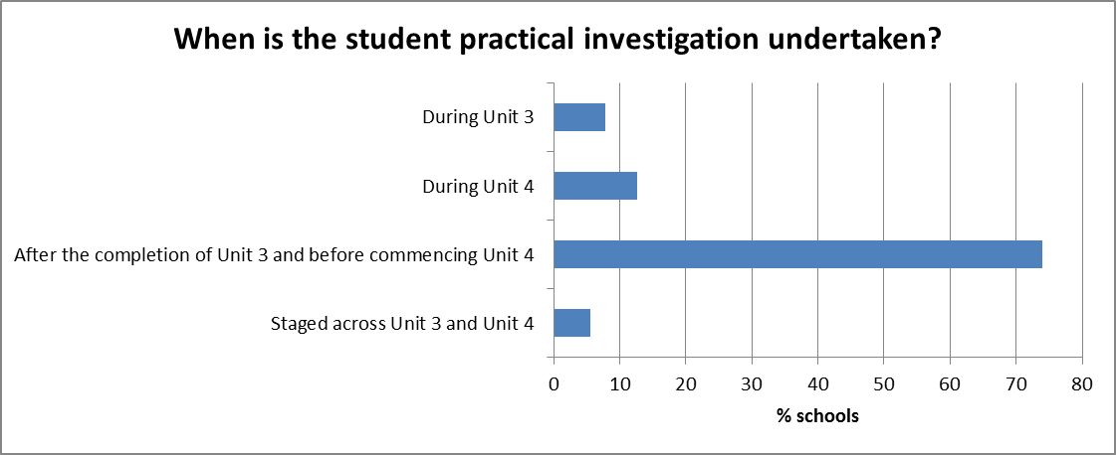
A number of audit schools provided students with a booklet to scaffold student investigation planning and progress as an adjunct to the student logbook and/or to provide an overview of the scientific investigation process to be followed.
Each student should be assessed on their individual capacity to design, undertake and report on an investigation. In cases where schools have multiple classes or large numbers of students in a single class, it may not be practicable for each student to undertake a unique investigation. In these cases, it is an acceptable practice for students to work in groups to generate data after they have been assessed on their capacity to design an investigation. Teachers must approve all student investigations to be undertaken; not all planned student investigations can proceed due to issues including safety, equipment availability, time constraints and/or management of large student numbers. Further advice is provided in the VCE Physics Advice for teachers.
The audit findings showed that a number of schools offered students a range of choices of topic across multiple Areas of study for the Unit 4 Outcome 3 investigation, as shown in the graph below:
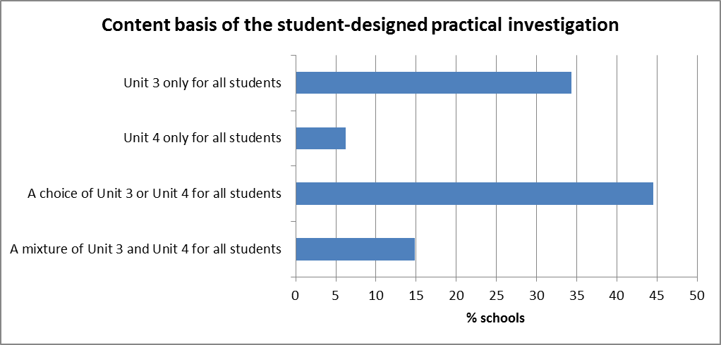
Many of the investigations related to the topic of ‘motion’ and correlated to topics undertaken in the previous study design’s extended practical investigation task. The use of sporting contexts was common, for example, ‘How does the varying mass and the release angle of a golf club affect the range of a golf ball?’ and ‘How does varying the length of a string attached to a ball in Totem Tennis set and the mass of the ball affect the period of rotation of the ball?’. Some schools used the newer content areas of the study design as the basis of student investigations, for example, investigations involving the use of water as a prism and the effects of temperature and various concentrations of solutes on water’s refractive index. In some cases, schools provided students with their own choice of topics whilst in other cases, a general question or statement related to a specific topic or phenomenon was given to students who then developed their own question for investigation, for example, using demonstrations of the motion of a magnet as it rolls down an inclined metal surface as a prompt for further exploration by students.
A major audit finding was that, in a number of audit schools, students did not investigate two independent continuous variables. For example, a proposed investigation question related to the elasticity of different types of sports balls is inappropriate because only one independent variable is investigated, and one variable (type of ball) is not continuous. The question would have been better structured by using only one type of ball and varying the drop height and some other property of the ball as the second continuous variable, for example, the pressure inside a basketball, the temperature of a squash ball or the extra injected water inside a table tennis ball. Schools should note that, although two continuous independent variables must be investigated, the student’s poster write-up need only refer to one of the investigated independent variables. If the investigation is undertaken in pairs, one student may report on one of the continuous independent variables whilst the other student reports on the second continuous independent variable.
Schools must ensure that the investigation topics are aligned to Units 3 or 4, for example, the general question ‘What factors affect the bounciness of squash/golf/tennis balls?’ could appropriately be explored by considering impulse and conservation of energy as relevant to Unit 3 content rather than to Unit 2 content.
Further information was often required as further evidence in the next stage of the audit in situations where schools had not yet finalised student investigation topics.
SPECIFIC INFORMATION

Unit 3 - How do fields explain motion and electricity?
For Unit 3 the student is required to demonstrate the achievement of three outcomes. In addition, students may undertake the Unit 4 Outcome 3 task (the design and undertaking of a practical investigation related to waves, fields or motion, and the presentation of methodologies, findings and conclusions in a scientific poster) across Units 3 and/or 4.
The same set of eleven assessment task types apply to each of the three outcomes, with schools required to select at least one task for each outcome which is different from the tasks selected in the other two outcomes. Teachers are advised to consider carefully the number – and length – of the suite of assessment tasks developed across the Unit.
The number of SAC tasks undertaken in Unit 3 is shown in the graph below:
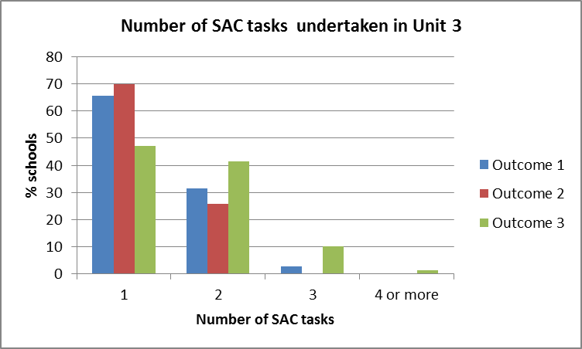
In some schools, over three-and-a-half hours were allocated to assessment: this was deemed to be ‘over-assessing’ students. For these schools, it was suggested that tasks were shortened in time and/or task number was reduced, particularly where the same types of skills were being re-assessed.
The graph below shows the popularity of each task type for each outcome (note that total percentages for the set of tasks in each outcome exceed 100% since some schools undertook multiple tasks):
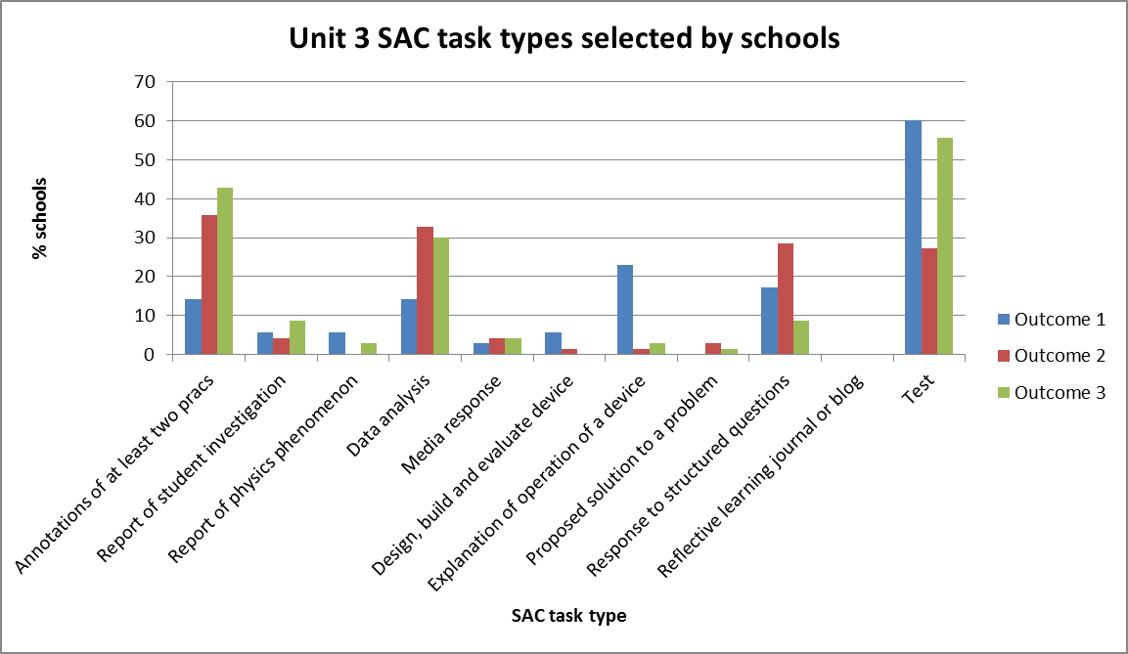

Only one task type – the reflective learning journal or blog – was not selected by any audit school in Unit 3.
Some schools combined two task types into one, for example, annotations of a set of four practical activities on motion using data sensors and one practical activity on circular motion was combined with a short set of linked test questions. Other schools used shortened multiple tasks to reduce student assessment pressure, for example, annotations of two practical activities related to Hooke’s Law followed at a later date by a set of test questions on motion in general. Combining a ‘test’ with ‘data analysis’ was another common combination to construct a single 50-minute task; in this instance where two ‘examination mimic’ type tasks are combined, teachers must ensure that assessment balance is achieved across other unit outcomes.
Most schools demonstrated a strong focus on the use of assessment tasks for formative, as well as summative, purposes, with extensive feedback being provided to students regarding misunderstandings and identified areas for improvement.
Audit findings related to some of the newer assessment task types are summarised below:
- annotations of at least two practical activities from a practical logbook
For most audit responses the practical activities were selected from across the entire Area of study, for example, quantitative experiments related to the effects of changing various field types (electric, magnetic and gravitational). However there were instances where what would normally be one experiment on one key knowledge point in the study design was described by teachers as being several experiments. Multi-part experiments related to a single key knowledge point in the study design are considered as one practical activity and an additional activity should therefore be incorporated in the assessment task. The assessment task states 'at least two practical activities'. It is recommended that at least two key knowledge points in the study design should be covered by the activities to ensure broader representation of the outcome.
One school allowed students to choose which practical activities they annotated; this allowed for students who may have been absent for a particular practical activity.
The audit also showed that, for Outcome 1, there were very few instances of practical activities on ‘electric fields’.
- media analysis/response
Relevant contemporary research and media/journal articles related to physics should be used in order to avoid authentication problems. Energy was a common theme. Some schools, for example, used the recent electricity grid issues in South Australia as the stimulus material for analysis whilst others used articles that required students to evaluate contrasting views about the safety of electromagnetic fields. The outcomes of the Community Energy Congress held in Melbourne were evaluated by some schools whilst government policy on renewable energy and carbon emission reduction targets were examined by other schools as applications of an understanding of electricity and how it is produced. One school used an advertisement by an automobile company that promoted the strength of a particular chassis, where two 600 kg balls were tied to the front and rear of a ute and the entire structure was rotated about its centre of gravity; this provided the opportunity to assess key knowledge in addition to key science skills.
One school used a media article that reported the experimental results related to time dilation for lithium ions accelerated to approximately 0.3c to assess students’ understanding of Einstein’s special theory of relativity including the implications of Einstein’s postulates on time, length and kinetic energy in the context of the lithium ions in the experiment.
- an explanation of the operation of a device
A worksheet from a subject association, with a range of devices suggested, was often used by schools; schools are reminded that publicly available assessment tasks must be modified prior to use. Other schools assessed the same device, commonly the DC motor, but in one case a power generation and transmission system for a remote mining operation. In many schools, students undertook research about a nominated (or negotiated) device, keeping dated notes in their logbooks, and then presented their findings (often a response to several questions) in the form of an oral presentation, infographic or PowerPoint presentation. An excursion to Luna Park formed the basis of an assessment task requiring students to explain the physics of a selected ride. For tasks where work is completed, in part, out of class, appropriate authentication procedures must be put in place to ensure that student work can be authenticated. The more generic questions of ‘What does the device do?’, ‘How does it work?’ and ‘What are the physics principles that underpin the operation of this device?’ require modification if re-used, even for different devices, so that SAC tasks do not become predictable. Audit findings were that the ‘explanation’ took various forms, commonly a PowerPoint presentation.
- data analysis
This task type requires that students generate and analyse graphs from primary and/or secondary data. A task involving higher order thinking skills submitted by one school focused on a comparison of motion with reference to Newton and Einstein. Another approach to undertaking assessment involved students undertaking a practical activity prior to the SAC task, recording results in their log books and then being provided with a set of deliberately flawed results from a theoretical student based on the same experiments and evaluating the results, including error analysis and evaluation of investigation methodology.
- a report of a student investigation
The student investigation should involve the generation of primary data.In some instances the topic being investigated was a conventional experiment that was a better fit with the 'annotation' task type. In other audit submissions, a DC motor activity was listed as an assessment task for Outcome 2, when the topic is not part of Area of study 2 on ‘electrical energy’ but rather in Area of study 1 on ‘fields’.

(If conducted during Unit 3): Unit 4 Outcome 3 (Area of study 3 – practical investigation)
Only 6% of schools audited chose to schedule the practical investigation assessment task for Unit 4 Outcome 3 during Unit 3, despite almost one-third of schools reporting that Unit 3 would form the basis of the investigation. The audit found that the schools undertaking the student investigation during Unit 3 largely offered topics and managed the assessment task in a similar manner in which the ‘extended practical investigation’ was run in the previous study design.
Different approaches were used in supporting students to develop their own questions. Some teachers set a general question, for example: ‘What factors affect a spring/mass undergoing transformations between kinetic energy and gravitational potential energy in Newton’s cradle?’ Students then used the general question to develop their own more specific investigation question that identified at least two continuous independent variables. Schools are advised to check the VCAA's Advice for teachers resource, which has an extensive list of possible topics. However, schools are reminded that since these resources are available in the public domain, they must be modified prior to use as an assessment task.
A major audit issue for this Outcome relates to only one continuous independent variable (rather than two) being investigated, for example the question ‘What is the relationship between the magnitude of the force applied and the resulting acceleration?’ is not a valid question for this Outcome whilst ‘How does the length and width of duct tape affect the amount of force it can support?’ forms the basis of a valid investigation.
Generally the audit found that too much class time had been allocated to the preparation of the poster, often as much as one-third of the total class time, and insufficient class time was allocated to measurement and analysis, given that the investigation task requires consideration of two independent continuous variables.
Unit 4 - How can two contradictory models explain both light and matter?
For Unit 4 the student is required to demonstrate the achievement of three Outcomes. Outcomes 1 and 2 in Unit 4 allow choice from the same set of eleven task types, with the proviso that at least one different task is selected for each of these two Outcomes. Whilst the Unit 4 Outcome 3 task may be undertaken across Units 3 and/or 4, almost all schools audited completed this Outcome during Unit 4. Practical work averaged 4.5 hours for Area of study 1 and 4 hours for Area of study 2. The student investigation for Outcome 3 was staged, on average, over 9 hours for Area of Study 3.

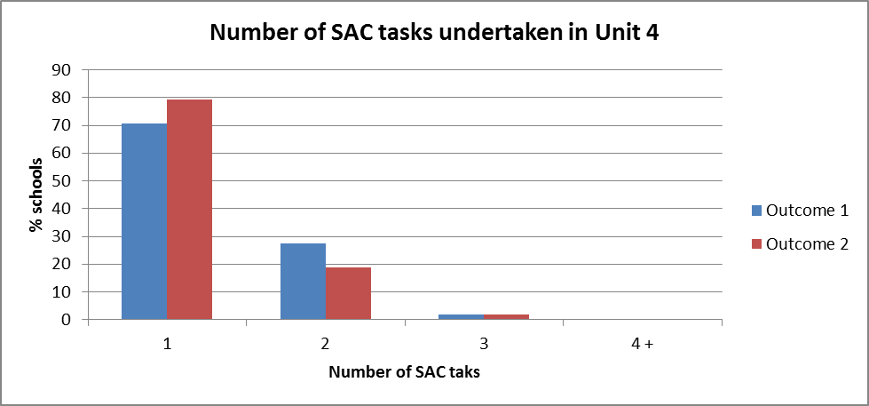
Almost all schools undertook only one or two 50-minute SAC tasks for Outcomes 1 and 2 in Unit 4 as shown in the graph below:

As in the Unit 3 audit, most tasks selected by schools in Unit 4 were either those that were also relevant to the previous study design and/or test-like assessment tasks, as shown in the graph below:
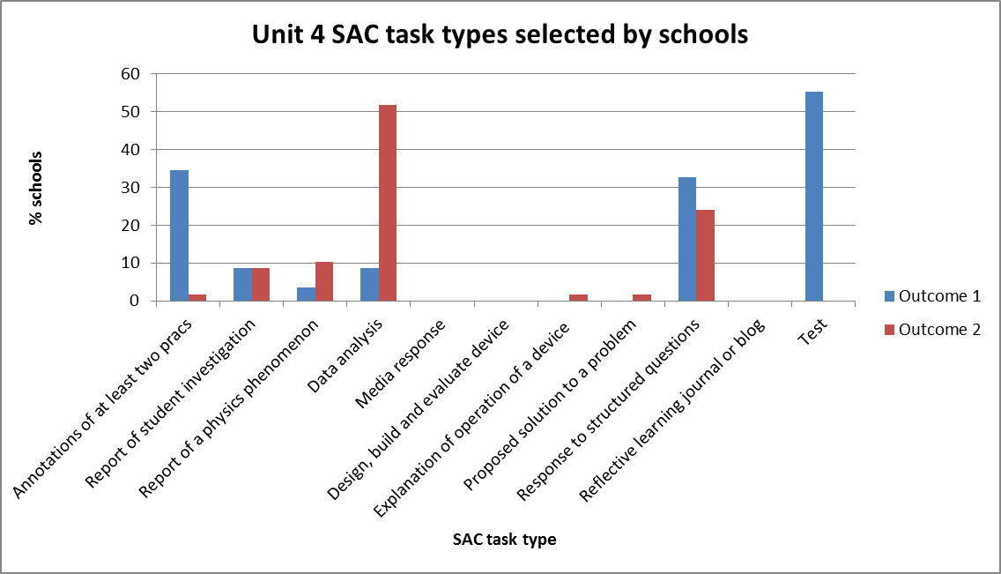

Schools are reminded that students should be provided with a variety of opportunities and task types to demonstrate a range of skills and knowledge appropriate to VCE Physics.
Audit findings related to some of the more commonly undertaken assessment task types are summarised below:
- annotations of at least two practical activities from a practical logbook
Although students generally worked in pairs or small groups when undertaking practical activities, in all schools the formal part of the SAC task involving the annotations was undertaken individually by students under test conditions under teacher supervision.
- data analysis
Students should be expected to not just calculate, but also to plot data and analyse the graph to determine gradients and intercepts. The supplied data should also include several readings for each data point so that error bars can be plotted, with these being used to generate uncertainties in the gradient and intercept values.
- report of a student investigation
Although simulations are appropriate practical activities in cases where equipment or safety may be an issue for the school, this should not be the preferred option for practical work where equipment is readily available, for example, experiments related to Snell’s Law. Practical experiments enable students to be exposed to data ‘outliers’ as well as to develop their practical handling and data generation skills.
- report of a phenomenon
Some schools incorrectly applied the term ‘phenomenon’ to a specifically constructed experimental design. A ‘phenomenon’ is an observable event in nature such as polarisation, the Doppler effect, the aurora and mirages.
- test
Some schools included unmodified past VCAA examination questions in the ‘test’ task. All materials available in the public domain must be modified for authentication purposes.
- response to structured questions
A number of schools interpreted this task as being an examination-mimic task, by replicating the structure of the external examination. The online VCE Physics Advice for teachers provides more information about the nature of this task. This task should be structured based on stimulus material with a set of questions related to relevant key knowledge and key science skills. Stimulus materials may include, for example, experimental set-ups, research snippets, media items and/or advertisements such as those for vehicular/spacecraft safety features or electricity provision.

Unit 4 Outcome 3 (Practical investigation)
Audit findings were that almost 60% of schools audited offered students a choice of investigation topic across Units 3 and 4, rather than restricting the investigation topic to one unit.
Overall, most schools provided opportunities for students to explore a broad range of investigation topics. The same assessment rubric was used to ensure comparability of task scope and demand.
Audit concerns for Outcome 3 included:
- investigation of only one, rather than two, continuous independent variables
- investigation of a discrete (rather than continuous) variable
- investigation question does not identify the variables being investigated
- giving students a topic and possible variables, thereby not providing students with opportunities to work independently to design their own investigations
- student questions that could simply be answered with ‘yes’ or ‘no’
- generation of a very limited number of experimental data points
- too much time spent on poster production
- comparison of experimental results to theoretical values
- some student investigation questions do not rely on practical experimentation to find an answer
- submission of multiple drafts.

