Curriculum Mapping

Why undertake curriculum mapping?
Mapping identifies the extent of curriculum coverage in units of work/sequences of lessons and clearly links teaching, learning and assessment while working with the curriculum continuum.

A mapping template has been developed to support teachers to identify where content descriptions and achievement standards are being explicitly addressed within the school’s teaching and learning program.

A mapping template example

Note: This template is partially completed and is provided as an example only. The template for each curriculum area will look slightly different in recognition of different structures, overall number of content descriptions, and reflecting specific issues within the curriculum area.

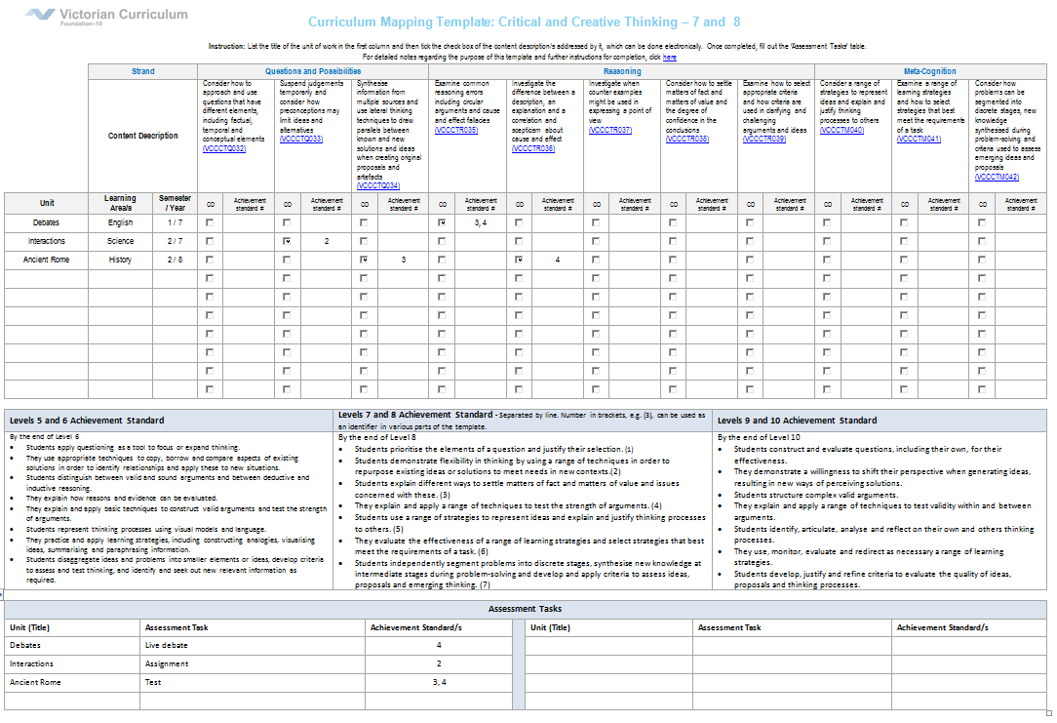

How to use the mapping template
Curriculum mapping has two steps, filling in the template and analysing the findings.
This template can be completed electronically or printed on A3 paper.

Step 1 – Filling in the template – see annotations below
- Take a unit of work/sequence of lessons, fill in the unit name and the semester / year when it is taught.
- Use the check box or place a in the relevant content description cell.
- Indicate within each marked cell the connection to the relevant sentence/s in the achievement standard, using the numbering scheme provided. Each sentence in the achievement standard has been numbered, for example (1).
NB: You may find that a content description does not address the entire sentence from the achievement standard. This exercise is to highlight the contribution towards the achievement standard so that assessment can be discussed.

This process needs to be repeated if the unit covers more curriculum content than is represented on the template, for example it may be more than one strand or curriculum area.

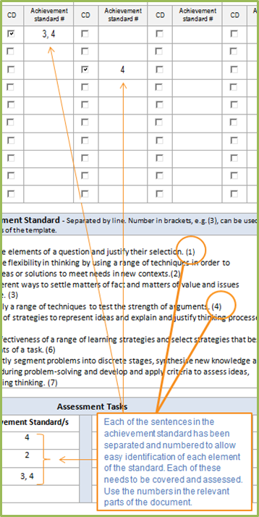
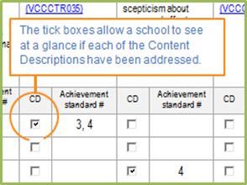

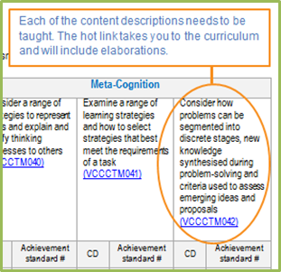

Step 2 – Analysing the findings
Once the templates are completed the essential next step is to analyse the findings. The following questions could be used as prompts for the analysis process:
- Are all content descriptions equal? Do you think they all take the same amount of time to teach?
- Is anything being over taught?
- Is anything being missed completely or given insufficient attention?
- Is there sufficient “time on task”? Are you allowing enough time to develop knowledge ,understanding and skills that are included in the curriculum and thus enable students to progress along the continuum?
- Does the unit/sequence of lessons cater for a range of students abilities? Does the unit/sequence of lessons provide access and challenge for all students in the cohort?
- Is it easier to teach in depth or more broadly?
- Is there a logical sequence?

