Preparing for bushfires

Lesson: Bushfires matter to all Victorians

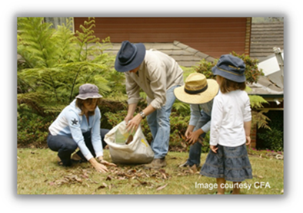
Overview
Curriculum levels: 5 and 6
Time: 50 minutes (approximately)
Links to the Victorian Curriculum F–10:
Geography, Levels 5 and 6
Geographical Concepts and Skills
Describe and explain interconnections within places and between places, and the effects of these interconnections (VCGGC087)
Geographical Knowledge
Impacts of bushfires or floods on environments and communities, and how people can respond (VCGGK095)
Critical and Creative Thinking, Levels 5 and 6
Questions and Possibilities
Identify and form links and patterns from multiple information sources to generate non-routine ideas and possibilities (VCCCTQ023)
Learning intention:
Students consider why it is important to learn about bushfires and bushfire safety in order for them to begin understanding the risks of bushfire in their own area. They will debunk some common misconceptions regarding bushfires and become familiar with the actual risks associated with bushfires.
Suggested resources:
- Whiteboard, IWB or poster paper, and appropriate markers
- Materials as selected for recording student responses, e.g. workbooks and markers, tablets, recording devices
- Online resources such as the images and linked resources listed in the Resources section of the VCAA Bushfire Education webpages

Activities

Starting
Revise and remind students about the ideas and learning points covered in the ‘Learning about bushfires’ section.
Brainstorm, list and discuss ideas in response to the following questions:
- Why do you think it is important to learn about bushfires?
- Why do you think it is important to learn about bushfire safety?
Key ideas to discuss:
- Victoria is prone to bushfires.
- Bushfires matter to all Victorians for many reasons. For example, consider the following points:
- People may live or travel in areas affected by bushfires.
- People may feel sad or worried when there is a bushfire because they care about the people and places affected.
- Everyone benefits from creating bushfire safety plans and helping others to feel safe.
Reiterate that there are different types of fires that we all need to be aware of – bushfires, grassfires and coastal and scrub fires.

Exploring
Discussion focus question:
- Do you believe that you live in an area where a bushfire could start or spread?
Have each student create a table with columns headed ‘Not likely’, ‘Possible’ and ‘Highly likely’.
Could a bushfire start and spread in our area? | Not likely | Possible | Highly likely
Reasons:
Under each column, students record their ideas to explain why they think a bushfire might or might not start or spread near their homes.
Some examples include:
- previous bushfires
- the number of trees
- their home’s proximity to a forest
- cultivated gardens or grasslands.
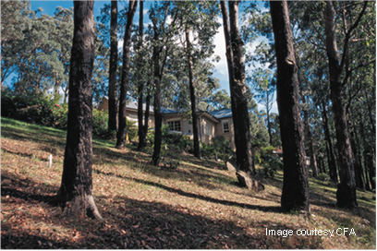
Misconceptions may arise about:
- green grass and trees (i.e. that they do not burn)
- living near the beach or in an area with few trees
- having property near local bushland (i.e. increased likelihood of fire).
Use this activity to challenge students’ misconceptions.
Refer to the ‘Bushfire Myths and Misconceptions’ fact sheet.

Bringing it together
Provide students with a copy of selected excerpts from transcripts from the Victorian Bushfires Royal Commission. These statements detail the local residents’ views on their risks and preparations for bushfire in 2009.
Note: Witness statements from the 2009 Victorian Bushfires Royal Commission final report can be accessed via the archived version of the 2009 Victorian Bushfires Royal Commission webpages held by the National Library of Australia.
Please note: There is potential for discomfort or distress among some students when talking, viewing and reading about bushfires. Teachers need to preview, adapt and manage teaching and learning resources, such as the transcripts listed below, with respect to the particular needs and backgrounds of their students.
Statements:
- Jillian Kane (Bendigo), Paragraphs 4–6
- Anna Macgowan (Bendigo), Paragraphs 4–7
- Sue Exell (Haven), Paragraphs 5 and 6
- Professor Ed Cherry (Marysville), Paragraphs 7 and 11
- David O'Halloran (Flowerdale), Paragraphs 7–10

Key ideas:
- During the 2009 bushfires, many residents thought that they were safe because they were in a town.
Students should record the reasons and ideas presented by the residents’ statements on why they were or were not prepared for the bushfires, including things that the residents had not thought of.
After reading the witness statements, students can then review and update the ideas recorded on their table about bushfires starting in their area.
Finally, discuss and develop a list of risks for a bushfire.

Extending

Assessing the local vegetation
Provide or ask students to bring a photograph of their homes, nearby natural areas or the school environment featuring vegetation. Compare and contrast the environment to the images from ‘Vegetation examples’ (pp. 7–9) in the CFA’s Fire Ready Kit.
Invite students to:
- compare the vegetation in the images to that near their homes and school
- identify the types of vegetation that can be found in the surrounding area
- discuss whether the surrounding vegetation is a fire danger
- list other environmental elements that influence bushfires, e.g. climate, weather, fuel and topography.
Have students assess these factors against the area in which they live, to help them assess their risk.

