Preparing for bushfires

Lesson: Investigating the importance of bushfire survival plans

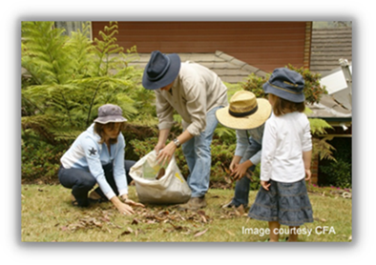
Overview
Curriculum levels: 5 and 6
Time: 50 minutes (approximately)
Links to the Victorian Curriculum F–10:
Geography, Levels 5 and 6
Geographical Knowledge
Impacts of bushfires or floods on environments and communities, and how people can respond (VCGGK095)
Science, Levels 5 and 6
Science Understanding
Scientific understandings, discoveries and inventions are used to inform personal and community decisions and to solve problems that directly affect people’s lives (VCSSU073)
English, Level 5
Reading and Viewing
Use comprehension strategies to analyse information, integrating and linking ideas from a variety of print and digital sources (VCELY319)
Drama, Levels 5 and 6
Explore and Express Ideas
Explore dramatic action, empathy and space in improvisations, play-building and scripted drama, to develop characters and situations (VCADRE029)
Learning intention:
Students discover the importance of developing a bushfire survival plan as an essential part of preparing for the bushfire season for families in bushfire-prone areas. Students also learn the specific components that need to be included in a bushfire survival plan, and how every member of a family can be part of the plan.
Suggested resources:
- Whiteboard, IWB or poster paper, and appropriate markers
- Materials as selected for recording student responses, e.g. workbooks and markers, tablets, recording devices
- Student workbooks or paper
- Pens, pencils or markers
- Online resources such as the images and linked resources listed in the Resources section of the VCAA Bushfire Education webpages

Activities

Starting
As a class, read and review the ‘Am I at risk?’ section in the CFA’s Fire Ready Kit, which emphasises that all types of houses in different environments are vulnerable to bushfires.
Discuss:
- What is a bushfire survival plan?
- Why is it important?
- Who should be part of this plan?
Refer to the CFA’s Fire Ready Kit to identify the phases for planning:
- Actions leading up to the bushfire season
- Actions during bushfire season
- Actions leading up to high fire-risk days
- Actions on fire-risk days
Ask students:
- Why has the CFA supplied a planning kit rather than a definite set of instructions?
Make explicit:
- The CFA recommends that people leave early as the safest option to protect people.
- Bushfire survival plans need to be specific to a particular location and circumstances.
- It is important to understand what your local risk is – bushfire, grassfire or coastal and scrub fire.
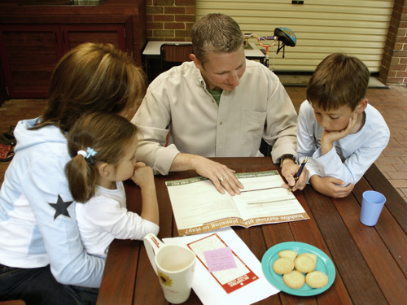
- Bushfire preparation needs to be done in consultation with the whole family.
Image courtesy CFA

Exploring

Hypothetical case study
- Plan the characters
Divide the class into five groups, and give each group a copy of ‘Meet the McIntosh family’, which has background information about the McIntosh family. Allocate a member of the McIntosh family to each group. All students should read this background information and use it to build their group’s allocated character. The character should have a personality and individual priorities to discuss when creating a bushfire survival plan with the rest of the family. Once the character has been developed, one member of the group will play that character in the family discussion about developing a bushfire survival plan.
After all groups have created their characters, assemble the five students (one from each group) assigned to play their character in the class role-play. Allow these students some time away from the class to introduce their character to the rest of the ‘family’, to ensure that the family members ‘know’ each other.
- Allocate roles as observers
Brief the rest of the class on their role as observers. Explain that their task is to check if the family is including the key steps and components of a bushfire survival plan. Give each student a copy of the ‘Checklist for observers’ and, using the checklist as a guide, briefly explain what they might be looking for.
- Role-play the family creating their bushfire survival plan
Bring the family characters before the class and set the scene for the role-play. Explain that the father has read about the need for families to have a bushfire survival plan, and has called the family together around the kitchen table. Tell the actors that they have a certain amount of time (e.g. 15 minutes) to spontaneously role-play the scene. The father begins the role-play with the following statement: ‘I have been reading information from the CFA, and they say we should have a bushfire survival plan well before the bushfire season. It’s June now. Should we give it a go?’
Once time for the role-play has elapsed, call a halt, no matter what stage the action has reached.

Bringing it together

Role-play evaluation and discussion
Ask the audience for their observations about:
- any perceived problems in the process
- major omissions of important considerations
- questionable decisions made
- whether the family has addressed the major components of a bushfire survival plan.
The five role-players can also contribute to the discussion. Ensure that they differentiate between the characters and themselves, and that they understand that criticism of a character’s part or position in the role-play is not a personal criticism.
Ensure the following key ideas are addressed during the discussion:
- the responsibilities of individuals
- planning for all four phases of bushfire preparation
- the family’s decision to leave early or defend their property and how this decision was made
- the triggers for leaving
- items to take if they leave (Has the family left out any essential items or taken any non-essentials?)
- getting help from organisations such as the CFA (e.g. property assessments), or from local groups such as the Community Fireguard Group
- information the family still needs to find out.

Extending

Developing a bushfire survival plan
Divide students into small groups and have them use the role-play and discuss the CFA’s ‘Leaving Early: Bushfire Survival Planning Template’ as the basis for developing a practical bushfire survival plan for the McIntosh family.
Groups will make their own decisions on whether the McIntosh family should leave early or stay to defend their home. Groups should compare their survival plans and comment on the strengths and weaknesses of each.
Refer students to the ‘On Fire Risk Days: Leaving Early’ and ‘Defending Your Property’ section of the CFA’s Fire Ready Kit.

