Responding to bushfires

Lesson: Defending the home

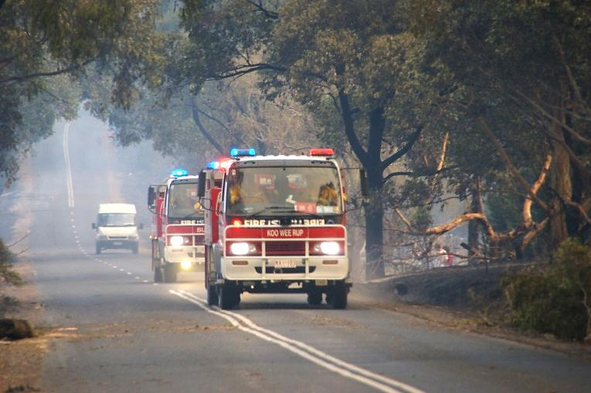
Overview
Image: CFA Strategic Communications

Curriculum levels: 7 and 8
Time: 50 minutes (approximately)
Links to the Victorian Curriculum F–10:
Health and Physical Education, Levels 7 and 8
Personal, Social and Community Health
Plan and use strategies and resources to enhance the health, safety and wellbeing of their communities (VCHPEP130)
Critical and Creative Thinking, Levels 7 and 8
Questions and Possibilities
Suspend judgements temporarily and consider how preconceptions may limit ideas and alternatives (VCCCTQ033)
Reasoning
Examine common reasoning errors including circular arguments and cause and effect fallacies (VCCCTR035)
Learning intention:
Students learn that being fully prepared in bushfire season, even if your bushfire survival plan is to leave early, can help save lives. This is especially important if you need to change plans as a result of new circumstances.
Suggested resources:
- Online resources such as the linked resources listed below

Activities

Starting
Introduce the session with a myth: ‘When the fire comes, the best thing to do is to hide in the bathroom and sit in the bath.’ Discuss students’ responses to this myth.
Highlight the following points:
- the need for a plan and backup plans in case the ‘Leave Early’ approach is no longer viable
- why the bathroom would not offer protection if the house did catch fire
- that a more sensible approach, if caught in that situation, would be to monitor what was happening to the fire and the house; for example, embers causing spot fires, windows cracking due to radiant heat
- that it would be possible to shelter in a house until the fire front passed and then move to a safer area that had already been burned, and was not at risk of radiant heat.
For additional information and examples, please see the ‘Bushfire myths & misconceptions’ fact sheet (available from the Resources section of the VCAA Bushfire Education webpages).

Exploring
Organise students into pairs to read the ‘Defending the home’ fact sheet (available from the Resources section of the VCAA Bushfire Education webpages).
After they have read the scenarios, ask each pair to analyse the way these residents responded to the threat of bushfire and defended their homes.
Show students how to create a ‘plus (+), minus (-), things I’d change (Δ)’ chart for each scenario.
 | Plus (+) | Minus (–) | Things I’d change (Δ)
Resident 1
Resident 2
Resident 3
Explain each category:
- The pluses are things the residents did that students think helped save lives and property. Students need to include reasons why they rated those things as pluses.
- The minuses are things the residents did that students think put them and their property at risk. Students need to include reasons why they rated those things as minuses.
- The ‘things I’d change’ should relate to students responding differently from the way the resident did.
As a class, discuss the tables developed by each pair.
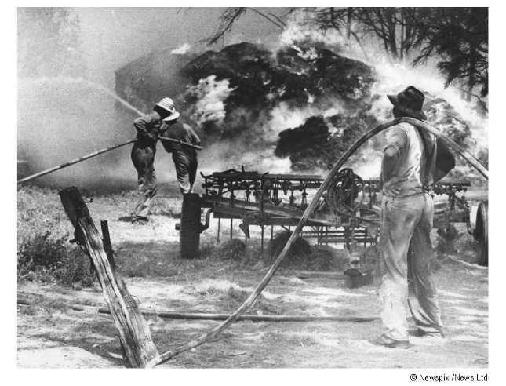

Bringing it together
As a result of their analysis, develop a list of actions that people could take to be better prepared for bushfire, identifying things that residents may not think of while a bushfire is in progress. An example of this is that it is not enough to simply have all the safety equipment that you think you need – it actually has to be ready and set up for use, just in case.
Discuss what it means to be mentally prepared as well as having the home prepared for the threat of bushfire.

