Responding to bushfires

Lesson: Facing reality

Overview

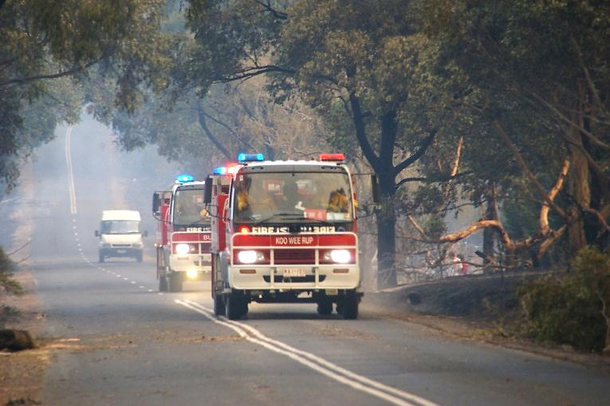

Image: CFA Strategic Communications

**Curriculum levels:** 7 and 8

**Time:** 50 minutes (approximately)

**Links to the Victorian Curriculum F–10:**

Health and Physical Education, Levels 7 and 8

Personal, Social and Community Health

Investigate and select strategies to promote health, safety and wellbeing [(VCHPEP126)](https://victoriancurriculum.vcaa.vic.edu.au/Curriculum/ContentDescription/VCHPEP126)

Plan and use strategies and resources to enhance the health, safety and wellbeing of their communities [(VCHPEP130)](https://victoriancurriculum.vcaa.vic.edu.au/Curriculum/ContentDescription/VCHPEP130)

Critical and Creative Thinking, Levels 7 and 8

Reasoning

Consider how to settle matters of fact and matters of value and the degree of confidence in the conclusions [(VCCCTR038)](https://victoriancurriculum.vcaa.vic.edu.au/Curriculum/ContentDescription/VCCCTR038)

**Learning intention:**

Students learn that by having a well-practised bushfire survival plan well before bushfire season, people can respond effectively and flexibly in a bushfire situation and increase their chances of staying safe.

**Note:** Prior to attempting this activity, students need to have a good understanding of the nature of bushfires and bushfire behaviour (see the ‘Understanding bushfire behaviour’ sessions). They also need to have successfully completed the ‘Bushfire survival plans’ session.

**Suggested resources:**

* Online resources such as the images and linked resources listed in the [Resources](https://www.vcaa.vic.edu.au/curriculum/foundation-10/crosscurriculumresources/bushfireeductation/Pages/Resources.aspx) section of the VCAA Bushfire Education webpages

Activities

Starting

Introduce students to the activity task. They are going to explore a hypothetical scenario to examine the usefulness of a bushfire survival plan, using their knowledge of bushfires and exercising their problem-solving and decision-making skills.

**Please note:** All educators need to be aware that there is potential for discomfort or distress among some learners when talking, viewing and reading about bushfires. Bushfires are traumatic events for many in the Victorian community, and teachers need to preview, adapt and manage the teaching and learning activities and resources with respect to the particular needs and backgrounds of their learners. Further information and support can be found in the Department of Education and Training’s [Mental health support after an emergency](https://www.education.vic.gov.au/school/teachers/health/mentalhealth/Pages/mental-health-support-after-emergency.aspx).

Re-introduce students to the Carson family and their circumstances (use the fact sheet titled ‘[Carson family background](https://www.vcaa.vic.edu.au/Documents/viccurric/bushfire/preparing/CarsonsBackgroundInfo.pdf)’,in the [Resources](https://www.vcaa.vic.edu.au/curriculum/foundation-10/crosscurriculumresources/bushfireeductation/Pages/Resources.aspx) section of the VCAA Bushfire Education webpages).

Hand out copies of the ‘[Carson family’s bushfire survival plan](https://www.vcaa.vic.edu.au/Documents/viccurric/bushfire/preparing/CarsonBushfireSurvivalPlan.pdf)’. Explain that this is the bushfire survival plan the Carsons decided on prior to the bushfire season.

Remind the class of the following considerations:

* Even with improved bushfire awareness and education, not everyone will be adequately prepared for a bushfire.
* Even well-prepared people need to have a backup plan to cover the range of circumstances that an actual bushfire might present.
* An individual or family’s safety is dependent on a range of factors beyond their immediate control, including:
* topography
* emergency services resourcing and local deployment
* fuel management strategies on public and neighbouring private land
* how well the community has planned and prepared, and whether shelters are available
* fire weather in their area
* whether there is sufficient time from when the fire starts to issue a formal warning or issue any warning at all.

Have the class discuss the Carson family’s bushfire survival plan and relocation kit. Ensure students understand that this plan is not an exemplar – it may have flaws! Ask students to highlight what they perceive as its strengths and weaknesses. Arrive at a consensus evaluation of the effectiveness of the plan as a response to a bushfire situation. Explain that the class is now going to apply that plan to a scenario to see how it might work as a bushfire response.

Exploring

Divide students into groups and read ‘[Carson family: bushfire scenario](https://www.vcaa.vic.edu.au/Documents/viccurric/bushfire/preparing/CarsonBushfireScenario.pdf)’ to the class. Pause at each crisis and ask the groups to briefly discuss what they would do next and then to answer the three questions contained in the crisis box.

When all six crises have been addressed and the scenario is complete, the class evaluates the Carson family’s plan and suggests changes that would have made it a more effective plan for the bushfire with which they were confronted.

Man and girl packing an SUV to leave early before a bushfire. They are patting a dog, who is sitting in the boot of the car.

*Preparing for bushfires – loading the car to leave early*

Bringing it together

As a summative activity, or a formative assessment piece, have each student write up:

* a short account of what happened in their ‘family’
* an evaluation of the effectiveness of the Carson family’s bushfire survival plan
* what the hypothetical tells us about how bushfire survival plans can keep people safer in bushfires.