Responding to bushfires

Lesson: Learning what to do in a fire emergency

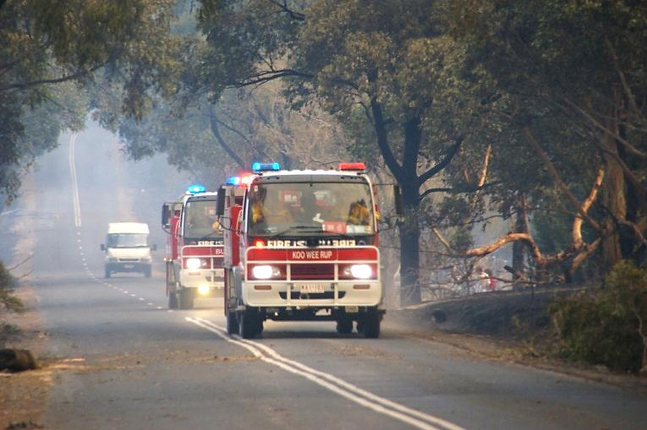
Overview
Image: CFA Strategic Communications

Curriculum levels: 1 and 2
Time: 50 minutes (approximately)
Links to the Victorian Curriculum F–10:
English, Level 2
Speaking and Listening
Understand that language varies when people take on different roles in social and classroom interactions and how the use of key interpersonal language resources varies depending on context (VCELA235)
Understand the use of vocabulary about familiar and new topics and experiment with and begin to make conscious choices of vocabulary to suit audience and purpose (VCELA237)
Health and Physical Education, Levels 1 and 2
Personal, Social and Community Health
Recognise situations and opportunities to promote their own health, safety and wellbeing (VCHPEP074)
Learning intention:
Through exploring a scenario in which children call emergency Triple Zero to report a fire, students come to appreciate the correct way to report an emergency. They will be guided to think about and identify the action taken by the characters to alert ‘000’ (Triple Zero) and stay safe.
Suggested resources:
- Whiteboard, IWB or poster paper and appropriate markers
- Materials as selected for recording student responses, e.g. workbooks and markers, tablets, recording devices
- Online resources such as the images and linked resources listed in the Resources section of the VCAA Bushfire Education webpages

Activities

Starting
Ask the students what they know about Emergency Triple Zero (000).
Use prompting questions, such as:
- What is special about an emergency call?
- Why do we need to know the emergency number?
- Who answers an emergency call?
- What questions do you think the person who answers the call will ask?

Exploring
Visit the Triple Zero kids’ challenge website. Start the game and then select ‘Skip’ to reach the Triple Zero Kids Challenge area.
Together, explore the story about two children (Pete and Kate) who need to report a fire while visiting a relative in the country.
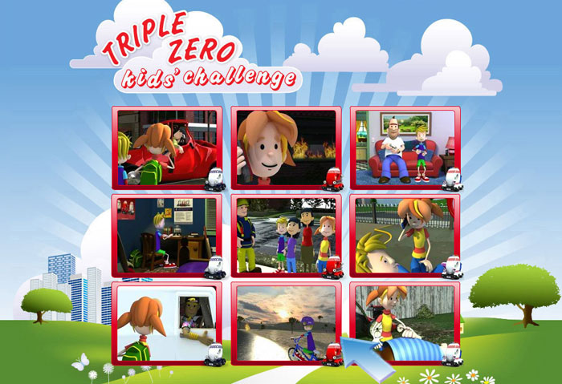
© Fire & Rescue NSW on behalf of Triple Zero Awareness Group
Before viewing:
- tell the students a little about the scenario.
During viewing:
- encourage predictions of what Pete and Kate will do next, and why.
After viewing, ask:
- What did the children do and how did they behave?
- How did the children know what to do?
- How well did they do it?
- What happened in the phone call?
- What information did Kate have to give the operator?

Bringing it together
As a class, review what students have learned from Pete and Kate’s story about what to do if there is a bushfire emergency.
Guide the discussion to focus on:
- the importance of getting away from the fire and reporting it from a safe place
- alerting an adult and, if possible, having a parent or another adult call for help
- the number that Kate called – ‘Triple Zero’ or ‘000’
- the information that Kate needs to provide, particularly her name and where she is, and also her phone number
- the way Kate listens very carefully and follows all instructions.

Extending
Allow students to choose and explore other animated information clips located on the Triple Zero kids’ challenge website. After each story, ask the students to record and/or discuss:
- What was the emergency?
- What did the children do?
- How did the children behave?
- How did the children know what to do?
- How well did they do it?

