Responding to bushfires

Lesson: Reporting an emergency to Triple Zero (000)

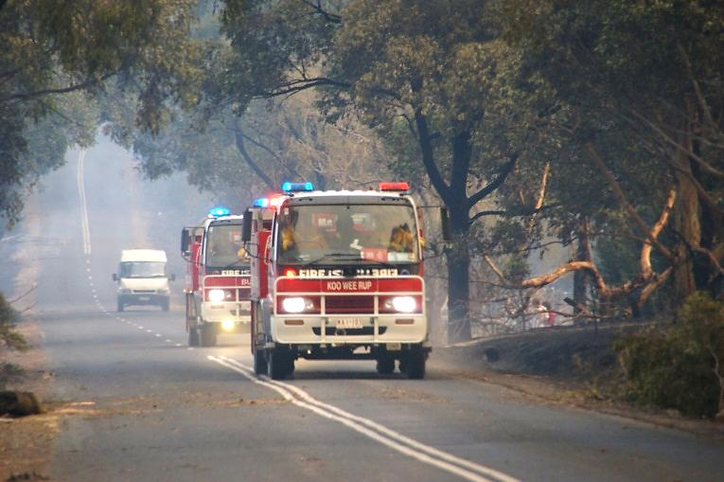
Overview
Curriculum levels: 1 and 2
Time: 50 minutes (approximately)
Links to the Victorian Curriculum F–10:
English, Level 2
Speaking and Listening
Understand that language varies when people take on different roles in social and classroom interactions and how the use of key interpersonal language resources varies depending on context (VCELA235)
Image: CFA Strategic Communications

Image: CFA Strategic Communications

Understand the use of vocabulary about familiar and new topics and experiment with and begin to make conscious choices of vocabulary to suit audience and purpose (VCELA237)
Health and Physical Education, Levels 1 and 2
Personal, Social and Community Health
Recognise situations and opportunities to promote their own health, safety and wellbeing (VCHPEP074)
Learning intention:
Students come to understand the seriousness of calling Triple Zero (000). They will understand the process of making an emergency call, including how to articulate and speak clearly and answer questions thoroughly to ensure the call is completed successfully.
Suggested resources:
- Student workbooks or paper
- Pens, pencils or markers
- Cameras
- Access to ICT tools
- Online resources such as the images and linked resources listed in the Resources section of the VCAA Bushfire Education webpages
- Triple Zero webpage

Activities

Starting
Prompt students to recall key points covered in earlier lessons about safety. For example, discuss:
- the importance of being in a safe place away from the fire
- the fact that adults will be in control of the situation
- the special role of firefighters, police and ambulance officers in keeping everyone safe.
Lead the discussion to explore:
- How do we get help? i.e. by calling Triple Zero (000)
Note: This should always be said as ‘Triple Zero’, not ‘Triple oh’.
Ask and discuss:
- Is it important for everyone to know how to call the emergency number?
- Why or why not?
Make explicit:
- the seriousness of reporting a fire
- the seriousness of calling the emergency number.
- that there may be times when children are the only ones who can call for help.

Exploring
Ask, discuss and detail:
- What happens on an emergency Triple Zero (000) phone call?
Make explicit:
- An emergency operator’s questions will include asking for the caller’s name and address or location.
Refer to How to call Triple Zero (000).
Reinforce the language that students will need in order to be able to respond appropriately in a bushfire emergency.
Have the students practise responding clearly to the following questions:
- What is your name?
- Where do you live?
Provide plenty of support and practice to help younger students gain confidence in answering these questions.
Talk with students about the difference between ‘What is your address?’ (i.e. where do you live?), and ‘Where are you?’ (i.e. what is your location?).

Bringing it together
Engage students in the following activities focusing on location and reinforcing positional language. Language of size and colour could also be included.

Play ‘I Spy’
Play a game of ‘I Spy’ using location clues (e.g. I spy something next to the door … outside our window … near the fire extinguisher … under the smoke alarm) and clues relating to the size and colour of objects.

School locations
Take students to different locations at the school, both inside and outside. Practise describing the locations – what we can see, what things look like and where different things are.

Role-play Triple Zero (000) phone calls
Use images supplied in the resource gallery, or images from picture books and other resources that show a particular setting. Have students pretend to be in that setting and describe their location through a role-play Triple Zero (000) phone call, with the operator asking ‘What is your location?’ and ‘Can you describe where you are?’

Extending
Practise the clear and descriptive language required to make Triple Zero (000) emergency calls though the following activities:

Photos and a slide show presentation
Students use digital cameras to take photos of locations in their area and practise describing them. They can present their photos in a slide show presentation and create simple text to accompany them.

Operator and caller role-play
Students might conduct a role-play between an emergency operator and a caller who is carefully following the operator’s instructions and describing his or her location.

