Responding to bushfires

Lesson: Reporting an emergency to Triple Zero (000)

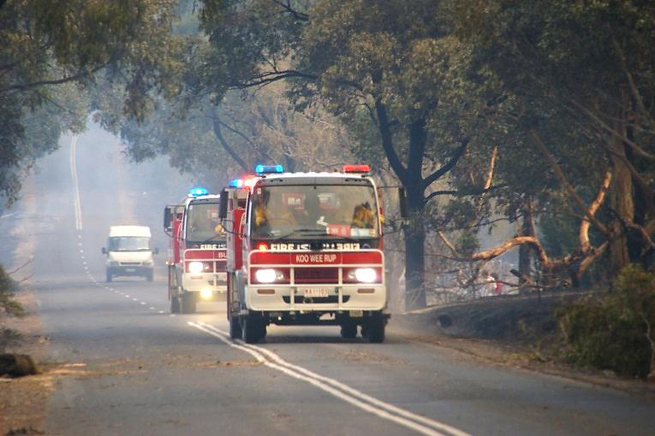
Overview
Image: CFA Strategic Communications

Curriculum levels: 5 and 6
Time: 50 minutes (approximately)
Links to the Victorian Curriculum F–10:
Health and Physical Education, Levels 5 and 6
Personal, Social and Community Health
Investigate community resources and strategies to seek help about health, safety and wellbeing (VCHPEP107)
Plan and practise strategies to promote health, safety and wellbeing (VCHPEP108)
English, Level 5
Speaking and Listening
Understand that patterns of language interaction vary across social contexts and types of texts and that they help to signal social roles and relationships (VCELA334)
Clarify understanding of content as it unfolds in formal and informal situations, connecting ideas to students’ own experiences, and present and justify a point of view or recount an experience using interaction skills (VCELY337)
Learning intention:
Students learn how to call for adult assistance in a bushfire situation by phoning Triple Zero (000) and responding to the operator’s questions.
Suggested resources:
- Whiteboard, IWB or poster paper, and appropriate markers
- Materials as selected for recording student responses, e.g. workbooks and markers, tablets, recording devices
- Online resources such as the images and linked resources listed in the Resources section of the VCAA Bushfire Education webpages

Activities

Starting
Ask and discuss:
- How can we get help in an emergency? i.e. by calling Triple Zero (000)
Note: This should always be said ‘Triple Zero’, not ‘Triple oh’.
Ask:
- Is it important for everyone to know how to call the emergency number?
- Why or why not?
Make explicit:
- the seriousness of reporting a fire and of calling the emergency number
- there may be times when children are the only ones who can call for help.

Exploring
Ask and discuss:
- What happens on an emergency Triple Zero (000) phone call?
Provide students with access to the How to call Triple Zero web page or a printed or electronic copy of the Triple Zero Fact Sheet.
During reading, have students record summarised notes of the key information the caller needs to give the operator during Triple Zero (000) emergency calls, as well as find out the options available for people who are deaf or have a speech or hearing impairment.
Refer also to the CFA Emergency Call 000 webpage.

Bringing it together

Triple Zero (000) role-play
Have students work through a Triple Zero (000) phone call scenario with a partner.
The caller must describe his or her present location at school to the Triple Zero (000) operator. The student should describe the location as if the school’s address was unknown and there was no one present to ask.
In preparation for the role-play, students may plan their answers to describe the school location.
Provide the following scripted questions for the student playing the operator:
- ‘Where is your emergency?’
What is the location of the fire? The street or road name? The nearest intersection?
- ‘What is the type of incident?’
What is happening? Is it a building fire, grassfire or bushfire?
- ‘How many people are involved?’
Are there people in danger? How many?
- ‘Is other assistance required?’
Ambulance or police?
- ‘What is your name, address and telephone number?’
Contact details in case we need to follow up with you later.
In another role-play, give students photographs of locations selected from the ‘Image gallery’ in the Resources section of the VCAA Bushfire Education webpages, so students can practise describing locations in the same way, using any clues found in the pictures. Students should share their answers and discuss the clues they would use to construct their descriptions.

Extending

Evaluating responses to emergency situations
Allow students to choose and explore the animated information clips located in the Triple Zero kids’ challenge website.
After each story, the students are to answer the following questions:
- What was the emergency?
- What did the children do?
- How did the children behave?
- How did the children know what to do?
- How well did they do it?

