Responding to bushfires

Lesson: Safe behaviours

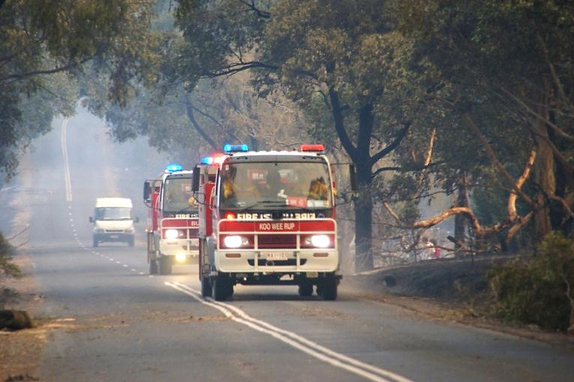
Overview
Image: CFA Strategic Communications

Curriculum levels: 7 and 8
Time: 50 minutes (approximately)
Links to the Victorian Curriculum F–10:
Health and Physical Education, Levels 7 and 8
Personal, Social and Community Health
Investigate and select strategies to promote health, safety and wellbeing (VCHPEP126)
Plan and use strategies and resources to enhance the health, safety and wellbeing of their communities (VCHPEP130)
Learning intention:
By understanding the key risks and the science of bushfires, there are many things people can do to make themselves safer in a bushfire or high fire-risk situation. Radiant heat is a killer. Establishing distance, taking appropriate shelter, wearing suitable clothing and drinking fluids can help protect the body from the harmful effects of radiant heat.
Note to teachers:
Teachers are advised that some students may find aspects of the following activities personally disturbing. Teachers need to review all materials prior to use and carefully choose and/or adapt the activities and resources that are the most appropriate for the context, background and experience of students in their particular classroom.
Advice: Teachers conducting demonstrations are advised to trial the activity prior to the session to ensure they are aware of any inherent safety requirements and potential issues. Demonstrations that involve burning should be undertaken in a fume cupboard or in a well-ventilated area. Check for smoke alarms that may be triggered by demonstrations involving burning.
Ensure students are made aware of safety instructions when working with a heat lamp. Ensure the bench is clear of any flammable materials. Explain safety rules, such as not touching the lamp and making sure fabrics do not come in contact with the lamp.
Suggested resources:
- Resources required for investigations as listed below
- Online resources such as the linked resources listed below

Activities

Starting
Pose the question, ‘What can we do to protect ourselves from the effects of radiant heat from a bushfire?’
Recap the main points of the ‘Heat transfer’ session. These points include:
- Radiant heat travels in straight lines.
- The further away from the heat source, the less radiant heat there is.
- Certain solid materials block radiant heat.
- Radiant heat can pass through glass.
Discuss students’ responses to the initial question and then point out that radiant heat from a bushfire can be 50,000 times as intense as that from a campfire or a radiator heater.
To further emphasise the intensity of radiant heat from a bushfire, show a relevant video, such as the home video and commentary of a householder in the St Andrews area who survived the 2009 bushfires, ‘2009 Victorian Firestorm with Tornado’ (note: video contains low-level explicit language).
Prior to viewing the video, ask students what they expect to see in the home video of a person witnessing an intense bushfire. After viewing, discuss the video, focusing on the various ways the householder attempted to protect himself from radiant heat and why those methods may or may not be useful. For example:
- sheltering behind a wall
- wearing suitable clothing such as pants and long-sleeved shirts made of natural fibres
- moving further away from the bushfire.

Exploring

Distance
Have students research the concept of ‘Neighbourhood Safer Place – Bushfire Place of Last Resort’ from the CFA website.
Discuss the distance set for these ‘safe places’: if it is an outside area, it must be at least 310 metres from a bushfire hazard; if it is a structure, it must be at least 140 metres from a bushfire hazard. Ask students to explain:
- why distance from a fire hazard is important
- why the distances are different
- why the CFA information stresses the limitations of Neighbourhood Safer Places.

Shelter
Pose the question, ‘If it is not possible to establish enough distance from the radiant heat, what is the next safest option?’ Discuss possible scenarios where people may be caught out by the effects of fire and need to seek shelter.

Review the advice from the ‘On Fire Risk Days: Leaving Early’ and ‘Defending Your Property’ sections CFA’s Fire Ready Kit and have students complete the following activities:
- List any well-prepared houses or buildings in your area that could be a safer place to shelter if you are caught out during a bushfire.
- Think about where you plan to shelter if it is unsafe to leave your property. This is an extremely dangerous situation, and you must seek shelter from radiant heat in the most well-prepared building on your property.
Have students use their knowledge and understanding of radiant heat to explore what materials and characteristics these shelters would need to have.

Clothing
Ask students to examine the photos under ‘Responding to bushfires’ on the Resources section of the VCAA Bushfire Education webpages that show CFA and Department of Environment, Land, Water & Planning staff and volunteers responding to bushfires. What do students notice about their clothing? Discuss what possible purposes there would be for this clothing. Suggestions may include protection from flame and scorch burns, high visibility, etc.
Pose the question, ‘Can clothing can be of any use as a barrier to radiant heat?’

Investigation: blocking radiant heat
Set up a teacher demonstration or support students to use a heat lamp safely to investigate the properties of a range of fabrics and their ability to block radiant heat.
Materials required:
- heat lamp
- swatches of a range of fabrics, such as wool, cotton, denim, leather and polyester
- thermometer
- ruler
Set up an appropriate distance (for example, 20 centimetres) from the lamp and measure the temperature immediately in front of and immediately behind the fabrics. Record the results in a table and have students explain their observations.
Discussion: Which of the selected fabrics would be most appropriate to provide protection from radiant heat? Ask students to consider their own clothing at home and to think about what they would wear in the threat of bushfire. Ensure that they include headwear and footwear in their list. Have them compare their selections and their reasons for these.

Dehydration
Have students investigate or research how the body maintains a constant temperature in hot weather or when we undertake demanding physical activity.
Discuss reasons why the body produces sweat and its role in maintaining body temperature. Pose the question, ‘How do we support the body in maintaining this process?’ Have students suggest what effect radiant heat would have on this body function when people are fighting a bushfire, staying to defend their home or travelling during a bushfire. Pose the question, ‘What happens to the body when it does not have enough fluids to deal with heat?’ During this discussion students will most likely use the terms ‘dehydration’ or ‘heatstroke’.
Pose the questions, ‘What are the first signs of dehydration or heatstroke? What can be done to prevent this threat to personal safety?’
To find out more about dehydration, its effects and why it is an issue, give students approximately 10–15 minutes to conduct an internet search using key words such as:
- dehydration
- heatstroke
- fluid loss
- kidneys and dehydration
- urinary system.
Ask students the following questions:
- Think of a time you felt really thirsty. What were you doing? What were the conditions? How did you feel?
- If you have not had enough fluids, what changes do you notice in the colour and amount of urine passed? Why might this happen?
- What role is played by the other organs in your body that are linked to systems that control fluid balance?
- Why is dehydration an issue?
- What are the key messages about dehydration?

Bringing it together
Have students rate the following statements as myth or fact and provide their reasoning:
- Moving away from a bushfire is the best way to protect yourself from radiant heat.
- During a bushfire, you are safer outside a house than you are taking shelter inside a house.
- A fire can start inside a house due to radiant heat from a bushfire.
- Fighting fires in a T-shirt and shorts is advisable, as you would lose less fluid through sweating.
- Feeling thirsty is a good indicator of when to drink to make sure you don’t get dehydrated.
Explain that the CFA suggests the following hierarchy of actions to attempt to deal with the effects of radiant heat and increase your safety in a bushfire.
- Move as far away from the bushfire as possible. In a fire plan, this is the Leave Early approach.
- If in a bushfire situation, shelter in a building behind a wall or some structure that will block the radiant heat.
- Wear appropriate clothing, such as trousers and a long-sleeved top that will shield you from radiant heat.
- Ensure fluids are kept up to avoid dehydration.

