DIGITAL TECHNOLOGIES:
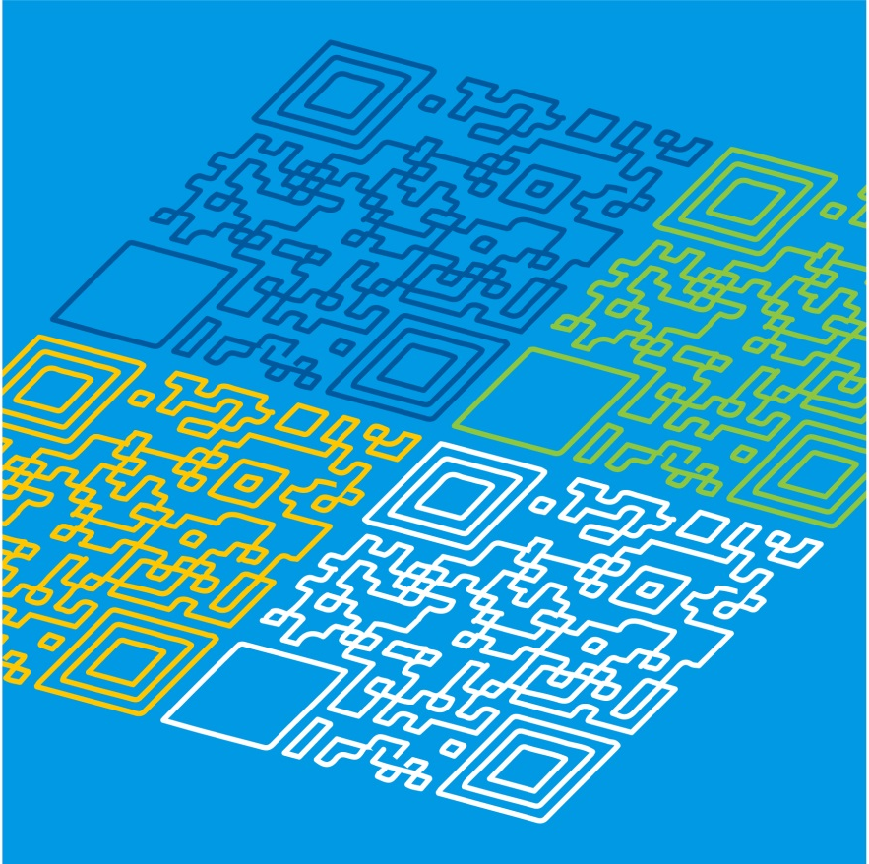
UNPACKING THE CONTENT DESCRIPTIONS
PLEASE NOTE:
This pack does not contain all content descriptions for Foundation to Level 2, but can be used as a guide to develop your own lesson plans
Digital Technologies: Unpacking the Content Descriptions

Strand | Creating Digital Solutions |  | Sample activities
Content Description | Follow, describe and represent a sequence of steps and decisions (algorithms) needed to solve simple problems |  | Unplugged – without a digital device:  - following basic step-by-step instructions, such as a recipe  - use of terminology: start, stop, forwards, backwards, left and right  - using cards with arrows or symbols to create a simple algorithm  - programming a class mate as a robot, for example developing instructions for another student to follow  - following instructions and steps sequentially, including decision-making  - recording the steps as symbols to solve a problem, for example using arrows  Plugged - with a digital device:  - exploring the functions of buttons on a digital device  - experimenting with a digital device, for example going forward and backward  - programming a digital device to follow a simple sequence of steps to solve a problem, for example following a set of instructions written as arrows  - programming a digital device to make a square programming a digital device to follow a path to avoid an obstacle
Related extract from Achievement Standard | Students design solutions to simple problems using a sequence of steps and decisions.
Suggested focus | Lessons may focus on:  - introducing algorithms and following steps sequentially  - discussing the terminology around algorithms  - making decisions when following step-by-step instructions  - solving a problem by developing an algorithm, for example writing a sequence of steps or using arrows or symbols

Digital Technologies: Unpacking the Content Descriptions
Strand | Data and Information |  | Sample activities
Content Description | Recognise and explore patterns in data and represent data as pictures, symbols and diagrams |  | - creating a pictograph using emojis  - surveying a class mate to find similarities and differences  - sorting a collection of items using different categories, such as alphabetical order, numerical order and size order  - collecting class data about birthday months and using Unifix blocks in different colours to display information  - representing data as patterns in different ways, for example images and sound  - reducing an image file so that it could be emailed by reducing the dimensions or choosing a different format
Related extract from Achievement Standard | Students use digital systems to represent simple patterns in data in different ways and collect familiar data and display them to convey meaning.
Suggested focus | Lessons may focus on:  - data represented as patterns, pictures, objects and symbols  - graphing with symbols, such as pictographs  - how to collect data in class for sorting or graphing  - different ways of sorting and comparing data, for example shortest to longest, smallest to largest  - relationship between picture size and file size

Digital Technologies: Unpacking the Content Descriptions
Strand | Data and Information |  | Sample activities
Content Description | Independently and with others create and organise ideas and information using information systems, and share these with known people in safe online environments |  | - creating a multimedia document, such as a character profile or a class profile that includes an image of each student that is shared on the school intranet or class blog  - creating a personal audio/video recording and a written message on the school intranet  - collaboratively creating a photo story online as a blog with text, images and audio/video to illustrate a familiar or creative story  - discussing cybersafety obligations with students, for example checking that all parents of students in a photo have given permission for the photo to be shared safely online on the school intranet or class blog  - a teacher-directed activity involving the sharing of ideas and information online safely through blogs or class email, messaging only to people that students know  - using bookmarked websites when searching for information  - using moderated online spaces, such as the school intranet or class blog when sharing information
Related extract from Achievement Standard | They create and organise ideas and information using information systems and share these in safe online environments.
Suggested focus | Lessons may focus on:  - using different types of data such as text, images and sound to create information for sharing online with a known audience  - planning and creating text, image and sound files to share online with a known audience  - making ethical decisions when using images for public viewing  - making ethical decisions when using the work of others  - identifying and participating in safe online environments, for example the school’s intranet

Digital Technologies: Unpacking the Content Descriptions
Strand | Digital Systems |  | Sample activities
Content Description | Identify and explore digital systems (hardware and software components) for a purpose |  | - identifying common digital systems in the classroom and their purpose, for example laptops, tablets, interactive whiteboards  - identifying common digital systems at home and their purpose, for example smart phones, desktop computers, tablets and smart TVs  - linking identified digital systems with an identified purpose, for example using a laptop to word process a story or using a tablet to take photographs  - identifying that inputs are a way of entering data into a digital system, for example keyboard, mouse, touch pad, touch screen, buttons on a robotic device  - identifying that outputs are a way for a digital system to represent data to the user, for example a monitor for displaying information and speakers to provide sound  - using a digital system to take photographs and inserting them into a document  - creating a multimedia solution that includes text, images, audio and video
Related extract from Achievement Standard | Students identify how common digital systems are used to meet specific purposes.
Suggested focus | Lessons may focus on:  - types of common digital systems and their purpose  - basic functions of inputs and outputs  - using digital systems to download and store images  - learning to create an audio recording while exploring hardware and software  - learning to create a video recording while exploring hardware and software  - learning to create a photo story using photos and music

