Food and you, Foundation

Foundation Level

Authorised and published by the Victorian Curriculum and Assessment Authority
Level 7, 2 Lonsdale Street
Melbourne VIC 3000
© Victorian Curriculum and Assessment Authority 2019.
No part of this publication may be reproduced except as specified under the Copyright Act 1968 or by permission from the VCAA. Excepting third-party elements, schools may use this resource in accordance with the VCAA educational allowance. For more information go to: www.vcaa.vic.edu.au/Pages/aboutus/policies/policy-copyright.aspx.
The VCAA provides the only official, up-to-date versions of VCAA publications. Details of updates can be found on the VCAA website: www.vcaa.vic.edu.au.
This publication may contain copyright material belonging to a third party. Every effort has been made to contact all copyright owners. If you believe that material in this publication is an infringement of your copyright, please email the Copyright Officer: vcaa.copyright@edumail.vic.gov.au
Copyright in materials appearing at any sites linked to this document rests with the copyright owner/s of those materials, subject to the Copyright Act. The VCAA recommends you refer to copyright statements at linked sites before using such materials.

The VCAA logo is a registered trademark of the Victorian Curriculum and Assessment Authority.

Contents

Introduction to the unit of work 4
Overview 4
Learning intentions 4
Victorian Curriculum correlation 5
Advice and teaching considerations 5
Learning activities, resources and tips 6
Learning activity 1: Five food groups and discretionary foods 6
Learning activity 2: Rethink sugary drinks 7
Learning activity 3: Discretionary foods interview 8
Learning activity 4: Practical session: Make a healthy snack 9
Further resources 10
Appendix 1 11
Appendix 2 13
Appendix 3 14
Appendix 4 15

Introduction to the unit of work
Unit of work: Food and you
Time (approximate): 120 minutes (4 × learning activities)
Curriculum level: Foundation
Curriculum areas: Design and Technologies
Health and Physical Education

Overview
Students explore foods for healthy eating and learn that discretionary foods are those that should be eaten only sometimes and in small amounts. They take part in an interview about discretionary foods and identify and prepare a healthy snack that could be eaten every day.

Learning intentions
- Explore different foods and group them according to the five food groups.
- Identify and explain what a discretionary food is and why they should be eaten only sometimes and in small amounts.
- Recognise the ingredients needed and the steps required in making a healthy snack.

Victorian Curriculum correlation

Design and Technologies strands | Health and Physical Education strand
Technologies Contexts  Creating Designed Solutions | Personal, Social and Community Health
Achievement Standards (extract)
By the end of Level 2, students:  - identify the features and uses of some technologies for the prescribed technologies contexts (food specialisations). With guidance, students create designed solutions for each of the prescribed technologies contexts. They describe given needs or opportunities. | By the end of Foundation Level, students:  - identify actions that help them be healthy, safe and physically active.
Content Descriptions (extract)
Food specialisations  - Explore how food is selected and prepared for healthy eating (VCDSTC016)  Investigating  - Explore needs or opportunities for designing, and the technologies needed to realise designed solutions (VCDSCD018) | Contributing to health and active communities  - identify actions that promote health, safety and wellbeing (VCHPEP062)
This unit of work also builds on the Victorian Early Years Learning and Development Framework, Outcome 3, in which children show an increasing awareness of healthy lifestyles and good nutrition.

Advice and teaching considerations
- Consider spaces for practical lessons, e.g. school canteen, staff kitchen, wet area in your classroom.
- Invite parents or carers to come in and help with the practical class.
- Ask the canteen manager to come in and talk to students about some healthy snacks they sell.
- Consider a cross-curricular link with Digital Technologies by getting students to learn an algorithm for the steps of their recipe – Follow, describe and represent a sequence of steps and decisions (algorithms) needed to solve simple problems (VCDTCD017).
- See Ideas to try with your foundation class for tips on using digital resources in your prep classroom.

Learning activities, resources and tips

Learning activity 1: Five food groups and discretionary foods
Learning intention:
Explore different foods and group them according to the five food groups.

- Introduce students to the five food groups in the Australian Guide to Healthy Eating diagram.
- Bring in a range of foods for students to sort into the five food groups or use the worksheet with images of food (Appendix 1). Include discretionary foods, and sort these into their own group alongside the five food groups, too.
- Discuss with students why discretionary foods should be eaten only sometimes and in small amounts.
- Students can take photos and display food groups on a collage.
- To finish the class, or as a further activity if time allows, students can play the online Food Balance Game, where they must choose healthy foods from the five food groups.

Essential resource
- Australian Guide to Healthy Eating diagram, showing the five food groups

Optional resources
- Worksheet containing food images (Appendix 1), if not bringing food products into the classroom, or a collection of your own from magazines or websites
- Digital tools for a collage – PowerPoint or AutoCollage (available on eduSTAR) or Pic Collage (iPad)
- Food Balance Game, in which students choose healthy foods from the five food groups

Tip
If you have a kitchen garden, students can take photos of the garden to add to their collage.

Learning activity 2: Rethink sugary drinks
Learning intention:
Identify and explain what a discretionary food is and why they should be eaten only sometimes and in small amounts.

- As a class, brainstorm the different types of drinks available.
- Get students to predict how many teaspoons of sugar are in a cup (250mL) of different types of drink.
- Use the worksheet (Appendix 2) to match up the sugar content with popular drinks. (Answers: 250mL water contains 0 teaspoons of sugar, 250mL soft drink contains 7 teaspoons of sugar and 250mL juice contains 6 teaspoons of sugar.)
- As a class, discuss why water is an everyday food and other drinks are discretionary foods. What are some occasions when people drink sugar-sweetened beverages?
- Students then use pictures of a teaspoon (Appendix 3) to show how many teaspoons of sugar are in all the different types of drink.

Essential resource
- ‘How much sugar’ worksheet (Appendix 2).

Tip
- To demonstrate how much sugar is in popular drinks, bring in different types of drinks and then measure out the sugar in each drink into an empty glass.

Note
This lesson and Appendix 2 is adapted from the Making healthy choices, making healthy food resource produced by Home Economics Victoria for the Department of Health.

Learning activity 3: Discretionary foods interview
Learning intention:
Identify and explain what a discretionary food is and why they should be eaten only sometimes and in small amounts.

- In pairs or small groups, students set up and conduct a 30-second to one-minute interview on the topic:
- What is a discretionary food and why should they be eaten only sometimes?
- In their groups, students decide on the interview questions to be asked, who is going to be the interviewer and who is being interviewed.
- Students record their interviews.
- Interviews are shared with the whole class and/or on an online collaborative space.

Essential resource
- An application to record the interviews, such as iMovie or OneNote

Tips
- iMovie can be used to film the interview on an iPad.
- The interview could be recorded using voice recording tools on an iPad, computer or mobile phone.
- Use the record function in OneNote to embed an audio file on the page.

Learning activity 4: Practical session: Make a healthy snack
Learning intention:
Recognise the ingredients needed and the steps required in making a healthy snack.

- Ensure students understand food safety and hygiene (see the Department of Education’s Clean Hands curriculum resources).
- Students use the ‘Recipe for a healthy snack’ worksheet (Appendix 4) to document how they will make fruit kebabs and yoghurt. They document:
- the ingredients and the steps in the process
- the food groups represented
- why this is a snack that can be eaten every day.
- As a class, make fruit kebabs and yoghurt.
- Chop fruit and thread onto skewers.
- Serve with low-fat store-bought yoghurt.

Essential resources
- Department of Education’s Clean Hands curriculum resources
- ‘Recipe for a healthy snack’ worksheet (Appendix 4)

Tips
- Other recipe ideas:
- vegetables and dip
- banana smoothie
- pikelets
- popcorn
- pita bread wraps.
- Tips for food preparation classes with 5–8 year olds.
- Students could draw or photograph the steps of the recipe to add to their worksheet.

Further resources
The Eat for Health website outlines the Australian Dietary Guidelines and the Australian Guide to Healthy Eating. It has a range of resources for teachers including:
- information on the five food groups
- Australian Guide to Healthy Eating poster
- Food Balance games
- free posters and resources available to order for display in the classroom
- other downloadable and printable resources.

Information about how much sugar is in popular drinks can be found at:
- Rethink sugary drinks FUSE resource
- ‘How much sugar is in ...?’ table

The Department of Education’s Clean Hands curriculum resources aimed at this age group include:
- Clean Hands lesson plans for P–2
- ‘Be a Soapy Hero!’ animation
- ‘Be a Soapy Hero’ poster

Useful resources for safety and hygiene include:
- Food allergies guidelines
- Guidelines for the prevention of anaphylaxis in schools, preschools and childcare
- Hand hygiene guidelines
- Hand hygiene teaching resources
- Safe food handling guidelines
- Food and healthy eating guidelines

Appendix 1

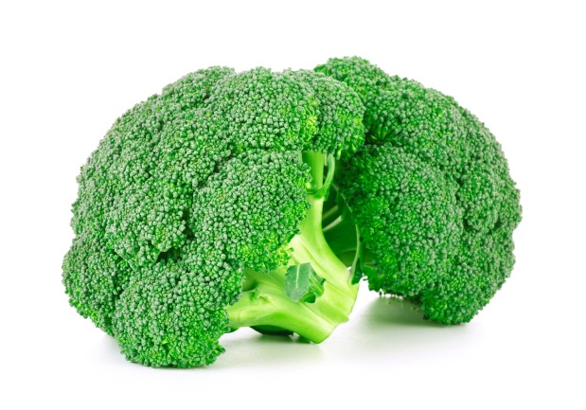 | 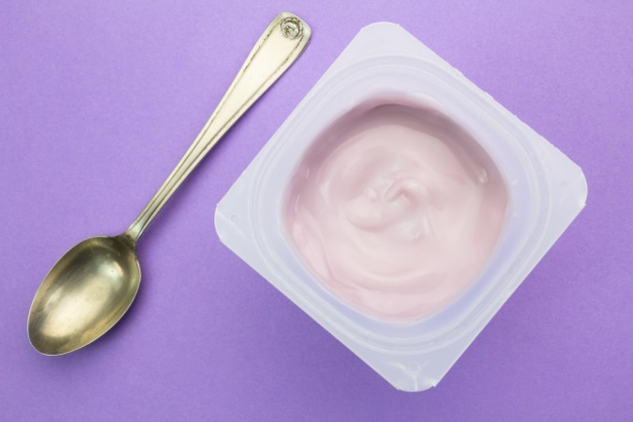 | 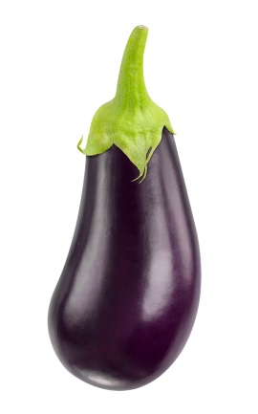
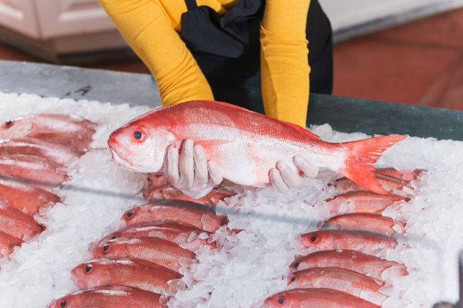 | 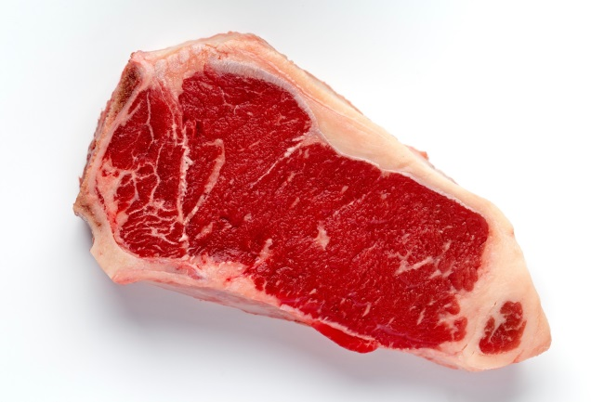 | 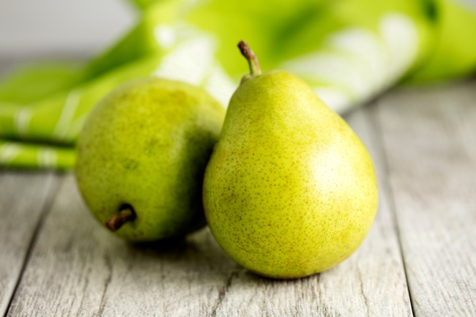
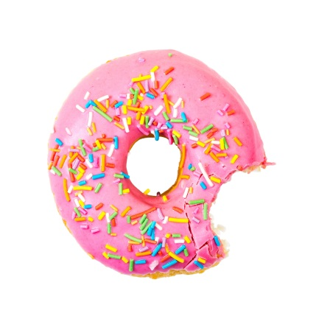 | 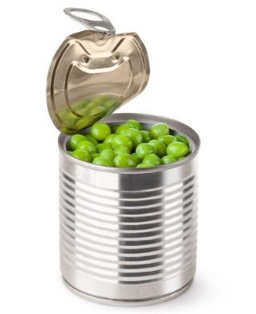 | 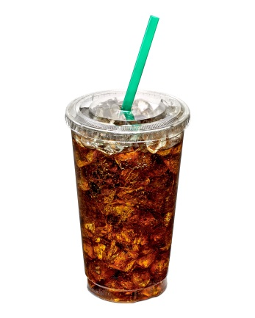
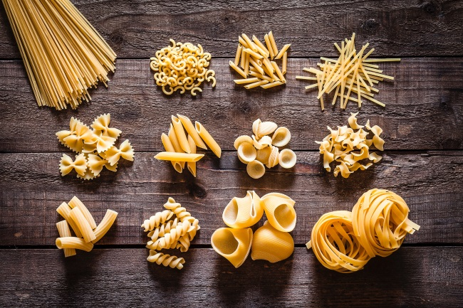 | 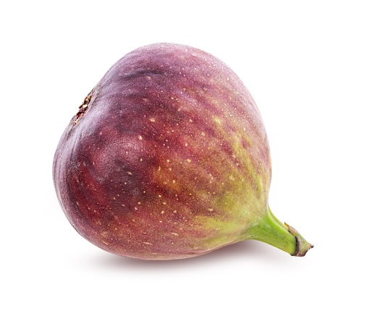 | 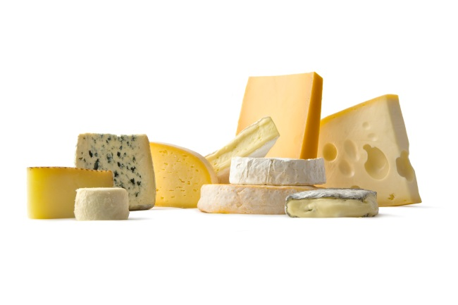
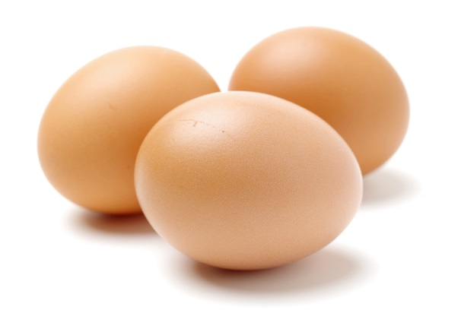 | 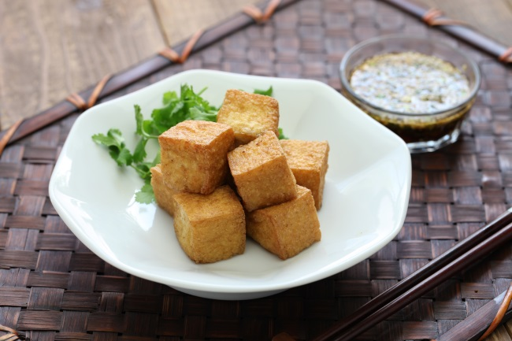 | 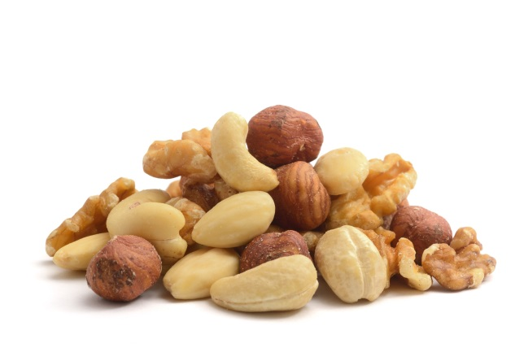
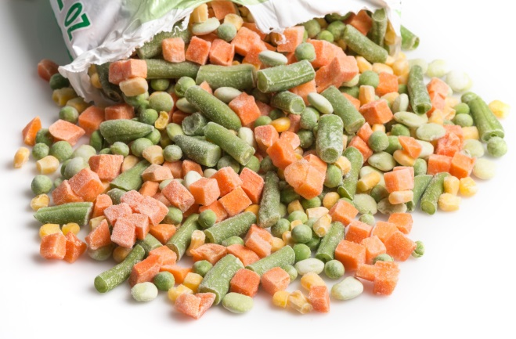 | 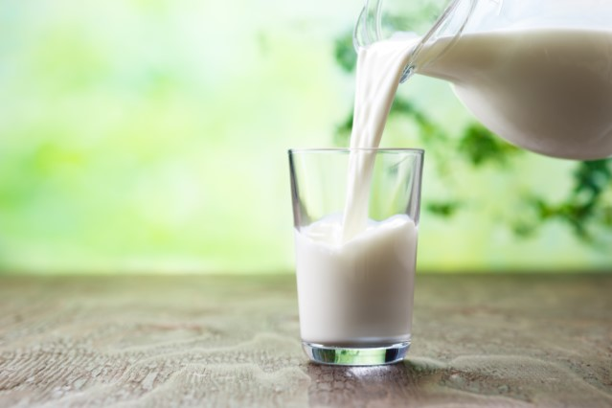 | 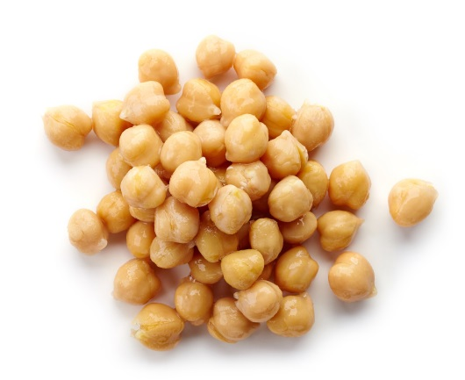

Appendix 2
How much sugar?
Draw a line from each of the drinks to the number of teaspoons
of sugar found in that drink.
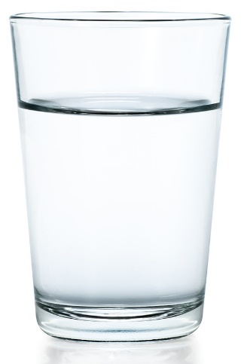  glass of water  (250mL) |  | 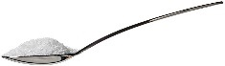  6  teaspoons of sugar
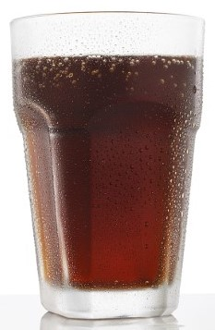  glass of soft drink  (250mL) |  | 0  teaspoons of sugar
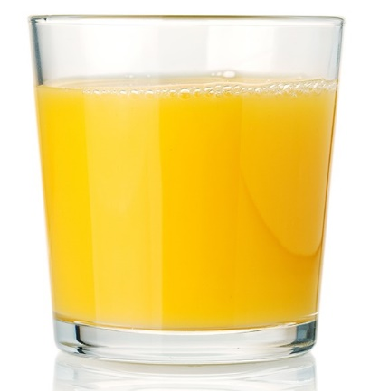  glass of fruit juice  (250mL) |  | 7  teaspoons of sugar

Appendix 3
Teaspoons of sugar

Appendix 4
Recipe for a healthy snack
1. List the ingredients you need.

2. Circle the food groups that
the ingredients belong to.

grains and cereals

vegetables and legumes/beans

lean meat and chicken, eggs, nuts, seeds, tofu, legumes/beans

milk, cheese, yoghurt

fruit
3. Draw what you will do.

4. I can eat this snack every day because …

