Differentiating existing learning sequences for English as an Additional Language students

English, Reading and Viewing mode, Level 2,
for EAL learners at Level A2
Existing learning sequences linked to particular learning areas in the Victorian Curriculum F–10 can be adapted to support differentiated teaching for English as an Additional Language (EAL) students. Teachers can adapt, remove or add to elements of their learning sequences in order to cater for all students in their classrooms.

1. Identify an existing learning sequence
Existing learning sequence: Edward the Emu and Feathers for Phoebe – reading and understanding two different stories
Curriculum area and levels: English, Reading and Viewing mode, Level 2
Note: This learning sequence is designed to be used in conjunction with the accompanying Writing Level 2 sequence. The Reading and Viewing sequence should be completed before the Writing sequence. After reading the stories Edward the Emu by Sheena Knowles and Feathers for Phoebe by Rod Clement, students write and illustrate their responses to each of the texts and compare their opinions with others.

2. Identify the level of language learning of your students
The EAL curriculum is a continuum structured as three EAL pathways (A, B, C). Each pathway describes a different stage of English-language learning (early, mid and late), and each pathway is divided into different levels of language learning (A1, A2, BL, B1, B2, B3, CL, C1, C2, C3, C4).
While the implementation of the EAL curriculum is the responsibility of all teachers, the EAL specialist plays a leading role in its delivery, as the expert in the field. Your EAL specialist will determine the most appropriate pathway for each EAL learner in your classroom and advise you of their current level of learning.
The differentiation suggestions provided in this document are for students working at Level A2 of the EAL curriculum.
EAL learners at Level A2 will typically be able to:
- retell and talk about texts read and viewed in class
- read back their own writing or their own sentences recorded by another
- identify the purpose of a simple story read in class
- share ideas with a trusted peer or teacher.

3. Adapt the learning sequence to differentiate for EAL students
Existing learning sequence | Differentiated teaching for EAL learners at Level A2
Overview | Overview
Learning intentions:  - Students will comprehend two selected stories  - Students will understand the difference between a literal and an implied meaning  - Students will be able to summarise the basic narrative structure of each story | Learning intentions:  - Students will comprehend most of the events in the selected stories  - Students will understand the importance of noticing characters, setting and events  - Students will recall the literal events of the stories  - Students may understand the idea of an implied message
Relevant content descriptions in English, Reading and Viewing mode, Level 2:  Discuss different texts on a similar topic, identifying similarities and differences between the texts (VCELY220)  Use comprehension strategies to build literal and inferred meaning and begin to analyse texts by drawing on growing knowledge of context, language and visual features and print and multimodal text structures (VCELY222) | Additional EAL Level A2 content descriptions:  Understand information in texts read and viewed in class (VCEALC113)  Use knowledge of context, text structure and language to understand literal and inferred meanings (VCEALC114)
Relevant achievement standard:  By the end of Level 2, students understand how similar texts share characteristics … They identify literal and implied meaning, main ideas and supporting detail. Students make connections between texts by comparing content. | Relevant achievement standard:  At Level A2 students read and respond to a wide range of familiar texts … predict, ask questions, retell and talk about texts read and viewed in class. They can read familiar texts with some fluency … They discuss simply the events in texts and characters’ feelings and actions.
Teaching and learning activities | Teaching and learning activities  Differentiated teaching is required to support EAL learners with the following learning activities.
Activity 1: Shared reading  Edward The Emu by Sheena Knowles (illustrated by Rod Clement)  Tell students that you will read Edward The Emu together. After the story you will ask them about the literal meaning – what happened? – and the implied meaning – what was the message?  Read the text, stopping periodically to discuss the characters, setting and events.  Have students work in pairs to identify the author’s message (implied meaning) and share ideas. | Activity 1: Shared reading  Edward The Emu by Sheena Knowles (illustrated by Rod Clement)  Explain the concepts of ‘literal’ and ‘implied’. This can be illustrated by explaining to students that some information is stated in the text and some information is hidden or hinted.  For a physical illustration of inference, stand up and stomp your feet. Then ask your students two questions:  - What did I do? (You stomped your feet.)  - How did I feel? (You felt angry.)  This could be further illustrated by asking students to pretend to cry or laugh, and asking the same two questions. Or you could show the students an image and ask these same questions; for example:  - What is the girl doing? (She is rubbing her face. She is crying. Her eyes are closed.)  - What is she feeling? (She is sad.)  Before reading Edward the Emu, pre-teach or revise essential vocabulary, including ‘emu’, ‘seal’, ‘lion’, ‘snake’, ‘pretend’.  This vocabulary can be pre-taught by acting out each of the animals. Show the students images on a screen or poster and repeat the word ‘pretend’ in your requests, ‘Pretend to be a … Now pretend to be a …’  See Appendix – Vocabulary reference table for a helpful vocabulary table that you can refer to and add to throughout the learning activities. You may need to pre-teach some of this vocabulary to students.  Before reading Edward the Emu, pre-tell a summary of the story, to familiarise students with the text.  Tip: Your goal is to give students the gist of the story so they find it accessible when it is read aloud. They do not need to know every detail, so a simple summary will suffice.  You may use a series of images to help you do this. Suggested words to be supported by images are indicated in bold with a star (*). Some image examples are also provided.  An essential summary of the story, for you to read aloud, has been scripted:  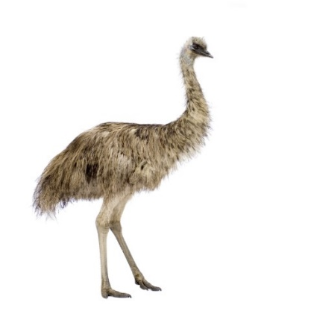  - I’m going to read you a story about an emu(*) called Edward.  - Edward wants to change who he is so he can feel special(*).  - Each day, he tries to be a different animal in the zoo.  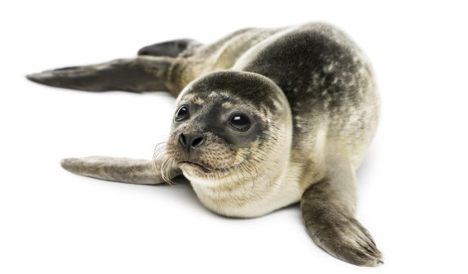  - First, he pretends(*) to be a seal(*).  - Then, he pretends to be a lion(*).  - Then, he pretends to be a snake(*).  - Then, he hears someone say emus are the best, so he becomes an emu(*) again.  - When he tries to return to his enclosure, he makes friends(*) with another emu. He feels special(*).  After reading the story from the book, summarise a simplified message of the story for the students; for example, ‘Edward wants to be special, so he tries to change himself, but he realises that he does not need to change’.  Ensure that students understand this by asking them, as you turn the pages of the book slowly, to say ‘stop’ when there is a page where Edward ‘changes’ or ‘pretends’.
Activity 2: Shared reading  Feathers for Phoebe by Rod Clement  Tell students that you will read Feathers for Phoebe together. After the story you will ask them about the literal meaning – what happened? – and the implied meaning – what was the message?  Read the book, stopping periodically to discuss the characters, setting and events.  Have students work in pairs to identify the author’s message (implied meaning) and share ideas. | Activity 2: Shared reading  Feathers for Phoebe by Rod Clement  Before reading, pre-teach vocabulary. You may like to use an image as a starting point.  - Show students a picture of a bird.  - Elicit single words about the picture from the students; for example, ‘head’, ‘wing’, ‘flying’.  - Scribe these words around the image.  Before reading the story, tell students that this story is similar to Edward the Emu because it is also about someone who wants to change so they can feel special.  As in Activity 1, before reading Feathers for Phoebe, pre-tell a summary of the story you are about to read, to familiarise students with the text. You may hold up a series of images to help you do this. Words that could be supported by images are suggested below, in bold with a star (*).  An essential summary of the story has been scripted for you:  - I’m going to read you a story about a bird(*) called Phoebe.  - Phoebe wants to change who she is so she can be special(*).  - One at a time, Zelda helps Phoebe to change parts of how she looks.  - First, Phoebe changes her crest(*).  - Then, she changes her tail(*).  - Then, she changes her wings(*).  - Then, Phoebe asks Zelda to change her whole body(*).  - But Phoebe still doesn’t feel special.  - She tries to learn a new song(*).  - All dressed up and singing, she falls(*) down and all the decorations fall off.  - Another bird, who looks like her, helps her and is glad she looks like herself again. They become friends(*).  After reading the story from the book, summarise a simplified message of the story for the students; for example, ‘Phoebe wants to be special, so she changes the way she looks, but she realises she does not need to change’.  Ensure that students understand the story by asking them to point to the parts of their own bodies that Phoebe tries to change. For example, students may touch their heads to show ‘crest’ or their arms to show ‘wings’.
Activity 3: Story skeletons  Students work with turn-and-talk partners to verbally complete a ‘story skeleton’ for each of the texts, one at a time.  The skeleton structure is:  Somebody wanted  But ___________  So ___________  Then __________  At the end ___________  For example: Edward wants … but … so … then … at the end …  Select students to share.  For example: Phoebe wants … but … so … then … at the end …  Select students to share. | Activity 3: Story skeletons  On the board, model in written form and verbally the first steps to complete the ‘story skeleton’, before students break into turn-and-talk-pairs. Encourage chorusing or repeating from students. Clarify by asking questions. For example:  Teacher: ‘Somebody.’  Students: ‘Somebody.’  Teacher: ‘Who is this story about?’  Students: ‘Edward.’  Teacher: ‘Yes, Edward wants …’

Additional resources
You can access the EAL curriculum on the Victorian Curriculum F–10 website.
You can access a range of resources to assist with implementing the EAL curriculum on the VCAA English as an Additional Language webpage, including profiles of EAL learners, sample progressions through the EAL pathways, a language and learning interview, FAQs, professional learning opportunities and links to external resources.

Appendix – Vocabulary reference table
Content-specific vocabulary | Linguistic-specific vocabulary  (verbs of instruction) | Language for interaction | Language for clarification
story  narrative  literal  implied  message  author  illustrator  illustration  pictures  events  characters  change  pretend  ideas  setting  structure | Say …  Tell …  Finish this sentence …  Work with a partner to … | Before we read …  Now, I want you to listen for …  Did anyone hear which animal …?  Turn to your partner … | Can you repeat that, please?  What was the step again?  Is this what a snake does?

