Differentiating existing learning sequences for English as an Additional Language students

Dance, Levels 3 and 4, for EAL learners at Level B2
Existing learning sequences linked to particular learning areas in the Victorian Curriculum F–10 can be adapted to support differentiated teaching for English as an Additional Language (EAL) students. Teachers can adapt, remove or add to elements of their learning sequences in order to cater for all students in their classrooms.

1. Identify an existing learning sequence
Existing learning sequence: Learning and performing a choreographed dance routine
Curriculum area and levels: Dance, Levels 3 and 4

2. Identify the level of language learning of your students
The EAL curriculum is a continuum structured as three EAL pathways (A, B, C). Each pathway describes a different stage of English-language learning (early, mid and late), and each pathway is divided into different levels of language learning (A1, A2, BL, B1, B2, B3, CL, C1, C2, C3, C4).
While the implementation of the EAL curriculum is the responsibility of all teachers, the EAL specialist plays a leading role in its delivery, as the expert in the field. Your EAL specialist will determine the most appropriate pathway for each EAL learner in your classroom and advise you of their current level of learning.
The differentiation suggestions provided in this document are for students working at Level B2 of the EAL curriculum.
EAL learners at Level B2 will typically be able to:
- understand short, verbal instructions accompanied by visual supports
- model their work from the examples of a teacher and/or peers
- ask for assistance if they need clarification.

3. Adapt the learning sequence to differentiate for EAL students
Existing learning sequence | Differentiated teaching for EAL learners at Level B2
Overview | Overview
Learning intentions:  - Students will perform choreographed dance moves safely  - Students will practise body actions and skills  - Students will respond accurately to teacher instructions and directions | Learning intentions:  - Students will learn the vocabulary of a warm-up activity  - Students will demonstrate listening skills by responding accurately to teacher instructions and directions  - Students will perform choreographed dance moves safely  - Students will practise body actions and skills
Relevant content descriptions in Dance, Levels 3 and 4:  Improvise and structure movement ideas for dance sequences using safe dance practice, the elements of dance and choreographic devices (VCADAE025)  Use choreographic devices to organise dance sequences, and practise body actions and technical skills (VCADAD026) | Additional EAL Level B2 content descriptions:  Identify key points of information in short spoken texts (VCEALC326)  Respond to a short sequence of instructions in a familiar context (VCEALL340)  Participate appropriately in social and learning situations (VCEALA329)
Relevant achievement standard:  By the end of Level 4, students structure movements into dance sequences … They make dances and perform safely with control, accuracy, projection and focus. | Relevant achievement standard:  At Level B2 students communicate and learn English in predictable social and learning situations, understanding some de-contextualised English … They negotiate simple transactions … They understand instructions … when supported by clear contexts…

Existing learning sequence | Differentiated teaching for EAL learners at Level B2
Teaching and learning activities | Teaching and learning activities  Differentiated teaching is required to support EAL learners with the following learning activities.
Activity 1: Warm-up  Conduct the ‘Bean game’ activity to enable students to warm up and prepare their bodies and minds for their dance. As students jog or walk around the room, call out types of beans; for example, green bean, jumping bean, Mr Bean, broad bean, jelly bean, beans on toast, chilli bean … Encourage students to react by creating different shapes, movements or stretches to represent the types of beans named. | Activity 1: Warm-up  Before beginning the game, use a series of flashcards or posters to pre-teach students the key words from Appendix 1 – Vocabulary reference table and actions for the ‘Bean game’. (Note that you can refer to and add to the Vocabulary reference table throughout the learning activities.) Some sample images are provided.  Each flashcard presents an image of a different type of bean. Elicit from the class the different ways to ‘act out’ that type of bean. For each action:  - Name the action or type of bean.  - Repeat the name, while doing the action.  - Ask a student to copy the action, while repeating the name.  - Have all students copy the action in unison, while saying the type of bean aloud.  Green bean – hands above head, on tiptoes, stretch high to make your body very narrow and tall.  Jumping bean – jump up and down.  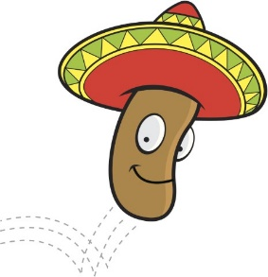  Mr Bean – make a funny face, mimicking the awkward smile of Mr Bean in the television show, and walk very rigidly.  Tip: As Mr Bean is a culturally specific reference, many students, both EAL and non-EAL, may not be familiar with the reference. A short clip, image or demonstration by a student or teacher will help with modelling.  Broad bean – spread arms and feet out on either side while standing up, to make your body very wide.  Jelly bean – wobble as you walk, occasionally falling to the ground.  Beans on toast – fall to the floor and spread arms out wide.  Chilli bean – hop from one foot to another making an ‘ooh aah’ noise.  Tip: When teaching EAL students new vocabulary, a technique called Total Physical Recall (TPR) is very effective. By assigning a physical action to words and repeating them, students are more likely to retain the vocabulary.
Activity 2: Crazy boot scootin’  Introduce students to the concept of line dancing as a form of social dance. One of the benefits of line dancing is that many people can participate in a simple repetitive routine as part of a social gathering without requiring partners. Another benefit of line dancing is that because the dance is performed in a line, participants only need to learn the steps without having to think about moving from the place where they are dancing. Some line dances do require the participants to change direction while remaining in their own personal dance space.  Introduce students to the following four crazy boot scootin’ moves (see Appendix 2 for a description of each move):  - heel and toe shuffle  - lasso gallop  - cowboy jump and march  - gallop on spot with a quarter turn to the left.  Introduce the four moves without turning by allowing students to repeat all four moves facing the front of the room a number of times. | Activity 2: Crazy boot scootin’  To provide cultural context for students who are unfamiliar with line dancing and boot scootin’ traditions, a short video could be played for the class; for example:  - 'Boot Scooting Boogie # Line Dance' video (yvan leonard, YouTube)  - ‘Gloriday Catalan Creations & Lizard Angels - FINALLY TOGETHER - Voghera Country Festival 2019' video (Eros Gloria, YouTube)  Tip: There are many dance traditions, all over the world, similar to line dancing. It would be useful to elicit some examples of dances from different cultures with similar conventions (for example, Polynesian cultural dances or Polish folk dancing).  Pre-teach the concept of ‘counts’ and the key words from the Vocabulary reference table (Appendix 1) for ‘16 counts’ and ‘four counts’. Do this by modelling a complete dance sequence, while counting. You can also use hand gestures and increase the stress and volume to emphasise ’16 counts’. It’s important that the students are aware of keeping in time, as well as the movements themselves, as they may be unfamiliar with the conventions of this kind of structured dancing.  For each action, follow a specific pattern of instruction and modelling, in a similar way to pre-teaching the ‘Bean game’ warm-up. See Appendix 2 for a description of each move.  - Name the dance move; for example, ‘Heel and toe shuffle’.  - Model the dance move, repeating its name.  - Slow down the dance move into its parts, counting and naming each part as you model it.  - Have an individual student model the dance move, as you count and name each part.  - Have all students stand behind you and repeat the name of the dance move, count the steps and attempt the movement.  Tip: After modelling each step, give the students a couple of minutes to confer or teach one another. This is a good opportunity for students who share the same home language to clarify instructions for one another, or for peers to help each other. You can encourage this and scaffold by providing suggested exchanges. For example:  Have you got it? Do you want me to help?  Can you show me that step again?  Tip: It is important for teachers to include opportunities for plurilingualism in their classrooms; teachers should encourage EAL students to use their home languages, as well as English. Using their home languages for clarification and refining ideas helps EAL students to both negotiate new concepts and develop their confidence with language.
Activity 3: Dance sequence  When the students are confident to perform each move, start to teach the dance sequence:  - complete the four moves  - quarter turn to the left  - repeat the four moves  - quarter turn to the left  - repeat until the routine has been performed facing all four walls of the room.  These 16 sets of steps and three turns equal ‘one full rotation of the dance’. | Activity 3: Dance sequence  Pre-teach the vocabulary of a quarter turn by using gestures to point to and count the four walls of the room. Name each wall ‘1’, ‘2’, ‘3’, ‘4’, then indicate that each turn is a quarter of the space. Repeat and emphasise the word ‘quarter’ and ‘quarter turn’ by modelling the turn and pointing to each of the walls as you turn. This may also be illustrated by providing a diagram or image (see example in Appendix 3).

Additional resources
You can access the EAL curriculum on the Victorian Curriculum F–10 website.
You can access a range of resources to assist with implementing the EAL curriculum on the VCAA English as an Additional Language webpage, including profiles of EAL learners, sample progressions through the EAL pathways, a language and learning interview, FAQs, professional learning opportunities and links to external resources.

Appendices

Appendix 1 – Vocabulary reference table
Content-specific vocabulary | Linguistic-specific vocabulary  (verbs of instruction) | Language for interaction | Language for clarification
country and western dancing  line dancing  boot scootin’  heel and toe shuffle  cowboy  cowboy hat  braces  lasso  jump  march  gallop  turn  quarter turn  repeat  rotation  green bean  jumping bean  Mr Bean  broad bean  jelly bean  beans on toast  baked bean  chilli bean  jumping jack  16 counts  four counts | Turn …  Face …  Stand …  Sit …  Step to the _____  Jump …  March …  Gallop …  Watch …  Follow my lead.  Step to the right/left.  Take two steps.  Make a ______  Gallop to the left/right.  Gallop on the spot. | Watch me.  Now, stand up and try.  Try to copy …  Count with me.  How many counts?  Our next move is … | Is this what you/they mean?  Is this right?  Can you show me?  What was the step again?

Appendix 2: Crazy boot scootin’ moves
Step | Description | Arm/body movements | Total counts
Heel and toe shuffle | Perform heel and toe × 2 with right foot, take 2 steps to the right = 8 counts  Perform heel and toe × 2 with left foot, take 2 steps to the left = 8 counts | Hands hold onto pretend braces. | 16
Lasso gallop | Gallop to the right = 8 counts  Gallop to the left = 8 counts | Right arm moves like a lasso.  Left arm moves like a lasso. | 16
Cowboy jump and march | Jumping jack × 2, March on spot × 4 = 8 counts  Jumping jack × 2, March on spot × 4 = 8 counts | Arms on hips during Jumping jacks and swing in opposition to legs during march. | 16
Gallop on spot with quarter turn | Gallop on the spot = 8 counts  Gallop while completing a quarter turn to the left = 8 counts | Wave cowboy hat above head. | 16
Repeat all × 4: One full rotation of the dance includes performing the routine facing each of the four walls of the room.

Appendix 3: Quarter turn diagram
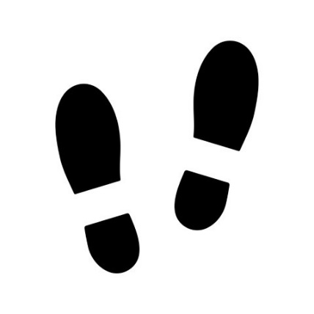
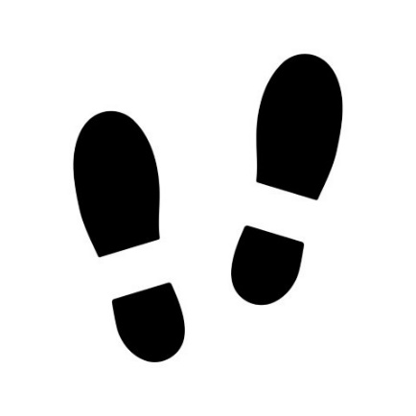
1
2

4
3

