Differentiating existing learning sequences for English as an Additional Language students

Media Arts, Levels 7 and 8, for EAL learners at Level CL
Existing learning sequences linked to particular learning areas in the Victorian Curriculum F–10 can be adapted to support differentiated teaching for English as an Additional Language (EAL) students. Teachers can adapt, remove or add to elements of their learning sequences in order to cater for all students in their classrooms.

1. Identify an existing learning sequence
Existing learning sequence: Analysing documentaries
Curriculum area and levels: Media Arts, Levels 7 and 8

2. Identify the level of language learning of your students
The EAL curriculum is a continuum structured as three EAL pathways (A, B, C). Each pathway describes a different stage of English-language learning (early, mid and late), and each pathway is divided into different levels of language learning (A1, A2, BL, B1, B2, B3, CL, C1, C2, C3, C4).
While the implementation of the EAL curriculum is the responsibility of all teachers, the EAL specialist plays a leading role in its delivery, as the expert in the field. Your EAL specialist will determine the most appropriate pathway for each EAL learner in your classroom and advise you of their current level of learning.
The differentiation suggestions provided in this document are for students working at Level CL of the EAL curriculum.
EAL learners at Level CL will typically be able to:
- communicate simply but effectively in English
- use short, simple and well-rehearsed language
- complete simple, structured activities
- employ strategies such as pointing to words to support reading.

3. Adapt the learning sequence to differentiate for EAL students
Existing learning sequence | Differentiated teaching for EAL learners at Level CL
Overview | Overview
Learning intentions:  - Students will understand the purpose of documentary films and recognise how these films convey a message for their audience  - Students will identify features filmmakers use to illustrate their message in documentary filmmaking  - Students will understand the topic for their documentary through independent inquiry research | Learning intentions:  - Students will understand that documentary films have a message for their audience  - Students will understand what subject matter may be best communicated through documentary films  - Students will record notes that document their research about an assigned topic
Relevant content descriptions in Media Arts, Levels 7 and 8:  Experiment with the organisation of ideas to structure stories through settings, genre conventions and viewpoints, in images, sounds and text (VCAMAE033)  Develop media representations to show familiar or shared social and cultural values and beliefs (VCAMAE034)  Identify specific features and purposes of media artworks from contemporary and past times, including media artworks of Aboriginal and Torres Strait Islander Peoples, to explore viewpoints and enrich their media arts making (VCAMAR039) | Additional EAL Level CL content descriptions:  Interact simply with peers in group work activities (VCEALC485)  Distinguish spoken English from other languages and attempt to respond in English (VCEALA490)  Use basic verb forms in context (VCEALL497)  Use a range of vocabulary from lexical sets related to immediate need, interest or learning (VCEALL500)
Relevant achievement standard:  By the end of Level 8, students identify and analyse how representations of social values and viewpoints are portrayed in the media artworks they make, distribute and view.  Students use intent, structure, setting, characters and genre conventions to shape technical and symbolic elements for specific purposes and meanings.  Students produce representations of social values and viewpoints in media artworks for particular audiences. | Relevant achievement standard:  At Level CL students communicate simply but effectively in English … They communicate using formulaic language; short, simple and well-rehearsed grammatical features …  At Level CL students read and complete simple, structured activities around a wide range of familiar, short, simple texts that … are strongly supported by illustrations.  They use simple strategies such as pointing to words as they read or as shared texts are read aloud in class

Existing learning sequence | Differentiated teaching for EAL learners at Level CL
Teaching and learning activities | Teaching and learning activities  Differentiated teaching is required to support EAL learners with the following learning activities.
This learning sequence follows lessons introducing students to documentary-style filmmaking. Students will already be familiar with the documentary genre and understand they will be researching content for, and producing, their own short documentaries.
Activity 1: Farm to fork videos  Introduce the concept of ‘farm to fork’ through online video resources. Discuss the concept and how it differs from more traditional food processes in Australia. | Activity 1: Farm to fork videos  Tip: Though EAL students may comprehend the literal meaning of words ‘farm’ and ‘fork’, they may not have the cultural capital to understand what the ‘farm to fork movement’ is. Depending on an EAL student’s country of origin, a ‘movement’ encouraging ‘farm to fork’ values may be confusing. In some countries, food may already commonly be purchased from farms. In other countries, purchasing directly from a farm may be improbable.  Before presenting video resources in class, provide EAL students with more detailed information about the farm to fork movement, noting that ‘farm to fork’ and ‘farm to table’ have the same meaning. Students working at Level CL will benefit from exposure to resources in advance, such as:  - a handout with simple explanations and images, provided the week before they begin the unit. A diagram that simply explains the elements of the farm to fork movement would be useful too; for example, see the Farm to Fork diagram on the European Commission’s Food Safety page. EAL students could be given this diagram in advance and asked to translate the vocabulary and terminology.  - a list of short videos to view, before watching them in class:  - From farm to fork - sustainable food for our future (EU Food & Farming, YouTube)  - Farm To Fork Animated Explainer Video (Tivoli Films Inc., YouTube)  - From Food Waste To Farm To Fork: An Animation By Natural World Products (MyNI Life, YouTube)  - Crunchy Carrots: from farm to fork (Eat Happy Project, YouTube)  (although titled ‘Farm to Fork’, this video is about the traditional food distribution chain, so it is helpful for background information)  - Farm-to-Table: Animated Story w/Chef Bobo (calhounschool, YouTube)  When viewing the videos, always ensure English subtitles are switched on, if available.  - a list of essential vocabulary, accompanied by images, that students will need to research and learn in order to understand the topic. Suggested essential vocabulary includes ‘farm to fork movement’, ‘slow food movement’, ‘social movement’, ‘society’, ‘community’, ‘sustainable’, ‘processing’, ‘production’, ‘consumption’, ‘prevention’.  - picture books that address similar ideas to those that will be studied, for example:  - Martin, H, Simpson, J 2016 The ABC Kids Book of Food  - Bone, E 2017 It all starts with a seed … how food grows  - French, V 1995 Oliver's Vegetables  - Wild, M 2018 The Sloth Who Slowed Us Down  See Appendix 1 – Vocabulary reference table for a helpful vocabulary table that you can refer to and add to throughout the learning activities. You may need to pre-teach some of this vocabulary to students.  EAL students will need the concept of the farm to fork movement to be unpacked carefully. These steps will be useful for explaining the concept to EAL students:  - Provide students with an anchor sentence: a simple one- to two-sentence explanation of the farm to fork movement. This should be a simple explanation that students can translate in their own time and return to if they feel confused over the course of the unit. For example:  The farm to fork movement: When a community of people want the journey from farming food to eating food to be sustainable.  - The explanation will need to be supported with visuals. Showing a pair of images, with minor distinctions in the second image, can be helpful for students. For example, refer to the flow chart provided on the Queensland Government’s Safe Food page.  You can make it clear that this diagram shows the usual method for getting food, then add an arrow directly from the farm to the plate, to communicate that the farm to fork movement is distinct; it aims to make the journey between farm and plate shorter, simpler and more sustainable.  Tip: Students at Level CL may find it easier to express their understanding by pointing or gesturing. You could clarify students’ understanding of the farm to fork concept by asking them to ‘point to the part of the diagram that shows farm to fork’ or ‘point to where transport takes place’ to confirm their comprehension.  - Model a concept attainment table (template provided in Appendix 3) on the board and then discuss it as a whole class, to help EAL students solidify their understanding of unfamiliar concepts. For example:  Concept attainment: Farm to fork movement  Example – YES Non-example – NO  Buying from local stores Buying from supermarket chains  Getting food directly from producers Getting food that has been packaged in a factory  Eating locally grown vegetables Eating vegetables shipped from overseas
Activity 2: Discussing documentaries  As a class, discuss the ideas represented in the videos and the purpose of the videos. Discuss how the short films are structured to communicate a message to a specific audience. Discuss the characteristics of audience types who would watch the farm to fork videos. | Activity 2: Discussing documentaries  After viewing the videos, guide discussion by putting three questions on the board. These three questions could also be provided to EAL students in advance, to offer them an opportunity to more fully participate in discussion.  - Who would watch these videos? (audience)  - What is the message of these videos? (purpose)  - What parts of the videos communicate this message? (structure)  Tip: Students at Level CL are likely to respond to questions using single words or phrases. Students can be encouraged to expand on their ideas and answer in complete sentences, by having teachers scaffold classroom discussion with short scripts, modelled verbally and supported on the whiteboard. For example, a teacher may instruct students:  Okay everyone, who do you think would be watching these videos? Can someone answer like this: ‘The target audience is ______’  Alternatively, teachers may encourage individual EAL students to recast their answers. (Recasting refers to repeating a sentence, adopting corrections.) For example:  Teacher: ‘Okay, who is the audience?’  Student: ‘Young people.’  Teacher: ‘Yes, correct. Try for me: The target audience is ________’  Student: ‘The target audience is young people.’  To encourage EAL students to contribute to whole class discussions, scaffold discussion by beginning with Think, Pair, Write, Share time for students to speak with a trusted partner and take some brief notes they can then refer to in class discussion.
Activity 3: Examining the supply chain  Students choose a food and research its supply chain. Using the farm to fork videos as inspiration, students work out the sequence or process for their chosen food. Prompt students with the following questions:  - What is the food you have chosen?  - Where is it grown?  - How is it harvested or picked?  - How is transported from the farm for processing?  - What steps are used in the processing?  - Is the food packaged?  - Where is it sold?  - How does it get to where it is sold?  - How is it prepared and cooked?  - What types of dishes is it eaten in? | Activity 3: Examining the supply chain  Provide EAL students with a detailed graphic organiser (see Appendix 2) that scaffolds the research task and includes:  - research topic  - research questions (prompts)  - sentence stems and frames to assist in taking notes  - illustrations to clarify concepts  - room for notes in the student’s home language  - space for vocabulary lists.  Tip: If possible, print the graphic organiser on A3 paper, to give students plenty of space to complete their responses,  Students at Level CL are likely to need further clarification of questions, as they complete the research task. Approach them intermittently to check their understanding.  Tip: Students at Level CL may be reluctant to ask for help or may need more language to be able to express the difficulties they are having. Assist EAL learners by:  - asking ‘What are you finding difficult?’ or ‘Which part would you like me to explain?’ instead of ‘Are you okay?’ or ‘Do you understand?’ These latter questions can be answered with a ‘yes’ or ‘no’ and EAL learners may not ask for the help they require.  - examining the task and predicting where EAL students may become confused. For example, the question ‘What types of dishes is it eaten in?’ is likely to need clarification; ‘dishes’ refers to recipes or menu items, but students may answer ‘bowl’ or ‘cup’ to this question.

Additional resources
You can access the EAL curriculum on the Victorian Curriculum F–10 website.
You can access a range of resources to assist with implementing the EAL curriculum on the VCAA English as an Additional Language webpage, including profiles of EAL learners, sample progressions through the EAL pathways, a language and learning interview, FAQs, professional learning opportunities and links to external resources.

Appendices

Appendix 1 – Vocabulary reference table
Content-specific vocabulary | Linguistic-specific vocabulary  (verbs of instruction) | Language for interaction | Language for clarification
farm to fork movement  slow food movement  social movement  society  community  sustainable  sustainability  values  processing  production  consumption  prevention  cycle  source | Pre-watch …  Read …  Listen …  Take notes on this sheet.  Answer this question.  Use this phrase to begin …  Look at this diagram …  Look at this (pointing).  Point to the …  Tell me which part …  Show me where … | First …  Then …  Now …  I think …  What do you think?  Your turn.  What did you write?  I wrote …  What part is difficult for you? | Help, please.  I don’t understand.  I see.  Is this the word?  Is this it?  I tried this answer, but I’m not sure …  Can you check this?

Appendix 2: Graphic organiser for research task

Research topic (Which food are you researching?): I am researching …
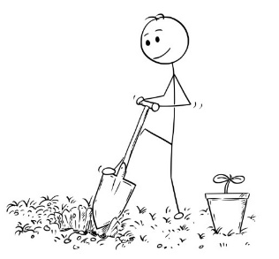  Where is it grown? | 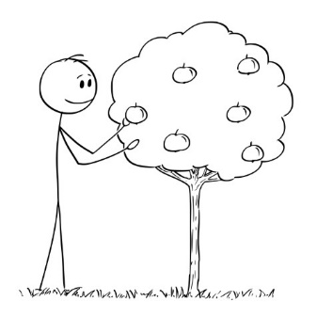  How is it harvested or picked? | 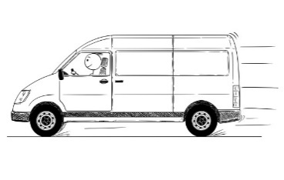  How is it transported from the farm for processing? | 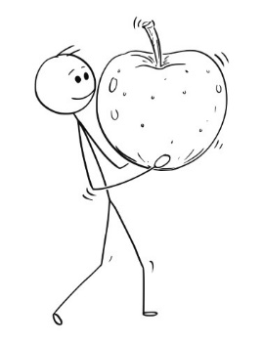  How is it processed?
It is grown in/on/at _________ | It is harvested by __________ | It is transported from the farm by _____________________ | First, ____________________  Then, ___________________  And then, ________________  Finally, __________________

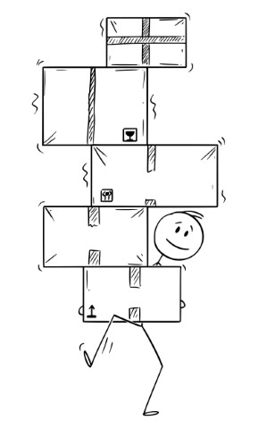  How is it packaged? | 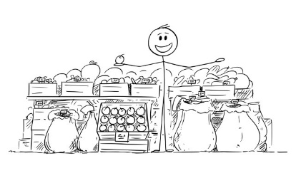  Where is it sold? | How is it prepared and cooked? | What types of dishes is it eaten in?
It is/is not packaged.  It is packaged in ___________  It is packaged at ___________ | It is sold at _______________ | It is prepared by ___________  It is usually cooked in/on/by __  It is sometimes cooked in/on/by __________________ | It is usually served in/with/on ________________  It is often made into ________  ________________________

Vocabulary I need to learn (English) | Vocabulary I need to learn (translation)

Questions I need to ask my teacher or peers:

Appendix 3: Concept attainment table
Example – YES | Non-example – NO

