Differentiating existing learning sequences for English as an Additional Language students

Science and Design and Technologies, Levels 3 and 4, for EAL learners at Level BL
Existing learning sequences linked to particular learning areas in the Victorian Curriculum F–10 can be adapted to support differentiated teaching for English as an Additional Language (EAL) students. Teachers can adapt, remove or add to elements of their learning sequences in order to cater for all students in their classrooms.

1. Identify an existing learning sequence
Existing learning sequence: Life cycles and environments of native Australian animals
Curriculum area and levels: Science and Design and Technologies, Levels 3 and 4

2. Identify the level of language learning of your students
The EAL curriculum is a continuum structured as three EAL pathways (A, B, C). Each pathway describes a different stage of English-language learning (early, mid and late), and each pathway is divided into different levels of language learning (A1, A2, BL, B1, B2, B3, CL, C1, C2, C3, C4).
While the implementation of the EAL curriculum is the responsibility of all teachers, the EAL specialist plays a leading role in its delivery, as the expert in the field. Your EAL specialist will determine the most appropriate pathway for each EAL learner in your classroom and advise you of their current level of learning.
The differentiation suggestions provided in this document are for students working at Level BL of the EAL curriculum.
EAL learners at Level BL will typically be able to:
- communicate in basic English, using simple combinations of one, two or three words
- recognise some of the letter–sound relationships in English
- read some familiar words and phrases
- copy words and phrases
- form some letters and place text appropriately.

3. Adapt the learning sequence to differentiate for EAL students
Existing learning sequence | Differentiated teaching for EAL learners at Level BL
Overview | Overview
Learning intentions:  - Students will understand the life cycles of different animals, including mammals and birds  - Students will understand the nesting sites of different animals  - Students will understand how loss of environments and nesting sites can affect Australian animals  - Students will understand ways humans can help animals to thrive | Learning intentions:  - Students will understand the life cycles of different animals, including mammals and birds  - Students will understand the nesting sites of different animals  - Students will understand how loss of environments can affect Australian animals  - Students will understand ways humans can help animals  Language focus:  - Students will learn the names of some Australian animals and vocabulary to describe them  - Students will be able to use some simple words for negation (‘no’, ‘not’)  - Students will write simple sentences using ‘have’
Relevant content description in Science, Levels 3 and 4:  Different living things have different life cycles and depend on each other and the environment to survive (VCSSU058)  Relevant content description in Design and Technologies, Levels 3 and 4:  Critique needs or opportunities for designing and explore and test a variety of materials, components, tools and equipment and the techniques needed to create designed solutions (VCDSCD028) | Additional EAL Level BL content descriptions:  Identify basic items of information in short spoken texts (VCEALC167)  Construct two- or three-word utterances, with the support of actions, gestures or visuals (VCEALL173)  Use a small range of learnt word patterns for appropriate purposes (VCEALL175)  Acquire information from simple images, with teacher direction and support (VCEALC186)  Understand some familiar words in different contexts (VCEALC185)  Write sentences that may not follow standard word order (VCEALL230)  Use drawings, symbols, strings of letters and some words in own written work (VCEALC214)  Copy words, phrases or sentences accurately and carefully (VCEALC216)  Write some familiar words and complete simple, repetitive modelled sentences in writing (VCEALC217)
Relevant achievement standard:  Science  Students … describe relationships that assist the survival of living things. They … relate life cycles to growth and survival.  Design and Technologies  Students … explain needs or opportunities and evaluate ideas and designed solutions against identified criteria for success, including sustainability considerations. | Relevant achievement standard:  At Level BL students communicate simply … They learn through English that is well supported by context … [and] use simple English to respond to the ideas of others. Students’ oral expression in English is characterised by short utterances… [and] repetitive grammar patterns … They show beginning understanding of the letter–sound relationships of English. They read some familiar words and phrases in context, and recognise, name and know the sounds related to all letters and some common letter groups … They model their writing on shared writing activities and published texts, and use some basic strategies, such as copying words or phrases from lists, using images and asking how to write a word. They begin to form letters and place text appropriately.

Existing learning sequence | Differentiated teaching for EAL learners at Level BL
Teaching and learning activities | Teaching and learning activities  Differentiated teaching is required to support EAL learners with the following learning activities.  Students at Level BL have very simple spoken or written English. As much as possible, carefully choose a limited vocabulary and incorporate visuals throughout the lesson to demonstrate concepts and new words. Also encourage students to create their own pictures or to use actions and gestures when giving responses. Encourage the use of bilingual dictionaries and sharing with home language peers. EAL learners at Level BL may understand the concepts being taught, despite not having the vocabulary to demonstrate their understanding.  Remember that at Level BL, EAL learners are not expected to be able to complete the tasks set for other students in the class. Simple but purposeful tasks – such as labelling diagrams, drawing pictures, copying words and sentences, and substituting single words to make new sentences – are appropriate at this level. Keep in mind that while an EAL learner may not know the English words and phrases to demonstrate their understanding, they may still have knowledge of the concepts you are teaching and, as such, they can gain further understanding through being actively involved in lessons with their peers.
Activity 1: Introducing the life cycle  Preparation: Put a nesting box on display at the front of the room. Do not explain what it is, but allow its presence to encourage curiosity among students.  Begin by asking students how animals begin their lives, diagnosing their current understanding of life cycles. Document their ideas either on a whiteboard or in a class journal (for example, in a hard-copy class journal or in a class blog using software such as Global2 or Padlet). | Activity 1: Introducing the life cycle  Preparation: Put a nesting box on display at the front of the room. Do not explain what it is, but allow its presence to encourage curiosity among students.  Tip: Provide relevant visuals (such as photographs, sketches, graphic organisers, diagrams, videos, 3D models and/or real objects) to set the context at the beginning of the lesson. This can help EAL learners make sense of what is being taught in the curriculum and connect to previous experiences and knowledge.  Set the context: Display examples of the life cycles of some native animals, such as an Australian magpie and a kangaroo.  Ask students to predict:  What are we going to talk about today?
Introduce the term ‘life cycle’ and discuss with students what it might mean, discussing ‘life’ and ‘cycle’ separately as needed. | Introduce new vocabulary (in context): Refer to the images to introduce the term ‘life cycle’ and discuss with students what it might mean. Discuss ‘life’ and ‘cycle’ separately as needed. Demonstrate with visuals. Use the word ‘again’ and ‘again’ and ‘again’ while pointing around the cycle to emphasise that it is a continual process.  See Appendix 1 – Vocabulary reference table for a helpful vocabulary table that you can refer to and add to throughout the learning activities. You may need to pre-teach some of this vocabulary to students.
Provide students with examples of different life cycles of native animals, including mammals, birds and fish. Discuss the progression and stages they can see. | Demonstration or modelling: Show students simple diagrams of the life cycles of native animals, such as the Australian magpie and kangaroo, from earlier in the lesson. Choose one animal that produces eggs, and one that gives birth to live young.  Use the diagrams to introduce new words, including ‘egg’, ‘live young’, ‘baby’, ‘young’ and ‘adult’. Students will use these words to label their own life cycle diagrams later in the lesson.  Point at each image in the diagrams. Say each new word and encourage students to repeat the word in unison.  Write the word next to each step of the life cycle for students’ reference. For example:  - egg > baby magpie > young magpie > adult magpie  - baby kangaroo > young kangaroo > adult kangaroo.  Tip: When choosing key vocabulary to teach to EAL learners at Level BL, select words that are useful to the broader context and can be used more generally, such as ‘baby’, ‘young’ and ‘adult’, rather than technical words that are specific to the topic, such as ‘embryo’, ‘hatchling’ and ‘joey’. This will give students more opportunities to use these new words outside of the classroom, which is important at this level of language development, before developing technical and academic vocabulary.  Guided practice: Using the templates below, have students draw a picture in each box and label their own life cycle diagrams by copying the words from the board.  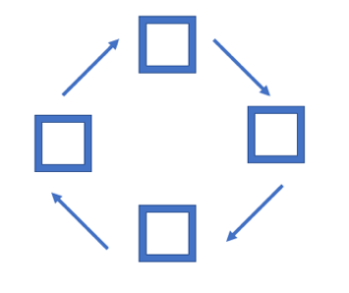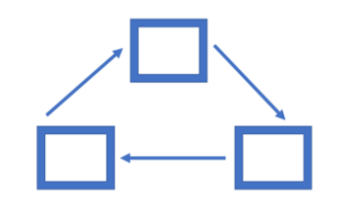  Independent practice: Provide students with examples of the life cycles of two native animals (one that produces eggs and one that gives birth to live young). Have students place the images in the correct order and label them by substituting the name of a new animal. For example, substitute ‘baby parrot’ for ‘baby magpie’ and ‘young parrot’ for ‘young magpie’.  Feedback: Display the correct answers on the board. Use this to give students the opportunity to practise new vocabulary. Point at each of the images. Say each word and encourage students to repeat the word in unison. For example: ‘egg’, ‘baby parrot’, ‘young parrot’, ‘adult parrot’.  Tip: Take note of how the Gradual Release Model (Pearson and Gallagher, 1983) is used above to scaffold activities for EAL learners, even for simple tasks.  - Set the context using visuals  - Introduce the new vocabulary in context  - Demonstrate the task, provide examples (‘I do’)  - Guided practice (‘We do’)  - Independent practice (‘You do’)  - Feedback  Some EAL learners may not have prior schooling, although others may have extensive schooling – but do not assume that classroom tasks (such as matching or labelling) are common in education systems in other countries. Demonstrate each task clearly, with actions and examples.
Identify similarities and differences. | Identify similarities and differences: Provide the students with visual examples of five native animals, including mammals, birds and fish. Say:  These animals are from Australia. They are native Australian animals.  Have students use Appendix 2 to predict which native animals produce eggs and which give birth to live young. Demonstrate the task using the two animals from the previous activity.  Have students compare answers with a partner. It would be helpful for an EAL student at Level BL to be paired with a peer who speaks the same home language, if possible.  Check answers by providing visuals on the board (for example, a baby parrot hatching from an egg).  Tip: When forming small groups to complete activities, be aware of the language requirements of the task and place EAL learners where they will receive the most support. It is particularly helpful for EAL learners on the Level BL pathway to be paired with a student at Level B1 or B2 so one can assist the other.
Activity 2: The nesting hollow  Ask students what they think an animal would need to support its young and introduce the idea of a nesting hollow. Explain to students that nesting hollows form naturally over time, taking up to 100 years to form. Show students examples of nesting hollows for different species and discuss the key features of each.  Ensure students understand the key point that many Australian animals (300 or more species) depend on nesting hollows for shelter and breeding, and that this is a key relationship in their life cycles. | Activity 2: The nesting hollow  Preparation: Keep the nesting box on display at the front of the room. Do not explain what it is, but allow its presence to encourage curiosity among students.  Set the context: Display images of the nests and nesting hollows of different animals and birds. Ask students to predict:  What are we going to talk about today?  Introduce new vocabulary (in context): Keep the images on the board and introduce the terms ‘nest’ and ‘nesting hollow’. Discuss with students what they might mean. Point at the images of nests and repeat the word ‘nest’ with each nest that is identified. Encourage students to repeat the word in unison. Repeat for ‘nesting hollow’. Use the hollow of your hand to demonstrate the meaning of the word ‘hollow’.  Tip: To create an inclusive classroom environment that instils a sense of belonging for all students, try to include visuals that encompass experiences and knowledge that are relevant to EAL learners in your classroom. For example, when selecting homes to display for this next task, you may be able to include homes or natural environments from the cultural backgrounds of your EAL learners.  Introduction: Display images of a nesting hollow next to three different kinds of houses on the board. Ask the students:  Why do we need a house? Why do we need a home?  Encourage simple answers, such as ‘sleep’, ‘eat’, ‘stay warm’, ‘have babies or families’. Write the words on the board. Point at each word and read it aloud, encouraging students to repeat in unison. Then encourage students to use these words in the following sentence:  We need a home to … (sleep, eat, have families, stay warm).  Tip: When asking questions, always provide ample wait or thinking time for EAL learners to process information and formulate their responses. At this stage, some Level BL learners may need to use pictures to show their understanding of the question because they may not yet have the vocabulary to demonstrate their understanding. They may also need help from their home language peers wherever possible.  Demonstrate the task: Display images of animals and birds that live in nests and nesting hollows on the board, along with the images of nests and nesting hollows. Match the animals and birds with their homes. Complete one example on the board, as a class.  Guided practice: Students copy the example from the board into their books.  Independent practice: Students complete the task independently.  Feedback: Students check answers with a partner. It would be helpful for an EAL student at Level BL to be paired with a peer who speaks the same home language, if possible. Then check answers as a class. Display and point to the correct matches.  Tip: When checking answers as a class, try to find ways to use gestures (such as pointing) or images (such as projecting the worksheet on the board and showing the correct answers) to provide context cues to supplement the limited language of EAL learners at Level BL. For example, it is more helpful to show a worksheet where students can see how the line connects a to b, than to state that ‘a matches b’.
Activity 3: Environment to thrive  Ask students to name five things in their home or bedroom that they think they need to survive. Ask them to imagine trying to manage or live without one or more of those things.  Introduce and define the term ‘environment to thrive’ and discuss examples such as the greater bilby’s desert environment and the orangutan’s rainforest environment. Use visuals to support the discussion (see FUSE resource package FH227K). Help students identify why an animal might need a certain environment to thrive.  Ask students what they think might happen to an animal if it lost its environment. Make the link to what might happen to them if they lost their bedroom.  To stimulate discussion, show students examples of loss of environments in Australia due to land clearing for buildings and roads, or bushfires. Focus on local examples where possible.  Tip: Be aware that there is potential for discomfort or distress among some learners when talking, viewing and reading about bushfires. Preview, adapt and manage this learning activity with respect to the particular needs and backgrounds of your learners.  Provide students with examples of Australian species that have been affected by environmental loss; for example, Leadbeater’s possum. Provide resources or research time for students to explore how the environment was (or is) being lost and the consequences for particular animal species.  Frame a question similar to the following:  How can we help animals that have lost their nesting hollows?  Ask students to brainstorm possible solutions to this problem. Record these solutions in a class journal for reference in later sessions. | Activity 3: Environment to thrive  Preparation: Keep the nesting box on display at the front of the room. Do not explain what it is, but allow its presence to encourage curiosity among students.  Tip: Another core principle of EAL teaching and learning is to connect familiar vocabulary or a familiar concept (such as a student’s own home) with a topic that may contain unfamiliar vocabulary or an unfamiliar concept (such as a natural environment that is an animal’s home).  Set the context: Provide an image of a home or bedroom. Ask:  What does this home/room have in it? What can you see?  Elicit simple responses from students, such as ‘bed’, ‘desk’, ‘light’, ‘table’, ‘chair’. Point at these objects to indicate the meaning of these words.  Repeat the words, point at each object and demonstrate the use of the sentence stem: ‘It has …’ For example:  It has a bed. It has a desk. It has a light. It has a table. It has a chair.  Provide an image of a healthy environment, such as a rainforest. Ask:  What does this home have in it? What can you see?  Elicit simple responses from students, such as ‘tree’, ‘water’, ‘sun’, ‘cloud’, ‘land’, ‘rain’, ‘baby’, ‘nest’. Say:  Everyone needs a home.  Introduce the task: Display images before and after the destruction of healthy environments; for example, images from the Australian bush before and after the 2019/2020 bushfires, the orangutan’s rainforest environment before and after deforestation, and a riverbed before and after drought. Ask students to predict:  What are we going to talk about today?  Introduce the terms ‘healthy environment’ and ‘unhealthy environment’ by pointing at the images.  Tip: Be aware that there is potential for discomfort or distress among some learners when talking, viewing and reading about bushfires. Preview, adapt and manage this learning activity with respect to the particular needs and backgrounds of your learners.  Demonstrate the task: Use the images and information from the activity above to complete this task. See Appendix 3. Point to the images of the healthy environment and say:  This is a healthy environment.  Ask:  Who lives here?  Students may answer ‘animals’, ‘kangaroo’, ‘possum’.  Show students examples of Australian species that have been affected by environmental loss; for example, the Leadbeater’s possum. Ask:  What do these animals need?  Review vocabulary from previous activities, such as ‘houses’, ‘homes’, ‘green trees’, ‘food’, ‘water’.  If possible, encourage students to use the sentence stem: ‘They need …’ Note that EAL learners at Level BL may only be able to say a single word and may not be able to use the sentence stem.  Point to the images of the unhealthy environment and say:  This is an unhealthy environment (emphasise the prefix ‘un-’). What doesn’t it have?  Students may answer ‘houses’, ‘homes’, ‘animals’, ‘green trees’, ‘food’. Encourage students to use the sentence starter: ‘It doesn’t have …’  Tip: Actions, visuals and frequent repetition can help EAL learners to learn new words. Review vocabulary from past activities and give students many opportunities to practise the same words in different activities and contexts.  Guided practice: Demonstrate how to complete the task (Appendix 3) by displaying the worksheet on the board. Read the words and the instructions aloud. Do one example together as a class. Students copy the example onto their own worksheets.  Independent practice: Students complete the task independently.  Feedback: Monitor students as they complete the task and provide feedback where required. This may involve clarifying the task or helping students find information.  Reflection: Bring the nesting box from the front of the room to the students’ attention. Ask:  What is this? How will it help?  Students may answer ‘house’ or ‘home’. Display images of nesting boxes in the bush or other natural environments. Say:  Everyone needs a home. We can help animals by building nesting boxes.

Additional resources
You can access the EAL curriculum on the Victorian Curriculum F–10 website.
You can access a range of resources to assist with implementing the EAL curriculum on the VCAA English as an Additional Language webpage, including profiles of EAL learners, sample progressions through the EAL pathways, a language and learning interview, FAQs, professional learning opportunities and links to external resources.

Appendices

Appendix 1 – Vocabulary reference table
Content-specific vocabulary | Linguistic-specific vocabulary  (verbs of instruction) | Language for interaction | Language for clarification
life  cycle  life cycle  animal  again  egg  baby  young  adult  magpie  kangaroo  parrot  [names of a small number of chosen native animals for activities]  Australia  native animals  house  home  birth  egg  live young  nest  nesting hollow  tree  water  sun  land  cloud  rain  baby animal  bush  fire  river  sleep  bed  eat  food  family  warm  cold  healthy  unhealthy  environment  lost  help  word  sentence | Copy the word.  Say the word.  Repeat the word.  Draw a picture.  Put in order.  List the words.  Tick the box.  Label the picture.  Check your answers.  Talk to your partner.  Match … | What are we going to talk about today?  What’s this?  It’s a …  How can it help?  By …  What can we do?  We can …  What does it need?  It needs …  What does it have?  It has …  What doesn’t it have?  It doesn’t have … | Repeat please.  I don’t understand.  Help please.  Like this?  What’s this?  How do I spell this?  Please show me …

Appendix 2 – Eggs or live young?
 | Eggs?  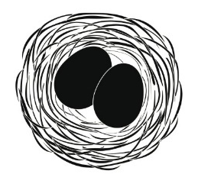 | Live young?  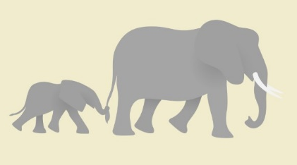
Magpie
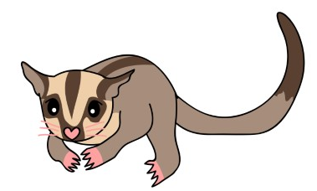
Possum
Kangaroo
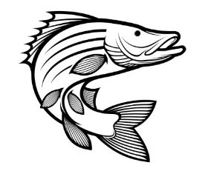
Barramundi
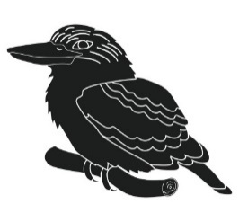
Kookaburra
Lizard

Appendix 3 – Healthy environments
Healthy environment | Unhealthy environment
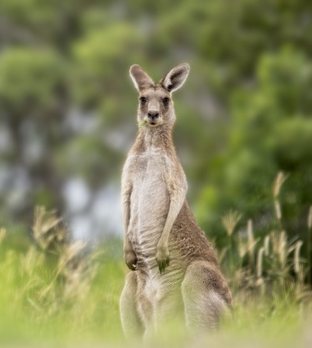 | 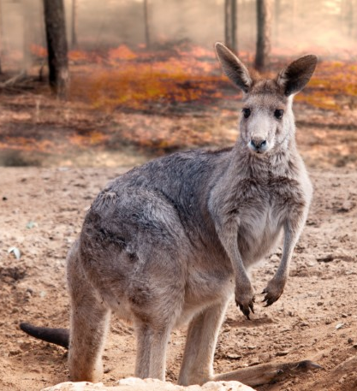
List four words to describe a healthy environment. | List four words to describe an unhealthy environment. Use the word ‘no’ to write your answers.
1. Trees | 1. No trees
2. | 2.
3. | 3.
4. | 4.
Now write four sentences here. | Now write four sentences here.
1. It has trees. | 1. It does not have trees.
2. It has _________________________________ | 2. It does not have ___________________________
3. | 3.
4. | 4.

