Pet Ownership,
Levels 5 and 6

Teacher resources

The following resources have been provided in this document.

Session 1
Needs and wants word list

Session 3
Pets at the vet

Session 4
Fake money
Pet shop items

Session 5
Industry cards
What work? worksheet

Session 1 resource

Needs and wants
EDUCATION | VITAMINS
A JACKET IN WINTER | A PLACE TO LIVE
SUNSCREEN | DESSERT EVERY NIGHT
SHAMPOO | A HOLIDAY TO BALI
FRIENDS | A SISTER
A KING SIZE BED | A BOTTLE OF SOFT DRINK
CLEAN WATER | AN INTERNET CONNECTION
SHOES | A LARGE HOUSE
MEDICINE | LOVE
A PIZZA MAKER | FRUIT AND VEGETABLES
MAKE-UP | SOMEONE TO LOOK AFTER YOU
A SUNHAT IN SUMMER | SLEEP
A COMPUTER | AN XBOX

Session 3 resource

Pets at the vet
Dr De Silva is a veterinarian working in a vet clinic in the small town of Sunnydale.
She loves her job and is extremely dedicated to caring for all kinds of animals. Dr De Silva is in high demand and has trouble allocating her time to help all the animals that need her. She is able to see patients for only 30 hours a week.
In one week the people listed in Cut sheets 1–4 have left messages to make an appointment with
Dr De Silva. You need to put these patients in order of who you think should see Dr De Silva. Remember there are only 30 available hours to book patients in and there are 54 hours of enquiries. Some patients might have to wait and see the vet next week!
Decide which people and their animals will be given appointments to see Dr De Silva. The total time for these appointments must be exactly 30 hours.
Cut each selected appointment out from Cut sheets 1–4, then stick them on the Monday–Friday pages.
Think about the relative importance of each pet requiring medical attention from the veterinarian. Which cases should have the highest priority and why? Which cases are a lower priority and why? Then, allocate the 30 hours of appointments as you would schedule them for Dr De Silva.

MONDAY | TUESDAY
30 MIN | 30 MIN
30 MIN | 30 MIN
30 MIN | 30 MIN
30 MIN | 30 MIN
30 MIN | 30 MIN
30 MIN | 30 MIN
30 MIN | 30 MIN
30 MIN | 30 MIN
30 MIN | 30 MIN
30 MIN | 30 MIN
30 MIN | 30 MIN
30 MIN | 30 MIN

WEDNESDAY | THURSDAY
30 MIN | 30 MIN
30 MIN | 30 MIN
30 MIN | 30 MIN
30 MIN | 30 MIN
30 MIN | 30 MIN
30 MIN | 30 MIN
30 MIN | 30 MIN
30 MIN | 30 MIN
30 MIN | 30 MIN
30 MIN | 30 MIN
30 MIN | 30 MIN
30 MIN | 30 MIN

FRIDAY

30 MIN

30 MIN

30 MIN

30 MIN

30 MIN

30 MIN

30 MIN

30 MIN

30 MIN

30 MIN

30 MIN

30 MIN

Cut sheet 1
Mr Smithson needs to bring his old kelpie in to get  his nails trimmed. – 30 minutes | Karen Grindley would like to bring her cavoodle in  for a flea and tick treatment – 30 minutes
Krissy Rennie has asked to make an appointment  for her two Maltese terriers. They have been barking  a lot lately and she wants to know what’s wrong  with them. – 1 hour | Kathryn Cabarubia has bought a new Siamese kitten that needs to get her immunisations before she is  16 weeks old. – 1 hour
David Keng has a French bulldog he would like to bring in to be groomed for an upcoming dog show.  – 3 hours | Avneet Kaur has a pregnant ferret that is about to  give birth. – 4 hours
Jamie Perra is looking to buy some hens so he can have fresh eggs and would like the vet’s advice on what breed to buy.
– 1 hour
The Kerr’s family dog has been bitten by a spider and needs antivenene. – 30 minutes | Karen Benedicto has a large aviary of pigeons. She would like the vet to come and check that she has provided a comfortable environment for her birds because they are racing pigeons and cost her a lot of money. – 2 hours
Nathan Johnson would like to buy some more frozen mince to feed his python. – 30 minutes
Sammy the labrador has swallowed some parts off a chew toy and needs to be X-rayed. – 1 hour

Cut sheet 2
Doug Pursell has a horse with a cough. The vet will need to drive out to his farm. – 4 hours | An ewe on Liam Singh’s farm is having trouble giving birth and need assistance. – 4 hours
Jordan Wallace has goldfish that aren’t swimming  very enthusiastically. – 30 minutes | Brooke Evans’ cat has put on lots of weight and  needs to be checked over. – 30 minutes
Frank’s kelpie is needed to work on the farm but she has a large splinter in her paw. – 1 hour | Alcide has found a bird that has fallen from its nest. It needs to be monitored for a few hours. – 3 hours
Mohammad’s kitten has not had anything to eat or drink for a few days. She needs some blood tests.
– 2 hours

Cut sheet 3
Kiyara Ragell has two cats that need to be microchipped. – 1 hour | A French bulldog has been hit by a car in the main street and needs urgent surgery. – 6 hours

Shanzay has a prize-winning alpaca with a
sore throat. – 1 hour

Joseph Tabone would like to bring in his Seeing Eye Dog to investigate a lump on its leg. – 2 hours

Margaret Walters would like the vet to visit her
sick cat Ginger because Margaret can’t drive.
– 2 hours

Cut sheet 4
Jen’s kitten Rosie needs a glass slide procedure/  nasal passage discharge. – 30 minutes | Trish needs some antibiotic treatment for her sick budgerigar Blossom. – 30 minutes
Ms Seath wants her new puppy Tiger to be desexed.  – 1 hour | Poor Mrs O’Reilly has to have her pet mouse Spud euthanised. – 1 hour
Chris needs his pet alpacas Indigo and Violet to  have ultrasounds for possible kidney problems.  This means a long visit to Chris’s place.  – 3 hours | Shane wants his best milking cow, Daisy, to receive  an endoscopy for a possible stomach ulcer. This means a long visit to Shane’s place.  – 3 hours

Session 4 resource

Fake money
$50 | $50
$50 | $50
$50 | $50
$50 | $50
$50 | $50

$20 | $20
$20 | $20
$20 | $20
$20 | $20
$20 | $20

$10 | $10
$10 | $10
$10 | $10
$10 | $10
$10 | $10

$10 | $10
$10 | $10
$10 | $10
$10 | $10
$10 | $10

$5 | $5
$5 | $5
$5 | $5
$5 | $5
$5 | $5

$5 | $5
$5 | $5
$5 | $5
$5 | $5
$5 | $5

Session 4 resource

Pet shop items

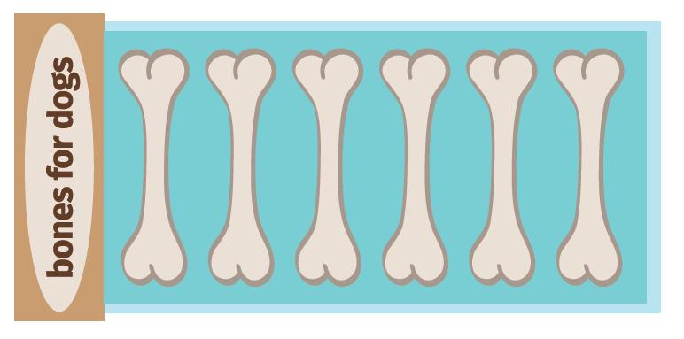
Bones for dogs

Food for cats

Fish bowl

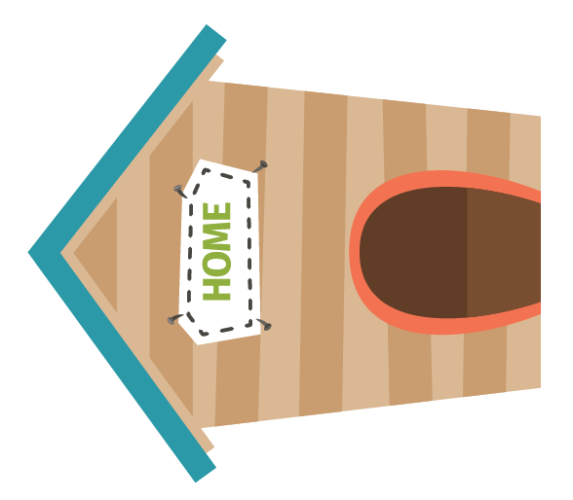
Dog kennel

Cat house

First aid kit

Pet carrier

Water bowl

Pet leash

Pet collar

Tin of cat food

Pet nail clippers

Pet food

Hairbrush

Thermometer

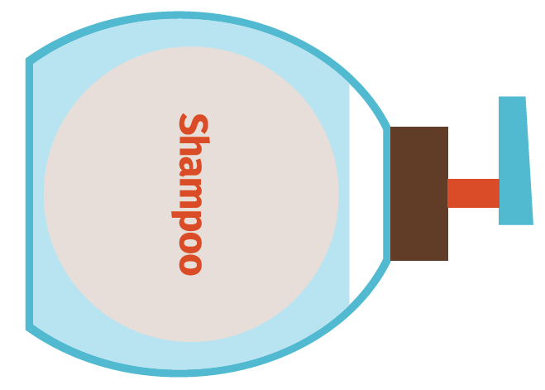
Pet shampoo

Frisbee

Retractable leash

Ball

Session 5 resource

Industry cards

Computer and IT industry

People who sell or design goods
and services for computers

Tourism and hospitality
industry

People working in restaurants,
hotels, caravan parks and with
airlines

Sport and entertainment
industry

People working in theatre, TV,
writing, arts, music and sport

Food production industry

People who use raw ingredients to
prepare food and drink

Mining industry

People who extract valuable, raw
materials from the ground, like coal,
gold or oil

Automotive industry

People who sell, repair or design
machinery

Clothing and textile
industry

People making or designing
clothes and other textiles, like
curtains

Farming industry

People who grow food like fruit
and vegetables and/or who farm
sheep or cattle for milk and/or
meat production

Health services industry

People who care for others like
nurses, social workers and doctors

Retail industry

People working in shops or
companies that sell goods and
services directly to the consumer

A building industry

Examples include carpenters,
plasterers, painters and architects

Transport industry

People working in transporting
people or freight

The Public Service

Examples are police, politicians,
and people working for government

Education industry

Examples are people working in
pre-schools, schools, colleges
or universities

Professional services

Examples are doctors, lawyers
and accountants

Session 5 resource

What work?
Insert the correct term from the list below to match the work category definitions.
Full time, part time, casual, casual, outworkers, on call

Work category | Work category definition
 | These workers are contractors or employees who perform their work at a place that is not the work office. This type of work is common in the textile, clothing and footwear industry.
 | This employee has a permanent job and works around 38 hours each week, on average. The actual hours of work for an employee in a particular job or industry are agreed.
 | This worker usually works fewer than 38 hours per week but they do have regular weekly hours. They are entitled to the same benefits as a full time employee depending on how many hours they work. This type of work is a permanent job.
 | These employees work when their employer needs them to work. They get paid a higher rate because they don’t get benefits such as sick or annual leave.
 | Organisations employ these workers during special events, peak hours or when the business needs them. These employees are on standby until called to work, which means they must be available to work when the business needs them to.
 | This type of worker works ‘shifts’ and gets an extra payment for working shift hours. This usually happens in jobs that run 24 hours a day, like in hospitals. Each shift is usually 8 or 12 hours long.

