Moderating student work samples – Levels C and D, English
Annotated student work samples

Authorised and published by the Victorian Curriculum and Assessment Authority
Level 7, 2 Lonsdale Street
Melbourne VIC 3000
© Victorian Curriculum and Assessment Authority 2022

No part of this publication may be reproduced except as specified under the Copyright Act 1968 or by permission from the VCAA. Excepting third-party elements, schools may use this resource in accordance with the VCAA educational allowance. For more information go to https://www.vcaa.vic.edu.au/Footer/Pages/Copyright.aspx.
The VCAA provides the only official, up-to-date versions of VCAA publications. Details of updates can be found on the VCAA website at www.vcaa.vic.edu.au.
This publication may contain copyright material belonging to a third party. Every effort has been made to contact all copyright owners. If you believe that material in this publication is an infringement of your copyright, please email the Copyright Officer vcaa.copyright@education.vic.gov.au
Copyright in materials appearing at any sites linked to this document rests with the copyright owner/s of those materials, subject to the Copyright Act. The VCAA recommends you refer to copyright statements at linked sites before using such materials.
The VCAA logo is a registered trademark of the Victorian Curriculum and Assessment Authority.

Contact us if you need this information in an accessible format - for example, large print or audio.
Telephone (03) 9032 1635 or email vcaa.media.publications@education.vic.gov.au

Contents
Introduction 1
Context 1
Key principles 1
Framework 2
The student work samples 3
Sample 1 4
Sample 2 6
Sample 3 8
Sample 4 10
Sample 5 12
Sample 6 14

Introduction

Context
The Victorian Curriculum and Assessment Authority (VCAA) partnered with Concord School, a specialist school, and Dr Anna Bortoli, a special education consultant, in a moderation project looking specifically at Levels C and D from the Towards Foundation Level Victorian Curriculum (Levels A–D) for students with disabilities and additional learning needs. The group explored six samples of student work (provided by Concord School). The following case study documents the processes used by the group to moderate, including some discussions and reflections.
Students attending Concord School are funded through the Program for Students with Disabilities under the criteria of Intellectual Disability.
A note from the VCAA:
The content descriptions and the achievement standards in the Victorian Curriculum F–10 represent the mandated curriculum schools implement and assess. Implementation and pedagogy are school-based decisions. Teachers and schools are empowered to enact the curriculum in their classrooms in ways that best meet their cohort, context and community.
The content descriptions and the achievement standards indicate proficiency in knowledge and skills at each level. It is important for teachers and schools to continue to provide students with new knowledge and skills as they achieve proficiency, as well as explore any objectives in terms of quality in the context of their own classrooms.

Key principles
Key principles were agreed on by the group:
- Attitudes around learning for students with disabilities have moved to a strength-based model.
- Students with disabilities learn in many ways; it is critical that diversity is acknowledged, and assessment of learning is individualised.
- Collaborative moderation is very important.
- A framework is important for collaborative moderation to provide for objectivity, fairness and consistency.

Framework
The following table was the framework used by the group for this moderation.
Student name: | Year level:
Learning area and relevant achievement standard:
1. Initial thoughts on the student’s learning as shown by the work sample. (Circle one.)
Working at the achievement standard
Working towards the achievement standard
2. What is the learning demonstrated by the student as shown in the work sample? (Be specific.)
3. What are the gaps in the student’s learning as indicated by the work sample? (Be specific.)
How might the teacher address these gaps in this learning area?
4. What are the highlights in the student’s learning as shown in the work sample? (Be specific.)
How might the teacher extend the student in this learning area?

The student work samples
The group moderated student work samples provided by Concord School.
These samples were all generated from the same activity: students engaging with and describing their experiences in a garden. The task involved students using a picture to engage with their earlier experiences in the garden. They were asked to label the picture and to recount, in order, what they did in the garden. Students were offered several supports, including a word wall that included visuals and words from which they could select (or copy) words to label the picture and to recount their experiences or the events. The use of visual supports such as this word wall, also known as an Aided Language Device (ALD), capitalises on the student’s strengths in visual processing.
The following content descriptions were used by the teachers in their planning of the lesson.
Level C:
- Know that symbols, words and images can communicate needs
- Use spoken words, sign or Augmentative Alternative Communication [AAC] System to communicate and understand that images can be used to write and express ideas
- Know the beginning sounds (onset) of familiar words
- Retell an event or familiar text through images and illustrations
- Create simple texts by labelling images from an event with own ‘writing’
- Review choices made during shared construction of personalised multimodal texts during shared review
- Trace patterns and letters
- Use software or application by selecting images and typing to ‘label’ images
Level D:
- Understand that language can be represented as written text
- Copy own name and recognise some of the letters within it, and understand that pausing is presented as a full stop in written text
- Use, communicate or articulate high-frequency words and reproduce familiar sounds and their letters
- Identify the onset of familiar words and some words that have the same rime
- Retell familiar text or event by sequencing images and simple statements
- Use symbols, letters and words to create a simple statement about an idea or event
- Copy and write letters, symbols and numbers
- Use software or application by selecting images and suggesting simple sentences to accompany the image
This activity offered an authentic experience for students and connected across different environments – both school and home.
The group selected six samples to moderate, discussing the activity, the individual student, the evidence in the work sample (highlights and gaps), and opportunities for extension in teaching and learning.
Note, the word wall that could be used as assistance in these work samples was co-created by the students and their teachers. After their experiences in the garden, the students and teachers shared their thoughts, brainstormed language and created the word wall. Those words were then made available to students on the wall of the classroom as they worked on their recounts. Some students had the words transferred onto paper that they could have them beside them on their desk. Other students had the words aligned to images, to use as a reference.

Sample 1
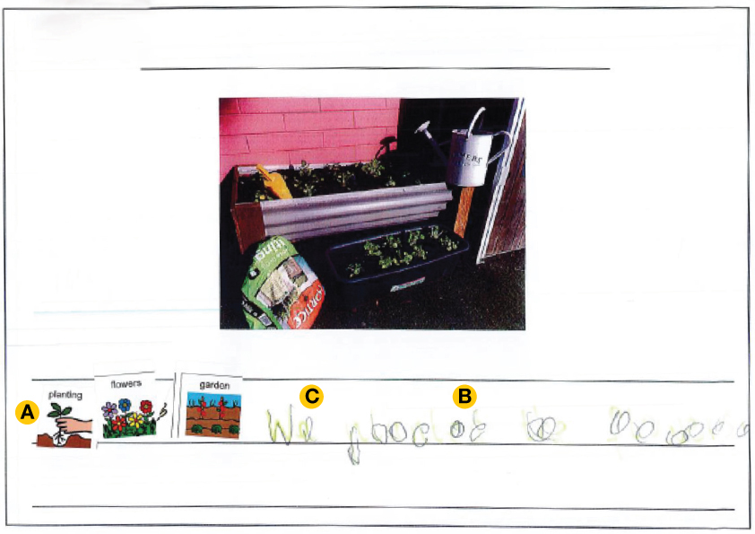

Assistance provided to the student
- Word wall, including visuals (ALD)
- Prompts to choose visuals
- Oral prompts
- Verbal recounting (student) and scribing (teacher)

Highlights
- Has grouped words and visuals that represent the picture and the garden (see ‘A’ on the sample)
- Has verbally expressed a recount, which was then scribed
- Has traced some of those letters, specifically the first two letters (see ‘B’ on the sample)
- Shows emerging sentence skills, demonstrating sequence (see ‘C’ on the sample)

Gaps
- Demonstrates ‘splinter’ skills; has traced some letters but they are not consistent
- Lost focus after the first word (‘We’)

Opportunities
- Use consistent, structured and predictable format for lessons
- Encourage use of labelling, working with first letters and initial sounds
- Introduce other supports such as typing
- Use colourful semantics to build further understanding of sentence structures

Mapped to the Victorian Curriculum English, Levels A–D
This work sample provides evidence of the student working at standard for Level C.
Relevant extracts from the Level C achievement standard include:
- add writing such as scribble to label or comment on drawings, and imitate writing words and sentences
- express and record their wants and needs through a word, a picture or symbol selection
- use a pencil to make purposeful marks on paper
- select pictures that are important to create a picture storybook.

Planning the next stage of student learning
When planning the next stage of the teaching and learning program to progress this student’s learning, focus on the following skills and knowledge in Level D.
Level D content descriptions:
- Use symbols, letters and words to create a simple statement about an idea or event (VCELY125)
- Copy and write letters, symbols and numbers (VCELY127)
- Use software or application by selecting images and suggesting simple sentences to accompany the image (VCELY128)

Sample 2
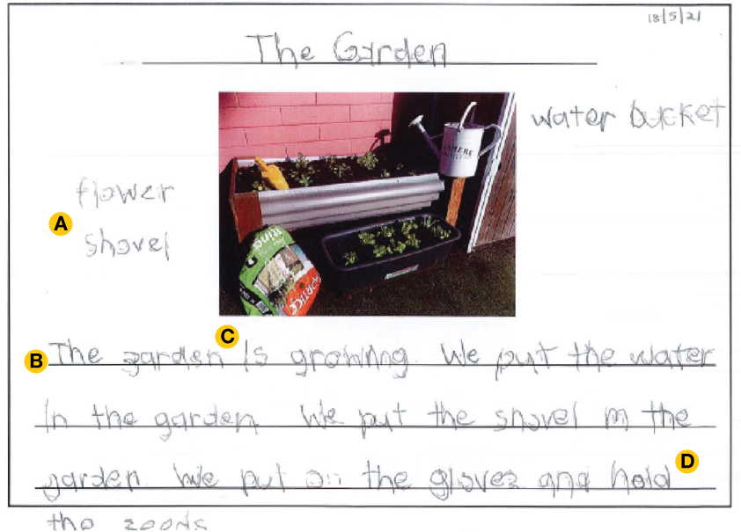

Assistance provided to the student
- Verbal recounting (student) and scribing (teacher)
- Some prompting (‘Can you tell me more?’)

Highlights
- Clear labelling of the picture (see ‘A’ on the sample)
- Complete and well-formed sentences (see ‘B’ on the sample)
- Good pressure with the pencil (see ‘C’ on the sample)
- Intentional writing
- Clear recount (see ‘D’ on the sample)
- Can manipulate a pencil and trace letters
- Can form letters (wrote name independently) but skips between upper and lower case
- Can stay on task
- Selected own words

Gaps
- The recount lacks sequence
- Cannot encode, but can trace

Opportunities
- Explore more assisted technologies – change the mode of output to move this student into Foundation Level?

Mapped to the Victorian Curriculum English, Levels A–D
This work sample provides evidence of the student working at standard for Level D.
Relevant extracts from the Level D achievement standard include:
- produce ‘text-like’ writing to convey meaning and label images
- trace letter-like patterns moving left to right across a page
- copy or write familiar letters with beginning accuracy and copy/type their first name
- select and sequence pictures and key words to describe a personally significant event or experience
- contribute key words to teacher-constructed texts to describe pictures they have selected
- understand that what is said can be written down, indicate words, and demonstrate knowledge of some rules associated with writing, such as working from left to right, top to bottom and spacing.

Discussion
This student work sample prompted a lot of discussion in the group. This student did demonstrate clear understanding of the activity and a good sense of their experiences in the garden. They recognised the key elements in the picture and could verbally – and then by tracing letters – recount. Cognitively, this student demonstrated knowledge and skills but struggles with fine motor skills. The skills indicated in the curriculum are important but individual experiences also need to be considered. Teacher judgment, flexibility and accommodation for specific disability and needs should come into play. The curriculum should be considered holistically, and the resulting assessment tasks should be appropriate, engaging and situated within the individual context. If, after teaching and learning, knowledge and skills cannot be demonstrated by the student, particularly in the case of fine motor skills, it could be appropriate to address these gaps through the use of contextualised Aided Language Devices (ALD) and Augmentative Alternative Communication (AAC) devices.

Planning the next stage of student learning
When planning the next stage of the teaching and learning program to progress this student’s learning, focus on the following skills and knowledge in Foundation Level.
Foundation Level content description:
- Construct texts using software including word processing programs (VCELY163)

Sample 3
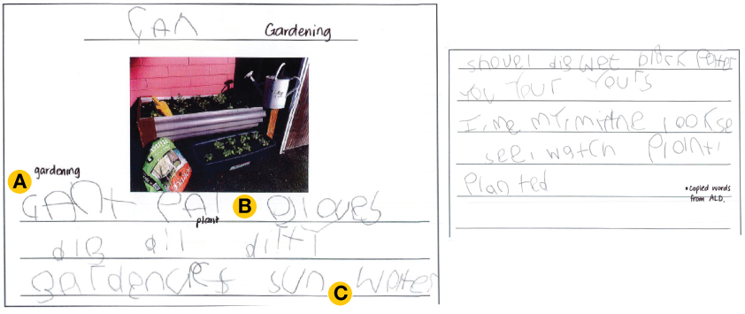

Assistance provided to the student
- Word wall, including visuals (ALD)

Highlights
- Selects and copies words related to the picture (see ‘A’ on the sample)
- Has appropriate spaces between words (see ‘B’ on the sample)
- Forms letters
- Uses initial sounds and graphemes, and sound knowledge
- Uses consistent letter formation
- Understands words should be on lines (see ‘C’ on the sample)
- Works left to right

Gaps
- Lacks sequence; no full sentences
- Doesn’t appear to understand the purpose to communicate an idea; lacks an idea
- Hasn’t been able to articulate thinking around the picture

Opportunities
- Develop knowledge around the purpose of writing
- Explore authentic messages for the student, so they know why they are writing
- Lots of modelling for replication
- Work through turning verbal sentences into written sentences – What does a sentence sound like and how does it look on a page?
- Work on organisation

Mapped to the Victorian Curriculum English, Levels A–D
This work sample provides evidence of the student working towards standard at Level D.
Relevant extracts from the Level D achievement standard include:
- produce ‘text-like’ writing to convey meaning and label images
- trace letter-like patterns moving left to right across a page
- select and sequence pictures and key words to describe a personally significant event or experience
- contribute key words to teacher-constructed texts to describe pictures they have selected
- understand that what is said can be written down, indicate words, and demonstrate knowledge of some rules associated with writing, such as working from left to right, top to bottom and spacing.

Planning the next stage of student learning
When planning the next stage of the teaching and learning program to progress this student’s learning, focus on the following skills and knowledge in Level D.
Level D content descriptions:
- Retell familiar text or event by sequencing images and simple statements (VCELT124)
- … understand that pausing is presented as a full stop in written text (VCELA121)
- Review own text and make changes during shared editing (VCELY126)

Sample 4
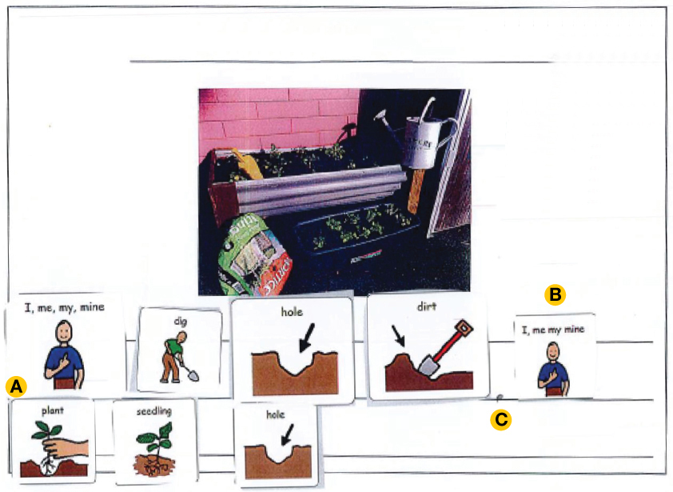

Assistance provided to the student
- Word wall, including visuals (ALD)

Highlights
- Demonstrates a good understanding of the task
- Produces a sequence of the images (see ‘A’ on the sample)
- The sequence is correct and retells their experience (‘dig’ first and ‘plant’ second)
- Understands that words in a sequence convey a message
- Works left to right
- Includes full stop after the first sentence (see ‘C’ on the sample)
- Uses verbs and nouns (including pronouns) (see ‘B’ on the sample)

Gaps
- No independent word formation
- No letter–sound connections
- No tracing or copying
- Doesn’t yet have connectives (this is also missing in their verbal communication)

Opportunities
- Develop a focus on connective words
- Use writing to fill the gaps
- Consider using colourful semantics
- Consider creating images for the connectives

Mapped to the Victorian Curriculum English, Levels A–D
This work sample provides evidence of the student working at standard for Level C.
Relevant extracts from the Level C achievement standard include:
- express and record their wants and needs through a word, a picture or symbol selection
- demonstrate fine motor grasp and manipulating skills such as moving, picking up and manipulating objects
- select pictures that are important to create a picture storybook.

Discussion
This student work sample also provoked some interesting discussions with the group. This student demonstrates good cognition but has no fine motor skills. So while this student has some strong knowledge, they have gaps in a key skill set (fine motor and handwriting). There was discussion about modelling writing and writing under the pictures selected by the student. There was also discussion, as in the case of Sample 2, of supporting this student’s learning through assisted technologies.

Planning the next stage of student learning
When planning the next stage of the teaching and learning program to progress this student’s learning, focus on the following skills and knowledge in Level D.
Level D content descriptions:
- Use symbols, letters and words to create a simple statement about an idea or event (VCELY125)
- Use software or application by selecting images and suggesting simple sentences to accompany the image (VCELY128)

Sample 5
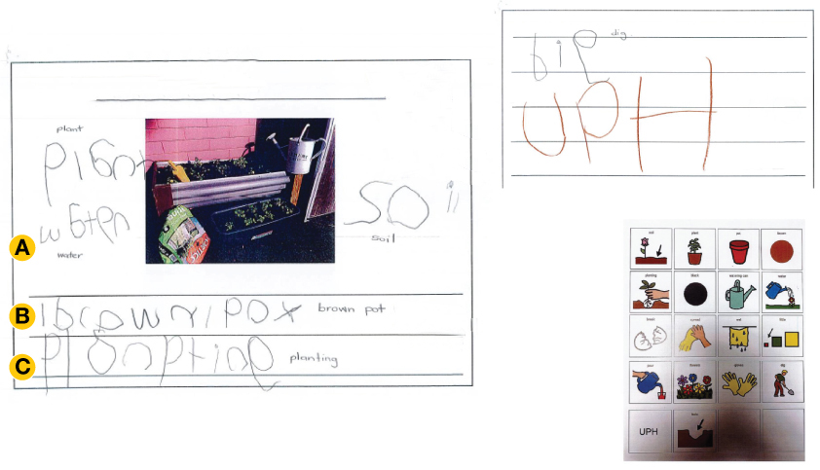

Assistance provided to the student
- Word wall, including visuals (ALD)
- Verbal cues (‘Tell me more’)

Highlights
- Understands the task
- Understands words and labelling (see ‘A’ on the sample)
- Selection of words demonstrates an understanding of a recount of the experience (see ‘B’ on the sample)
- Work was completed independently
- Knew how to select and copy
- Work is intentional and deliberate
- Understands words should be on lines
- Works left to right (see ‘C’ on the sample)

Gaps
- Words without sentences

Opportunities
- Work with scribing and exploring full sentences with the student

Mapped to the Victorian Curriculum English, Levels A–D
This work sample provides evidence of the student working towards standard for Level D.
Relevant extracts from the Level D achievement standard include:
- produce ‘text-like’ writing to convey meaning and label images
- trace letter-like patterns moving left to right across a page
- select and sequence pictures and key words to describe a personally significant event or experience
- contribute key words to teacher-constructed texts to describe pictures they have selected
- understand that what is said can be written down, indicate words, and demonstrate knowledge of some rules associated with writing, such as working from left to right, top to bottom and spacing.

Discussion
The group explored this student work sample in the context of the student’s experience. This student completed this task independently, which would have represented a high cognitive load. More might have been demonstrated with more support, particularly through prompts, scribing and tracing.

Planning the next stage of student learning
When planning the next stage of the teaching and learning program to progress this student’s learning, focus on the following skills and knowledge in Level D.
Level D content descriptions:
- Use symbols, letters and words to create a simple statement about an idea or event (VCELY125)
- Retell familiar text or event by sequencing images and simple statements (VCELT124)

Sample 6

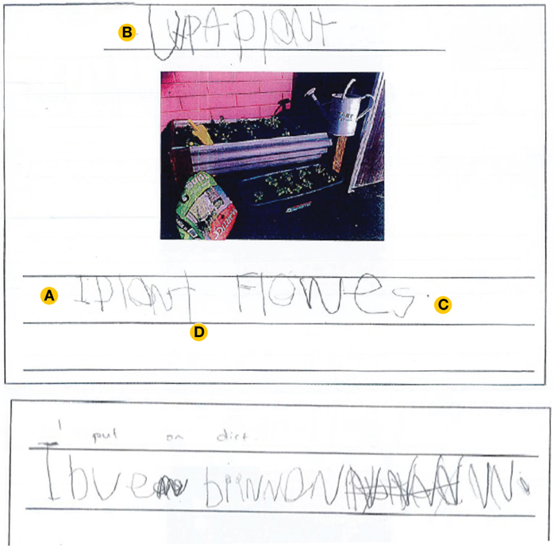

Assistance provided to the student
- Speaking with a teacher

Highlights
- Understands that a sentence is a group of words (see ‘A’ on the sample)
- This student spoke their sentences and then wrote them
- Uses heading (organisation) (see ‘B’ on the sample)
- Use of punctuation (see ‘C’ on the sample)
- Good letter and sound knowledge
- Conveys meaning
- Appropriate spaces between words (see ‘D’ on the sample)

Gaps
- Second sentence is weaker

Opportunities
- Assistance to develop a more sustained message
- Support their thinking, and assist to continue to develop their written skills

Mapped to the Victorian Curriculum English, Levels A–D
This work sample provides evidence of the student working at standard for Level D.
Relevant extracts from the Level D achievement standard include:
- produce ‘text-like’ writing to convey meaning and label images
- trace letter-like patterns moving left to right across a page
- hold a pencil to trace over lines, shapes and patterns with some accuracy
- select and sequence pictures and key words to describe a personally significant event or experience
- contribute key words to teacher-constructed texts to describe pictures they have selected
- understand that what is said can be written down, indicate words, and demonstrate knowledge of some rules associated with writing, such as working from left to right, top to bottom and spacing.

Discussion
The group explored the cognitive load required for this student to write these sentences independently, including selecting the words. The student apparently changed their mind when writing the second sentence, which then led to the crossing out. With additional support, this student could be working within Foundation Level and demonstrate a more sustained sample of writing. Again, assisted technology might assist this student so the demonstration of knowledge and skills in the task can come closer to the cognition demonstrated to the teacher in class.

Planning the next stage of student learning
When planning the next stage of the teaching and learning program to progress this student’s learning, focus on the following skills and knowledge in Foundation Level.
Foundation Level content descriptions:
- Retell familiar literary texts through performance, use of illustrations and images (VCELT159)
- Create short texts to explore, record and report ideas and events using familiar words and beginning writing knowledge (VCELY160)
- Construct texts using software including word processing programs (VCELY163)

