**Using formative assessment rubrics in English**

Persuasive writing  
Level 7



Authorised and published by the Victorian Curriculum and Assessment Authority  
Level 7, 2 Lonsdale Street  
Melbourne VIC 3000

© Victorian Curriculum and Assessment Authority 2019.

No part of this publication may be reproduced except as specified under the *Copyright Act 1968* or by permission from the VCAA. Excepting third-party elements, schools may use this resource in accordance with the [VCAA educational allowance](https://www.vcaa.vic.edu.au/Footer/Pages/Copyright.aspx#schools). For more information go to: <https://www.vcaa.vic.edu.au/Footer/Pages/Copyright.aspx>.

The VCAA provides the only official, up-to-date versions of VCAA publications. Details of updates can be found on the VCAA website: [www.vcaa.vic.edu.au](http://www.vcaa.vic.edu.au).

This publication may contain copyright material belonging to a third party. Every effort has been made to contact all copyright owners. If you believe that material in this publication is an infringement of your copyright, please email the Copyright Officer: [vcaa.copyright@edumail.vic.gov.au](mailto:vcaa.copyright@edumail.vic.gov.au)

Copyright in materials appearing at any sites linked to this document rests with the copyright owner/s of those materials, subject to the Copyright Act. The VCAA recommends you refer to copyright statements at linked sites before using such materials.

At the time of publication the hyperlinked URLs (website addresses) in this document were checked for accuracy and appropriateness of content; however, due to the transient nature of material placed on the web, their continuing accuracy cannot be verified.

The VCAA logo is a registered trademark of the Victorian Curriculum and Assessment Authority.

Contents

What is formative assessment? 4

Using formative assessment rubrics in schools 4

The formative assessment rubric 5

Links to the Victorian Curriculum F–10 5

The formative assessment task 7

Description of the task (administration guidelines) 7

Evidence collected from this task 8

Interpreting evidence of student learning 9

Setting the scene 9

Sample 1 10

Sample 1: Evidence of student learning 11

Any feedback given 11

Sample 2 12

Sample 2: Evidence of student learning 13

Any feedback given 13

Sample 3 14

Sample 3: Evidence of student learning 15

Any feedback given 15

Sample 4 16

Sample 4: Evidence of student learning 17

Any feedback given 17

Using evidence to plan for future teaching and learning 18

Teacher reflections 18

Appendix 1: Template – Understanding persuasive writing structure 19

**What is formative assessment?**

Formative assessment is any assessment that is used to improve teaching and learning. Best-practice formative assessment uses a rigorous approach in which each step of the assessment process is carefully thought through.

Assessment is a three-step process by which evidence is collected, interpreted and used. By definition, the final step of formative assessment requires a use that improves teaching and learning.

For the best results, teachers can work together to interrogate the curriculum and use their professional expertise and knowledge of their students to outline a learning continuum including a rubric of measurable, user-friendly descriptions of skills and knowledge. Teachers can draw on this learning continuum and rubric to decide how to collect evidence of each student’s current learning in order to provide formative feedback and understand what they are ready to learn next.

The VCAA’s *Guide to Formative Assessment Rubrics* outlines how to develop a formative assessment rubric to collect, interpret and use evidence of student learning to plan teaching and learning. For more information about formative assessment and to access a copy of the guide, please go to the [Formative Assessment section](https://www.vcaa.vic.edu.au/foundation10/Pages/viccurriculum/formative_assessment.aspx) of the VCAA website.

**Using formative assessment rubrics in schools**

This document is based on the material developed by one group of teachers in the 2019 Formative Assessment Rubrics project. The VCAA acknowledges the valuable contribution to this resource of the following teachers: Lorraine Connell (Catholic Ladies’ College, Eltham), Melissa Antonuik (Brighton Secondary College), and Andrea Leonard (Alkira Secondary College). The Victorian Curriculum and Assessment Authority partnered with the Assessment Research Centre, University of Melbourne, to provide professional learning for teachers interested in strengthening their understanding and use of formative assessment rubrics.

This resource includes a sample formative assessment rubric, a description of a task/activity undertaken to gather evidence of learning, and annotated student work samples.

Schools have flexibility in how they choose to use this resource, including as:

* a model that they adapt to suit their own teaching and learning plans
* a resource to support them as they develop their own formative assessment rubrics and tasks.

This resource is not an exemplar.

Additional support and advice on high-quality curriculum planning is available from the [Curriculum Planning Resource](http://curriculumplanning.vcaa.vic.edu.au/).

The formative assessment rubric

The rubric in this document was developed to help inform teaching and learning of persuasive writing in English. This rubric can be used to assess and develop students’ understanding of the structure of persuasive essays. The rubric focuses on:

* the development of a focused contention from an issue
* the sequencing of a line of argument
* the selection of appropriate evidence
* the acknowledgement and productive use of opposing arguments (rebuttals).

The rubric can be used to support the explicit teaching of the structure of persuasive writing from Levels 7 to 10, particularly given the use of rebuttals is assessed in the rubric and is articulated at Level 10. That said, given the focus is on planning, the formative assessment rubric has been mapped to a Level 7 content description.

Links to the Victorian Curriculum F–10

**Curriculum area:** English

Mode: Writing

Strand: Literacy

Sub-strand: Creating texts

**Levels/Bands:** Levels 7 to 10

**Achievement standard/s extract:** Level 7: They understand how to draw on personal knowledge, textual analysis and other sources to express or challenge a point of view.

**Content Description/s:** Level 7: Plan, draft and publish imaginative, informative and persuasive texts, selecting aspects of subject matter and particular language, visual, and audio features to convey information and ideas to a specific audience [(VCELY387](https://victoriancurriculum.vcaa.vic.edu.au/Curriculum/ContentDescription/VCELY387)).

|  |  |  |  |  |  |  |
| --- | --- | --- | --- | --- | --- | --- |
| **Learning continuum**  English Level 7  The learning continuum is based on:  Mode: Writing  Strand: Literacy  Sub-Strand: Creating texts | | | **Phase 1** | **Phase 2** | **Phase 3** | **Phase 4** |
| Student’s work demonstrates they can distinguish an issue from a topic and can provide information that relates to the issue. They can identify types of evidence and arguments different to their own. | Student’s work demonstrates they can take a position on an issue. They are able to articulate arguments that relate to their point of view. They are able to list evidence that relates to the issue and question arguments different to their own. | Student’s work demonstrates they can create a contention that expands upon their point of view. They choose arguments that support their contention. They refute opposing arguments by offering their opinion and counter evidence. | Student’s work demonstrates they can extend upon their contention by focusing on a common thread. They offer a sequenced line of argument, supported and furthered by evidence. They acknowledge sources to increase credibility of evidence. They are able to consider, refute and reframe opposing arguments. |
| **Organising element** | **Action** | **Insufficient evidence** | **Quality criteria** | | | |
| Plan persuasive texts, articulating a contention, outlining appropriate arguments and possible evidence, and countering alternative views. | 1. Argues a point of view on a chosen issue (contention). | 1.0 Insufficient evidence | 1.1 Identifies an issue.  ‘I’m arguing about pill testing.’ | 1.2 Articulates agreement or disagreement with an issue.  ‘I’m arguing for pill testing.’ | 1.3 Develops a contention.  ‘I’m arguing that pill testing should be legalised.’ | 1.4 Creates a contention with a common thread.  ‘I’m arguing that legalising pill testing will have economic benefits.’ |
| 2. Supports point of view with arguments. | 2.0 Insufficient evidence | 2.1 Provides ideas related to issue. | 2.2 Outlines arguments that relate to their point of view. | 2.3 Selects arguments to defend contention. | 2.4 Organises arguments based around a common thread. |
| 3. Chooses evidence to support point of view. | 3.0 Insufficient Evidence | 3.1 Identifies type of evidence to be used. | 3.2 Lists evidence that relates to the issue. | 3.3 Selects evidence to support arguments. | 3.4 Acknowledges sources to add credibility to evidence. |
| 4. Addresses and challenges alternative perspectives (rebuttal). | 4.0 Insufficient Evidence | 4.1 Identifies an argument that challenges their own. | 4.2 Questions the validity of arguments that differ from their own. | 4.3 Refutes other arguments by providing evidence and opinion. | 4.4 Reframes opposing arguments to support or further their own. |

The formative assessment task

The following formative assessment task was developed to elicit evidence of each student’s current learning and what they are ready to learn next.

Description of the task (administration guidelines)

This task is designed to be used at the beginning stage of a persuasive writing unit and is used as a diagnostic tool for future learning and teaching. The task is focused on the understanding of persuasive writing structure (i.e. contention, argument, evidence, rebuttal). The task does not assess the use of rhetorical devices or stylistic features, nor crafting writing for audiences and purposes.

While the task can be used from Level 7 to 10 to assess students’ ability to plan a persuasive task, the level of abstraction and higher order reasoning evident within the planning also gives an indication at which level the student is performing.

**Instructions**

Teachers:

* familiarise themselves with the formative assessment rubric provided
* provide students with an accessible and generic topic, such as ‘Mobile phones and young people.’ This may be written on the board and is placed at the top of the template (Appendix 1)
* explain that the template must be completed independently under test conditions, and that it will be used to assess students’ ability to formulate and support an argument in relation to an issue
* distribute the template; but, offer little guidance on how to approach the task. Clarification questions about the process of the task may be answered; however, no guidance may be given regarding how to respond to the instructions in the template. Within the template, there are some explanatory comments and prompting questions that will support the students collect the templates after 15 minutes, despite varying levels of completion. No research is necessary to complete the task
* assess the template using the formative assessment rubric provided.

Students:

* have 15 minutes to complete the task
* are given an accessible and generic topic, such as ‘Mobile phones and young people.’ From this topic, students are to create an issue
* complete a planning template for a persuasive writing piece. The template includes ‘Issue’, ‘Contention’, ‘Supporting Arguments’, ‘Evidence’, and ‘Rebuttal’
* should write Contention and Supporting Arguments in full sentences as they would appear in a formal piece of writing
* identify the types of evidence they would use to reinforce their supporting argument, such as an anecdote of a teacher, expert opinion of a psychologist, etc.
* need to acknowledge other perspectives (rebuttal)
* submit template to teacher for assessment on formative rubric.

**Considerations**

* Students may complete the task in the format that best suits their needs (e.g. handwritten or typed).

Evidence collected from this task

Student work when they complete the template.

Interpreting evidence of student learning

Evidence collected from each student was mapped against the rubric:

* The quality criteria that were achieved was shaded in blue.
* 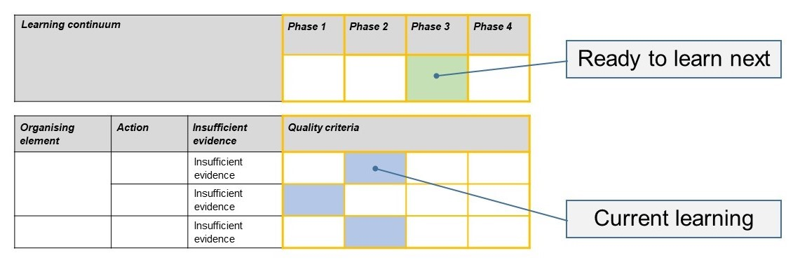The phase that the student is ready to learn next was shaded in green.

Please note, the following annotated student work samples are representative examples only.

Setting the scene

* The task was given to a Year 7 class in the context of their persuasive writing unit.
* The task was undertaken early in the unit. Before completing the task, the teacher had jointly deconstructed a model persuasive text and had created a worked example with the students to model effective planning of a persuasive piece of writing. Students had also had the opportunity to undertake some initial planning for an issue of interest to them. For some students, this included some research.
* Students were provided with the template to begin their planning on a student-selected issue. They were instructed to identify an issue, provide a contention, state at least three supporting arguments, provide evidence, and acknowledge and rebut an opposing view.
* The task fits into the ‘Writing Mode’ of the English curriculum. It seeks to intervene early in the process of writing to identify exactly where each student is at in their learning. This provided the classroom teacher with an opportunity to collect evidence of prior knowledge, leading to targeted planning for future lessons.
* No adjustments were necessary for this group of students.

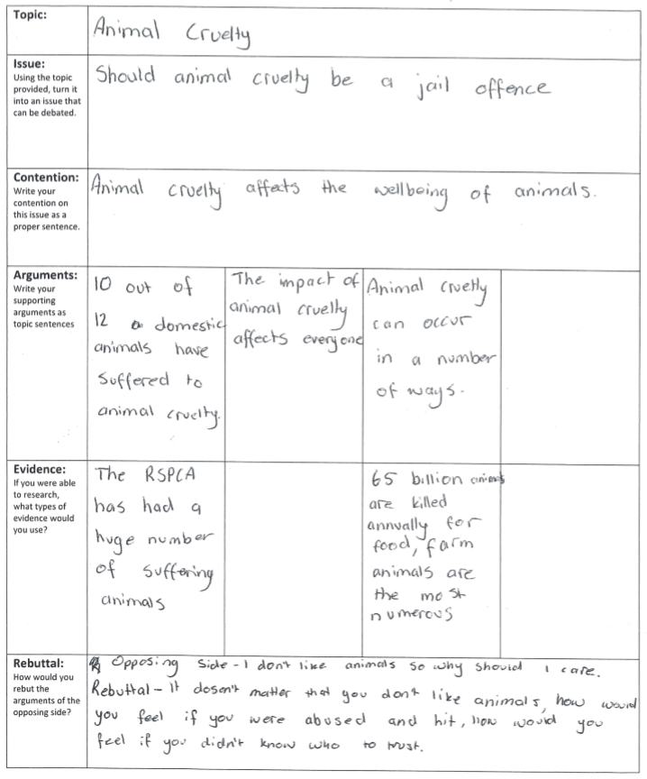Sample 1

Sample 1: Evidence of student learning

Annotations

* 2.1: Provided ideas – not yet formulated as arguments.
* 3.2: Student listed evidence that related to animal cruelty but it does not support the argument.
* 4.2: Clearly identified opposing arguments and was able to question and undermine the assumptions of that perspective.

Insufficient evidence

* 1.0: The student focussed on animal cruelty in general rather than addressing whether it is a jailable offence. Expository not persuasive writing.

What is the student ready to learn next?

Sample 1 shaded rubricThe next phase of learning for this student is Phase 2. The student provided ideas around a topic but has struggled to provide an opinion which is supported by argument. This has affected their ability to select arguments with clarity.

Any feedback given

‘You need to revisit your issue. To ensure a strong contention, you must ensure clarity of the identified issue. Once established, brainstorm arguments that best support your contention and choose three.’

Sample 2

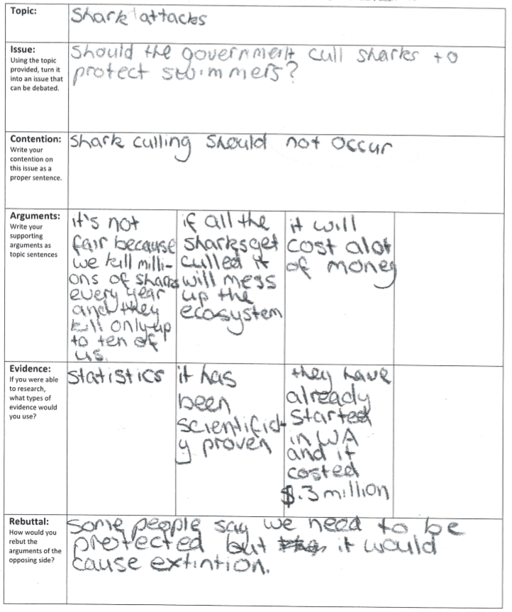

Sample 2: Evidence of student learning

**Annotations**

* 1.2: Clearly showed disagreement with issue (shark culling).
* 2.3: All arguments support the contention.
* 3.1: Most evidence was not specific to argument.
* 4.2: Identified an opposing argument and attempts to challenge it.

**What is the student ready to learn next?**

The next phase of learning for this student is Phase 3. The student has achieved two actions in Phase 2 and one in Phase 3. For Action 3, additional time and targeted assistance should enable the student to expand upon selected evidence. This should also enable her to expand on the rebuttal.

Student 2 shaded rubricAny feedback given

‘You should revisit your contention and arguments by addressing your stated issue more directly. You could unify your contention and arguments more effectively by making reference to the need for swimmers to be protected. You need to provide more specific evidence; for example, consider what specific statistics you could use to support your argument.’

Sample 3

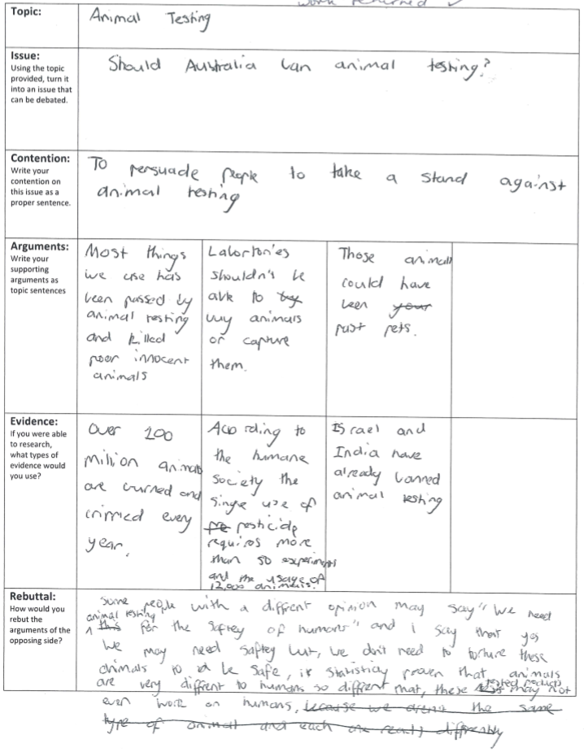

Sample 3: Evidence of student learning

**Annotations**

* 1.2: Able to assert disagreement with issue.
* 2.1: Able to provide ideas and these still need to be shaped into arguments.
* 3.2: Lists evidence but not supporting any arguments at this point because the arguments are yet to be developed.
* 4.3: Clearly indicates opposing arguments and relates it with evidence and logic. The student needed to more explicitly frame her rebuttal to be awarded 4.4.

**What is the student ready to learn next?**

The next phase of learning for this student is Phase 3. The student has achieved all but one criterion of Phase 2. With additional support and worked examples, the student should be able to achieve this criterion and move into Phase 3.

Student 3 shaded rubricAny feedback given

‘The area you most need to work on is shaping your ideas into arguments that directly support your contention. Once these are in place, you need to pair your arguments with evidence.’

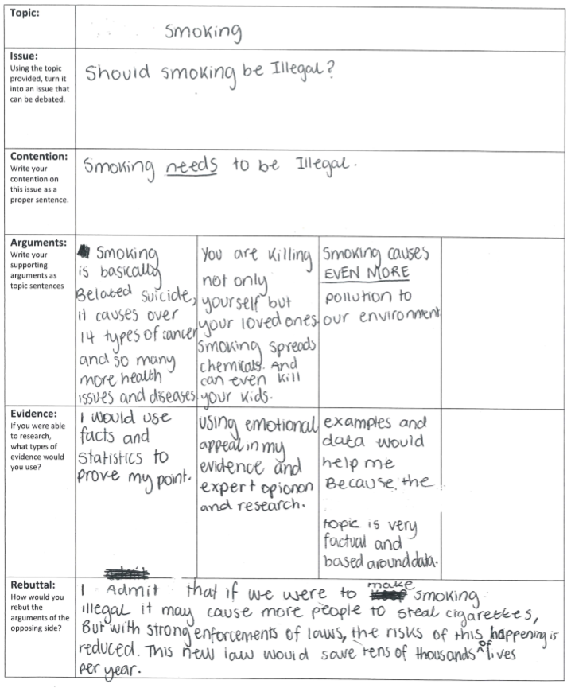Sample 4

Sample 4: Evidence of student learning

**Annotations**

* 1.3: Student developed a contention that took a clear position as identified by ‘needs’ and ‘illegal’.
* 2.3: Student’s arguments were clearly in defence of her contention. She was close to receiving 2.4; however, the absence of a common thread in her contention lead is likely the cause for the absence of a common thread in her identified arguments.
* 3.1: Student simply identified persuasive language devices such as statistics, emotional appeals.
* 4.4: Student was able to identify opposing arguments, counter the argument with evidence and reframe it support her own point of view.

**What is the student ready to learn next?**

The next phase of learning for this student is Phase 4. She has demonstrated an understanding of contention and arguments at Phase 3.She needs to be supported to identify a common thread to her argumentation. While Action 3 was assessed at a lower level, with some intensive intervention the student could be supported to select appropriate evidence. Alternatively, more evidence and time may have been needed for the student to demonstrate higher level skills.

Student 4 shaded rubricAny feedback given

‘You need to do some specific work on evidence and, following this, you are ready to move on to Phase 4 of your learning in this area. Your contention could be enhanced by identifying the common thread this is becoming apparent in your arguments.’

Using evidence to plan for future teaching and learning

* The data revealed that there was a broad range of abilities in the class, with the most obvious areas for improvement being ‘Action 2: Supports point of view with arguments’ and ‘Action 3: Chooses evidence to support point of view.’ Many students were capable of indicating agreement or disagreement with an issue as well as addressing opposing arguments.
* As a result of the data, more targeted teaching is needed in order to develop a stronger connection between contention and supporting arguments. This could begin with mini-lessons on sentence structure or the use of key words.
* Future planning of teaching and learning could include station activities that address individual actions on the rubric, such as worked examples, peer evaluation and feedback, one-on-one conferencing, and self-evaluation and tracking with rubric.

Teacher reflections

* This formative assessment rubric could support learning about persuasive writing in other secondary schooling contexts as it addresses the foundational elements of all effective persuasive writing. It allows both teachers and students to track growth as well as to make the next step in their learning clearly visible.
* Creating the formative assessment rubric challenged our assumptions, leading to greater clarity being provided around key elements of persuasive writing. The rubric allowed for a distinction to be made between an understanding of persuasive language and the structural elements required to create a piece of effective and coherent persuasive writing. This prompted a shift in the focus, moving away from learning ‘persuasive language techniques’ to ‘how to use techniques effectively’ in a piece of writing.

Appendix 1: Template – Understanding persuasive writing structure

|  |  |  |  |  |
| --- | --- | --- | --- | --- |
| **Topic:** | *Mobile phones and young people* | | | |
| **Issue:**  Using the topic provided, write an issue that can be debated. |  | | | |
| **Contention:**  Write your contention on this issue as a proper sentence. |  | | | |
| **Arguments:**  Write your supporting arguments as topic sentences. |  |  |  |  |
| **Evidence:**  If you were able to conduct research, what types of evidence would you use? |  |  |  |  |
| **Rebuttal:**  Identify opposing argument(s).  Provide your rebuttal. |  | | | |