**Using formative assessment rubrics in English**

****Analytical response  
Level 10

Authorised and published by the Victorian Curriculum and Assessment Authority  
Level 7, 2 Lonsdale Street  
Melbourne VIC 3000

© Victorian Curriculum and Assessment Authority 2019.

No part of this publication may be reproduced except as specified under the *Copyright Act 1968* or by permission from the VCAA. Excepting third-party elements, schools may use this resource in accordance with the [VCAA educational allowance](https://www.vcaa.vic.edu.au/Footer/Pages/Copyright.aspx#schools). For more information go to: <https://www.vcaa.vic.edu.au/Footer/Pages/Copyright.aspx>.

The VCAA provides the only official, up-to-date versions of VCAA publications. Details of updates can be found on the VCAA website: [www.vcaa.vic.edu.au](http://www.vcaa.vic.edu.au).

This publication may contain copyright material belonging to a third party. Every effort has been made to contact all copyright owners. If you believe that material in this publication is an infringement of your copyright, please email the Copyright Officer: [vcaa.copyright@edumail.vic.gov.au](mailto:vcaa.copyright@edumail.vic.gov.au)

Copyright in materials appearing at any sites linked to this document rests with the copyright owner/s of those materials, subject to the Copyright Act. The VCAA recommends you refer to copyright statements at linked sites before using such materials.

At the time of publication the hyperlinked URLs (website addresses) in this document were checked for accuracy and appropriateness of content; however, due to the transient nature of material placed on the web, their continuing accuracy cannot be verified.

The VCAA logo is a registered trademark of the Victorian Curriculum and Assessment Authority.

**Contents**

What is formative assessment? 4

Using formative assessment rubrics in schools 4

The formative assessment rubric 5

Links to the Victorian Curriculum F–10 5

The formative assessment task 7

Description of the task (administration guidelines) 7

Evidence collected from this task 8

Interpreting evidence of student learning 9

Setting the scene 9

Sample 1 10

Sample 1: Evidence of student learning 10

Any feedback given 11

Sample 2 12

Sample 2: Evidence of student learning 14

Any feedback given 14

Sample 3 15

Sample 3: Evidence of student learning 16

Using evidence to plan for future teaching and learning 17

Teacher reflections 17

**What is formative assessment?**

Formative assessment is any assessment that is used to improve teaching and learning. Best-practice formative assessment uses a rigorous approach in which each step of the assessment process is carefully thought through.

Assessment is a three-step process by which evidence is collected, interpreted and used. By definition, the final step of formative assessment requires a use that improves teaching and learning.

For the best results, teachers can work together to interrogate the curriculum and use their professional expertise and knowledge of their students to outline a learning continuum including a rubric of measurable, user-friendly descriptions of skills and knowledge. Teachers can draw on this learning continuum and rubric to decide how to collect evidence of each student’s current learning in order to provide formative feedback and understand what they are ready to learn next.

The VCAA’s *Guide to Formative Assessment Rubrics* outlines how to develop a formative assessment rubric to collect, interpret and use evidence of student learning to plan teaching and learning. For more information about formative assessment and to access a copy of the guide, please go to the [Formative Assessment section](https://www.vcaa.vic.edu.au/foundation10/Pages/viccurriculum/formative_assessment.aspx) of the VCAA website.

Using formative assessment rubrics in schools

This document is based on the material developed by one group of teachers in the 2019 Formative Assessment Rubrics project. The VCAA acknowledges the valuable contribution to this resource of the following teachers:Michelle Ainley, (Daylesford College) and Alex Nelson (Beechworth Secondary College). The Victorian Curriculum and Assessment Authority partnered with the Assessment Research Centre, University of Melbourne, to provide professional learning for teachers interested in strengthening their understanding and use of formative assessment rubrics.

This resource includes a sample formative assessment rubric, a description of a task/activity undertaken to gather evidence of learning, and annotated student work samples.

Schools have flexibility in how they choose to use this resource, including as:

* a model that they adapt to suit their own teaching and learning plans
* a resource to support them as they develop their own formative assessment rubrics and tasks.

This resource is not an exemplar.

Additional support and advice on high-quality curriculum planning is available from the [Curriculum Planning Resource](http://curriculumplanning.vcaa.vic.edu.au/).

The formative assessment rubric

The rubric in this document was developed to help inform teaching and learning in English. This rubric supports the explicit teaching of:

* higher order analytical thinking concepts
* the structure of a written analytical response to a topic.

Links to the Victorian Curriculum F–10

**Curriculum area:** English

Mode: Writing

**Levels/Bands:** 10

**Achievement standard/s extract:** Students explain different viewpoints, attitudes and perspectives through the development of cohesive and logical arguments.

**Content Description/s:** Strand: Literacy

Sub-strand: Creating texts

Create sustained texts, including texts that combine specific digital or media content, for imaginative, informative, or persuasive purposes that reflect upon challenging and complex issues ([VCELY479](https://victoriancurriculum.vcaa.vic.edu.au/Curriculum/ContentDescription/VCELY479))

Strand: Language

Sub-strand: Expressing and developing ideas

Refine vocabulary choices to discriminate between shades of meaning, with deliberate attention to the effect on audiences ([VCELA474](https://victoriancurriculum.vcaa.vic.edu.au/Curriculum/ContentDescription/VCELA474))

|  |  |  |  |  |  |  |
| --- | --- | --- | --- | --- | --- | --- |
| **Learning continuum**  English Level 10  Mode: Writing | | | Phase 1 | Phase 2 | Phase 3 | Phase 4 |
| Student responds to a topic. | Student constructs a response to the topic using examples. | Student refines a response to the topic comparing examples. | Student synthesise different perspectives on the topic through the development of arguments. |
|  | | | | | | |
| Organising element | Action | Insufficient evidence | Quality criteria | | | |
| Create sustained persuasive texts using higher order concepts to structure argument | 1 Develops a response | 1.0 Insufficient evidence | 1.1 Restates topic in own words. | 1.2 Writes a response which takes a position on the topic. | 1.3 Writes a response which acknowledges different contexts. | 1.4 Writes a response which evaluates different contexts and justifies their position. |
| 2 Uses vocabulary to convey ideas | 2.0 Insufficient evidence | 2.1 Names key ideas. | 2.2 Uses synonyms to expand ideas. |  | 2.3 Uses conditional terms to qualify the ideas. |
| 3 Links ideas | 3.0 Insufficient evidence |  | 3.1 Makes connections between ideas. | 3.2 Orders ideas to reinforce the connections. | 3.3 Makes logical segues between ideas to build coherence across the response. |

The formative assessment task

The following formative assessment task was developed to elicit evidence of each student’s current learning and what they are ready to learn next.

Description of the task (administration guidelines)

The following formative assessment task was developed to elicit evidence of student ability to construct a persuasive response to a given topic. The stimulus text was short, which enabled the task to better assess students’ ability to develop a contention and then structure and write a sustained response. Using the short text also meant that students were not constrained or limited by their understanding of longer texts; rather, the task enabled students to demonstrate higher order thinking in their development of a short persuasive response.

**Task instructions**

Before the task:

1. The teacher chooses a short text which explores a big idea (see Text selection).
2. The teacher develops a topic on a big idea in the text, but not limited to the world of the text. For example:

*'An isolated community must protect its own in order to survive.' Discuss.*

1. The teacher organises for the task to be completed in one lesson (50 minute period) under the following conditions:

* Students have no than 15 minutes to read, annotate and discuss the stimulus text
* Students have 30 minutes to write their response
* Students complete task individually
* Responses can be digital or handwritten.

Considerations:

* Students who require additional support to complete the task can be prompted to develop a plan for their response instead of writing.

During the task:

1. Read/view the text with students, allowing them to discuss reactions and ask questions to build comprehension on context. Keep to 15 minutes maximum to read and discuss.
2. Give students the prepared topic without unpacking it.
3. Ask students to develop a response to the topic incorporating ideas from the text, as well as from their own worlds and/or other texts they’ve encountered.
4. Inform students you will be assessing the way they introduce their ideas, expand upon them and structure their response. You are looking for evidence of their big-picture thinking.
5. Students can be encouraged to keep writing, but not given feedback or prompted on ideas.
6. Students should have access to stimulus text while writing.

**Text selection**

If using at the beginning of a unit, the teacher is advised to choose a text that:

* is short (no more than 10 minutes to view/read)
* is self-contained (doesn't rely on knowledge of other texts)
* explores a big idea (possibly connecting to a longer text for future or parallel study)
* engages cohort, connects with students' world, and deals with ideas at an appropriate level.

NB. Teachers can use a combination of texts, such as still image, persuasive letter, picture book, animation.

If using the task in the middle of a unit, the teacher could choose excerpts from the studied text, representative of big ideas.

If using the task later in the overall unit, the teacher could draw on students’ cumulative knowledge of the studied text.

Evidence collected from this task

* student writing samples

Interpreting evidence of student learning

Evidence collected from each student was mapped against the rubric:

* The quality criteria that were achieved was shaded in blue.
* 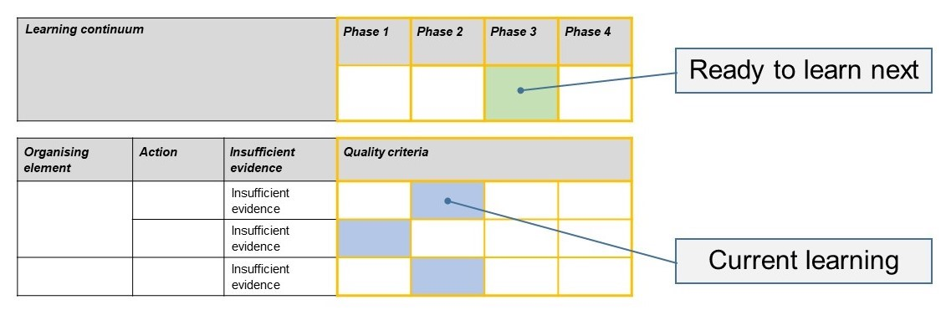The phase that the student is ready to learn next was shaded in green.

Please note, the following annotated student work samples are representative examples only.

Setting the scene

These samples were collected from a small rural secondary school, with two English classes at each year level. The school is currently working on a whole-of-school approach to lift student attainment in writing. This approach is informed by evidence and, this year, the focus was on writing-to-learn strategies to improve students’ writing confidence and stamina.

The samples were derived from an introductory task to a unit on comparing texts. In a previous lesson, students had brainstormed personal responses to a range of themes, one of which links to the task’s writing prompt.

The class read a children’s picture book that explore ideas of identity, belonging and personal integrity. Students were given the prompt: ‘The only truth that matters is being true to oneself’ along with the instructions as described in the Description of the task (administration guidelines).

Sample 1

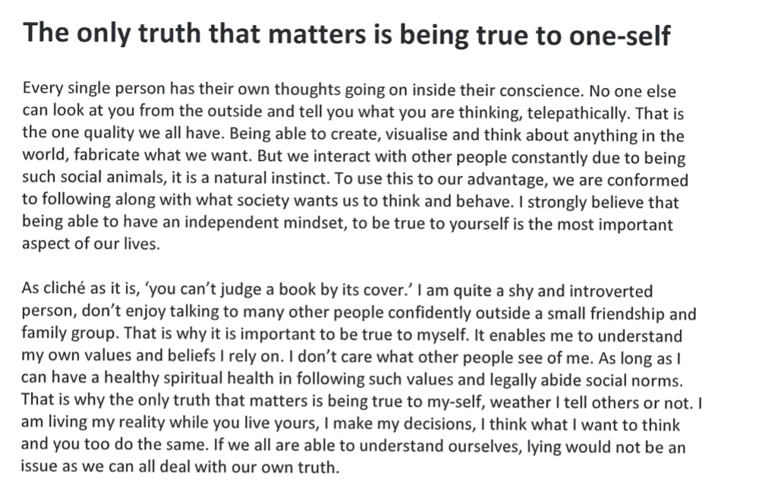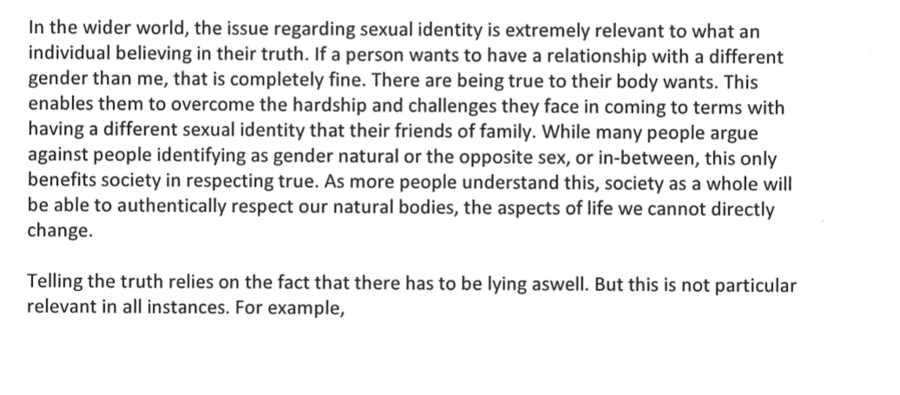Sample 1: Evidence of student learning

Annotations

* 1.4 The student uses different contexts to present and explore the stated contention, e.g. ‘we are conformed to following along with what society wants’, ‘I am quite a shy and introverted person’ and ‘sexual identity’.
* 2.3 The student uses conditional phrases to qualify claims, e.g. ‘whether I tell others or not’, ‘while many people argue…this only benefits society…’ and ‘not particularly relevant in all instances’.
* 3.2 The student orders paragraphs sequentially, from general (‘every single person’, ‘it is a natural instinct’), to individual (‘it is important to be true to myself’), to universal (‘in the wider world’, ‘society as a whole’). However the segues between these are not explicitly signposted.

What is the student ready to learn next?

This student is already doing some synthesis of their ideas, and the sequential ordering shows higher order thinking. The next step is for this student to use connective vocabulary to make segues between ideas explicit, and to ensure he is framing his argument effectively with synthesising vocabulary to conclude the response.

Student 1 shaded rubric

Any feedback given

To improve the coherence of your response to the topic, choose connective vocabulary to make the connections between each idea explicit. For example, you can also use synthesising vocabulary to conclude your response to clarify how your ideas have built to your contention.

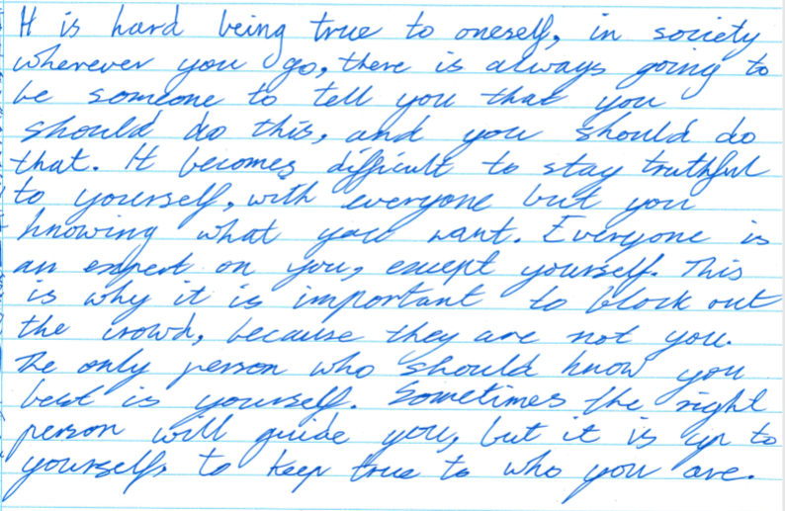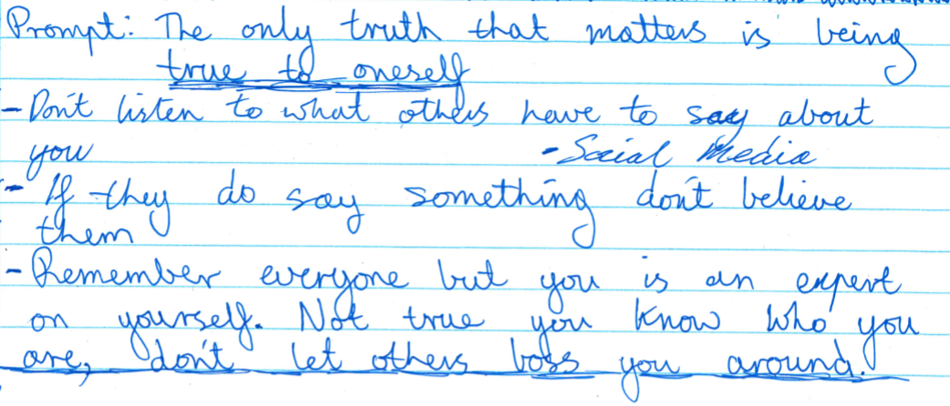Sample 2

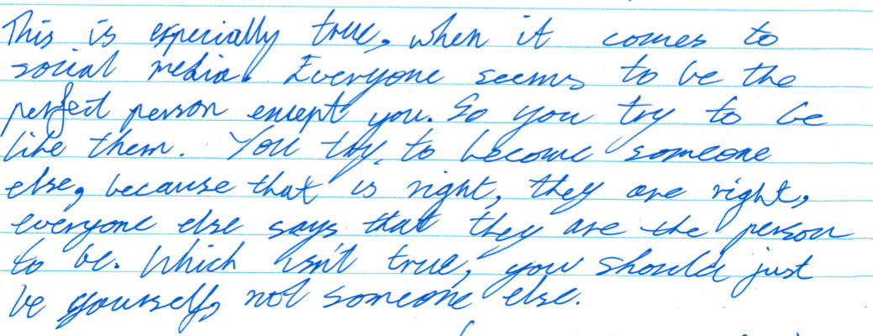

Sample 2: Evidence of student learning

Annotations

* 1.3 The student writes a response in the context of public perception and pressure, e.g. ‘everyone is an expert on you’ and ‘social media’. The student has not yet compared or evaluated other contexts.
* 2.2 The student uses synonyms, e.g. ‘stay truthful to yourself’, ‘who should know you best’, ‘the right person to guide you’ and ‘to be the perfect person’
* 3.1 The student makes links between ideas, e.g. ‘This is especially true’ and ‘this is why’. However, these are not arranged in an obviously intentional order to build coherence.

What is the student ready to learn next?

This student has presented and expanded her ideas clearly, and with some development. She is yet to group and order these ideas intentionally to build coherence.

The next step in her learning is to ‘chunk’ ideas into more discrete subtopics, and then order them to build her argument sequentially. The student should also compare the examples used, and use comparative vocabulary to signpost how these evaluations have led to her conclusion.

Sample 2 shaded rubric

Any feedback given

Separate your ideas into ‘chunks’ or sub-topics, then order them in a way which builds your argument sequentially. For example, you might go from ‘you’ to ‘the world’ or from ‘problem’, through ‘impact’ to ‘solution’. Also, compare the impact of the different examples you have used. Does one have a more significant impact? Use comparative vocab when you write this, to signpost to your reader why you have reached your conclusion.

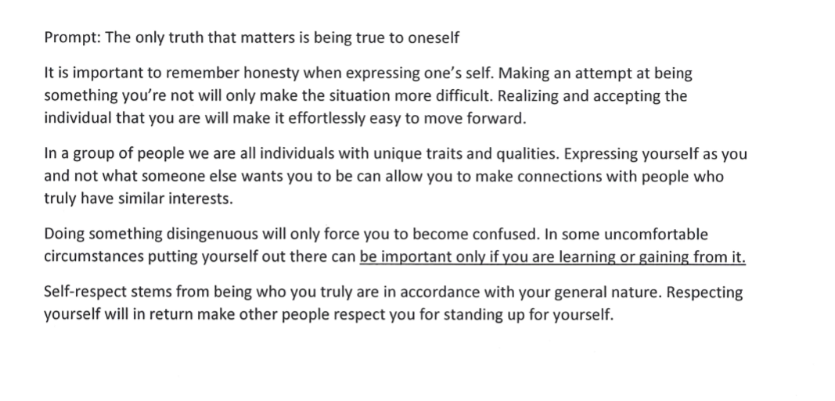Sample 3

Sample 3: Evidence of student learning

Annotations

* 1.4 The student has presented his ideas in multiple contexts, which contribute to a position and justification of its validity (e.g. ‘it is important to remember honesty’ and ‘self-respect stems from being who you truly are’).
* 2.3 The student has qualified listed claims with phrases such as ‘in some uncomfortable circumstances’ and ‘can be important only if…’
* 3.1 The student makes connections in the elaboration of each idea. There is also an implicit through-line in the argument. However, there is no direct connection made between any of the mini paragraphs. Nor is there an obvious sequential order to their presentation.

What is the student ready to learn next?

While the student has presented some quite sophisticated ideas, with appropriate and precise vocabulary, the response is limited by its lack of cohesion. The student is not yet at the ‘refining’ phase. However, with some focused teaching on ordering and linking ideas, the student may well move quickly to ‘synthesizing’ them.

Sample 3 shaded rubric

**Any feedback given**

Put your ideas in an order that builds your argument sequentially. For example, you might go from ‘you’ to ‘the world’ or from ‘problem’, through ‘impact’ to ‘solution’. Use comparative vocabulary when you write this, to signpost to your reader why you have reached your conclusion. While not the focus of this rubric, you need to expand your ideas, using examples to demonstrate your ideas.

Using evidence to plan for future teaching and learning

The data revealed that this student cohort has a broad spread of ability in this skill, which is often missed when the task is more dependent on textual knowledge. For example, students in this task were able to demonstrate higher order thinking without being limited by their application or comprehension of longer, set texts. Vice versa, some students were constrained in their development of ideas because they stuck too closely to the analysis of the material provided. This meant the rubric provided a very useful distinction to inform future teaching.

Teacher reflections

Developing rubrics like this will be an excellent experience of professional learning for teachers to deepen their understanding of the Victorian Curriculum F–10 as a skills continuum, and to shift the focus away from summative, product-centred teaching.

While written for the Year 10 English curriculum, this rubric was designed with scope for it to be used across the curriculum, as well as from F–10 and beyond. We foresee developing a series of writing rubrics for use in secondary settings which can be ‘chunked’ according to particular classes and cohorts.

I am planning to have my class co-construct the next rubric. I can also see using this with parents – the positive language focus on what students can do, say, make or write is entirely appropriate and useful for discussion with parents about student learning.

We discussed the power of developing a set of Year 7 to 12 prompts and texts to do with each year level to support teacher planning in grouping, understanding teacher judgement data. Perhaps also this could be a Grade 6 task with feeder –primary schools to support transition.