,

**Using formative assessment rubrics in Health and Physical Education**

Health: Emotional responses

Levels F–2

Authorised and published by the Victorian Curriculum and Assessment Authority  
Level 7, 2 Lonsdale Street  
Melbourne VIC 3000

© Victorian Curriculum and Assessment Authority 2019.

No part of this publication may be reproduced except as specified under the *Copyright Act 1968* or by permission from the VCAA. Excepting third-party elements, schools may use this resource in accordance with the [VCAA educational allowance](https://www.vcaa.vic.edu.au/Footer/Pages/Copyright.aspx#schools). For more information go to: <https://www.vcaa.vic.edu.au/Footer/Pages/Copyright.aspx>.

The VCAA provides the only official, up-to-date versions of VCAA publications. Details of updates can be found on the VCAA website: [www.vcaa.vic.edu.au](http://www.vcaa.vic.edu.au).

This publication may contain copyright material belonging to a third party. Every effort has been made to contact all copyright owners. If you believe that material in this publication is an infringement of your copyright, please email the Copyright Officer: [vcaa.copyright@edumail.vic.gov.au](mailto:vcaa.copyright@edumail.vic.gov.au)

Copyright in materials appearing at any sites linked to this document rests with the copyright owner/s of those materials, subject to the Copyright Act. The VCAA recommends you refer to copyright statements at linked sites before using such materials.

At the time of publication the hyperlinked URLs (website addresses) in this document were checked for accuracy and appropriateness of content; however, due to the transient nature of material placed on the web, their continuing accuracy cannot be verified.

The VCAA logo is a registered trademark of the Victorian Curriculum and Assessment Authority.

**Contents**

What is formative assessment? 4

Using formative assessment rubrics in schools 4

The formative assessment rubric 5

Links to the Victorian Curriculum F–10 5

The formative assessment task 7

Interpreting evidence of student learning 8

Setting the scene 8

Sample 1 9

Annotated evidence of student learning annotations 9

Using evidence to plan for future teaching and learning 11

Teacher reflections 12

Setting the scene 13

Sample 2 14

Annotated evidence of student learning 14

Sample 3 17

Annotated evidence of student learning 17

Using evidence to plan for future teaching and learning 20

Teacher reflections 20

Appendix 1: Scenario options 21

Appendix 2: Emotions in Me, Emotions in You worksheet 22

**What is formative assessment?**

Formative assessment is any assessment that is used to improve teaching and learning. Best-practice formative assessment uses a rigorous approach in which each step of the assessment process is carefully thought through.

Assessment is a three-step process by which evidence is collected, interpreted and used. By definition, the final step of formative assessment requires a use that improves teaching and learning.

For the best results, teachers can work together to interrogate the curriculum and use their professional expertise and knowledge of their students to outline a learning continuum including a rubric of measurable, user-friendly descriptions of skills and knowledge. Teachers can draw on this learning continuum and rubric to decide how to collect evidence of each student’s current learning in order to provide formative feedback and understand what they are ready to learn next.

The VCAA’s *Guide to Formative Assessment Rubrics* outlines how to develop a formative assessment rubric to collect, interpret and use evidence of student learning to plan teaching and learning. For more information about formative assessment and to access a copy of the guide, please go to the [Formative Assessment section](https://www.vcaa.vic.edu.au/foundation10/Pages/viccurriculum/formative_assessment.aspx) of the VCAA website.

**Using formative assessment rubrics in schools**

This document is based on the material developed by one group of teachers in the 2019 Formative Assessment Rubrics project. The VCAA acknowledges the valuable contribution to this resource of the following teachers: Joh Butler (Lilydale Primary School), Sally Wilson (Mackellar Primary School), Gina Oliver (St Mary of The Cross Primary School, Point Cook) and Sapna Sachdeva (Specialist teacher). The Victorian Curriculum and Assessment Authority partnered with the Assessment Research Centre, University of Melbourne, to provide professional learning for teachers interested in strengthening their understanding and use of formative assessment rubrics.

This resource includes a sample formative assessment rubric, a description of a task/activity undertaken to gather evidence of learning, and annotated student work samples.

Schools have flexibility in how they choose to use this resource, including as:

* a model that they adapt to suit their own teaching and learning plans
* a resource to support them as they develop their own formative assessment rubrics and tasks.

This resource is not an exemplar.

Additional support and advice on high-quality curriculum planning is available from the [Curriculum Planning Resource](http://curriculumplanning.vcaa.vic.edu.au/).

The formative assessment rubric

The rubric in this document was developed to help inform teaching and learning in Health and Physical Education. This rubric supports the explicit teaching of emotional responses in the sub-strand Communicating and interacting for health and wellbeing.

This formative assessment rubric is designed to provide teachers with information about what students are currently demonstrating in relation to emotional responses. It is designed to enable students to show they can:

* identify and describe different emotions people experience
* understand how emotional responses impact on others’ feelings.

Links to the Victorian Curriculum F–10

**Curriculum area:** Health and Physical Education

Strand: Personal, Social and Community Health

Sub-strand: Communicating and interacting for health and wellbeing

**Levels/Bands:** Foundation to Level 2

**Achievement standard/s extract:** Foundation

They identify and describe the different emotions people experience.

Level 2

They understand how emotional responses impact on others’ feelings.

**Content Description/s:** Foundation:

Identify and describe emotional responses people may experience in different situations [(VCHPEP061)](https://victoriancurriculum.vcaa.vic.edu.au/Search?q=VCHPEP061).

Level 2:

Identify and practise emotional responses that account for own and others’ feelings [(VCHPEP076)](https://victoriancurriculum.vcaa.vic.edu.au/Search?q=VCHPEP076).

|  |  |  |  |  |  |  |
| --- | --- | --- | --- | --- | --- | --- |
| **Learning continuum**  Health and Physical Education  Foundation to Level 2  Strand: Personal, Social and Community Health  Sub-strand: Communicating and interacting for health and wellbeing | | | **Phase 1** | **Phase 2** | **Phase 3** | **Phase 4** |
| Students can name different emotions. | Students can identify different emotional responses. | Students can describe emotional responses in themselves and others. | Students can identify how emotional responses impact others. |
|  | | | | | | |
| **Organising element** | **Action** | **Insufficient evidence** | **Quality criteria** | | | |
| Emotional responses | 1 Identifies different emotions | 1.0 Insufficient evidence | 1.1 Indicates a range of emotions using pictures and/or words. | 1.2 Identifies emotions in different situations. | 1.3 Recognises emotional responses in self. |  |
| 2 Describes different emotions | 2.0 Insufficient evidence |  | 2.1 Identifies emotions in others. | 2.2 Describes emotions in others. | 2.3 Predicts how a person or character may be feeling. |
| 3 Discusses responses to emotions | 3.0 Insufficient evidence |  | 3.1 Identifies physical responses to different emotions. | 3.2 Describes how emotional responses affect self. | 3.3 Explains impact of emotional responses on others. |

The formative assessment task

The following formative assessment task was developed to elicit evidence of student learning in order to work out what students can say, make, do or write and what they are ready to learn next.

This assessment can be used to establish the entry point for students for the unit or as formative assessment to inform the teaching and learning needed to progress student learning.

Students in Year 1 and 2 would be expected to have some prior learning in this topic.

**Instructions:**

* Familiarise yourself with the rubric and teacher guidelines.
* Select a scenario from the list provided (Appendix 1), or devise a scenario relevant to your cohort of students and add to worksheet (Appendix 2).
* Read a picture storybook about emotions that sets the scene. For example, Rose meets Mr Wintergarden, When I Feel…, The Very Cranky Bear, Alexander and the Terrible, Horrible, No Good, Very Bad Day. Don’t provide any explanatory discussion.
* Ask students to complete the worksheet as an independent task (on an A3 sheet) within one session.
* Collect worksheets and staple a rubric to each one.
* Use the rubric to identify students’ level of competency.

**Considerations:**

* Photocopy worksheets on A3 paper to allow ease of filling it out.
* Scribe for students who are unable to complete in their own writing. This assessment is focussed on their knowledge, not on their ability to write.

Evidence collected from this task

* Student worksheets
* Anecdotal notes/teacher observation (optional)

Interpreting evidence of student learning

Evidence collected from each student was mapped against the rubric:

* The quality criteria that were achieved was shaded in blue.
* 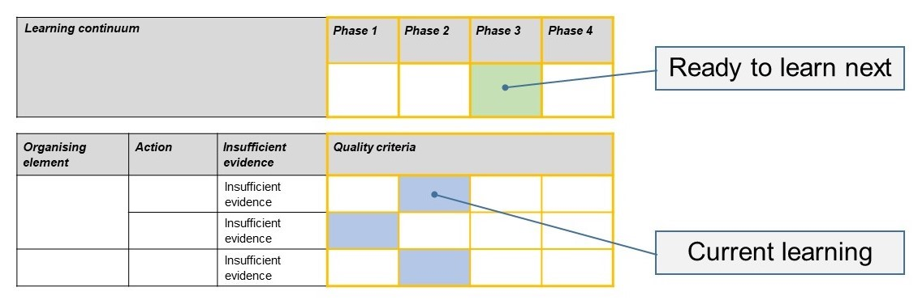The phase that the student is ready to learn next was shaded in green.

Please note, the following annotated student work samples are representative examples only.

Setting the scene

The following sample was collected from a Primary School of 350 students from diverse cultural and socio-economic backgrounds.

This task was delivered to our Foundation – Year 2 students by an external facilitator, not their homegroup teacher. With our diverse cultural backgrounds, it was evident to us that we had a need to develop a greater understanding of individual needs. The school is implementing activities that aim to strengthen student understanding of emotions and their ability to self-regulate emotional responses.

This activity was delivered as part of our Wellbeing program. It was delivered in one 45-minute session with very little discussion or prompting. There was no need for prior learning or explicit teaching to fulfil this task.

This task could be used as a pre and post test as part of a Wellbeing unit. As we administered this task to a visually impaired student, it was necessary to provide a modified worksheet.

Sample 1

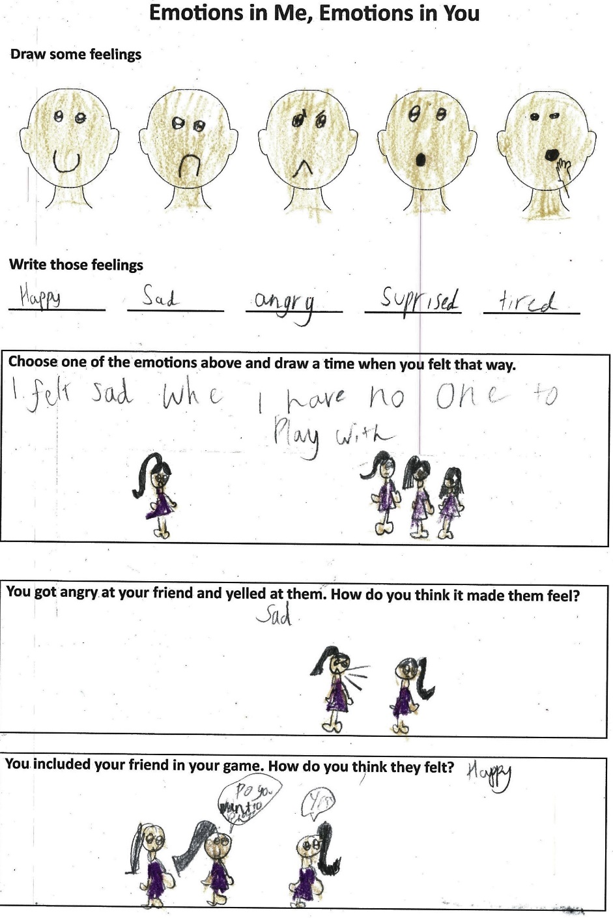Annotated evidence of student learning annotations

1.3 The student has drawn and named emotions, and has been able to recognise emotions in self with ‘I felt sad when I have no one to play with’.

2.2 The student has recognised and described emotions in others.

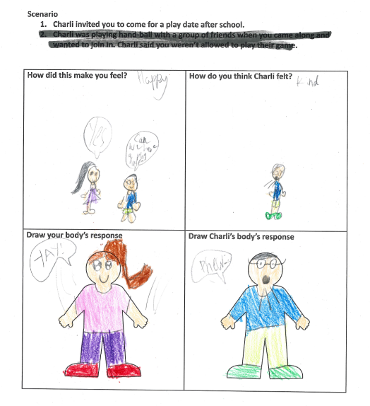

Note:

This student was responding to the first scenario only.

3.1 The student identified physical responses (smile, speech bubble) to different emotions but didn’t have the opportunity to describe or explain.

What is the student ready to learn next?

The student is ready to learn Phase 3 with activities that provide opportunities to describe emotional responses and how they affect the student. An additional task was created to provide all students with an opportunity to demonstrate 3.3. For example, students could be asked to role play a scenario where they describe how they are feeling in a given situation and how their response to the situation could impact on others, including family and friends.

Sample1 shaded rubricUsing evidence to plan for future teaching and learning

The data from this task showed us where the students were at with regard to understanding their emotions and how their responses can impact others. The rubric showed that there was a range of abilities and understandings. The way our task was written allowed students to demonstrate their understanding and knowledge in drawing and writing but, in hindsight, there needed to be greater opportunity to discuss.

The data gave us a great starting point and identified where we should target our teaching to continue to progress students in this area of the curriculum. Evidence showed that with the varying abilities there is a need to scaffold the task to meet individual needs and learning styles.

Teacher reflections

I can see that in the future, our school could focus on embedding formative assessment practices in specialist subjects like Health and Physical Education, Art, Languages, Kitchen and Garden.

Setting the scene

Work samples 2 and 3 were collected from a small school of approximately 250 students in the outer suburbs. The school has students from a variety cultural and socio-economic backgrounds.

The task was administered in the Prep classes by the two teachers. The lesson began with a picture story book that explored feelings as a theme. The task was then given to the students. It was broken down so that they completed one aspect of the task at a time. Students were prompted to complete each section. They then told the teacher what they had drawn for each section so that the teacher could scribe their answers, particularly for students who were still learning to write.

The task was completed in a one hour.

Sample 2

Annotated evidence of student learning

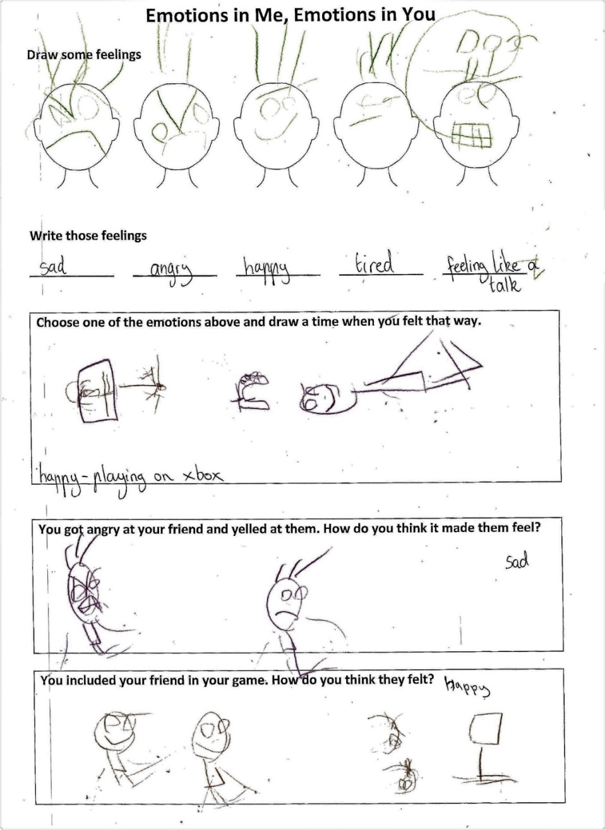Samp

1.2 The student was able to draw and identify emotions, including being able to draw a range of facial expressions to match emotions.

2.1 The student was able to recognise emotions in others.

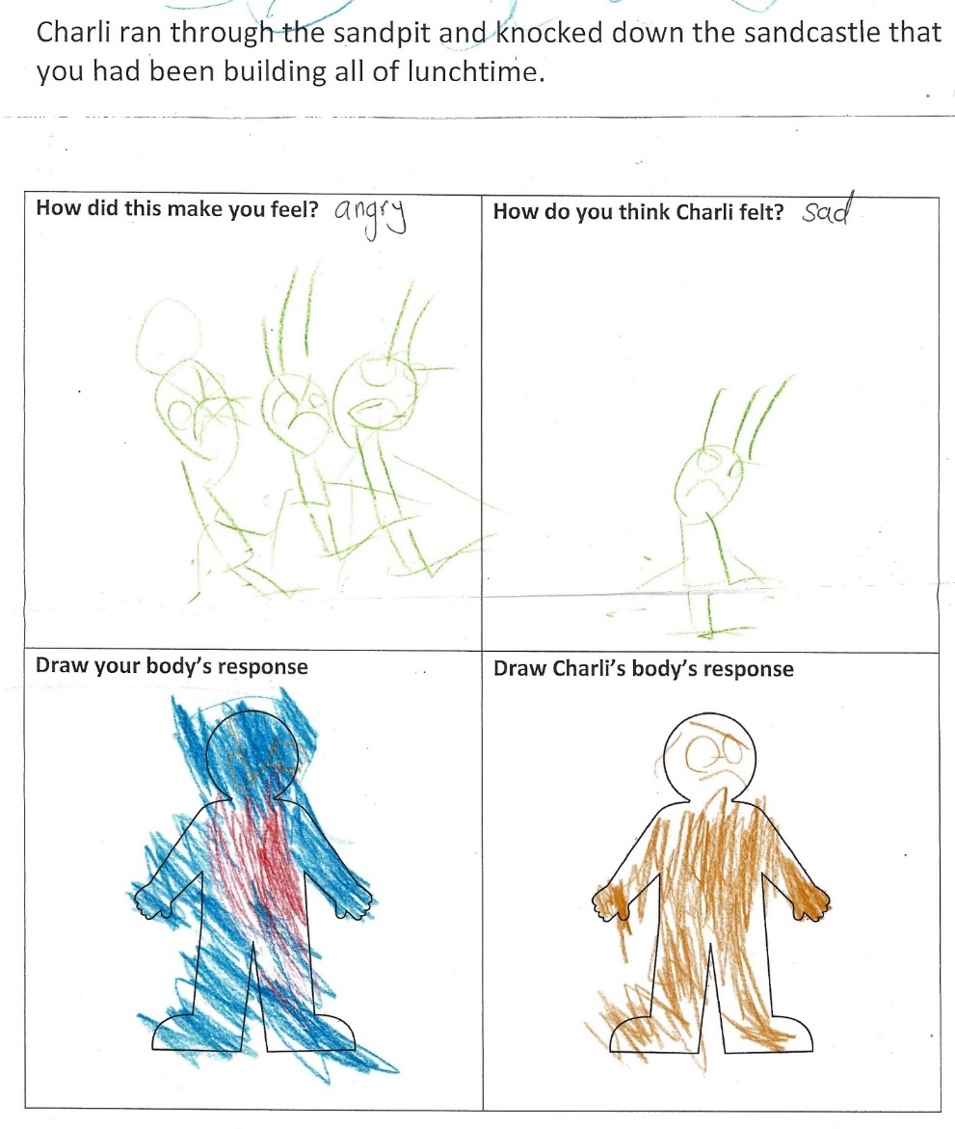

3.0 The student was not able to provide evidence that they could discuss emotions.

What is the student ready to learn next?

The student is ready to learn Phase 2 with future activities focusing on providing questions drawing out a more detailed responses about emotions.

Sample 2 shaded rubric

Sample 3

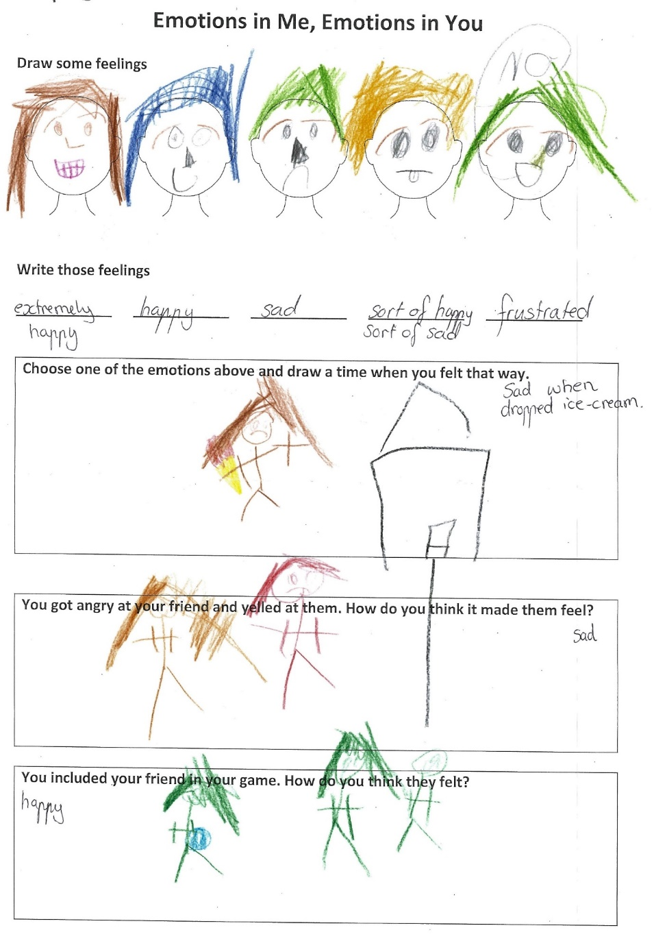Annotated evidence of student learning

1.3 The student draws and identifies emotions and recognises emotions in self, including a drawing about being sad when dropping an ice-cream.

2.1 The student was able to recognise emotions in others, but the drawing doesn’t really describe emotions.

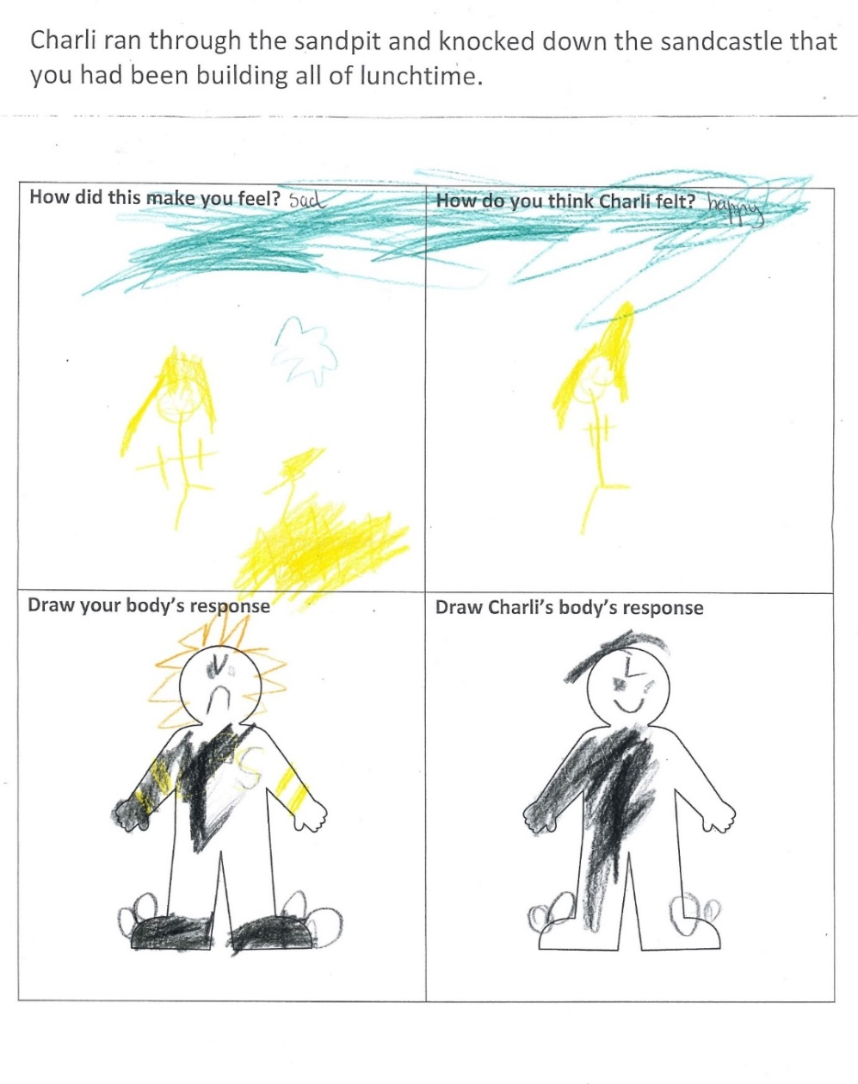

3.1 The drawings provide evidence of two different physical ways emotions can be shown with a frown and a smile.

What is the student ready to learn next?

Sample 3 shaded rubricThe student is ready to learn Phase 3. The student has demonstrated that they are able to recognise emotional responses in themselves but is still developing their ability to describe emotions in others and to recognise and describe how their emotional response to a situation may affect themselves and others.

Using evidence to plan for future teaching and learning

The data showed us that there was a clear progression in understanding of emotions and feelings. It enabled us to see where students' understandings were and where they needed to further develop understanding. It showed that although students could easily name and draw different feelings, they found it difficult to describe the body's emotional reactions.

Teacher reflections

The process of designing the rubric has allowed me to realise how I can effectively design rubrics for other areas. This rubric could possibly be adapted to assess social-emotional capabilities.

Appendix 1: Scenario options

1. Charli ran through the sandpit and knocked down the sandcastle that you had been building all of lunchtime.
2. Charli invited you to come for a play date after school.
3. Charli was playing hand-ball with a group of friends when you came along and wanted to join in. Charli said you weren’t allowed to play their game.
4. In Show and Tell, Charli brings a new puppy to share with the class.

Appendix 2: Emotions in Me, Emotions in You worksheet

**Draw some feelings**

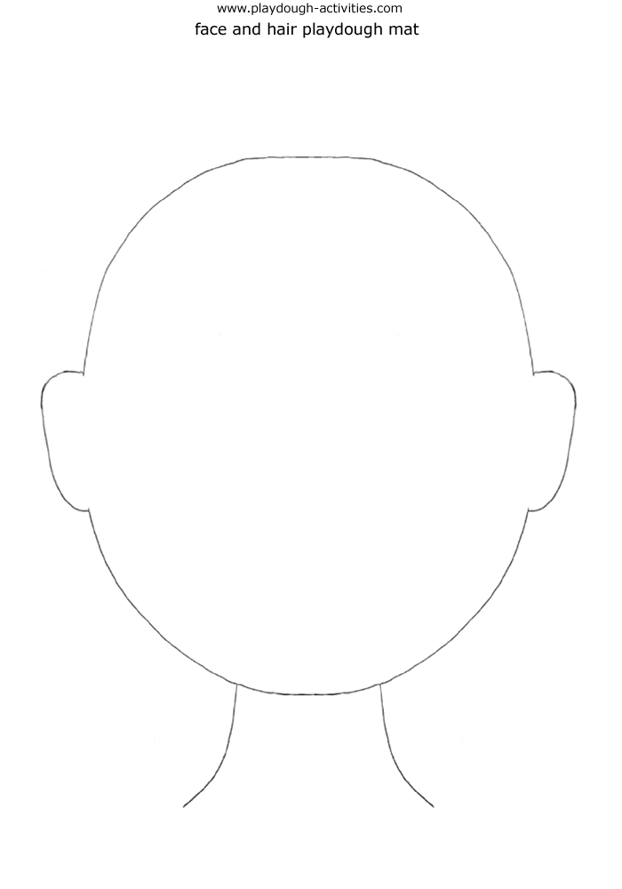

**Write those feelings**

**____________ ____________ ____________ ____________ ____________**

|  |
| --- |
| **Choose one of the emotions above and draw a time when you felt that way.** |

|  |
| --- |
| **You got angry at your friend and yelled at them. How do you think it made them feel?** |

|  |
| --- |
| **You included your friend in your game. How do you think they felt?** |

**Scenario**

|  |  |
| --- | --- |
| **How did this make you feel?** | **How do you think Charli felt?** |
| **Draw your body’s response**  Body Outline Printable | Medical Anatomy | **Draw Charli’s body’s response**  Body Outline Printable | Medical Anatomy |