**Using formative assessment rubrics in Health and Physical Education**

****Health   
Levels 7 to 10

Authorised and published by the Victorian Curriculum and Assessment Authority  
Level 7, 2 Lonsdale Street  
Melbourne VIC 3000

© Victorian Curriculum and Assessment Authority 2019.

No part of this publication may be reproduced except as specified under the *Copyright Act 1968* or by permission from the VCAA. Excepting third-party elements, schools may use this resource in accordance with the [VCAA educational allowance](https://www.vcaa.vic.edu.au/Footer/Pages/Copyright.aspx#schools). For more information go to: <https://www.vcaa.vic.edu.au/Footer/Pages/Copyright.aspx>.

The VCAA provides the only official, up-to-date versions of VCAA publications. Details of updates can be found on the VCAA website: [www.vcaa.vic.edu.au](http://www.vcaa.vic.edu.au).

This publication may contain copyright material belonging to a third party. Every effort has been made to contact all copyright owners. If you believe that material in this publication is an infringement of your copyright, please email the Copyright Officer: [vcaa.copyright@edumail.vic.gov.au](mailto:vcaa.copyright@edumail.vic.gov.au)

Copyright in materials appearing at any sites linked to this document rests with the copyright owner/s of those materials, subject to the Copyright Act. The VCAA recommends you refer to copyright statements at linked sites before using such materials.

At the time of publication the hyperlinked URLs (website addresses) in this document were checked for accuracy and appropriateness of content; however, due to the transient nature of material placed on the web, their continuing accuracy cannot be verified.

The VCAA logo is a registered trademark of the Victorian Curriculum and Assessment Authority.

**Contents**

What is formative assessment? 4

Using formative assessment rubrics in schools 4

The formative assessment rubric 5

Links to the Victorian Curriculum F–10 5

The formative assessment task 7

Description of the task (administration guidelines) 7

Evidence collected from this task 7

Interpreting evidence of student learning 8

Setting the scene 8

Sample 1 9

Sample 1: Evidence of student learning 11

Any feedback given 11

Setting the scene 12

Sample 2 13

Sample 2: Evidence of student learning 14

Any feedback given 15

Using evidence to plan for future teaching and learning 16

Teacher reflections 16

What is formative assessment?

Formative assessment is any assessment that is used to improve teaching and learning. Best-practice formative assessment uses a rigorous approach in which each step of the assessment process is carefully thought through.

Assessment is a three-step process by which evidence is collected, interpreted and used. By definition, the final step of formative assessment requires a use that improves teaching and learning.

For the best results, teachers can work together to interrogate the curriculum and use their professional expertise and knowledge of their students to outline a learning continuum including a rubric of measurable, user-friendly descriptions of skills and knowledge. Teachers can draw on this learning continuum and rubric to collect evidence of each student’s current learning in order to provide formative feedback and understand what they are ready to learn next.

The VCAA’s *Guide to Formative Assessment Rubrics* outlines how to develop a formative assessment rubric to collect, interpret and use evidence of student learning to plan teaching and learning. For more information about formative assessment and to access a copy of the guide, please go to the [Formative Assessment section](https://www.vcaa.vic.edu.au/foundation10/Pages/viccurriculum/formative_assessment.aspx) of the VCAA website.

Using formative assessment rubrics in schools

This document is based on the material developed by one group of teachers in the 2019 Formative Assessment Rubrics project. The VCAA acknowledges the valuable contribution to this resource of the following teachers: Alister Stuart (Lilydale High School), Sam Downward (Kambrya Secondary College), Hilary Gilbert-Wilson (Brunswick Secondary College) and David Regazzoli (Dandenong High School). The Victorian Curriculum and Assessment Authority partnered with the Assessment Research Centre, University of Melbourne, to provide professional learning for teachers interested in strengthening their understanding and use or formative assessment rubrics.

This resource includes a sample formative assessment rubric and task and describes how the teachers implemented the task in their schools and also includes representative student work samples.

Schools have flexibility in how they choose to use this resource, including as:

* a model that they adapt to suit their own teaching and learning plans
* a resource to support them as they develop their own formative assessment rubrics and tasks.

This resource is not an exemplar. Schools are advised to consider whether the sample formative assessment rubric and task meet the needs of their student cohort and is appropriate in the context of their whole-school teaching and learning plan. Additional support and advice on high-quality curriculum planning is available from the [Curriculum Planning Resource](http://curriculumplanning.vcaa.vic.edu.au/).

The formative assessment rubric

The rubric in this document was developed to help inform teaching and learning in Health and Physical Education. This rubric supports the explicit teaching of the students ability to Investigate and select strategies to promote health, safety and wellbeing.

The rubric can be used across a range of focus areas with a focus on the students’ ability to select appropriate strategies to promote health, safety and wellbeing.

Links to the Victorian Curriculum F–10

**Curriculum area:** Health and Physical Education

Strand: Personal, Social and Community Health

Sub-strand: Being healthy, safe and active

**Levels/Bands:** Levels 7 to 10

**Achievement standard/s extract:** Levels 7 and 8:

Students learn how to take positive action to enhance their own and others health, safety and wellbeing

Levels 9 and10:

They compare and contrast a range of actions that could be undertaken to enhance their own and others’ health, safety and wellbeing.

**Content Description/s:** Levels 7 and 8:

Investigate and select strategies to promote health, safety and wellbeing [(VCHPEP126)](https://victoriancurriculum.vcaa.vic.edu.au/Search?q=VCHPEP126).

Levels 9 and 10:

Plan, rehearse and evaluate options (including CPR and first aid) for managing situations where their own or others’ health, safety and wellbeing may be at risk [(VCHPEP144)](https://victoriancurriculum.vcaa.vic.edu.au/Curriculum/ContentDescription/VCHPEP144).

Identify and critique the accessibility and effectiveness of support services based in the community that impact on the ability to make healthy and safe choices (VCHPEP145).

|  |  |  |  |  |  |  |
| --- | --- | --- | --- | --- | --- | --- |
| **Learning continuum**  Health  Level 7 to 10  Strand: Personal, Social and Community Health  Sub-strand: Being healthy, safe and active | | | **Phase 1** | **Phase 2** | **Phase 3** | **Phase 4** |
| Students can interpret health information and identify actions that promote health, safety and wellbeing. | Students can utilise criteria to select strategies that promote health, safety and wellbeing. | Students can apply health information and strategies to enhance health, safety and wellbeing. | Students can propose health strategies and justify how these promote health, safety and wellbeing. |
|  | | | | | | |
| **Organising element** | **Action** | **Insufficient evidence** | **Quality criteria** | | | |
| Being healthy, safe and active | Investigates health information | 1.0 Insufficient evidence | 1.1 List health information based on supplied criteria. | 1.2 Explain the impact of health information based on supplied criteria. | 1.3 Categorise and apply health information based on supplied criteria. |  |
| Explores health strategies | 2.0 Insufficient evidence | 2.1 Identify actions that promote health, safety and wellbeing. | 2.2 Describe strategies that enhance health, safety and wellbeing. | 2.3 Apply health strategies that enhance health, safety and wellbeing. |  |
| Analyses health strategies | 3.0 Insufficient evidence |  | 3.1 List strengths and weaknesses of a health strategy. |  | 3.2 Critique the effectiveness of a health strategy in promoting health, safety and wellbeing. |

The formative assessment task

The following formative assessment task was developed to elicit evidence of each student’s current learning and what they are ready to learn next.

Description of the task (administration guidelines)

The task can be completed by students individually and written responses collected, or they may prefer to answer the questions verbally. Alternatively, the task could be completed as a whole-class activity where students brainstorm ideas in small groups and record these on the whiteboard to share with the whole class.

**Scenario analysis**

You will need to provide the students with a scenario that enables them to come up with a strategy to promote health, safety and wellbeing. Select a scenario based on the content you are teaching for this formative assessment task.

**Prior knowledge**

This task assumes that students would have learnt material that covered:

* risk minimisation strategies
* content related to the classification of stimulant and depressant drugs.

**Scenario**

Tim attends a friend’s 15th birthday party on the weekend. There are people at the party who are engaging in risk taking behavior. Some of Tim’s friends are drinking alcohol while some others are smoking cigarettes. Some other people from his school are smoking marijuana.

**Task**

1. a. List the drugs in the scenario above.

b. Categorise the drugs at the party as a depressant or stimulant.

2. Choose one of the substances at the party and explain how it may impact someone’s behavior.

3. Identify and describe three strategies Tim could use to stay safe.

4. Pick one strategy and list the strengths and weaknesses of it.

5. Tim wants to stay at the party but ensure he stays safe. Develop a strategy for Tim to stay at the party and explain why that strategy is appropriate.

Evidence collected from this task

* Written responses
* Verbal answers the task

Interpreting evidence of student learning

Evidence collected from each student was mapped against the rubric:

* The quality criteria that were achieved was shaded in blue.
* 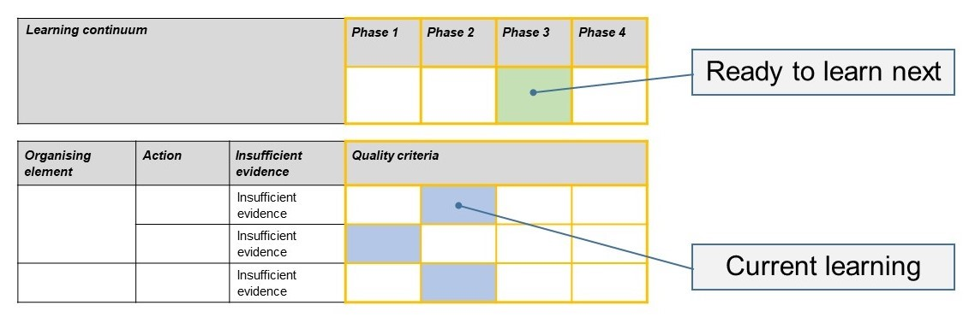The phase that the student is ready to learn next was shaded in green.

Please note, the following annotated student work samples are representative examples only.

Setting the scene

The following work sample was collected from a government secondary school located in Melbourne.

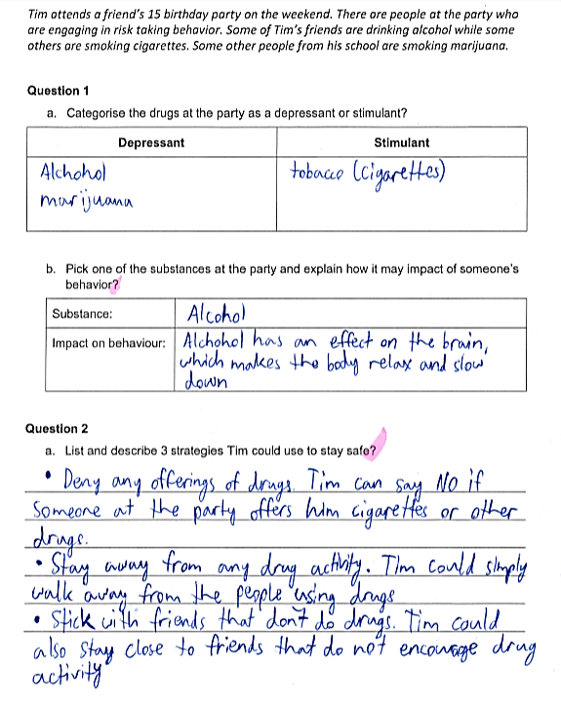Sample 1

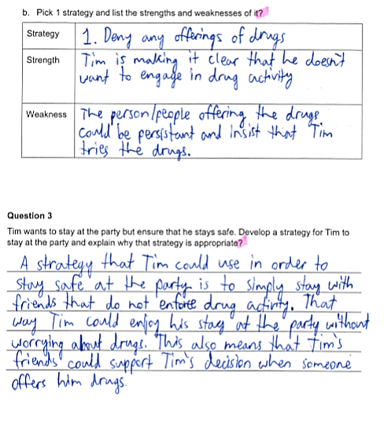

Sample 1: Evidence of student learning

Annotations

* 1.3 The student was able to categorise the three drugs as a depressant or stimulant while also being able to explain the impact on the body and categorise the health information based on the criteria.
* 2.3 In question 2a, the students was able to list and describe three different strategies that were suitable and relevant to the scenario to ensure that they had the best opportunity to stay safe in the given situation. In question 3, was able to identify how the strategy was appropriate to the scenario.
* 3.2 The student has been able to identify realistic strengths and weaknesses of the selected strategy.

**What is the student ready to learn next?**

The student is ready to learn Phase 4 and the next step would be able to critique the effectiveness of a healthy strategy to be able ensure the students is able to apply these skills to a number of different scenarios.

Sample 1 shaded rubric

Any feedback given

The student has worked well with a base understanding of the content shown and has been able to understand the scenario and develop and apply a number of strategies to help improve their health and wellbeing

Setting the scene

This work sample was collected from a Year 8 class in a government secondary school. The task was undertaken four weeks into a unit. The students were required to draw on content taught in a previous semester around risk assessment and developing appropriate strategies. The task took around 10 minutes to complete. The scenario and questions were handed out to the students and they were asked to complete the task individually.

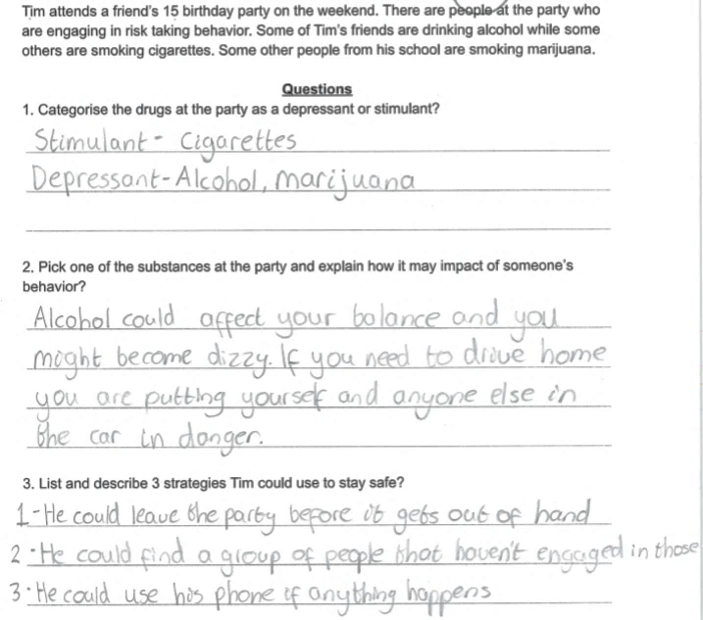Sample 2

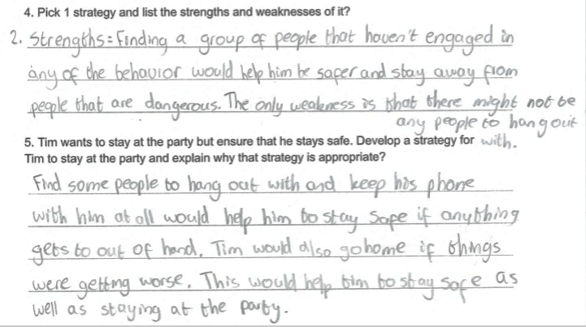Sample 2: Evidence of student learning

Annotations:

* 1.3 The student could identify the category for each of the supplied drugs in question 1.
* 2.3 The student was able to select a suitable strategy to enhance their safety while at the party as shown in question 4 and 5.
* 3.1 The student was able to list the strengths and weaknesses of their selected strategy in question 4.

**What is the student ready to learn next?**

The student is ready to learn Phase 4 and future activities will focus on their ability to critique a strategy.

Sample 2 shaded rubricOn the rubric, the student was able to demonstrate 2.1 and 2.3; however, they were not able to demonstrate 2.2. Further activities will focus on providing additional evidence of what the student knows about Action 2 to confirm the assessment made in this task.

Any feedback given

The student needs to ensure that they complete each of the key skills identified in the question, such as describing the strategy.

Using evidence to plan for future teaching and learning

The data clearly stated that there was a range of abilities in the class. Some students were able to answer the questions well, while others found some of the questions quite difficult. The data from this activity will assist me to group the students and to identify content areas that the students may need extra time with.

Teacher reflections

The formative assessment rubric could be used from Year 7 to 9 in the health curriculum that we cover. The questions will need to be modified to cater for different content.

Upon reflection of the implementation of the task and the data that we collected, we made minor adjustments to the rubric and the task.