Using formative assessment rubrics in Mathematics

Addition and subtraction of fractions
Levels 4–7

Authorised and published by the Victorian Curriculum and Assessment Authority
Level 7, 2 Lonsdale Street
Melbourne VIC 3000
© Victorian Curriculum and Assessment Authority 2019.

No part of this publication may be reproduced except as specified under the Copyright Act 1968 or by permission from the VCAA. Excepting third-party elements, schools may use this resource in accordance with the VCAA educational allowance. For more information go to: https://www.vcaa.vic.edu.au/Footer/Pages/Copyright.aspx.
The VCAA provides the only official, up-to-date versions of VCAA publications. Details of updates can be found on the VCAA website: www.vcaa.vic.edu.au.
This publication may contain copyright material belonging to a third party. Every effort has been made to contact all copyright owners. If you believe that material in this publication is an infringement of your copyright, please email the Copyright Officer: vcaa.copyright@edumail.vic.gov.au
Copyright in materials appearing at any sites linked to this document rests with the copyright owner/s of those materials, subject to the Copyright Act. The VCAA recommends you refer to copyright statements at linked sites before using such materials.
At the time of publication the hyperlinked URLs (website addresses) in this document were checked for accuracy and appropriateness of content; however, due to the transient nature of material placed on the web, their continuing accuracy cannot be verified.

The VCAA logo is a registered trademark of the Victorian Curriculum and Assessment Authority.

Contents
What is formative assessment? 4
Using formative assessment rubrics in schools 4
The formative assessment rubric 5
Links to the Victorian Curriculum F–10 5
The formative assessment task 7
Description of the task (administration guidelines) 7
Interpreting evidence of student learning 8
Setting the scene 8
Sample 1 9
Sample 2 12
Sample 3 14
Sample 4 16
Using evidence to plan for future teaching and learning 18
Teacher reflections 18
Appendix 1 19

What is formative assessment?
Formative assessment is any assessment that is used to improve teaching and learning. Best-practice formative assessment uses a rigorous approach in which each step of the assessment process is carefully thought through.
Assessment is a three-step process by which evidence is collected, interpreted and used. By definition, the final step of formative assessment requires a use that improves teaching and learning.
For the best results, teachers can work together to interrogate the curriculum and use their professional expertise and knowledge of their students to outline a learning continuum including a rubric of measurable, user-friendly descriptions of skills and knowledge. Teachers can draw on this learning continuum and rubric to decide how to collect evidence of each student’s current learning in order to provide formative feedback and understand what they are ready to learn next.
The VCAA’s Guide to Formative Assessment Rubrics outlines how to develop a formative assessment rubric to collect, interpret and use evidence of student learning to plan teaching and learning. For more information about formative assessment and to access a copy of the guide, please go to the Formative Assessment section of the VCAA website.

Using formative assessment rubrics in schools
This document is based on the material developed by one group of teachers in the 2019 Formative Assessment Rubrics project. The VCAA acknowledges the valuable contribution to this resource of the following teachers: Katrina Jung (Peranbin Primary College), Diane Kinder (Wedge Park Primary School) and Jamie Castellas (Taylors Hill Primary School). The Victorian Curriculum and Assessment Authority partnered with the Assessment Research Centre, University of Melbourne, to provide professional learning for teachers interested in strengthening their understanding and use of formative assessment rubrics.
This resource includes a sample formative assessment rubric, a description of a task/activity undertaken to gather evidence of learning, and annotated student work samples.
Schools have flexibility in how they choose to use this resource, including as:
- a model that they adapt to suit their own teaching and learning plans
- a resource to support them as they develop their own formative assessment rubrics and tasks.
This resource is not an exemplar.
Additional support and advice on high-quality curriculum planning is available from the Curriculum Planning Resource.

The formative assessment rubric
The rubric in this document was developed by three Victorian teachers to help inform teaching and learning in Mathematics. This rubric supports the explicit teaching of addition and subtraction of fractions.
This formative assessment rubric is designed to provide teachers with information regarding a student’s current knowledge and skills in adding and subtracting fractions. It can be used in conjunction with the formative assessment task to give students the chance to show that they can:
- identify equivalent fractions
- add and subtract proper fractions with the same denominator
- add and subtract proper and improper fractions with related denominators
- add and subtract mixed fractions with related denominators
- add and subtract proper, improper and mixed fractions with all denominators.

Links to the Victorian Curriculum F–10

Curriculum area: Mathematics
Strand: Number and Algebra
Levels: Levels 4–7
Achievement standards extracts:
Level 4 – They … recognise common equivalent fractions in familiar contexts …
Level 5 – Students add and subtract fractions with the same denominator. They find unknown quantities in number sentences …
Level 6 – They solve problems involving the addition and subtraction of related fractions. Students calculate a simple fraction of a quantity …
Level 7 – They solve problems involving all four operations with fractions, decimals, percentages and their equivalences, and express fractions in their simplest form.
Content descriptions:
Level 4 – Investigate equivalent fractions used in contexts (VCMNA157)
Level 5 – Investigate strategies to solve problems involving addition and subtraction of fractions with the same denominator (VCMNA188)
Level 6 – Solve problems involving addition and subtraction of fractions with the same or related denominators (VCMNA212)
Level 7 – Solve problems involving addition and subtraction of fractions, including those with unrelated denominators (VCMNA243)

Learning continuum  Mathematics, Number and Algebra, Levels 4–7 |  |  | Phase 1 | Phase 2 | Phase 3 | Phase 4 | Phase 5
 |  |  | Students continue number sequences involving multiples of single digit numbers and unit fractions and locate them on a number line. | Students add and subtract proper fractions with the same denominator. | Students add and subtract fractions with related denominators. | Students add and subtract improper and mixed fractions with related denominators. | Students add and subtract proper, improper and mixed fractions with unrelated denominators.
Organising element | Action | Insufficient evidence | Quality criteria
Addition and subtraction of fractions | 1 Understanding the equivalence of fractions | 1.0 Insufficient evidence |  | 1.1 Identifies equivalent fractions | 1.2 Uses knowledge of equivalence to add and subtract fractions with related denominators | 1.3 Uses knowledge of equivalence to add and subtract improper and mixed fractions | 1.4 Locates the lowest common denominator to add and subtract fractions
 | 2 Applying strategies to solve addition problems | 2.0 Insufficient evidence | 2.1 Adds simple proper fractions to make a whole using a number line (e.g. halves, quarters, eighths, thirds and fifths) | 2.2 Adds fractions with the same denominator (can use visual strategies to represent this, such as count on, number line and manipulatives) | 2.3 Adds fractions with related denominators |  | 2.4 Adds fractions with unrelated denominators
 | 3 Applying strategies to solve subtraction problems | 3.0 Insufficient evidence | 3.1 Subtracts proper fractions from a whole using a number line (e.g. halves, quarters, eighths, thirds and fifths) | 3.2 Subtracts fractions with the same denominator (can use visual strategies to represent this, such as count on, number line and manipulatives) | 3.3 Subtracts fractions with related denominators |  | 3.4 Subtracts fractions with unrelated denominators

The formative assessment task
The following formative assessment task was developed to elicit evidence of each student’s current learning and what they are ready to learn next.

Description of the task (administration guidelines)

This task is a pre-assessment to be implemented at the beginning of a unit on addition and subtraction of fractions. It could be adapted as a post-assessment to track student’s growth using the rubric.
Before implementing this as a pre-assessment task, the teacher makes the assumption that students:
- have prior understanding of what a fraction is (part of a whole)
- can identify the numerator and denominator
- can identify halves, quarters, eighths, thirds and fifths
- can continue number sequences involving multiples of these fractions (e.g. ½, 1, 1½, 2, 2½, 3 …)
- can locate these fractions on a number line.

Instructions:
- Familiarise yourself with the pre-assessment task (Appendix 1*), these teacher guidelines and the rubric.
- Explain to students that they are going to be completing a task in which they can show their knowledge of fractions. Students will have 20–30 minutes to complete the pre-assessment task.
- Unpack with students that they can represent their answers in two ways: using manipulatives/drawing pictures and/or writing a fraction.
- Distribute the pre-assessment task to students.
- After the task, use the rubric to identify student’s entry knowledge and skills in the addition and subtraction of fractions.

Evidence collected from this task
- Pre-assessment task
- Teacher observations based on the rubric

*Please see the Teacher reflections section. After implementing the task and mapping the evidence to the rubric, the teachers felt that the task would be more valuable if there were more questions per quality criterion, giving students multiple opportunities to show their learning. If using the task sheet included in this document, please adapt as necessary.

Interpreting evidence of student learning
Evidence collected from each student was mapped against the rubric:
- The quality criteria that were achieved was shaded in blue.
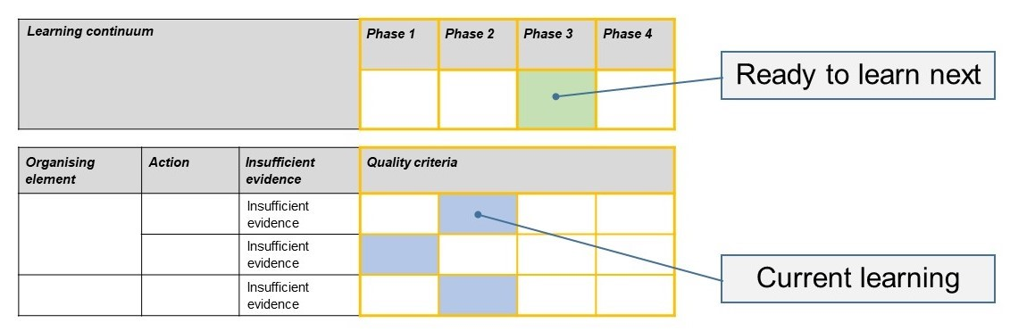
- The phase that the student is ready to learn next was shaded in green.

Please note, the following annotated student work samples are representative examples only.

Setting the scene
This formative assessment task was implemented in two Victorian Primary schools. One school was large metropolitan school; the other was a small rural school. In one school it was implemented with a Year 6 class; in the other, the task was implemented with Years 4, 5 and 6 students.
The assessment was undertaken at the beginning of a unit of Fractions as a pre-test to gauge student’s prior knowledge. Students were given a short verbal overview of the expectations of the task, including the prompt to make/draw representations of their thinking processes. Assumptions were made about student’s prior knowledge, including that they understood the concept of what a fraction is, could identify a numerator and denominator, knew simple factions such as half and quarters, and knew how to use a number line.

Sample 1
1.1 Identifies equivalent fractions
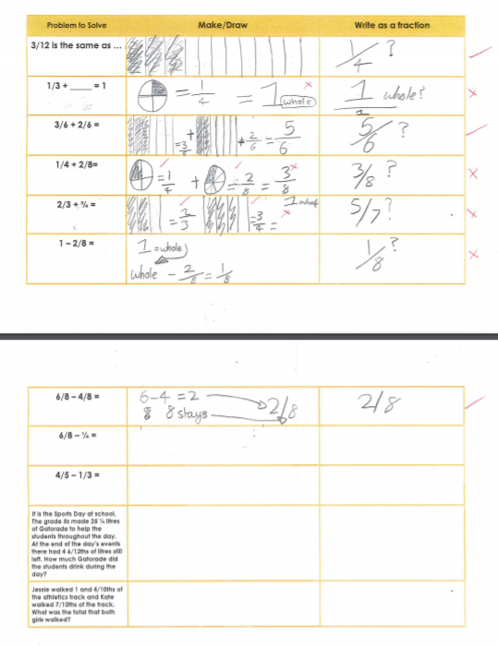
2.2 Adds fractions with the same denominator
3.2 Subtracts fractions with the same denominator

Sample 1: Evidence of student learning

Annotations
- 1.1 Identifies equivalent fractions
- 2.2 – Student adds fractions with the same denominator
- 3.2 – Student subtracts fractions with the same denominator
During the assessment, the student required encouragement to have a go and draw representations to show her thinking.

What is the student ready to learn next?
The student was assessed as ready to learn Phase 3 next. She is ready to learn how to use her knowledge of equivalent fractions to add and subtract fractions with related denominators (quality criteria 1.2, 2.3 and 3.3).
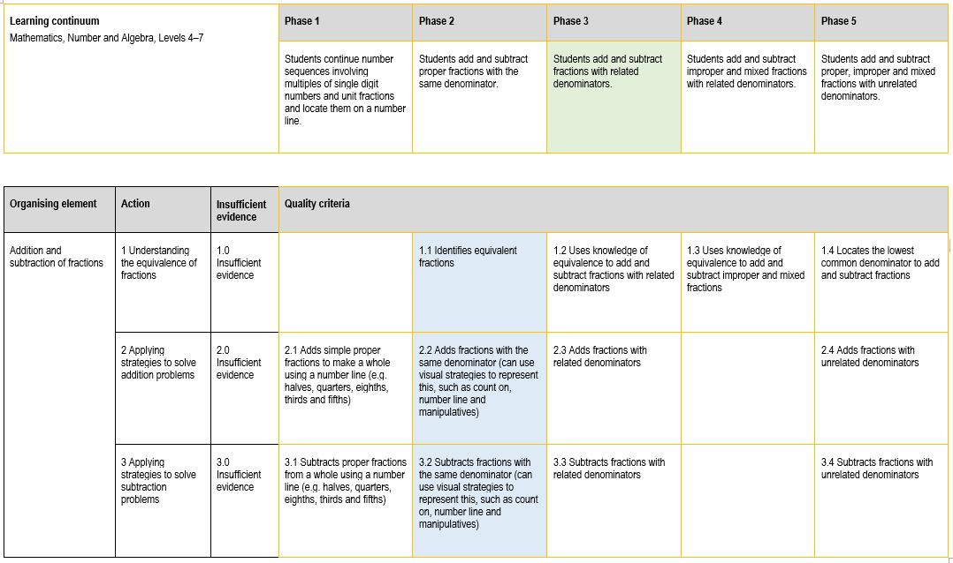
The student demonstrated foundational skills in understanding how to simplify fractions using knowledge of equivalence. She also showed ability to add and subtract fractions with the same denominator so the next step is to apply this to solve problems with related denominators.

Any feedback given
The teacher modelled visual strategies, such as drawing models, to highlight the link between equivalent fractions (which the student demonstrated she understood) and adding and subtracting fractions with related denominators.

Sample 2
1.1 Identifies equivalent fractions

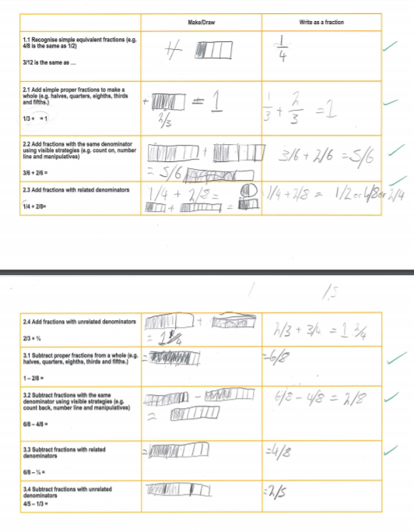
2.3 Adds fractions with related denominators

1.2 Uses knowledge of equivalence to add fractions with related denominators
1.2 Uses knowledge of equivalence to subtract fractions with related denominators
3.3 Subtracts fractions with related denominators

Sample 2: Evidence of student learning

Annotations
- Student provided visual evidence of problem solving.
- Student consistently solved all problems relating to the addition and subtraction of fractions with the same and related denominators (quality criteria 1.2, 2.1–2.3 and 3.1–3.3).
During the test, the student asked how to solve questions relating to Phase 5 as they were keen to further their knowledge and learn new concepts.

What is the student ready to learn next?
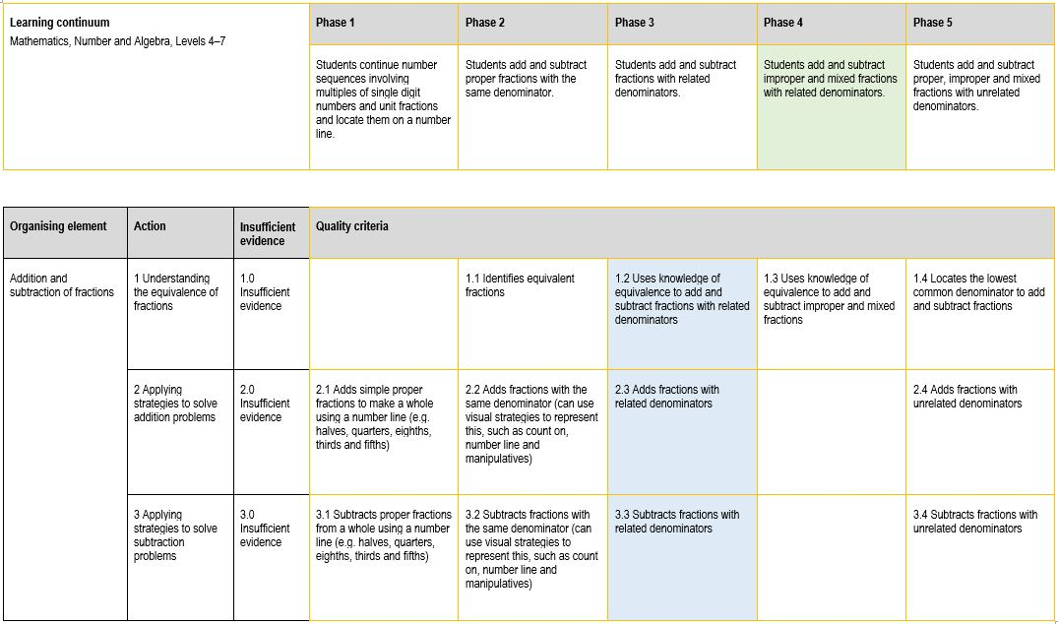
The student was assessed as ready to learn Phase 4 next and then Phase 5. Based on the answers that the student provided, they can add and subtract related fractions but not unrelated fractions. They are ready to focus on adding and subtracting fractions with unrelated denominators and mixed fractions.

Sample 3
1.1 Identifies equivalent fractions

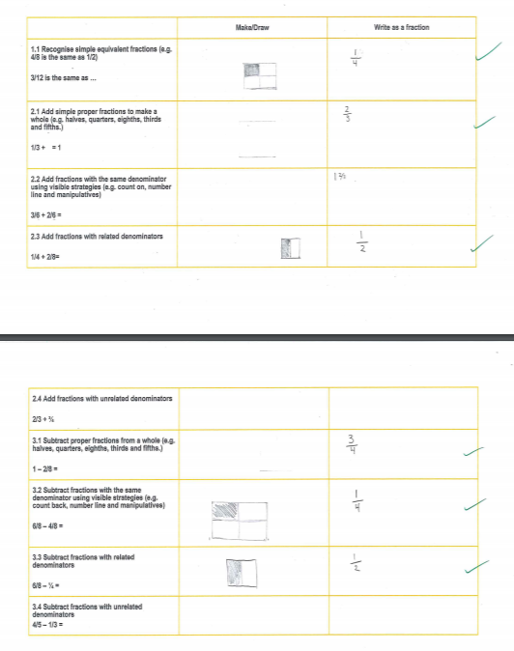
3.3 Subtracts fractions with related denominators

2.3 Adds fractions with related denominators

1.2 Uses knowledge of equivalence to add and subtract fractions with related denominators

Sample 3: Evidence of student learning

Annotations
- Student provided some visual evidence of problem solving.
- Student solved addition problems to create a whole (quality criterion 2.1) and with related denominators (quality criterion 2.3) but not with the same denominator (quality criterion 2.2), which is an anomaly. This is because the student misunderstood the question relating to quality criterion 2.2. They thought that when adding fractions with the same denominators, they had to make them equivalent first. The student demonstrated they did understand the concept, though, when answering the same question with a subtraction operation.

What is the student ready to learn next?
The student was assessed as ready to learn Phase 4 next. This is based on the answers the student provided as well as student feedback once the assessment was analysed and teacher had met with them and addressed the misconception about quality criterion 2.2.

Any feedback given
The teacher discussed the anomaly (not meeting quality criterion 2.2) with the student to find out how they solved the addition problem with related denominators and not the same denominators. The student stated that when adding fractions with the same denominators, they thought they had to make them equivalent first and now understood their mistake. The teacher modelled the correct problem solving process and verbally gave the student another problem, which the student solved with ease.

Sample 4
1.1 Identifies equivalent fractions

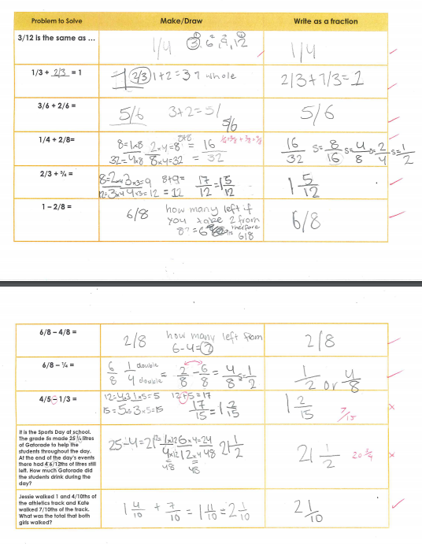
Sample 4: Evidence of student learning
1.3 Locates the lowest common denominator to add and subtract fractions
2.4 Adds fractions with unrelated denominators

3.3 Subtracts fractions with related denominators

1.2 Uses knowledge of equivalence to add and subtract fractions with related denominators

Annotations
- Student provided visual evidence of problem solving.
- Student was able to apply knowledge of equivalent fractions to add fractions with unrelated denominators (quality criterion 2.4); however, they made an operational error when subtracting fractions with unrelated denominators so did not meet quality criterion 3.4. This could indicate that they do have the knowledge but misread the question.

What is the student ready to learn next?
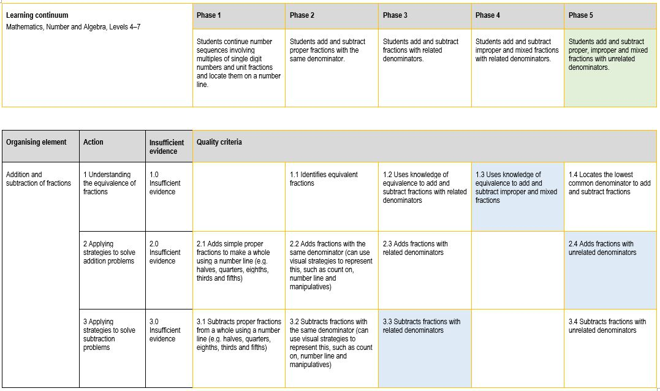
The student was assessed as ready to learn Phase 5 next. They require further consolidation in phase 5 particularly with Quality Criteria 3.4. It would be recommended that the student further consolidate their understanding of addition and subtraction with mixed fractions and subtraction of fractions with unrelated denominators.

Any feedback given
The teacher gave direct feedback to the student by unpacking the misconceptions demonstrated and modelling the correct procedure.

Using evidence to plan for future teaching and learning
The collected evidence assisted us to identify misconceptions students had about adding and subtracting fractions. We noticed trends such as students not applying their knowledge of equivalent fractions to solve problems with related denominators. We also found that there were not enough opportunities for students to demonstrate competencies in a quality criterion.
The task was administered as a pre-test to inform planning for a unit on adding and subtracting fractions. The results supported teachers to group students based on areas of need and target teaching to address the Zone of Proximal Development. The same task could be administered as a summative assessment to gauge students’ growth within the topic area.

Teacher reflections
In future, to ensure that we can collect evidence of a solid understanding of the concepts, we think the task should be amended and more questions should be added per quality criteria. This would also ensure student calculation errors are less likely to affect overall assessment and the determination about what they are ready to learn next.

Appendix 1
Problem to solve | Make or draw | Write as a fraction
$\frac{3}{12}$ is the same as
$\frac{1}{3}$ + _____ = 1
$\frac{3}{6}+ \frac{2}{6}$ =

$\frac{1}{4}+\frac{2}{8}$ =

$\frac{2}{3}+ \frac{3}{4}$ =
$$1- \frac{2}{8}$$

$\frac{6}{8}-\frac{4}{8}$ =

$\frac{6}{8}-\frac{1}{4}$ =

$\frac{4}{5}-\frac{1}{3}$ =

It is the Sports Day at school. The grade 5s made $25\frac{1}{4}$litres of Gatorade to help the students throughout the day. At the end of the day’s events they had $4\frac{1}{2}$litres still left. How much Gatorade did the students drink during the day?
Jessie walked $1\frac{4}{10}$ of the athletics track and Kate walked $\frac{7}{10}$ of the track. What was the total that both girls walked?

*Please see the Teacher reflections section. After implementing the task and mapping the evidence to the rubric, the teachers felt that the task would be more valuable if there were more questions per quality criterion, giving students multiple opportunities to show their learning. If using the task sheet included in this document, please adapt as necessary.

