Using formative assessment rubrics in Mathematics

Collecting and interpreting data
Levels 7–9

Authorised and published by the Victorian Curriculum and Assessment Authority
Level 7, 2 Lonsdale Street
Melbourne VIC 3000
© Victorian Curriculum and Assessment Authority 2019.

No part of this publication may be reproduced except as specified under the Copyright Act 1968 or by permission from the VCAA. Excepting third-party elements, schools may use this resource in accordance with the VCAA educational allowance. For more information go to: https://www.vcaa.vic.edu.au/Footer/Pages/Copyright.aspx.
The VCAA provides the only official, up-to-date versions of VCAA publications. Details of updates can be found on the VCAA website: www.vcaa.vic.edu.au.
This publication may contain copyright material belonging to a third party. Every effort has been made to contact all copyright owners. If you believe that material in this publication is an infringement of your copyright, please email the Copyright Officer: vcaa.copyright@edumail.vic.gov.au
Copyright in materials appearing at any sites linked to this document rests with the copyright owner/s of those materials, subject to the Copyright Act. The VCAA recommends you refer to copyright statements at linked sites before using such materials.
At the time of publication the hyperlinked URLs (website addresses) in this document were checked for accuracy and appropriateness of content; however, due to the transient nature of material placed on the web, their continuing accuracy cannot be verified.

The VCAA logo is a registered trademark of the Victorian Curriculum and Assessment Authority.

Contents
What is formative assessment? 4
Using formative assessment rubrics in schools 4
The formative assessment rubric 5
Links to the Victorian Curriculum F–10 5
The formative assessment task 7
Description of the task (administration guidelines) 7
Interpreting evidence of student learning 8
Sample 1 9
Sample 2 12
Sample 3 14
Using evidence to plan for future teaching and learning 16
Appendix 1 – Worksheet 17

What is formative assessment?
Formative assessment is any assessment that is used to improve teaching and learning. Best-practice formative assessment uses a rigorous approach in which each step of the assessment process is carefully thought through.
Assessment is a three-step process by which evidence is collected, interpreted and used. By definition, the final step of formative assessment requires a use that improves teaching and learning.
For the best results, teachers can work together to interrogate the curriculum and use their professional expertise and knowledge of their students to outline a learning continuum including a rubric of measurable, user-friendly descriptions of skills and knowledge. Teachers can draw on this learning continuum and rubric to decide how to collect evidence of each student’s current learning in order to provide formative feedback and understand what they are ready to learn next.
The VCAA’s Guide to Formative Assessment Rubrics outlines how to develop a formative assessment rubric to collect, interpret and use evidence of student learning to plan teaching and learning. For more information about formative assessment and to access a copy of the guide, please go to the Formative Assessment section of the VCAA website.

Using formative assessment rubrics in schools
This document is based on the material developed by one group of teachers in the 2019 Formative Assessment Rubrics project. The VCAA acknowledges the valuable contribution to this resource of the following teachers: Natalie Hammond (Bayside P-12 College), Cherie Heintze (Wodonga Middle Years College) and Danielle Mortimer (Brentwood Secondary College). The Victorian Curriculum and Assessment Authority partnered with the Assessment Research Centre, University of Melbourne, to provide professional learning for teachers interested in strengthening their understanding and use of formative assessment rubrics.
This resource includes a sample formative assessment rubric, a description of a task/activity undertaken to gather evidence of learning, and annotated student work samples.
Schools have flexibility in how they choose to use this resource, including as:
- a model that they adapt to suit their own teaching and learning plans
- a resource to support them as they develop their own formative assessment rubrics and tasks.
This resource is not an exemplar.
Additional support and advice on high-quality curriculum planning is available from the Curriculum Planning Resource.

The formative assessment rubric
The rubric in this document was developed by three Victorian teachers to help inform teaching and learning in Mathematics. This rubric supports the explicit teaching of statistics and probability.
This formative assessment rubric is designed to be used in conjunction with the formative assessment task to provide teachers with information regarding a student’s current knowledge and skills.

Links to the Victorian Curriculum F–10

Curriculum area: Mathematics
Strand: Statistics and Probability
Sub-strand: Data representation and interpretation
Levels: 7–9

Achievement standard/s extract:
Level 7 – Students identify issues involving the collection of discrete and continuous data from primary and secondary sources.
Level 8 – Students choose appropriate language to describe events and experiments.
Level 9 – Students compare techniques for collecting data from primary and secondary sources, and identify questions and issues involving different data types.
Content description/s:
Level 7 – Identify and investigate issues involving numerical data collected from primary and secondary sources (VCMSP268)
Level 8 – Distinguish between a population and a sample and investigate techniques for collecting data, including census, sampling and observation (VCMSP297)
Level 9 – Identify everyday questions and issues involving at least one numerical and at least one categorical variable, and collect data directly from secondary sources (VCMSP324)

Learning continuum  Mathematics, Levels 7–9  Strand: Statistics and Probability  Sub-strand: Data representation and interpretation | Phase 1 | Phase 2 | Phase 3 | Phase 4
 | Students can form a focus for investigation. | Students plan for their intended focus for investigation. | Students determine meaningful methods of data collection that support their hypothesis. | Students can align their intended data collection with their hypothesis using specific strategies to account for biases.

Organising element | Action | Insufficient evidence | Quality criteria
Planning Data Collection | 1. Development of hypothesis | 1.0 Insufficient evidence | 1.1 Identifies an area for investigation | 1.2 Develops hypothesis that is specific and testable
 | 2. Appropriateness of population or sample | 2.0 Insufficient evidence | 2.1 Distinguishes between population and sample |  | 2.2 Justifies population or sample | 2.3 Justifies population or sample and includes calculation of sample size using a suitable formula
 | 3. Construction of questions for specific data types | 3.0 Insufficient evidence | 3.1 Constructs question that is not related to specific data type identified | 3.2 Constructs questions to collect specific data type identified | 3.3 Constructs questions related to hypothesis
 | 4. Sources of bias specific to data collection | 4.0 Insufficient evidence |  |  | 4.1 Identifies a potential source/s of bias | 4.2 Considers strategies to address potential sources of bias

The formative assessment task
The following formative assessment task was developed to elicit evidence of each student’s current learning and what they are ready to learn next.

Description of the task (administration guidelines)

Students were given worksheets that covered the following example scenario and questions. They were given 20 minutes to complete the task.

Example scenario:
The school council has asked you to investigate whether or not they should start a school canteen. Before you can begin your investigation, you need to submit a document that shows the scope of your research. The questions below need to be answered and submitted to the school council before they can approve your investigation.
Specific areas for research within this scenario include:
- availability of healthy options
- catering for diverse dietary requirements
- financial viability
- convenience.

Questions:
- Identify an area for research and develop a hypothesis.
- Who will you collect data from? Identify your reasoning.
- Write two questions to collect categorical data in relation to your hypothesis.
- Write two questions to collect numerical data in relation to your hypothesis.
- Bias is problematic in data collection. List potential bias issues that may arise. What could you do to address this issue in your investigation?

Evidence collected from this task
- Student responses to questions
- Videos of discussions

*The worksheet for this task were revised after implementation. The annotated student work samples contain the original worksheet questions (above), and the revised worksheet can be found in Appendix 1.

Interpreting evidence of student learning
Evidence collected from each student was mapped against the rubric:
- The quality criteria that were achieved was shaded in blue.
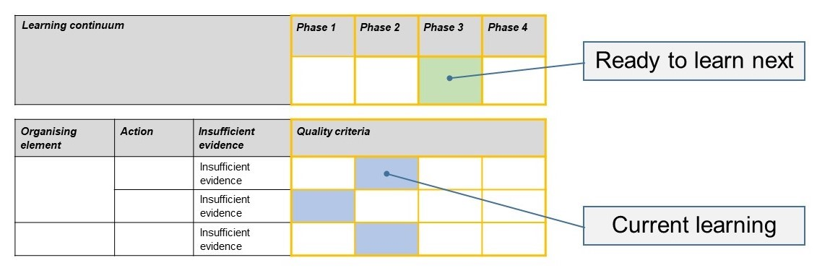
- The phase that the student is ready to learn next was shaded in green.

Please note, the following annotated student work samples are representative examples only.
Setting the scene
This formative assessment task was undertaken by Year 8 and 9 classes across three different schools, including schools in metropolitan and country settings. Students were given 20 minutes to complete the task.
Two samples are taken from a Year 8 enrichment class. Students were shown the rubric at the beginning of a unit of work. During the unit of work they would be taking an inquiry-based approach and they had been tasked with focusing on how data and statistics can be used to affect change. Students were asked to develop their hypothesis prior to the administration of this task.
One sample is taken from a Year 9 class. The task was given at the beginning of the data and statistics topic. It was presented as a real-life scenario and students were given no further information other than some possible areas to research (for example, availability of healthy options, financial viability).

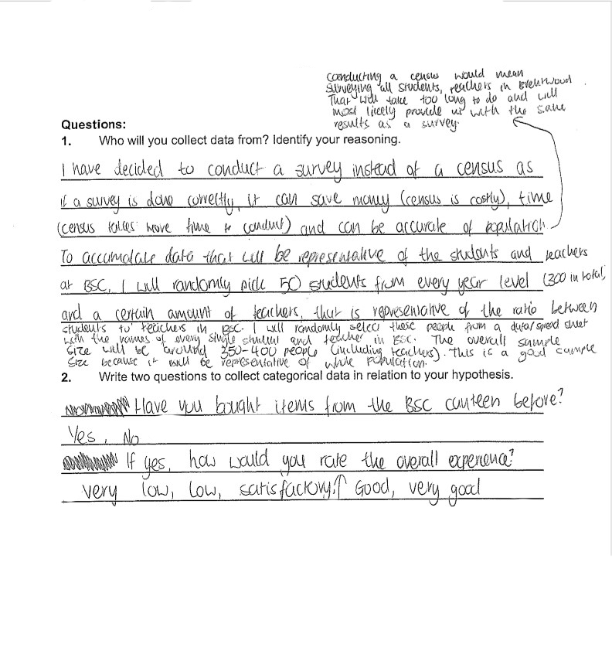
Sample 1

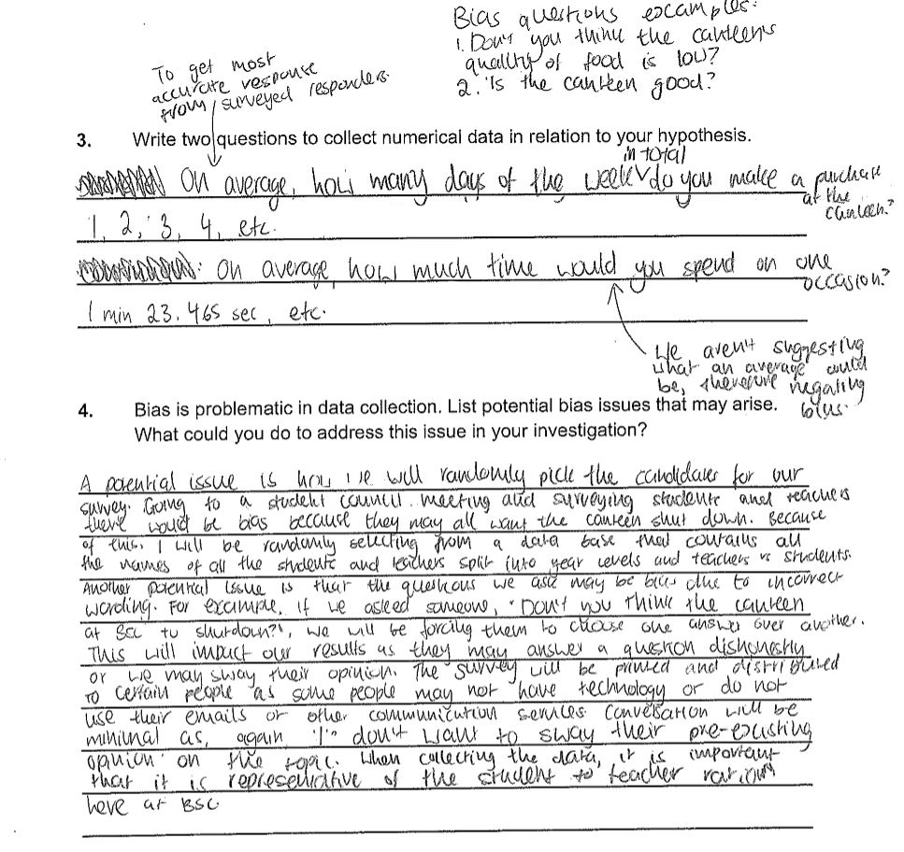

Sample 1: Evidence of student learning

Annotations
- Quality criterion 2.2 – There is evidence of justification for sample, including issues of practicality and costs; however, while a specific sample size was stated, no calculations were present to support this number.
- Quality criterion 3.3 – Student constructed questions that clearly indicated type of data to be collected. The questions did relate to the hypothesis, but it should be noted that the hypothesis is not visible on this task.
- Quality criterion 4.2 – There are multiple examples of proposing strategies to negate bias. Examples include ‘randomly selecting from a database’, ‘mode of collection being paper or using technology’.
Indirect evidence:
- Quality criterion 1.2 – Students were required to develop a hypothesis in a previous lesson. This is not evidenced on the sheet.

What is the student ready to learn next?
The student was assessed as ready to learn Phase 4 next. Specifically, she should focus on calculating sample size and interpreting this value to determine if a survey or a census is most appropriate.
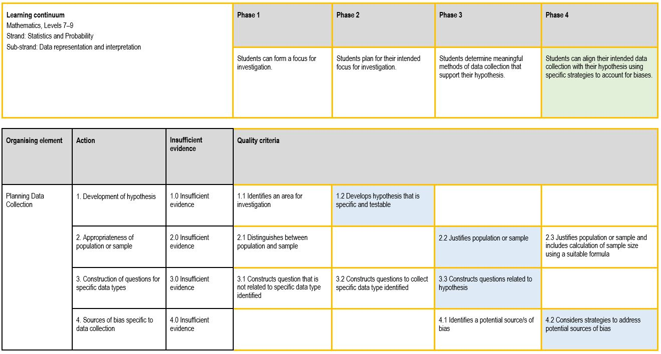
The student has clearly demonstrated an ability to identify sources of bias and is able to develop strategies to minimise their effects. In order to further deepen her understanding and enhance her ability to collect data effectively, she should focus on using sample size calculations to inform her decision about conducting a census or a survey.

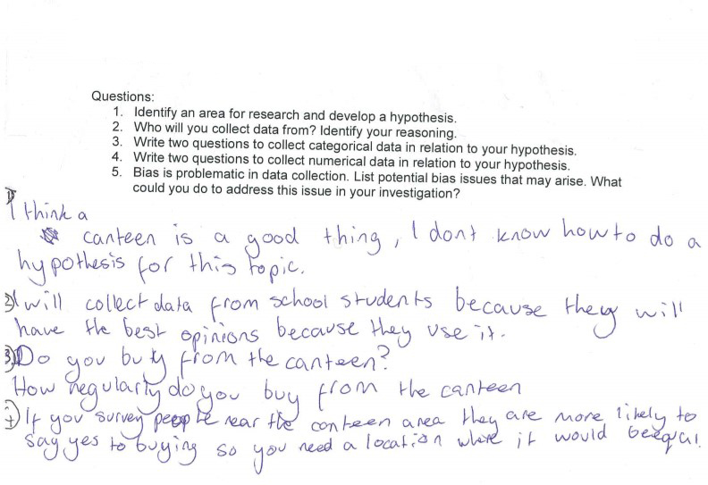
Sample 2

Sample 2: Evidence of student learning

Annotations
- Quality criterion 3.1 – Student wrote questions but there was no evidence he understood different data types.
- Quality criterion 4.2 – The source of bias (location of data collection) was identified and a strategy (change location) was suggested.
Insufficient evidence:
- The student’s answer did not address quality criteria 1.1 or 1.2.
- Question 2 on the original task did not clearly prompt students to address action 2.

What is the student ready to learn next?
The student was assessed as ready to learn Phase 1 next. He will need extensive scaffolding to develop a hypothesis in preparation for his summative assessment piece later in the unit of work. This is especially important to success in collecting data.
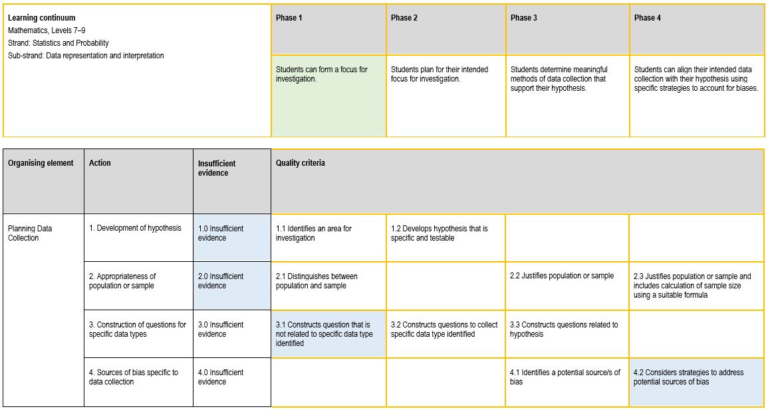

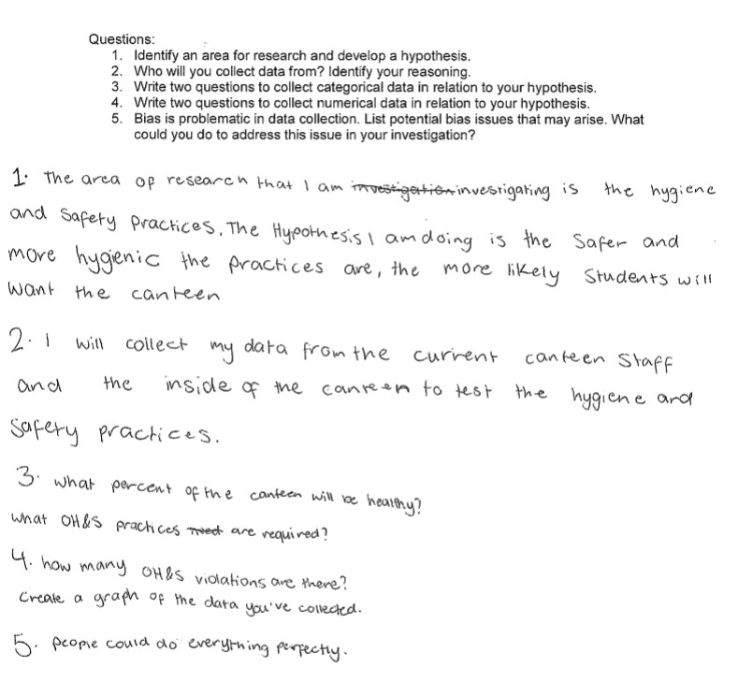
Sample 3

Sample 3: Evidence of student learning

Annotations
- Quality criterion 1.2 – ‘… the safer and more hygienic the practices are, the more likely students will want the canteen’ is specific and testable.
- Quality criterion 2.1 – The wording ‘collect my data from the current canteen staff’ indicates understanding the difference between population and sample, although the question on the original task was deemed to not clearly prompt students to address Action 2.
- Quality criterion 3.1 – The student constructed questions to collect both numerical and categorical data in response to Question 3 on the worksheet. The first question will collect numerical data and the second will collect categorical data.

Insufficient evidence:
- Action 4

What is the student ready to learn next?
The student was assessed as ready to learn Phase 3 next.
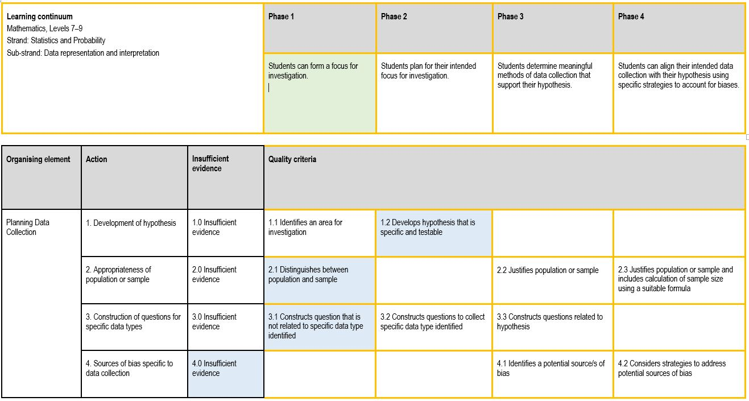

Using evidence to plan for future teaching and learning
The range of results provide an indication for future individual learning needs. Most students were able to demonstrate quality criteria 1.1 and 3.1. Most students will need additional support to gain an understanding of potential sources of bias and how to address these
Minor adjustments were made to the task as the original task did not prompt students to identify the appropriateness of population or sample (action 2).
The formative assessment rubric and refined task will be used with Year 9 students at our schools to track student understanding and lead future teaching.

Appendix 1 – Worksheet

Example scenario:
The school council has asked you to investigate whether or not they should start a school canteen. Before you can begin your investigation, you need to submit a document that shows the scope of your research. The questions below need to be answered and submitted to the school council before they can approve your investigation.
Specific areas for research within this scenario include:
- availability of healthy options
- catering for diverse dietary requirements
- financial viability
- convenience.

Questions:
- Identify an area for research and develop a hypothesis.
- What is the difference between ‘census’ and ‘survey’? Which would be more appropriate to use in your investigation? Justify your reasoning.*
- Write two questions to collect categorical data in relation to your hypothesis.
- Write two questions to collect numerical data in relation to your hypothesis.
- Bias is problematic in data collection. List potential bias issues that may arise. What could you do to address this issue in your investigation?

