**Using formative assessment rubrics in Personal and Social Capability**

****Managing conflict  
Levels 7 and 8

Authorised and published by the Victorian Curriculum and Assessment Authority  
Level 7, 2 Lonsdale Street  
Melbourne VIC 3000

© Victorian Curriculum and Assessment Authority 2019.

No part of this publication may be reproduced except as specified under the *Copyright Act 1968* or by permission from the VCAA. Excepting third-party elements, schools may use this resource in accordance with the [VCAA educational allowance](https://www.vcaa.vic.edu.au/Footer/Pages/Copyright.aspx#schools). For more information go to: <https://www.vcaa.vic.edu.au/Footer/Pages/Copyright.aspx>.

The VCAA provides the only official, up-to-date versions of VCAA publications. Details of updates can be found on the VCAA website: [www.vcaa.vic.edu.au](http://www.vcaa.vic.edu.au).

This publication may contain copyright material belonging to a third party. Every effort has been made to contact all copyright owners. If you believe that material in this publication is an infringement of your copyright, please email the Copyright Officer: [vcaa.copyright@edumail.vic.gov.au](mailto:vcaa.copyright@edumail.vic.gov.au)

Copyright in materials appearing at any sites linked to this document rests with the copyright owner/s of those materials, subject to the Copyright Act. The VCAA recommends you refer to copyright statements at linked sites before using such materials.

At the time of publication the hyperlinked URLs (website addresses) in this document were checked for accuracy and appropriateness of content; however, due to the transient nature of material placed on the web, their continuing accuracy cannot be verified.

The VCAA logo is a registered trademark of the Victorian Curriculum and Assessment Authority.

**Contents**

What is formative assessment? 4

Using formative assessment rubrics in schools 4

The formative assessment rubric 5

Links to the Victorian Curriculum F–10 5

The formative assessment task 7

Description of the task (administration guidelines) 7

Evidence collected from this task 8

Interpreting evidence of student learning 9

Setting the scene 9

Sample 1 10

Sample 1: Evidence of student learning 12

Any feedback given 12

Sample 2 13

Sample 2: Evidence of student learning 15

Any feedback given 15

Using evidence to plan for future teaching and learning 16

Appendix 1: Templates 17

**What is formative assessment?**

Formative assessment is any assessment that is used to improve teaching and learning. Best-practice formative assessment uses a rigorous approach in which each step of the assessment process is carefully thought through.

Assessment is a three-step process by which evidence is collected, interpreted and used. By definition, the final step of formative assessment requires a use that improves teaching and learning.

For the best results, teachers can work together to interrogate the curriculum and use their professional expertise and knowledge of their students to outline a learning continuum including a rubric of measurable, user-friendly descriptions of skills and knowledge. Teachers can draw on this learning continuum and rubric to decide how to collect evidence of each student’s current learning in order to provide formative feedback and understand what they are ready to learn next.

The VCAA’s *Guide to Formative Assessment Rubrics* outlines how to develop a formative assessment rubric to collect, interpret and use evidence of student learning to plan teaching and learning. For more information about formative assessment and to access a copy of the guide, please go to the [Formative Assessment section](https://www.vcaa.vic.edu.au/foundation10/Pages/viccurriculum/formative_assessment.aspx) of the VCAA website.

**Using formative assessment rubrics in schools**

This document is based on the material developed by one group of teachers in the 2019 Formative Assessment Rubrics project. The VCAA acknowledges the valuable contribution to this resource of the following teachers: Angus McLaurin and Caroline Michie (The Alpine School), and Jessica Wade (Elisabeth Murdoch College). The Victorian Curriculum and Assessment Authority partnered with the Assessment Research Centre, University of Melbourne, to provide professional learning for teachers interested in strengthening their understanding and use of formative assessment rubrics.

This resource includes a sample formative assessment rubric, a description of a task/activity undertaken to gather evidence of learning, and annotated student work samples.

Schools have flexibility in how they choose to use this resource, including as:

* a model that they adapt to suit their own teaching and learning plans
* a resource to support them as they develop their own formative assessment rubrics and tasks.

This resource is not an exemplar.

Additional support and advice on high-quality curriculum planning is available from the [Curriculum Planning Resource](http://curriculumplanning.vcaa.vic.edu.au/).

The formative assessment rubric

The rubric in this document was developed to help inform teaching and learning in Personal and Social Capability. This rubric supports the explicit teaching of managing conflict. It focuses on identifying ways to be proactive in initiating strategies to prevent and/or accomplish positive resolutions to conflict

Links to the Victorian Curriculum F–10

**Curriculum area:** Personal and Social Capability

Strand: Collaboration

**Levels/Bands:** Levels 7 and 8

**Achievement standard/s extract:** They assess the appropriateness of various strategies to avoid or resolve conflict in a range of situations.

**Content Description/s:** Identify ways to be proactive in initiating strategies to prevent and/or accomplish positive resolutions to conflict [(VCPSCSO042)](https://victoriancurriculum.vcaa.vic.edu.au/Curriculum/ContentDescription/VCPSCSO042)

|  |  |  |  |  |  |  |  |  |  |
| --- | --- | --- | --- | --- | --- | --- | --- | --- | --- |
| **Learning continuum**  Personal and Social Capability  Strand: Collaboration  Levels 7 and 8 | | | **Phase 1** | | **Phase 2** | **Phase 3** | **Phase 4** | **Phase 5** | **Phase 6** |
| Students can identify conflicts. | | Students can identify causes and effects of conflict and a range of management strategies. | Students can analyse a conflict and apply strategies to manage conflict. | Students can assess a conflict and the appropriateness of conflict management strategies. | Students can modify conflict strategies depending on the situation. | Students can generate and evaluate conflict strategies in a range of contexts. |
|  | | | |
| **Organising element** | **Action** | **Insufficient evidence** | **Quality criteria** | | | | | | |
| Conflict | 1 Evaluates conflict | 1.0 Insufficient evidence | 1.1 Describes a conflict. | | 1.2 Recognises causes and effects of a conflict. | 1.3 Links causes and effects of a conflict. | 1.4 Assesses potential conflict and possible effects. |  |  |
| Conflict prevention and resolution strategies | 2. Assesses conflict prevention strategies | 2.0 Insufficient evidence |  | | 2.1 Outlines prevention strategies. | 2.2 Applies a prevention strategy or strategies. | 2.3 Assesses suitability of prevention strategies in relation to the context. | 2.4 Modifies a prevention strategy or strategies based on context. | 2.5 Justifies an alternate prevention strategy or strategies for a range of contexts. |
| 3. Assesses conflict resolution strategies | 3.0 Insufficient evidence |  | | 3.1 Outlines resolution strategies. | 3.2 Applies a resolution strategy or strategies. | 3.3 Assesses suitability of resolution strategies in relation to the context. | 3.4 Modifies a resolution strategy or strategies based on context. | 3.5 Justifies an alternate resolution strategy or strategies for a range of contexts. |

The formative assessment task

The following formative assessment task was developed to elicit evidence of each student’s current learning and what they are ready to learn next.

Description of the task (administration guidelines)

* Review prior knowledge of conflict management strategies. In small groups, students respond to the following questions:
* What is conflict? Write a definition
* Why does it happen; what are some causes?
* What are the impacts of conflict?
* Is conflict good or bad? Explain
* This task is designed to be completed in approximately 90 minutes. Extra time should be allocated if student groups perform their show.
* Introduce ‘Talent Show’ performance activity:
* Divide students into groups of 4 to 5
* Groups are to perform some kind of skill/talent in 1 to 2 minutes, such as singing or hopping
* Everyone needs to be involved in the performance
* Each group is to choose an item from a pool of items equal to the number of groups
* Each group is to use the item in the performance, but not for its intended use. For example, a ball couldn’t be used to be thrown, but it could be used to represent the world.
* Students work in groups on Talent Show activity for 5 to 7 minutes.
* Stop. Break groups into pairs/threes. Review conflict using the attached reflection worksheet (Appendix 1), as per the following:
* Describe a conflict your group just experienced
* What were the causes of that conflict?
* What impact is that having on the group?
* How could have this conflict been avoided?
* What are some conflicts you may have next?
* How could you solve this new conflict?
* As a class, discuss group reflections and explicitly teach how to assess conflict, and a range of conflict management strategies and how to assess them to fill gaps in student understanding. Conflict management should include strategies to proactively prevent conflict as well as resolve conflict.
* Regroup students into their talent show performance teams and ask each group to decide on a conflict management strategy to apply whilst continuing to work on performance task for another 7 to 10 minutes.
* As a whole class, reflect on the conflict management strategies each group chose to use. Each group shares their reflections with the whole class. Some prompting questions for this discussion include:
* At what times was there potential for conflict in this task? For example:
* How the group was formed?
* How was the item chosen and used?
* How did the group decide what talent to perform?
* How did the group involve reluctant participants?
* How did the group manage different engagement levels?
* How did the group manage fear of performing?
* How was it decided which group member performs when?
* If you didn’t experience any conflict, why was this the case?
* What strategy did you use?
* Was it effective? Why?
* What would you do differently?
* If time, students perform their various skills/talents.
* Individually, students describe a new conflict management strategy learnt today. See Exit Ticket template (Appendix 1). In what situation in future could you use this strategy?

Evidence collected from this task

* Written responses to reflection questions (please note, given there are multiple worksheets collected, perhaps give each student their own coloured worksheets, along with their own envelope to store their responses)
* Observations made during the activity.

Interpreting evidence of student learning

Evidence collected from each student was mapped against the rubric:

* The quality criteria that were achieved was shaded in blue.
* 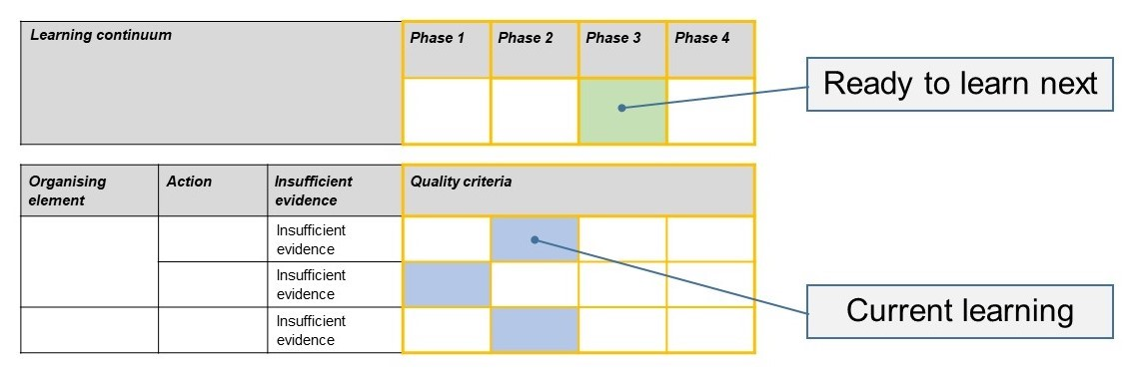The phase that the student is ready to learn next was shaded in green.

Please note, the following annotated student work samples are representative examples only.

Setting the scene

This task was used as a preliminary activity to establish baseline data for the cohort.

The talent show activity was a suitable context for eliciting conflicts for this particular cohort. Front loading of some understanding of conflict and conflict-management strategies were added to the activity to allow students to express their understanding of conflict more effectively.

In our school, the information from this activity was used to predict potential opportunities for skill building and to identify areas to strengthen for group working activities. Further explicit teaching of conflict management and contexts would follow this task. Note the focus is on student thinking and reflection rather than the ‘talent show’.

Sample 1

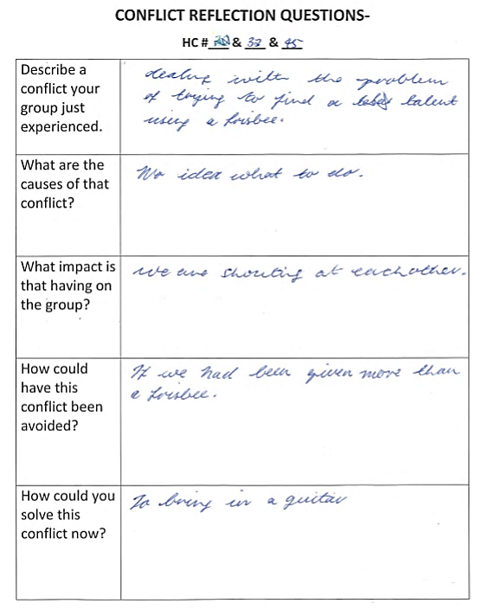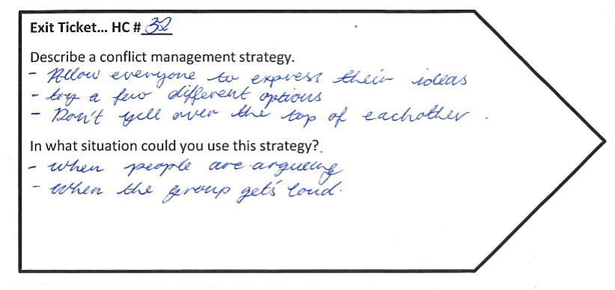

Sample 1: Evidence of student learning

Annotations

* 1.2 The student lists a cause and impact (effect) but does not directly link causes and effects.
* 3.2 The student suggested one strategy for prevention and several strategies for resolution and applied one strategy (see indirect evidence).

Insufficient evidence:

* 2.0 There was insufficient evidence that the student understood how aligning resources and talents (having more than a Frisbee or bringing in a guitar) could manage conflict in this context nor that some of the strategies listed could be used for prevention as well as resolution.

Indirect evidence:

* Supporting 3.2: It was observed that the student asked her group to stop and form a circle to discuss ideas when they were not moving forward in their discussions.

What is the student ready to learn next?

Sample 1 shaded rubricIn this task, the student has expressed the Phase 2 criteria on balance and is ready to learn Phase 3. Further discussion and observation may be required to confirm the ‘next learning phase’.

Any feedback given

In future learning activities, I would encourage the student to justify the use of particular strategies and consider the context of the conflict and how changes may impact on the strategy used.

Sample 2

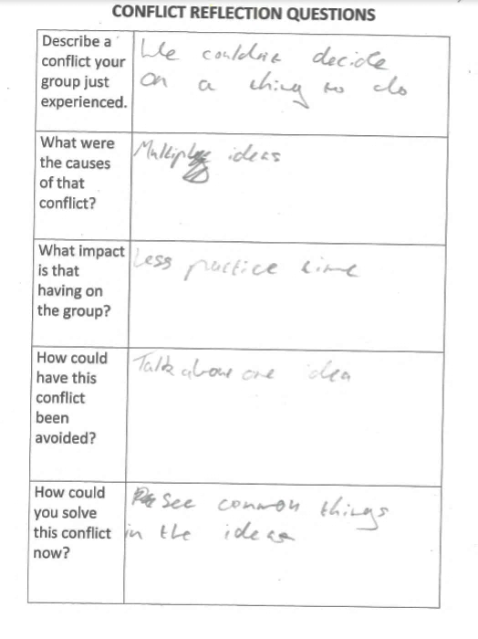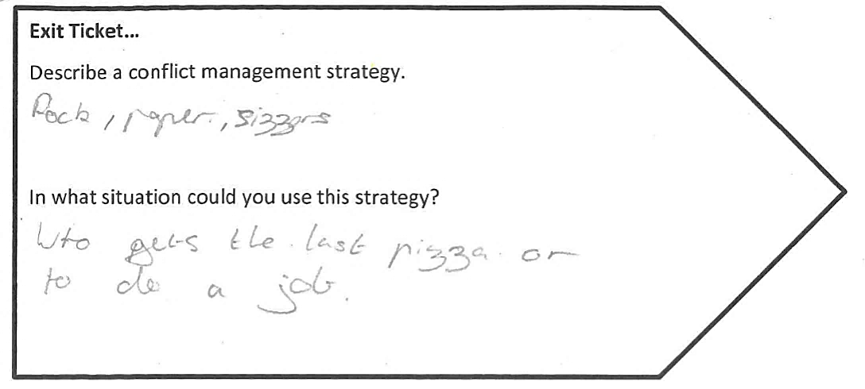

Sample 2: Evidence of student learning

Annotations

* 1.3 The student linked having multiple ideas to decreased practice time.
* 2.2 Talking about one idea and seeing common things in the ideas indicates that he is applying and reflecting on a prevention strategy (see indirect evidence).
* 3.2 A resolution strategy is listed which reflects understanding of its use in a low stakes context.

Indirect evidence:

* In support of 2.2: Observed application of ‘talking about one idea’ as a resolution and prevention strategy.

What is the student ready to learn next?

Sample 2 shaded rubricThe student has shown the application of strategies and can actively reflect on conflict strategies and link them to context. The student is ready to learn Phase 4.

Any feedback given

The student should continue to communicate his responses in a linked fashion as it demonstrates depth of understanding for an idea. His next step could be to record multiple ideas and expand on them in his ‘linked’ fashion and consider explicitly how context will influence a choice of strategies.

Using evidence to plan for future teaching and learning

The data provided information about the relative knowledge and skills of students in the cohort. It allowed the teacher to provide more individualised questioning and feedback on both this task and to support future learning about conflict and prevention.

Teacher reflections

* The exit ticket questions were modified for clarity after the collection of work samples.

Appendix 1: Templates

**Conflict resolution questions**

|  |  |
| --- | --- |
| Describe a conflict your group just experienced. |  |
| What were the causes of that conflict? |  |
| What impact is that having on the group? |  |
| How could have this conflict been avoided? |  |
| What are some conflicts you may have next? |  |
| How could you solve this new conflict? |  |

**Exit Ticket…**

Describe a new conflict management strategy learnt today.

In what situation could you use this strategy in future?