Using formative assessment rubrics in Health and Physical Education

Invasion, net/wall, striking and fielding games

Levels 7 to 10

Authorised and published by the Victorian Curriculum and Assessment Authority
Level 7, 2 Lonsdale Street
Melbourne VIC 3000
© Victorian Curriculum and Assessment Authority 2019.

No part of this publication may be reproduced except as specified under the Copyright Act 1968 or by permission from the VCAA. Excepting third-party elements, schools may use this resource in accordance with the VCAA educational allowance. For more information go to: https://www.vcaa.vic.edu.au/Footer/Pages/Copyright.aspx.
The VCAA provides the only official, up-to-date versions of VCAA publications. Details of updates can be found on the VCAA website: www.vcaa.vic.edu.au.
This publication may contain copyright material belonging to a third party. Every effort has been made to contact all copyright owners. If you believe that material in this publication is an infringement of your copyright, please email the Copyright Officer: vcaa.copyright@edumail.vic.gov.au
Copyright in materials appearing at any sites linked to this document rests with the copyright owner/s of those materials, subject to the Copyright Act. The VCAA recommends you refer to copyright statements at linked sites before using such materials.
At the time of publication the hyperlinked URLs (website addresses) in this document were checked for accuracy and appropriateness of content; however, due to the transient nature of material placed on the web, their continuing accuracy cannot be verified.

The VCAA logo is a registered trademark of the Victorian Curriculum and Assessment Authority.

Contents
The formative assessment rubric 5
Links to the Victorian Curriculum F–10 5
The formative assessment task 8
Description of the task (administration guidelines) 8
Evidence collected from this task 10
Formative Assessment Tasks 11
Task 1: Target kicking 11
Task 2: Partner passing 12
Task 3: Corner passing 13
Task 4: Four corners 14
Task 5: Consecutive passes (three versus one) 15
Task 6: Endzone (three versus three or four versus four) 16
Setting the scene 17
Action 1: Performs movement skills 18
Action 2: Uses movement strategies 18
Action 3: Solves movement challenges 18
Using evidence to plan for future teaching and learning 19

What is formative assessment?
Formative assessment is any assessment that is used to improve teaching and learning. Best-practice formative assessment uses a rigorous approach in which each step of the assessment process is carefully thought through.
Assessment is a three-step process by which evidence is collected, interpreted and used. By definition, the final step of formative assessment requires a use that improves teaching and learning.
For the best results, teachers can work together to interrogate the curriculum and use their professional expertise and knowledge of their students to outline a learning continuum including a rubric of measurable, user-friendly descriptions of skills and knowledge. Teachers can draw on this learning continuum and rubric to decide how to collect evidence of each student’s current learning in order to provide formative feedback and understand what they are ready to learn next.
The VCAA’s Guide to Formative Assessment Rubrics outlines how to develop a formative assessment rubric to collect, interpret and use evidence of student learning to plan teaching and learning. For more information about formative assessment and to access a copy of the guide, please go to the Formative Assessment section of the VCAA website.

Using formative assessment rubrics in schools
This document is based on the material developed by one group of teachers in the 2018/19 Formative Assessment Rubrics project. The VCAA acknowledges the valuable contribution to this resource of the following teachers: Alister Stuart (Lilydale High School), Hilary Gilbert (Brunswick Secondary College) and Noel Skehan (Sacred Heart College Yarrawonga). The Victorian Curriculum and Assessment Authority partnered with the Assessment Research Centre, University of Melbourne, to provide professional learning for teachers interested in strengthening their understanding and use of formative assessment rubrics.
This resource includes a sample formative assessment rubric, a description of a task/activity undertaken to gather evidence of learning, and annotated student work samples.
Schools have flexibility in how they choose to use this resource, including as:
- a model that they adapt to suit their own teaching and learning plans
- a resource to support them as they develop their own formative assessment rubrics and tasks.
This resource is not an exemplar.
Additional support and advice on high-quality curriculum planning is available from the Curriculum Planning Resource.

The formative assessment rubric
The rubric in this document was developed to help inform teaching and learning in Health and Physical Education. This rubric supports the explicit teaching of Physical Education in a unit with a focus on invasion, net/wall, striking and fielding games or in a sport based unit such as football, soccer, volleyball, softball. The example tasks provided are designed to formatively assess students in an invasion game, however, the rubric can be used to assess movement skills, strategies and challenges in a variety of games and sports.
The rubric is designed to assess student ability to perform movement skills, use movement strategies and solve movement challenges, with the intention that each row in the rubric can be used independent to each other.

Links to the Victorian Curriculum F–10

Curriculum area: Health and Physical Education
Strand: Movement and Physical Activity
Sub-strand: Moving the body and Learning through movement
Levels/Bands: Levels 7 to 10
Achievement standard/s extract: Level 7 and 8:
Students demonstrate control and accuracy when performing specialised movement skills. They apply and refine movement concepts and strategies to suit different movement situations. They apply the elements of movement to compose and perform movement sequences.
Level 9 and 10:
Students apply and transfer movement concepts and strategies to new and challenging movement situations. They apply criteria to make judgments about and refine their own and others’ specialised movement skills and movement performances. They work collaboratively to design and apply solutions to movement challenges.
Content Description/s: Levels 7 and 8:
Use feedback to improve body control and coordination when performing specialised movement skills (VCHPEM133)

Practise, apply and transfer movement concepts and strategies (VCHPEM135)
Evaluate and justify reasons for decisions and choices of action when solving movement challenges (VCHPEM140)
Levels 9 and 10:
Perform and refine specialised movement skills in challenging movement (VCHPEM152)
Develop, implement and evaluate movement concepts and strategies for successful outcomes (VCHPEM154)
Transfer understanding from previous movement experiences to create solutions to movement challenges (VCHPEM159)

Learning continuum  Health and Physical Education  Levels 7 to 10  Strand: Movement and Physical Activity |  |  | Phase 1 | Phase 2 | Phase 3 | Phase 4
 |  |  | Students perform movement skills in isolation. | Students perform movement skills in structured situations. | Students apply and refine movement skills and strategies to suit different movement situations. | Students transfer movement skills and strategies into a range of different movement situations.
Organising element | Action | Insufficient evidence | Quality criteria
Movement skills | 1 Performs movement skills | 1.0 Insufficient evidence | 1.1 Practise fundamental movement skills in isolation with prescribed technique. | 1.2 Demonstrates movement skills in structured situations. | 1.3 Apply movement skills to a modified game situation. | 1.4 Perform movement skills with technique in pressure situations.
Movement concepts | 2 Uses movement strategies | 2.0 Insufficient evidence | 2.1 Follows instructions to perform a set strategy in isolation. | 2.2 Implement different movement strategies in structured situations. | 2.3 Select and apply movement strategies in a game context. | 2.4 Construct, apply and refine movement strategies in a game context.
Movement challenges | 3 Solves movement challenges | 3.0 Insufficient evidence | 3.1 React to cues and select a strategy. | 3.2 Attend to cues to solve structured movement challenges. | 3.3 Select a solution to movement challenges using cues in a game situation. | 3.4 Reflect on past game situations to solve movement challenges.

Key: Different tasks have been designed to assist teachers to assess the skills across the phases in this formative assessment rubric.
Task | Designed to assess quality criteria
1 and 2 | 1.1
3 | 1.2, 2.1 and 3.1
4 and 5 | 2.2 and 3.2
5 and 6 | 1.3
6 and 7 | 2.3, 2.4, 3.3 and 3.4
7 | 1.4

The formative assessment task
The following formative assessment task was developed to elicit evidence of each student’s current learning and what they are ready to learn next.

Description of the task (administration guidelines)

Delivery
- The formative assessment tasks can be used to assess students in Years 7 to10.
- Teachers are advised to begin assessing students using Task 4.
- If there are students who are unable to demonstrate the skills required to successfully complete this task, reassess their ability using Task 1, 2 or 3, depending on their perceived ability level.
- Students who can demonstrate the skills in Task 4 should be assessed using Tasks 5, 6 or 7.
- This will allow teachers to determine a starting point for each student from which their learning can be progressed. The time spent on each task will be dependent on the skill level of your students. If students are demonstrating proficiency in the task, progress them to a more challenging situation. Students should remain on the task if they have not demonstrated proficiency and teaching and learning activities to develop the skills implemented. Students will be demonstrating their ability in different quality criteria; this may mean that you will have different students or groups completing different tasks at the same time.
- The task is designed to give the students opportunity to demonstrate where they are on the learning continuum. If there is insufficient evidence to ensure the student has demonstrated the criteria, then they should not be assessed with subsequent tasks.
- Once a student’s level of proficiency is established, teachers need to develop a teaching and learning program that will allow the student to develop the skills to progress along the learning continuum.
- The assessment tasks can be used at regular intervals throughout the teaching and learning program to monitor student progression and continue to give them feedback to support them to progress.
Considerations
- The example provided is based on the skills and game strategies involved in soccer, but can be adapted to cater for different movement skills, sports and games.
- The task and rubric can be used at the start, and throughout a unit to determine student progression. The evidence collected can then inform entry points for students as they attempt other units in physical education.

Support strategies when using formative assessment in Physical Education
Some suggestions to assist with delivering the assessment task and assessing students include:
Grouping students on perceived ability
Teachers could use prior knowledge of students’ performance of past activities to develop ability groups that allow you to pitch the task to the appropriate level depending on your cohort of students.
Team teaching with a colleague
Teachers could work with a colleague to complete the assessment. One teacher would instruct the class to complete the task while the other teacher completes the assessment using the rubric.
Direct observation and or video recording
Teachers could use a spread sheet to record student achievement of the quality criteria as they observe students performing the tasks during class or video student performance for reviewing and assessing at a later date.
Use of questioning, freeze play and teachable moments
Teachers could use questioning, freeze play and teachable moments to establish students level of proficiency. See examples in task 2 and 4.
Glossary
The following glossary terms have been extracted from the glossary for Health and Physical Education.
Fundamental movement skills (FMS)
Provide the foundation for competent and confident participation in a range of physical activities. The fundamental movement skills to be developed through Health and Physical Education include:
- locomotor and non-locomotor skills — rolling, balancing, sliding, jogging, running, leaping, jumping, hopping, dodging, galloping, skipping, floating and moving the body through water to safety
- object control skills — bouncing, throwing, catching, kicking, striking.
Movement challenges
Movement tasks that require individual students or groups of students to solve a problem in order to successfully complete the task.
Movement concepts and strategies
These provide a framework for enhancing movement performance. Movement concepts (or elements of movement) explored in the curriculum include body awareness; spatial awareness; effort awareness; and relationship to/with objects, people and space. Movement strategies refer to a variety of approaches that will help a player or team to successfully achieve a movement outcome or goal. Movement strategies include moving into space to receive a pass from a team-mate or hitting the ball away from opponents in order to make it difficult to retrieve or return the ball. Different games and sports may require similar activities or goals and will therefore use similar movement strategies in order to achieve success.
Movement skills
Movement skills that are required in more organised games and activities. Examples of specialised movement skills include fielding a ground ball in softball, climbing a rock wall and performing a grapevine step in dance.
Reference
Breed, R., & Spittle, M. (2011). Developing game sense through tactical learning: A resource for teachers and coaches. Cambridge University Press.

Evidence collected from this task
- Teacher observation
- Video recording.

Formative Assessment Tasks

Task 1: Target kicking
A structured drill that involves the performance of a FMS in isolation.
The student kicks a stationary ball to a stationary target. The teacher or student selects the target from options of increasing difficulty, such as:
- soccer goal (7.32 metres wide)
- 5 metres wide
- 3 metres wide
- 1 metre wide
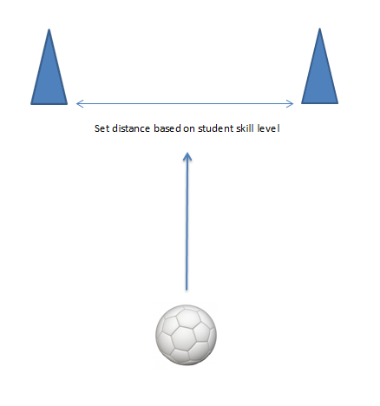
- a single cone.

Task 2: Partner passing
A structured drill that involves the performance of a movement skill in isolation. The student demonstrates specific movement skills such as kicking, trapping or passing by passing and receiving a ball with a partner.
- Students stand opposite their partner at a set distance.
- One student stands between two cones spaced 1.5 metres apart. The student is able to move between the cones.
- The other student passes the ball to their partner who must receive the ball within the allocated space (1.5m).
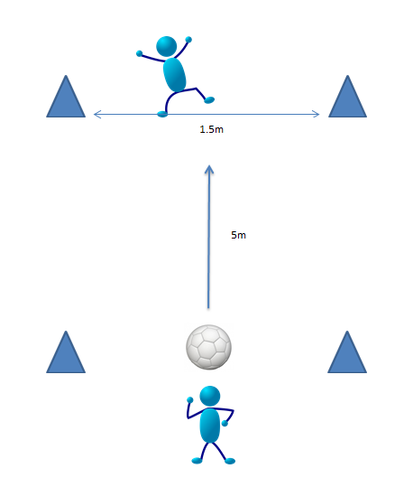
- The passing distance can be increased to challenge competent students.

Task 3: Corner passing
A structured activity that allows students to perform movement skills in a predictable environment (knowing where to run and where to pass), with some variability in conditions (speed of player moving to receive ball, speed of ball).
- In groups of three, a 5 x 5 m grid is set up. Each student starts by standing on a different corner. One corner is empty.
- One student starts with the ball.
- Students without the ball can move to the empty corner to receive the ball.
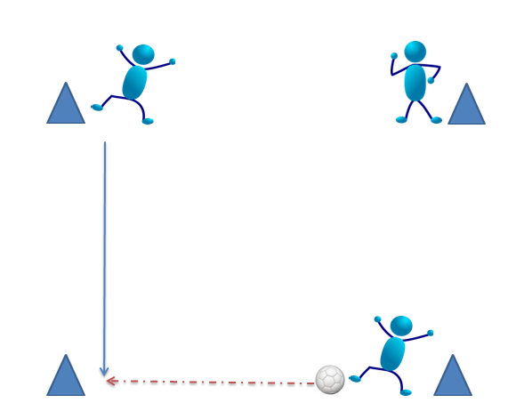
- The ball must not be passed diagonally and students cannot run diagonally to reach an empty corner.

Task 4: Four corners*
* Teachers are advised to begin assessing students using Task 4.
A minor game that allows students to perform movement skills in a semi-structured environment that either represents or exaggerates a tactical strategy, such as ‘stack the attack’ or ‘draw the defender’.
- Students work in groups of four in a 5 x 5 m grid
- Three attackers start on a corner each. One corner is empty.
- One defender starts in the middle of the square.
- The three attackers aim to pass the ball and keep possession.
- The ball must not be passed diagonally.
- After each pass, an attacker must run to the vacant corner (they cannot run diagonally), giving the passer only two options.
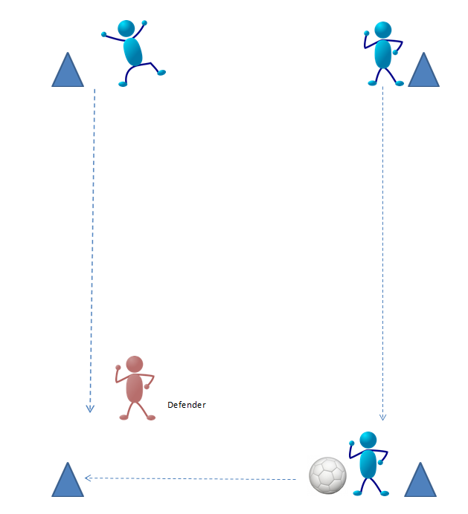
- After 20 to 30 seconds, swap the defender.
Throughout the activity, questioning can be used to collect evidence of each student’s understanding of movement strategies and solving movement challenges.
- What is the best type of pass to use?
- When should the attackers move to the vacant corner?
- What was the best way to defend?
- How can you relate this to another invasion game?
This task is based on Breed and Spittle, 2011, page 95.

Task 5: Consecutive passes (three versus one)
- A modified game that allows students to perform movement skills in a semi-structured, open environment, to demonstrate the use of movement strategies to solve movement challenges. Students work in groups of four (three attackers, 1 defender).
- The offensive team is working as a team to get as many consecutive passes (movement challenge) as possible by moving around the allocated space.
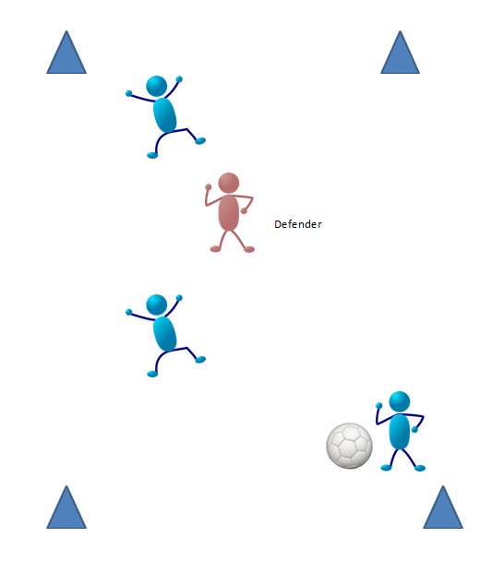
- Students swap roles after an allocated time or if an intercept is made.

Tasks 4 and 5 may be used to assess students against the movement skills quality criteria as well as the movement strategies and challenges criteria. Teachers should be looking for a student’s ability to uses different strategies such as drawing the defender, moving into space, dummy/fake pass, one-on-one defense etc. Additionally, the student’s ability to select the most appropriate pass and where to move to maintain possession, based on their interpretation of the cues presented in the situation can also be determined through this task.

Task 6: Endzone (three versus three or four versus four)
A game situation that allows students to demonstrate the movement skills and strategies needed to achieve the outcome of the game, such as ‘keeping possession’ or ‘scoring goals’.
- The game is played on approximately a third to a half of a netball court.
- Only the attacking players are allowed in the ‘endzone’.
- If the ball is passed into the endzone, the attacking team immediately attack going in the other direction.
- If the ball is turned over, the ball goes back to the centre and play starts again with the attacking team.
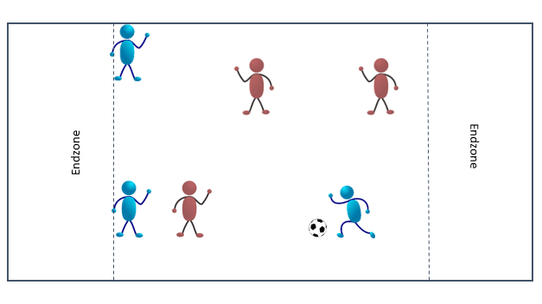
- Teams swap roles after a set period of time.
Throughout the activity, questioning can be used to collect evidence of each student’s understanding of movement strategies and solving movement challenges.
- How can you work as a team to create space?
- What type of defence did you use?
- Was it effective?
- How else could you have defended?
- Is it better for the attacking team to move the ball quickly or slowly?
- Why does slow movement make it easier for the defenders?
This task is based on Breed and Spittle, 2011, page 103.

Setting the scene
The following work samples were collected from a Year 9 class in a Government Secondary school in eastern metropolitan Melbourne.
The following videos provide evidence of students performing some of skills outlined in each action in the rubric. The videos provide a snapshot to help inform other teachers about how to distinguish different levels of performance across the quality criteria in their class. No phase is indicated for individual students in these work samples.
Note that evidence of learning is at the upper end of the rubric. This is not unexpected for students in Year 9 as it is likely students at this year level will be progressing toward the Level 10 achievement standard. The video provides only a short excerpt of footage for quality criteria 3.4. No example is provided for 2.4 as this is a complex skill and may require multiple observations across a number of performances/activities.

Action 1: Performs movement skills
Within the examples shown, students demonstrate the ‘throw’ in Ultimate Frisbee. Accuracy in passing, consistency and control are observed in the students who are ready to learn at Phase 4.
See Put formative assessment rubrics into practice in Health and Physical Education –Invasion, net/wall, striking and fielding games Levels 7–10.

Action 2: Uses movement strategies
Within the examples shown, students demonstrate a range of different movement strategies to know when to pass (draw the defender, one-on-one defending), and where to move to receive the pass (move into space, move away from the defender).
See Put formative assessment rubrics into practice in Health and Physical Education –Invasion, net/wall, striking and fielding games Levels 7–10.

Action 3: Solves movement challenges
Within the examples shown, students work to solve movement challenges under different conditions. In Task 3, the challenge for the defender is to intercept the Frisbee; Task 4 is to keep possession; Task 5 is for the maximum number of consecutive passes. In Task 6, the challenge is to get the Frisbee into the Endzone.
See Put formative assessment rubrics into practice in Health and Physical Education –Invasion, net/wall, striking and fielding games Levels 7–10.

Using evidence to plan for future teaching and learning
The use of the formative assessment rubric will allow teachers to determine where students are in their learning and to structure teaching and learning activities to optimally challenge each student within the class.
Based on the data collected, students in this class ranged from Phase 1 through to Phase 4. This is not unexpected or uncommon. The challenge for teachers is to design activities that will allow each student to progress in their learning. The formative assessment rubric assists to teachers to establish what it is that students are ready to learn next.
Students who are at Phase 1 need activities that allow for the development of movement skills before they will be able to apply these skills in semi-structured or game like environments. If thrown into games situations, it is unlikely that these students will be able to participate fully or contribute to the successful outcome of the activity.
Conversely, students who are ready to learn at Phase 4 will not engage with activities that do not challenge them, such as practicing movement skills in isolation. These students need to be provided with opportunities to solve more complex movement challenges and to think strategically about how to successfully achieve the desired outcome of the activity or game.
In a class setting, this may involve the use of a variety of activities. These can be that either self-selected by students or teacher directed. It is critical that each activity is progressed as students achieve success. With small-sided activities, students should be focusing on their own performance, seeking and implementing feedback from the outcomes of the task, their peers and the teacher to further refine and develop their movement skills, strategies and to solve movement challenges.

