Using formative assessment rubrics in Science

Scientific questioning

Levels 5 to 8

Authorised and published by the Victorian Curriculum and Assessment Authority
Level 7, 2 Lonsdale Street
Melbourne VIC 3000
© Victorian Curriculum and Assessment Authority 2019.

No part of this publication may be reproduced except as specified under the Copyright Act 1968 or by permission from the VCAA. Excepting third-party elements, schools may use this resource in accordance with the VCAA educational allowance. For more information go to: https://www.vcaa.vic.edu.au/Footer/Pages/Copyright.aspx.
The VCAA provides the only official, up-to-date versions of VCAA publications. Details of updates can be found on the VCAA website: www.vcaa.vic.edu.au.
This publication may contain copyright material belonging to a third party. Every effort has been made to contact all copyright owners. If you believe that material in this publication is an infringement of your copyright, please email the Copyright Officer: vcaa.copyright@edumail.vic.gov.au
Copyright in materials appearing at any sites linked to this document rests with the copyright owner/s of those materials, subject to the Copyright Act. The VCAA recommends you refer to copyright statements at linked sites before using such materials.
At the time of publication the hyperlinked URLs (website addresses) in this document were checked for accuracy and appropriateness of content; however, due to the transient nature of material placed on the web, their continuing accuracy cannot be verified.

The VCAA logo is a registered trademark of the Victorian Curriculum and Assessment Authority.

Contents
What is formative assessment? 4
Using formative assessment rubrics in schools 4
The formative assessment rubric 5
Links to the Victorian Curriculum F–10 5
The formative assessment task 7
Description of the task (administration guidelines) 7
Evidence collected from this task 8
Interpreting evidence of student learning 9
Setting the scene 9
Sample 1 10
Sample 1: Evidence of student learning 10
Any feedback given 11
Sample 2 12
Sample 2: Evidence of student learning 12
Any feedback given 13
Using evidence to plan for future teaching and learning 14
Teacher reflections 14
Setting the scene 15
Sample 3 16
Sample 3: Evidence of student learning 16
Any feedback given 17
Sample 4 18
Sample 4: Evidence of student learning 18
Any feedback given 19
Using evidence to plan for future teaching and learning 20
Teacher reflections 20

What is formative assessment?
Formative assessment is any assessment that is used to improve teaching and learning. Best-practice formative assessment uses a rigorous approach in which each step of the assessment process is carefully thought through.
Assessment is a three-step process by which evidence is collected, interpreted and used. By definition, the final step of formative assessment requires a use that improves teaching and learning.
For the best results, teachers can work together to interrogate the curriculum and use their professional expertise and knowledge of their students to outline a learning continuum including a rubric of measurable, user-friendly descriptions of skills and knowledge. Teachers can draw on this learning continuum and rubric to decide how to collect evidence of each student’s current learning in order to provide formative feedback and understand what they are ready to learn next.
The VCAA’s Guide to Formative Assessment Rubrics outlines how to develop a formative assessment rubric to collect, interpret and use evidence of student learning to plan teaching and learning. For more information about formative assessment and to access a copy of the guide, please go to the Formative Assessment section of the VCAA website.

Using formative assessment rubrics in schools
This document is based on the material developed by one group of teachers in the 2019 Formative Assessment Rubrics project. The VCAA acknowledges the valuable contribution to this resource of the following teachers: Belinda Scott (Gisborne Primary School) and Kate McLeod (Rangeview Primary School). The Victorian Curriculum and Assessment Authority partnered with the Assessment Research Centre, University of Melbourne, to provide professional learning for teachers interested in strengthening their understanding and use of formative assessment rubrics.
This resource includes a sample formative assessment rubric, a description of a task/activity undertaken to gather evidence of learning, and annotated student work samples.
Schools have flexibility in how they choose to use this resource, including as:
- a model that they adapt to suit their own teaching and learning plans
- a resource to support them as they develop their own formative assessment rubrics and tasks.
This resource is not an exemplar.
Additional support and advice on high-quality curriculum planning is available from the Curriculum Planning Resource.

The formative assessment rubric
The rubric in this document was developed to help inform teaching and learning in Science. This rubric supports the explicit teaching of the Science inquiry skill of questioning.
This formative assessment rubric is designed to provide teachers with information about student’s ability to:
- identify a topic
- pose a scientific question.
This rubric does not include the assessment of prediction. Whilst you are likely to teach predication in conjunction with questioning, the purpose of this rubric is to focus on the ability of students to select a topic and pose a question.

Links to the Victorian Curriculum F–10

Curriculum area: Science
Strand: Science Inquiry Skills
Sub-strand: Questioning and predicting
Levels/Bands: Levels 5 to 8
Achievement standard/s extract: Levels 5 and 6:
Students follow procedures to develop questions they can investigate.
Levels 7 and 8:
Students identify and construct questions and problems that they can investigate scientifically.
Content Description/s: Levels 5 and 6:
With guidance, pose questions to clarify practical problems or inform a scientific investigation, and predict what the findings of an investigation might be based on previous experiences or general rules (VCSIS082).
Levels 7 and 8:
Identify questions, problems and claims that can be investigated scientifically and make predictions based on scientific knowledge (VCSIS107).

Learning continuum  Science  Levels 5 to Level 8.  The learning continuum is based on:  Strand: Science Inquiry Skills  Sub Strand: Questioning and predicting |  |  | Phase 1 | Phase 2 | Phase 3 | Phase 4
 |  |  | With guidance, students can identify closed questions about a given topic. | With guidance, students can identify cause and effects in problems and create open-ended questions about a given topic. | Students can independently formulate open-ended related to a given scientific topic. | Students can independently pose questions about a given topic that can be investigated scientifically.
Organising element | Action | Insufficient evidence | Quality criteria
Questioning | 1 Posing questions for investigating | 1.0 Insufficient evidence | 1.1 Asks closed questions. | 1.2 Responds to scaffold to produce open-ended questions. | 1.3 Independently formulates open-ended questions.
 | 2 Identifying a specific question for investigation | 2.0 Insufficient evidence | 2.1 Responds to scaffolding to identify a question about a given topic. | 2.2 Responds to scaffolding to identify the causes and effects of a problem related to a given topic. | 2.3 Independently identifies the causes and effects of a problem related to a given topic. | 2.4 Independently formulates a cause-and-effect question relevant to the given topic.

The formative assessment task
The following formative assessment task was developed to elicit evidence of each student’s current learning and what they are ready to learn next.

Description of the task (administration guidelines)

Students were explicitly taught:
- a scientific question can be answered and explained through direct observations or through scientific investigations (not just used for data collection)
- how to write a scientific question through modelling
- the difference between closed and open questions using examples
- how to use a mind map to organise thoughts and ideas
- how to identify cause and effect in a topic.
Instructions:
- Introduce the topic and explain the learning intention and success criteria. Say:
‘Today we are learning what a scientific question is. We know we have learnt this if we can identify a problem and create a scientific question to be investigated.’
- Introduce and explain the concept of ‘cause and effect’ on the specific topic. Students practise identifying cause and effect as a class or small group.
- As a class, discuss the difference between a closed and an open-ended question. Provide examples for students to identify the difference in language and question construction, between questions with a yes/no answer and questions that investigate cause and effect.
- Model how to create a mind map with multiple questions on a single topic.
- Ask students create a mind map with questions they could investigate on the topic.
- Explain what a scientific question is.
- Model writing a scientific question not related to current topic, for example: Does sunscreen with a higher SPF value block more UV light than a sunscreen with a lower SPF value? What is the fastest route to school?
- Students identify questions, including cause and effect, about the topic from their mind map and refine them into scientific questions that could be investigated.
Considerations
- Students will need to have an understanding of the topic, including any important concepts or terminology such as ‘cause and effect’, before the task is administered.
- Students may identify and create questions verbally, they may require their ideas scribed, or they can write independently. Assessing students’ literacy skills is not the focus of this task.
- If students are finding identifying or creating questions difficult, provide support according to their needs.

Evidence collected from this task
- Students mind maps
- Student scientific question to be investigated.

Interpreting evidence of student learning
Evidence collected from each student was mapped against the rubric:
- The quality criteria that were achieved was shaded in blue.
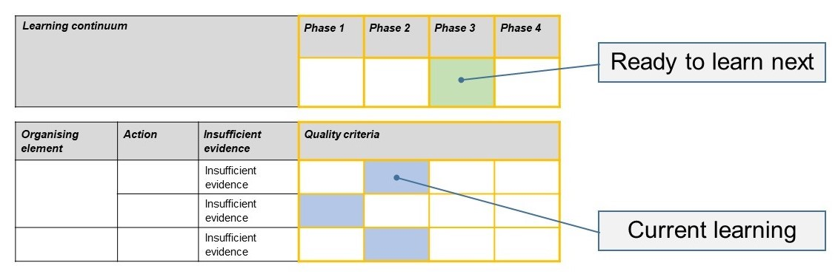
- The phase that the student is ready to learn next was shaded in green.

Please note, the following annotated student work samples are representative examples only.

Setting the scene
- The following work samples were collected from students in a Year 5-6 class in an outer metropolitan primary school.
- When introducing the activity, students were reminded of links to the current inquiry unit being undertaken during the previous three weeks. The students had been working on the topic ‘Future Transport Problems’ and were well immersed in the inquiry unit.
- Students were given the learning intention and success criteria.
- The concept of cause and effect was introduced and explained in relation to the specific topic. Some ideas were written on the whiteboard and students were then given the opportunity to practise identifying cause and effect in small groups.
- The task fits with the teaching and learning plan of our school. A priority this year is to improve student outcomes with a focus on assessment in Science. This includes activities and professional learning to increase teacher confidence and consistency when assessing students. Formative assessment has been identified as a tool to support and strengthen student voice and agency. To increase engagement, students were not told they were being ‘assessed’ and teacher modelling occurred prior to the task including use of a video to describe the characteristics of a good scientific question.
- The duration of the task was 45 minutes.
- One student with hearing impairment ensured she was sitting at the front of the class.

Sample 1
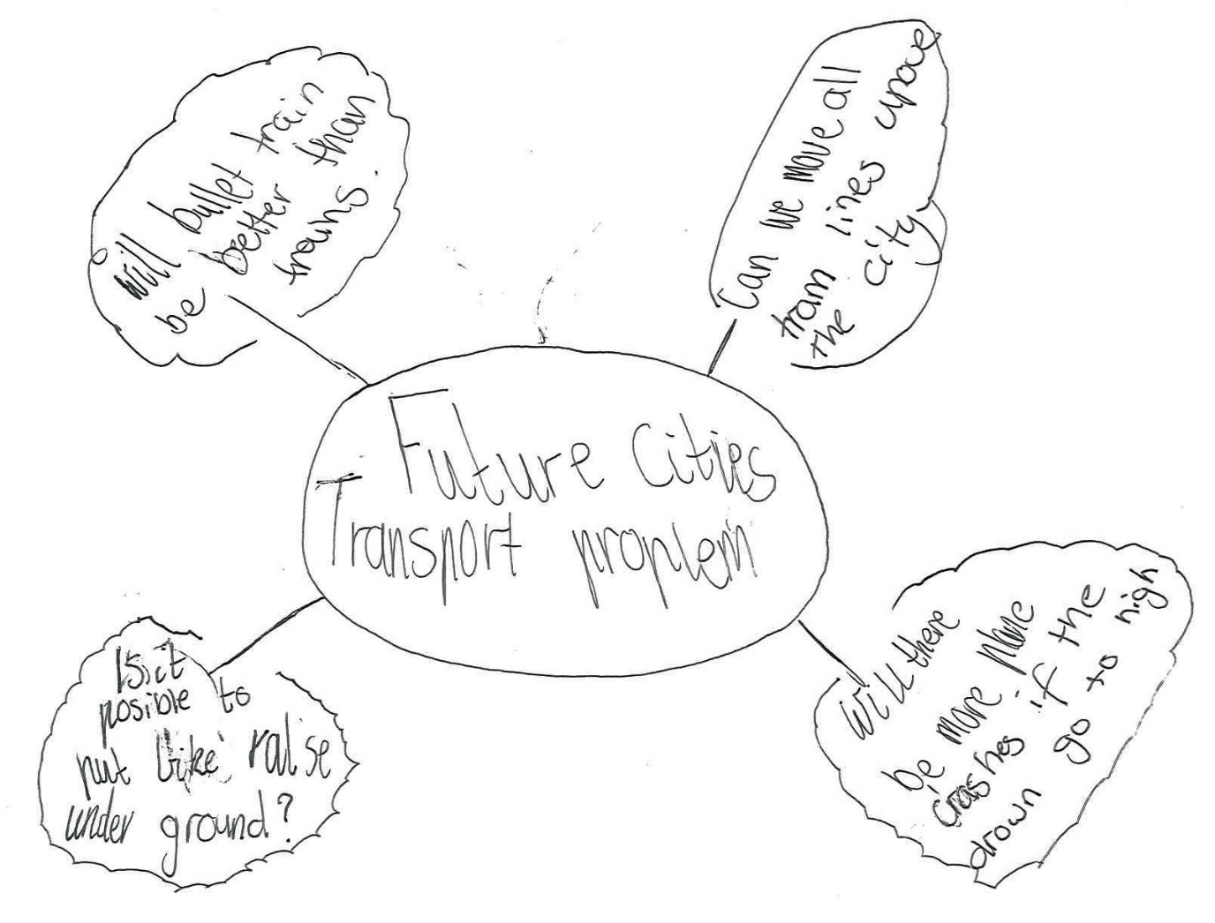

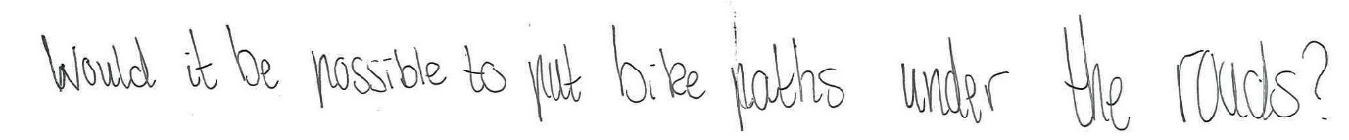
Sample 1: Evidence of student learning

Annotations
- 1.1 This student was only able to ask a closed question.
- 2.1 This student was only able to identify a question about the topic with scaffolding.
Indirect evidence:
- I provided scaffolding for this student by speaking with them one-to-one. They were not able to move any further than Phase 1 on the learning continuum even with prompting.

What is the student ready to learn next?
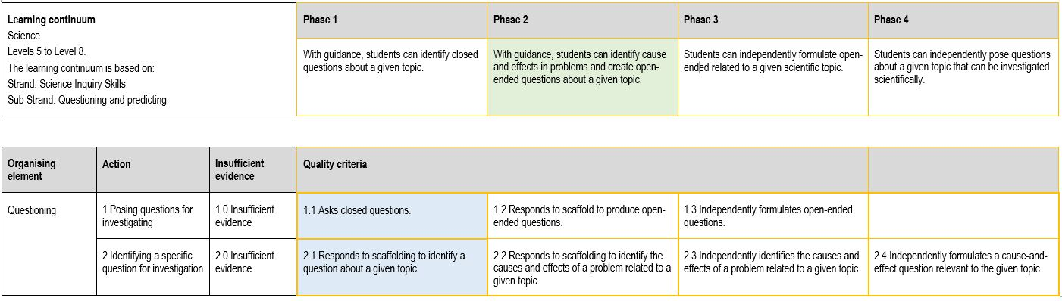
In the sample of student work, the student was able to show me their knowledge of quality criteria for Phase 1 and so is ready to learn Phase 2 of the learning continuum. This will include activities to practise and consolidate the ability to identify cause and effect or create an open-ended question.

Any feedback given
When the task was complete, I spoke with this student asking them to tell me some of the cause and effect problems that arise from the topic ‘future transport problems’. I suggested that they could use brainstorming as a strategy to help them to identify these before formulating a question.

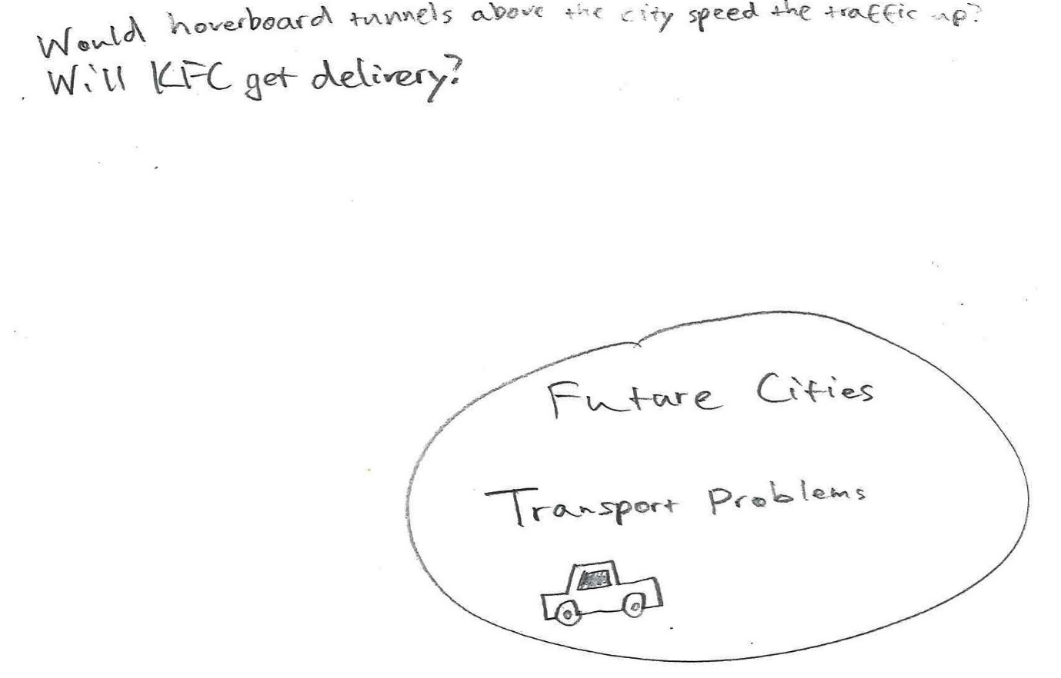
Sample 2

Sample 2: Evidence of student learning

Annotations
- 1.3 This student was able to formulate a scientific open-ended question independently.
- 2.3 This student was able to independently identify causes and effects related to the unit topic and reflect this in an open-ended scientific question.
Indirect evidence:
- I observed this student independently talking to other students about the topic, discussing causes and effects and possible scientific questions they could use.

What is the student ready to learn next?
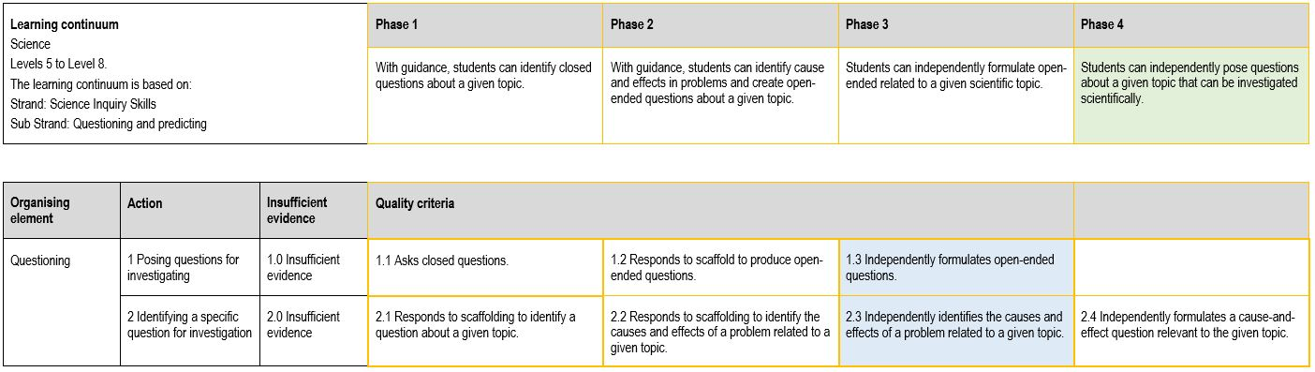
In the sample of student work, this student was the only student able to demonstrate Phase 3 on the rubric. To extend their learning, the student will be encouraged to consider how their question could be investigated scientifically and encouraged to refine their questions based on the investigation type chosen.

Any feedback given
When the task was complete, I spoke with this student and asked them to clarify why the final scientific question was important in relation to the topic of Future Transport Problems. Feedback to the student was that they had successfully identified causes and effects of the topic and formulated an open-ended scientific question.

Using evidence to plan for future teaching and learning
- The data showed that most students could formulate an open-ended question about the topic with assistance but that more scaffolding and support would allow them to be able to create a scientific question about the topic independently.
- This information could be used to plan a subsequent learning activity for the class for this area of the curriculum by showing the areas that challenge the students and allowing the teacher to identify the range of learning requirements for students.
- The results showed that my students needed further scaffolding and practise with identifying causes and effects about the topic. I planned to revisit this before moving on to the questioning requirement.
- The information also showed that a small group of students needed explicit instruction to understand the difference between open and closed questions and I would need to create a short activity to address this.

Teacher reflections
- I feel that it is important not to advise students that they are being assessed until after the task so that the formative assessment is a true indication of ability.
- I would like to convert the formative assessment rubrics into ‘kid speak’ so that students could complete a self-assessment after the task.

Setting the scene
- The following work samples were collected from a Year 6 class in a regional Government school. Formative assessment fits in with the school’s priority to increase student voice and agency.
- The learning intention and success criteria of the lesson were explained to students prior to the task.
- Students were asked to explain what they thought an open-ended and closed question was. Examples were provided and students were told to identify which question was closed and which question was open-ended.
- A short video clip was used to help explain what a scientific question is. Using the example from the clip, I modelled writing a scientific question that was not related to the topic, for example, the question ’How do plants grow?’ was discussed and refined to ‘What does a lavender seed need to grow into a healthy young plant?’.
- A list of natural disasters was brainstormed by the class and written on the board for students to refer to. Students were asked to choose a natural disaster and identify questions they would like to investigate about the natural disaster. They were then asked to create a scientific question that they will investigate.
- Students were at the beginning of the unit and had only been immersed in the topic for a couple of weeks. Students had learnt about natural disasters in previous years, so assumptions were made that they had a good understanding of some of the natural disasters.
- The task was planned for one 60 minute lesson, however on reflection this would have been better delivered across two lessons. Modelling of creating a mind map was required to support student understanding of the task.

Sample 3

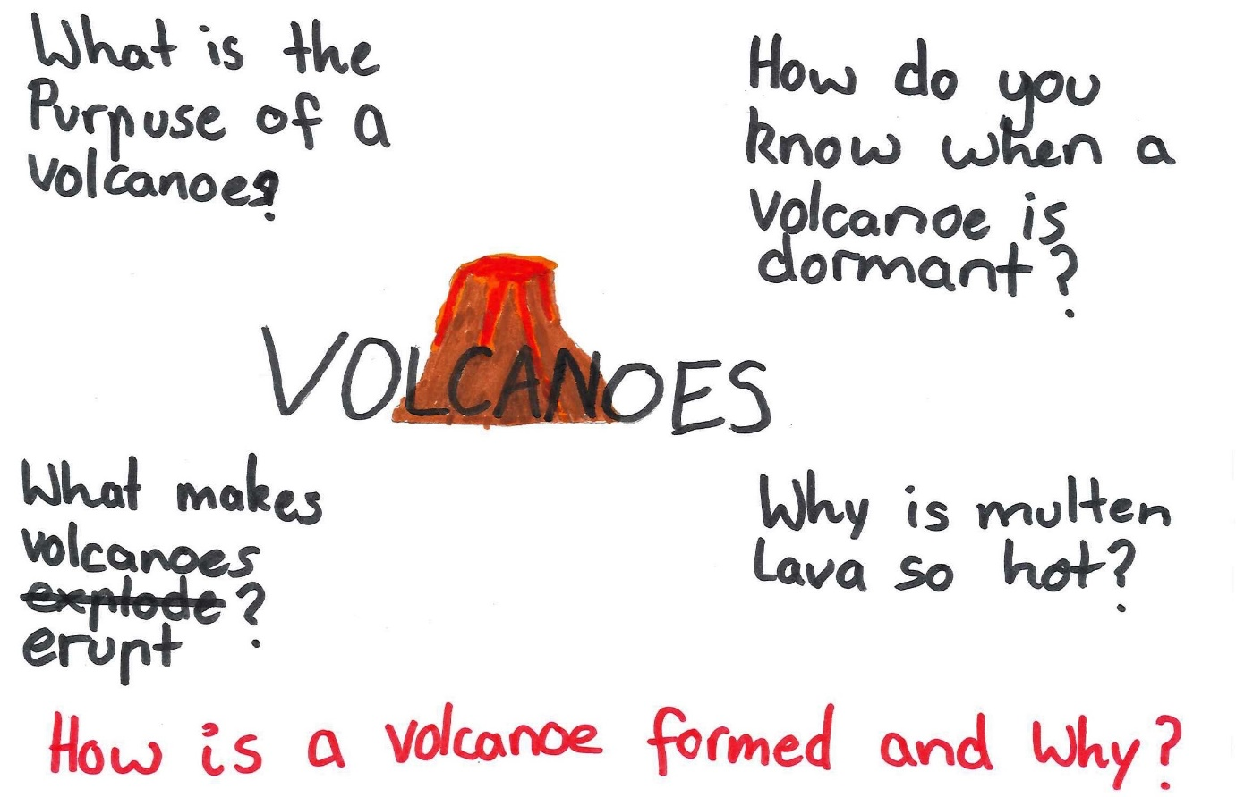
Sample 3: Evidence of student learning

Annotations
- This student was marked at 1.3 because they could identify a range of open-ended questions independently in their mind map and could include a scientific question: What makes volcanoes erupt?
- They were marked at 2.1 because when choosing one specific scientific question to investigate (shown in red), they provided an open-ended question relating to the topic, however it did not focus on cause and effect. Although it was open ended, it was not a specific scientific question.
Indirect evidence:
- No additional support was given to this student after the explicit teaching and modelling of the task.

What is the student ready to learn next?
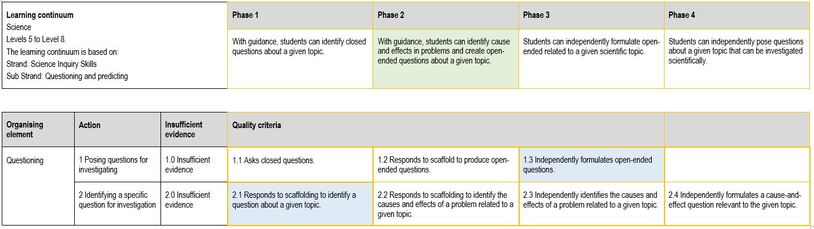
This student was assessed at being ready to learn Phase 2. This is because, although the student can brainstorm open-ended questions, some which were scientific, they were not able to identify cause and effect issues around volcanoes. This student also needs support in refining a question into a specific scientific question.

Any feedback given
I commented that the question about what makes volcanoes erupt was more scientific because it was more specific and could be investigated with experiments to get an understanding of volcanoes. The student did not have time to refine the question. Next steps would be to go back and refine the wording of the question.

Sample 4

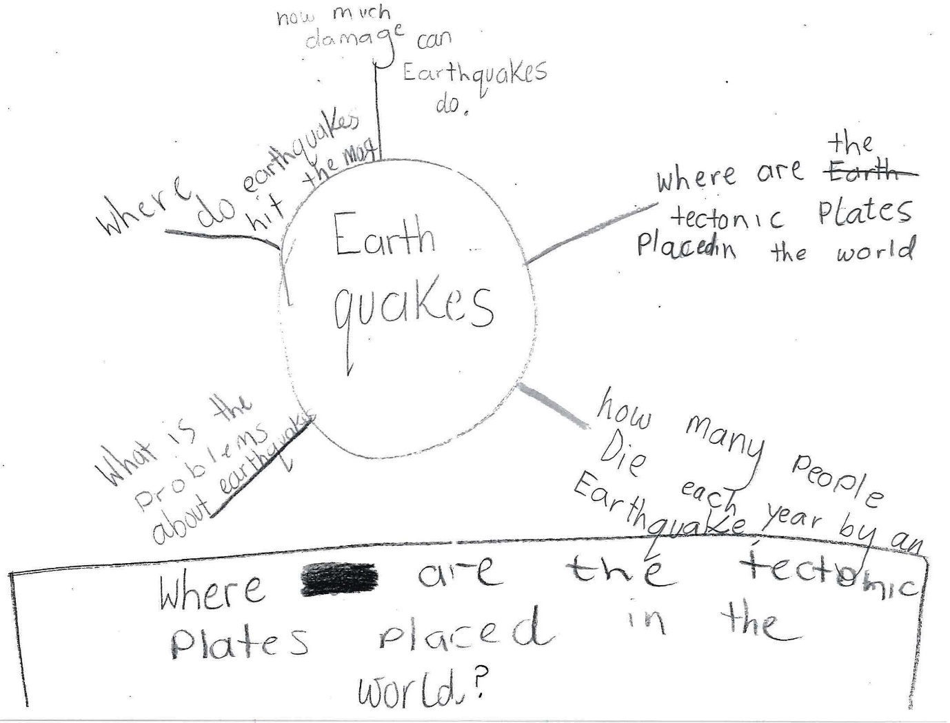
Sample 4: Evidence of student learning

Annotations
- This student was marked at 1.2 because the student could identify some closed and open-ended questions about earthquakes. The questions were not scientific and the student required scaffolding throughout the process.
- They were marked at 2.1 because when choosing one specific scientific question to investigate (shown in the box at the bottom of the page), they chose a closed question that was not open-ended or scientific and did not link to cause and effect.
Indirect evidence:
- The student required questioning prompts such as: What do I want to know about earthquakes? What could I investigate using an experiment? How can this question be more open-ended?

What is the student ready to learn next?
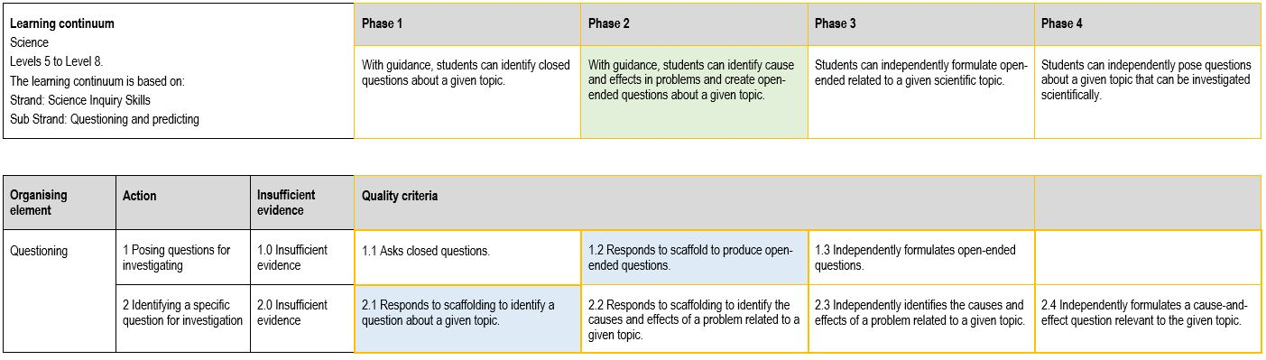
This student was assessed at being ready to learn Phase 2. This is because, although they can brainstorm open-ended questions, they were not able to identify cause and effect issues around earthquakes. This student also needs support in refining a question into a specific, scientific question.

Any feedback given
The feedback I would provide to this student would be to ask themselves if their question is something that could be investigated using an experiment and whether it is possible to reword the question starting with ‘how’ or ‘what’?

Using evidence to plan for future teaching and learning
- The data showed that students had a good understanding of what an open-ended and closed question was. Most students could create an open-ended question about the topic with scaffolding. However, further scaffolding was needed to support learning on how to develop scientific questions in order to be able to do it independently.
- Upon reflection of the data and work samples, lessons that explicitly teach the cause and effect of topics and how to formulate questions around this is required. Students need further support in refining open-ended questions into scientific questions.

Teacher reflections
- This process has shown me how effective rubrics can be that are also teacher friendly. Focusing on learning in one area of the Science curriculum gives a very clear picture of students understanding and knowledge.
- I have already begun to write and develop other rubrics with teachers in my school and have used my experience with this one to pass my knowledge onto other staff during Professional Learning sessions. Feedback from staff at my school indicates that all teachers are willing to develop simple yet targeted rubrics for a variety of areas.
- After developing and administering the task and rubric, I can clearly see how effective this would be in other areas of the curriculum such as literacy and numeracy.
- I feel more confident in creating assessments and assessing students in different areas of the curriculum. My understanding of the curriculum has also increased based on my learning during this Professional Learning. Understanding how to break down the curriculum will assist me to plan and to support learning for all students.

