**Using formative assessment rubrics in Science**

The relationship between the

Sun, Moon and Earth

Levels 3 to 6



Authorised and published by the Victorian Curriculum and Assessment Authority  
Level 7, 2 Lonsdale Street  
Melbourne VIC 3000

© Victorian Curriculum and Assessment Authority 2019.

No part of this publication may be reproduced except as specified under the *Copyright Act 1968* or by permission from the VCAA. Excepting third-party elements, schools may use this resource in accordance with the [VCAA educational allowance](https://www.vcaa.vic.edu.au/Footer/Pages/Copyright.aspx#schools). For more information go to: <https://www.vcaa.vic.edu.au/Footer/Pages/Copyright.aspx>.

The VCAA provides the only official, up-to-date versions of VCAA publications. Details of updates can be found on the VCAA website: [www.vcaa.vic.edu.au](http://www.vcaa.vic.edu.au).

This publication may contain copyright material belonging to a third party. Every effort has been made to contact all copyright owners. If you believe that material in this publication is an infringement of your copyright, please email the Copyright Officer: [vcaa.copyright@edumail.vic.gov.au](mailto:vcaa.copyright@edumail.vic.gov.au)

Copyright in materials appearing at any sites linked to this document rests with the copyright owner/s of those materials, subject to the Copyright Act. The VCAA recommends you refer to copyright statements at linked sites before using such materials.

At the time of publication the hyperlinked URLs (website addresses) in this document were checked for accuracy and appropriateness of content; however, due to the transient nature of material placed on the web, their continuing accuracy cannot be verified.

The VCAA logo is a registered trademark of the Victorian Curriculum and Assessment Authority.

**Contents**

The formative assessment rubric 5

Links to the Victorian Curriculum F–10 5

The formative assessment task 7

Description of the task (administration guidelines) 7

Night and Day Model 7

Evidence collected from this task 8

Interpreting evidence of student learning 9

Setting the scene 9

Sample 1 10

Sample 1: Evidence of student learning 11

Any feedback given 11

Sample 2 12

Sample 2: Evidence of student learning 13

Sample 3 14

Sample 3: Evidence of student learning 15

Sample 4 16

Sample 4: Evidence of student learning 17

Using evidence to plan for future teaching and learning 18

Teacher reflections 18

Appendix 1: Earth, Moon and Sun handout 19

**What is formative assessment?**

Formative assessment is any assessment that is used to improve teaching and learning. Best-practice formative assessment uses a rigorous approach in which each step of the assessment process is carefully thought through.

Assessment is a three-step process by which evidence is collected, interpreted and used. By definition, the final step of formative assessment requires a use that improves teaching and learning.

For the best results, teachers can work together to interrogate the curriculum and use their professional expertise and knowledge of their students to outline a learning continuum including a rubric of measurable, user-friendly descriptions of skills and knowledge. Teachers can draw on this learning continuum and rubric to decide how to collect evidence of each student’s current learning in order to provide formative feedback and understand what they are ready to learn next.

The VCAA’s *Guide to Formative Assessment Rubrics* outlines how to develop a formative assessment rubric to collect, interpret and use evidence of student learning to plan teaching and learning. For more information about formative assessment and to access a copy of the guide, please go to the [Formative Assessment section](https://www.vcaa.vic.edu.au/foundation10/Pages/viccurriculum/formative_assessment.aspx) of the VCAA website.

**Using formative assessment rubrics in schools**

This document is based on the material developed by one group of teachers in the 2019 Formative Assessment Rubrics project. The VCAA acknowledges the valuable contribution to this resource of the following teachers: Alex Furphy (Gisborne Primary School) and Nicole Sadler (St Aloysius Primary School Queenscliff). The Victorian Curriculum and Assessment Authority partnered with the Assessment Research Centre, University of Melbourne, to provide professional learning for teachers interested in strengthening their understanding and use of formative assessment rubrics.

This resource includes a sample formative assessment rubric, a description of a task/activity undertaken to gather evidence of learning, and annotated student work samples.

Schools have flexibility in how they choose to use this resource, including as:

* a model that they adapt to suit their own teaching and learning plans
* a resource to support them as they develop their own formative assessment rubrics and tasks.

This resource is not an exemplar.

Additional support and advice on high-quality curriculum planning is available from the [Curriculum Planning Resource](http://curriculumplanning.vcaa.vic.edu.au/).

The formative assessment rubric

The rubric in this document was developed to help inform teaching and learning in Science. This rubric supports the explicit teaching of the relationship between the Sun, Moon and Earth.

This formative assessment rubric is designed to provide teachers with information about what students are currently demonstrating in relation to their knowledge of the Sun, Moon and Earth relationship. It is designed to enable students to show that they can:

* explain the day/night cycle.
* model how the Earth, Sun and Moon interact in this cycle.

Please note this rubric does not assess the skills component of the Science Curriculum. However the suggested task could be used to also assess the creation of a labelled diagram.

Links to the Victorian Curriculum F–10

**Curriculum area:** Science

Strand: Earth and space sciences

**Levels/Bands:** Levels 3 to 6

**Achievement standard/s extract:** Levels 3 and 4

Students explain the effects of Earth’s rotation on its axis.

Levels 5 and 6

Students use models to describe the key features of our Solar System. Students explain everyday phenomena associated with the absorption, reflection and refraction of light.

**Content Description/s:** Levels 3 and 4

Earth’s rotation on its axis causes regular changes, including night and day [(VCSSU061)](https://victoriancurriculum.vcaa.vic.edu.au/Curriculum/ContentDescription/VCSSU061).

Levels 5 and 6

Earth is part of a system of planets orbiting around a star (the Sun) [(VCSSU078)](https://victoriancurriculum.vcaa.vic.edu.au/Curriculum/ContentDescription/VCSSU078).

Light from a source forms shadows and can be absorbed, reflected and refracted [(VCSSU080)](https://victoriancurriculum.vcaa.vic.edu.au/Curriculum/ContentDescription/VCSSU080).

|  |  |  |  |  |  |  |  |
| --- | --- | --- | --- | --- | --- | --- | --- |
| **Learning continuum**  Science  Levels 3 to 6  Strand: Earth and space sciences | | | **Phase 1** | **Phase 2** | **Phase 3** | **Phase 4** | **Phase 5** |
| Students can demonstrate understanding that Earth is part of system with moving parts. | Students can demonstrate understanding that whilst the Sun remains still, the Earth rotates about its own axis. | Students can demonstrate understanding that night happens on the ‘shadow’ side of the Earth because even though the Earth is smaller than the Sun its proximal distance stops light from falling on its ‘shadow’ side. | Students demonstrate understanding that time is related to the orbital cycles of the Earth and Moon. | Students can demonstrate understanding that different places on Earth experience different lengths of light and darkness depending on their distance from the Sun caused by the Earth’s spherical shape its tilt and orbit around the Sun. |
|  | | | | | | | |
| **Organising element** | **Action** | **Insufficient evidence** | **Quality criteria** | | | | |
| Earth’s day/night cycle | 1 Explores the Sun/Earth/Moon system relationship | 1.0 Insufficient evidence | 1.1 Models that the Sun and Earth and Moon are part of a system. | 1.2 Models that the Earth, Moon and Sun are round (spherical). | 1.3 Compares the relative sizes and distances of the Sun, Earth and Moon. |  | 1.4 Explains how objects such as the Sun can look smaller when they are further away. |
| 2 Explores the movement of the Earth, Sun and Moon | 2.0 Insufficient evidence | 2.1 Identifies that the Sun is stationary while the Earth and Moon move. |  | 2.2 Explain that the Moon travels in an orbit around the Earth. | 2.3 Identifies that the Earth travels in an (elliptical) orbit around the Sun. | 2.4 Describes how the Earth’s tilt increases or decreases the distance from the Sun for certain places on Earth. |
| 3 Links Earth’s rotation on its axis to time | 3.0 Insufficient evidence |  | 3.1 Links a full rotation of the Earth to one calendar day. | 3.2The Earth’s axis is an invisible line that runs north to south. | 3.3 Outlines that the Earth’s tilt affects the amount of light and shadow falling on any given place (on Earth) at any given time. | 3.4 Relates that world time is a human construct and can be changed without changing the Earth/Sun/Moon relationship. |
| 4. Examines the night and day cycle | 4.0 Insufficient evidence | 4.1 Describes how the Sun’s shadow cast by Earth is night and the Sun’s light is day. |  | 4.2 Describes how the Sun’s shadow cast by Earth is night. | 4.3 Identifies that the Moon is not required for night to occur and is only visible from Earth due to the reflected light from the Sun. | 4.4 Explains that not all places on Earth receive the same amount of light or shadow because of the Earth’s tilt. |

The formative assessment task

The following formative assessment task was developed to elicit evidence of each student’s current learning and what they are ready to learn next.

Description of the task (administration guidelines)

This assessment task can be used before learning, during learning and after learning to inform planning and teaching of concepts.

Night and Day Model

**Resources:**

* Plasticine
* Earth, Moon and Sun handout (Appendix 1)
* Toothpicks
* String
* Camera and or digital device to take photos of student work and record any verbal responses.

**Considerations for implementation:**

* Make sure the plasticine is in ‘bars’ rather than blobs so that students are not directed towards spherical shapes rather they can make them themselves.
* Have toothpicks and string available for students to use should they need to show rotation and tilt.
* Familiarise yourself with the rubric and teacher guidelines.
* Collect student work through photos and/or recordings.
* Use the rubric to identify students level of knowledge in the written work and to support the follow-up conversation.
* It is expected that the duration of assessment is 60 minutes. Allow at least 30 minutes for model completion. Prepare a follow up activity so that individual follow up conversations can occur in the final 30 minutes.
* If students need further time this should be allowed.
* Don’t engage in further explanations until each student has had at least 30 minutes to complete the model element of the task.

**Instructions for administration of the task:**

1. Verbal instructions to students:

*Today I would like you to show me what you know about how day and night happens by creating a labelled model of the Sun, Moon and Earth. I am going to give you some plasticine and a worksheet that you can draw on if you need to. I also have some toothpicks and string if these help you to explain what you know. I want you to include as much detail as you can. You have approximately 30 minutes to create you model, if you need more time that’s okay. When you have finished make sure you take some time to answer the questions at the bottom of the handout. At the end you will have time to explain your model to me.*

1. Hand out worksheets and plasticine.
2. Monitor students to ensure they complete the task independently.
3. After 30 minutes, direct students to the alternative task and meet with each student individually to discuss their model.
4. Use rubric and guiding questions while speaking with students to record their understanding.

**Follow-up conversation starters:**

The following prompts are provided to assist teachers to elicit more information about what students know by exploring what they wrote, drew or made using the plasticine. Teachers may add their own prompt in relation to student response. The purpose is to allow the student the opportunity to tell you what they know about the topic.

Start the conversation with each student with *‘What can you show me about the Earth, Moon and Sun relationship today?’*

Further prompt if needed *‘What else do you know about day and night?’*

If there is not sufficient evidence of quality criteria 1.2, 1.4 or 2.4 after student’s explanation ask: *‘Is there any other movement you want to show me?’*

If there is not sufficient evidence for quality criteria 2.5, 3.2, 3.5 after student’s explanation ask: *‘Do you know anything about the earth’s axis and tilt?’*

If there is not sufficient evidence for quality criteria 3.3 and 3.4 after student’s explanation ask: *‘What do you know about how Sun, Moon and Earth relationship affects time?’*

If there is not sufficient evidence for quality criteria 4.2 and 4.4 after student’s explanation ask: *‘What do you know about the moon?’*

If there is not sufficient evidence for quality criteria 4.3 after student’s explanation ask: *‘How do we get night?’*

If there is not sufficient evidence for quality criteria 4.5 after student’s explanation ask: *‘Is night the same for everyone?’*

If the student demonstrates that the Sun is larger than the earth, prompt them with the question: *“If the Sun is bigger than the Earth why does it look smaller to us?”* to identify their knowledge of quality criteria 2.3.

Evidence collected from this task

* Written work and photograph of model
* Video recording of student/teacher conversation

Interpreting evidence of student learning

Evidence collected from each student was mapped against the rubric:

* The quality criteria that were achieved was shaded in blue.
* 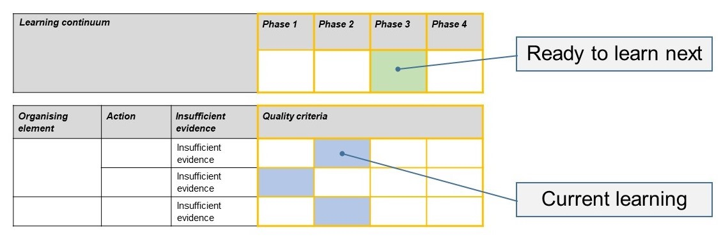The phase that the student is ready to learn next was shaded in green.

Please note, the following annotated student work samples are representative examples only.

Setting the scene

* The following work samples were collected from a Grade 5 class. Science is taught at this school as a dedicated specialist subject. The school promotes itself as a science of school excellence.
* The teacher implemented the task according to the task description. The teacher also elected to film follow-up conversations with the students, and this footage has also been provided with these samples. The footage can be used to understand how indirect evidence can be gathered by asking a set of probing questions to support assessment of what the students know and can do.

[Using formative assessment rubrics in Science – Task example](https://www.vcaa.vic.edu.au/assessment/f-10assessment/formative-assessment/formative-assessment-rubric-samples/Pages/SciencePrimarySamples.aspx)

* The samples were collected as pre-assessment at the end of Term 2 in anticipation of the following Term’s unit.

Sample 1

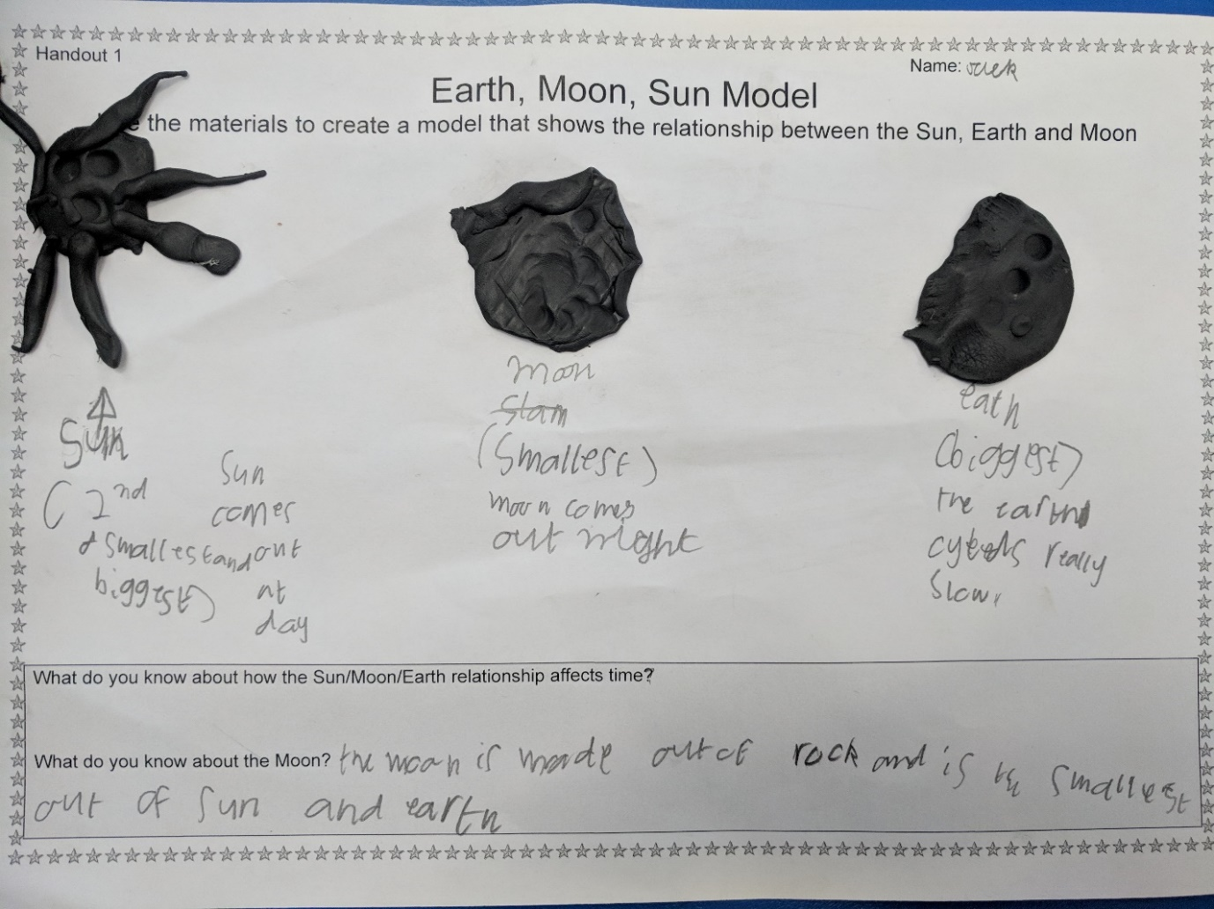Written evidence

Video evidence

Annotated student work sample 1 video (see [Put formative assessment rubrics into practice in Science – Primary](https://www.vcaa.vic.edu.au/assessment/f-10assessment/formative-assessment/formative-assessment-rubric-samples/Pages/SciencePrimarySamples.aspx))

Sample 1: Evidence of student learning

Annotations

* 1.1 The student included the sun, earth and moon in his written response. The video provide indirect evidence to support 1.1 as the student was able to talk about their relationship when questioned. The student was able demonstrate the ability to compare the relative size of the sun, earth and moon (1.3), but the comparison showed some misunderstanding, for example, the student wrote “The moon is made out of rock and is the smallest out of sun and earth” but also wrote that “The sun is the second smallest”.
* 4.1 The written sample demonstrates evidence of understanding that the sun comes out at day. The conversation confirmed this.

Insufficient evidence

* Both the written and follow up conversation did not provide evidence for 2.1 or 3.1.

What is the student ready to learn next?

Sample 1 shaded rubricThe student is ready to learn Phase 1. Student typically showing Phase 1 abilities can be supported though guidance that strengthens their ability to wonder about the natural world based on observations.

Any feedback given

This activity was used as a pre-test to support planning for the follow Term so feedback wasn’t provided.

Sample 2

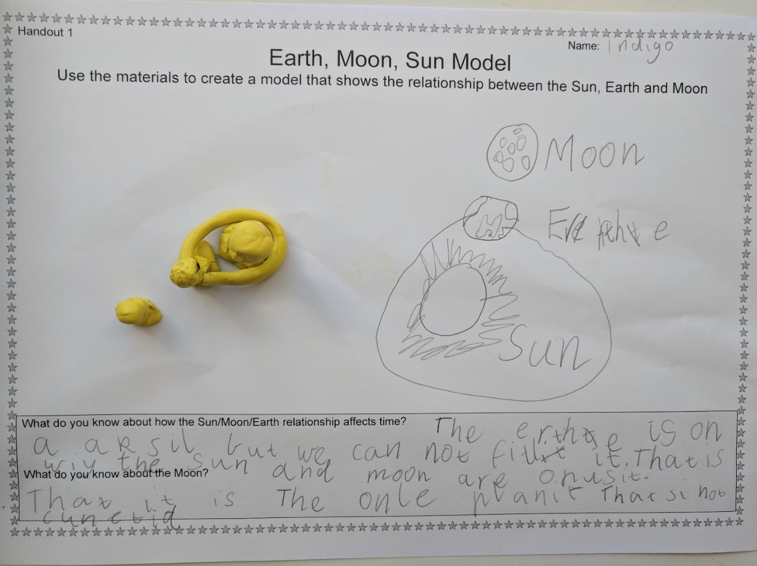Written evidence

Video evidence

Annotated student work sample 2 video (see [Put formative assessment rubrics into practice in Science – Primary](https://www.vcaa.vic.edu.au/assessment/f-10assessment/formative-assessment/formative-assessment-rubric-samples/Pages/SciencePrimarySamples.aspx))

Sample 2: Evidence of student learning

Annotations

* 1.4 This students written work sample provide evidence at 1.2. The plasticine models are clearly spherical. The follow up conversation shows an understanding at 1.5 because the student articulates the distance between planets makes them appear smaller.
* 2.3 The student was able to say that the earth orbits the sun, and the written sample shows that the student has drawn the path of the earth around the sun.
* 3.1 The student was able to say that the rotation of the earth was linked to a day. The student had some understanding of the earth spinning on an axis (related to 3.2).
* 4.1 The student work sample (both written and spoken) indicate some misconception in that the moon and the sun are ‘opposite’, but the student knows that day is denoted by the sun being in the sky.

What is the student ready to learn next?

This student is ready to learn Phase 3. For this student, future learning activities would focus on observing shadows and the concept of light travelling in a straight line.

Sample 2 shaded rubric

Sample 3

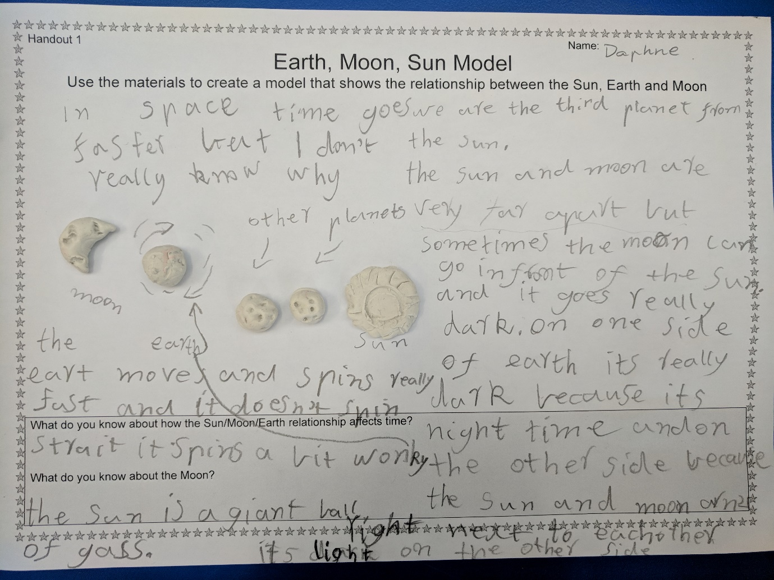Written evidence

Video evidence

Annotated student work sample 3 video (see [Put formative assessment rubrics into practice in Science – Primary](https://www.vcaa.vic.edu.au/assessment/f-10assessment/formative-assessment/formative-assessment-rubric-samples/Pages/SciencePrimarySamples.aspx))

Sample 3: Evidence of student learning

Annotations

* 1.3 The student wrote that the sun and moon are very far apart.
* 3.1 The student written work sample and interview together provide evidence that the student can link one full rotation of the earth to one day.
* 4.1 The student knows its light during day time and dark during night time but can’t explain why its dark.

Insufficient evidence

* 2.0 The students written work sample and interview show that the student knows that the student understands that elements are moving but there is some misconception about what and where, for example, student said the sun and moon swap over and move around the earth.

What is the student ready to learn next?

Sample 3 shaded rubricThis student is ready to learn phase 2. The written work appears to provide evidence of a higher level of understanding, but the follow up conversations identified more misconceptions. The focus of learning in future activities will be around learning that the sun stays still using interactive models.

Sample 4

Written evidence 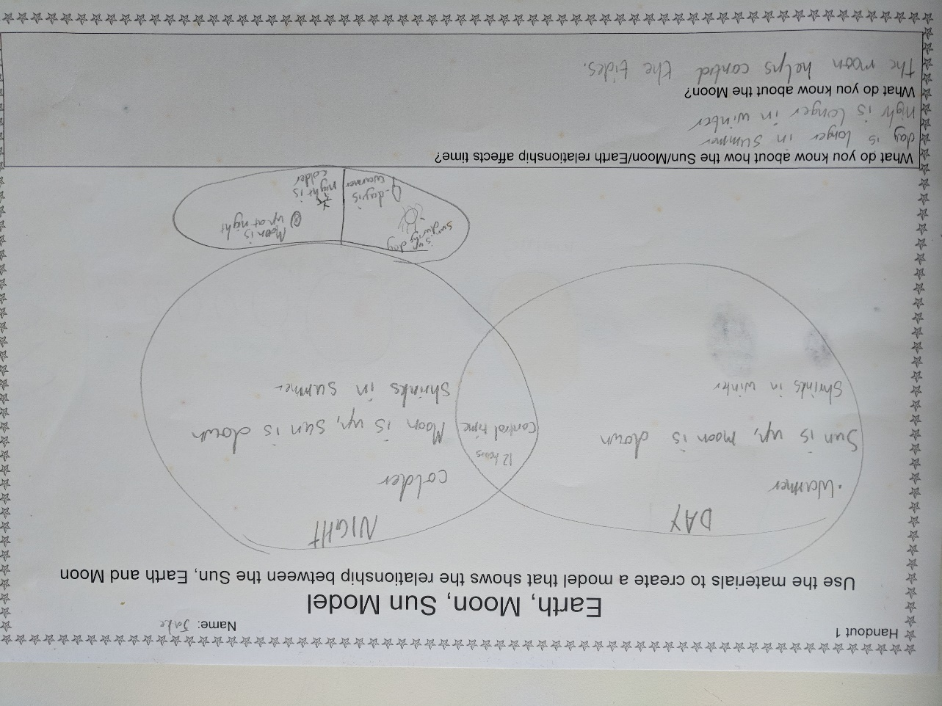

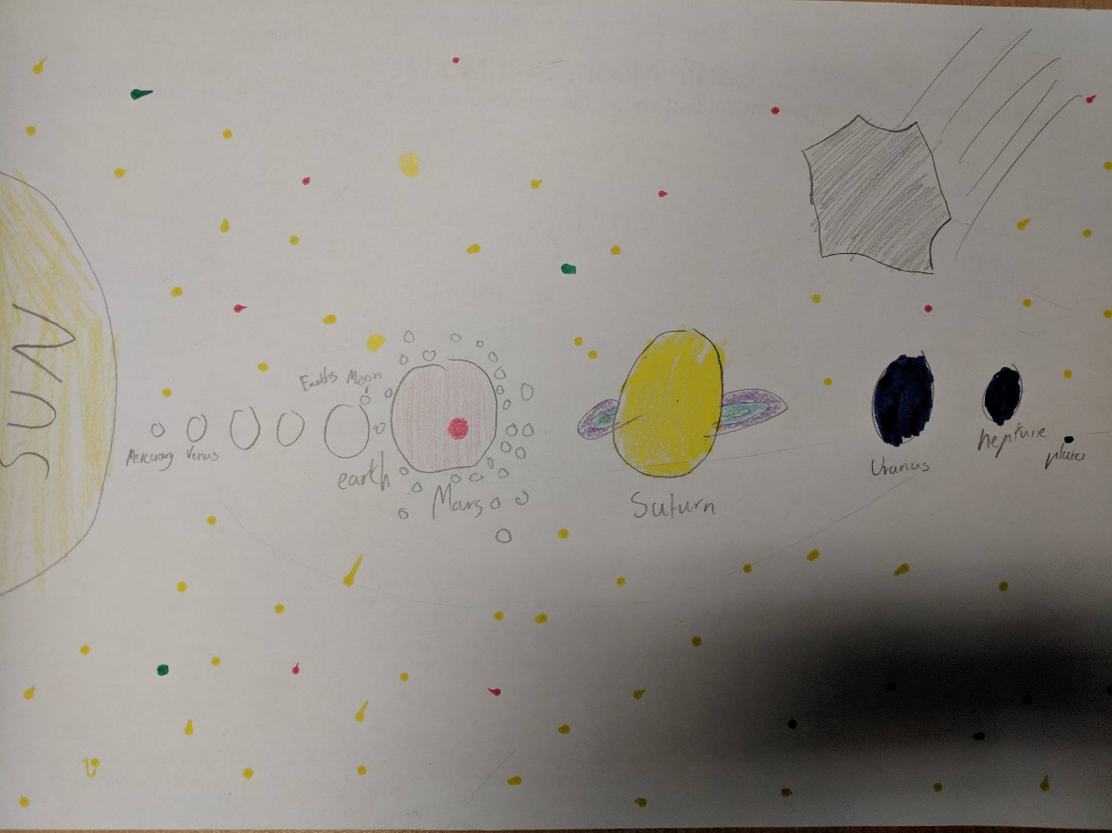

Video evidence

Annotated student work sample 4 video (see [Put formative assessment rubrics into practice in Science – Primary](https://www.vcaa.vic.edu.au/assessment/f-10assessment/formative-assessment/formative-assessment-rubric-samples/Pages/SciencePrimarySamples.aspx))

Sample 4: Evidence of student learning

Annotations

* 1.5 In the follow up conversation, the student said that the sun looks bigger compared to other stars because it is closer to Earth. No written or modelled evidence.
* 2.4 The student said that the earth rotates around the sun.
* 3.3 Even though the student didn’t say anything about the earths tilt, he was able to describe the effect of the tilt. On the written sample, he wrote ‘day shrinks in winter’ and ‘night shrinks in summer’.
* 4.2 The student said ‘at night, the earth faces away from the sun.’ The student demonstrated aspects of both 4.3 and 4.4, although the misconception that the moon is always an element of the night sky remained (in both conversation and written evidence).

What is the student ready to learn next?

The student is ready to learn Phase 5. The focus of learning activities will be on the earth’s tilt. Activities will use a globe model of the earth and light source to develop this understanding.

Sample 4 shaded rubric

Using evidence to plan for future teaching and learning

* For the Catholic primary school, the data was collected as a pre-test to inform planning for Term 3. It provided clear stating points for student exploration of topic. The teacher first identified common misconceptions and planned investigations that addressed these, including shadow experiments and observations, and student roll-play activities to address understanding of what moves where and how. Students also explored Aboriginal and Torres Strait Islander ways of understanding seasonality and time.

Teacher reflections

* The process of writing a learning continuum and implementing in the classroom was challenging. Revising after implementing the task was essential to refine the learning continuum to be a more accurate reflection of typical student learning. Considering how to ensure tasks are rich and provide lots opportunities for student to show what they know and can do was a key learning for school-based professional learning.
* The time commitment for follow-up conversations needs to be considered in terms of time and resource availability but does provide rich data. Teachers considering using this task may wish to only follow up with a sample of students.
* One teacher with many years of experience and one recent graduate both reflected that this professional learning experience has been positive and valuable.
* The learning step between 4.1 and 4.2 requires abstract thinking. Outdoor activities related to shadow can support this learning. 4.2 was moved and a gap created in the rubric to reflect this leap in learning.

Appendix 1: Earth, Moon and Sun handout

