Using formative assessment rubrics in Critical and Creative Thinking

Structure of an argument

Foundation – Level 4

Authorised and published by the Victorian Curriculum and Assessment Authority
Level 7, 2 Lonsdale Street
Melbourne VIC 3000
© Victorian Curriculum and Assessment Authority 2020.

No part of this publication may be reproduced except as specified under the Copyright Act 1968 or by permission from the VCAA. Excepting third-party elements, schools may use this resource in accordance with the VCAA educational allowance. For more information go to: https://www.vcaa.vic.edu.au/Footer/Pages/Copyright.aspx.
The VCAA provides the only official, up-to-date versions of VCAA publications. Details of updates can be found on the VCAA website: www.vcaa.vic.edu.au.
This publication may contain copyright material belonging to a third party. Every effort has been made to contact all copyright owners. If you believe that material in this publication is an infringement of your copyright, please email the Copyright Officer: vcaa.copyright@edumail.vic.gov.au
Copyright in materials appearing at any sites linked to this document rests with the copyright owner/s of those materials, subject to the Copyright Act. The VCAA recommends you refer to copyright statements at linked sites before using such materials.
At the time of publication the hyperlinked URLs (website addresses) in this document were checked for accuracy and appropriateness of content; however, due to the transient nature of material placed on the web, their continuing accuracy cannot be verified.

The VCAA logo is a registered trademark of the Victorian Curriculum and Assessment Authority.

Contents
What is formative assessment? 4
Using formative assessment rubrics in schools 4
The formative assessment rubric 5
Links to the Victorian Curriculum F–10 5
The formative assessment task 7
Description of the task (administration guidelines) 7
Evidence collected from this task 8
Interpreting evidence of student learning 9
Setting the scene 9
Sample 1 10
Sample 1: Evidence of student learning 11
Sample 1: Evidence of student learning 11
Any feedback given 11
Sample 2 12
Sample 2: Evidence of student learning 13
Sample 3 14
Sample 3: Evidence of student learning 15
Using evidence to plan for future teaching and learning 16
Teacher reflections 16

What is formative assessment?
Formative assessment is any assessment that is used to improve teaching and learning. Best-practice formative assessment uses a rigorous approach in which each step of the assessment process is carefully thought through.
Assessment is a three-step process by which evidence is collected, interpreted and used. By definition, the final step of formative assessment requires a use that improves teaching and learning.
For the best results, teachers can work together to interrogate the curriculum and use their professional expertise and knowledge of their students to outline a learning continuum including a rubric of measurable, user-friendly descriptions of skills and knowledge. Teachers can draw on this learning continuum and rubric to decide how to collect evidence of each student’s current learning in order to provide formative feedback and understand what they are ready to learn next.
The VCAA’s Guide to Formative Assessment Rubrics outlines how to develop a formative assessment rubric to collect, interpret and use evidence of student learning to plan teaching and learning. For more information about formative assessment and to access a copy of the guide, please go to the Formative Assessment section of the VCAA website.

Using formative assessment rubrics in schools
This document is based on the material developed by one group of teachers in the 2019 Formative Assessment Rubrics project. The VCAA acknowledges the valuable contribution to this resource of the following teachers: Levent Ibrahim (Albanvale Primary School), Kim Miter (Albanvale Primary School) and Anastasia Vrionis (Langwarrin Primary School).The Victorian Curriculum and Assessment Authority partnered with the Assessment Research Centre, University of Melbourne, to provide professional learning for teachers interested in strengthening their understanding and use of formative assessment rubrics.
This resource includes a sample formative assessment rubric, a description of a task/activity undertaken to gather evidence of learning, and annotated student work samples.
Schools have flexibility in how they choose to use this resource, including as:
- a model that they adapt to suit their own teaching and learning plans
- a resource to support them as they develop their own formative assessment rubrics and tasks.
This resource is not an exemplar.
Additional support and advice on high-quality curriculum planning is available from the Curriculum Planning Resource.

The formative assessment rubric
The rubric in this document was developed to help inform teaching and learning in Critical and Creative Thinking. This rubric supports the explicit teaching of the structure of an argument.
This formative assessment rubric is designed to provide teachers with information about what students are currently demonstrating in identifying the structure of an argument. It is designed to enable students to show that they can identify:
- an introduction with the point of view
- the reason/s (premise) with supporting evidence or examples
- the conclusion to summarise the main idea.
The purpose of this rubric is to focus on the ability of students to identify the structure of an argument using either key terms or inferentially.

Links to the Victorian Curriculum F–10

Curriculum area: Critical and Creative Thinking
Strand: Reasoning
Levels/Bands: Level 2 to 4
Achievement standard/s extract: Foundation to Level 2:
Students identify words that indicate components of a point of view.
Levels 3 and 4:
Students describe and structure arguments with clearly identified aims, premises and conclusions.
Content Description/s: Foundation to Level 2:
Examine words that show reasons and words that show conclusions (VCCCTR004).
Consider how reasons and examples are used to support a point of view and illustrate meaning (VCCCTR006).
Compare and contrast information and ideas in own and others reasoning (VCCCTR005).
Levels 3 and 4:
Examine and use the structure of a basic argument, with an aim, reasons and conclusion to present a point of view (VCCCTR013).
Distinguish between main and peripheral ideas in own and others information and points of view (VCCCTR014).

Learning continuum  Critical and Creative Thinking  Foundation to Level 4  Strand: Reasoning  The learning continuum is based on identifying the structure of an argument. |  |  | Phase 1 | Phase 2 | Phase 3 | Phase 4
 |  |  | Students identify the point of view, reasons and conclusion in an argument with a basic structure. | Students identify points of view, reasons and a conclusion when they are explicitly shown through use of key words or phrases. | Students can identify components of an argument when not in standard order. | Students can identify point of view, reasons and conclusion when not explicitly stated.
Organising element | Action | Insufficient evidence | Quality criteria
Reasoning | 1. Identifies the point of view | 1.0 Insufficient evidence | 1.1 Looks at the beginning of the text to identify the point of view. | 1.2 Identifies points of view in cases where key phrases are explicitly used. | 1.3 Identifies point of view when located in any part of a text. | 1.4 Identifies point of view when key phrases are not explicitly stated.
 | 2. Identifies reasons | 2.0 Insufficient evidence | 2.1 Looks at the middle of the text to locate the reasons. | 2.2 Identifies reasons in cases where key words indicating a reason are explicitly used. | 2.3 Identifies reasons when located in any part of a text. | 2.4 Identifies supporting reasons when key words are not explicitly stated.
 | 3. Identifies conclusion | 3.0 Insufficient evidence | 3.1 Looks at the end of the text to locate the conclusion. | 3.2 Identifies a conclusion in cases where key words indicating a conclusion are explicitly used. | 3.3 Identifies a conclusion when located in any part of a text. | 3.4 Identifies a conclusion when key words are not explicitly stated.

The formative assessment task
The following formative assessment task was developed to elicit evidence of each student’s current learning and what they are ready to learn next.

Description of the task (administration guidelines)

Students are explicitly taught the structure of an argument (introduction, reasons and conclusion), including:
- a basic order starting with a point of view, followed by at least two reasons, and ending with a conclusion
- the vocabulary used in constructing an argument, for example, ‘because’, ‘first’, ‘therefore’, ‘in conclusion’
- that reasons are often supported with evidence or examples
- points of view, reasons and conclusions can be found, even when key phrases and words are not used (essential for Grades 3 and 4, optional for Grades 1 and 2)
- sometimes the components of arguments vary from the basic structure (essential for Grades 3 and 4, optional for Grades 1 and 2)
- sometimes a main point of view can be supported by a series of reasons that are each justified with its own argument or other evidence (essential for Grades 3 and 4, optional for Grades 1 and 2).
Instructions:
- Familiarise yourself with the rubric and the teacher guidelines.
- Provide students with the following labels (Point of view, reason (x2) and conclusion).
- Provide students with an argumentative stimulus aimed at their reading level and in a mixed order.
- Students should paste labels against the appropriate part of the stimulus, or alternatively cut paragraphs from the stimulus and paste next to the label, for example the point of view label should be next to the point of view paragraph.
Considerations:
- Before commencing, check through learning activities that students are at Phase 1.
- The selected stimulus should be relevant to current classroom learning to reduce cognitive load (skill of identifying argument components is being assessed not learning area content).
- A stimulus with a point of view, two reasons and a conclusion (such as the Minecraft argument used in this task) targeting Phases 2 and 3 of the rubric should be given first and evidence from this task can be used to decide whether the student should go on with the second stimulus.
- The second stimulus should target Phases 3 and 4. It should have the components of an argument out of order; can involve reasons with their own supporting arguments; and, not include explicit vocabulary indicating each component of the argument (such as the Plastic Bags stimulus used in this task).

Evidence collected from this task
- Labelled and ordered argument
- Teacher–student conference as necessary to clarify decisions.

Interpreting evidence of student learning
Evidence collected from each student was mapped against the rubric:
- The quality criteria that were achieved was shaded in blue.
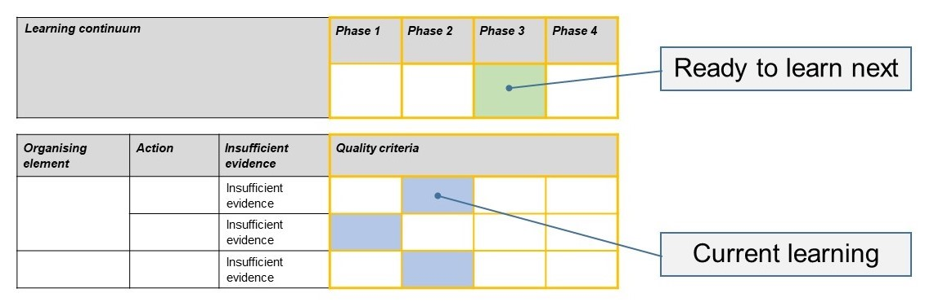
- The phase that the student is ready to learn next was shaded in green.

Please note, the following annotated student work samples are representative examples only.

Setting the scene
The following work samples were collected from a primary school.
One of the school’s current priorities is to ‘ensure that every student is a curious, critical and creative thinker and learner,’ and this has resulted in a focus on exploring how to incorporate the Victorian Curriculum F–10 Capabilities within the school’s teaching and learning program and to plan for explicit instruction. The school has taken a professional learning focus on implementing the capabilities in conjunction with the use of formative assessments rubrics to specifically gain more insight into how to teach and assess the capabilities.
The rubric was used in a number of ways including with Grade 2 students in a class focusing on STEM . This is reflected in Samples 1 and 2. The teacher explicitly taught them the structure of an argument, reviewed any vocabulary, and then administered the task. The sentences were read aloud to the students, to make sure that the vocabulary was appropriate to their reading level. The task was designed to be quick, with little to no writing required so that assessment of the structure of argument was the only variable. No modifications were made for individual students. Most students completed the task within 10 minutes.
Sample 3 has been collected from a Grade 4 student. The task was described as a challenge and not an assessment task. Students were previously exposed to persuasive writing throughout Term 2. Students were then taught content on constructing arguments and the task was administered as a ‘check in’. Students were able to make some connections to prior learnings in persuasive writing.
The hands on activities provided prior to the task exposed students to texts with arguments in them that they could cut out and put into an order. This allowed them to practice the skill of analysing the structure of arguments.

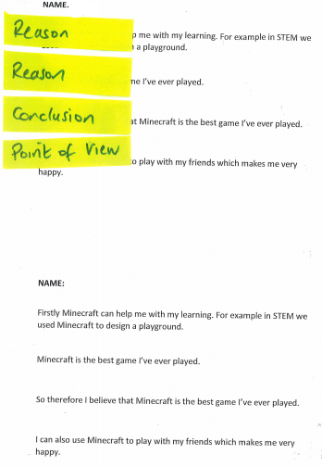
Sample 1

Sample 1: Evidence of student learning

Annotations
- 3.3 The student identified the conclusion located in the middle of the text correctly.
Insufficient evidence:
- 1.0 The point of view as not located.
- 2.0 One reason was labelled correctly. It contained key words ‘Firstly’ and ‘For example’. The student did not associate the key word ‘also’ with the second reason.

What is the student ready to learn next?
The student understands that arguments may be presented in different ways but needs to consolidate their ability to locate reasons when key words are used and points of view when key words are not used. After student conferencing, I would be clearer about the gaps in the student’s knowledge and would be more confident identifying the next phase for this student.

Any feedback given
I would conference with the student to ask her why she placed labels in certain places in order to clarify which phase she is in. The student appears to confuse a personal choice (playing Minecraft makes me happy) with a point of view conceived as a contention for an argument overall. Feedback would be given to help the student clarify concepts. It would unpack why ‘Minecraft is the best game I have ever played because it is the best game I’ve ever played’ is problematic as reasons need to not merely repeat conclusions.

Sample 2

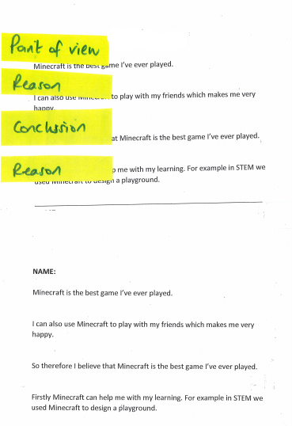
Sample 2: Evidence of student learning

Annotations
- 1.2 The students were taught that one way to analyse key wording in a point of view is to compare the wording in the conclusion to the statement under consideration. The paragraphs identified by the student as point of view and conclusion have similar phrasing (‘Minecraft is the best game I’ve ever played’), and the student selected both correctly.
- 2.3 Reasons were located correctly in a stimulus that did not follow the basic structure.
- 3.3 The conclusion in the middle of the text was labelled correctly.

What is the student ready to learn next?
The student is at Phase 3 and ready to learn Phase 4.

Sample 3

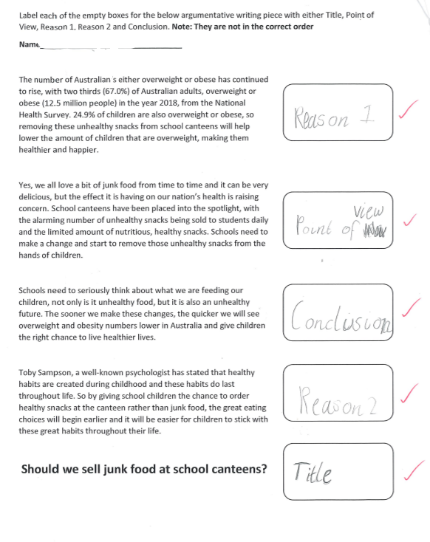
Sample 3: Evidence of student learning

Annotations
- 1.4 The student was able to identify the point of view of an argument where key words were not explicit and the wording of the point of view compared to the conclusion was not exactly the same.
- 2.4 The student was able to identify reasons where key words or phrases were not present and by using other strategies such as locating a point backed by evidence.
- 3.4 The student was able to identify the conclusion in an argument when not explicitly stated.

What is the student ready to learn next?
The student was able to demonstrate Phase 4. The next step in learning would be to develop understanding of how reasons within the text are the conclusions of their own arguments and how the text consists of a series of connected smaller arguments with an introduction (point of view) and overall conclusion.

Using evidence to plan for future teaching and learning

Samples 1 and 2
The data showed me that my Grade 2 STEM students can be grouped into three groups.
Firstly, those that can identify the order of an argument only. Teaching key vocabulary would be the next step and the use of anchor charts and ordering examples would provide appropriate scaffolding.
Secondly, it was clear that there was a group of students who can use key vocabulary to identify structure of an argument. They could be extended to identifying components of an argument where key vocabulary is not used. Worked examples would be key here, ideally linked to knowledge that students already have to allow focus on the skill of identifying the components.
Thirdly, there were a handful of students that were not able to identify the order of an argument, only parts of it. This handful of students would benefit from targeted, explicit learning to support them to identify the structural order of an argument.

Sample 3
For students achieving Phase 4, a next step in learning would be to provide scaffolding related to being able to identify components of an argument. This would focus on removing prompting about the material being out of order and trying to identify components of an argument in a simple unfamiliar context where taught strategies can be used.

Teacher reflections

Changes to the task
After moderating the student work samples using the rubric, we decided that some changes needed to be made to the task to ensure students are able to achieve all phases.
We found that the actual tasks and how it was implemented need to be modified because there were some areas of the rubric that we couldn’t assess or to determine if a student really understood the labelling or got it by chance.
The task provided here is still designed to be flexible enough so it can be modified to suit classes at different levels of learning.

General reflections
The formative assessment rubric was fantastic to use and it provided clear information about students’ learning. It will be administered again in the near future once the learning task has been modified to ensure students are able to achieve all phases.
The creation of the rubric as a formative assessment can be useful for any area of the curriculum. The rubric reduces the amount of time need to assess student work and provides a useful tool to ensure consistent judgement between teachers and classes.
Assessment tasks can be short and succinct and focus on particular areas of the curriculum where you want to gather more information to support student growth. I think they work well for pre- and post- assessment.

